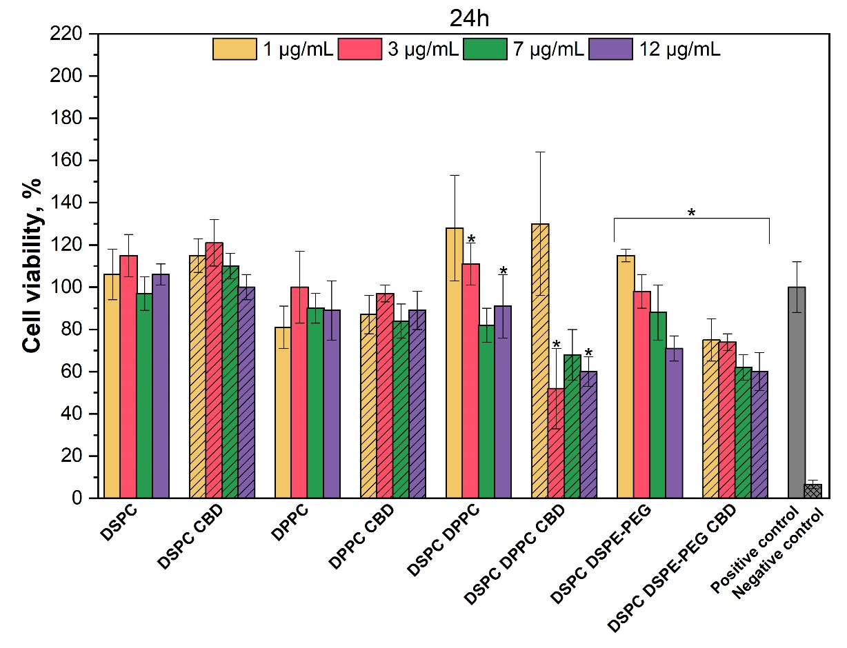
Fig. S1. The influence of liposomes with and without CBD on GMSCs viability after 24 h
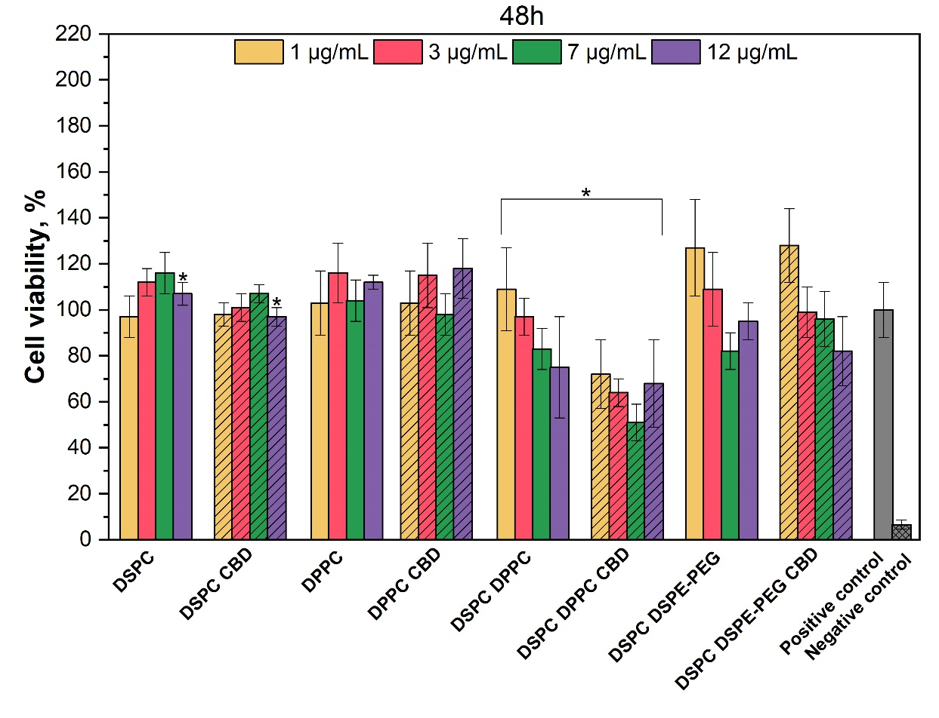
Fig. S2. The influence of liposomes with and without CBD on GMSCs viability after 48 h

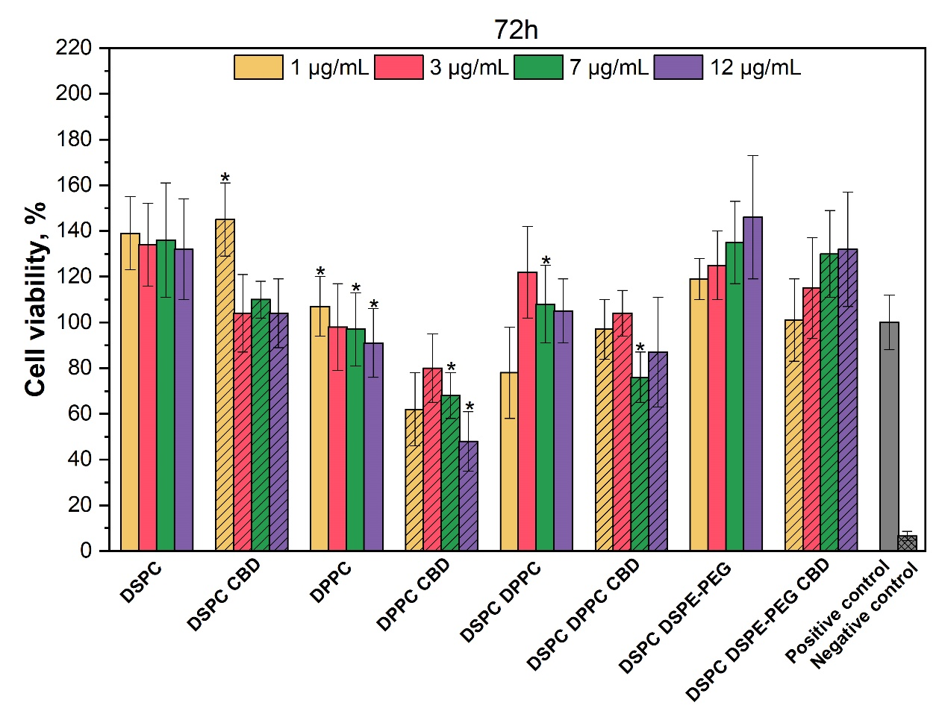
Fig. S3. The influence of liposomes with and without CBD on GMSCs viability after 72 h

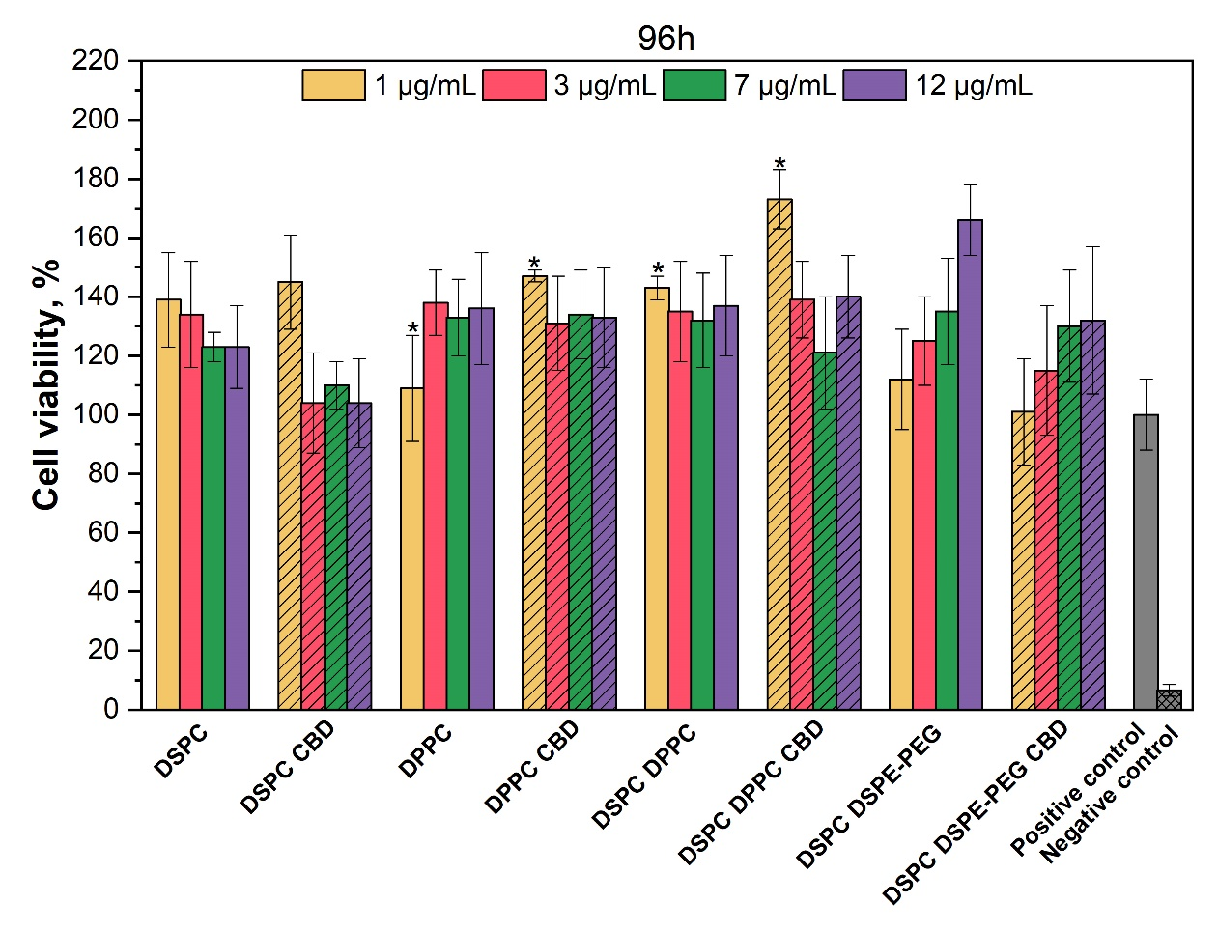
Fig. S4. The influence of liposomes with and without CBD on GMSCs viability after 96 h

