Supplementary Materials

Chronic cannabis use alters the spontaneous and oscillatory
gamma dynamics serving cognitive control

Mikki Schantell, Jason A. John, Anna T. Coutant, Hannah J. Okelberry, Lucy K. Horne, Ryan Glesinger, Seth D. Springer, Amirsalar Mansouri, Pamela E. May-Weeks, Tony W. Wilson

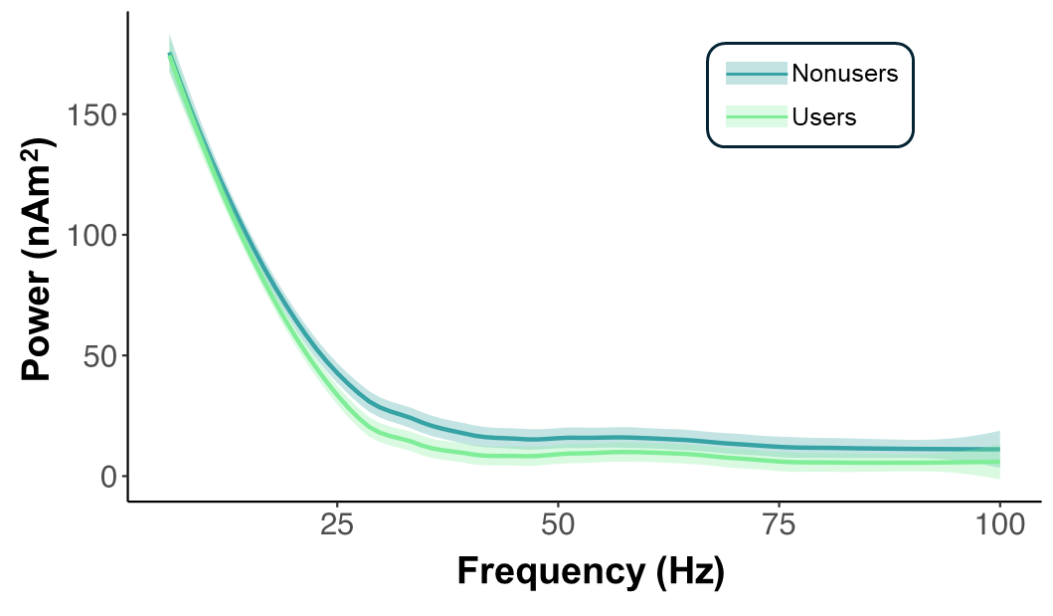
Supplementary Figure 1. Chronic cannabis use is associated with gamma-specific differences in the power spectra across the left frontal eye fields and temporoparietal junction. The power spectra during the pre-stimulus baseline period averaged across the left frontal eye fields (FEF) and temporoparietal junction (TPJ) shows that chronic cannabis use is associated with a greater suppression in gamma (i.e., frequencies ≥ 30 Hz) power, while power in the lower frequencies appears to be similar among cannabis users and nonusers. This suggests that cannabis-related differences in gamma power during the pre-stimulus baseline period are not simply due to broadband shifts, but instead, reflect the frequency-specific alterations in the neural dynamics that give rise to gamma activity.

