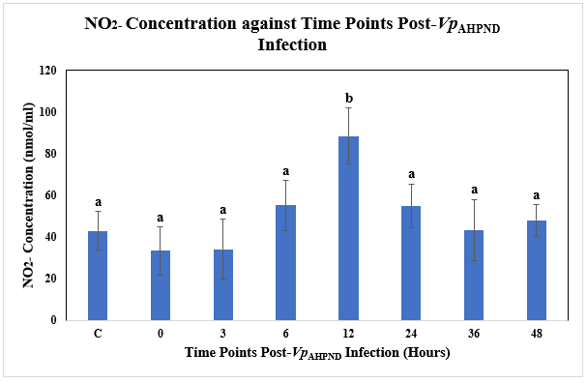
Figure 5 Supp: Nitrite (NO2-) Concentration (nmol/ml) against Time Post-Vp_{AHPND} Infection (Hours) using Vp_{AHPND}-infected P. monodon hepatopancreas tissue samples.
C= Uninfected Control
a and b represent different subsets obtained in Duncan post hoc test.
The error bars indicated standard deviations of the data.

