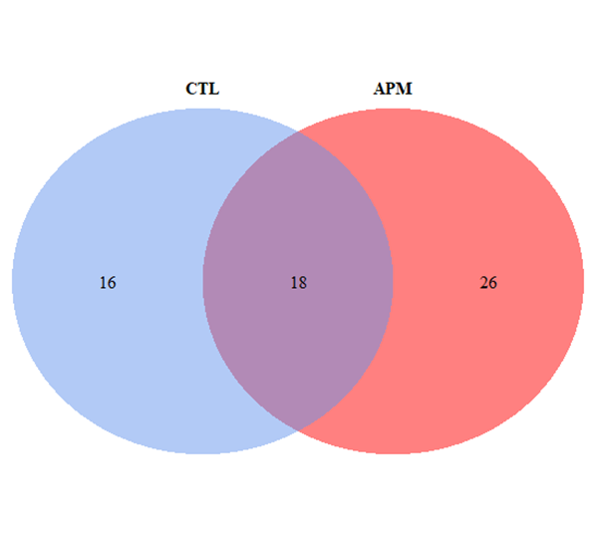
Figure 12 Supp: Venn diagram distribution (distance= 0.03) of OTUs from uninfected control group (CTL) and Vp_{AHPND}-infected group (APM).

