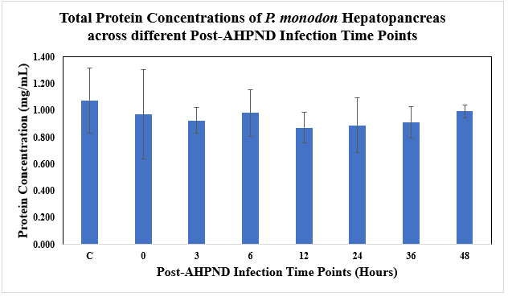
Figure 8 Supp: Total protein concentrations of Vp_{AHPND}-infected P. monodon hepatopancreas samples at different post-infection time points determined using Bradford’s Test standard curve plotted (595 nm).
C= Uninfected Control

