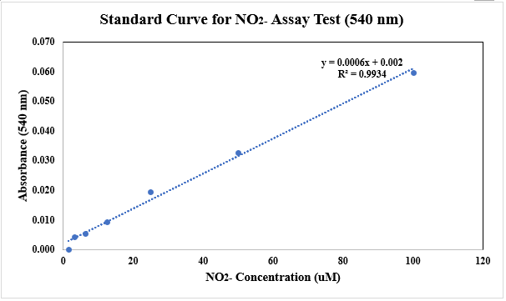
Figure 4 Supp: Standard Curve of Nitrite (NO2-) (OD 540 nm) Assay Test.

