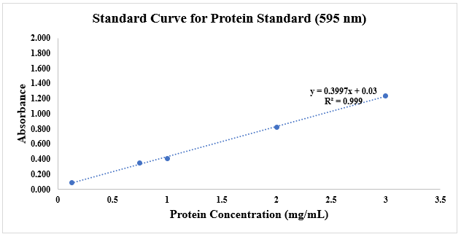
Figure 7 Supp: Bradford’s Test standard curve plotted using protein BSA standard (595 nm).

