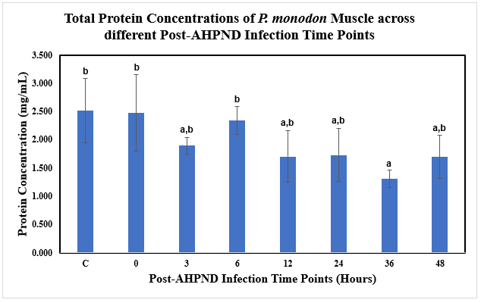
Figure 9 Supp: Total protein concentrations of Vp_{AHPND}-infected P. monodon muscle samples at different post-infection time points determined using Bradford’s Test standard curve plotted (595 nm).
C= Uninfected Control
a and b represent different subsets obtained in Duncan post hoc test.
The error bars indicated standard deviations of the data.

