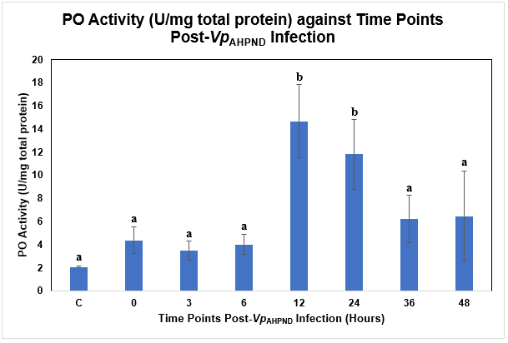
Figure 1 Supp: Phenoloxidase (PO) Activity (U/mg total protein) against Time Post-Vp_{AHPND} Infection (Hours) using Vp_{AHPND}-infected P. monodon hepatopancreas tissue samples.
C= Uninfected Control
a and b represent different subsets obtained in Duncan post hoc test.
The error bars indicated standard deviations of the data.

