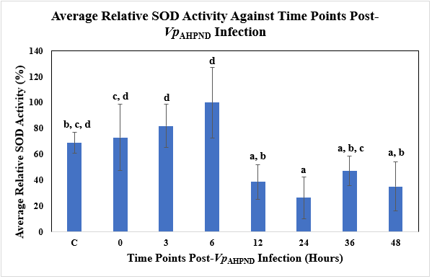
Figure 3 Supp: Average Relative SOD Activity against Time Post-Vp_{AHPND} Infection (Hours) using Vp_{AHPND}-infected P. monodon hepatopancreas tissue samples.
C= Uninfected Control
a, b, c, and d represent different subsets obtained in Duncan post hoc test.
The error bars indicated standard deviations of the data.

