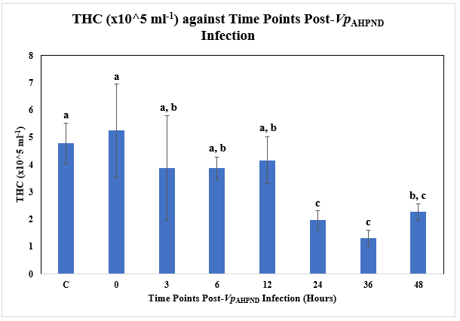
Figure 6 Supp: THC (x10^5 ml⁻¹) against Time Post-Vp_{AHPND} Infection (Hours) using Vp_{AHPND}-infected P. monodon haemolymph tissue samples.
C= Uninfected Control
a, b, and c represent different subsets obtained in Duncan post hoc test.
The error bars indicated standard deviations of the data.

