Supporting Information: Synthetic Cannabinoid Receptor Agonists are Monoamine Oxidase-A Selective Inhibitors
Sarah A Hindson ,^{1‡} Rachael C Andrews ,^{2,3‡} Michael J Danson ,¹ Marc W van der Kamp,⁴ Amy E Manley,⁵ Oliver Sutcliffe,⁶ Thomas Fincham-Haines,⁷ Thomas Freeman,⁸ Jennifer Scott,⁵ Stephen Husbands,⁹ Ian Blagbrough,⁹ JL Ross Anderson,⁴ David Carbery,^{2,3} Christopher R Pudney^{1,3,10}*
¹Department of Biology and Biochemistry, ²Department of Chemistry, ³Centre for Sustainable and Circular Technologies, University of Bath, Bath BA2 7AY, UK. ⁴School of Biochemistry, University of Bristol, Bristol, BS8 1TD. ⁵Faculty of Health Sciences, University of Bristol, Bristol, BS8 1TH. ⁶MANchester DRug Analysis & Knowledge Exchange (MANDRAKE), Department of Natural Sciences, Manchester Metropolitan University, Manchester, M15 5GD, UK. ⁷Department of Computer Science, ⁸Department of Psychology, ⁹Department of Pharmacy and Pharmacology, Centre for Therapeutic Innovation, University of Bath, Bath, BA2 7AY, UK.

Contents:
Figure S1. Validation study to compare Autodock 4.2 method with the co-crystallized inhibitors within MAO-A (left) and MAO-B (right).
Figure S2. Lowest energy binding poses between ligands and residues in the active site of MAO-A.
Figure S3. Lowest energy binding poses between ligands and residues in the active site of MAO-B.
Figure S4. ¹H NMR for N-5-fluoropentylindole, 6
Figure S5. ¹³C NMR for N-5-fluoropentylindole, 6.
Figure S6. ¹⁹F NMR for N-5-fluoropentylindole, 6.
Figure S7. IR spectrum for N-5-fluoropentylindole, 6.
Figure S8. MS confirmation for N-5-fluoropentylindole, 6.
Figure S9. ¹H NMR for N-5-fluoropentylindazole, 7.
Figure S10. ¹³C NMR for N-5-fluoropentylindazole, 7.
Figure S11. ¹⁹F NMR for N-5-fluoropentylindazole, 7.
Figure S12. IR spectrum for N-5-fluoropentylindazole, 7.
Figure S13. MS confirmation for N-5-fluoropentylindazole, 7.
Figure S14. ¹H NMR for N-pentylindole, 8.
Figure S15. ¹³C NMR for N-pentylindole, 8.
Figure S16. IR spectrum for N-pentylindole, 8.
Figure S17. MS confirmation for N-pentylindole, 8.
Figure S18. ¹H NMR for N-pentylindazole, 9.
Figure S19. ¹³C NMR for N-pentylindazole, 9.
Figure S20. IR spectrum for N-pentylindazole, 9.
Figure S21. MS confirmation for N-pentylindazole, 9.

Figures

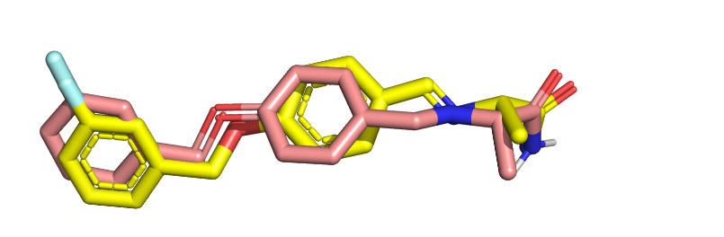
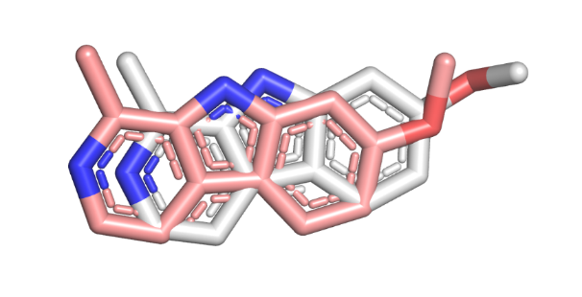

Figure S1. Validation study to compare Autodock 4.2 method with the co-crystallized inhibitors within MAO-A (left) and MAO-B (right). Following removal of co-crystalised inhibitor from the original pdb files, these compounds were then used for in-silico binding via Autodock Vina to validate the method in use during this study. The RMSD of the lowest energy binding pose and the co-crystalised configuration was compared. In both examples, the pink-coloured compound is the co-crystalised geometry obtained from the original pdb file. The RMSD of harmine in MAO-A (left) is 1.237 Å and RMSD of safinamide in MAO-B (right) is 0.965 Å, calculated using DockRMSD software.⁴² These RMSD values are below the accepted value of 2.0 Å for RMSD scoring.³⁸ Structure figures were generated using PyMol (The PyMOL Molecular Graphics System, Version 2.4.1, Schrödinger, LLC).

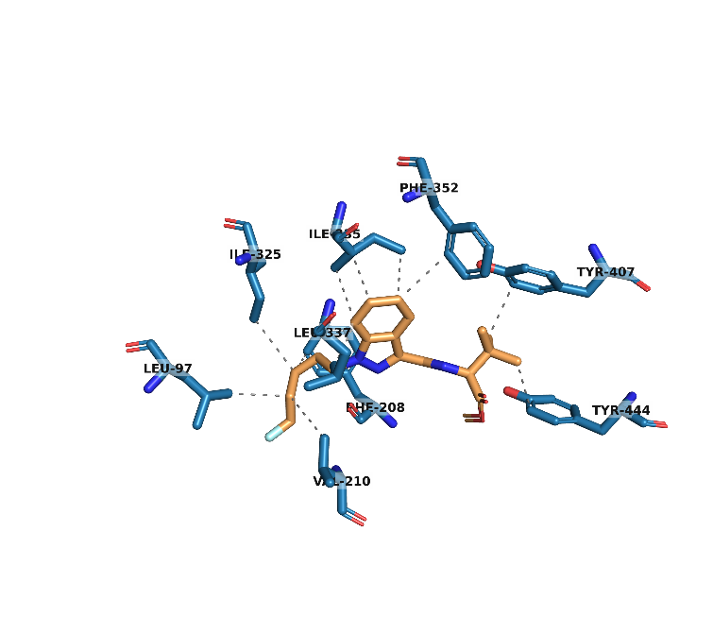
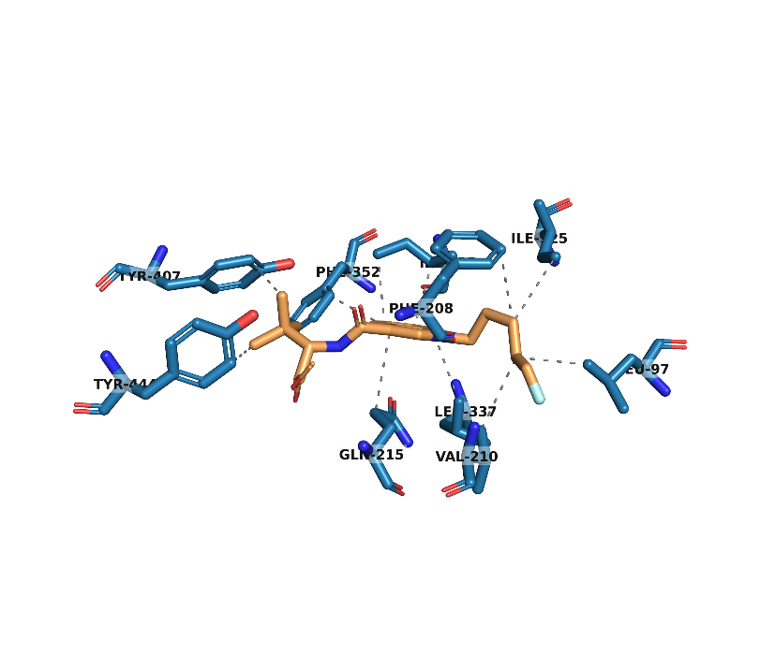
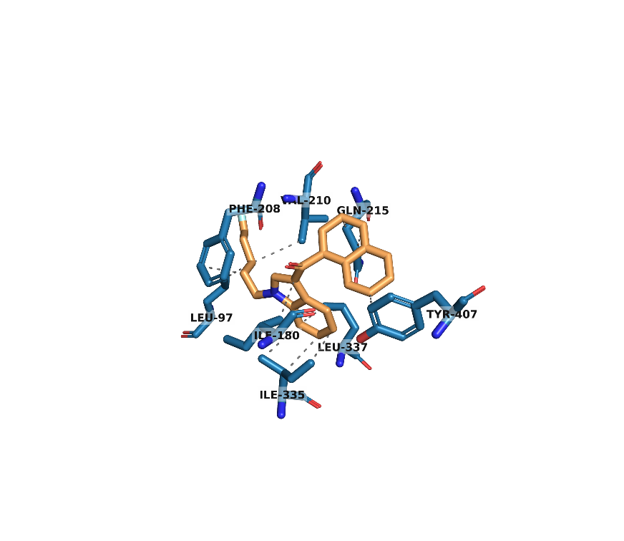
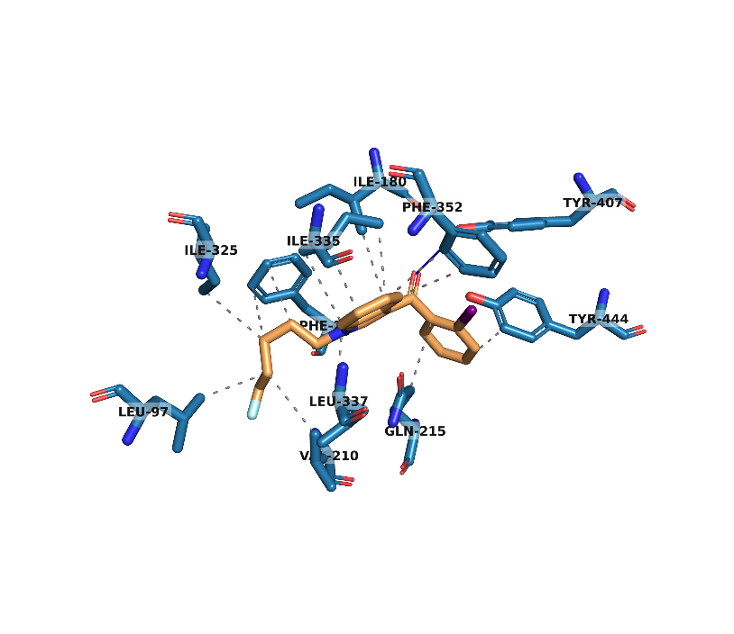
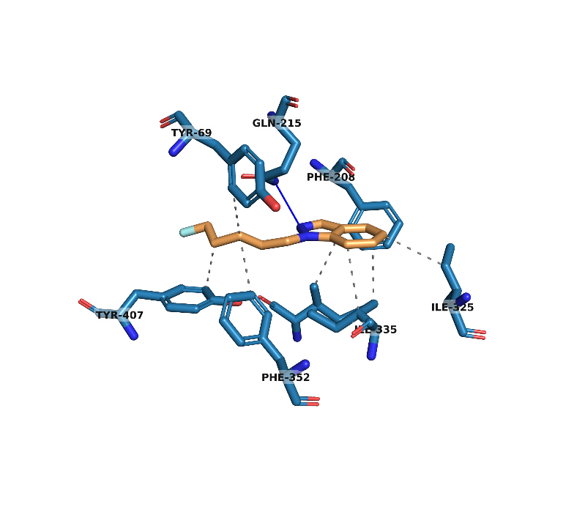
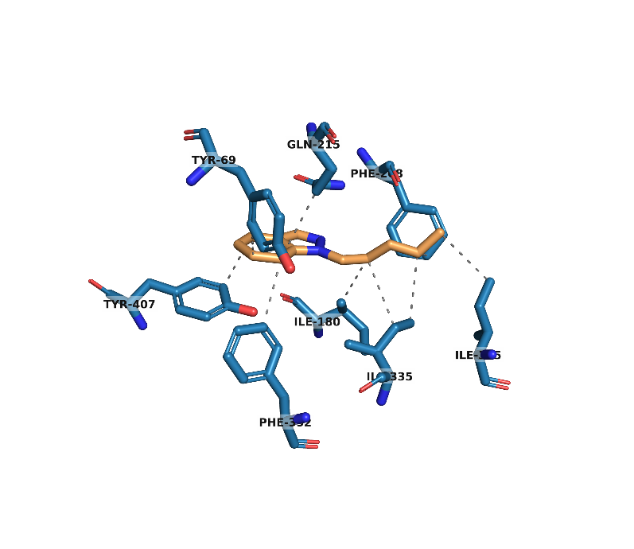
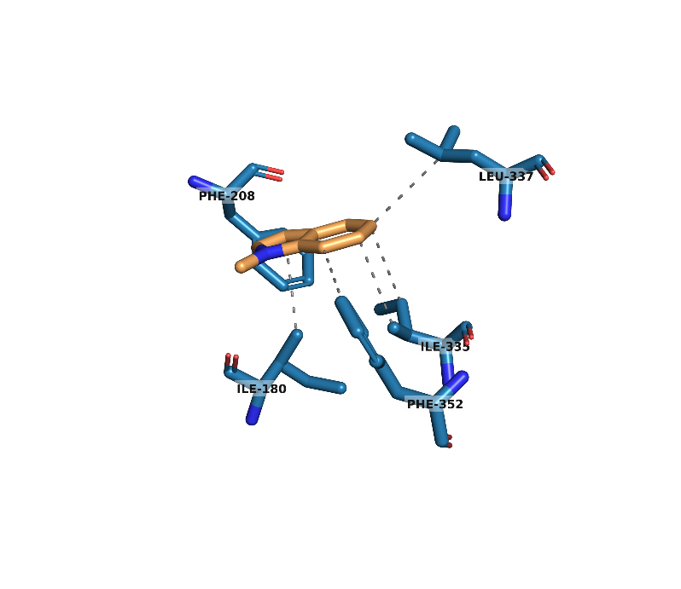
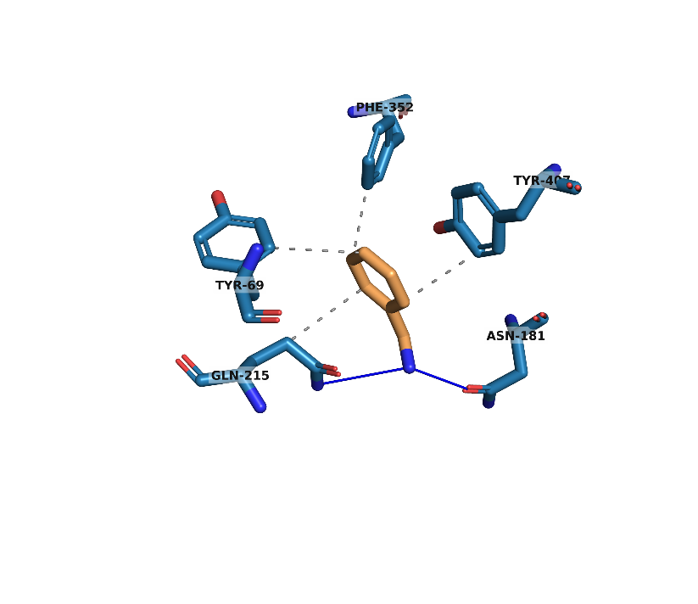
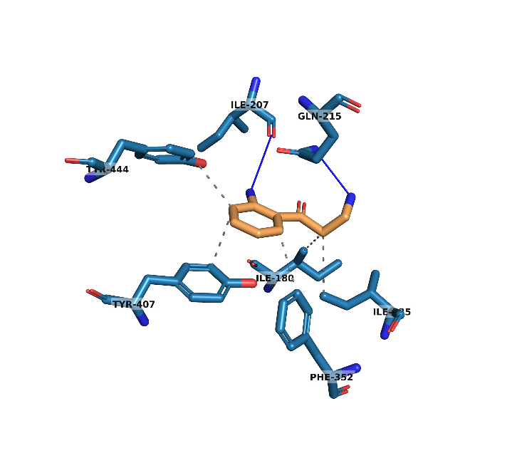
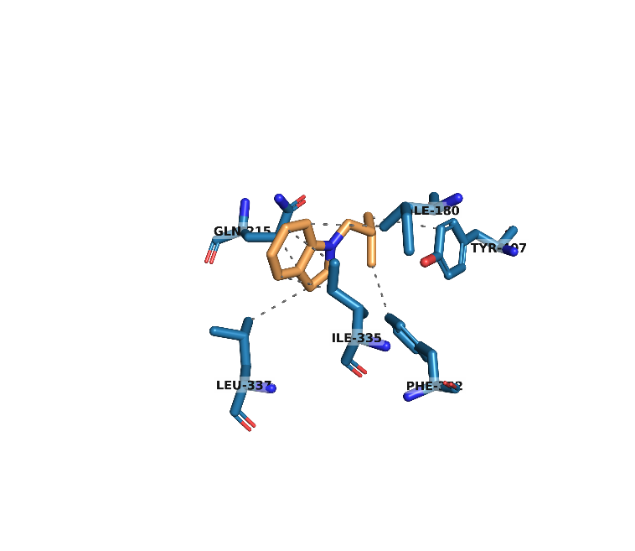
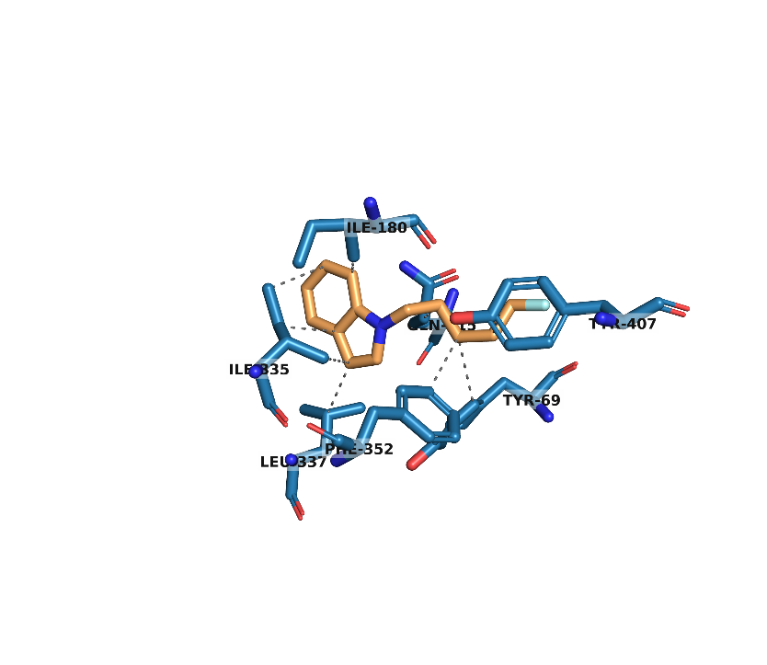
5F-ADB (1) in MAO-A
5F-MDMB-PICA (2) in MAO-A
AM-2201 (4) in MAO-A
AM-694 (5) in MAO-A
1-(5-fluoropentyl)-1H-Indole (6) in MAO-A
1-(5-fluoropentyl)-1H-Indazole (7) in MAO-A
1-pentyl-1H-Indole (8) in MAO-A
1-pentyl-1H-Indazole (9) in MAO-A
1-methyl-1H-Indole (10) in MAO-A
Benzylamine (11) in MAO-A
Kynuramine (12) in MAO-A

Figure S2. Lowest energy binding poses between ligands and residues in the active site of MAO-A. Structure figures were generated using PyMol (The PyMOL Molecular Graphics System, Version 2.4.1, Schrödinger, LLC).
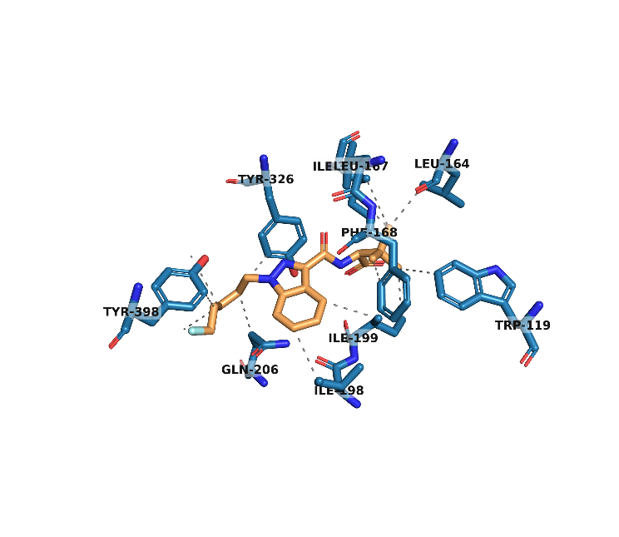
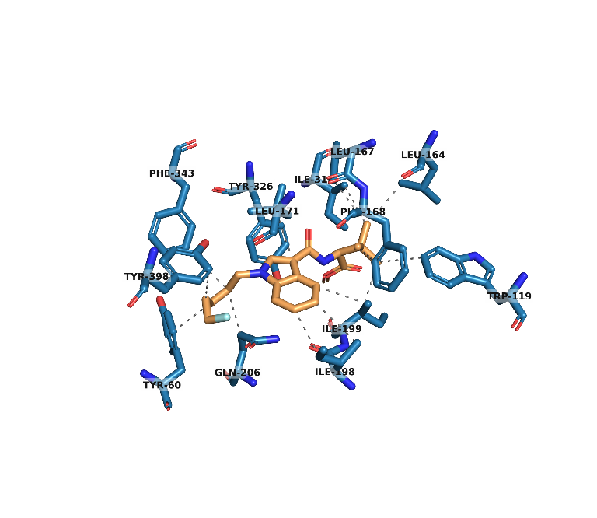
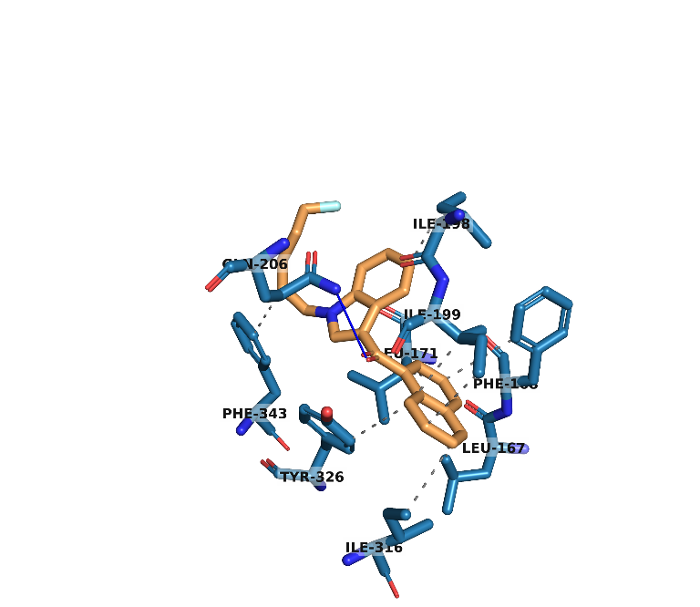
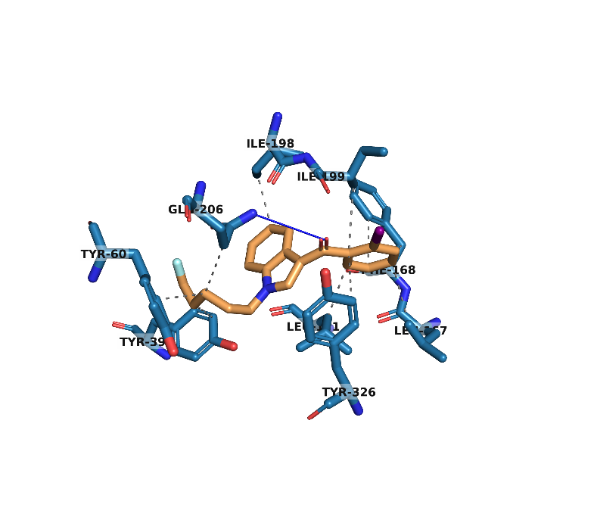
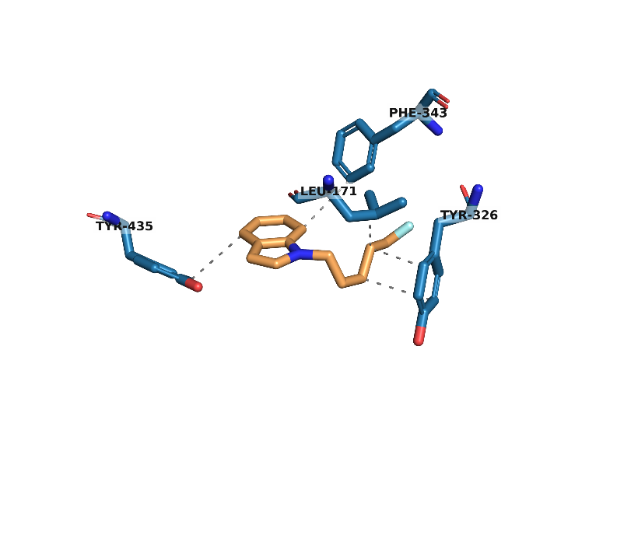
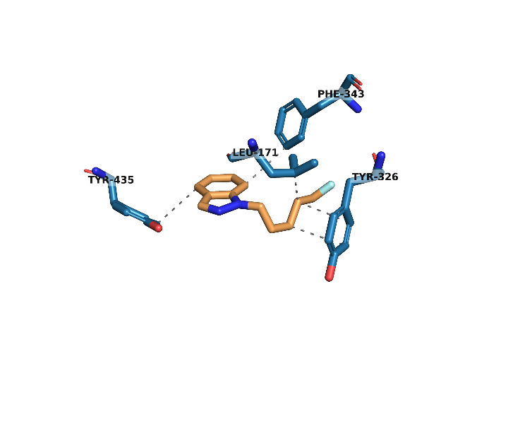
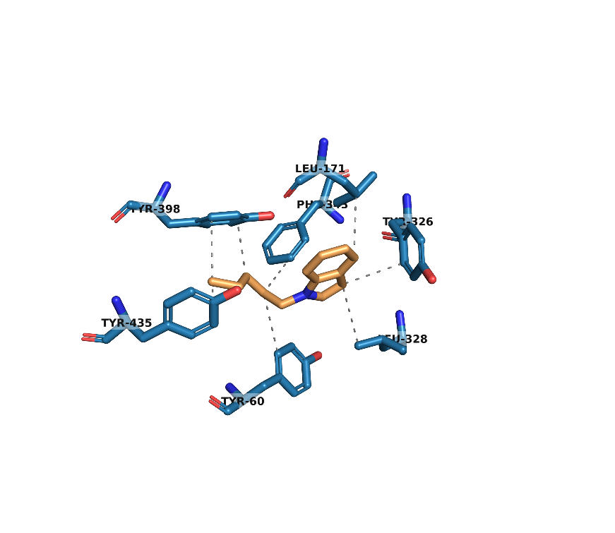
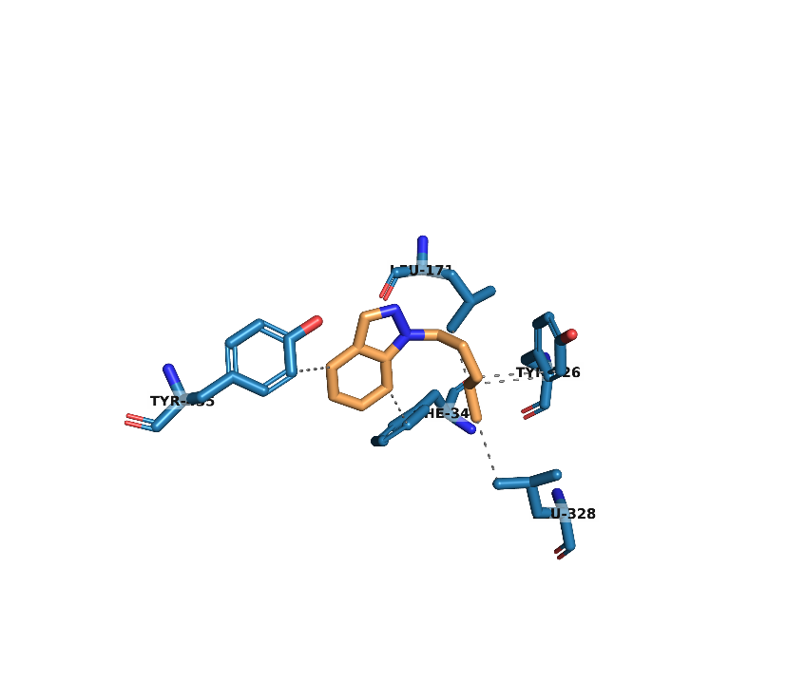
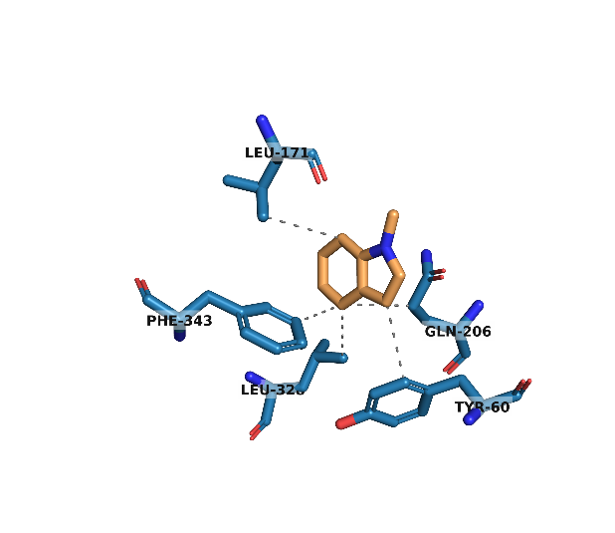
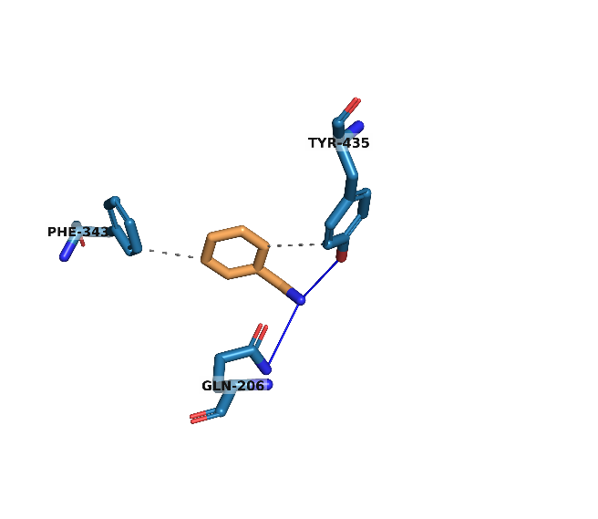
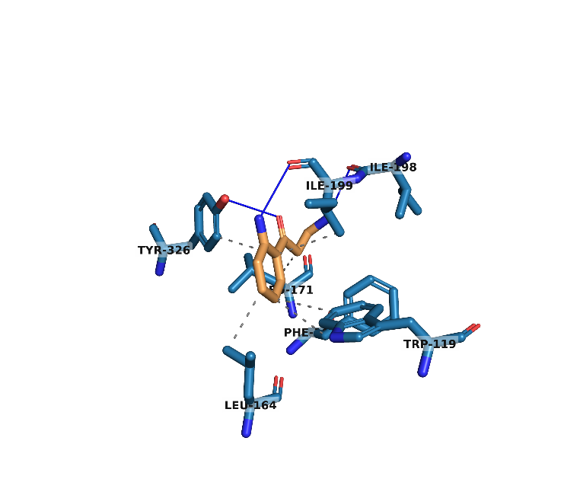
5F-ADB (1) in MAO-B
5F-MDMB-PICA (2) in MAO-B
AM-2201 (4) in MAO-B
AM-694 (5) in MAO-B
1-(5-fluoropentyl)-1H-Indole (6) in MAO-B
1-(5-fluoropentyl)-1H-Indazole (7) in MAO-B
1-pentyl-1H-Indole (8) in MAO-B
1-pentyl-1H-Indazole (9) in MAO-B
1-methyl-1H-Indole (10) in MAO-B
Benzylamine (11) in MAO-B
Kynuramine (12) in MAO-B

Figure S3. Lowest energy binding poses between ligands and residues in the active site of MAO-B. Structure figures were generated using PyMol (The PyMOL Molecular Graphics System, Version 2.4.1, Schrödinger, LLC).
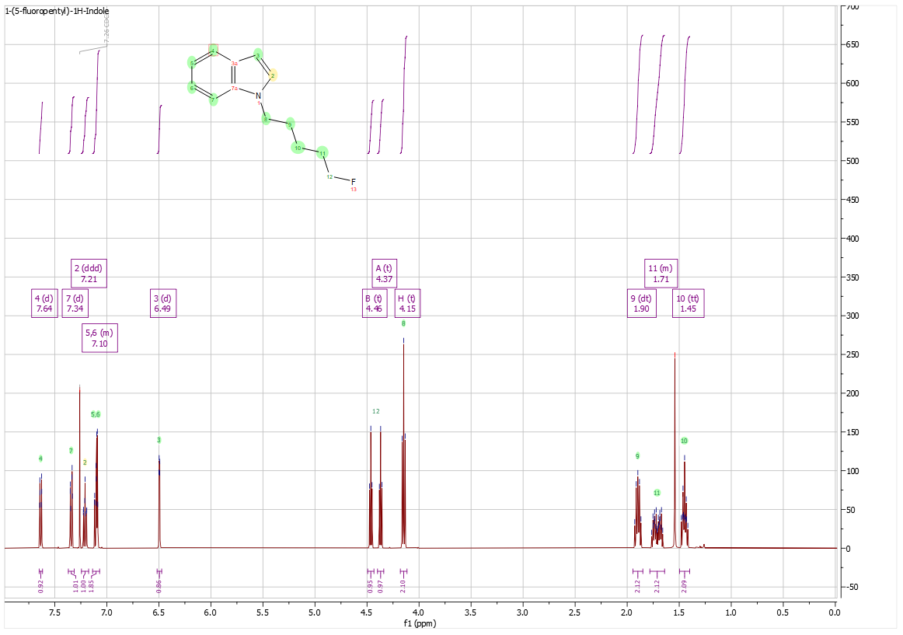
Figure S4. ¹H NMR for N-5-fluoropentylindole, 6.

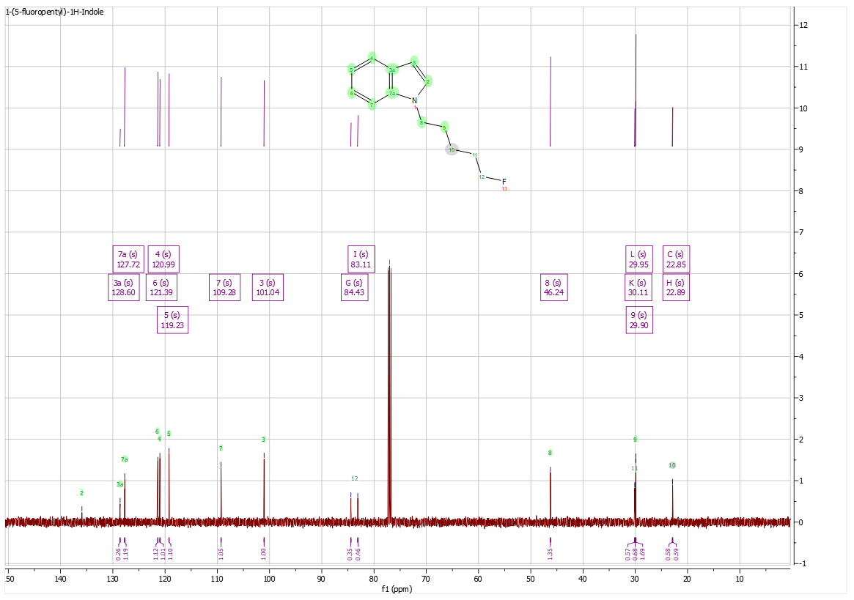
Figure S5. ¹³C NMR for N-5-fluoropentylindole, 6.

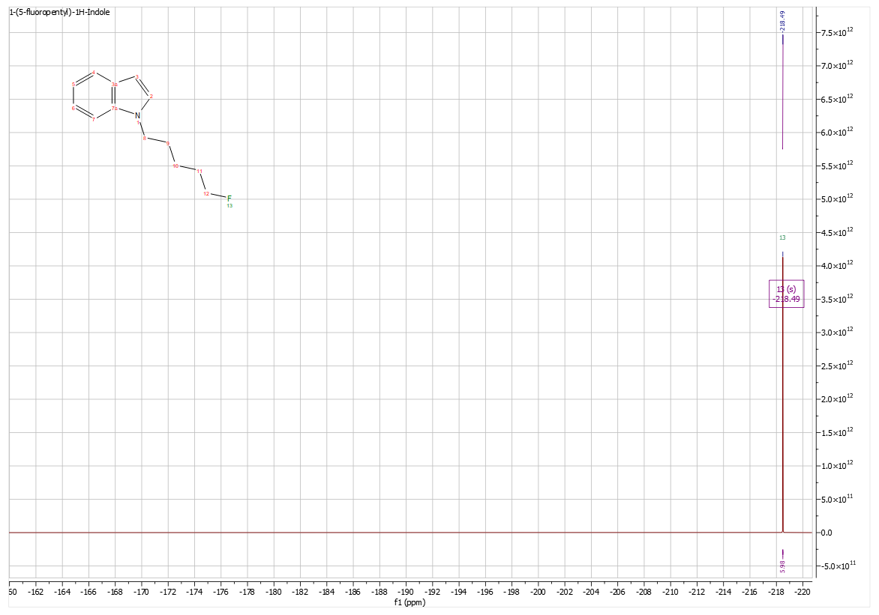
Figure S6. ¹⁹F NMR for N-5-fluoropentylindole, 6.

Figure S7. IR spectrum for N-5-fluoropentylindole, 6.
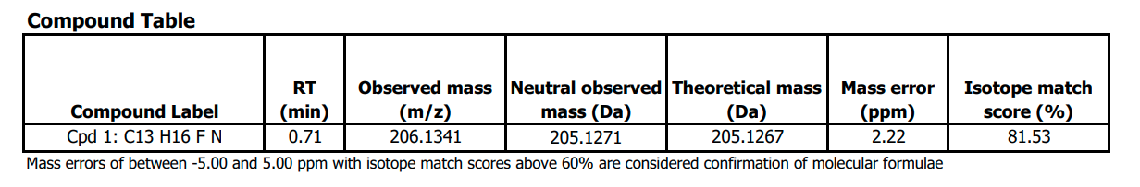
Figure S8. MS confirmation for N-5-fluoropentylindole, 6.
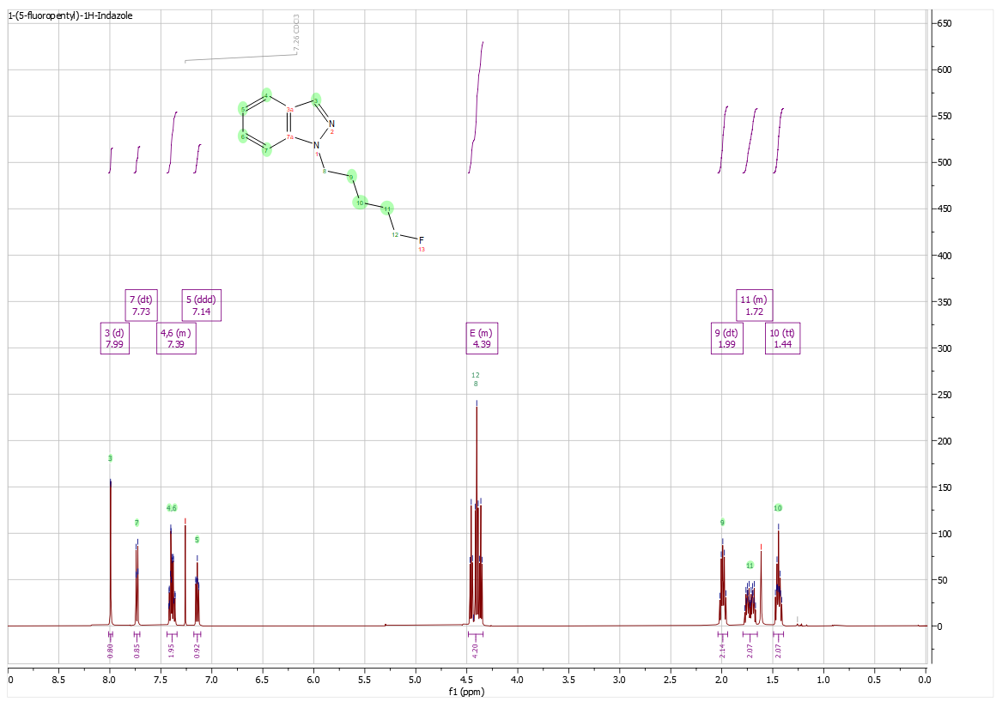
Figure S9. ¹H NMR for N-5-fluoropentylindazole, 7.

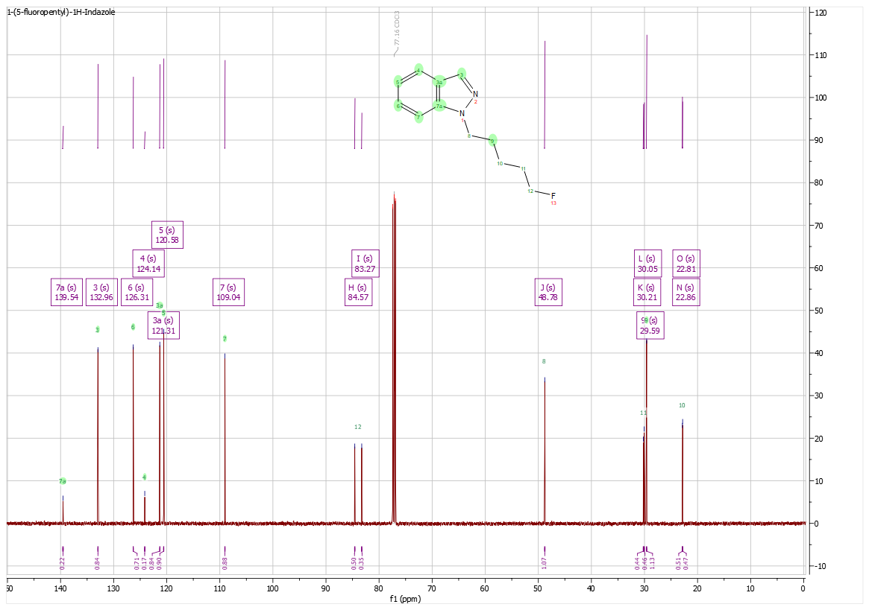
Figure S10. ¹³C NMR for N-5-fluoropentylindazole, 7.

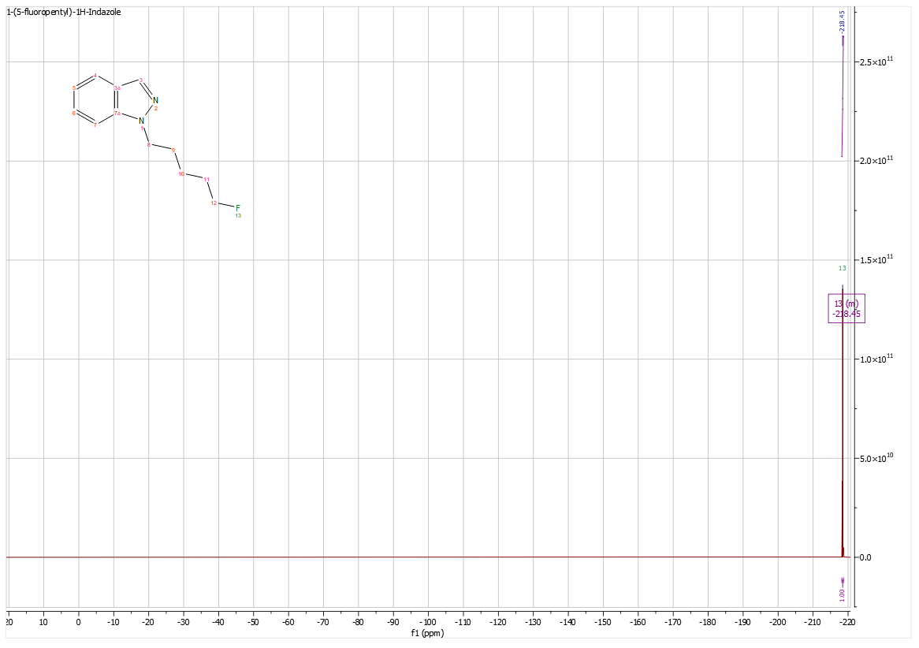
Figure S11. ¹⁹F NMR for N-5-fluoropentylindazole, 7.

Figure S12. IR spectrum for N-5-fluoropentylindazole, 7.
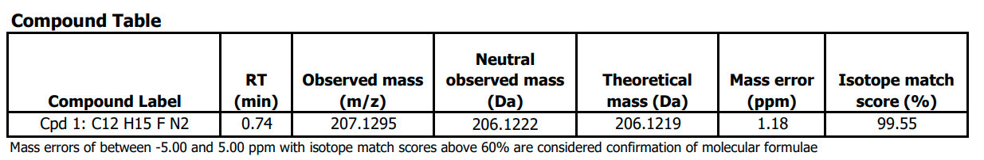
Figure S13. MS confirmation for N-5-fluoropentylindazole, 7.
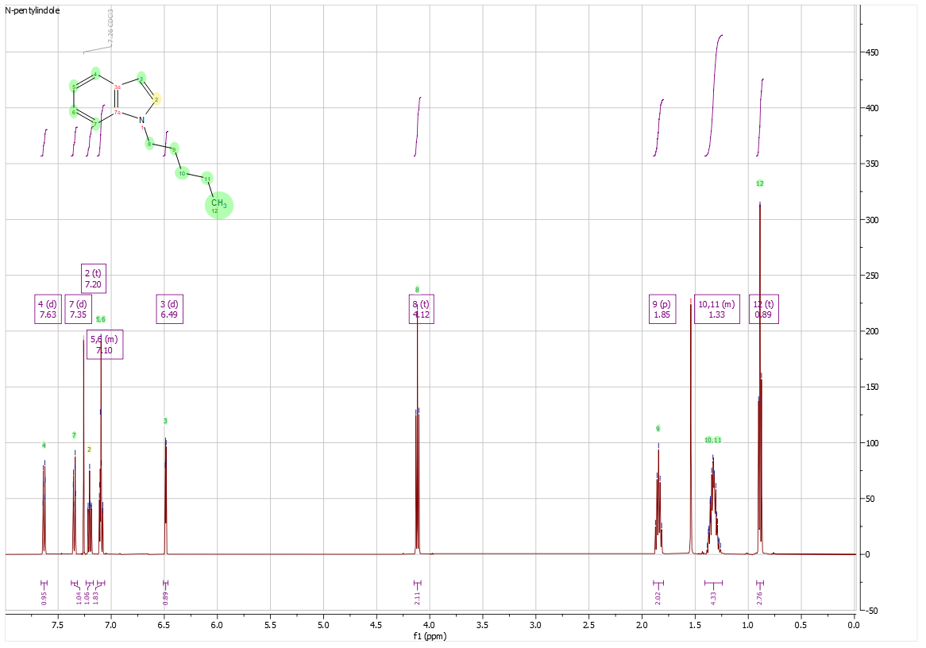
Figure S14. ¹H NMR for N-pentylindole, 8.

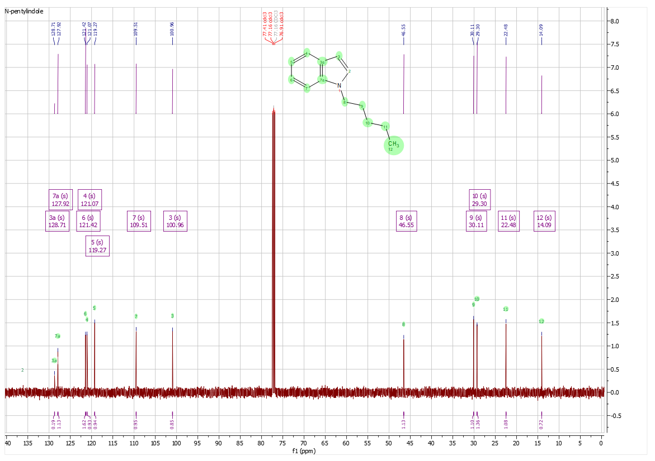
Figure S15. ¹³C NMR for N-pentylindole, 8.

Figure S16. IR spectrum for N-pentylindole, 8.
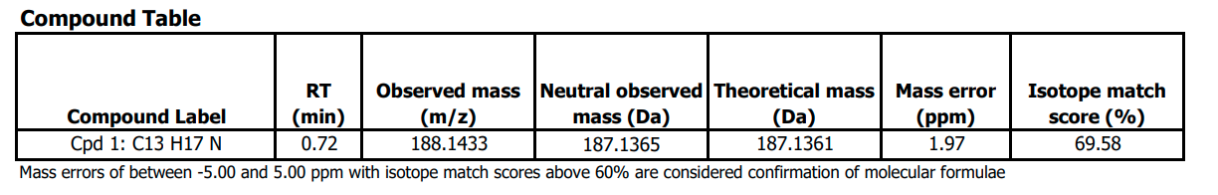
Figure S17. MS confirmation for N-pentylindole, 8.
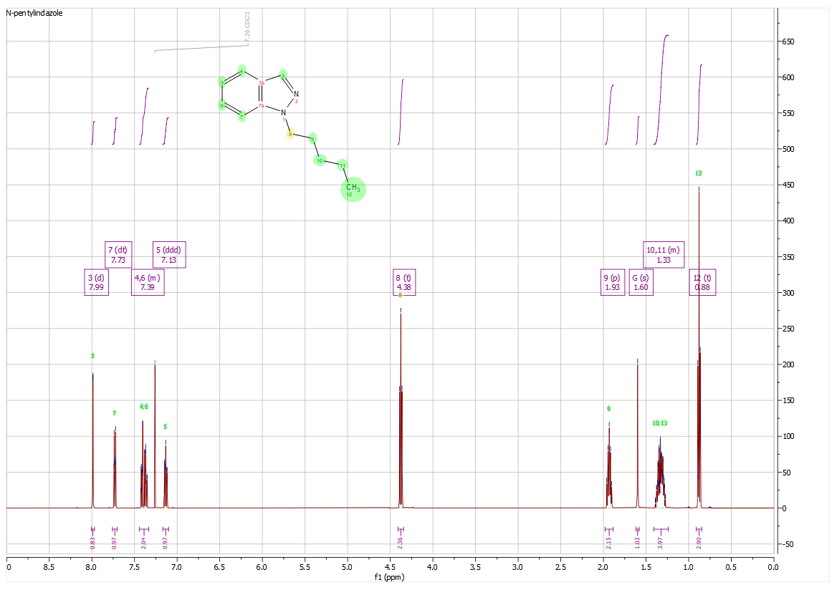
Figure S18. ¹H NMR for N-pentylindazole, 9.

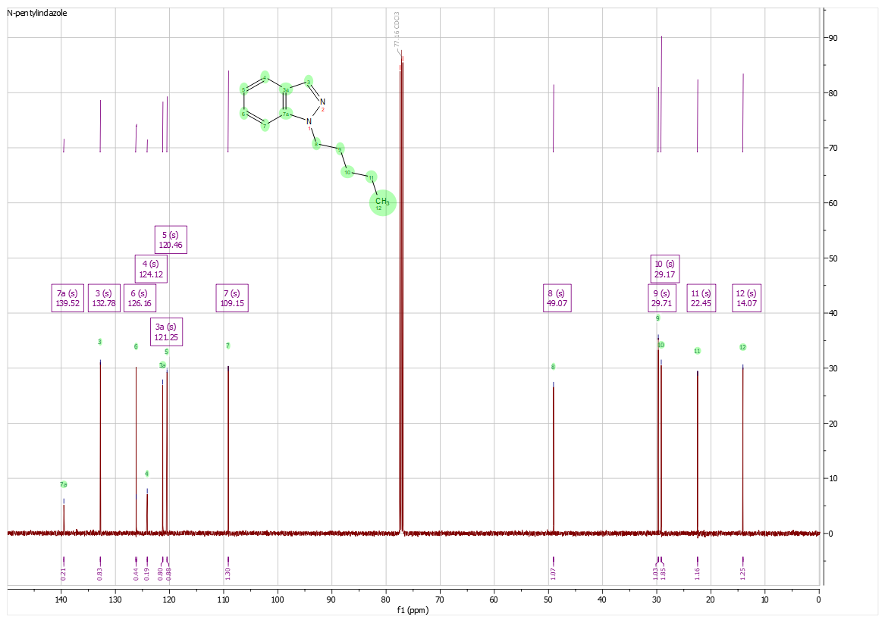
Figure S19. ¹³C NMR for N-pentylindazole, 9.

Figure S20. IR spectrum for N-pentylindazole, 9.
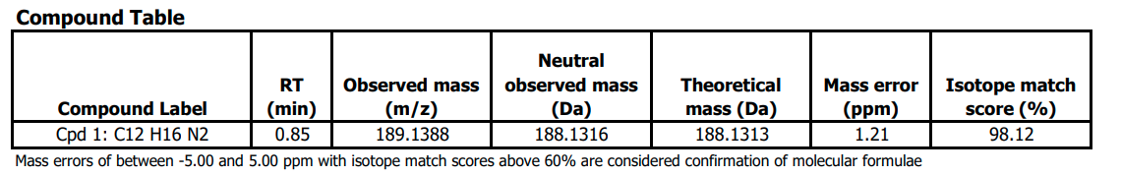
Figure S21. MS confirmation for N-pentylindazole, 9.

