Comparative efficacy and safety of stiripentol, cannabidiol and fenfluramine as first-line add-on therapies for seizures in Dravet syndrome: a network meta-analysis study – Supplementary Information

Table S 1. Search strategy sample (PubMed)
PubMed Search strategy (to 30/06/2023) | Returned hits
#1 “Epilepsies, Myoclonic”[Mesh] | 5425
#2 (child OR childhood OR children OR infan*) | 3737872
#3 #1 AND #2 | 2693
#4 “dravet syndrome” | 1454
#5 “severe myoclonic epilepsy” | 386
#6 SMEI | 182
#7 Dravet* | 1804
#8 "dravet's syndrome" | 41
#9 “childhood epileptic encephalopathy” | 35
#10 “childhood epilepsy encephalopathy” | 7559
#11 “childhood epileptic encephalopathies” | 23
#12 “childhood epilepsy encephalopathies” | 7559
#13 #3 OR #4 OR #5 OR #6 OR #7 OR #8 OR #9 OR #10 OR #11 OR #12 | 10775
#14 randomized controlled trial [pt] | 597342
#15 controlled clinical trial [pt] | 687790
#16 randomized [tiab] | 665153
#17 placebo [tiab] | 246561
#18 clinical trials as topic [mesh: noexp] | 383034
#19 randomly [tiab] | 412804
#20 trial [ti] | 288368
#21 #14 OR #15 OR #16 OR #17 OR #18 OR #19 OR #20 | 1629324
#22 #13 AND #21 | 547
#23 animals [mh] NOT humans [mh] | 5135662
#24 #22 NOT #23 | 551
Dravet syndrome search terms informed by searches conducted in NICE TA614, 2018 (see: https://www.nice.org.uk/guidance/ta614/evidence/appraisal-consultation-committee-papers-pdf-7017624830)

Table S 2. Eligibility criteria
Inclusion criteria
Population | - Patients of any age with a diagnosis of DS (with or without confirmed SCN1A mutation).  - If studies include mixed patient populations, only those reporting results separately for DS patients to be included
Intervention(s) | - Stiripentol licensed doses of up to 50mg/kg/day  - Fenfluramine licensed doses of 0.7 mg/kg/day, or 0.4 mg/kg/day if co-administered with stiripentol (including fenfluramine expressed as the hydrochloride salt at doses of 0.8mg/kg/day, or 0.5 mg/kg/day if co-administered with stiripentol.  - Pharmaceutical grade cannabidiolasused in the Epidyolex/Epidiolex formulation, at licensed doses of up to 10mg/kg/day or 20mg/kg/day
Comparator(s) | - Any drug comparator used as add-on therapy to standard of care ASMs  - Placebo/standard of care ASMs
Outcomes | - Any outcome relating to:  - Change in convulsive seizure frequency from baseline  - Responder rates (>50% [clinically meaningful], >75% [profound] or 100% reduction from baseline in convulsive seizure frequency)  - Serious adverse events rates  - Discontinuations due to adverse events
Study designs | - Any RCTs involving at least 10 subjects per treatment arm – including re-analyses of RCTs  - HTA and regulatory reports providing RCT data  - Systematic literature reviews – for background information, reference checking and any additional RCT data not provided in primary publications
Location, setting, and language | - Any geographic location or setting  - Any language

Table S 3. Study designs, eligibility criteria and endpoint assessments
Design element | Study
Design element | Stiripentol  STICLO-France (1) | Stiripentol  STICLO-Italy (2) | Fenfluramine  Study 1 (3) | Fenfluramine  Study 2 (4) | Fenfluramine  Study 3 (5) | Cannabidiol GWPCARE1 Part A (6) | Cannabidiol  GWPCARE1 Part B (7) | Cannabidiol  GWPCARE2 (8)
Intervention and  comparator | STP 50mg/kg/day or placebo | STP 50mg/kg/day or placebo | FFA 0.7mg/kg/day (max. 26mg/day) or  FFA 0.2mg/kg/day or  placebo | FFA 0.4mg/kg/day (max. 17mg/day) or  placebo | FFA 0.7mg/kg/day (max. 26mg/day) or  FFA 0.2mg/kg/day or  placebo | CBD 5mg/kg/day or CBD 10mg/kg/day or CBD 20mg/kg/day or placebo | CBD 20mg/kg/day or placebo | CBD 10mg/kg/day or CBD 20mg/kg/day or placebo
Study design | Phase 3 Placebo-controlled RCT |  | Phase 3 placebo-controlled RCT |  |  | Placebo-controlled RCT | Phase 3 placebo controlled RCT
n | 41 | 23 | 119 | 87 | 143 | 34 | 120 in full trial  (78 in subgroup taking CLB) | 198 in full trial  (126 in subgroup taking CLB)
Year(s) conducted | 1996-1998 | 1999-2000 | 2016–2018 | 2016–2018 | 2016-2020 | 2014-2015 | 2015 | 2015–2018
Study and treatment duration | 1 month baseline, 2 months treatment |  | 6-week baseline, 2- week titration + 12- week maintenance | 6-week baseline, 3- week titration + 12- week maintenance | 6-week baseline, 2- week titration + 12- week maintenance | 4-week baseline, 3-week treatment (including titration) | 4-week baseline, 2- week titration + 12- week maintenance
Eligibility | - Dravet Syndrome  - 3–18 years old  - ≥4 generalised clonic or tonic-clonic seizures per month during baseline |  | - Dravet Syndrome  - 2–18 years old  - ≥4 convulsive seizures per 4- week period during previous 12 weeks prior to screening |  | - Dravet Syndrome  - 2–18 years old | - Dravet Syndrome  - 4-10 years old  - <4 convulsive seizures during 4 week baseline | - Dravet Syndrome  - 2–18 years old  ≥4 convulsive seizures during 28-day baseline
Background ASM | - 100% receiving VPA + CLB |  | - One or more stable ASMs  - All other medications or interventions must be stable for ≥4 weeks prior to screening and are expected to remain stable throughout the study  - No STP in the 21 days prior to screening | - Receiving stable dose of CLB, and/or VPA, and 100% STP  - All medications or interventions for epilepsy must be stable for ≥4 weeks prior to screening and are expected to remain stable throughout the study | - One or more stable ASMs  - No STP in the 21 days prior to screening | - One or more stable ASMs | - One or more stable ASMs  - All medications or interventions must be stable for ≥4 weeks prior to screening and are expected to remain stable throughout the study
Convulsive seizure definition | Generalised clonic or tonic-clonic |  | Generalised tonic-clonic, tonic, clonic, tonic-atonic, hemiclonic, and focal seizures with an observable motor component |  | NS | Tonic, clonic, tonic-clonic or atonic
Reduction in convulsive seizures reporting | % change from baseline in MCSF after 1st month and after 2nd month of treatment period compared with baseline  (secondary endpoint)  Mean % reductions provided for each arm |  | % change in MCSF between baseline and T+M periods (per 28 days)  (primary endpoint)  Parametric assessment of % reduction from baseline in convulsive seizure frequency per 28 days compared with placebo  Median % reductions provided |  |  | NR | % change in MCSF between baseline and T+M periods (per 28 days)  (primary endpoint)  Parametric assessment of % reduction from baseline in convulsive seizure frequency per 28 days compared with placebo  Median % reductions provided
Responder rate (>50, >75 and 100% reduction from baseline in MCSF) reporting | Reported MCSF for 2nd month of treatment period compared with baseline (per 30 days)  (50% responder rate was primary endpoint) |  | Reported MCSF over combined T+M period (per 28 days) vs baseline  (key secondary endpoints) |  |  | NS | Reported MCSF over combined T+M period (per 28 days)  (key secondary endpoint)
Any AE reporting | Rates reported over treatment duration | NS | Rates reported over treatment duration |  |  | Rates reported over treatment duration | Rates reported over treatment duration
SAE reporting | Rates reported over treatment duration (NB: reported in regulatory documentation) |  |  |  |  | NS
Discontinuations due to AE reporting
Key: AE, adverse events, ASM, anti-seizure medication; CBD, cannabidiol; CLB, clobazam; MCSF, monthly convulsive seizure frequency; FFA, fenfluramine; NB, Nota Bene (please note); NR, not reported; NS, not stated in available publication; RCT, randomized controlled trial; SAE, serious AE; STP, stiripentol; T+M, titration and maintenance treatment period; VPA, valproate

Table S 4. Baseline characteristics of study participants (excluding GWPCARE1 Part A)
Characteristics | Study
Characteristics | Stiripentol  STICLO-France (1) | Stiripentol STICLO-Italy  (2) | Fenfluramine  Study 1 (3) | Fenfluramine Study 2 (4) | Fenfluramine Study 3 (5) | Cannabidiol GWPCARE1 Part B (full trial population) (7) | Cannabidiol GWPCARE2 (full trial population) (8) | Cannabidiol 10mg/kg/day + Clobazam subgroup (9) | Cannabidiol 20mg/kg/day + Clobazam subgroup (9)
N | 41 | 23 | 119 | 87 | 143 | 120 | 198 | 45 | 80
Age – yrs (mean±SD) | ~9.4 | 9.1 + 4 | 9.0 ±4.65 | 9.1 ±4.80 | ~9 | 9.8 ±4.8 | 9.3 ±4.4 | 9.1+4.1 | 9.3+4.3
Male – n (%) | 17 (41.5) | 13 (56.5) | 64 (54) | 50 (57.5) | 74 (51.7) | 62 (52) | 94 (47.5) | 23 (51) | 45 (56)
BMI – kg/m² (mean±SD) | NR | NR | 18.57 ±4.408 | 18.24 ±4.049 | NR | 18.7±4.6 | 18.7±4.3 | 18.9 | 19.0
White | NR | NR | 98 (82.4) | 52 (59.8) | 106 (74.1) | 94 (78.3) | 176 (88.9) | NR | NR
Black or African American | NR | NR | NR | 3 (3.4) | NR | 4 (3.3) | 5 (2.5) | NR | NR
Asian | NR | NR | 7 (5.9) | 3 (3.4) | 20 (14.0) | 1 (0.8) | 5 (2.5) | NR | NR
Other/not reported/unknown | 41 (100) | 23 (100) | 14 (11.8) | 29 (33.3) | 16 (11.2) | 21 (17.5) | 12 (6.0) | 45 (100) | 80 (100)
USA | 0 | 0 | 70 (58.8) | 22 (25.3) | NR | 72 (60) | 93 (47) | 22 (49) | 44 (55)
Rest of world | 41 (100) | 23 (100) | 49 (41.2) | 65 (74.7) | NR | 48 (40) | 105 (53) | 23 (51) | 36 (45)
Baseline MCSF | Per 30 days:  STP 50mg/kg/day: median 18  (IQR 4-73)  Placebo: 19  (IQR 4-76) | Per 30 days:  STP 50mg/kg/day: mean 27.4±28.6  Placebo: 33.6±28.2 | Per 28 days:  FFA 0.2 mg/kg/day: median 17.5  (range 4.7– 623.5)  FFA 0.7 mg/kg/day: median 20.7 (range 4.8–124.0)  Placebo:  median 27.3  (range 3.3–147.3) | Per 28 days:  FFA 0.4 mg/kg/day: median 14.0  (range 2.7– 213.3)  Placebo:  median 10.7  (range 2.7–162.7) | Per 28 days:  FFA 0.2 mg/kg/day: median 18.0  (range 4.0– 1464)  FFA 0.7 mg/kg/day: median 13.0 (range 2.7–2701)  Placebo:  median 12.7  (range 4.0–229.3) | Per 28 days:  CBD 20 mg/kg/day: median 12.4  (range 3.9–1717)  Placebo:  median 14.9  (range 3.7–718) | Per 28 days:  CBD 20  mg/kg/day:  median 9.0  (range 3.9–661.2)  (IQR 6, 21)  CBD 10  mg/kg/day:  median 13.5  (range 0–467.0)  (IQR 6, 31)  Placebo:  median 16.6  (range 3.0–770.5)  (IQR 7, 51) | Per 28 days:  GWPCARE1B:  CBD 20 mg/kg/day: median 9.6  (range 3.9–661.2)  GWPCARE2:  CBD 10 mg/kg/day: median 13.1  (range 4.0–238.4)  CBD 20 mg/kg/day: median 10.8  (range 3.9–553,5)  Placebo (n=79):  median 17.0  (range 3.0–448.9)
Previous ASMs | NR | NR | NR | NR | NR | 4.6±3.8 | Median 4 | Median 4 | Median 4
Concomitant ASMs | Mean 2.2 | NR | Mean 2.4 | Mean 3.5 | NR | Mean 2.9±1.0 | Median 3 | Median 3 | Median 3
Clobazam | 41 (100) | 23 (100) | 70 (58.8) | 82 (94.3) | NR | 78 (65) | 126 (64) | 45 (100) | 80 (100)
Valproate, all forms | 41 (100) | 23 (100) | 71 (59.7) | 66 (75.9) | NR | 71 (59) | 139 (70) | 30 (67) | 56 (70)
Stiripentol | - | - | 0 | 87 (100) | NR | 51 (42) | 71 (36) | 17 (38) | 51 (51)
Levetiracetam | 0 | 0 | 26 (21.8) | 10 (11.5) | NR | 33 (28) | 54 (27) | 11 (24) | 15 (19)
Topiramate | 0 | 0 | 30 (25.2) | 21 (24.1) | NR | 31 (26) | 46 (23) | 8 (18) | 18 (23)
Key: ASM; antiseizure medication; BMI, body mass index; CBD, cannabidiol; FFA, fenfluramine; NR, not reported; IQR, interquartile range; MCSF, monthly convulsive seizure frequency; No., number; SD, standard deviation; STP, stiripentol; yrs, years

Table S 5. Indirect comparison of SAEs for stiripentol vs fenfluramine vs cannabidiol
Indirect comparisons – Risk Differences [95% Confidence Interval] for experiencing SAEs
A – using full cannabidiol trial populations
 | STP | p-value | Placebo | p-value | FFA0_7 | p-value | CBD10 | p-value
STP | STP |  |  |  | . |  | .
Placebo | -0.05  [-0.26; 0.15] | 0.65 | Placebo
FFA0_7 | -0.08  [-0.29; 0.14] | 0.48 | -0.02  [-0.10; 0.05] | 0.61 | FFA0_7 |  | .
CBD10 | -0.10  [-0.34; 0.13] | 0.41 | -0.05  [-0.17; 0.08] | 0.44 | -0.03  [-0.17; 0.12] | 0.70 | CBD10
CBD20 | -0.16  [-0.38; 0.06] | 0.15 | -0.11  [-0.19; -0.02] | 0.0112 | -0.09  [-0.20; 0.03] | 0.13 | -0.06  [-0.19; 0.07] | 0.37
B – using subgroup of cannabidiol trial populations taking clobazam
 | STP | p-value | Placebo | p-value | FFA0_7 | p-value | CBD10_CLB | p-value
STP | STP |  |  |  | . |  | .
Placebo | -0.05  [-0.26; 0.15] | 0.65 | Placebo
FFA0_7 | -0.08  [-0.29; 0.14] | 0.48 | -0.02  [-0.10; 0.05] | 0.61 | FFA0_7 |  | .
CBD10_CLB | -0.13  [-0.39; 0.12] | 0.32 | -0.08  [-0.24; 0.08] | 0.33 | -0.06  [-0.23; 0.12] | 0.51 | CBD10_CLB
CBD20_CLB | -0.20  [-0.43; 0.03] | 0.09 | -0.15  [-0.25; -0.04] | 0.0051 | -0.13  [-0.26; 0.01] | 0.0587 | -0.07  [-0.23; 0.09] | 0.40
Treatments are ranked from best to worst along the leading diagonal. Indirect estimates of risk differences presented for treatments in columns vs treatments in rows. Bold figures are statistically significant (p-value <0.05).
CBD10, cannabidiol 10mg/kg/day; CBD10_CLB, cannabidiol 10mg/kg/day + clobazam; CBD20, cannabidiol 20mg/kg/day; CBD20_CLB, cannabidiol 20mg/kg/day + clobazam; FFA0_7, fenfluramine 0.7mg/kg/day; STP, stiripentol 50mg/kg/day

Table S 6. Sensitivity analyses around 50% responder rate outcome, full trial populations
Sensitivity analyses – 50% responder rates [95% Confidence Interval] utilising full cannabidiol trial populations
 | Random effects models |  |  | Fixed effect models
 | RR | OR | RD | RR | OR | RD
STP vs  placebo | 10.20  [2.62; 39.66] | 31.75  [6.25; 161.16] | 0.64  [0.46; 0.81] | 10.20  [2.62; 39.66] | 31.75  [6.25; 161.16] | 0.64  [0.46; 0.81]
FFA0_7 vs placebo | 7.20  [3.67; 14.11] | 22.75  [9.55; 54.23] | 0.62  [0.51; 0.74] | 7.20  [3.67; 14.11] | 22.75  [9.55; 54.23] | 0.62  [0.51; 0.74]
CBD10 vs placebo | 1.58 [1.03; 2.42] | 2.03  [1.03; 4.00] | 0.16  [0.01; 0.13] | 1.58  [1.03; 2.42] | 2.03  [1.03; 4.00] | 0.16  [0.01; 0.13]
CBD20 vs placebo | 1.73 [1.22; 2.45] | 2.36  [1.39; 4.00] | 0.19  [0.08; 0.31] | 1.73  [1.22; 2.45] | 2.36  [1.39; 4.00] | 0.19  [0.08; 0.31]
CBD10, cannabidiol 10mg/kg/day; CBD20, cannabidiol 20mg/kg/day; FFA0_7, fenfluramine 0.7mg/kg/day; OR, odds ratio; RD, risk difference; RR, relative risk; STP, stiripentol 50mg/kg/day

Table S 7. Scenario analysis: Indirect comparisons for 50% responder rates using only fully published, full trial populations
Indirect comparisons – Risk Differences [95% Confidence Interval] for 50% responder rates
Using fully published, full trial populations
 | STP | p-value | FFA0_7 | p-value | CBD20 | p-value | CBD10 | p-value
STP | STP |  | . |  | . |  | .
FFA0_7 | 0.11  [-0.17; 0.39] | 0.45 | FFA0_7 |  | . |  | .
CBD20 | 0.47  [ 0.22; 0.71] | 0.0002 | 0.36  [ 0.14; 0.57] | 0.0011 | CBD20
CBD10 | 0.50  [ 0.24; 0.77] | 0.0001 | 0.39  [ 0.15; 0.62] | 0.0012 | 0.03  [-0.12; 0.19] | 0.72 | CBD10
Placebo | 0.66  [ 0.45; 0.88] | 0.0002 | 0.55  [ 0.37; 0.73] | <0.0001 | 0.19  [ 0.08; 0.31] | 0.0013 | 0.16  [ 0.01; 0.31] | 0.0363
Treatments are ranked from best to worst along the leading diagonal. Indirect estimates of risk differences presented for treatments in columns vs treatments in rows. Bold figures are statistically significant (p-value <0.05).
CBD10, cannabidiol 10mg/kg/day; CBD20, cannabidiol 20mg/kg/day; FFA0_7, fenfluramine 0.7mg/kg/day; STP, stiripentol 50mg/kg/day

Figure S 1. PRISMA flow diagram
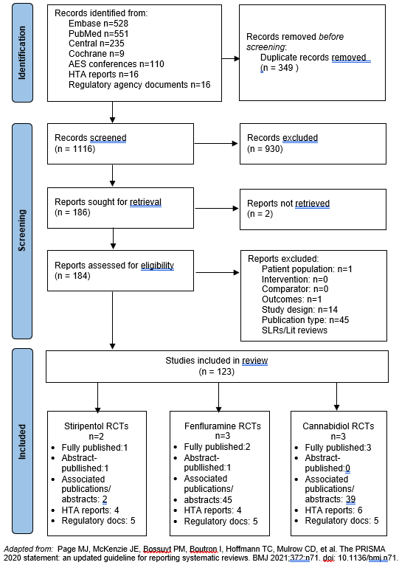
Figure S 2. Risk of bias assessment using Cochrane Risk of Bias 2 Tool
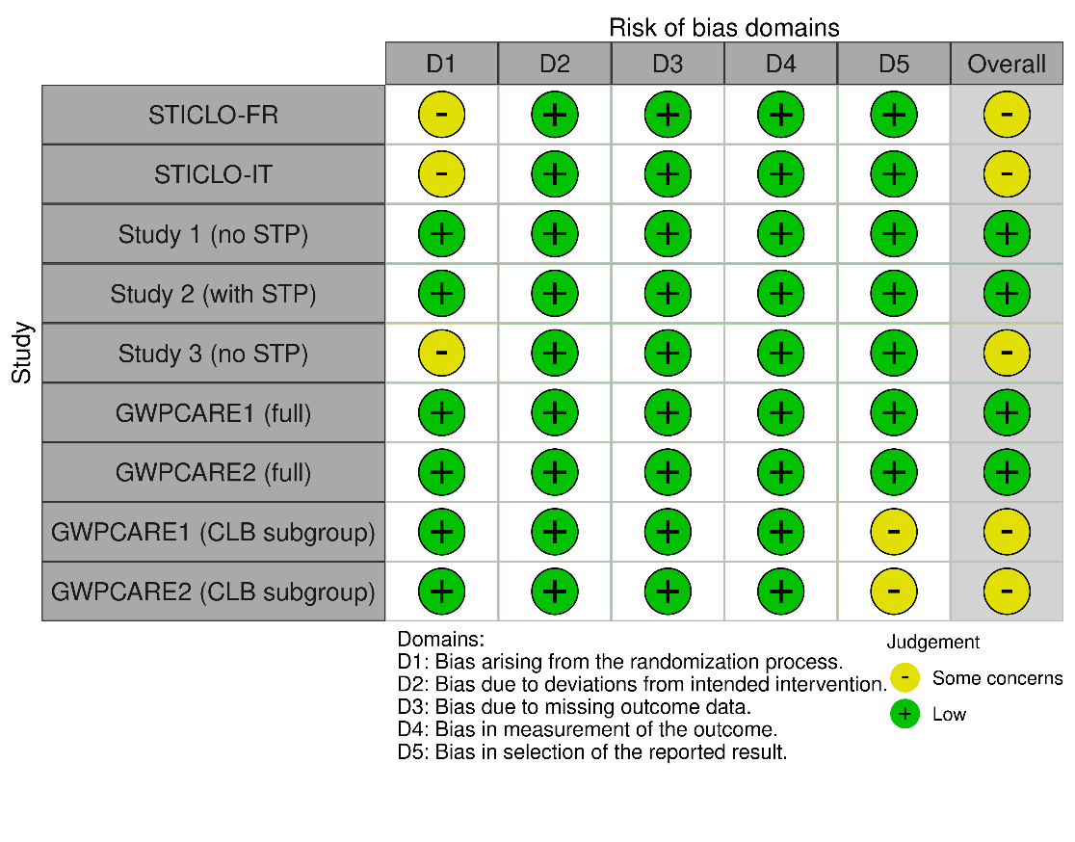
Generated using robvis: McGuinness, LA, Higgins, JPT. Risk-of-bias VISualization (robvis): An R package and Shiny web app for visualizing risk-of-bias assessments. Res Syn Meth. 2020; 1- 7. https://doi.org/10.1002/jrsm.1411. Available at: https://www.riskofbias.info/welcome/robvis-visualization-tool.

Figure S 3. Pairwise relative risks of achieving >50% reduction in MCSF vs placebo
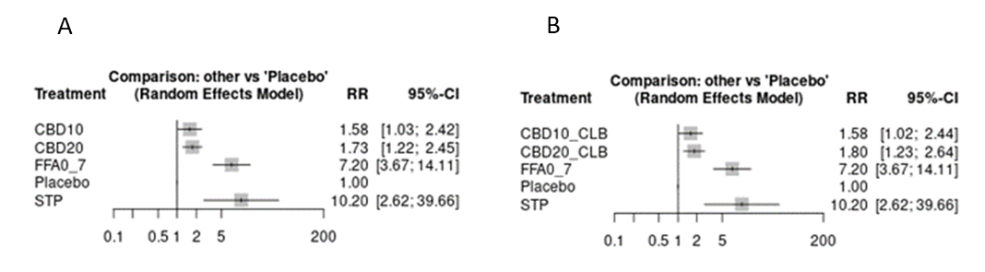
Key: A – 50% responder rates using full cannabidiol trial populations; B – 50% responder rates using subgroup of cannabidiol trial populations taking clobazam. CBD10, cannabidiol 10mg/kg/day; CBD10_CLB, cannabidiol 10mg/kg/day + clobazam; CBD20, cannabidiol 20mg/kg/day; CBD20_CLB, cannabidiol 20mg/kg/day + clobazam; FFA0_7, fenfluramine 0.7mg/kg/day; MCSF, monthly convulsive seizure frequency; RR, relative risk; STP, stiripentol 50mg/kg/day; 95%-CI, 95% confidence intervals

Figure S 4. Pairwise relative risks of experiencing SAEs
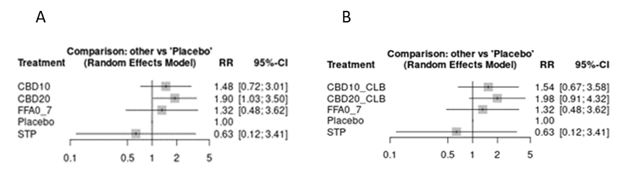
Key: A – SAE relative risks using full cannabidiol trial populations; B – SAE relative risks using subgroup of cannabidiol trial populations taking clobazam. CBD10, cannabidiol 10mg/kg/day; CBD10_CLB, cannabidiol 10mg/kg/day + clobazam; CBD20, cannabidiol 20mg/kg/day; CBD20_CLB, cannabidiol 20mg/kg/day + clobazam; FFA0_7, fenfluramine 0.7mg/kg/day; MCSF, monthly convulsive seizure frequency; RR, relative risk; STP, stiripentol 50mg/kg/day; 95%-CI, 95% confidence intervals.

Supplementary Information References

1. Chiron C, Marchand MC, Tran A, Rey E, d’Athis P, Vincent J, et al. Stiripentol in severe myoclonic epilepsy in infancy: a randomised placebo-controlled syndrome-dedicated trial. STICLO study group. Lancet (London, England). 2000/11/23 ed. 2000 Nov 11;356(9242):1638–42.
2. Guerrini R, Tonnelier S, d’Athis P, al. et. Stiripentol in severe myoclonic epilepsy in infancy (SMEI): a placebo-controlled Italian trial (P496). In Epilepsia; 2002.
3. Lagae L, Sullivan J, Knupp K, Laux L, Polster T, Nikanorova M, et al. Fenfluramine hydrochloride for the treatment of seizures in Dravet syndrome: a randomised, double-blind, placebo-controlled trial. Lancet. 2019;394(10216):2243–54.
4. Nabbout R, Mistry A, Zuberi S, Villeneuve N, Gil-Nagel A, Sanchez-Carpintero R, et al. Fenfluramine for Treatment-Resistant Seizures in Patients With Dravet Syndrome Receiving Stiripentol-Inclusive Regimens: a Randomized Clinical Trial. JAMA neurology. 2020;77(3):300‐308.
5. Sullivan J. 853. Fenfluramine (FINTEPLA) in Dravet syndrome: Results of a third randomized, placebo-controlled clinical trial (Study 3). In: Virtual American Epilepsy Society (AES) Annual Meeting. Virtual American Epilepsy Society (AES) Annual Meeting; 2020.
6. Devinsky O, Patel AD, Thiele EA, Wong MH, Appleton R, Harden CL, et al. Randomized, dose-ranging safety trial of cannabidiol in Dravet syndrome. Neurology. 2018/03/16 ed. 2018 Apr 3;90(14):e1204–11.
7. Devinsky O, Cross JH, Laux L, Marsh E, Miller I, Nabbout R, et al. Trial of Cannabidiol for Drug-Resistant Seizures in the Dravet Syndrome. The New England journal of medicine. 2017/05/26 ed. 2017 May 25;376(21):2011–20.
8. Miller I, Scheffer IE, Gunning B, Sanchez-Carpintero R, Gil-Nagel A, Perry MS, et al. Dose-Ranging Effect of Adjunctive Oral Cannabidiol vs Placebo on Convulsive Seizure Frequency in Dravet Syndrome: A Randomized Clinical Trial. JAMA Neurol. 2020;77(5):613–21.
9. Gunning B. Cannabidiol in conjunction with clobazam: analysis of four randomized controlled trials. Acta Neurol Scand. 2021;143:154–63.

