Supplementary Information

Identification of of tetrahydrocannabidiol metabolites in human urine

Willi Schirmer^{1, 2}, Isabelle Mösch¹, Stefan Schürch², Wolfgang Weinmann¹
¹Institute of Forensic Medicine, Forensic Toxicology and Chemistry, University of Bern, Murtenstrasse 26, 3008 Bern, Switzerland
²Department of Chemistry, Biochemistry and Pharmaceutical Sciences, University of Bern, Freiestrasse 3, 3012 Bern, Switzerland

Corresponding author:
Willi Schirmer, Institute of Forensic Medicine, Forensic Toxicology and Chemistry,
University of Bern, Murtenstrasse 26, 3008 Bern, Switzerland
e-mail address: willi.schirmer@irm.unibe.ch

Table of contents (Figures S1-S46)
- Quantification of H4CBD product by GC-MS S1
- Chromatogram of a deglucuronidated blank urine sample S2
- LC-HRMS/MS spectra of deglucuronidated H4CBD metabolites S3-S13
  - Metabolites M1 – M10 (Phase I metabolites)
- Chromatogram of a blank urine sample S14
- LC-HRMS/MS spectra of deglucuronidated H4CBD metabolites S15-S29
  - Metabolites M11 – M25 (Phase II metabolites)
- GC-MS spectra of deglucuronidated H4CBD metabolites S30-S41
  - Metabolites M26 – M37 (Phase I metabolites, TMS derivatives)
- LC-HRMS/MS spectra of 7-COOH-CBD S42-S43
- LC-HRMS/MS spectra of (S)- and (R)-H4CBD S44-S45
- Chromatogram of an n-alkane standard (Kováts indices) S46

Figure S1: Quantification of (R)- and (S)-H4CBD in the H4CBD product for recreational use with GC-MS.
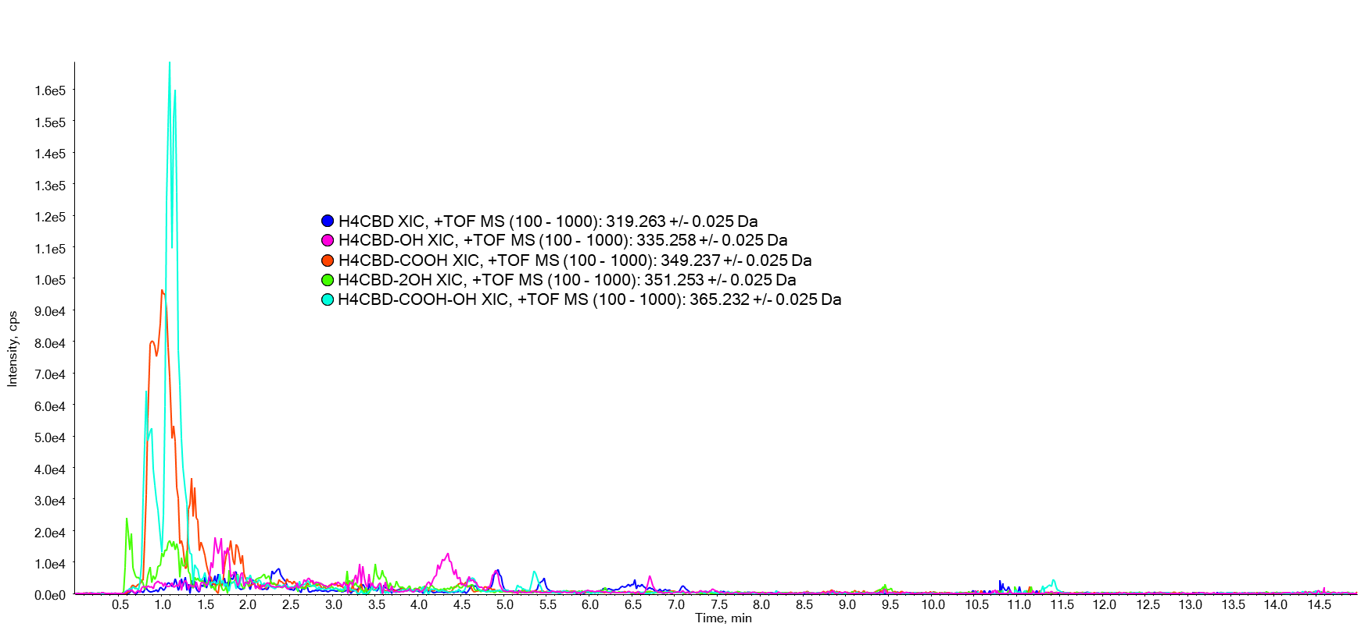
Figure S2: Chromatogram of deglucuronidated urine before ingestion of H4CBD, measured on a LC-QqTOF
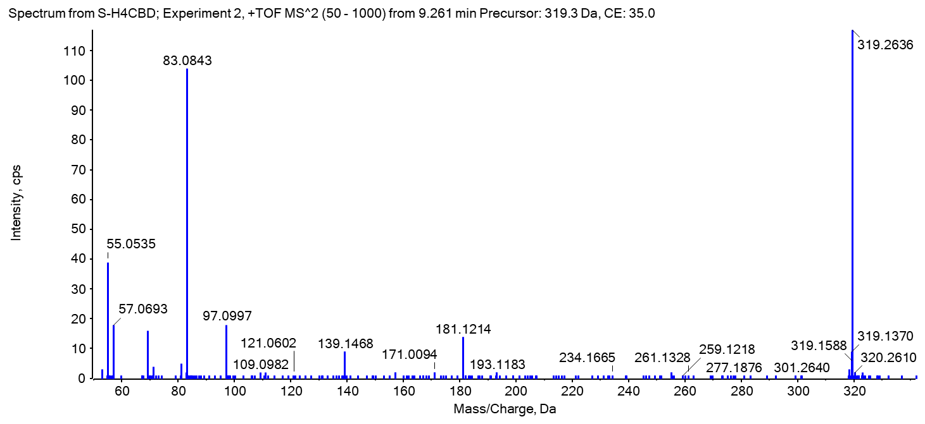
Figure S3: LC-QqTOF spectrum of (S)-H4CBD (Metabolite M1)
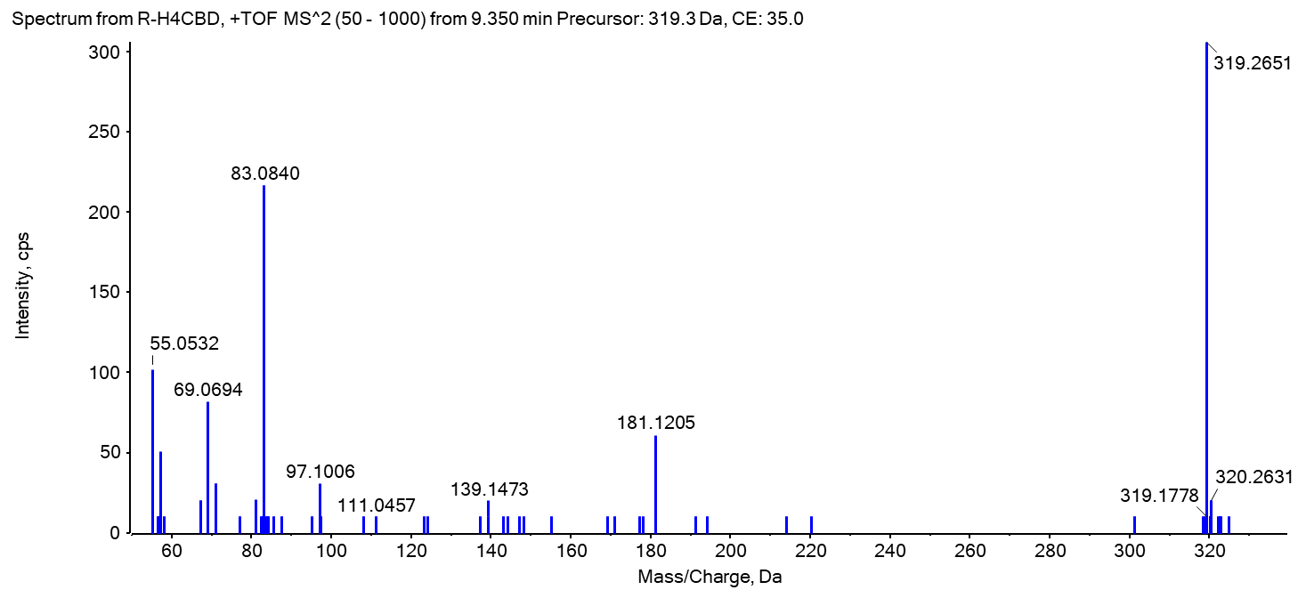
Figure S4: LC-QqTOF spectrum of (R)-H4CBD (Metabolite M1)
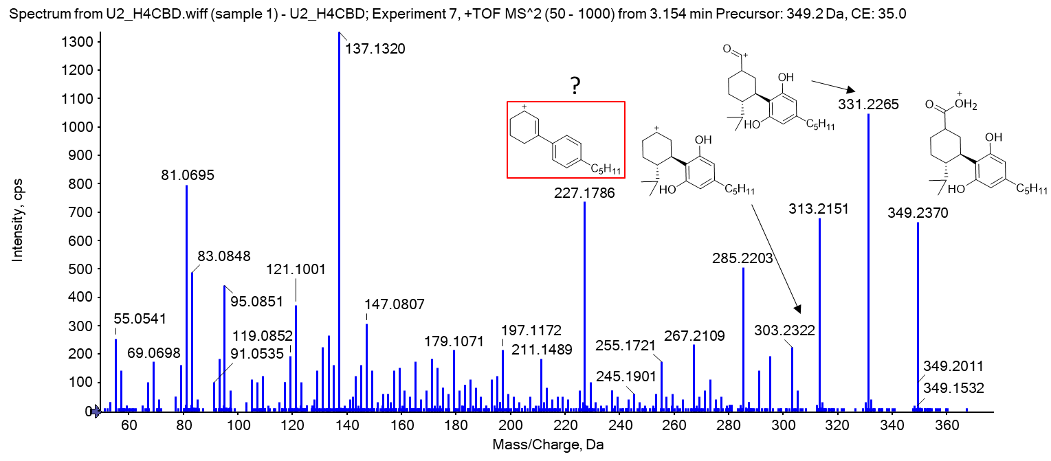
Figure S5: Mass spectrum of metabolite M2, a carboxylated metabolite of H4CBD (from a deglucuronidated urine sample 3 h after ingestion of 25 mg H4CBD)
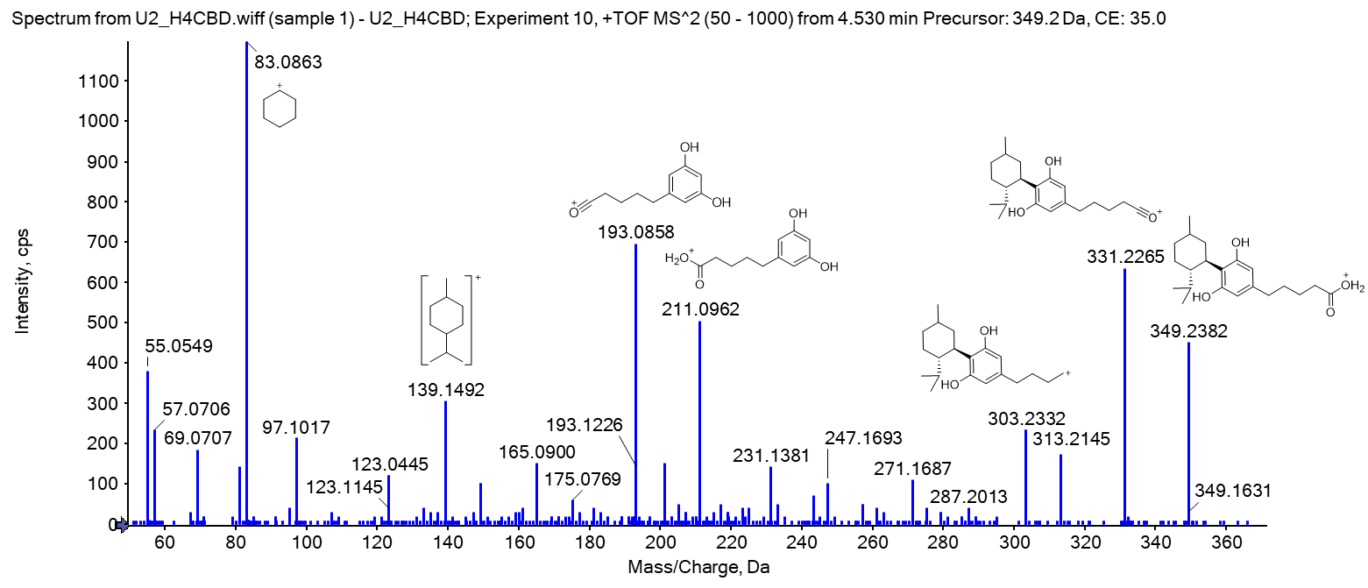
Figure S6: Mass spectrum of metabolite M3, a carboxylated metabolite of H4CBD (from a deglucuronidated urine sample 3 h after ingestion of 25 mg H4CBD)
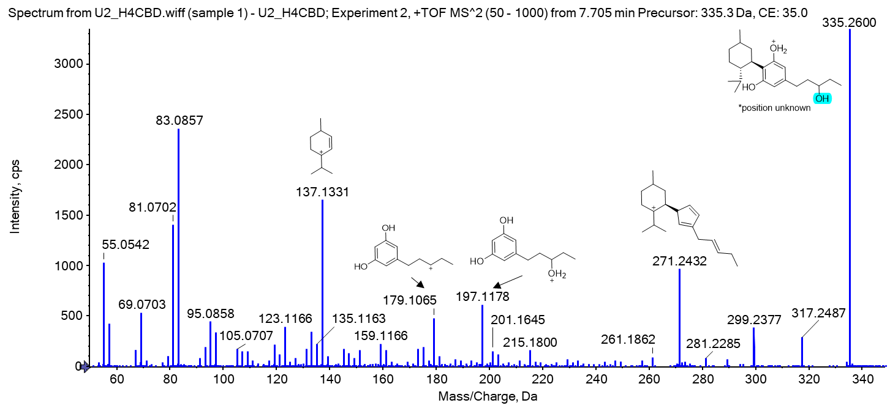
Figure S7: Mass spectrum of metabolite M4, a side chain hydroxylated metabolite of H4CBD (from a deglucuronidated urine sample 3 h after ingestion of 25 mg H4CBD). *The position of the hydroxy group is unknown.
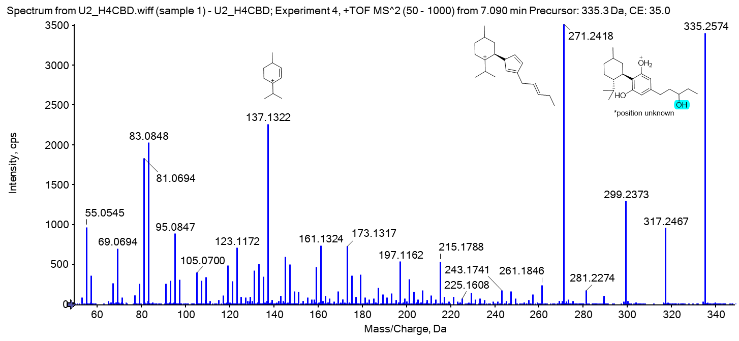
Figure S8: Mass spectrum of metabolite M5, a side chain hydroxylated metabolite of H4CBD (from a deglucuronidated urine sample 3 h after ingestion of 25 mg H4CBD). *The position of the hydroxy group is unknown.
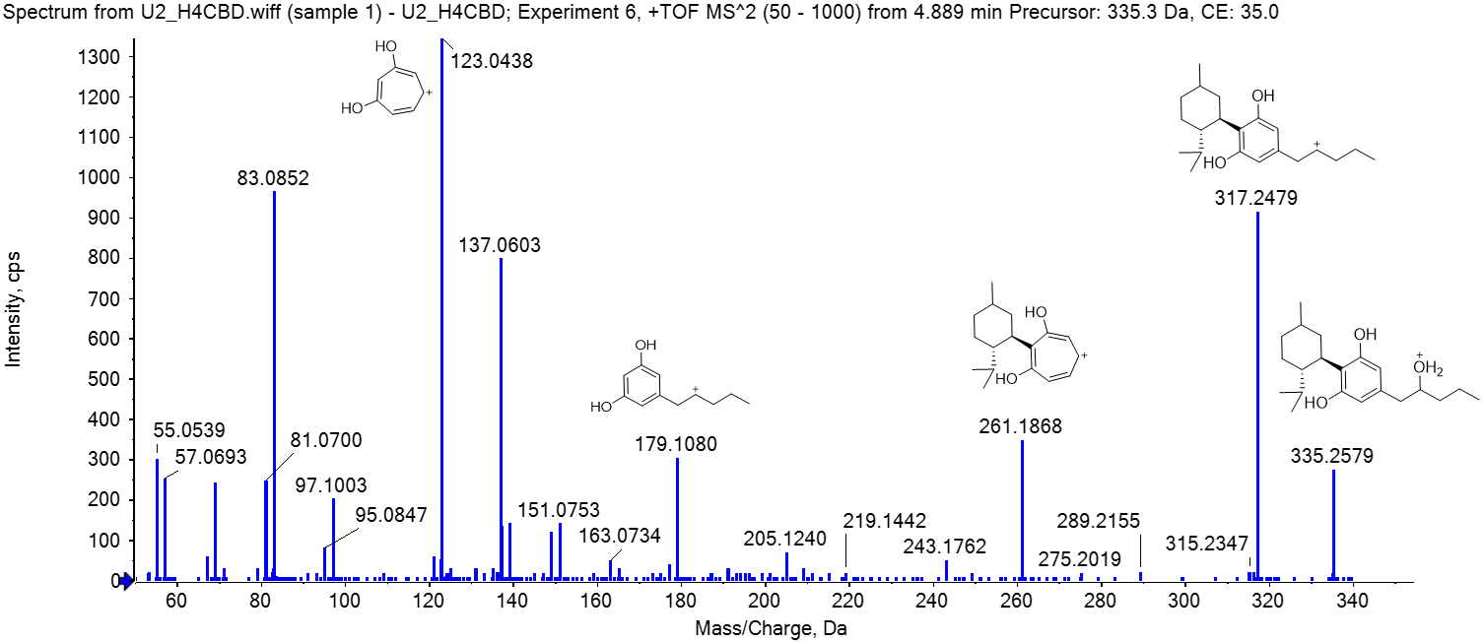
Figure S9: Mass spectrum of metabolite M6, a hydroxylated metabolite of H4CBD (from a deglucuronidated urine sample 3 h after ingestion of 25 mg H4CBD). Tentatively identified as an epimer of 2''OH-H4CBD.
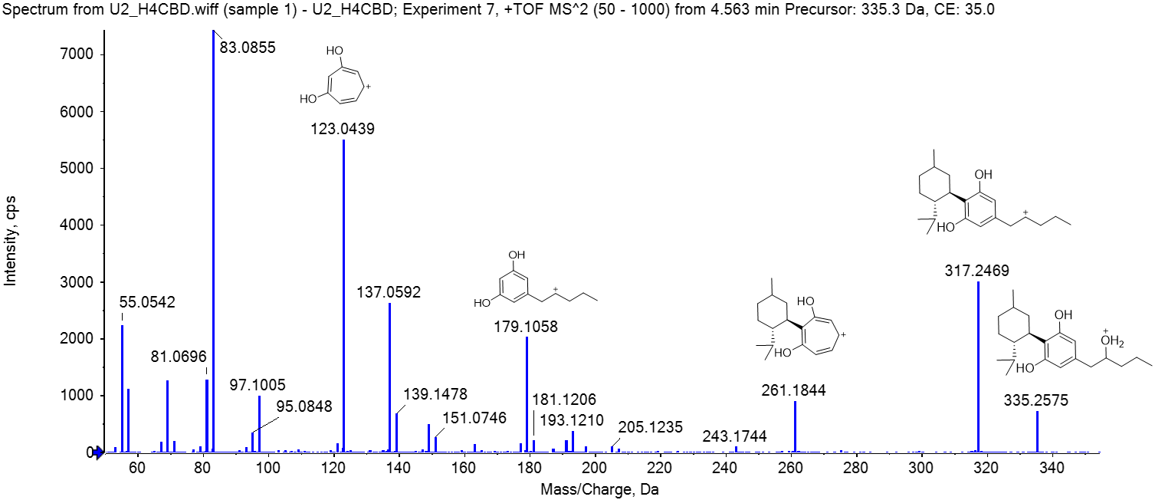
Figure S10: Mass spectrum of metabolite M7, a hydroxylated metabolite of H4CBD (from a deglucuronidated urine sample 3 h after ingestion of 25 mg H4CBD). Tentatively identified as an epimer of 2''OH-H4CBD.
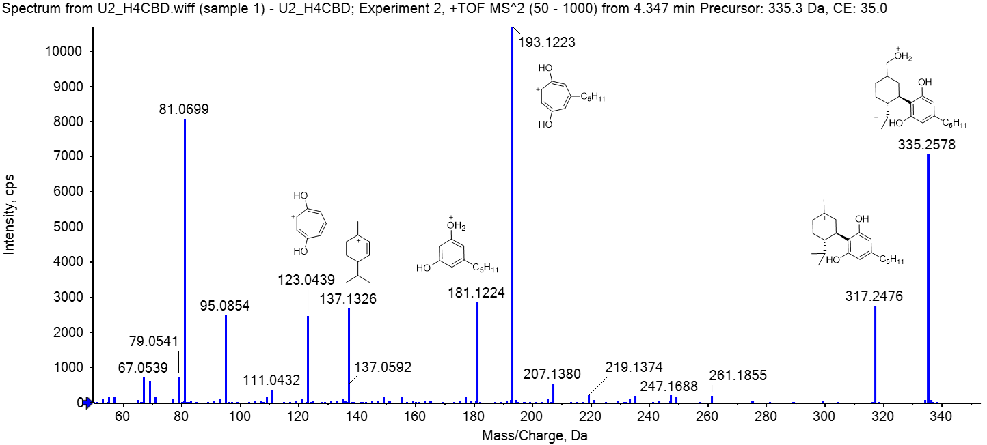
Figure S11: Mass spectrum of metabolite M8, a hydroxylated metabolite of H4CBD (from a deglucuronidated urine sample 3 h after ingestion of 25 mg H4CBD). Tentatively identified as an epimer of 7-OH-H4CBD.
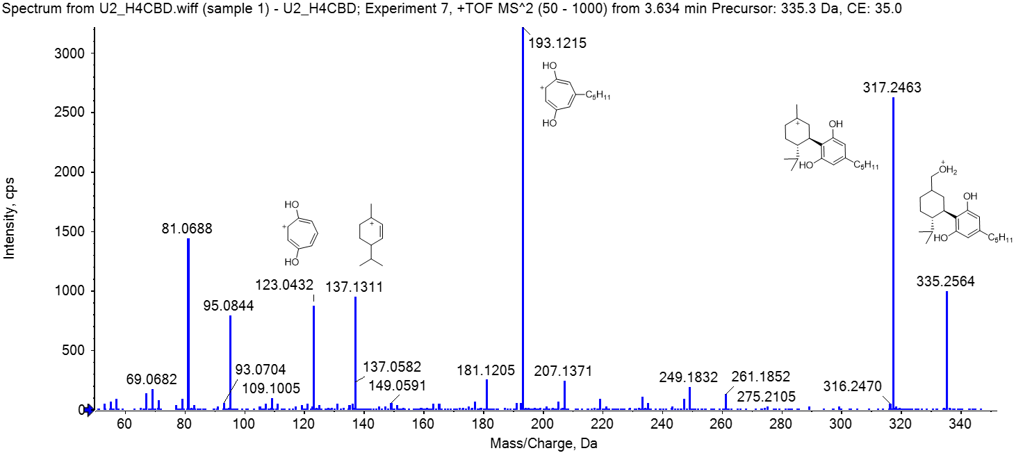
Figure S12: Mass spectrum of metabolite M9, a hydroxylated metabolite of H4CBD (from a deglucuronidated urine sample 3 h after ingestion of 25 mg H4CBD). Tentatively identified as an epimer of 7-OH-H4CBD.
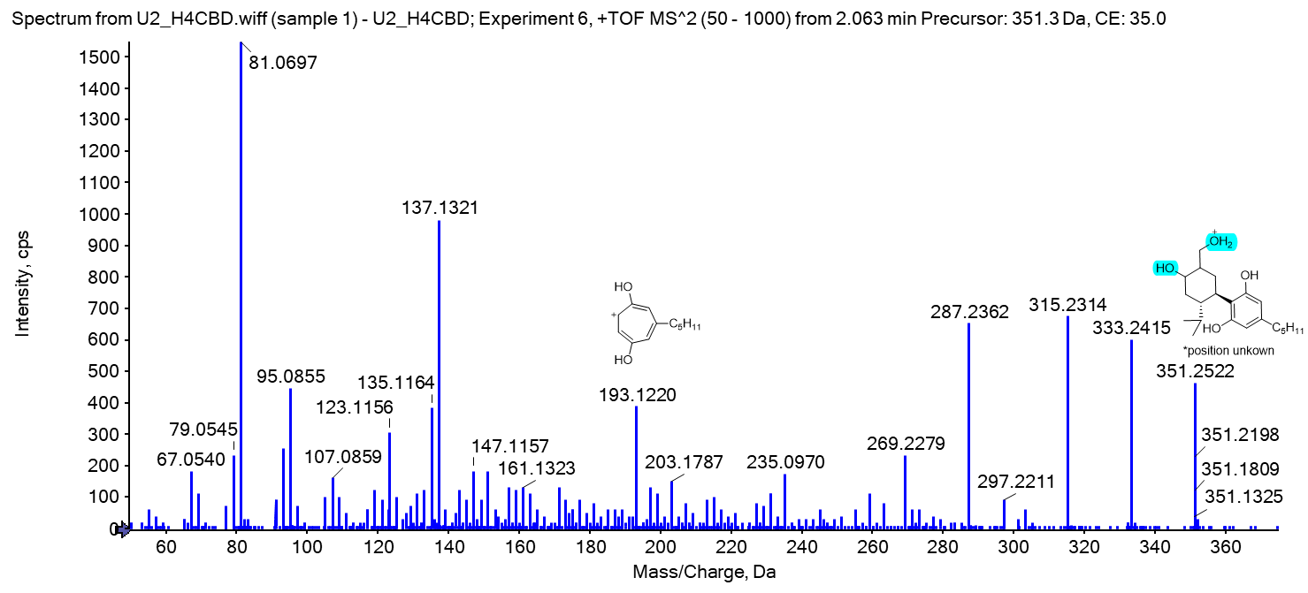
Figure S13: Mass spectrum of metabolite M10, a bishydroxylated metabolite of H4CBD (from a deglucuronidated urine sample 3 h after ingestion of 25 mg H4CBD). The position of the hydroxy groups are unknown.
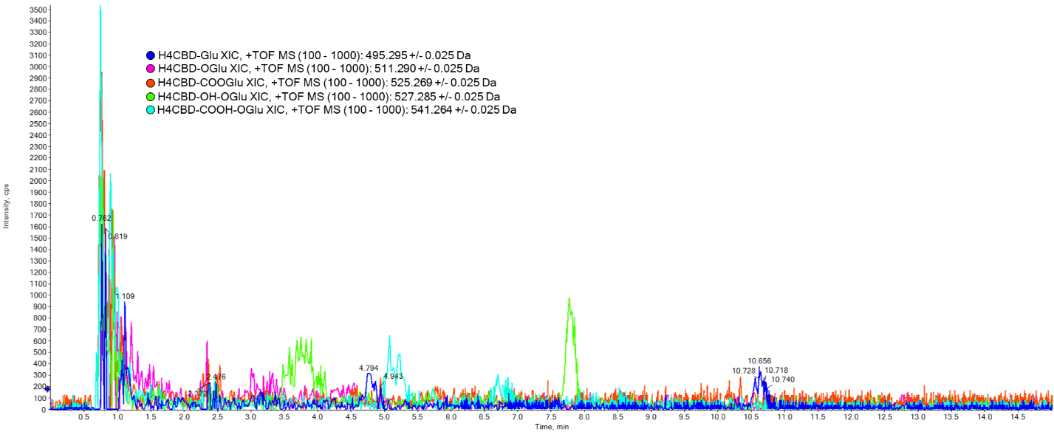
Figure S14: Chromatogram of a urine sample before ingestion of H4CBD, measured on a LC-QqTOF

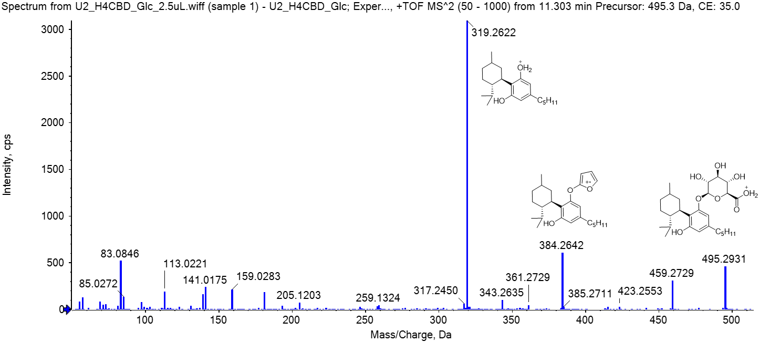
Figure S15: Mass spectrum of metabolite M11, a glucuronidated metabolite of H4CBD (from a urine sample 3 h after ingestion of 25 mg H4CBD).
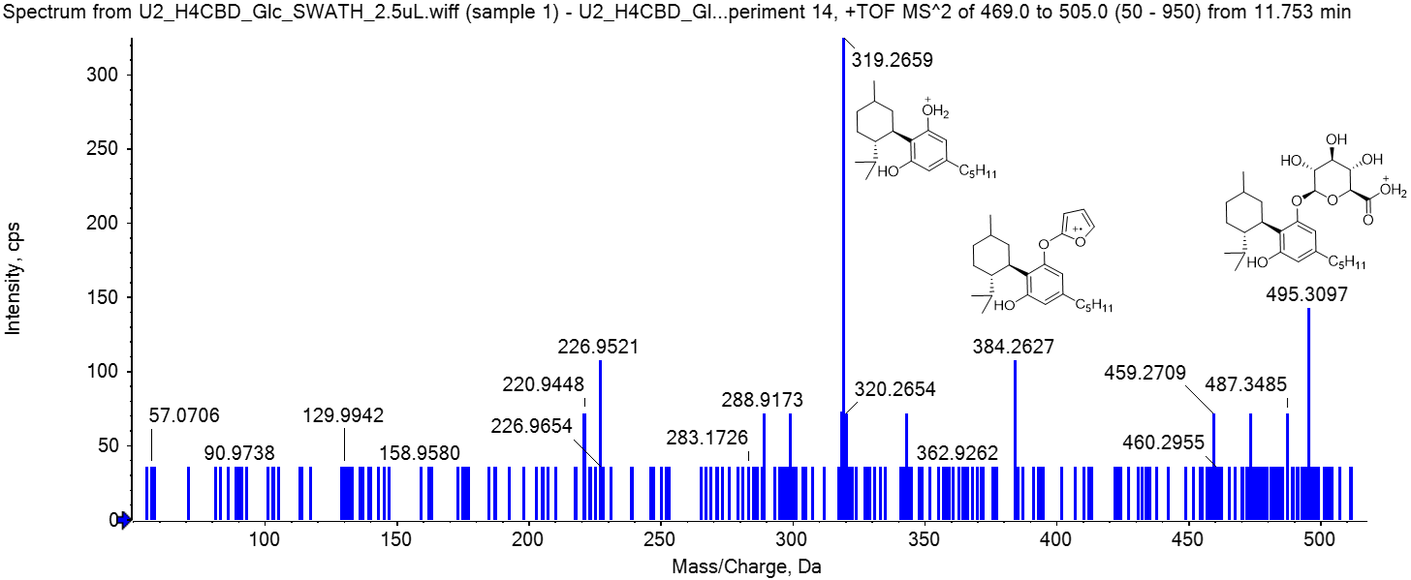
Figure S16: Mass spectrum of metabolite M12, a glucuronidated metabolite of H4CBD (from a urine sample 3 h after ingestion of 25 mg H4CBD). Acquired in SWATH mode.
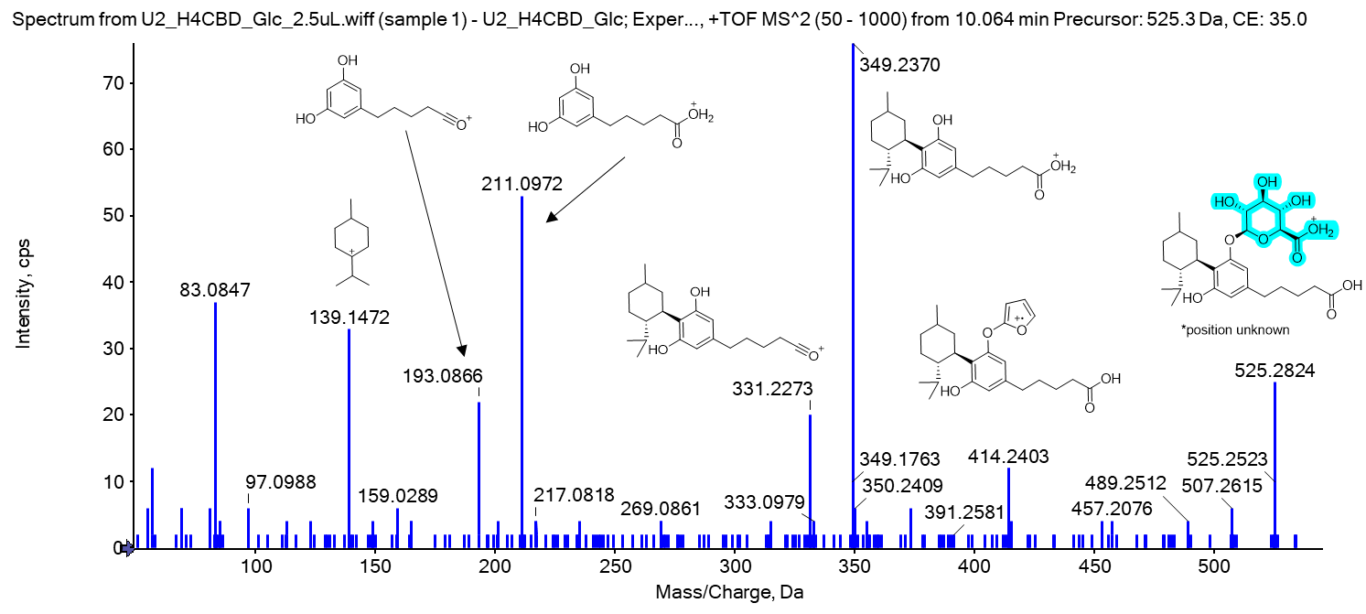
Figure S17: Mass spectrum of metabolite M13, a carboxylated and glucuronidated metabolite of H4CBD (from a urine sample 3 h after ingestion of 25 mg H4CBD). The position of the glucuronide moiety is unknown.
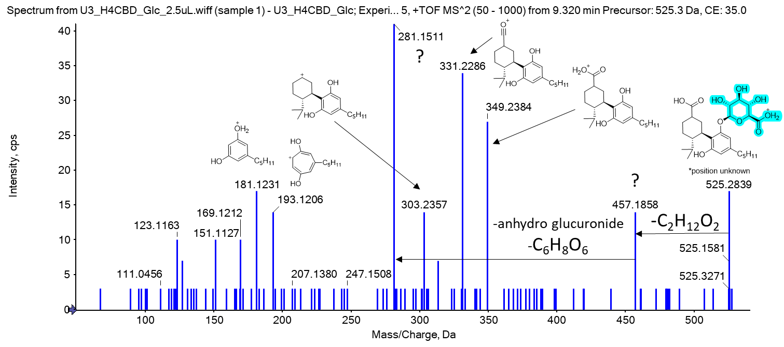
Figure S18: Mass spectrum of metabolite M14, a carboxylated and glucuronidated metabolite of H4CBD (from a urine sample 3 h after ingestion of 25 mg H4CBD). The position of the glucuronide moiety is unknown.
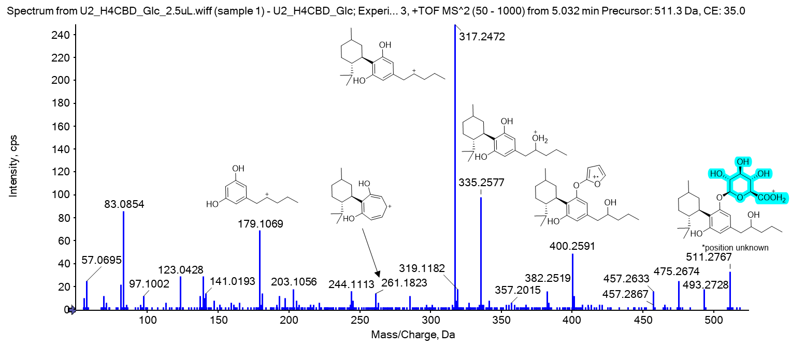
Figure S19: Mass spectrum of metabolite M15, a hydroxylated and glucuronidated metabolite of H4CBD (from a urine sample 3 h after ingestion of 25 mg H4CBD). The position of the glucuronide moiety is unknown.

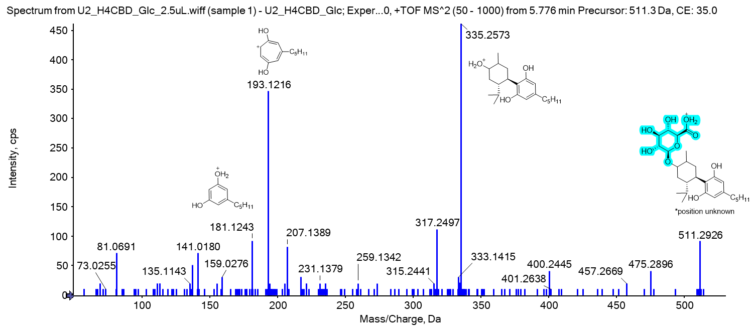
Figure S20: Mass spectrum of metabolite M16, a hydroxylated and glucuronidated metabolite of H4CBD (from a urine sample 3 h after ingestion of 25 mg H4CBD). The position of the glucuronide moiety and the hydroxy group are unknown.

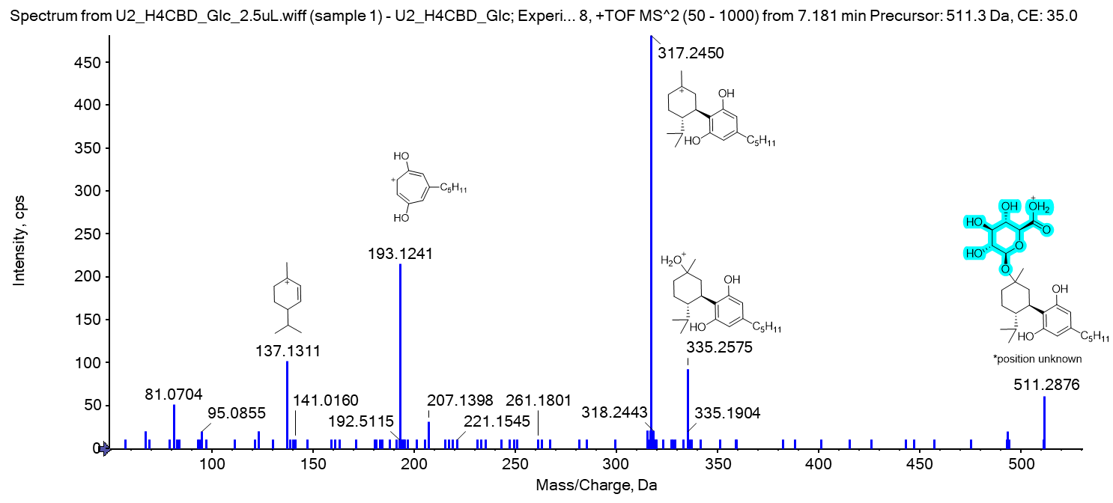
Figure S21: Mass spectrum of metabolite M17, a hydroxylated and glucuronidated metabolite of H4CBD (from a urine sample 3 h after ingestion of 25 mg H4CBD). The position of the glucuronide moiety and the hydroxy group is unknown.
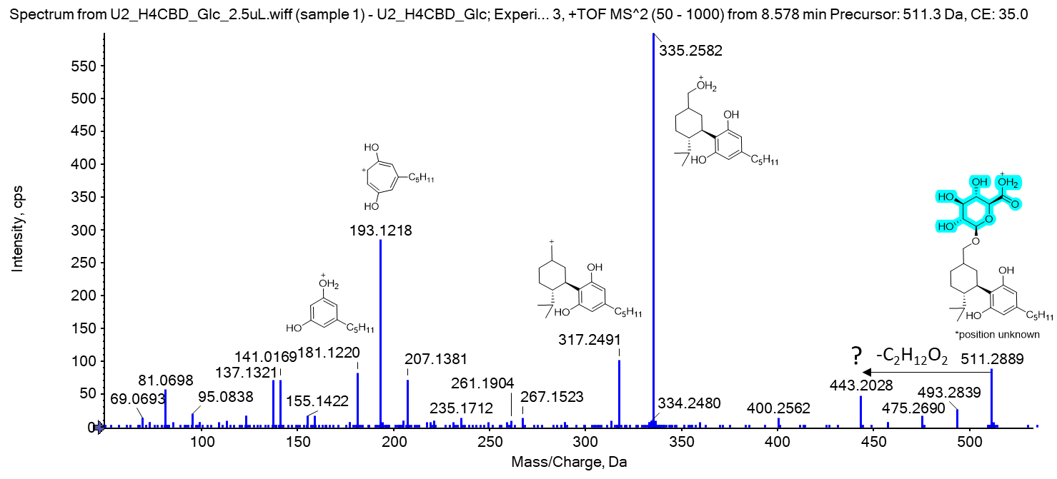
Figure S22: Mass spectrum of metabolite M18, a hydroxylated and glucuronidated metabolite of H4CBD (from a urine sample 3 h after ingestion of 25 mg H4CBD). The position of the glucuronide moiety is unknown.
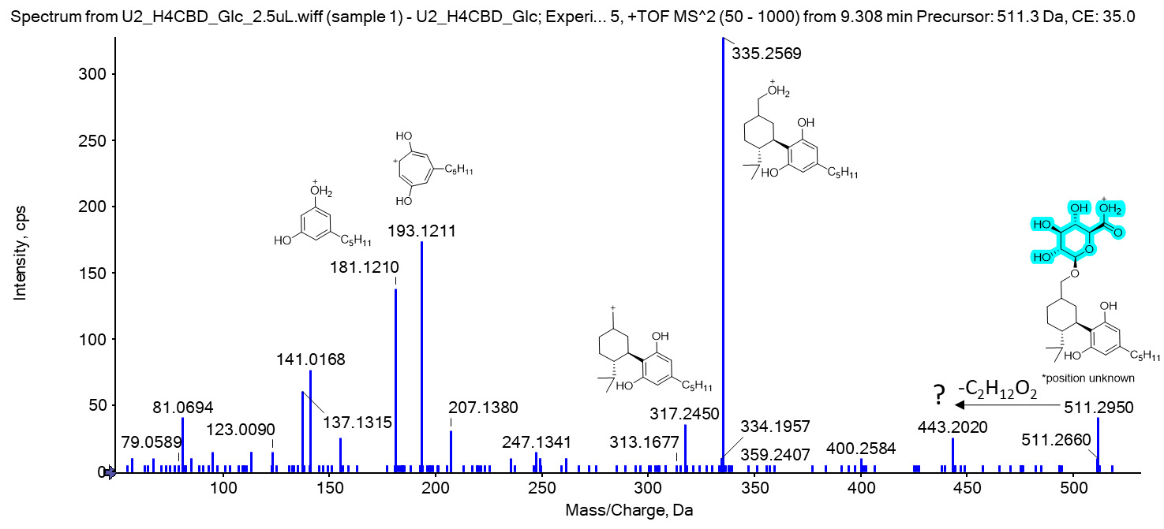
Figure S23: Mass spectrum of metabolite M19, a hydroxylated and glucuronidated metabolite of H4CBD (from a urine sample 3 h after ingestion of 25 mg H4CBD). The position of the glucuronide moiety is unknown.

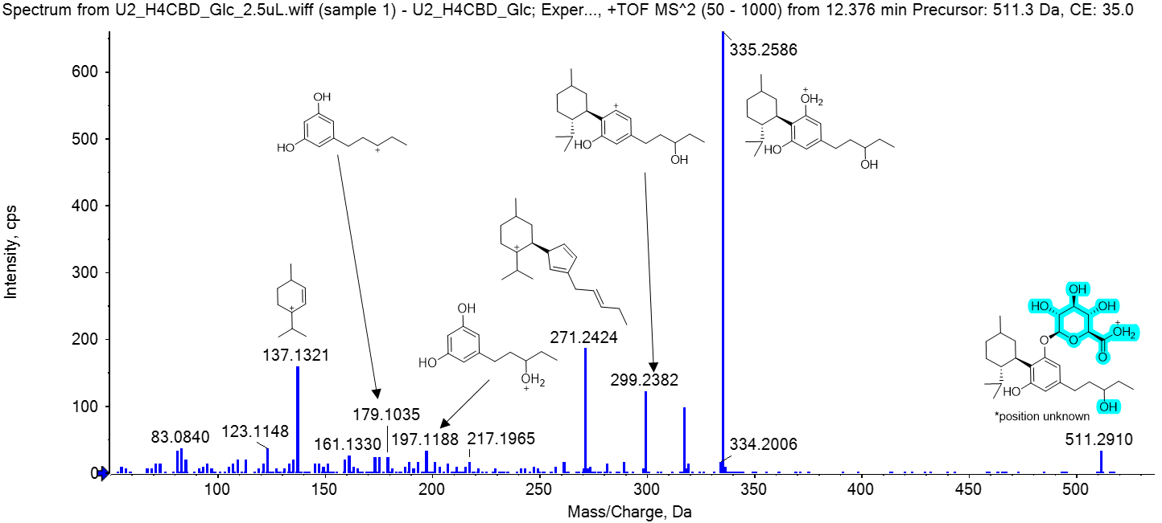
Figure S24: Mass spectrum of metabolite M20, a hydroxylated and glucuronidated metabolite of H4CBD (from a urine sample 3 h after ingestion of 25 mg H4CBD). The position of the hydroxy group and the glucuronide are unknown.
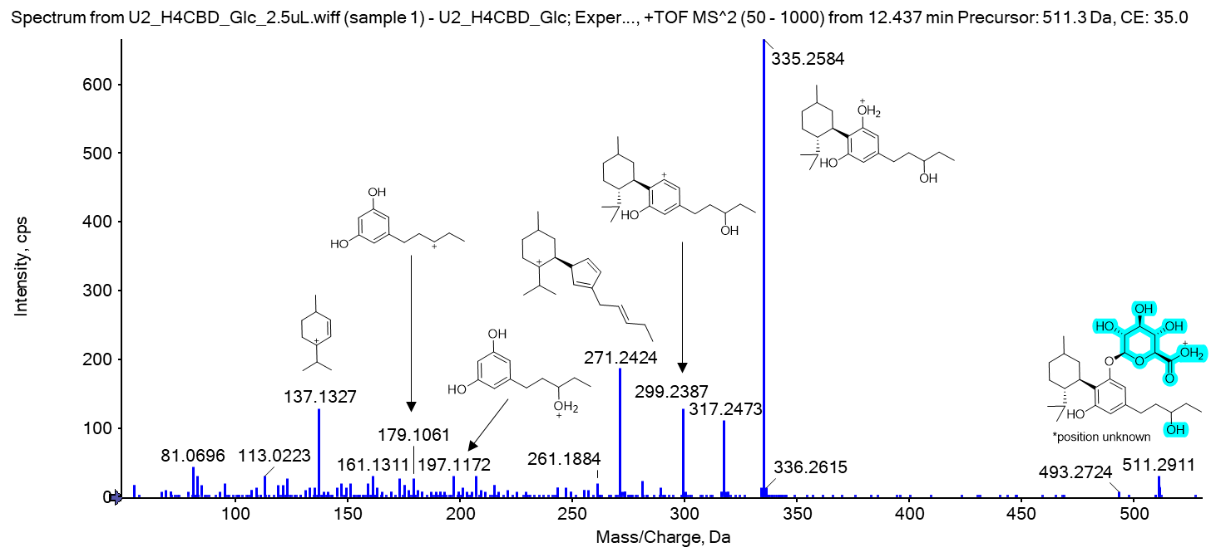
Figure S25: Mass spectrum of metabolite M21, a hydroxylated and glucuronidated metabolite of H4CBD (from a urine sample 3 h after ingestion of 25 mg H4CBD). The position of the hydroxy group and the glucuronide are unknown.
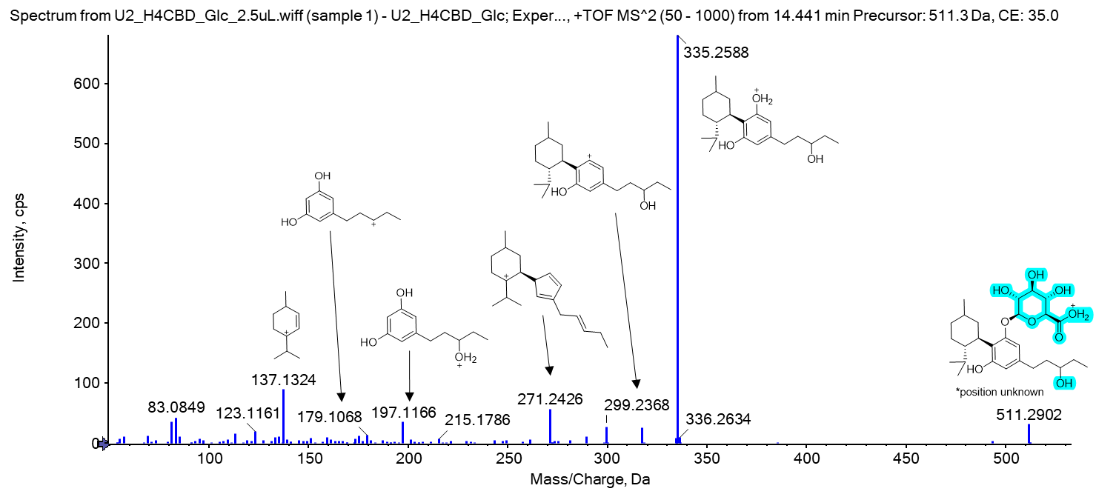
Figure S26: Mass spectrum of metabolite M22, a hydroxylated and glucuronidated metabolite of H4CBD (from a urine sample 3 h after ingestion of 25 mg H4CBD). The position of the hydroxy group and the glucuronide are unknown.
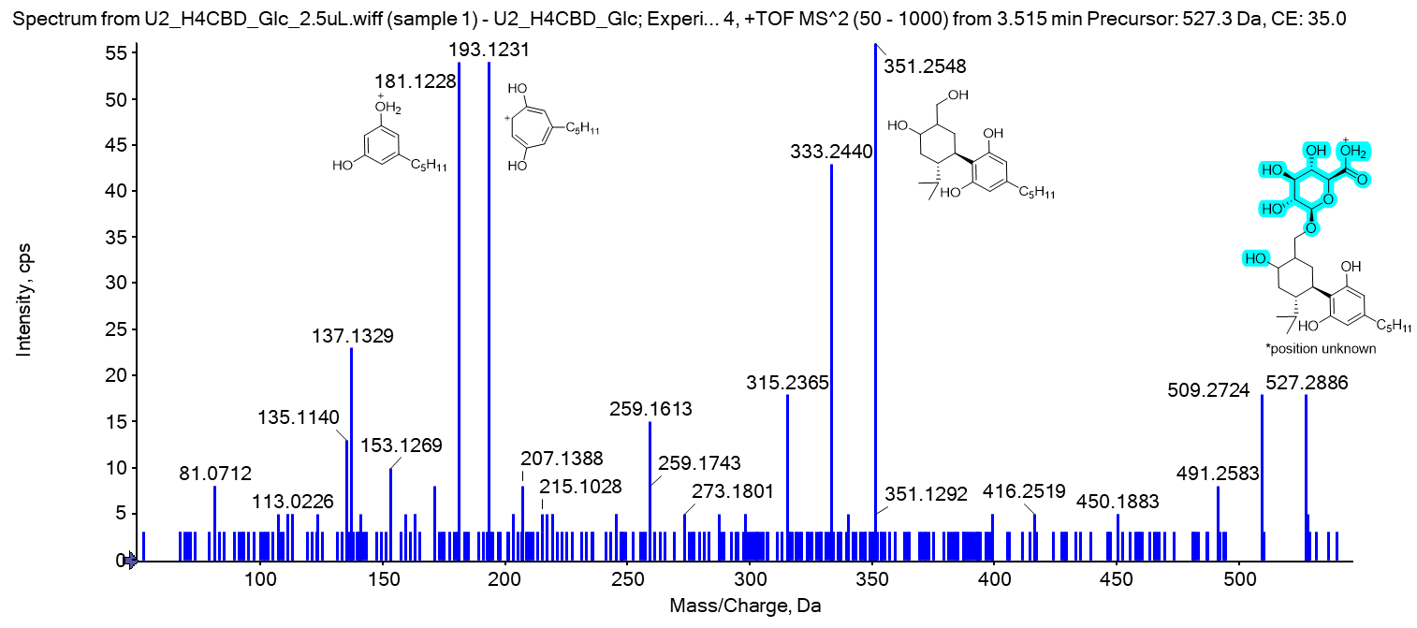
Figure S27: Mass spectrum of metabolite M23, a bishydroxylated and glucuronidated metabolite of H4CBD (from a urine sample 3 h after ingestion of 25 mg H4CBD). Both hydroxylation positions are found on the alicyclic moiety, their position and the position of the glucuronide are not clear.
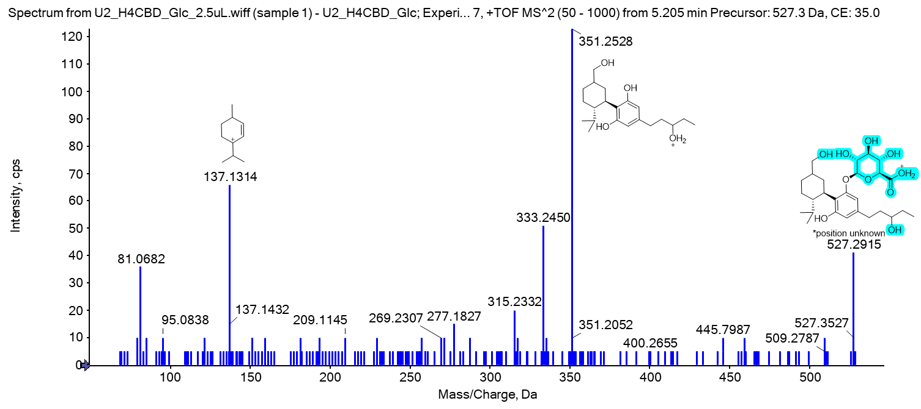
Figure S28: Mass spectrum of metabolite M24, a bishydroxylated and glucuronidated metabolite of H4CBD (from a urine sample 3 h after ingestion of 25 mg H4CBD). One hydroxylation positions is found on the alicyclic moiety, the other hydroxylation position is on the side-chain, their position and the position of the glucuronide are not clear.
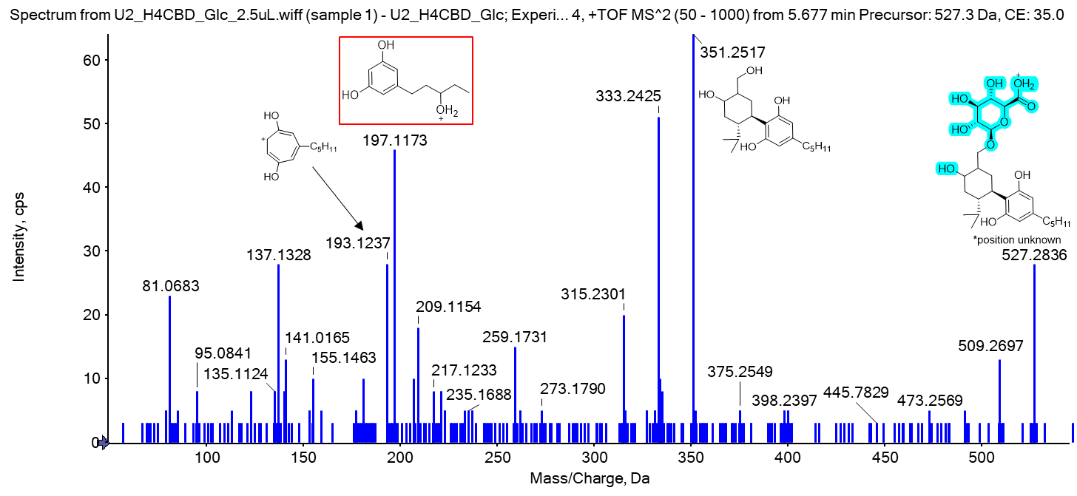
Figure S29: Mass spectrum of metabolite M25, a bishydroxylated and glucuronidated metabolite of H4CBD (from a urine sample 3 h after ingestion of 25 mg H4CBD). Both hydroxylation positions are found on the alicyclic moiety, their position and the position of the glucuronide are not clear. The ion m/z 197.1173 could result from a coeluting metabolite with a hydroxylation position on the side-chain.
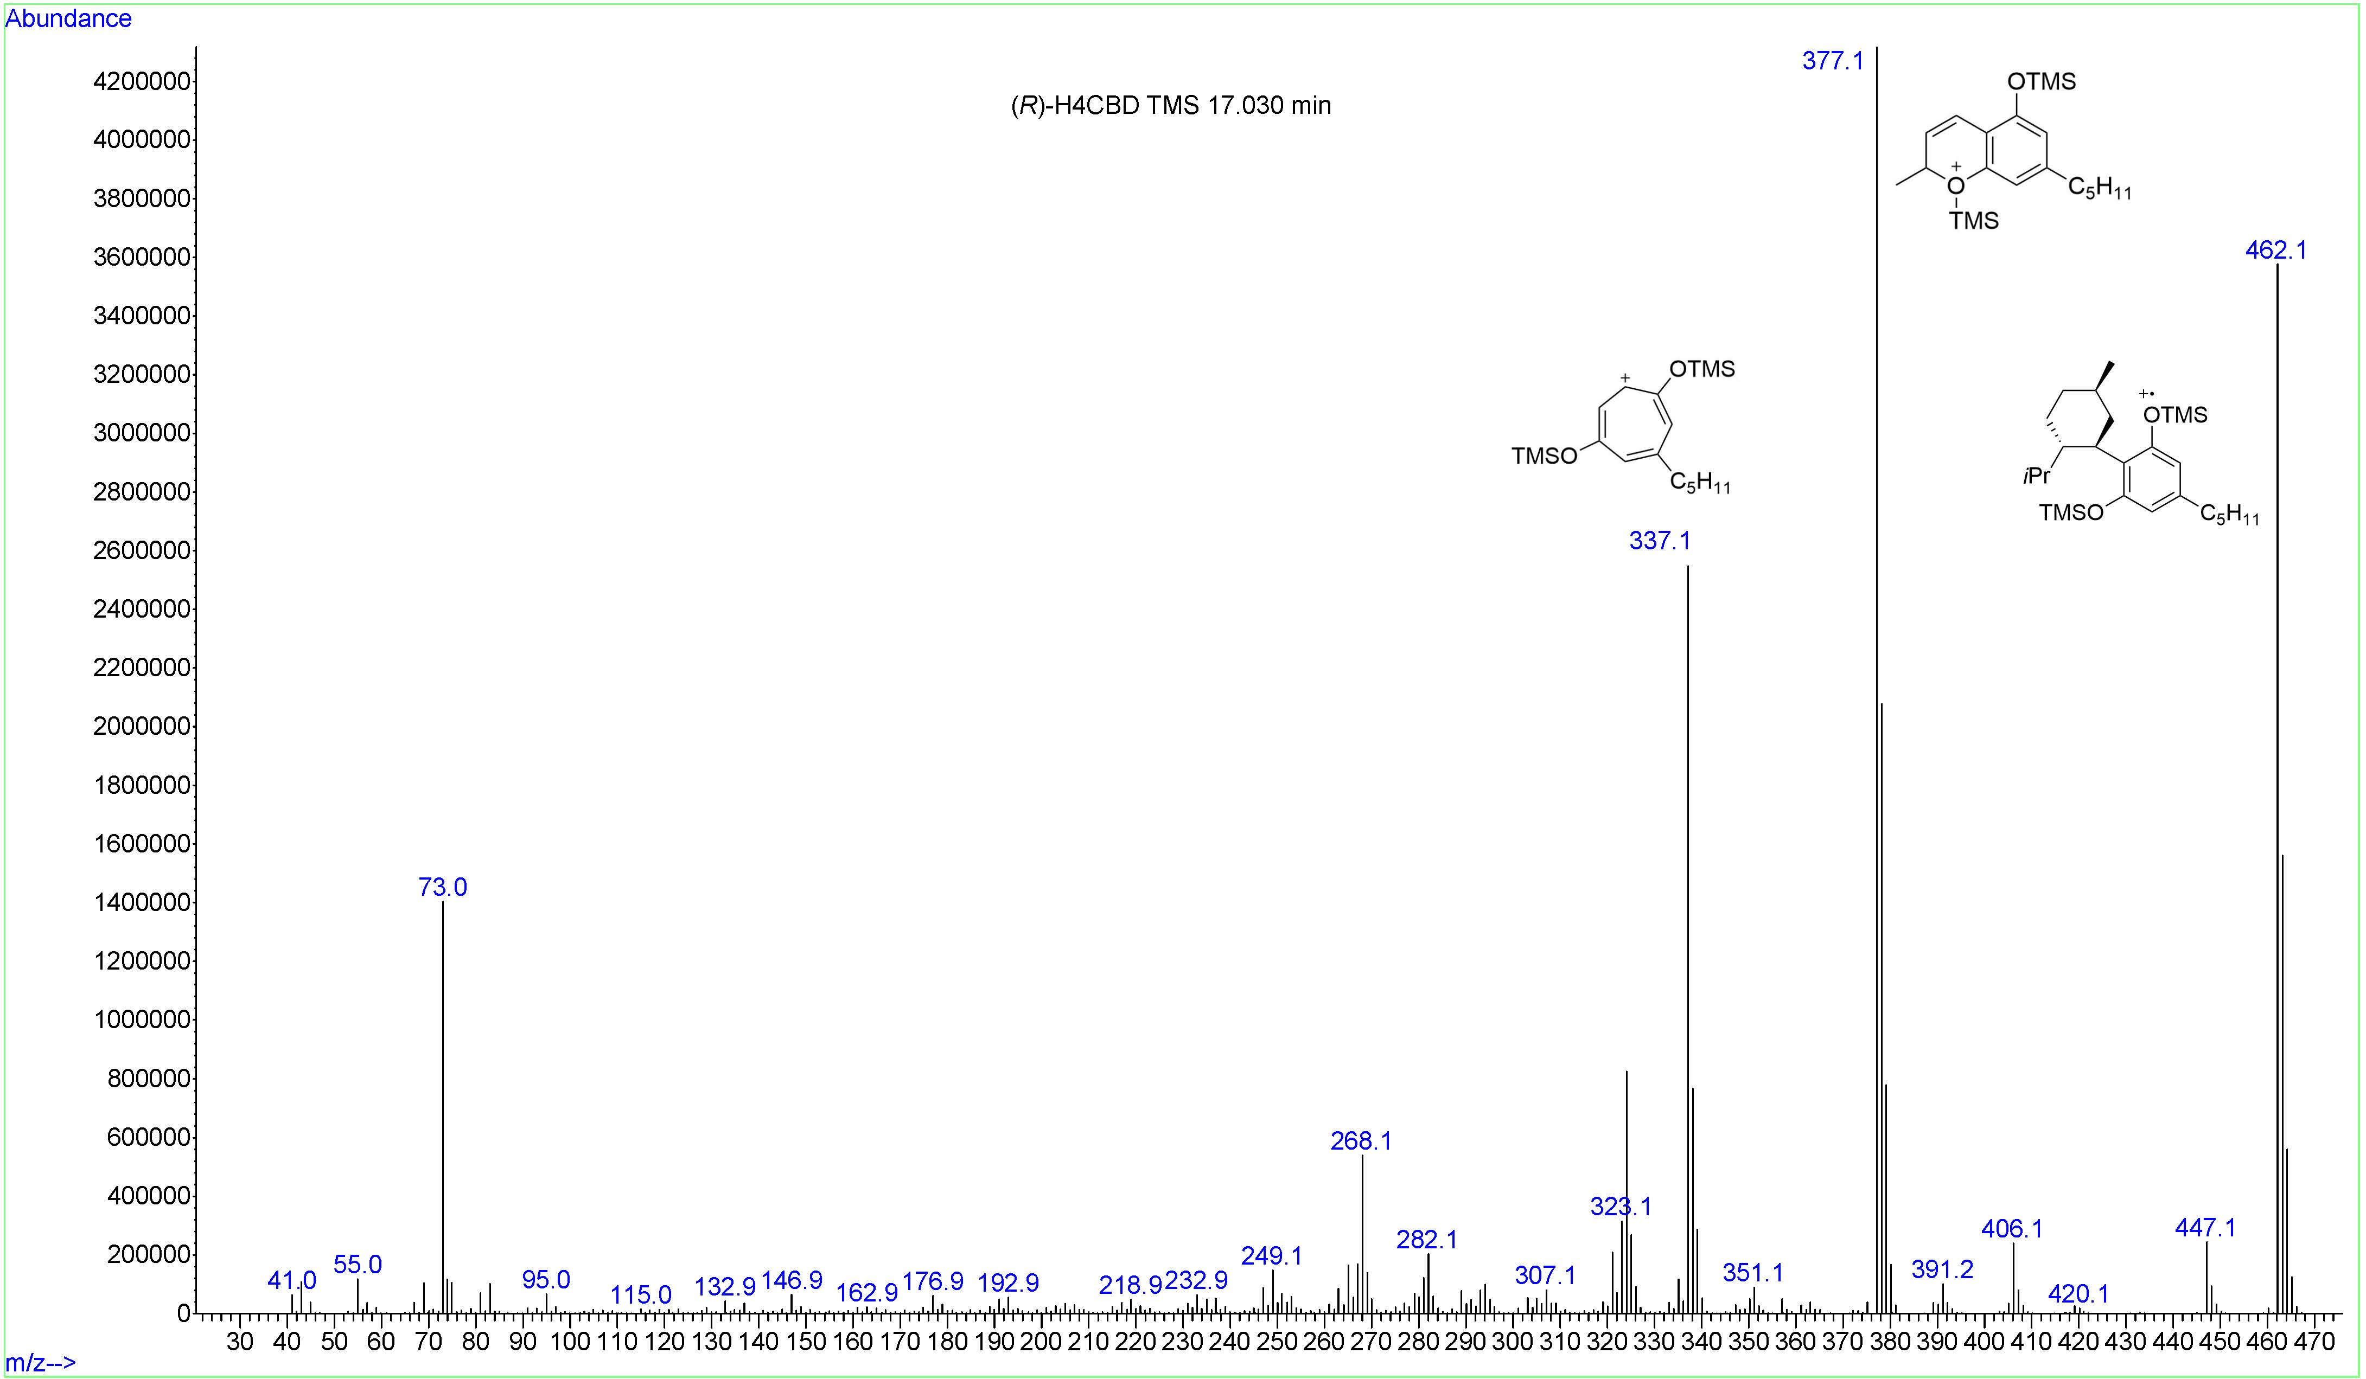
Figure S30: EI mass spectrum of the metabolite M26 (R)-H4CBD TMS
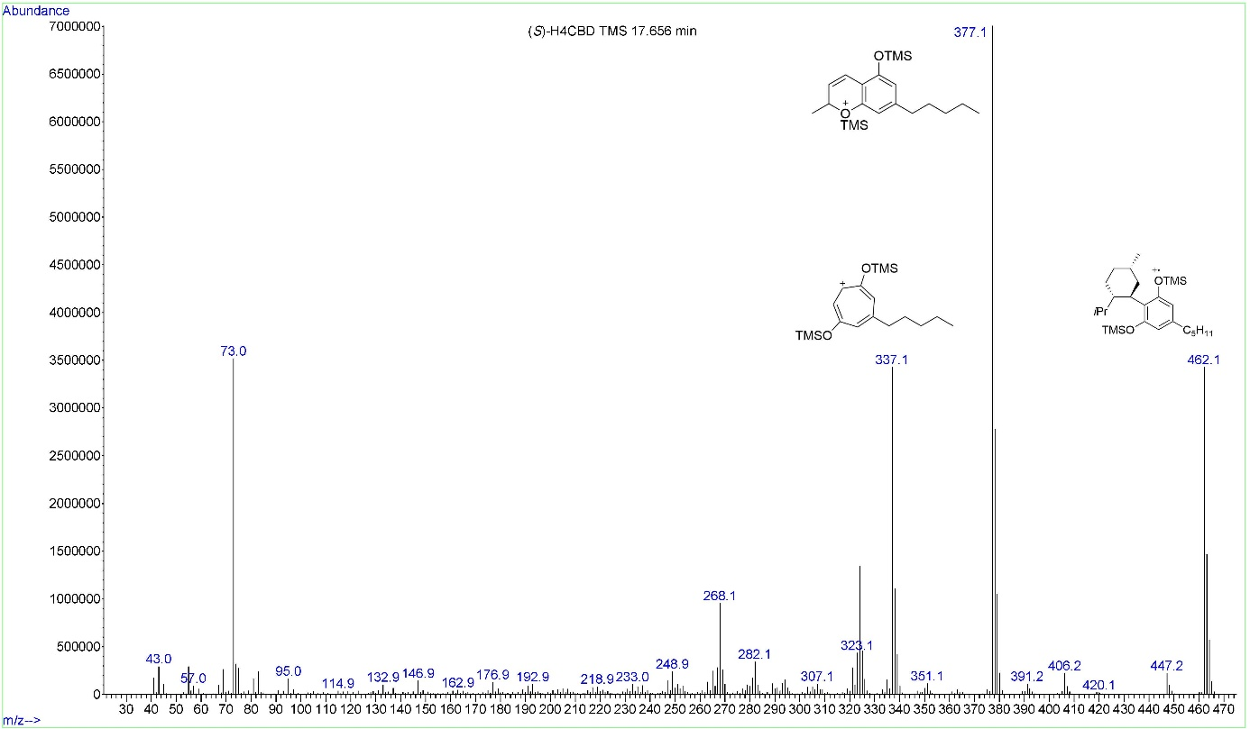
Figure S31: EI mass spectrum of the metabolite M27 (S)-H4CBD TMS, the same ions are formed as for (R)-H4CBD TMS.
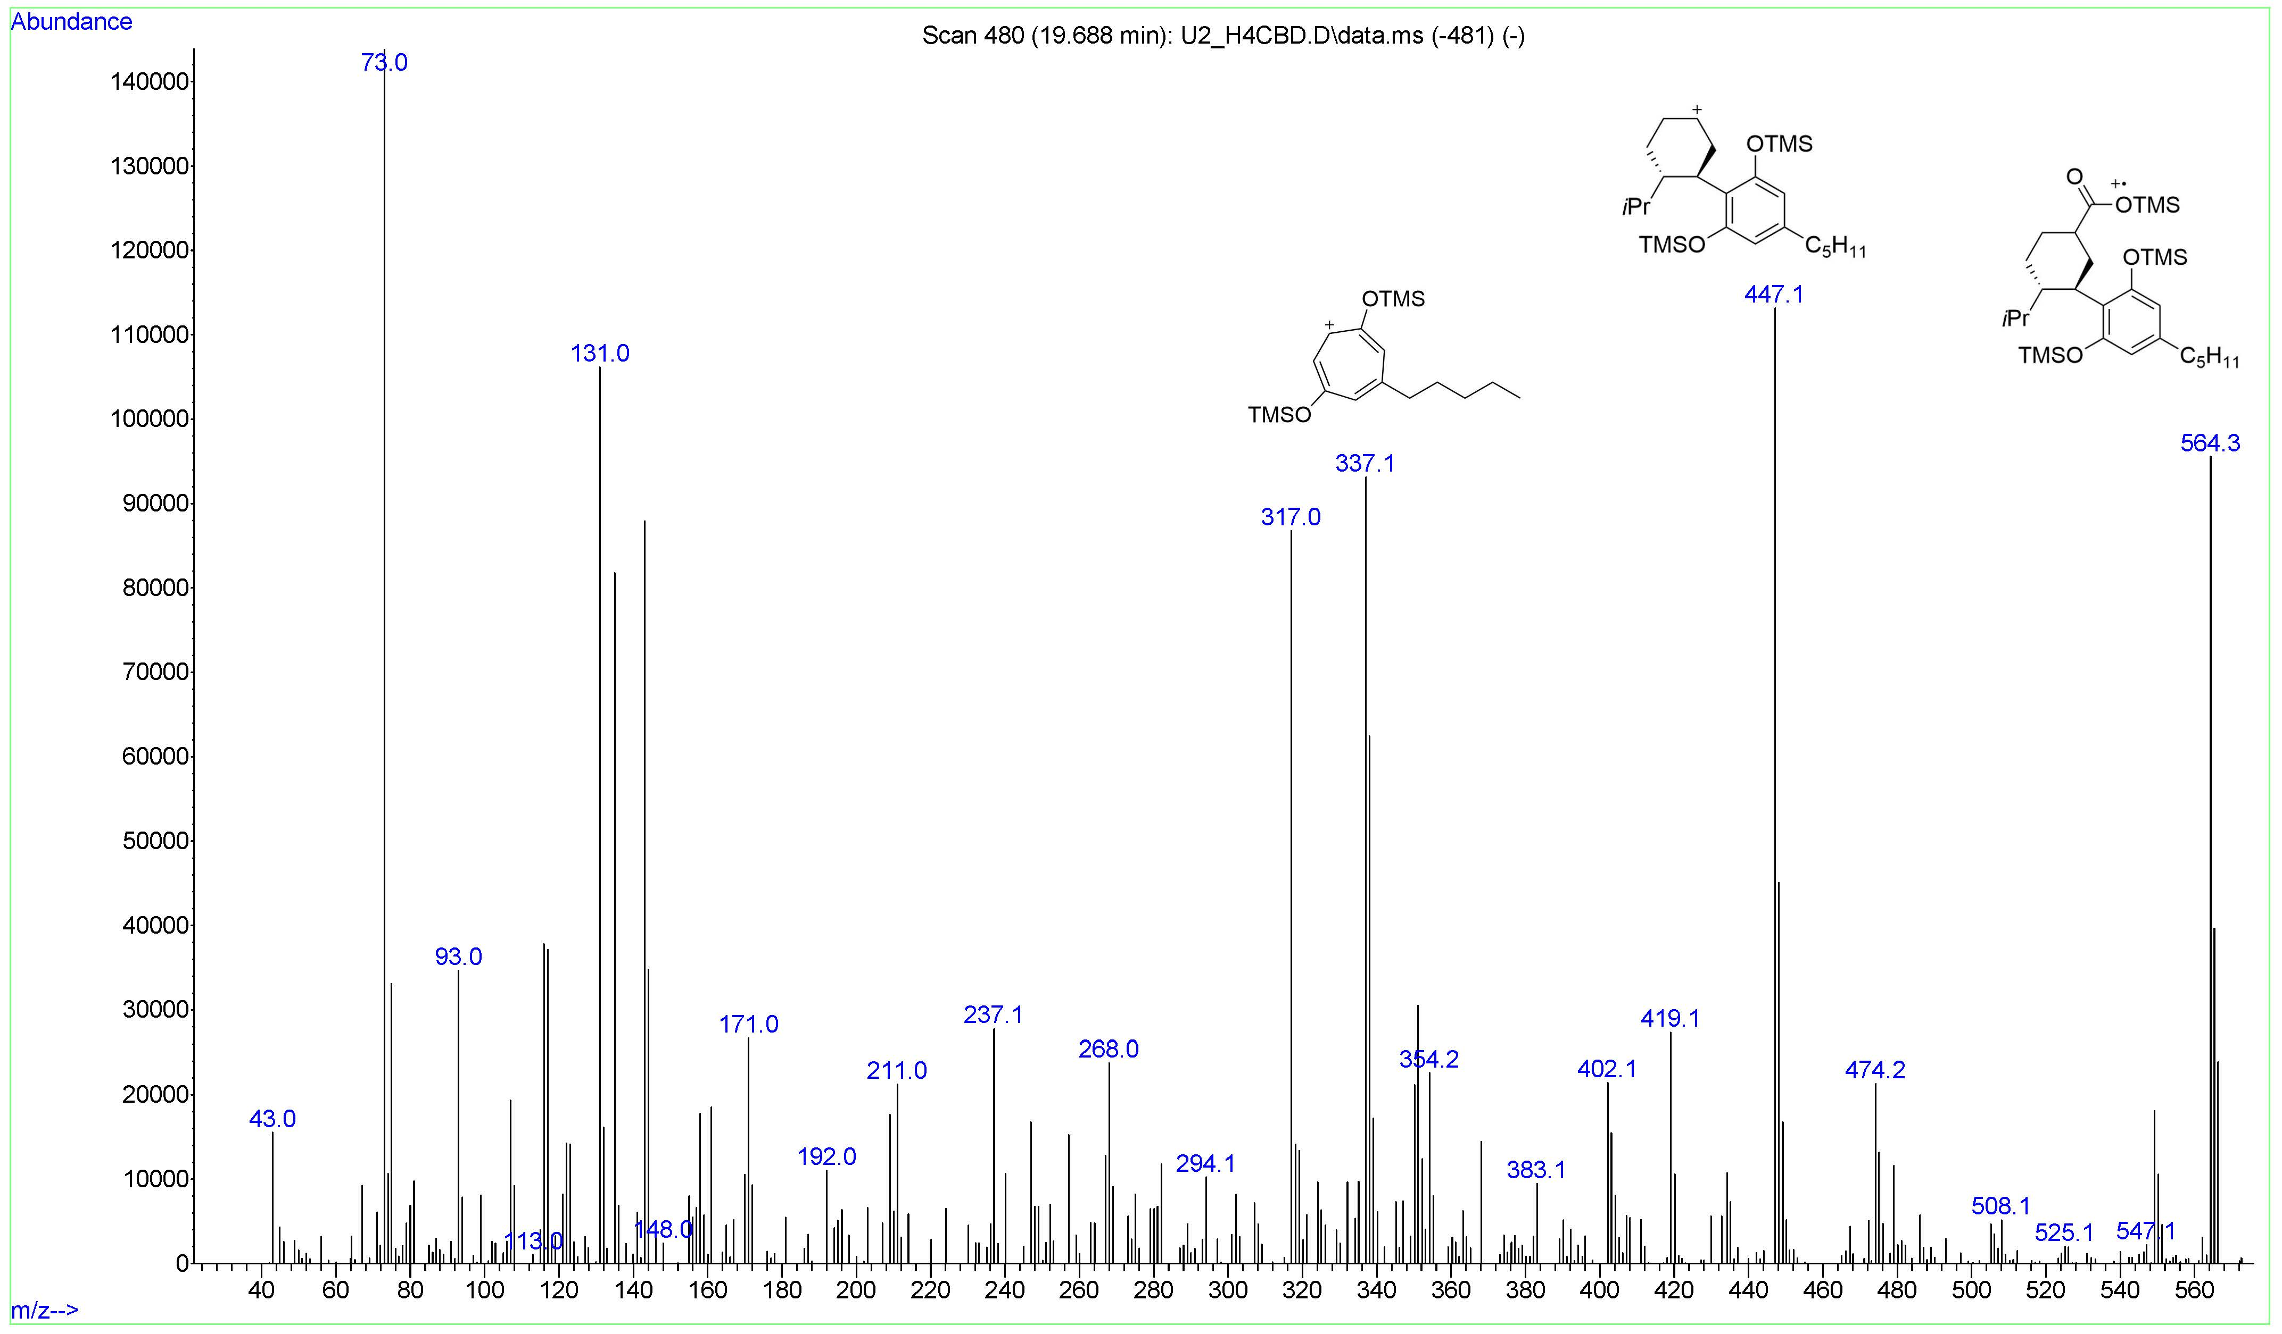
Figure S32: EI mass spectrum of the carboxylated metabolite M28 7-COOH-H4CBD TMS.
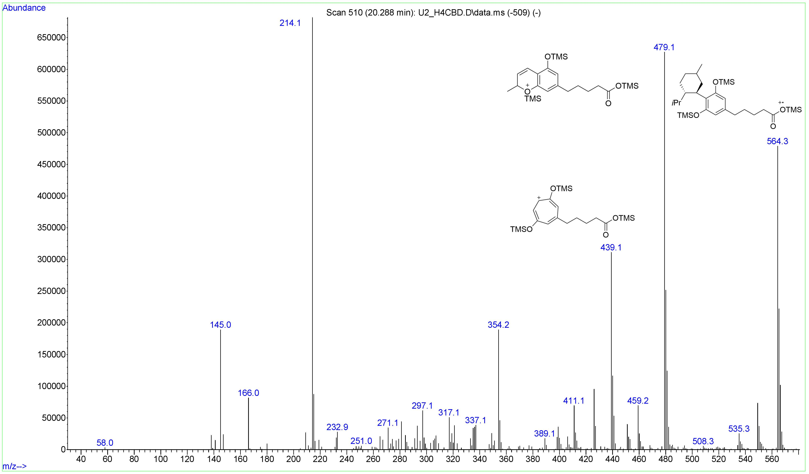
Figure S33: EI mass spectrum of the carboxylated metabolite M29 5''-COOH-H4CBD TMS.
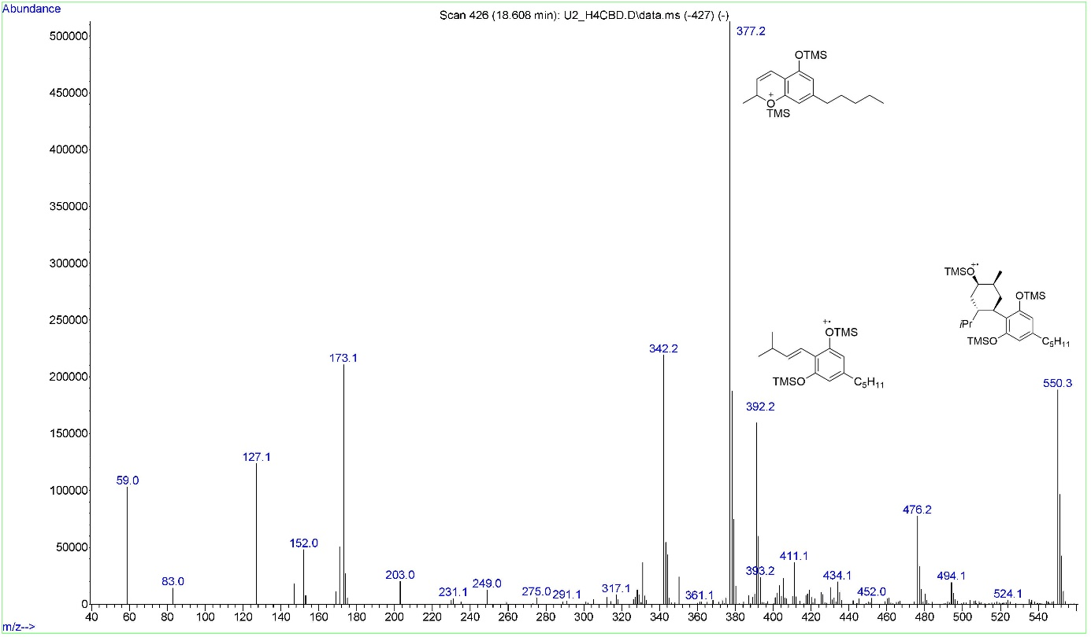
Figure S34: EI mass spectrum of the hydroxylated metabolite M30, hydroxylated on the alicyclic moiety.
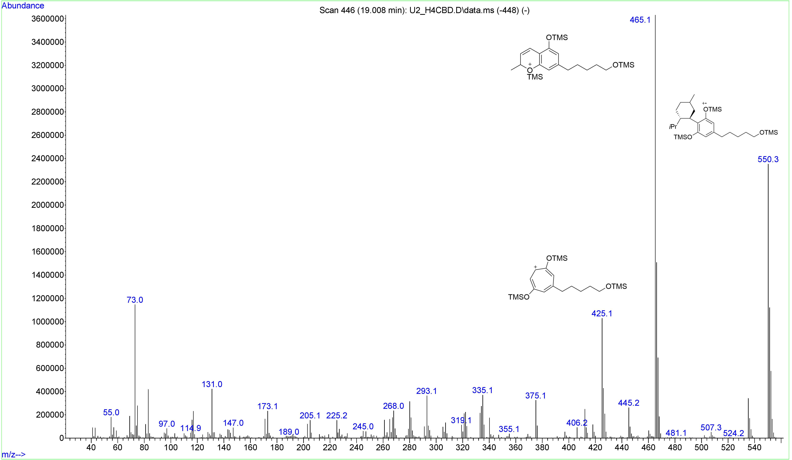
Figure S35: EI mass spectrum of the hydroxylated metabolite M31, hydroxylated on the side-chain. Hydroxylation position unknown.
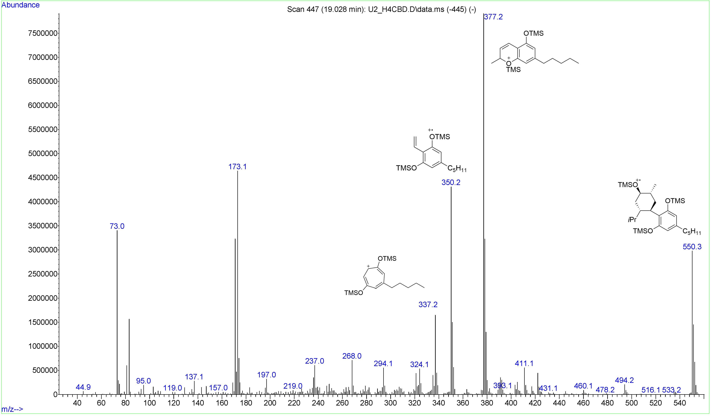
Figure S36: EI mass spectrum of the hydroxylated metabolite M32, hydroxylated on the alicyclic moiety.
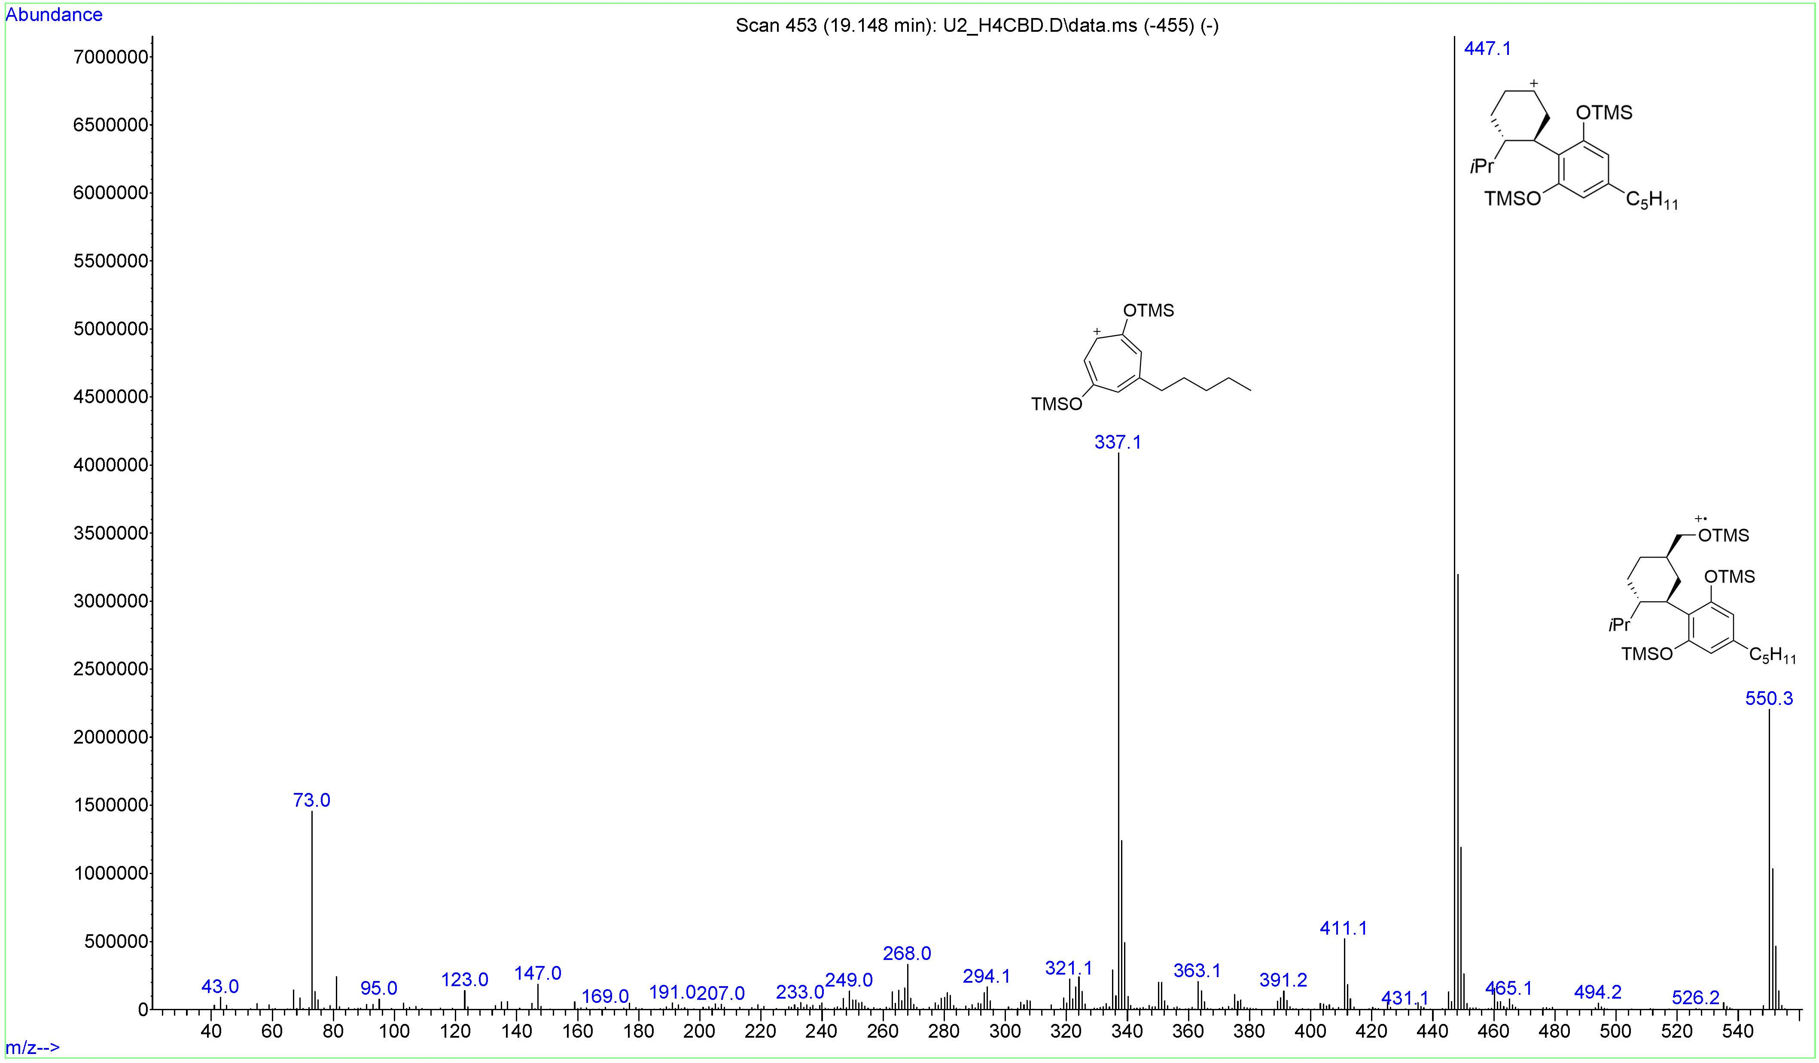
Figure S37: EI mass spectrum of the hydroxylated metabolite M33, hydroxylated on the alicyclic moiety. Presumably 7-OH-(R)-H4CBD
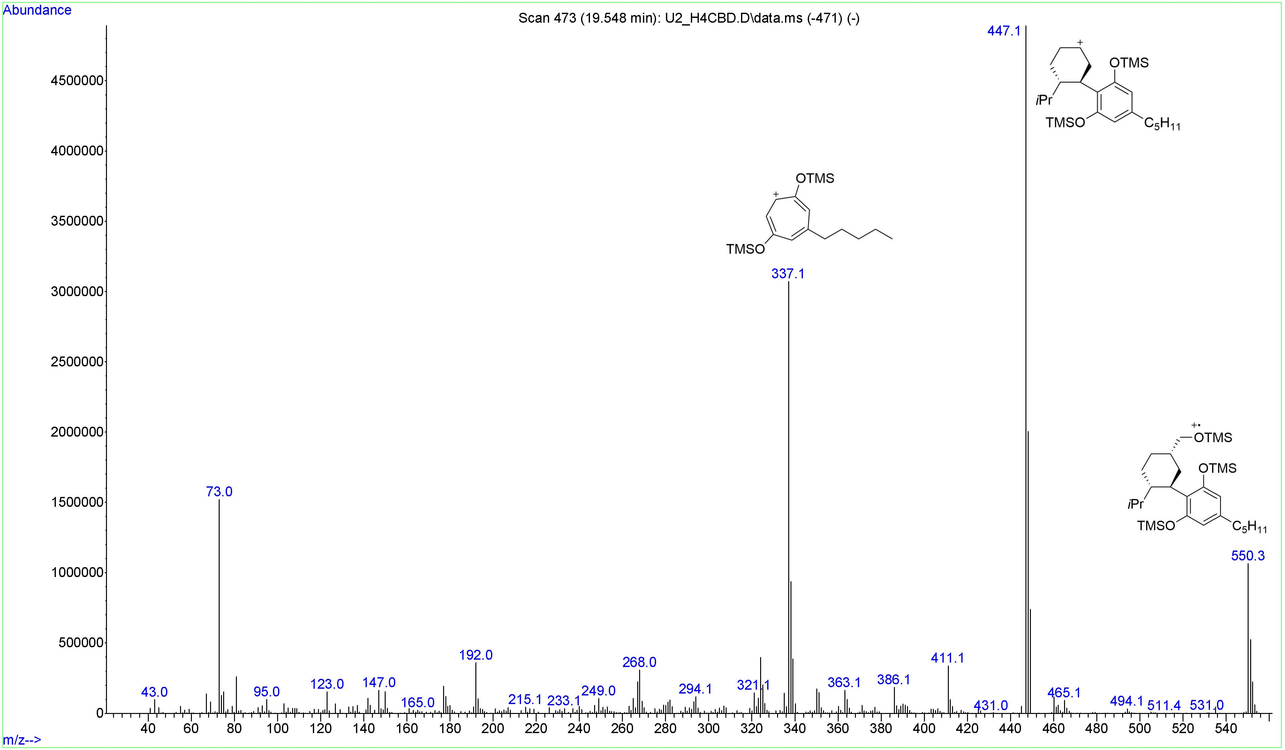
Figure S38: EI mass spectrum of the hydroxylated metabolite M34, hydroxylated on the alicyclic moiety. Presumably 7-OH-(S)-H4CBD
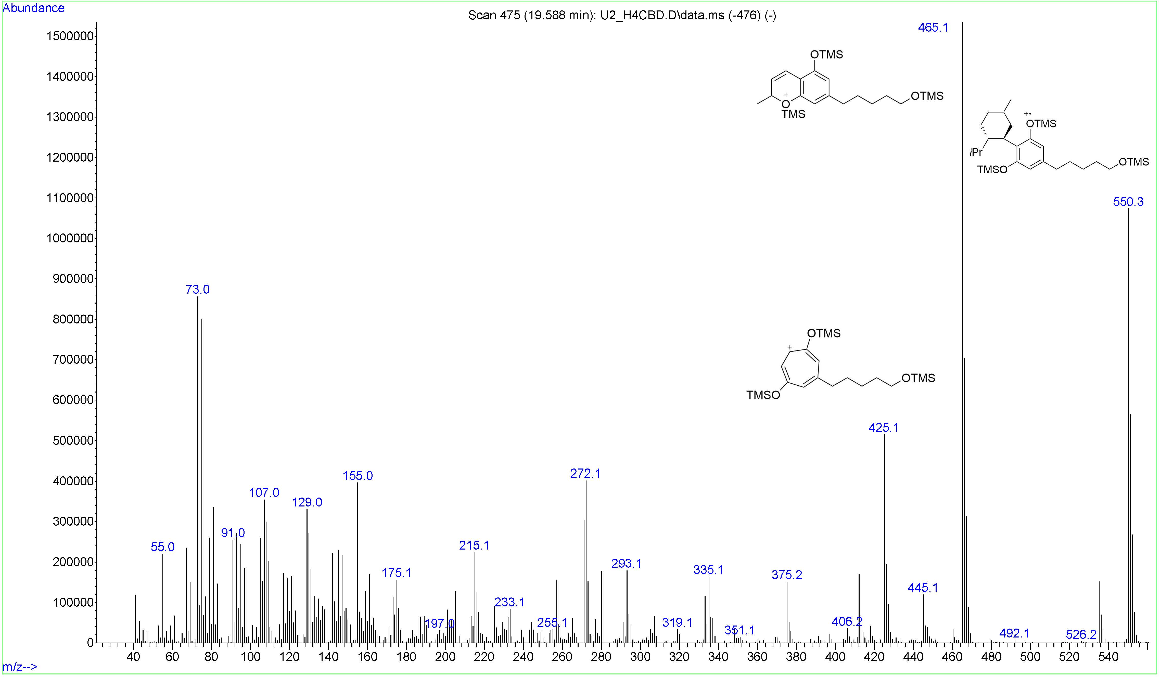
Figure S39: EI mass spectrum of the hydroxylated metabolite M35, hydroxylated on the side-chain. Hydroxylation position unknown.
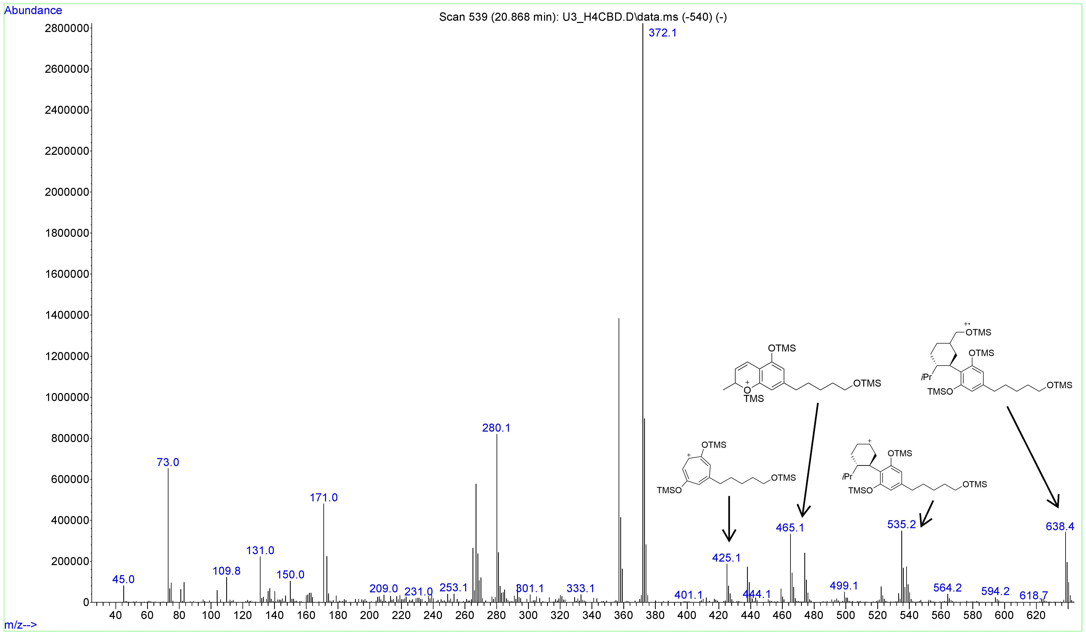
Figure S40: EI mass spectrum of the bishydroxylated metabolite M36, hydroxylated on C7 of the alicyclic moiety and on the side-chain. Position of the side-chain hydroxylation is unknown.
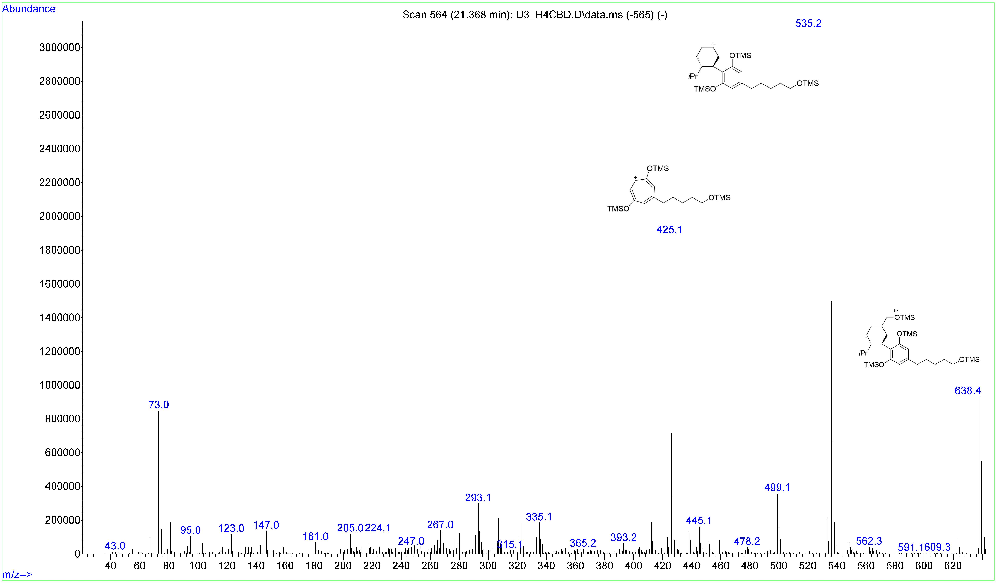
Figure S41: EI mass spectrum of the bishydroxylated metabolite M37, hydroxylated on C7 of the alicyclic moiety and on the side-chain. Position of the side-chain hydroxylation is unknown.
Figure S42: Product ion spectrum of 7-COOH-CBD at a collision energy of +46 V.
Figure S43: Product ion spectrum of 7-COOH-CBD at a collision energy of +73 V.

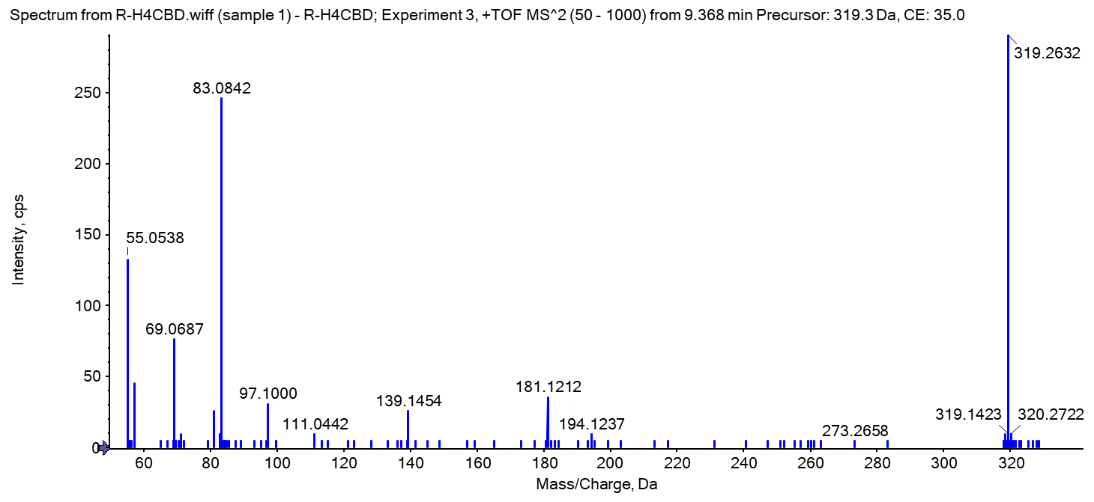
Figure S44: Product ion spectrum of (S)-H4CBD (reference standard).

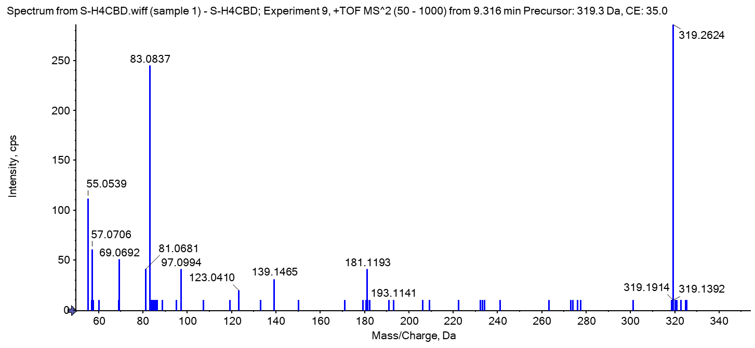

Figure S45: Product ion spectrum of (R)-H4CBD (reference standard).

Figure S46: Chromatogram of an n-alkane standard (C7-C40) used for the determination of Kováts indices.

