Supporting information
Characterising a new cannabis trend: Extensive analysis of semi-synthetic cannabinoid-containing seizures from Germany
Marica Hundertmark¹, Laura Besch², Jörg Röhrich¹, Tanja Germerott¹, Cora Wunder¹
¹Department of Forensic Toxicology, Institute of Legal Medicine, University Medical Center
²Forensic Science Institute, Dez.33 Chemistry/Toxicology, State Office of Criminal Investigation Rhineland-Palatinate, Mainz, Germany
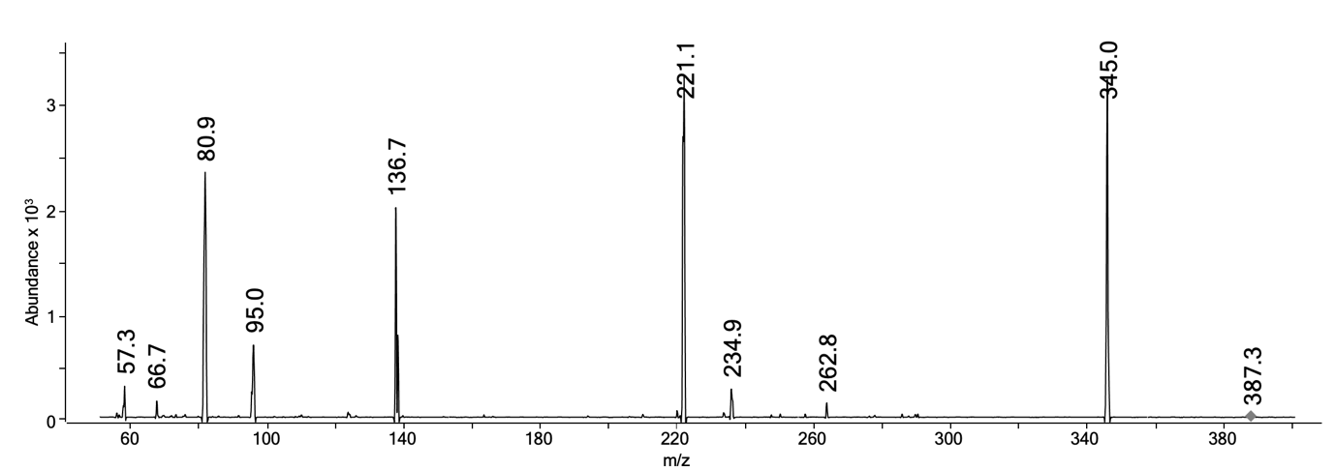
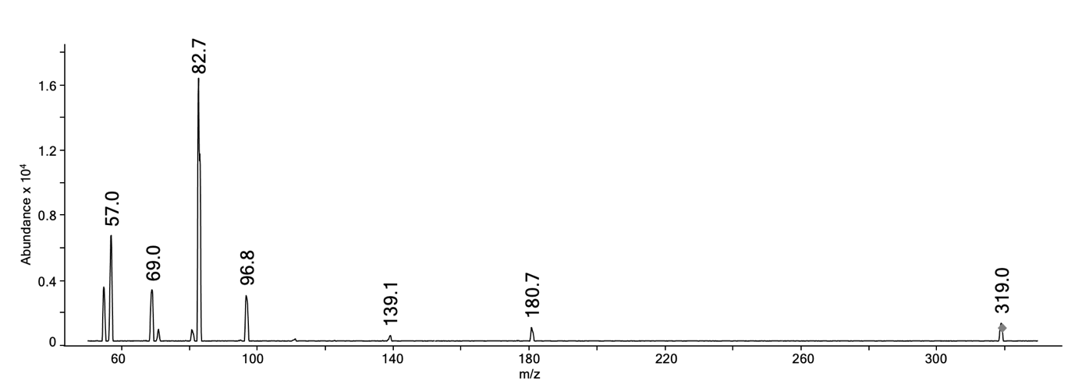
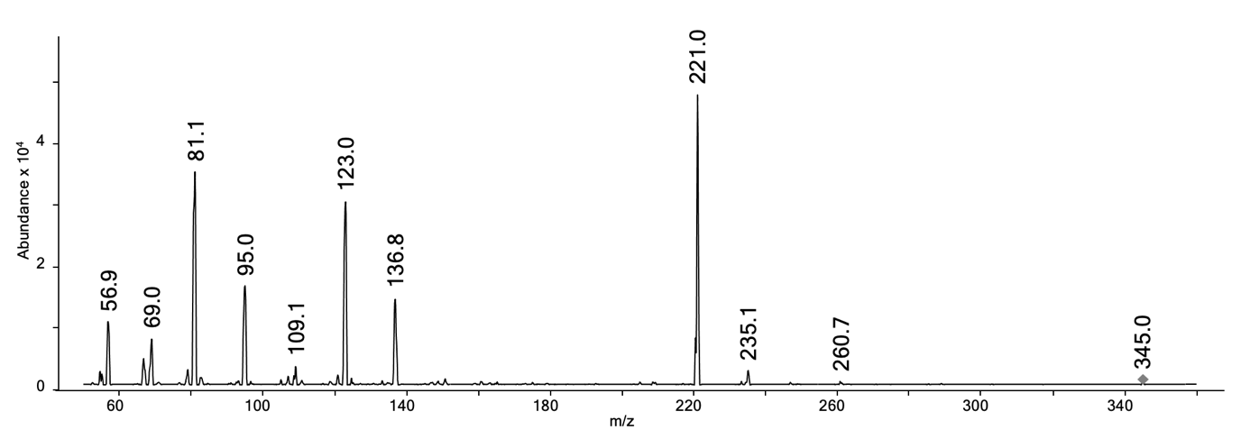
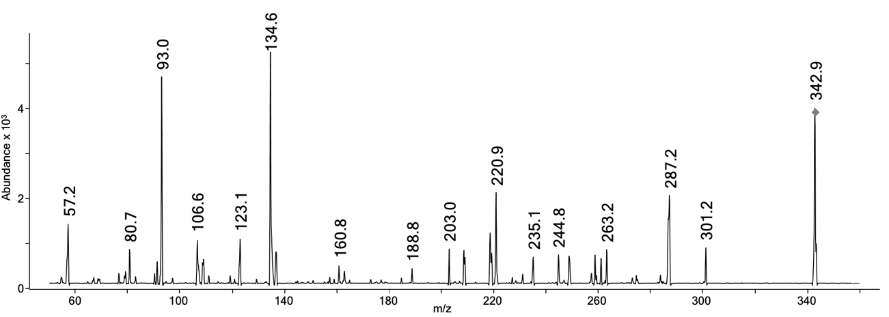
(d)
(a)
(b)
(c)
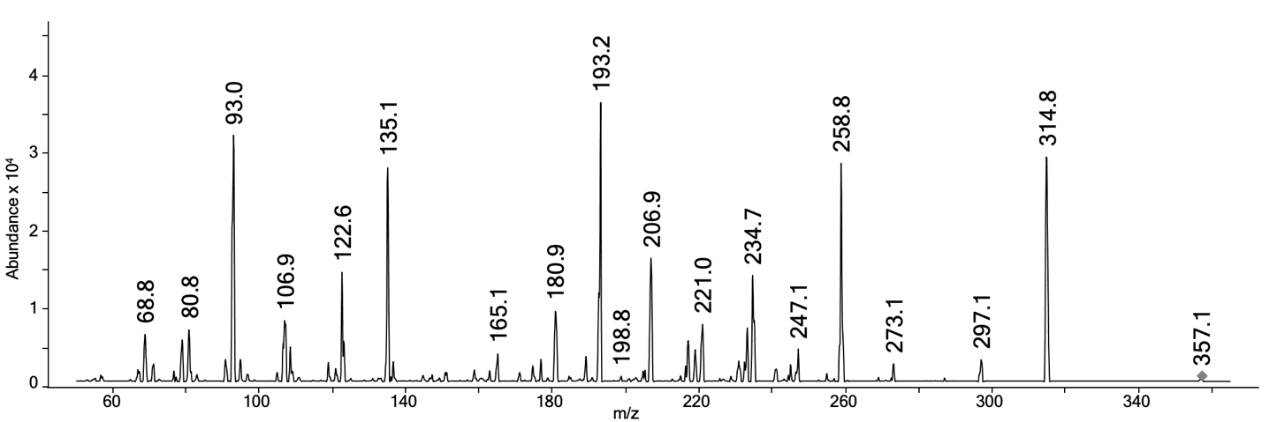
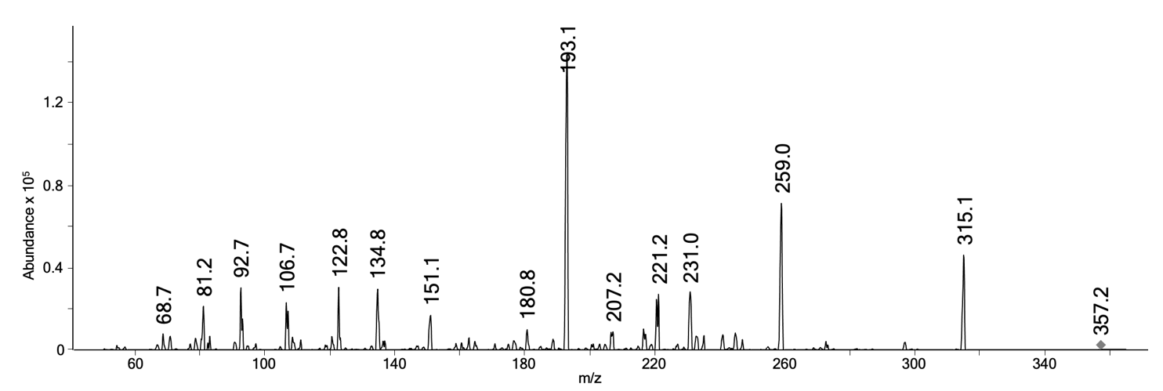
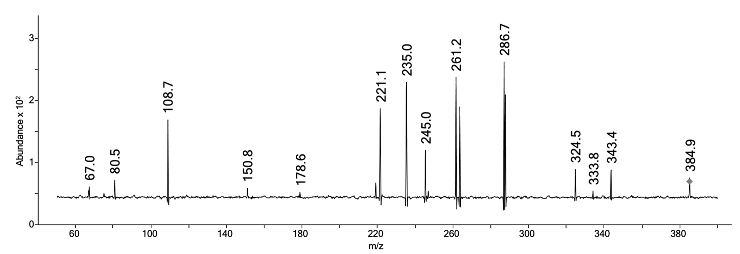
(g)
(f)
(e)
Figure S1 Product ion scans of SSC-derivatives. Depicted collision energies were chosen to show fragmentation as comprehensive as possible. Mass spectrum of seizure No. 2 showing HHCP (co-elution of (R) and (S)-diastereomer) at a collision energy of 38 eV (a). Mass spectrum of seizure No. 62 (a resin sample labelled with THCP) showing THCP (co-elution of Δ⁹-THCP and traces of Δ⁸-THCP) at a collision energy of 22 eV (b). Mass spectrum of the separately bought edibles showing H4CBD (co-elution of (R) and (S)-diastereomer) at a collision energy of 22 eV (c). Mass spectrum of acetylated seizure No. 59 showing HHCP-O (co-elution of (R) and (S)-diastereomer) at a collision energy of 30 eV (d). Mass spectrum of acetylated seizure No. 28 showing THC-P (co-elution of Δ⁹-THCP and traces of Δ⁸-THCP) at a collision energy of 30 eV (e). Mass spectrum of Δ⁹-THC-O (acetylation of a 10 µg/mL solution Δ⁹-THC) at a collision energy of 30 eV (f). Mass spectrum of Δ⁸-THC-O (acetylation of a 10 µg/mL solution Δ⁸-THC) at a collision energy of 30 eV (g).

Sample No. | Seizure No. | Total weight [g] | Description
Cannabis flowers
1 | 1 | 4.56 | Two sealed clip bags “HHC COSMIC Skywalker OG...vitalised CBD flowers 20% HHC <0.2% THC...2g” each contain cannabis flowers
2 | 2 | 51.8 | "Tangie 51"
3 | 2 | 130 | “Lemon King”
4 | 2 | 33.4 | Brown coated cannabis flowers, composite sample
5 | 3 | 1.01 | Sealed black clip bag containing cannabis flowers
6 | 4 | 1.10 | “White Cherry”, packed cannabis flowers
7 | 5 | 382 | 3 x brown coated cannabis flowers, composite sample
8 | 6 | 2.09 | Ground, brownish plant substance
9 | 7 | 93.1 | “Amnesia”
10 | 8 | 62.5 | Ground plant material
11 | 7 | 149 | “Northern Lights”
12 | 7 | 102 | “Purple Punch”
13 | 7 | 197 | “Hammer Haze”
14 | 8 | 0.31 | -
15 | 8 | 2.05 | -
16 | 7 | 97.4 | “Purple Punch”
17 | 7 | 97.6 | “Green Crack”
18 | 8 | 59.5 | “Amnesia Haze”, composite sample
19 | 8 | 149 | “New York Diesel”, composite sample
20 | 8 | 311 | “O.G. Kush”, composite sample
21 | 8 | 88.8 | “Gorilla Glue”, composite sample
22 | 8 | 38.0 | “Zkittelz”, composite sample
23 | 8 | 609 | “Gelatto”, composite sample
24 | 8 | 1.33 | Ground, brownish, sticky substance
25 | 8 | 71.8 | Ground plant material
26 | 9 | 4.82 | “Strawberry HHC”
27 | 9 | 4.98 | “Lemon Queen”
28 | 9 | 4.95 | “Haze Island”
29 | 9 | 4.99 | “Lemon King”
30 | 8 | 98.0 | “Amnesia”
31 | 7 | 68.4 | “Pineapple express”
32 | 7 | 98.8 | “Sour Diesel”
33 | 10 | 31.5 | -
34 | 10 | 48.6 | -
35 | 10 | 4.86 | -
36 | 10 | 2.41 | “Crazy seven”
37 | 10 | 5.32 | -
38 | 10 | 0.930 | -
39 | 10 | 3.13 | -
40 | 10 | 1.35 | -
41 | 10 | 0.930 | -
42 | 10 | 2.87 | Ground plant material
43 | 10 | 0.960 | -
44 | 10 | 0.940 | -
45 | 10 | 1.62 | “Lemon King”
46 | 10 | 1.60 | “Zushi Tsunami”
47 | 10 | 2.14 | -
48 | 11 | 17.2 | “Cali Jockerz CBD”, 9 packs of 2 g
49 | 11 | 20.4 | “Crazy 7 CBD”, 10 packs of 2 g
50 | 11 | 11.9 | “Strawberry CBD”, 6 packs of 2 g
51 | 11 | 12.2 | “Lemon Queen CBD”, 7 packs of 2 g
52 | 12 | 12.4 | “Gelato”
53 | 12 | 11.4 | “AK 47”
54 | 12 | 11.9 | “Strawberry”
55 | 12 | 11.5 | “Watermelon”
56 | 12 | 11.9 | “Lemon Diesel”
Cannabis resin
57 | 13 | not known | -
58 | 2 | 34.3 | Brown resin, composite sample
59 | 2 | 19.6 | Brown resin, composite sample
60 | 2 | 33.9 | Brown resin, composite sample
61 | 14 | 50.2 | Brown resin
62 | 15 | 53.1 | Sealed black clip bag “tv bubble hash … THCP 45 %, THC < 0.2 %” containing brown resin
63 | 8 | 19.3 | 10 brown-black resin balls, “CBD hash”
64 | 8 | 68.8 | “Maroke Hash”, brown resin, composite sample
65 | 8 | 7.75 | “Temple Balls Hash”, dark-brown resin
66 | 10 | 87.8 | Brown-black resin
67 | 10 | 96.6 | Brown-black resin
68 | 10 | 6.27 | “Hot Blondie”, brown resin
69 | 11 | 14.5 | “Nougat CBD”, 8 packs of 2 g, dark-brown resin
Edibles (gummies)
70 | 12 | 40.0 | “Strawberry belts”, orange stripe-shaped gummies with packaging
71 | 12 | 26.0 | “Million Rope Bites”, brown stripe-shaped gummies with packaging
72 | 16 | 38.8 | “Rainbow belts, 500 mg THC”, rainbow-coloured and striped gummies
73 | 17 | 391 | “Spacejellys, 250 mg HHC”, 17 packs of multicoloured, fruit-shaped gummy bears, 5 packs were sampled and contents completely homogenised
* | - | - | “H4CBD-gummies, 42 mg H4CBD”, pack of 3 gummies
Vape liquids
74 | 18 | 1.28 | Vape-Liquids ‘HHC’, fruity odour, brownish liquid, composite sample
75 | 19 | not known | Brownish, clear liquid, slightly viscous, sticky and approx. 0.2 mL filling level in a syringe with scale
Papers (presumably soaked with vape liquid)
76 | 20 | not known | 1x DIN A4 sheet (lined, with lettering, glossy surface)
77 | 20 | not known | 1x DIN A4 sheet (lined, with lettering, glossy surface)
78 | 20 | not known | 1x DIN A4 sheet (lined, with lettering, glossy surface)
79 | 20 | not known | 1x DIN A4 sheet (lined, with lettering, glossy surface)
Table S1 Descriptions of the seizures. The separately bought H4CBD gummies are marked with (*).

Analyte | Quantification [ng/mL]  validated method | Standard addition results
Analyte | Quantification [ng/mL]  validated method | Quantification [ng/mL] absolute  without ISTD, r² | Deviation [%] | Quantification [ng/mL] relative  with ISTD, r² | Deviation [%]
Seizure No. 2 – cannabis flower
(R)-HHC  (1:10,000 dilution) | 53.4 | 40.7  (0.999) | -23.7 | 48.3  (0.996) | -9.43
(S)-HHC  (1:10,000 dilution) | 18.1 | 15.3  (0.999) | -15.4 | 19.3  (0.994) | 6.93
Δ⁸-THC  (1:1,000 dilution) | 58.0 | 45.0  (0.993) | -22.4 | 51.6  (0.998) | 11.0
Δ⁹-THC  (1:1,000 dilution) | 50.8 | 39.8  (0.991) | -21.6 | 45.0  (0.997) | -11.3
CBD  (1:10,000 dilution) | 48.8 | 42.1  (0.999) | -13.9 | 48.9  (0.996) | 0.06
CBG  (1:1,000 dilution) | 34.4 | 28.6  (0.995) | -17.0 | 31.2  (0.996) | -9.24
CBN  (1:1,000 dilution) | 15.3 | 10.8  (0.992) | -29.3 | 16.7  (0.997) | 8.7
Δ⁹-THCAA  (1:10,000 dilution) | 7.99 | 8.81  (0.999) | 10.4 | 8.69  (0.998) | 8.68
CBDA  (1:10,000 dilution) | 348 | 262  (0.992) | -24.8 | 294  (0.992) | -15.6
CBGA  (1:1,000 dilution) | 221 | 173  (0.993) | -21.9 | 231  (0.993) | 4.64
CBNA  (1:1,000 dilution) | 6.71 | 4.71  (0.991) | -29.8 | 5.93  (0.998) | -11.6
(R)-HHC-O  (1:10,000 dilution) | 31.2 | 40.3  (0.998) | 29.5  (0.998) | 39.1  (0.993) | 25.6
(S)-HHC-O  (1:10,000 dilution) | 39.6 | 45.1  (0.991) | 14.2 | 35.8  (0.992) | -9.45
CBN-O  (1:10,000 dilution) | 3.38 | 3.44  (0.996) | 1.69 | 3.71  (1.00) | 9.62
Seizure No. 61 – cannabis resin
(R)-HHC  (1:100,000 dilution) | 73.3 | 57.7  (0.9979) | -21.3 | 65.4  (0.999) | -10.8
(S)-HHC  (1:100,000 dilution) | 18.1 | 14.3  (0.999) | -20.9 | 17.3  (0.999) | -4.69
Δ⁸-THC  (1:10,000 dilution) | 18.3 | 14.3  (1.00) | -21.8 | 15.6  (0.999) | -15.2
Δ⁹-THC  (1:10,000 dilution) | 67.2 | 52.8  (0.998) | -21.5 | 56.5  (0.996) | -15.9
CBD  (1:10,000 dilution) | 50.6 | 46.5  (0.999) | -7.99 | 49.2  (0.998) | -2.70
CBG  (1:10,000 dilution) | 396 | 299  (0.997) | -24.5 | 324  (0.992) | -18.3
CBN  (1:10,000 dilution) | 20.5 | 14.9  (0.995) | -27.4 | 17.1  (0.992) | -16.3
Δ⁹-THCAA  (1:100,000 dilution) | 6.54 | 6.54  (0.997) | 4.60 | 6.67  (0.998) | 2.00
CBDA  (1:10,000 dilution) | 42.9 | 44.8  (0.999) | 4.48 | 48.4  (0.994) | 12.9
CBGA  (1:10,000 dilution) | 206 | 222  (0.995) | 7.75 | 257  (0.993) | 24.4
CBNA  (1:10,000 dilution) | 7.99 | 7.16  (0.998) | -10.4 | 7.82  (0.991) | -2.16
(R)-HHC-O  (1:1,000 dilution) | 1.19 | 1.55  (0.997) | 29.9 | 1.50  (0.999) | 26.5
(S)-HHC-O  (1:10,000 dilution) | 1.85 | 2.19  (0.994) | 18.2 | 2.15  (0.998) | 16.2
Seizure No. 71 – edibles (gummie)
(R)-HHC  (1:1,000 dilution) | 14.5 | 13.2  (0.999) | -9.08 | 14.3  (0.998) | -1.56
(S)-HHC  (1:1,000 dilution) | 6.65 | 5.35  (0.999) | -19.5 | 6.37  (0.999) | -4.21
CBN  (1:1,000 dilution) | 5.37 | 4.76  (0.996) | -11.5 | 4.20  (0.994) | -21.7
(R)-HHC-O  (1:100,000 dilution) | 5.40 | 6.75  (0.998) | 24.9 | 6.71  (0.997) | 24.4
(S)-HHC-O  (1:100,000 dilution) | 11.8 | 9.64  (0.997) | -18.4 | 9.63  (0.995) | -18.5
CBN-O  (1:100,000 dilution) | 1.57 | 1.50  (0.999) | -4.55 | 1.49  (0.999) | -5.36
Table S2 Standard addition results.

# | (R)-HHC | (S)-HHC | HHC_{tot} | (R)/(S)-HHC | Δ⁹-THC | Δ⁹-THCAA | Δ⁹-THC_{tot} | Δ⁸-THC | CBN | CBNA | CBN_{tot} | CBD | CBDA | CBD_{tot} | CBG | CBGA | CBG_{tot}
Cannabis flowers
1 | 0.246 | 0.0535 | 0.300 | 4.61 | 0.196 | 0.0879 | 0.273 | 0.00591 | 0.0402 | 0.00725 | 0.0466 | 2.51 | 5.71 | 7.52 | 0.0668 | 0.158 | 0.205
2 | 1.30 | 0.449 | 1.75 | 2.90 | 0.119 | 0.199 | 0.293 | 0.144 | 0.0381 | 0.0167 | 0.0527 | 1.21 | 8.66 | 8.81 | 0.0854 | 0.549 | 0.567
3 | 20.6 | 6.51 | 27.2 | 3.17 | 0.0325 | 0.0392 | 0.0667 | 0.0139 | 0.0389 | 0.00704 | 0.0451 | 0.0900 | 0.377 | 0.421 | 0.190 | 5.09 | 4.65
4 | 4.79 | 1.96 | 9.24 | 2.18 | 0.0498 | 0.0137 | 0.0618 | 0.0144 | 0.0246 | 0.00119 | 0.0256 | 1.00 | 1.17 | 2.03 | 1.49 | 4.01 | 5.01
5 | 19.5 | 12.4 | 31.9 | 1.57 | 0.486 | 0.0308 | 0.0756 | 0.00443 | 0.0838 | 0.00159 | 0.0852 | 0.739 | 1.44 | 2.00 | 0.0196 | 0.0466 | 0.0605
6 | <LOQ | <LOQ | <LOQ | na | 0.0535 | 0.0152 | 0.0669 | nd | 0.00572 | 0.00212 | 0.00758 | 0.976 | 1.49 | 2.29 | 0.0689 | 0.179 | 0.226
7 | 18.3 | 7.14 | 25.4 | 2.56 | 0.115 | 0.0209 | 0.134 | 0.145 | 0.0603 | 0.00269 | 0.0627 | 30.1 | 1.03 | 31.0 | 0.0314 | 0.0204 | 0.0493
8 | 19.8 | 21.8 | 41.5 | 0.907 | 0.0643 | 0.0952 | 0.148 | 0.170 | 1.12 | 0.0303 | 1.15 | 1.72 | 3.53 | 4.82 | 0.0825 | 0.857 | 0.835
9 | 7.88 | 1.44 | 9.32 | 5.48 | 0.374 | 0.0751 | 0.440 | 0.250 | 0.0700 | 0.00911 | 0.0780 | 4.76 | 6.32 | 10.3 | 0.104 | 0.195 | 0.275
10 | 20.9 | 6.52 | 27.4 | 3.20 | 0.180 | 0.0173 | 0.196 | 0.155 | 0.0145 | nd | 0.0145 | 0.674 | 1.17 | 1.70 | 0.0159 | 0.0617 | 0.0700
11 | 9.25 | 3.70 | 13.0 | 2.50 | 0.320 | 0.0733 | 0.384 | 0.0684 | 0.314 | 0.00969 | 0.322 | 5.25 | 6.39 | 10.9 | 0.133 | 0.169 | 0.281
12 | 7.76 | 2.54 | 10.3 | 3.05 | 0.217 | 0.0524 | 0.263 | 0.0413 | 0.131 | 0.00705 | 0.137 | 4.20 | 4.38 | 8.04 | 0.0807 | 0.111 | 0.179
13 | 15.8 | 6.77 | 22.6 | 2.34 | 0.383 | 0.0761 | 0.450 | 0.207 | 0.297 | 0.00785 | 0.304 | 4.02 | 5.78 | 9.09 | 0.116 | 0.153 | 0.250
14 | <LOQ | <LOQ | <LOQ | na | 0.0249 | 0.00843 | 0.0322 | nd | 0.00721 | <LOQ | 0.00721 | 0.702 | 0.989 | 1.57 | 0.0269 | 0.0518 | 0.0721
15 | 39.9 | 12.4 | 52.3 | 3.23 | 0.311 | 0.0234 | 0.330 | 0.889 | 0.148 | 0.00354 | 0.151 | 1.02 | 2.06 | 2.82 | 0.0167 | 0.0284 | 0.0416
16 | 13.3 | 5.83 | 19.2 | 2.28 | 0.512 | 0.0951 | 0.595 | 0.181 | 0.309 | 0.0127 | 0.321 | 7.18 | 8.17 | 14.3 | 0.203 | 0.194 | 0.373
17 | 4.68 | 2.22 | 6.90 | 2.10 | 0.711 | 0.234 | 0.916 | 1.81 | 0.0550 | 0.0166 | 0.0695 | 6.31 | 7.81 | 13.2 | 0.295 | 0.484 | 0.721
18 | 2.02 | 0.624 | 2.65 | 3.24 | 0.0809 | 0.0349 | 0.112 | 0.0175 | 0.0112 | <LOQ | 0.0112 | 0.764 | 1.67 | 2.23 | 0.211 | 3.59 | 3.36
19 | 9.11 | 3.30 | 12.4 | 2.76 | 0.104 | 0.0205 | 0.121 | 0.0531 | 0.0146 | <LOQ | 0.0146 | 0.967 | 1.70 | 2.46 | 0.0225 | 0.0384 | 0.0562
20 | 8.29 | 2.62 | 10.9 | 3.17 | 0.113 | <LOQ | 0.113 | 0.0642 | 0.0187 | nd | 0.0187 | 1.54 | 1.96 | 3.04 | 0.0170 | 0.0330 | 0.0459
21 | 22.2 | 6.73 | 29.0 | 3.30 | 0.194 | 0.0231 | 0.214 | 0.178 | 0.0246 | 0.00322 | 0.0274 | 1.31 | 1.96 | 3.04 | 0.0306 | 0.0419 | 0.0674
22 | 6.54 | 2.11 | 8.65 | 3.10 | 0.0761 | 0.0187 | 0.0924 | 0.0492 | 0.00838 | nd | 0.00838 | 0.402 | 0.670 | 0.989 | 0.166 | 2.93 | 2.74
23 | 17.2 | 5.45 | 22.7 | 3.16 | 0.152 | 0.0275 | 0.176 | 0.121 | 0.00922 | nd | 0.00922 | 0.0788 | 0.133 | 0.195 | 0.333 | 6.21 | 5.79
24 | 13.3 | 6.12 | 19.4 | 2.17 | 0.173 | nd | 0.173 | 0.0721 | 0.0888 | nd | 0.0888 | 1.35 | 0.0733 | 1.41 | 9.13 | 0.404 | 9.49
25 | 1.38 | 0.466 | 1.85 | 2.97 | 0.0572 | 0.0105 | 0.0664 | 0.0168 | 0.0172 | <LOQ | 0.0172 | 1.44 | 1.63 | 2.87 | 0.0285 | 0.0428 | 0.0661
26 | 8.79 | 3.62 | 12.4 | 2.43 | 0.124 | 0.107 | 0.216 | 0.0324 | 0.0494 | 0.0132 | 0.0609 | 1.34 | 5.53 | 6.19 | 0.0408 | 0.101 | 0.130
27 | 0.377 | 0.144 | 0.521 | 2.62 | 0.0582 | 0.0329 | 0.0871 | nd | 0.0166 | 0.00293 | 0.0191 | 0.00876 | 0.0568 | 0.0586 | 0.250 | 11.2 | 10.1
28 | 0.540 | 0.218 | 0.757 | 2.48 | 0.224 | 0.127 | 0.335 | nd | 0.0237 | 0.00499 | 0.0281 | 2.46 | 7.98 | 9.46 | 0.0889 | 0.240 | 0.299
29 | 15.1 | 6.68 | 21.7 | 2.25 | 0.0722 | 0.0393 | 0.0772 | nd | 0.230 | 0.00173 | 0.231 | 0.00550 | 0.0422 | 0.0426 | 0.195 | 7.36 | 6.66
30 | 8.19 | 1.40 | 9.59 | 5.87 | 0.380 | 0.0665 | 0.439 | 0.282 | 0.0719 | 0.00934 | 0.0801 | 4.54 | 6.58 | 10.3 | 0.0915 | 0.125 | 0.201
31 | 8.66 | 2.55 | 11.2 | 3.40 | 0.396 | 0.0795 | 0.466 | 0.126 | 0.0867 | 0.00993 | 0.0954 | 6.24 | 9.77 | 14.8 | 0.208 | 0.274 | 0.449
32 | 7.79 | 1.38 | 9.17 | 5.62 | 0.373 | 0.0822 | 0.445 | 0.226 | 0.0752 | 0.0121 | 0.0858 | 5.11 | 7.26 | 11.5 | 0.137 | 0.284 | 0.387
33 | 7.89 | 2.39 | 10.3 | 3.30 | 0.0201 | 0.0392 | 0.0545 | 0.0443 | 0.0331 | 0.00978 | 0.0417 | 0.0878 | 0.0200 | 0.0263 | 0.181 | 7.27 | 6.57
34 | 0.333 | 0.110 | 0.442 | 3.02 | 0.0563 | 0.0382 | 0.0898 | 0.00738 | 1.13 | 0.00584 | 1.14 | 1.33 | 2.56 | 3.58 | 0.0669 | 0.528 | 0.530
35 | <LOQ | <LOQ | <LOQ | na | 0.178 | 0.0263 | 0.201 | 0.00812 | 0.0221 | 0.00186 | 0.0237 | 6.41 | 3.07 | 9.11 | 0.197 | 0.269 | 0.434
36 | <LOQ | <LOQ | <LOQ | na | 0.222 | 0.0504 | 0.266 | 0.00704 | 0.0241 | 0.00444 | 0.0280 | 5.94 | 4.04 | 9.49 | 0.103 | 0.220 | 0.297
37 | 0.00807 | 0.00390 | 0.0120 | 2.07 | 0.246 | 0.0608 | 0.299 | 0.00580 | 0.0289 | 0.00702 | 0.0351 | 6.21 | 5.19 | 10.8 | 0.111 | 0.206 | 0.292
38 | 0.138 | 0.281 | 0.420 | 2.04 | 0.0590 | 0.0469 | 0.100 | 0.00338 | 0.527 | 0.00709 | 0.533 | 1.04 | 2.51 | 3.25 | 0.0487 | 0.140 | 0.172
39 | 0.199 | 0.0594 | 0.259 | 3.35 | 0.229 | 0.0470 | 0.270 | 0.00980 | 0.0313 | 0.00438 | 0.0352 | 6.71 | 4.25 | 10.4 | 0.209 | 0.410 | 0.569
40 | 3.51 | 1.11 | 4.62 | 3.17 | 0.210 | 0.0513 | 0.255 | 0.00853 | 0.0392 | 0.00439 | 0.0430 | 5.03 | 3.56 | 8.37 | 0.300 | 1.77 | 1.86
41 | 0.105 | 0.0210 | 0.126 | 5.02 | 0.0666 | 0.0385 | 0.100 | 0.00398 | 0.493 | 0.00733 | 0.499 | 1.67 | 2.96 | 4.27 | 0.0429 | 0.0839 | 0.117
42 | 0.198 | 0.0707 | 0.268 | 2.80 | 0.229 | 0.0563 | 0.279 | 0.00927 | 0.0305 | 0.00460 | 0.0354 | 6.82 | 4.65 | 10.9 | 0.204 | 0.566 | 0.701
43 | 0.253 | 0.109 | 0.362 | 2.33 | 0.0583 | 0.0398 | 0.0932 | 0.00428 | 0.610 | 0.00752 | 0.617 | 1.29 | 2.68 | 3.65 | 0.0481 | 0.132 | 0.164
44 | 0.138 | 0.0247 | 0.163 | 5.59 | 0.0830 | 0.0342 | 0.113 | 0.00612 | 0.896 | 0.00617 | 0.901 | 1.95 | 3.13 | 4.70 | 0.0676 | 0.119 | 0.172
# | (R)-HHC | (S)-HHC | HHC_{tot} | (R)/(S)-HHC | Δ⁹-THC | Δ⁹-THCAA | Δ⁹-THC_{tot} | Δ⁸-THC | CBN | CBNA | CBN_{tot} | CBD | CBDA | CBD_{tot} | CBG | CBGA | CBG_{tot}
Cannabis flowers (continued)
45 | 7.37 | 2.23 | 9.61 | 3.30 | 0.0103 | 0.0203 | 0.0281 | 0.0126 | 0.0202 | 0.00992 | 0.0289 | 0.00386 | 0.00803 | 0.0109 | 0.109 | 6.65 | 5.95
46 | 0.103 | 0.0313 | 0.134 | 3.30 | 0.0291 | 0.0311 | 0.0563 | 0.00284 | 0.415 | 0.0148 | 0.428 | 1.17 | 2.64 | 3.49 | 0.0420 | 0.0665 | 0.100
47 | 0.00204 | <LOQ | 0.00204 | na | 0.200 | 0.0563 | 0.249 | 0.00574 | 0.0194 | 0.00507 | 0.0238 | 4.99 | 4.51 | 8.94 | 0.0995 | 0.539 | 0.779
48 | 5.48 | 2.30 | 7.79 | 2.38 | 0.157 | 0.0778 | 0.226 | 0.0188 | 0.0588 | 0.0112 | 0.0687 | 2.49 | 4.65 | 6.57 | 0.309 | 0.519 | 0.764
49 | 0.00232 | <LOQ | 0.00232 | na | 0.286 | 0.0805 | 0.356 | nd | 0.0329 | 0.00726 | 0.0392 | 4.41 | 6.37 | 10.0 | 0.184 | 0.397 | 0.533
50 | 5.88 | 2.43 | 8.31 | 2.42 | 0.268 | 0.137 | 0.388 | 0.0254 | 0.0716 | 0.0154 | 0.0851 | 3.83 | 7.45 | 10.3 | 0.238 | 0.475 | 0.655
51 | 0.589 | 0.250 | 0.839 | 2.35 | 0.0461 | 0.0540 | 0.0935 | 0.00255 | 0.0273 | 0.00794 | 0.0343 | 0.259 | 1.04 | 1.17 | 0.205 | 6.78 | 6.14
52 | 19.5 | 4.45 | 23.9 | 4.28 | 0.154 | 0.261 | 0.383 | 0.00949 | 0.0132 | 0.00532 | 0.0179 | 1.40 | 7.51 | 7.99 | 0.0483 | 0.258 | 0.275
53 | 18.0 | 4.06 | 22.0 | 4.42 | 0.191 | 0.251 | 0.411 | 0.00793 | 0.0130 | 0.00491 | 0.0173 | 1.74 | 7.80 | 8.57 | 0.0583 | 0.331 | 0.349
54 | 21.5 | 5.00 | 26.5 | 4.30 | 0.204 | 0.276 | 0.446 | 0.00942 | 0.0167 | 0.00626 | 0.0221 | 1.86 | 8.37 | 9.20 | 0.0881 | 0.489 | 0.516
55 | 14.6 | 3.25 | 17.8 | 4.47 | 0.197 | 0.223 | 0.393 | 0.00664 | 0.0110 | 0.00392 | 0.0144 | 1.72 | 7.42 | 8.23 | 0.0499 | 0.226 | 0.249
56 | 18.3 | 4.11 | 22.4 | 4.46 | 0.173 | 0.242 | 0.385 | 0.00857 | 0.0134 | 0.00516 | 0.0179 | 1.50 | 7.21 | 7.83 | 0.0706 | 0.419 | 0.439
Cannabis resin
57 | 28.1 | 8.89 | 37.0 | 3.16 | 0.228 | 0.0151 | 0.241 | 0.963 | 0.0468 | 0.00191 | 0.0485 | 1.11 | 0.612 | 1.65 | 0.0931 | 0.243 | 0.307
58 | 29.7 | 8.95 | 38.7 | 3.32 | 0.239 | 0.0119 | 0.249 | 0.366 | 0.210 | 0.000219 | 0.212 | 0.670 | 0.649 | 1.28 | 0.877 | 5.46 | 5.67
59 | 4.06 | 1.33 | 5.39 | 3.06 | 1.30 | 0.142 | 1.43 | 2.08 | 0.391 | 0.0175 | 0.406 | 12.4 | 2.64 | 14.7 | 2.44 | 2.50 | 4.63
60 | 32.0 | 9.85 | 41.9 | 3.25 | 0.230 | 0.0104 | 0.239 | 0.355 | 0.248 | <LOQ | 0.248 | 0.705 | 0.776 | 1.39 | 1.44 | 10.9 | 11.0
61 | 11.8 | 2.91 | 14.7 | 4.05 | 1.08 | 1.20 | 2.13 | 0.320 | 0.328 | 0.117 | 0.431 | 0.812 | 0.688 | 1.41 | 6.35 | 3.31 | 9.25
62 | 0.000782 | 0.000825 | 0.00161 | 0.947 | 0.0119 | nd | 0.0119 | 0.00299 | 0.0110 | 0.000455 | 0.0114 | 67.3 | 0.0490 | 67.3 | 1.49 | 1.75 | 3.46
63 | 29.0 | 9.01 | 38.0 | 3.22 | 0.216 | <LOQ | 0.216 | 0.189 | 0.0285 | <LOQ | 0.0285 | 0.681 | 0.627 | 1.23 | 1.75 | 11.4 | 11.7
64 | 28.0 | 8.87 | 36.9 | 3.16 | 0.220 | <LOQ | 0.220 | 0.194 | 0.0283 | <LOQ | 0.0283 | 0.567 | 0.502 | 1.01 | 1.68 | 8.41 | 9.12
65 | 9.56 | 4.68 | 14.2 | 2.04 | 0.0163 | nd | 0.0163 | 0.0131 | 0.0233 | nd | 0.0233 | 16.7 | 0.603 | 17.2 | 0.219 | 0.0350 | 0.250
66 | 22.8 | 6.19 | 29.0 | 3.68 | 0.281 | <LOQ | 0.281 | 0.716 | 0.0395 | nd | 0.0935 | 0.0431 | 0.0233 | 0.0635 | 3.72 | 11.3 | 13.7
67 | 0.0332 | 0.0110 | 0.0442 | 3.00 | 0.0261 | 0.00421 | 0.0298 | 0.00244 | 0.955 | 0.000385 | 0.955 | 0.947 | 0.763 | 1.62 | 2.51 | 10.6 | 11.8
68 | 24.4 | 6.81 | 31.2 | 3.59 | 0.322 | 0.115 | 0.427 | 0.589 | 0.0856 | 0.0245 | 0.105 | 0.681 | 0.569 | 1.18 | 1.19 | 9.19 | 9.26
69 | 0.0271 | 0.00830 | 0.0354 | 3.27 | 0.0362 | 0.00761 | 0.0429 | 0.00532 | 0.814 | 0.00187 | 0.815 | 0.886 | 0.786 | 1.58 | 2.41 | 8.66 | 10.0
Edibles (gummies)
70 | 0.00214 | 0.00435 | 0.00698 | 2.26 | nd | nd | nd | nd | 0.00206 | nd | 0.00206 | <LOQ | nd | <LOQ | nd | nd | nd
71 | 0.00651 | 0.00299 | 0.00950 | 2.18 | nd | nd | nd | nd | 0.00242 | nd | 0.00242 | <LOQ | nd | <LOQ | nd | nd | nd
72 | 0.0282 | 0.0120 | 0.0401 | 2.35 | <LOQ | nd | <LOQ | 0.000199 | <LOQ | nd | <LOQ | <LOQ | 0.0000660 | 0.0000506 | nd | nd | nd
73 | 0.0445 | 0.158 | 0.202 | 3.54 | 0.000657 | nd | 0.000657 | 0.000609 | 0.000601 | nd | 0.000601 | <LOQ | 0.0000572 | 0.0000460 | nd | nd | nd
* | 0.00462 | 0.0232 | 0.278 | 5.03 | 0.000165 | nd | 0.000165 | 0.000234 | 0.00000485 | nd | 0.0000485 | 0.000601 | 0.000233 | 0.000805 | nd | 0.000121 | 0.000106
Vape liquids
74 | 51.5 | 19.4 | 70.9 | 2.66 | 0.414 | nd | 0.414 | 0.433 | 0.164 | nd | 0.164 | 0.00997 | 0.0721 | 0.0732 | nd | 0.00463 | 0.00406
75 | 1.41 | 0.731 | 2.14 | 1.93 | 0.000605 | nd | 0.000605 | 0.00312 | 0.000314 | nd | 0.000314 | 0.00253 | nd | 0.00253 | nd | nd | nd
Papers (presumably soaked with vape liquid)
76 | positive | positive | positive | 2.86 | positive | nd | positive | positive | positive | nd | positive | positive | nd | positive | nd | nd | nd
77 | positive | positive | positive | 2.87 | positive | nd | positive | positive | positive | nd | positive | positive | nd | positive | nd | nd | nd
78 | positive | positive | positive | 2.85 | positive | nd | positive | positive | positive | nd | positive | positive | nd | positive | nd | nd | nd
79 | positive | positive | positive | 2.75 | positive | nd | positive | positive | positive | nd | positive | positive | nd | positive | nd | nd | nd
Table S3 Raw data - Quantification of HHC, Δ⁹-THC, Δ⁸-THC, CBN, CBD and CBG in the seizure collective. Seizures are sub-divided into groups according to their sample types and numbered. The separately bought H4CBD gummies are marked with (*). Elevated Δ⁹-THC, Δ⁸-THC and CBN-contents are marked (≥ 0.3 - ≤ 0.5 wt-%, ≥ 0.5 - ≤ 1.0 wt-%, ≥ 1.0 wt-%). The dominant cannabinoid of the carrier material is highlighted. In some cases, a mixture of CBD- and CBG-dominant carrier material of CBD- and CBG-dominant is to be considered. This was considered when the CBD exceeded 15% of the total cannabinoid content in CBG-dominant material or when the CBG content was conspicuously high (> 15 % of total cannabinoid content) in CBD-dominant material.

# | Quantitative data (wt-%) |  |  |  |  |  |  | Qualitative data (ISTD-Relative response ratios, normalised by dilution factor and weightings)
# | (R)-HHC-O | (S)-HHC-O | HHC-O_{tot} | (R)/(S)-HHC-O | HHC_{tot}  (HHC +  HHC-O) | CBN-O | CBN_{tot}  (CBN +  CBN-O) | H4CBD  (R); (S) | (R)/(S)-  H4CBD | HHCP  (R); (S) | (R)/(S)-  HHCP | Δ⁹-THCP | Δ⁸-THCP | HHCP-O  (R); (S) | THC-O  Σ Δ⁸+Δ⁹ | THCP-O  Σ Δ⁸+Δ⁹
Cannabis flowers
1 | 0.192 | 0.248 | 0.440 | 0.774 | 0.688 | 0.0229 | 0.0654 | nd | na | 26.4; 1.66 | 15.9 | nd | nd | 1.10; 0.266 | 51.8 | nd
2 | 0.799 | 0.982 | 1.78 | 0.814 | 3.32 | 0.0840 | 0.125 | nd | na | 109; 15.4 | 7.10 | 1.42 | 0.832 | 0.410; 0.176 | 21.31 | nd
3 | 0.00106 | 0.00125 | 0.00231 | 0.844 | 27.2 | nd | na | nd | na | nd | na | 0.515 | 0.0534 | nd | nd | nd
4 | 0.0393 | 0.0867 | 0.126 | 0.453 | 9.35 | nd | na | nd | na | nd | na | nd | nd | nd | 1.42 | nd
5 | <LOQ | <LOQ | <LOQ | na | na | nd | na | nd | na | nd | na | nd | nd | nd | nd | nd
6 | nd | nd | nd | na | na | nd | na | nd | na | nd | na | nd | nd | nd | nd | nd
7 | 0.00460 | 0.00778 | 0.0124 | 0.592 | 25.4 | 0.000322 | 0.0626 | 1.48; 0.498 | 2.98 | nd | na | nd | nd | nd | nd | nd
8 | 0.00247 | 0.00699 | 0.00946 | 0.353 | 41.5 | <LOQ | na | nd | na | nd | na | nd | nd | nd | nd | nd
9 | <LOQ | <LOQ | nd | na | na | nd | na | nd | na | nd | na | nd | nd | nd | nd | nd
10 | nd | nd | nd | na | na | nd | na | 5.42; 1.71 | 3.17 | 111; 7.95 | 14.0 | 1.44 | 1.21 | 0.640; 0.140 | nd | nd
11 | nd | nd | nd | na | na | nd | na | 4.13; 1.71 | 3.90 | nd | na | nd | nd | nd | nd | nd
12 | nd | nd | nd | na | na | nd | na | 25.7; 7.53 | 3.41 | nd | na | nd | nd | nd | nd | nd
13 | nd | nd | nd | na | na | nd | na | 6.60; 1.46 | 4.52 | 2.04; 0.190 | 10.7 | 1.87 | nd | nd | nd | nd
14 | nd | nd | nd | na | na | nd | na | nd | na | nd | na | nd | nd | nd | nd | nd
15 | 0.00626 | 0.00808 | 0.0143 | 0.775 | 52.3 | nd | na | 13.7; 4.58 | 2.99 | nd | na | nd | nd | nd | 4.69 | nd
16 | nd | nd | nd | na | na | nd | na | 8.55; 2.15 | 3.98 | 2.67; 0.200 | 13.4 | 2.76 | 0.22 | nd | nd | nd
17 | nd | nd | nd | na | na | nd | na | 30.4; 3.82 | 7.96 | nd | na | nd | nd | nd | nd | nd
18 | nd | nd | nd | na | na | nd | na | nd | na | 18.8; 1.99 | 9.45 | 0.209 | 0.0995 | nd | nd | nd
19 | nd | nd | nd | na | na | nd | na | 1.82; 0.584 | 3.12 | 96.3; 7.94 | 12.1 | 1.20 | 0.970 | 0.446; 0.109 | nd | nd
20 | nd | nd | nd | na | na | nd | na | 2.14; 0.734 | 2.92 | 0.793; 0.0569 | 13.9 | 1.05 | 1.05 | 0.693; 0.191 | nd | nd
21 | <LOQ | <LOQ | <LOQ | na | na | nd | na | 5.99; 1.75 | 3.43 | nd | na | nd | nd | nd | nd | nd
22 | nd | nd | nd | na | na | nd | na | 2.27; 0.507 | 4.47 | 60.3; 6.85 | 8.81 | 0.896 | 0.368 | nd | nd | nd
23 | <LOQ | <LOQ | <LOQ | na | na | nd | na | 4.45; 1.48 | 3.01 | nd | na | nd | nd | nd | nd | nd
24 | nd | nd | nd | na | na | nd | na | nd | na | nd | na | nd | nd | nd | nd | nd
25 | nd | nd | nd | na | na | nd | na | 3.37; nd | na | nd | na | nd | nd | nd | nd | nd
26 | <LOQ | 0.00512 | 0.00512 | na | 12.4 | nd | na | nd | na | nd | na | nd | nd | nd | nd | nd
27 | nd | nd | nd | na | na | nd | na | 61.7; 25.4 | 2.43 | 68.9; 5.74 | 12.0 | 1.29 | 0.310 | 0.667; 0.197 | nd | nd
28 | nd | nd | nd | na | na | nd | na | 225; 45.0 | 5.00 | nd | na | 229 | 5.45 | nd | nd | nd
29 | nd | nd | nd | na | na | nd | na | 1.29; 0.353 | 3.67 | nd | na | 0.667 | nd | nd | nd | nd
30 | <LOQ | <LOQ | <LOQ | na | na | nd | na | nd | na | nd | na | nd | nd | nd | nd | nd
31 | 0.00226 | 0.00445 | 0.00671 | 0.0509 | 11.2 | nd | na | nd | na | nd | na | nd | nd | nd | nd | nd
32 | <LOQ | <LOQ | <LOQ | na | na | nd | na | nd | na | nd | na | nd | nd | nd | nd | nd
33 | nd | nd | nd | na | na | nd | na | nd | na | 8.01; 2.85 | 2.81 | 0.477 | 0.375 | nd | nd | nd
34 | nd | nd | nd | na | na | nd | na | 202; 89.8 | 2.25 | 175; 13.3 | 13.2 | 15.5 | 0.871 | 1.03; 0.0980 | nd | nd
35 | nd | nd | nd | na | na | nd | na | 0.739; 0.202 | 3.65 | 7.98; nd | na | 40.9 | 98.1 | 2870; 1120 | nd | 2.04
36 | nd | nd | nd | na | na | nd | na | 0.636; 0.170 | 3.74 | 7.21; 0.285 | 25.3 | 32.4 | 81.0 | 2270; 872 | nd | 1.76
37 | nd | nd | nd | na | na | nd | na | 0.481; 0.134 | 3.59 | 6.35; 0.327 | 19.4 | 25.7 | 93.9 | 1730; 741 | nd | 1.46
38 | nd | nd | nd | na | na | nd | na | 86.9; 36.3 | 2.40 | 115; 8.85 | 13.0 | 4.25 | 0.365 | 1.46; 0.242 | nd | nd
39 | nd | nd | nd | na | na | nd | na | 0.924; 0.249 | 3.72 | 9.39; 0.438 | 21.4 | 49.0 | 112 | 2820; 1350 | nd | 2.40
40 | nd | nd | nd | na | na | nd | na | 0.547; 0.146 | 3.76 | 6.02; 0.283 | 21.3 | 29.0 | 70.9 | 2020; 771 | nd | 1.54
41 | nd | nd | nd | na | na | nd | na | 75.0; 34.1 | 2.20 | 65.0; 4.61 | 14.1 | 4.44 | 0.356 | 1.19; 0.226 | nd | nd
42 | nd | nd | nd | na | na | nd | na | 0.799; 0.219 | 3.66 | 8.28; 0.351 | 23.6 | 47.3 | 102 | 2770; 1350 | nd | 2.18
43 | nd | nd | nd | na | na | nd | na | 97.7; 41.4 | 2.36 | 106; 9.80 | 10.8 | 5.04 | 0.492 | 1.76; 0.359 | nd | nd
# | (R)-HHC-O | (S)-HHC-O | HHC-O_{tot} | (R)/(S)-HHC-O | HHC_{tot}  (HHC +  HHC-O) | CBN-O | CBN_{tot}  (CBN +  CBN-O) | H4CBD  (R); (S) | (R)/(S)-  H4CBD | HHCP  (R); (S) | (R)/(S)-  HHCP | Δ⁹-THCP | Δ⁸-THCP | HHCP-O  (R); (S) | THC-O  Σ Δ⁸+Δ⁹ | THCP-O  Σ Δ⁸+Δ⁹
Cannabis flowers (continued)
44 | nd | nd | nd | na | na | nd | na | 135; 61.1 | 2.21 | 131; 10.3 | 12.7 | 10.2 | 0.643 | 1.23; 0.189 | nd | nd
45 | 0.000598 | 0.000495 | 0.00109 | 1.21 | 9.61 | nd | na | nd | na | 0.560; 0.188 | 2.98 | nd | nd | 0.188; 0.0847 | nd | nd
46 | nd | nd | nd | na | na | nd | na | 52.4; 24.1 | 2.18 | 54.6; 4.41 | 12.4 | 0.535 | 0.249 | 1.66; 0.493 | nd | nd
47 | nd | nd | nd | na | na | nd | na | 0.417; 0.112 | 3.71 | 5.11; 0.203 | 25.2 | 25.0 | 56.9 | 1990; 764 | nd | 1.42
48 | <LOQ | <LOQ | <LOQ | na | na | nd | na | nd | na | nd | na | nd | nd | nd | nd | nd
49 | nd | nd | nd | na | na | nd | na | nd | na | nd | na | 183 | 52.0 | 2.25; 0.873 | nd | nd
50 | <LOQ | <LOQ | <LOQ | na | na | nd | na | nd | na | nd | na | nd | nd | nd | nd | nd
51 | nd | nd | nd | na | na | nd | na | 110; 49.0 | 2.24 | 106; 8.34 | 12.7 | 1.34 | 0.401 | 1.25; 0.372 | nd | nd
52 | <LOQ | <LOQ | <LOQ | na | na | nd | na | nd | na | nd | na | 1.45 | 0.409 | nd | nd | nd
53 | <LOQ | <LOQ | <LOQ | na | na | nd | na | nd | na | nd | na | 3.21 | 0.995 | nd | nd | nd
54 | <LOQ | <LOQ | <LOQ | na | na | nd | na | nd | na | nd | na | 7.90 | 2.16 | nd | nd | nd
55 | <LOQ | <LOQ | <LOQ | na | na | nd | na | nd | na | nd | na | 0.427 | 0.122 | nd | nd | nd
56 | <LOQ | <LOQ | <LOQ | na | na | nd | na | nd | na | nd | na | 6.71 | 1.79 | nd | nd | nd
Cannabis resin
57 | 0.00284 | 0.00744 | 0.0103 | 0.381 | 36.9 | nd | na | 0.311; 0.0823 | 3.78 | 0.137; 0.0390 | 3.51 | nd | nd | nd | 0.468 | nd
58 | 0.0122 | 0.0319 | 0.0441 | 0.382 | 38.7 | <LOQ | na | 0.307; 0.0801 | 3.83 | 0.144; 0.0317 | 4.52 | nd | nd | nd | 0.318 | nd
59 | nd | nd | nd | na | na | nd | na | nd | na | 34.5; 9.18 | 3.76 | 1.72 | 0.546 | nd | 0.459 | nd
60 | 0.0120 | 0.0283 | 0.0404 | 0.424 | 41.9 | nd | na | nd | na | nd | na | nd | nd | nd | nd | nd
61 | 0.00192 | 0.00297 | 0.00487 | 0.645 | 14.7 | nd | na | 0.164; 0.0738 | 2.22 | 0.456; nd | na | 4.75 | 0.138 | nd | 0.482 | nd
62 | nd | nd | nd | na | na | nd | na | nd | na | 136; 18.7 | 7.29 | 1.16 | 0.259 | 0.523; 0.209 | nd | nd
63 | 0.00281 | 0.00426 | 0.00707 | 0.659 | 14.3 | nd | na | 6.55; 2.13 | 3.07 | nd | na | nd | nd | nd | nd | nd
64 | 0.00296 | 0.00445 | 0.00742 | 0.665 | 36.9 | nd | na | 7.00; 2.01 | 3.48 | nd | na | nd | nd | nd | nd | nd
65 | 0.00331 | 0.00487 | 0.00818 | 0.680 | 14.3 | nd | na | nd | na | nd | na | nd | nd | nd | nd | nd
66 | 0.000952 | 0.00144 | 0.00239 | 0.662 | 29.0 | nd | na | 0.219; 0.0581 | 3.77 | 0.193; 0.0291 | 6.64 | nd | nd | 0.383; 0.124 | nd | nd
67 | nd | nd | nd | na | na | nd | na | 2290; 663 | 3.45 | nd | na | 251 | 35.3 | 0.178; 0.0507 | nd | nd
68 | 0.00141 | 0.00220 | 0.00361 | 0.640 | 31.2 | nd | na | 0.180; 0.0737 | 2.45 | 0.203; 0.0356 | 5.71 | nd | nd | 0.145; 0.0610 | nd | nd
69 | nd | nd | nd | na | na | nd | na | 2410; 677 | 3.55 | nd | na | 27.4 | 172 | nd | nd | nd
Edibles (gummies)
70 | 0.143 | 0.311 | 0.453 | 0.460 | 0.407 | 0.0439 | 0.0407 | nd | na | nd | na | nd | nd | 0.0415; 0.0356 | 0.109 | nd
71 | 0.243 | 0.531 | 0.773 | 0.457 | 0.692 | 0.0708 | 0.0647 | nd | na | nd | na | nd | nd | 0.0701; 0.0616 | 0.170 | nd
72 | 0.254 | 0.222 | 0.476 | 1.14 | 0.460 | 0.000736 | 0.000648 | nd | na | nd | na | nd | nd | 0.0523; 0.0248 | 1.33 | nd
73 | 0.0000630 | 0.0000818 | 0.000145 | 0.770 | 0.202 | nd | na | nd | na | nd | na | nd | nd | nd | nd | nd
* | <LOQ | <LOQ | <LOQ | na | na | nd | na | nd | na | nd | na | nd | nd | nd | nd | nd
Vape liquids
74 | 0.0343 | 0.0354 | 0.0697 | 0.971 | 70.9 | <LOQ | na | 31.1; 11.2 | 2.78 | 1.43; 0.264 | 5.42 | nd | nd | nd | nd | nd
75 | <LOQ | <LOQ | <LOQ | na | na | nd | na | nd | na | 0.00482; 0.00195 | 2.47 | nd | nd | nd | nd | nd
Papers (presumably soaked with vape liquid)
76 | <LOQ | <LOQ | <LOQ | na | na | nd | na | nd | na | nd | na | nd | nd | nd | nd | nd
77 | <LOQ | <LOQ | <LOQ | na | na | nd | na | nd | na | nd | na | nd | nd | nd | nd | nd
78 | <LOQ | <LOQ | <LOQ | na | na | nd | na | nd | na | nd | na | nd | nd | nd | nd | nd
79 | <LOQ | <LOQ | <LOQ | na | na | nd | na | nd | na | nd | na | nd | nd | nd | nd | nd
Table S4 Raw data - Quantification of HHC-O and CBN-O as well as qualitative analysis of further derivatives in the seizure collective. Elevated HHC-O (> 0.1 wt-%) and HHCP-O contents are marked. Isolated detections of HHCP-O without HHC-O or HHC-P are highlighted.

