Supplementary material
Identification of Three Novel Tetrahydrocannabinol analogues in the European Market
Evangelos Dadiotisª, Sotiris Mpakaoukasª, Vangelis Mitsis^{b}, Eleni Melliouª, Prokopios Magiatis^{a,*}
ªLaboratory of Pharmacognosy and Natural Products Chemistry, Department of Pharmacy, National and Kapodistrian University of Athens, Panepistimioupolis Zografou, 15771 Athens, Greece
^{b}Ekati Alchemy Lab SL, 08180 Moià, Barcelona, Spain

Table of Figures
Figure S1: GC-MS chromatogram of the "CB9" mixture with EI mass spectra for the main detected peaks 6
Figure S2: GC-MS chromatogram of the "tresconol" mixture with EI mass spectra for the main detected peaks. 9
Figure S3: GC-MS chromatogram of the "CBx" mixture with EI mass spectra for the main detected peaks. 15
Figure S4: GC-MS chromatogram of "CB9" mixture (1). 16
Figure S5: GC-MS chromatogram of "CB9" mixture (2). 16
Figure S6: EI mass spectra of [2-(E)-propen-1-yl]-Δ⁸-tetrahydrocannabinol-acetate, [M]^{.+}= 396.3. 17
Figure S7: ¹H NMR spectra of “CB9” mixture, in CDCl₃, 400 MHz. 17
Figure S8: Preparative HPLC trace for the isolation of the major peak from the “CB9” mixture 18
Figure S9: ¹H NMR spectra of "[2-(E)-propen-1-yl]-Δ⁸-tetrahydrocannabinol-acetate", in CDCl₃, 400 MHz. 19
Figure S10: ¹³C NMR spectra of "[2-(E)-propen-1-yl]-Δ⁸-tetrahydrocannabinol-acetate", in CDCl₃, 100 MHz. 20
Figure S11:¹H-¹³C HSQC-DEPT NMR spectra of "[2-(E)-propen-1-yl]-Δ⁸-tetrahydrocannabinol-acetate", in CDCl₃. 21
Figure S12: ¹H-¹³C HMBC NMR spectra of "[2-(E)-propen-1-yl]-Δ⁸-tetrahydrocannabinol-acetate", in CDCl₃. 22
Figure S13: ¹H- ¹H COSY spectra of "[2-(E)-propen-1-yl]-Δ8-tetrahydrocannabinol-acetate", in CDCl_{3.} 23
Figure S14: Structure of "[2-(E)-propen-1-yl]-Δ⁸-tetrahydrocannabinol-acetate". 24
Figure S15: GC-MS chromatogram of "tresconol" mixture (1). 25
Figure S16: GC-MS chromatogram of "tresconol" mixture (2). 25
Figure S17: EI mass spectra of “[2-propen-2-yl]-Δ⁹-tetrahydrocannabinol”, [M]^{.+}= 354.2. 26
Figure S18: ¹H NMR spectra of "tresconol", in CDCl₃, 400 MHz. 26
Figure S19: Preparative HPLC trace for the isolation of the major peak from the "tresconol" mixture. 27
Figure S20: ¹H NMR spectra of "[2-propen-2-yl]-Δ9-tetrahydrocannabinol", in CDCl₃, 400 MHz. 28
Figure S21: ¹³C NMR spectra of "[2-propen-2-yl]-Δ⁹-tetrahydrocannabinol", in CDCl₃, 100 MHz. 29
Figure S22: ¹H- ¹³C HMQC-DEPT NMR spectra of "[2-propen-2-yl]-Δ⁹-tetrahydrocannabinol", in CDCl₃. 30
Figure S23: ¹H- ¹³C HMBC NMR spectra of "[2-propen-2-yl]-Δ⁹-tetrahydrocannabinol", in CDCl₃. 31
Figure S24: ¹H- ¹H COSY NMR spectra of "[2-propen-2-yl]-Δ⁹-tetrahydrocannabinol", in CDCl₃. 32
Figure S25: Structure of "[2-propen-2-yl]-Δ⁹-tetrahydrocannabinol". 33
Figure S26: GC-MS chromatogram of "CBx" mixture (1). 34
Figure S27: GC-MS chromatogram of "CBx" mixture (2). 34
Figure S28: EI mass spectra of “[2-propen-2-yl]-Δ⁸-tetrahydrocannabinol”, [M]^{.+}= 354.2. 35
Figure S29: ¹H NMR spectra of "CBx", in CDCl₃, 400 MHz. 35
Figure 30: Preparative HPLC trace for the isolation of the major peak from the “CBx” mixture. 36
Figure S31: ¹H NMR spectra of "[2-propen-2-yl]-Δ⁸-tetrahydrocannabinol", in CDCl₃, 400 MHz. 37
Figure S32: ¹³C NMR spectra of "[2-propen-2-yl]-Δ⁸-tetrahydrocannabinol", in CDCl₃, 100 MHz. 38
Figure S33: ¹H- ¹³C HMQC-DEPT NMR spectra of "[2-propen-2-yl]-Δ⁸-tetrahydrocannabinol", in CDCl₃. 39
Figure S34: ¹H- ¹³C HMBC NMR spectra of "[2-propen-2-yl]-Δ⁸-tetrahydrocannabinol", in CDCl₃. 40
Figure S35: Structure of "[2-propen-2-yl]-Δ⁸-tetrahydrocannabinol". 41
Figure S36: Schematic representation of "[2-propen-2-yl]-Δ⁸-tetrahydrocannabinol" synthesis based on patent EP0279308A2. 41
“CB9” mixture GC-MS analysis
Figure S1: GC-MS chromatogram of the "CB9" mixture and the EI mass spectra of the main detected peaks (> 5%)

“Tresconol” mixture GC-MS analysis
Figure S2: GC-MS chromatogram of the "tresconol" mixture and the EI mass spectra of the main detected peaks (> 5%).

“CBx” mixture GC-MS analysis

Figure S3: GC-MS chromatogram of the "CBx" mixture and the EI mass spectra of the main detected peaks (> 5%).

“CB9” GC-MS and NMR analysis

Figure S4: GC-MS chromatogram of "CB9" mixture (1).

Figure S5: GC-MS chromatogram of "CB9" mixture (2).
Figure S6: EI mass spectra of [2-(E)-propen-1-yl]-Δ⁸-tetrahydrocannabinol-acetate, [M]^{.+}= 396.3.

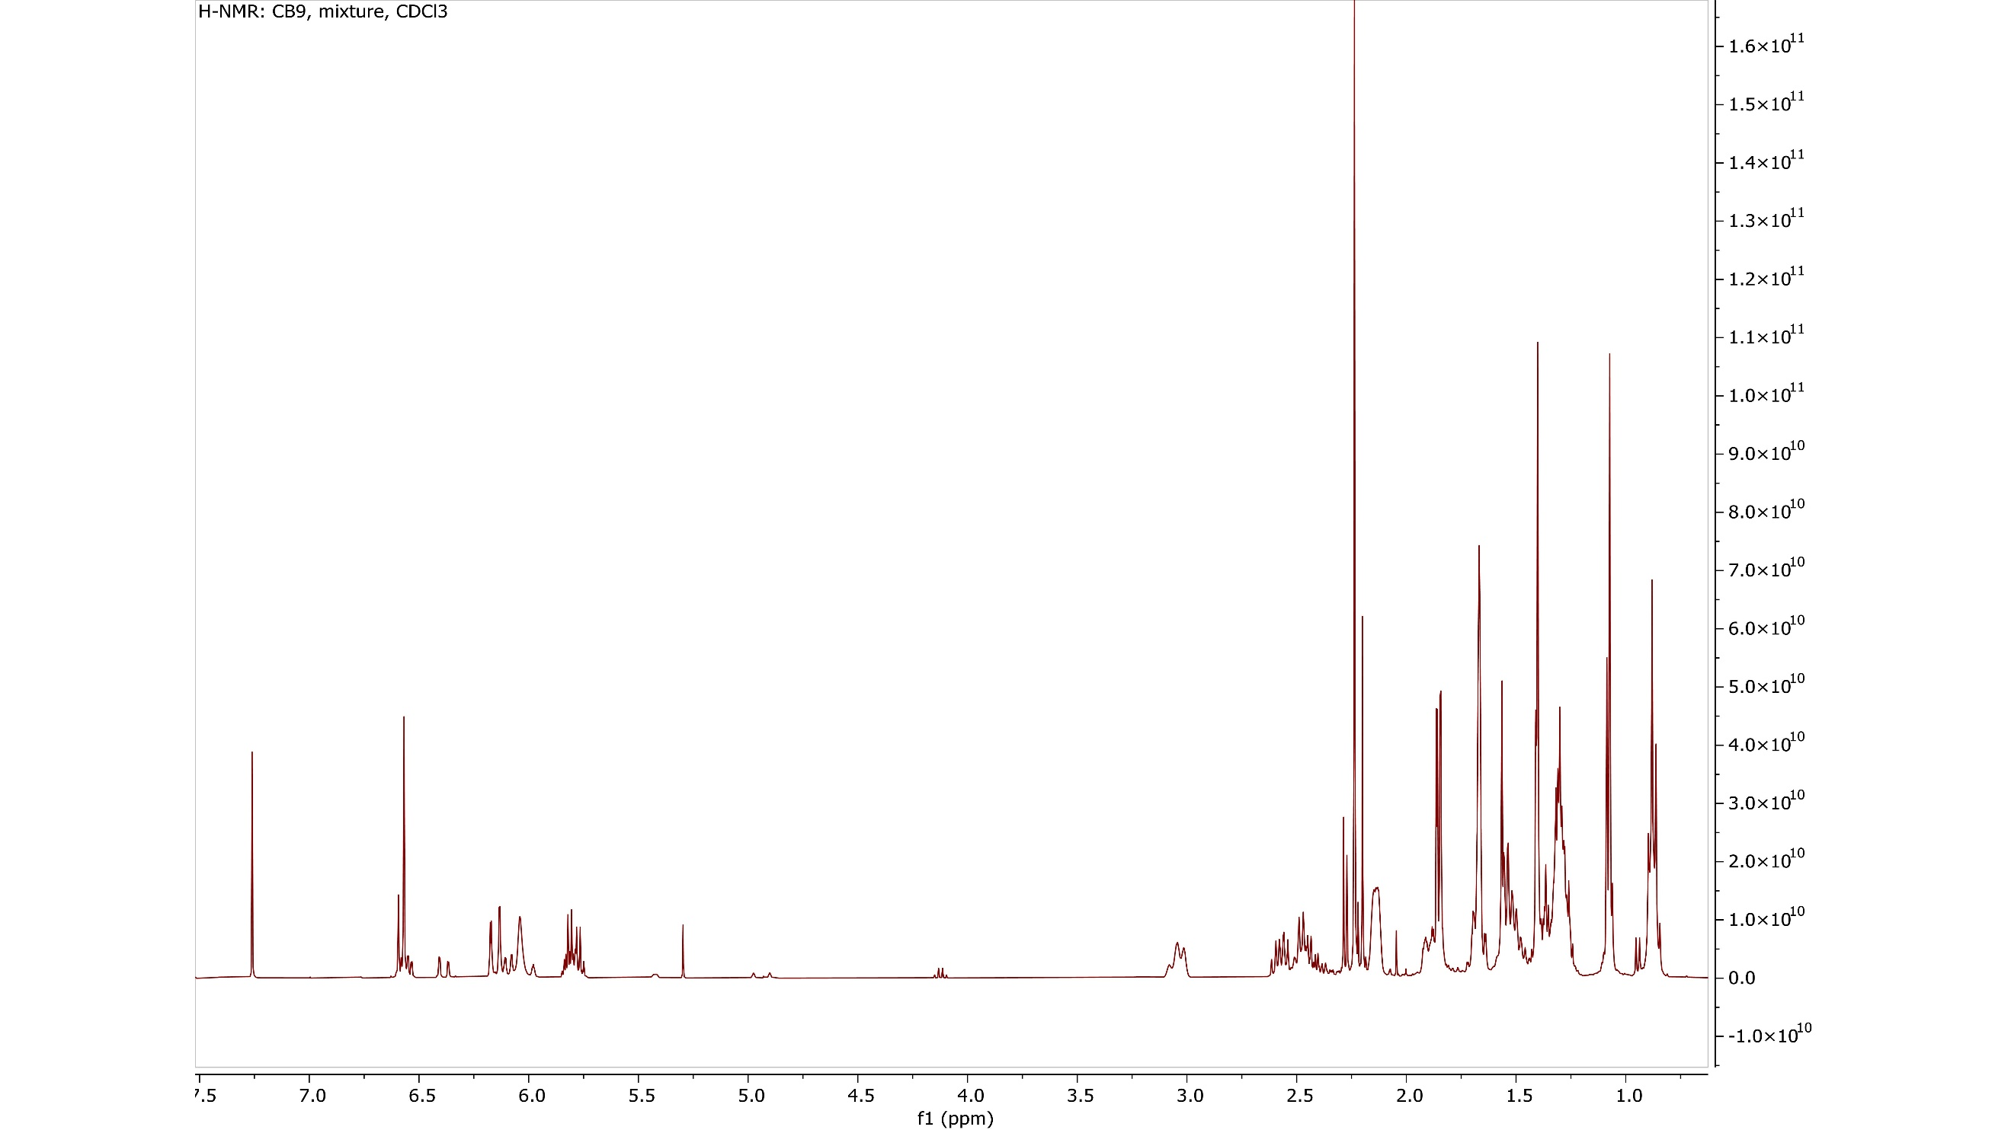
Figure S7: ¹H NMR spectra of “CB9” mixture, in CDCl₃, 400 MHz.
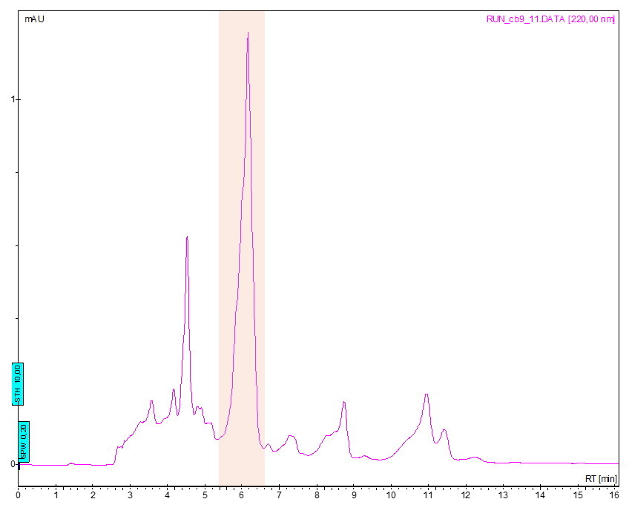
Figure S8: Preparative HPLC trace for the isolation of the major peak from the “CB9” mixture

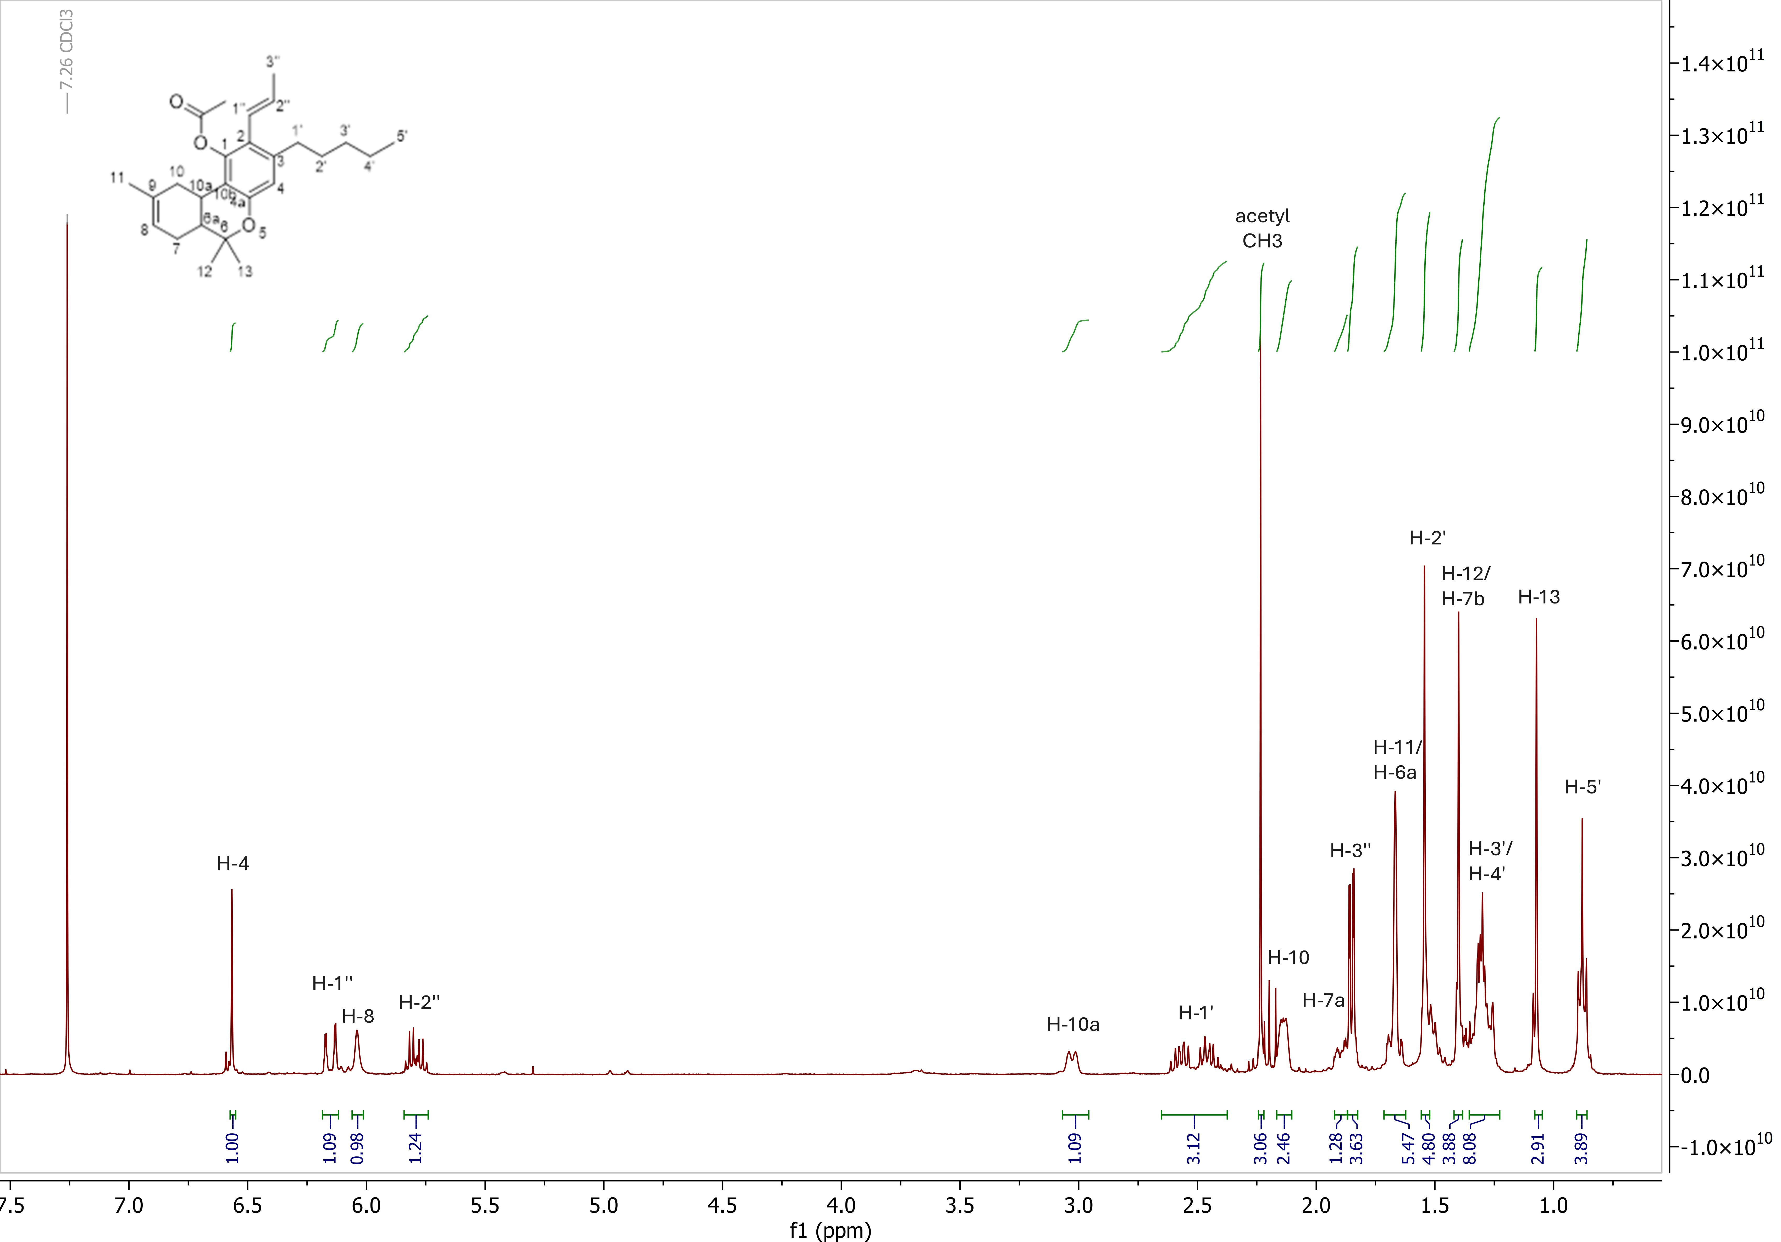

Figure S9: ¹H NMR spectra of "[2-(E)-propen-1-yl]-Δ⁸-tetrahydrocannabinol-acetate", in CDCl₃, 400 MHz.
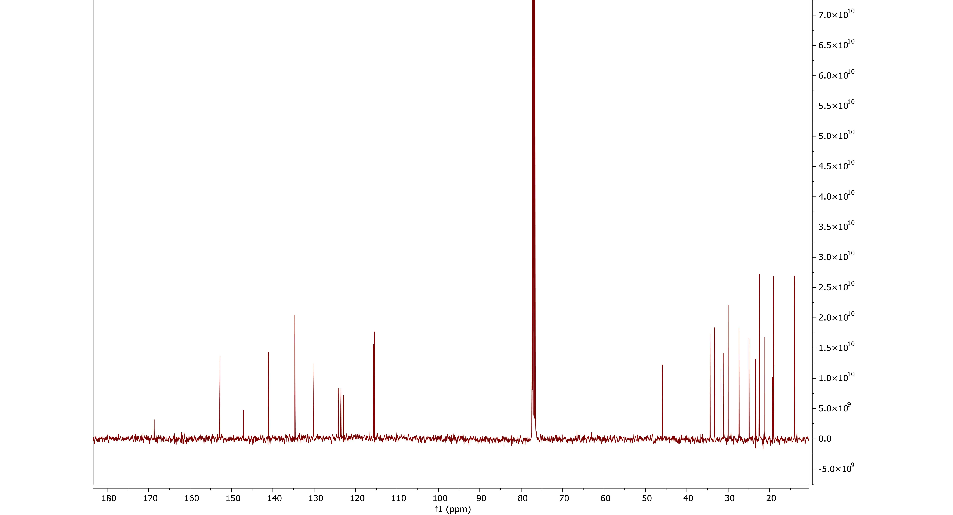

Figure S10: ¹³C NMR spectra of "[2-(E)-propen-1-yl]-Δ⁸-tetrahydrocannabinol-acetate", in CDCl₃, 100 MHz.

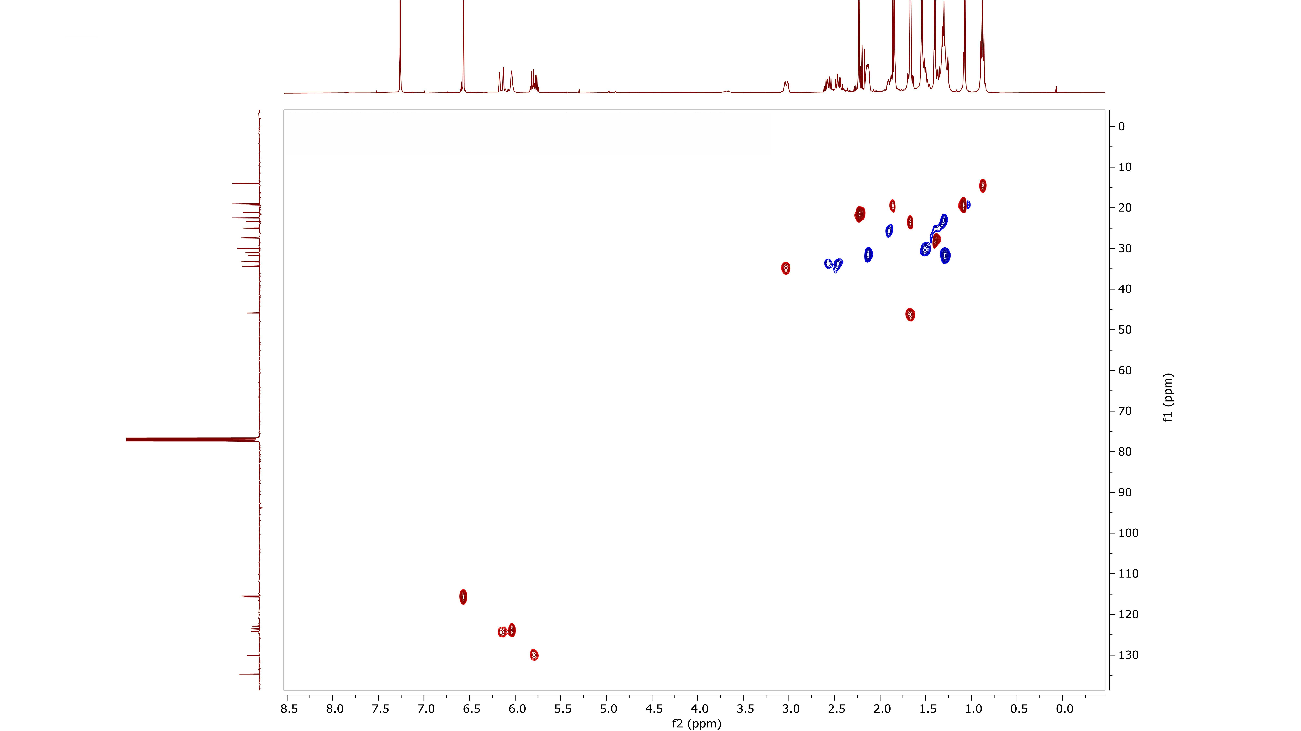

Figure S11:¹H-¹³C HSQC-DEPT NMR spectra of "[2-(E)-propen-1-yl]-Δ⁸-tetrahydrocannabinol-acetate", in CDCl₃.
.

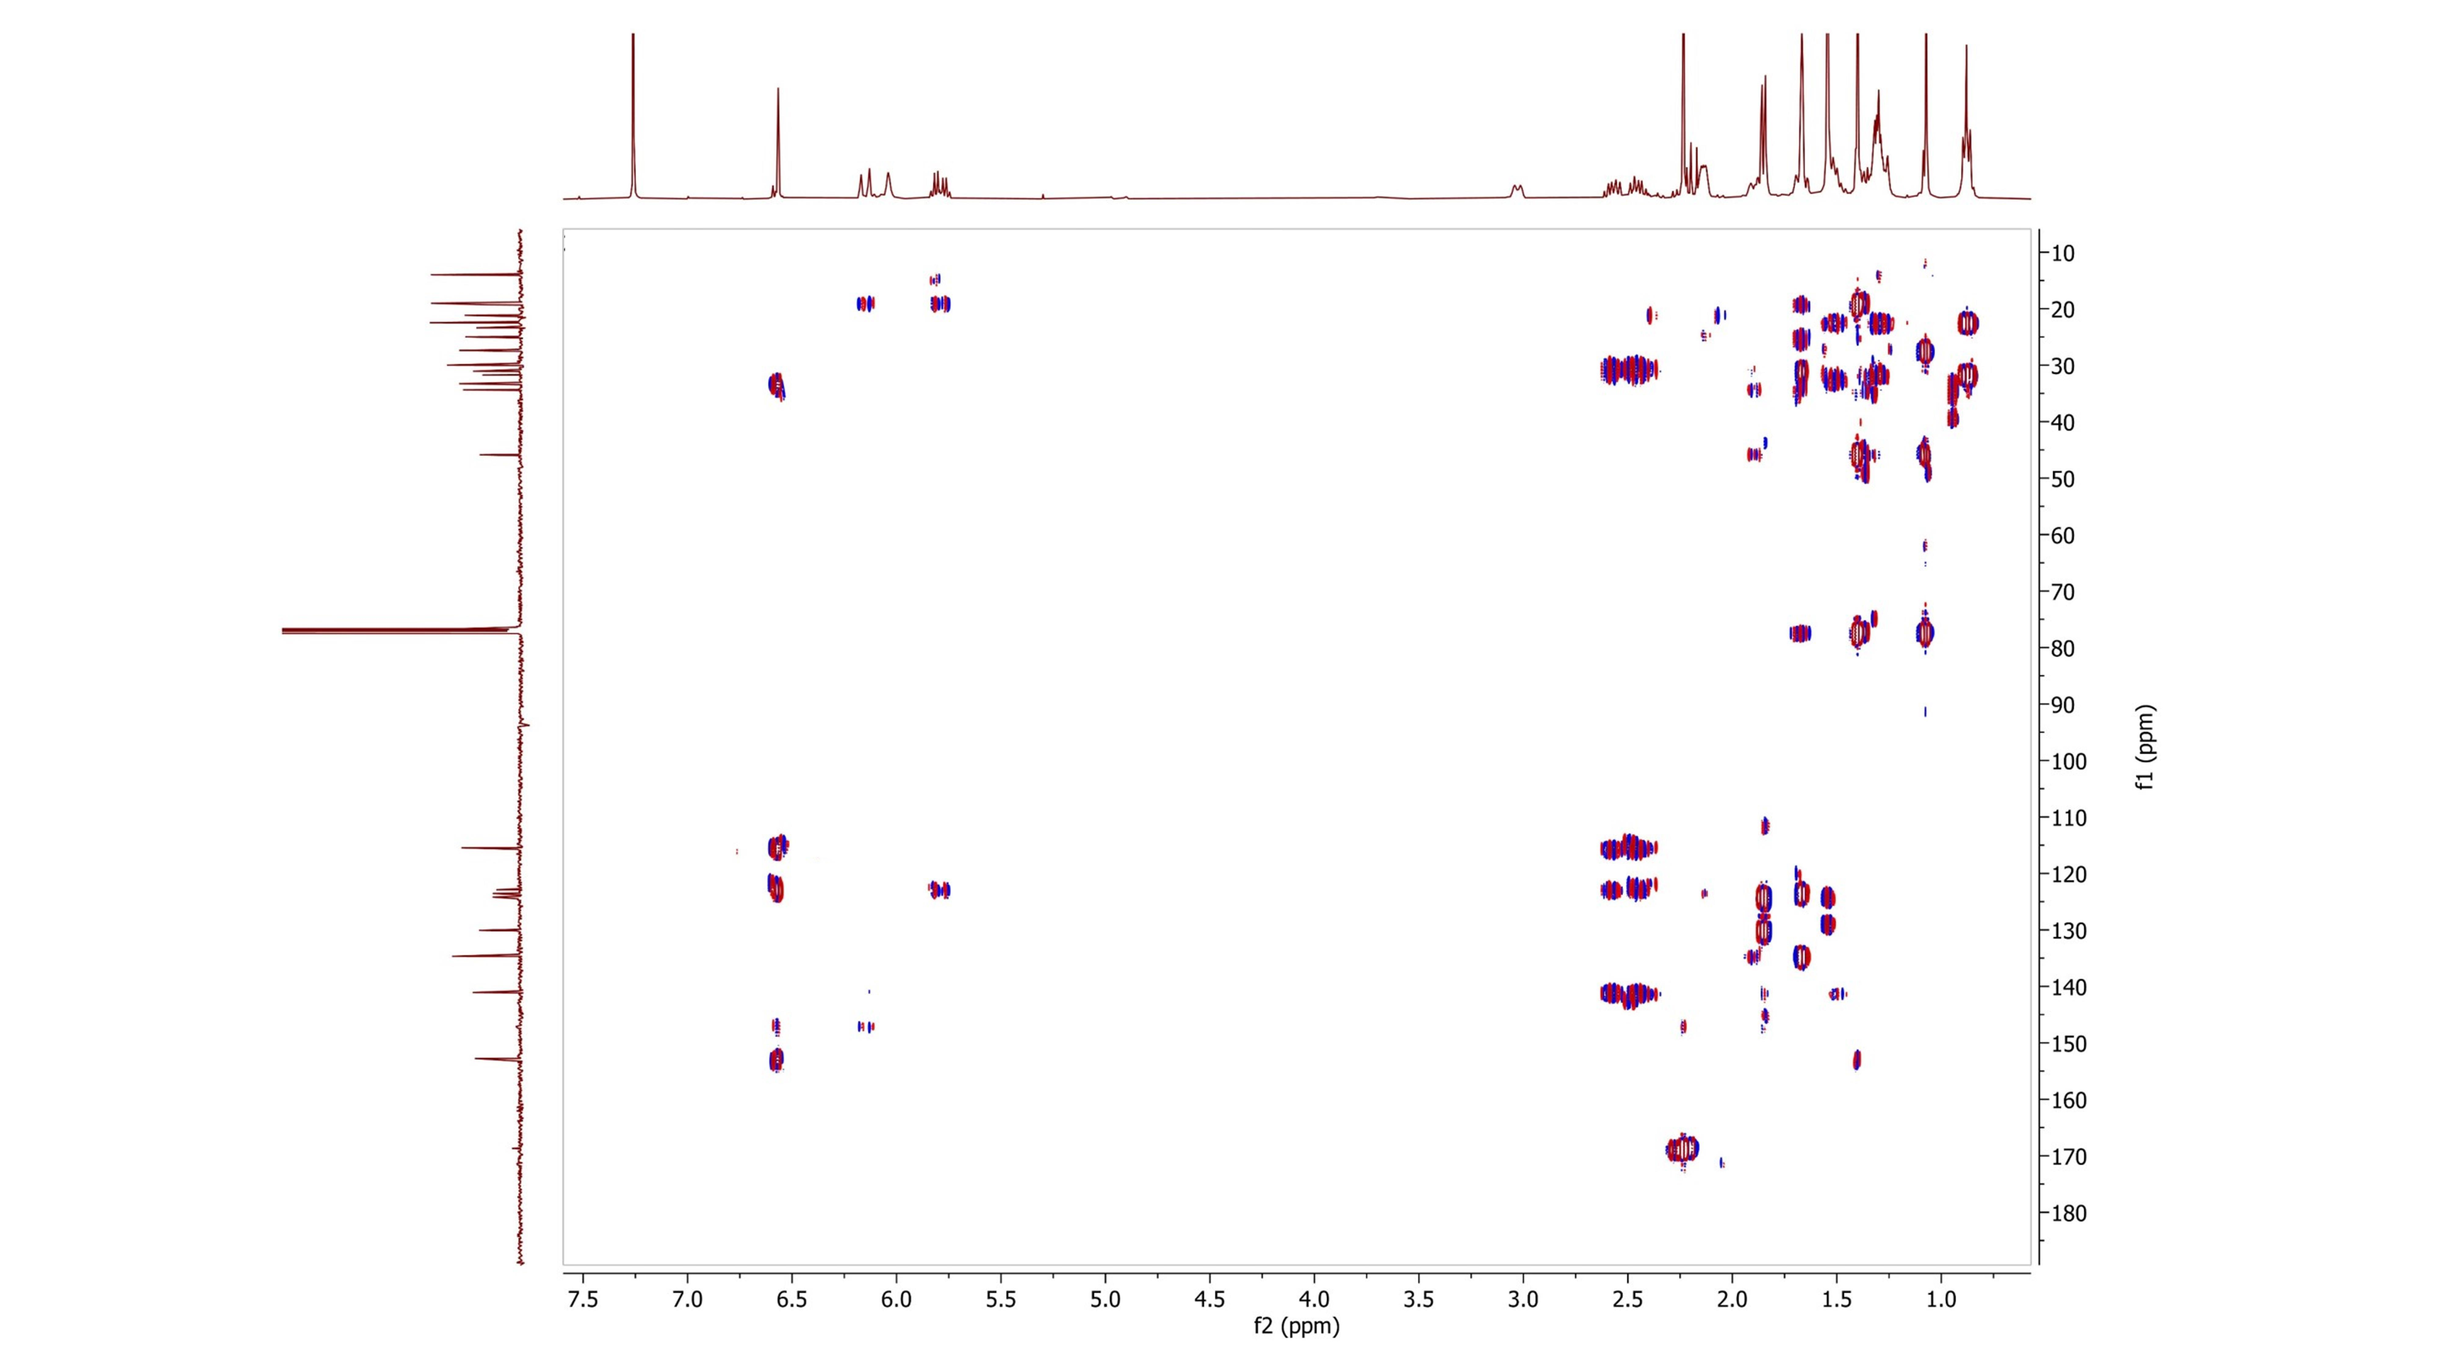

Figure S12: ¹H-¹³C HMBC NMR spectra of "[2-(E)-propen-1-yl]-Δ⁸-tetrahydrocannabinol-acetate", in CDCl₃.

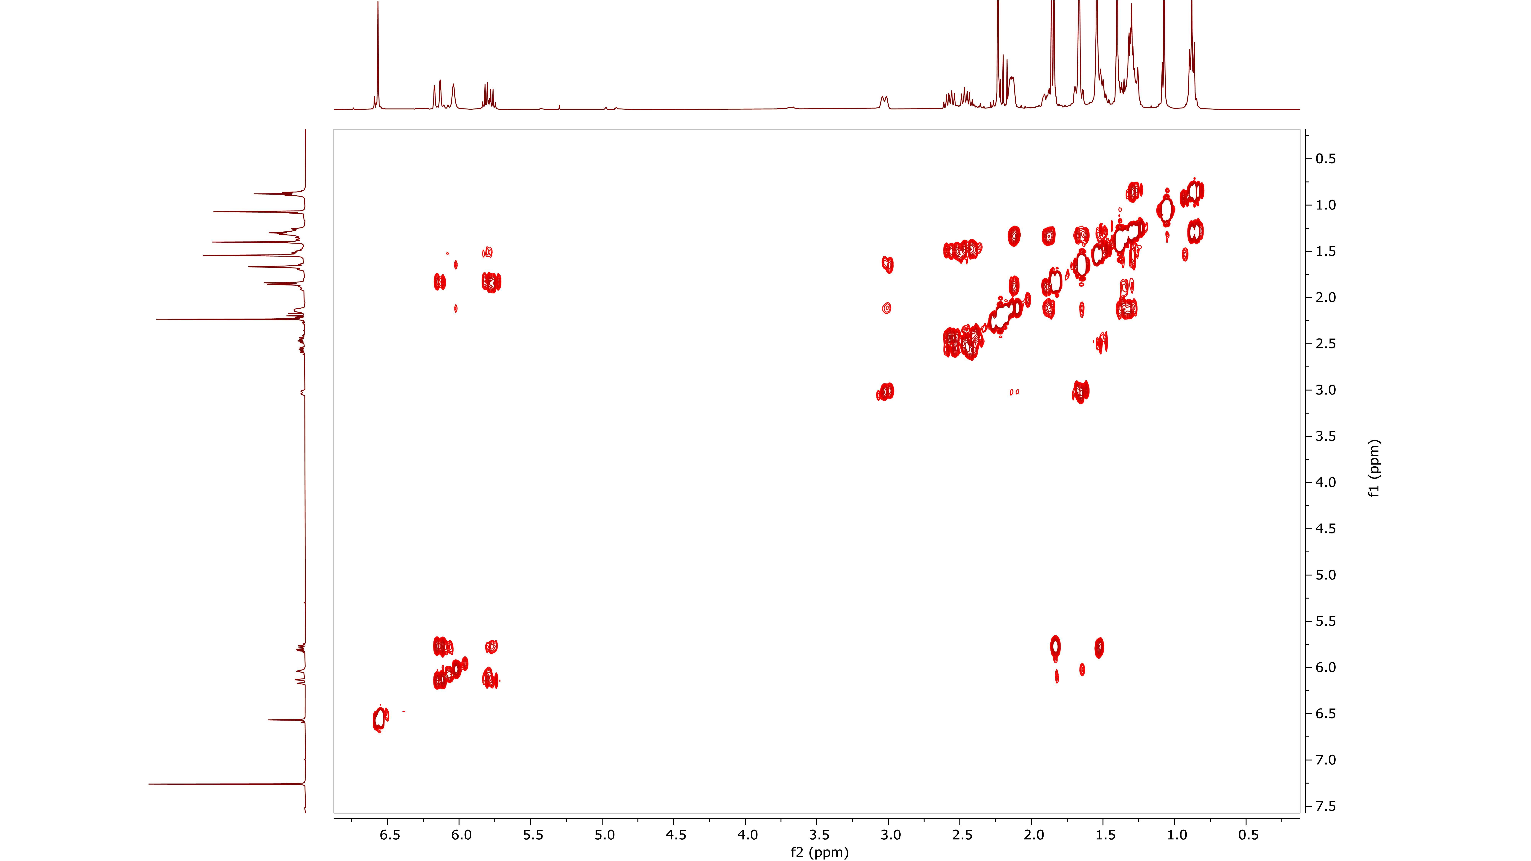

Figure S13: ¹H- ¹H COSY spectra of "[2-(E)-propen-1-yl]-Δ8-tetrahydrocannabinol-acetate", in CDCl_{3.}

Figure S14: Structure of "[2-(E)-propen-1-yl]-Δ⁸-tetrahydrocannabinol-acetate".

“Tresconol” GC-MS and NMR analysis

Figure S15: GC-MS chromatogram of "tresconol" mixture (1).

Figure S16: GC-MS chromatogram of "tresconol" mixture (2).

Figure S17: EI mass spectra of “[2-propen-2-yl]-Δ⁹-tetrahydrocannabinol”, [M]^{.+}= 354.2.

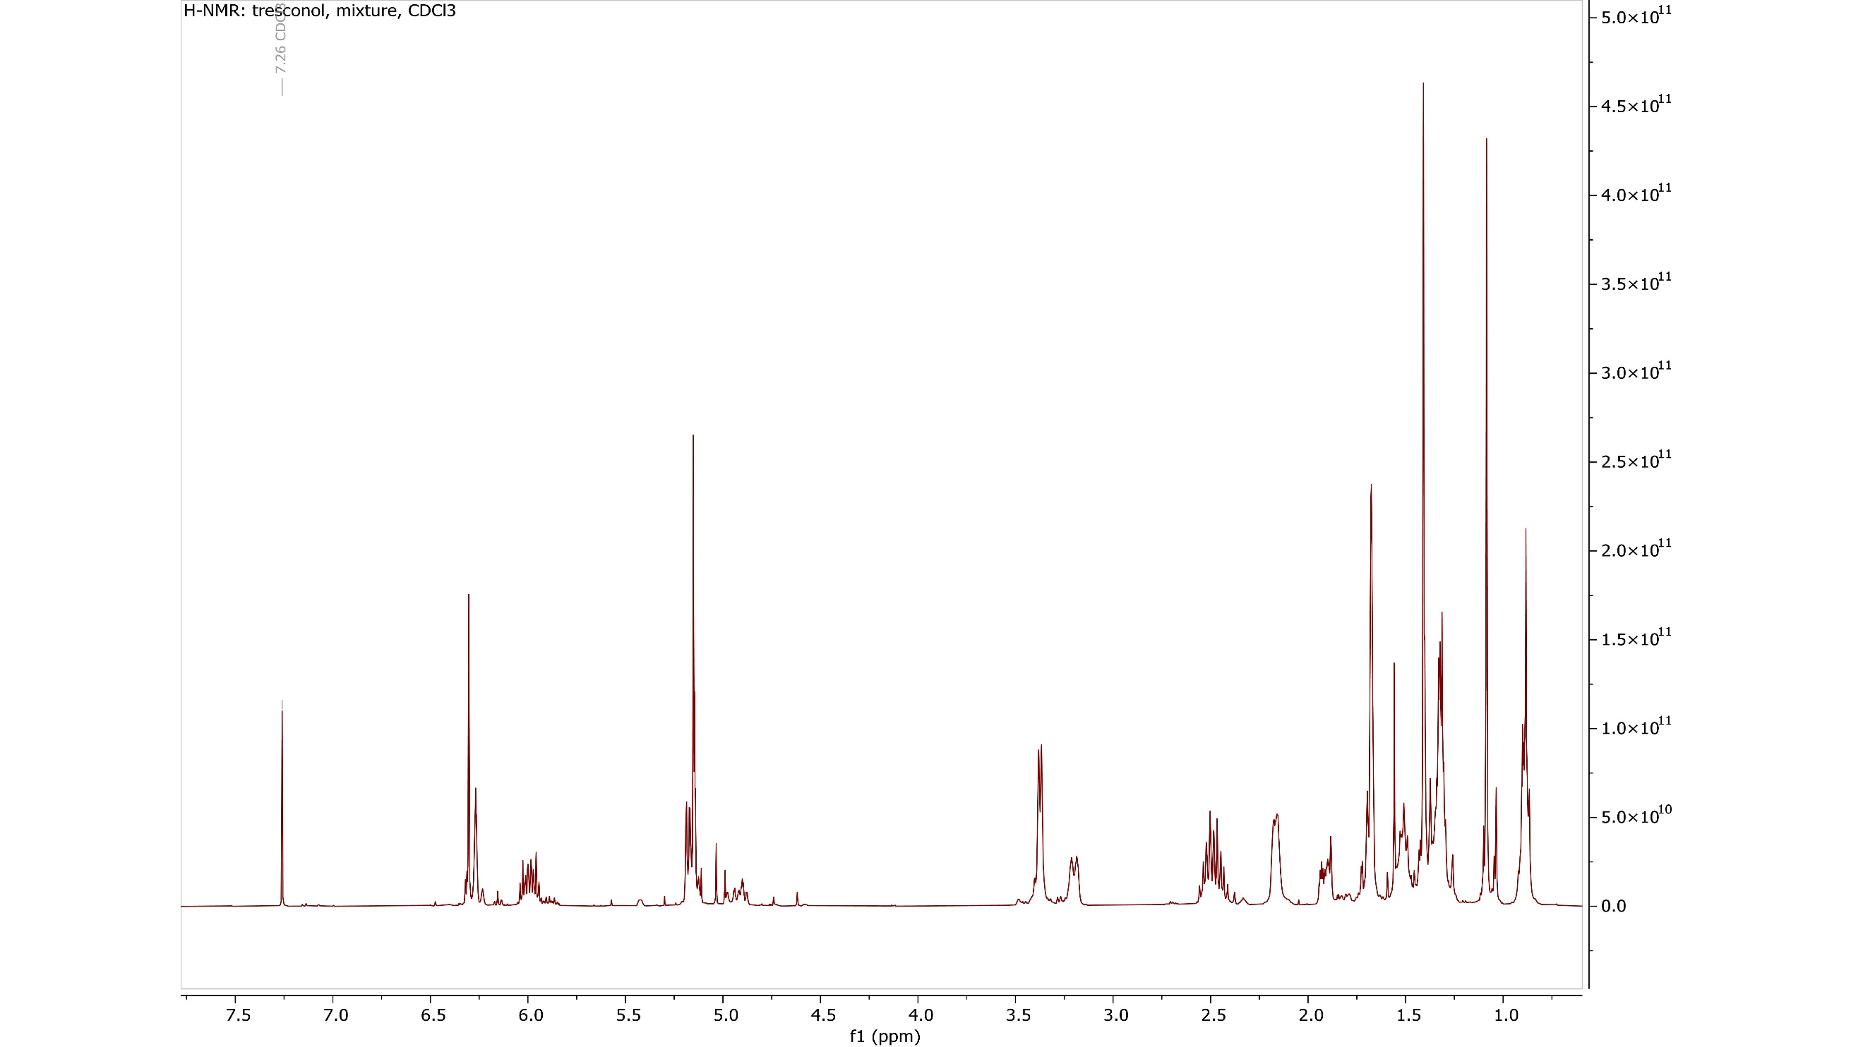
Figure S18: ¹H NMR spectra of "tresconol", in CDCl₃, 400 MHz.

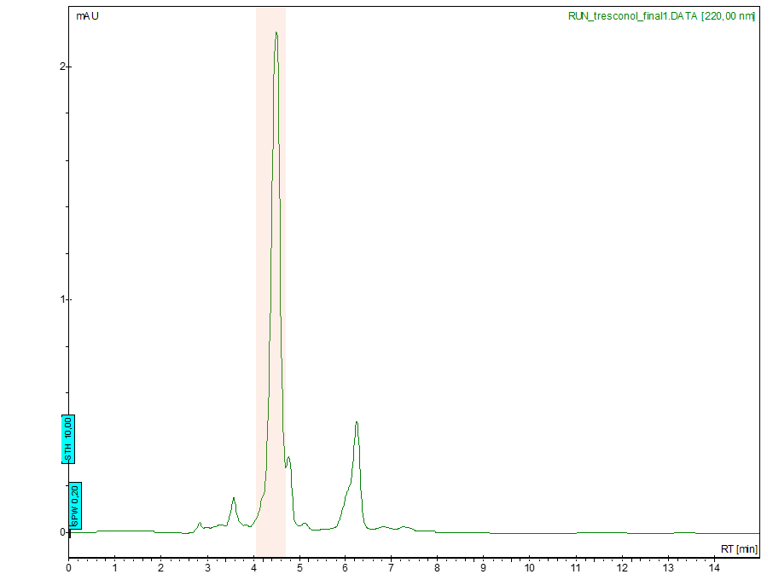
Figure S19: Preparative HPLC trace for the isolation of the major peak from the "tresconol" mixture.
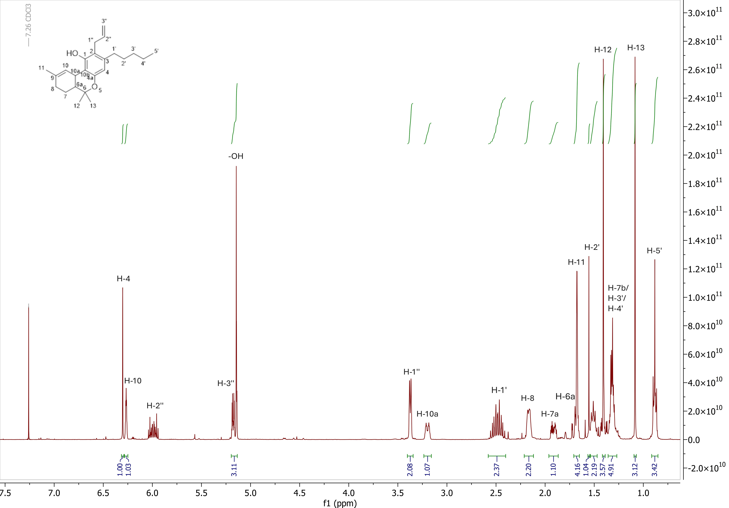

Figure S20: ¹H NMR spectra of "[2-propen-2-yl]-Δ⁹-tetrahydrocannabinol", in CDCl₃, 400 MHz.
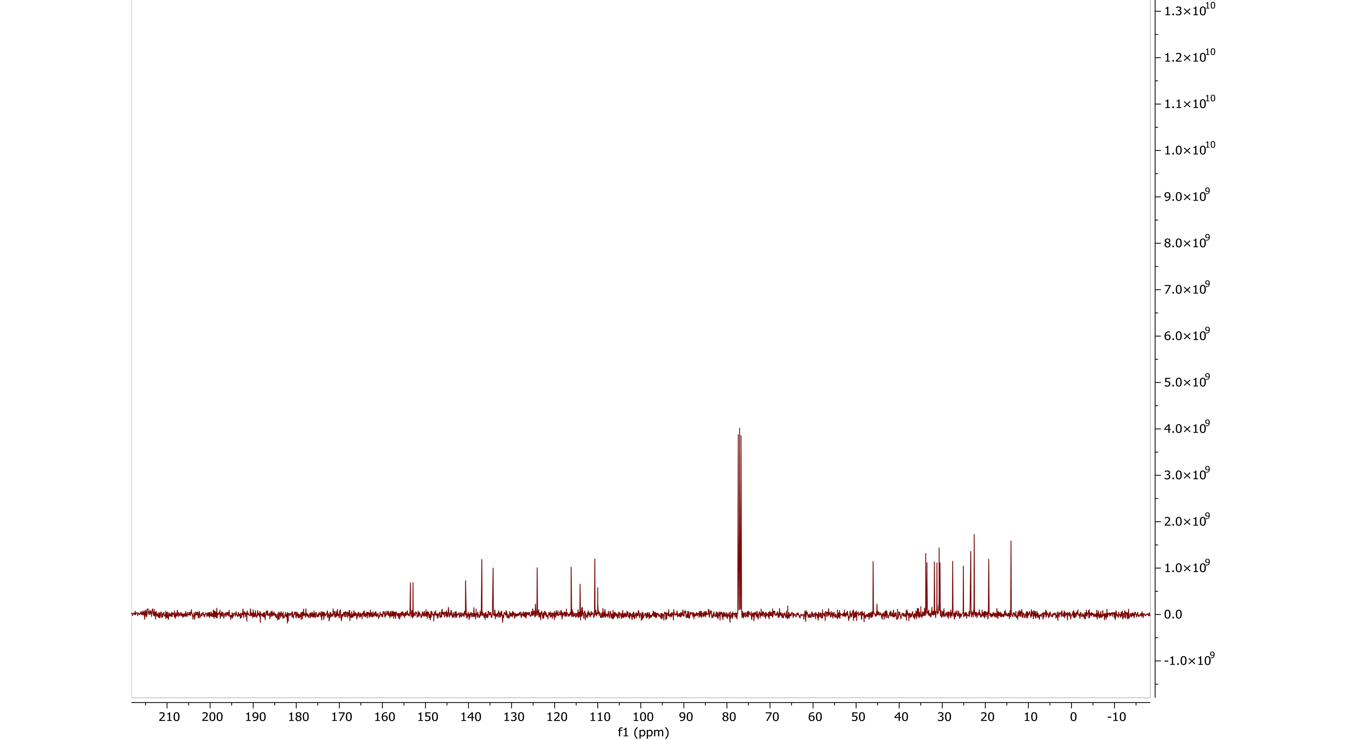

Figure S21: ¹³C NMR spectra of "[2-propen-2-yl]-Δ⁹-tetrahydrocannabinol", in CDCl₃, 100 MHz.
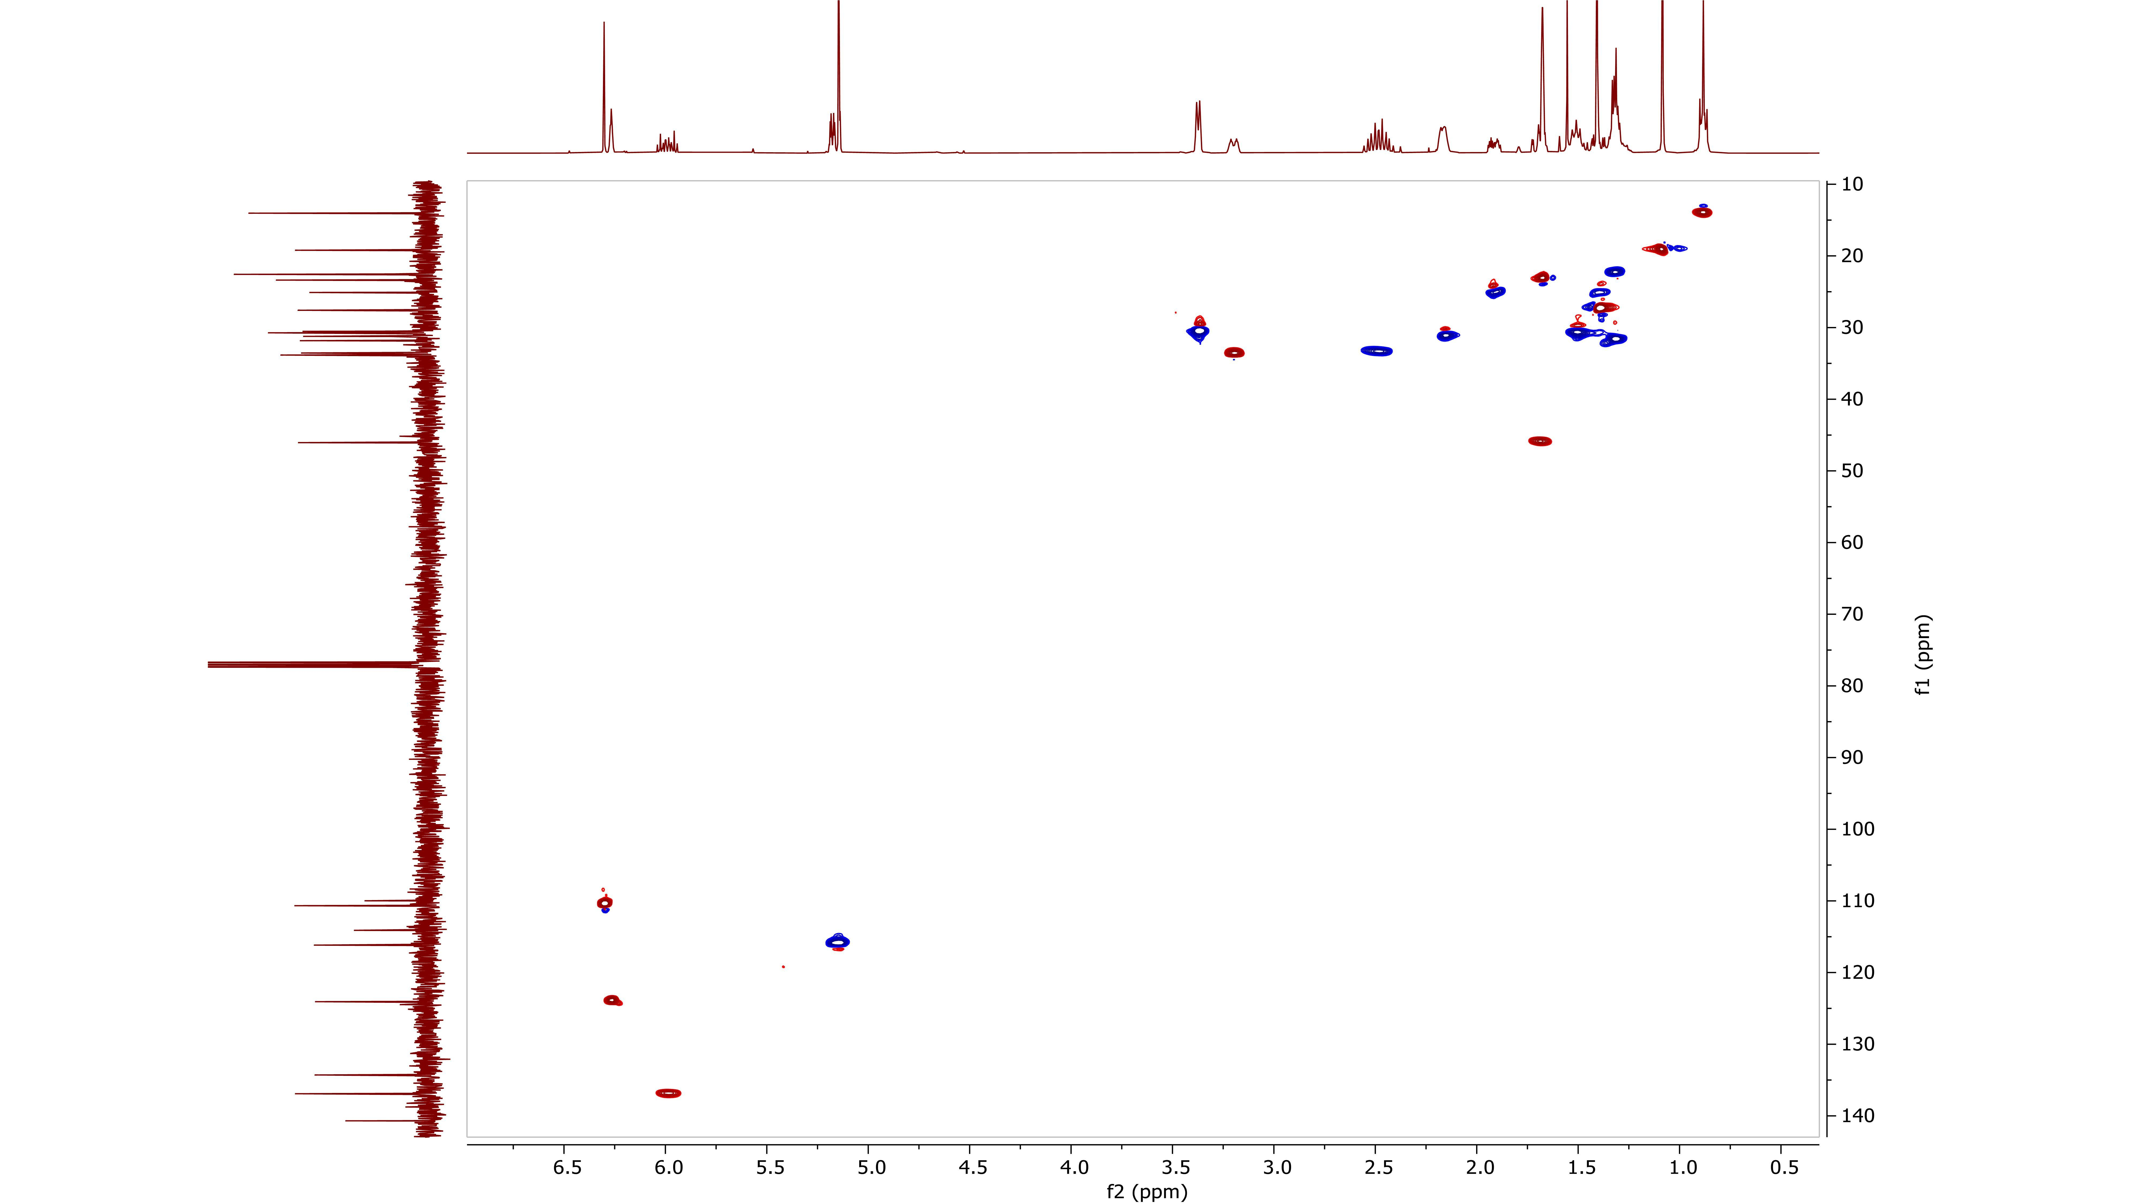

Figure S22: ¹H- ¹³C HMQC-DEPT NMR spectra of "[2-propen-2-yl]-Δ⁹-tetrahydrocannabinol", in CDCl₃.

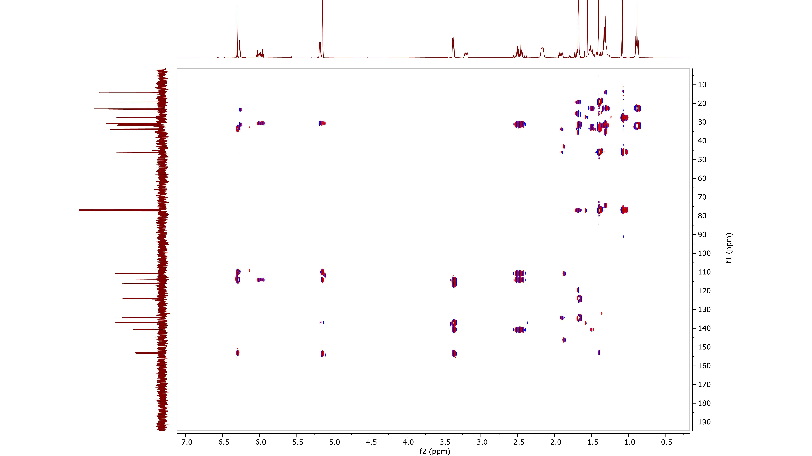

Figure S23: ¹H- ¹³C HMBC NMR spectra of "[2-propen-2-yl]-Δ⁹-tetrahydrocannabinol", in CDCl₃.
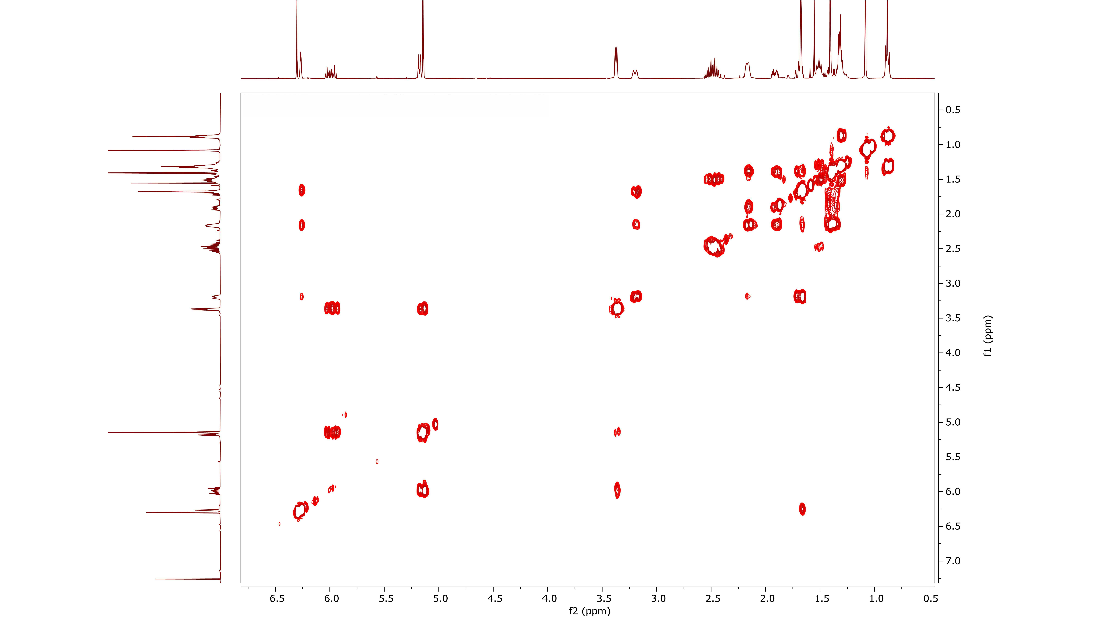

Figure S24: ¹H- ¹H COSY NMR spectra of "[2-propen-2-yl]-Δ⁹-tetrahydrocannabinol", in CDCl₃.

Figure S25: Structure of "[2-propen-2-yl]-Δ⁹-tetrahydrocannabinol".

“CBx” GC-MS and NMR analysis

Figure S26: GC-MS chromatogram of "CBx" mixture (1).

Figure S27: GC-MS chromatogram of "CBx" mixture (2).
Figure S28: EI mass spectra of “[2-propen-2-yl]-Δ⁸-tetrahydrocannabinol”, [M]⁺= 354.2.

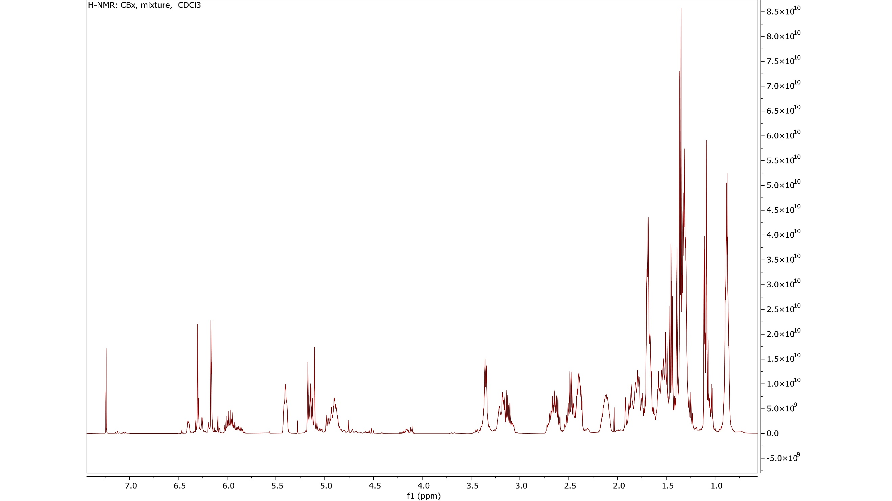
Figure S29: ¹H NMR spectra of "CBx", in CDCl₃, 400 MHz.

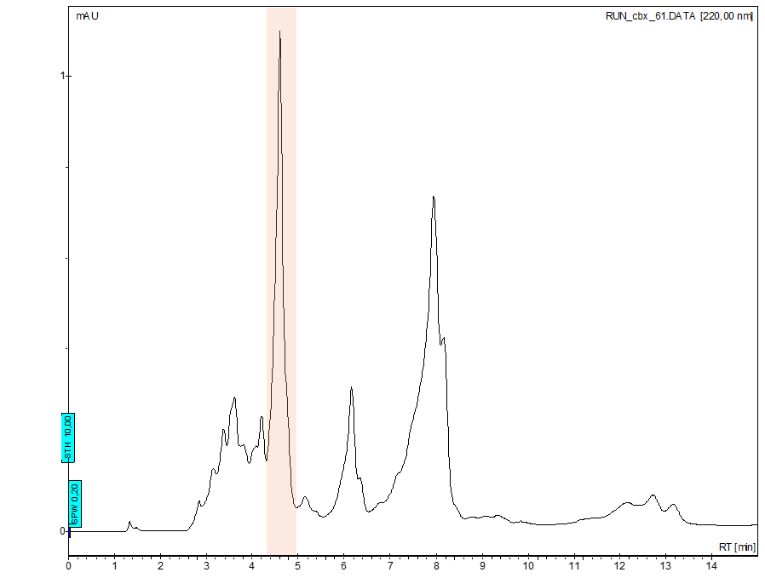
Figure 30: Preparative HPLC trace for the isolation of the major peak from the “CBx” mixture.

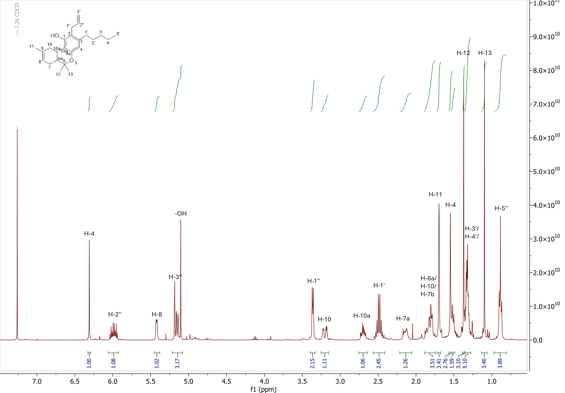

Figure S31: ¹H NMR spectra of "[2-propen-2-yl]-Δ⁸-tetrahydrocannabinol", in CDCl₃, 400 MHz.

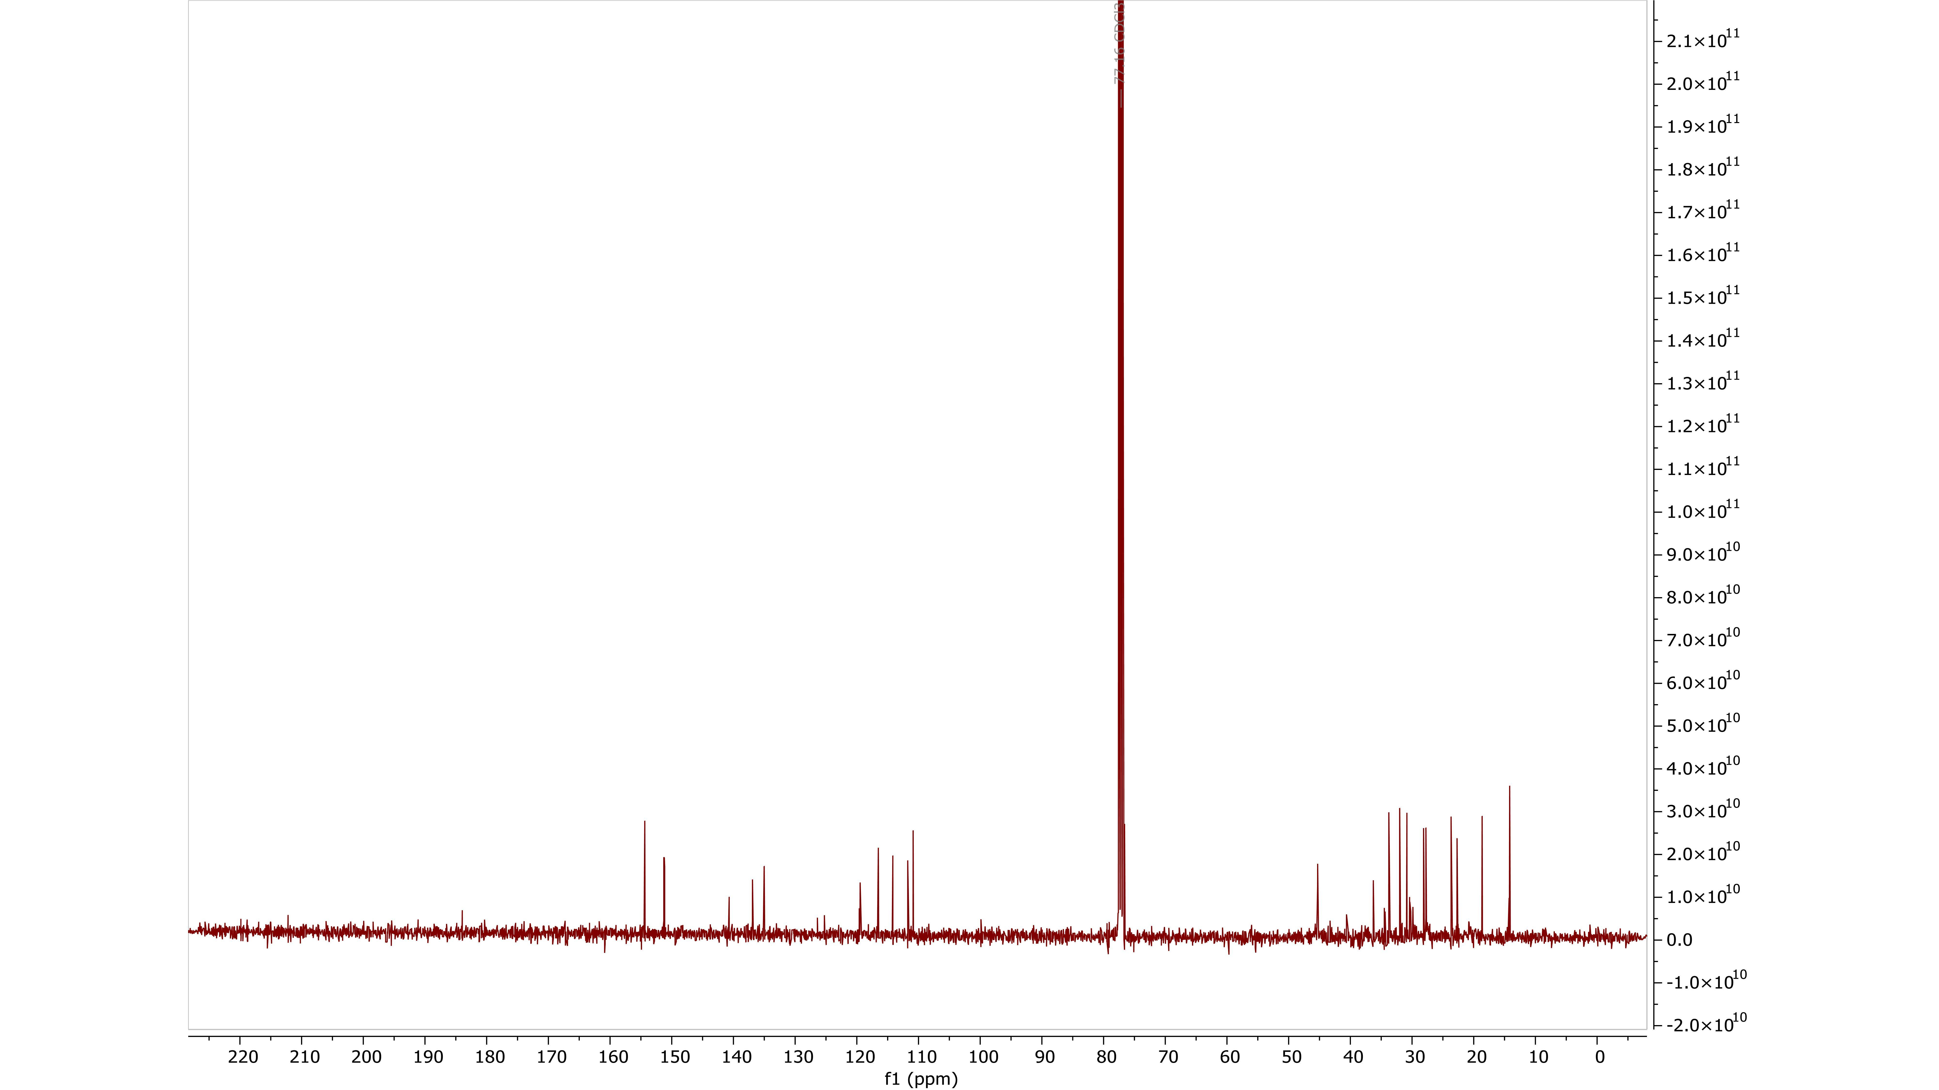

Figure S32: ¹³C NMR spectra of "[2-propen-2-yl]-Δ⁸-tetrahydrocannabinol", in CDCl₃, 100 MHz.
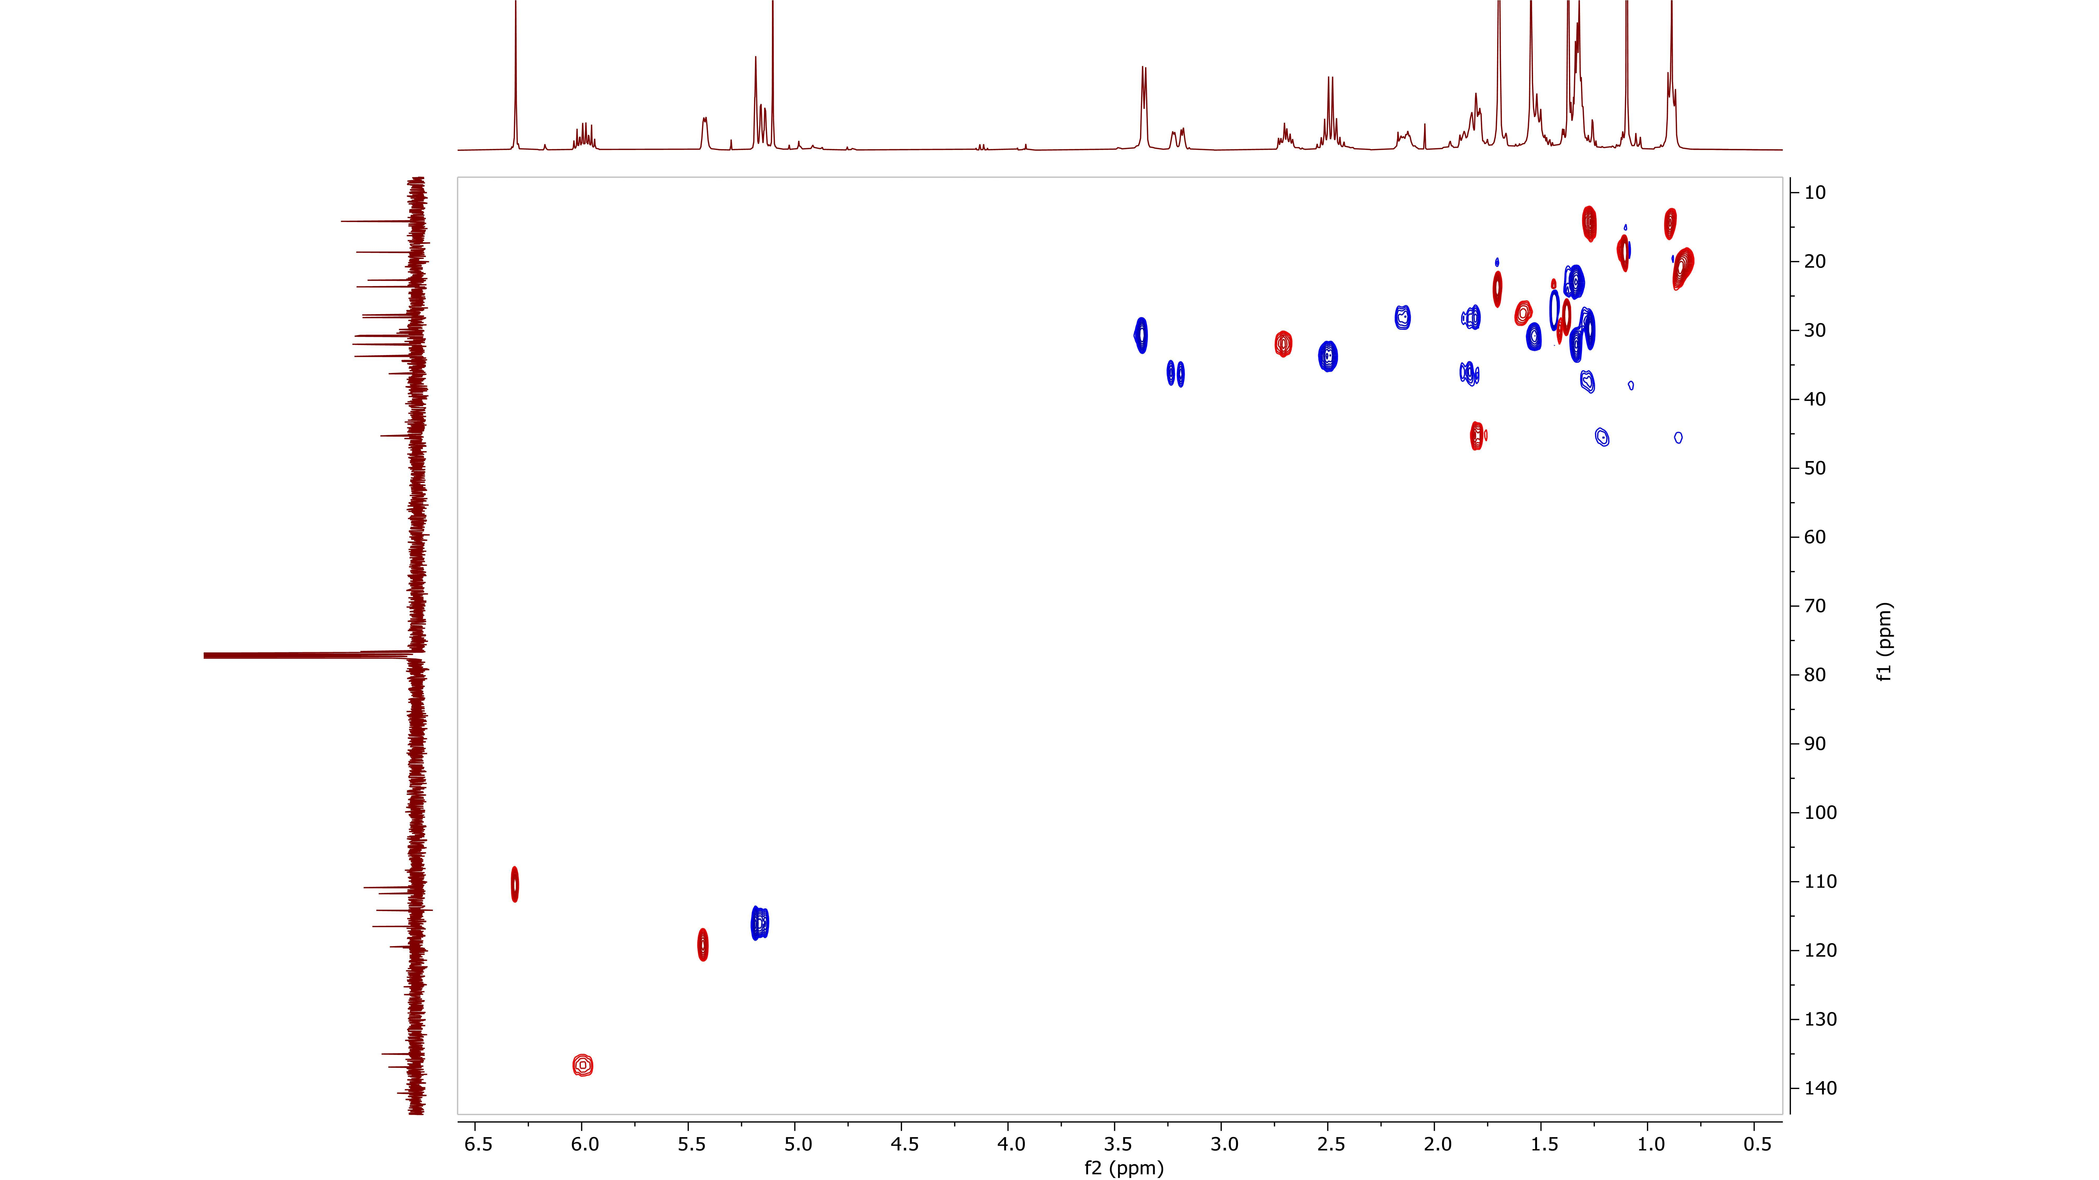

Figure S33: ¹H- ¹³C HMQC-DEPT NMR spectra of "[2-propen-2-yl]-Δ⁸-tetrahydrocannabinol", in CDCl₃.

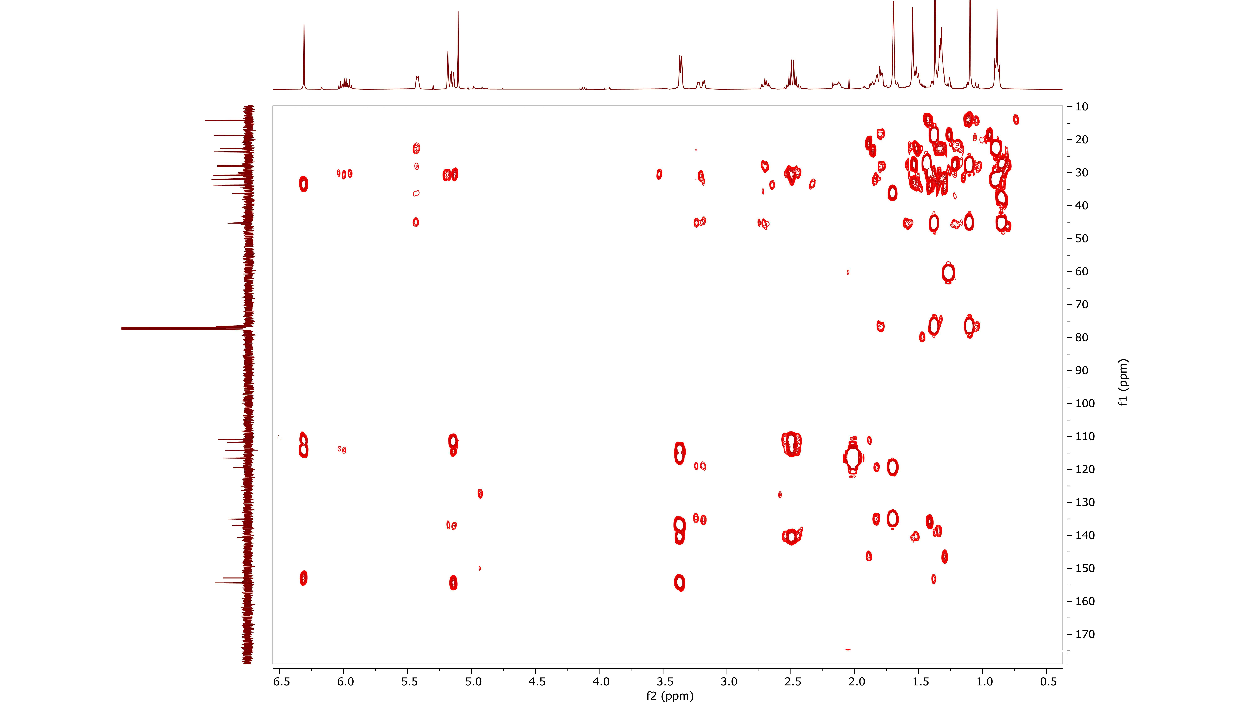

Figure S34: ¹H- ¹³C HMBC NMR spectra of "[2-propen-2-yl]-Δ⁸-tetrahydrocannabinol", in CDCl₃.

Figure S35: Structure of "[2-propen-2-yl]-Δ⁸-tetrahydrocannabinol".

Figure S36: Schematic representation of "[2-propen-2-yl]-Δ⁸-tetrahydrocannabinol" synthesis based on the patent EP0279308A2.

