Figure S1. Predicted probability of past 12-month cannabis use among those employed according to year of survey
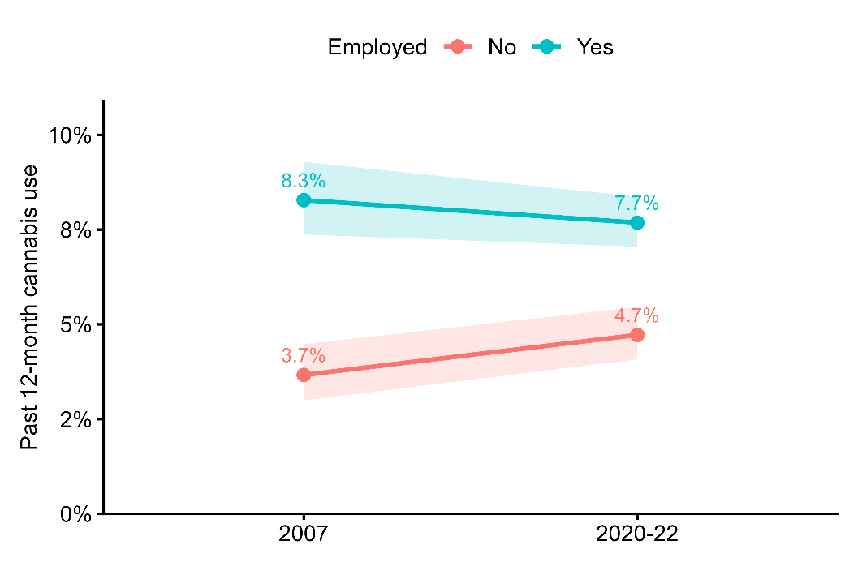
Figure S2. Predicted probability of past 12-month cannabis use disorder among those aged 16-25 years old according to year of survey
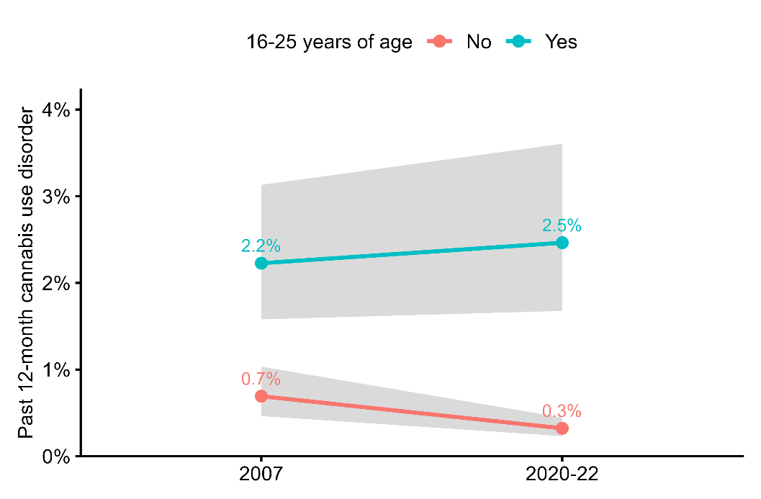
Figure S3. Predicted probability of past 12-month cannabis use disorder among those reporting school qualifications only according to year of survey
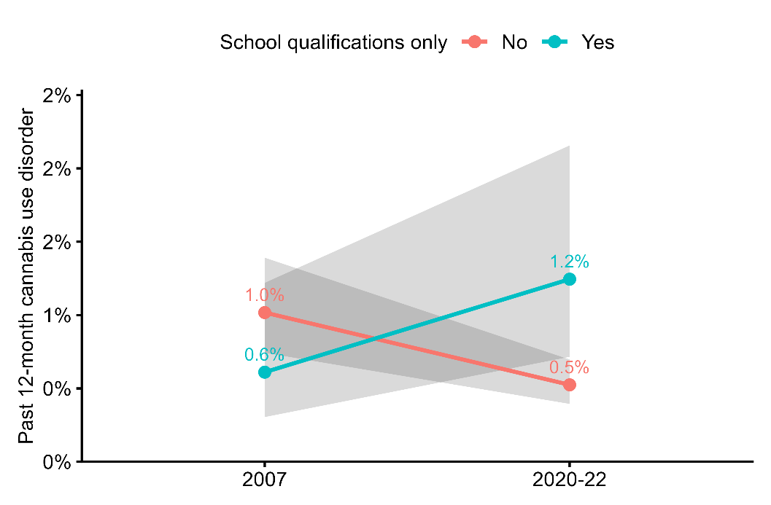
Figure S4. Predicted probability of past 12-month cannabis use among those reporting past 12-month tobacco use according to year of survey
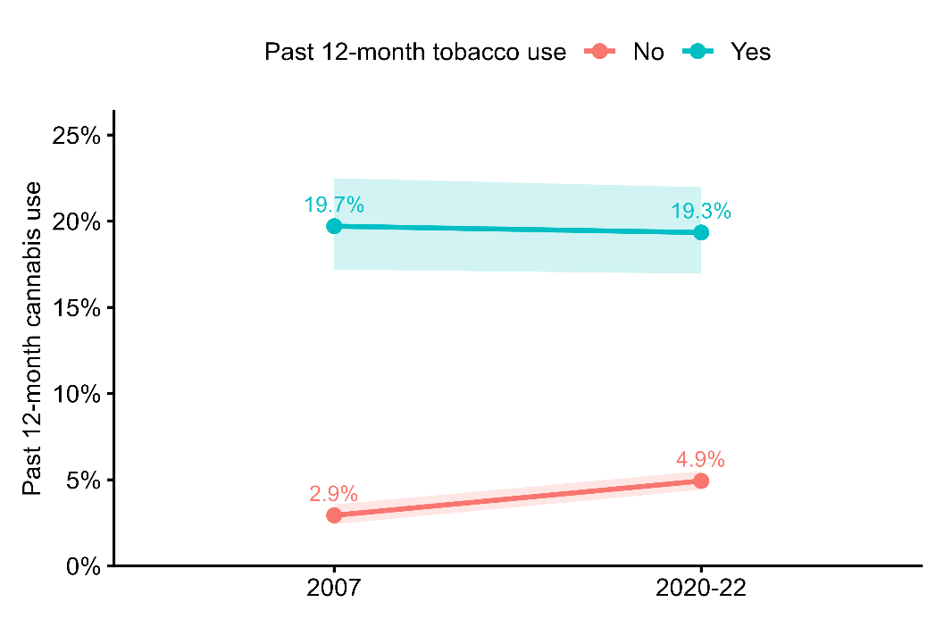

Figure S5. Predicted probability of past 12-month cannabis use disorder among those reporting past 12-month tobacco use according to year of survey
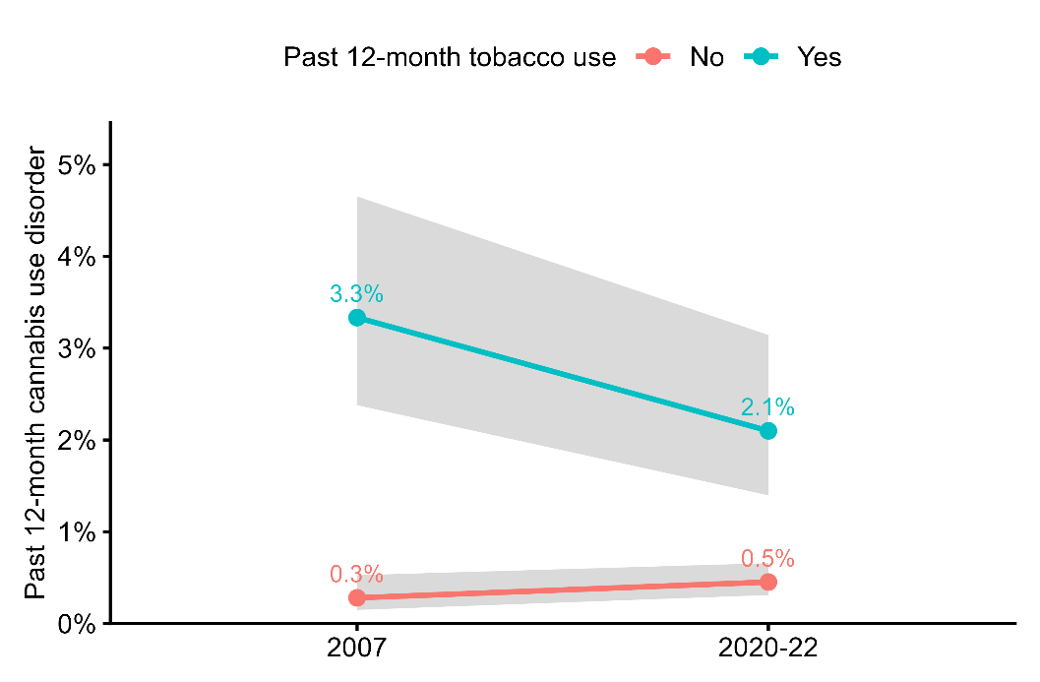
Figure S6. Predicted probability of past 12-month cannabis use disorder among those reporting past 12-month other substance use (sedatives, stimulants, or opioids) according to year of survey
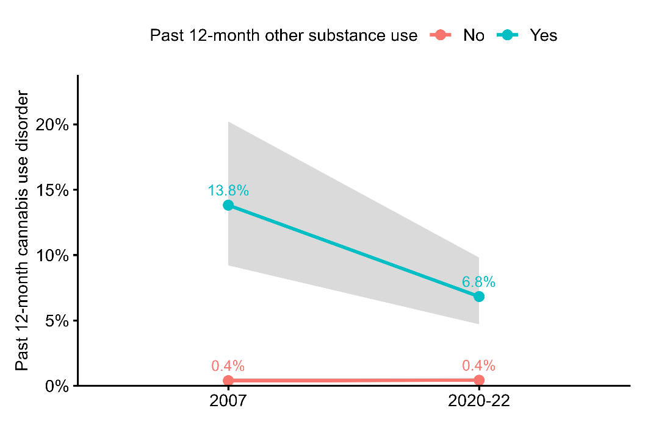

Figure S7. Predicted probability of past 12-month cannabis use among those reporting a past 12-month visit to a general practitioner according to year of survey

