SUPPLEMENTARY MATERIAL FOR “CHANGES IN DRUG-INDUCED HOSPITALISATIONS AND DEATHS FOLLOWING THE ONSET OF THE COVID-19 PANDEMIC IN AUSTRALIA”

Appendix A. STROBE Checklist 2
Appendix B. ICD Codes 5
Appendix C. Statistical tests and plots for assumptions of the ARIMA models 9
Appendix D. Results using the shorter time series from 1st July 2016 to 30th April 2021, with and without adjusting for all-cause hospitalisation rates 23

Appendix A. STROBE Checklist
STROBE Statement—Checklist of items that should be included in reports of cross-sectional studies
 | Item No | Recommendation | Complete
Title and abstract | 1 | (a) Indicate the study’s design with a commonly used term in the title or the abstract | ü
Title and abstract | 1 | (b) Provide in the abstract an informative and balanced summary of what was done and what was found | ü
Introduction
Background/rationale | 2 | Explain the scientific background and rationale for the investigation being reported | ü
Objectives | 3 | State specific objectives, including any prespecified hypotheses | ü
Methods
Study design | 4 | Present key elements of study design early in the paper | ü
Setting | 5 | Describe the setting, locations, and relevant dates, including periods of recruitment, exposure, follow-up, and data collection | ü
Participants | 6 | (a) Give the eligibility criteria, and the sources and methods of selection of participants | ü
Variables | 7 | Clearly define all outcomes, exposures, predictors, potential confounders, and effect modifiers. Give diagnostic criteria, if applicable | ü
Data sources/ measurement | 8* | For each variable of interest, give sources of data and details of methods of assessment (measurement). Describe comparability of assessment methods if there is more than one group | ü
Bias | 9 | Describe any efforts to address potential sources of bias | ü
Study size | 10 | Explain how the study size was arrived at | N.A. (given secondary data sources)
Quantitative variables | 11 | Explain how quantitative variables were handled in the analyses. If applicable, describe which groupings were chosen and why | ü
Statistical methods | 12 | (a) Describe all statistical methods, including those used to control for confounding | ü
Statistical methods | 12 | (b) Describe any methods used to examine subgroups and interactions | N.A.
Statistical methods | 12 | (c) Explain how missing data were addressed | N.A.
Statistical methods | 12 | (d) If applicable, describe analytical methods taking account of sampling strategy | ü
Statistical methods | 12 | (e) Describe any sensitivity analyses | ü
Results
Participants | 13* | (a) Report numbers of individuals at each stage of study—eg numbers potentially eligible, examined for eligibility, confirmed eligible, included in the study, completing follow-up, and analysed | ü
Participants | 13* | (b) Give reasons for non-participation at each stage | N.A.
Participants | 13* | (c) Consider use of a flow diagram | N.A.
Descriptive data | 14* | (a) Give characteristics of study participants (eg demographic, clinical, social) and information on exposures and potential confounders | ü
Descriptive data | 14* | (b) Indicate number of participants with missing data for each variable of interest | N.A.
Outcome data | 15* | Report numbers of outcome events or summary measures | ü
Main results | 16 | (a) Give unadjusted estimates and, if applicable, confounder-adjusted estimates and their precision (eg, 95% confidence interval). Make clear which confounders were adjusted for and why they were included | ü
Main results | 16 | (b) Report category boundaries when continuous variables were categorized | N.A.
Main results | 16 | (c) If relevant, consider translating estimates of relative risk into absolute risk for a meaningful time period | N.A.
Other analyses | 17 | Report other analyses done—eg analyses of subgroups and interactions, and sensitivity analyses | ü
Discussion
Key results | 18 | Summarise key results with reference to study objectives | ü
Limitations | 19 | Discuss limitations of the study, taking into account sources of potential bias or imprecision. Discuss both direction and magnitude of any potential bias | ü
Interpretation | 20 | Give a cautious overall interpretation of results considering objectives, limitations, multiplicity of analyses, results from similar studies, and other relevant evidence | ü
Generalisability | 21 | Discuss the generalisability (external validity) of the study results | ü
Other information
Funding | 22 | Give the source of funding and the role of the funders for the present study and, if applicable, for the original study on which the present article is based | ü

Appendix B. ICD Codes
NHMD: Hospitalisations for which the care type was reported as 'Newborn without qualified days’, and records for ‘Posthumous organ procurement’ and 'Hospital boarders’ were not provided.

Table B1. ICD-10-AM codes in principal diagnosis to identify drug-induced hospitalisations
ICD-10-AM code | Description
F11 | Mental and behavioural disorders due to use of opioids
F12 | Mental and behavioural disorders due to use of cannabinoids
F13 | Mental and behavioural disorders due to use of sedatives or hypnotics
F14 | Mental and behavioural disorders due to use of cocaine
F15 | Mental and behavioural disorders due to use of other stimulants, including caffeine
F16 | Mental and behavioural disorders due to use of hallucinogens
F18 | Mental and behavioural disorders due to use of volatile solvents
F19 | Mental and behavioural disorders due to multiple drug use and use of other psychoactive substances
F55.0 | Harmful use of nondependence-producing substance, antidepressants
F55.2 | Harmful use of nondependence-producing substance, analgesics
N14.0 | Drug- and heavy-metal-induced tubulo-interstitial and tubular conditions: Analgesic nephropathy
T39.0–T39.9 | Poisoning by nonopioid analgesics, antipyretics and antirheumatics
T40.0-T40.9 | Poisoning by narcotics and psychodysleptics [hallucinogens]
T41.2 | Poisoning by anaesthetics and therapeutic gases: Other and unspecified general anaesthetics
T42.0–T42.8 | Poisoning by antiepileptic, sedative-hypnotic and antiparkinsonism drugs
T43.0-T43.6 | Poisoning by (specified) psychotropic drugs,
T52.0–T52.9 | Toxic effect of organic solvents
T53.0–T53.9 | Toxic effect of halogen derivatives of aliphatic and aromatic hydrocarbons
T59.0, T59.8 | Toxic effect of other gases, fumes and vapours: Nitrogen oxides and Other specified gases, fumes and vapours

Table B2. ICD-10 codes for underlying causes of death to identify drug-induced mortality
ICD-10 codes | Description
D52.1 | Drug-induced folate deficiency anaemia
D59.0 | Drug-induced haemolytic anaemia
D59.2 | Drug-induced nonautoimmune haemolytic anaemia
D61.1 | Drug-induced aplastic anaemia
D64.2 | Secondary sideroblastic anaemia due to drugs and toxins
E06.4 | Drug-induced thyroiditis
E16.0 | Drug-induced hypoglycaemia without coma
E23.1 | Drug-induced hypopituitarism
E24.2 | Drug-induced Cushing’s syndrome
E27.3 | Drug-induced adrenocortical insufficiency
E66.1 | Drug-induced obesity
F11.0-F11.5 | Use of opioids causing intoxication harmful use (abuse) dependence withdrawal or psychosis
F11.7-F11.9 | Use of opioid causing late onset psychosis other mental and behavioural disorders and unspecified behavioural disorders
F12.0-F12.5 | Use of cannabis causing intoxication harmful use (abuse) dependence withdrawal or psychosis
F12.7-F12.9 | Use of cannabis causing late onset psychosis other mental and behavioural disorders and unspecified behavioural disorders.
F13.0-F13.5 | Use of sedative or hypnotics causing intoxication harmful use (abuse) dependence withdrawal or psychosis
F13.7-F13.9 | Use of sedative or hypnotics causing late onset psychosis other mental and behavioural disorders and unspecified behavioural disorders
F14.0-F14.5 | Use of cocaine causing intoxication harmful use (abuse) dependence withdrawal or psychosis
F14.7-F14.9 | Use of cocaine causing late onset psychosis other mental and behavioural disorders and unspecified behavioural disorders
F15.0-F15.5 | Use of caffeine causing intoxication harmful use (abuse) dependence withdrawal or psychosis
F15.7-F15.9 | Use of caffeine causing late onset psychosis other mental and behavioural disorders and unspecified behavioural disorders
F16.0-F16.5 | Use of hallucinogens causing intoxication harmful use (abuse) dependence withdrawal or psychosis
F16.7-F16.9 | Use of hallucinogens causing late onset psychosis other mental and behavioural disorders and unspecified behavioural disorders
F18.0-F18.5 | Use of volatile solvents causing intoxication harmful use (abuse) dependence withdrawal or psychosis
F18.7-F18.9 | Use of volatile solvents causing late onset psychosis other mental and behavioural disorders and unspecified behavioural disorders
F19.0-F19.5 | Use of multiple drugs and other psychoactive substances causing intoxication harmful use (abuse) dependence withdrawal or psychosis
F19.7-F19.9 | Use of multiple drugs and other psychoactive substances causing late onset psychosis other mental and behavioural disorders and unspecified behavioural disorders
G21.1 | Other drug-induced secondary Parkinsonism
G24.0 | Drug-induced dystonia
G25.1 | Drug-induced tremor
G25.4 | Drug-induced chorea
G25.6 | Drug-induced tics and other tics of organic origin
G44.4 | Drug-induced headache not elsewhere classified
G62.0 | Drug-induced polyneuropathy
G72.0 | Drug-induced myopathy
I95.2 | Hypotension due to drugs
J70.2 | Acute drug-induced interstitial lung disorders
J70.3 | Chronic drug-induced interstitial lung disorders
J70.4 | Drug-induced interstitial lung disorder unspecified
L10.5 | Drug-induced pemphigus
L27.0 | Generalized skin eruption due to drugs and medicaments
L27.1 | Localized skin eruption due to drugs and medicaments
M10.2 | Drug-induced gout
M32.0 | Drug-induced systemic lupus erythematosus
M80.4 | Drug-induced osteoporosis with pathological fracture
M81.4 | Drug-induced osteoporosis
M83.5 | Other drug-induced osteomalacia in adults
M87.1 | Osteonecrosis due to drugs
R78.1 | Finding of opiate drug in blood
R78.2 | Finding of cocaine in blood
R78.3 | Finding of hallucinogen in blood
R78.4 | Finding of other drugs of addictive potential in blood
R78.5 | Finding of psychotropic drug in blood
X40-X44 | Accidental poisoning by and exposure to drugs medicaments and biological substances
X60-X64 | Intentional self-poisoning (suicide) by and exposure to drugs medicaments and biological substances
X85 | Assault (homicide) by drugs medicaments and biological substances
Y10-Y14 | Poisoning by and exposure to drugs medicaments and biological substances undetermined intent

Drug-induced causes exclude accidents, homicides, and other causes indirectly related to drug use. Also excluded are newborn deaths associated with mother’s drug use.

Table B3. Drug groups and corresponding ICD-10-AM and ICD-10 codes used to identify the drug involved in drug-induced hospitalisations and deaths.
 |  | Hospitalisations with the selected ICD-10-AM codes in the principal diagnosis | Drug-induced deaths with selected ICD-10 codes in any of the associated causes of death
Drug groups | Drugs included | ICD-10-AM | ICD-10
Opioids |  | F11, T40.0-T40.4, T40.6 | T40.0-T40.4, T40.6
Heroin | Heroin | T40.1 | T40.1
Other opioids | Natural and semi-synthetic opioids (e.g., oxycodone, morphine), methadone, other synthetic opioids, other and unspecified opioids/narcotics (e.g., fentanyl, tramadol) | T40.2-T40.4, T40.6 | T40.2-T40.4, T40.6
Amphetamine-type stimulants | Amphetamine, methamphetamine, MDMA/ecstasy, caffeine | F15, T43.6 | T43.6
Cocaine | Cocaine | F14, T40.5 | T40.5
Cannabinoids | Cannabis | F12, T40.7 | T40.7

Appendix C. Statistical tests and plots for assumptions of the ARIMA models
Table C1. Statistical tests for assumptions of the ARIMA models
 | KPSS test
 | Drug-induced hospitalisations |  | Drug-induced deaths
Overall | 0.191 | 0.100 | 0.130 | 0.100
Sex
Males | 0.183 | 0.100 | 0.103 | 0.100
Females | 0.334 | 0.100 | 0.117 | 0.100
Age
15-34 | 0.128 | 0.100 | 0.078 | 0.100
35-54 | 0.187 | 0.100 | 0.155 | 0.100
55+ | 0.256 | 0.100 | 0.283 | 0.100
Drug involved
Opioids | 0.383 | 0.084 | 0.138 | 0.100
Heroin | 0.161 | 0.100 | 0.153 | 0.100
Other opioids | 0.395 | 0.079 | 0.215 | 0.100
Amphetamine-type stimulants | 0.126 | 0.100 | 0.095 | 0.100
Cocaine | 0.186 | 0.100 | n.p. | n.p.
Cannabinoids | 0.046 | 0.100 | 0.252 | 0.100
Note: ‘Other opioids’ exclude opium and heroin. n.p. = not published because the number of drug-induced deaths involving cocaine were too small, i.e. <5 events in at least one month of data.
ARIMA, autoregressive integrated moving average.

Figure C1. Residual plots for drug-induced hospitalisations. ARIMA, autoregressive integrated moving average; ATS, amphetamine-type stimulants 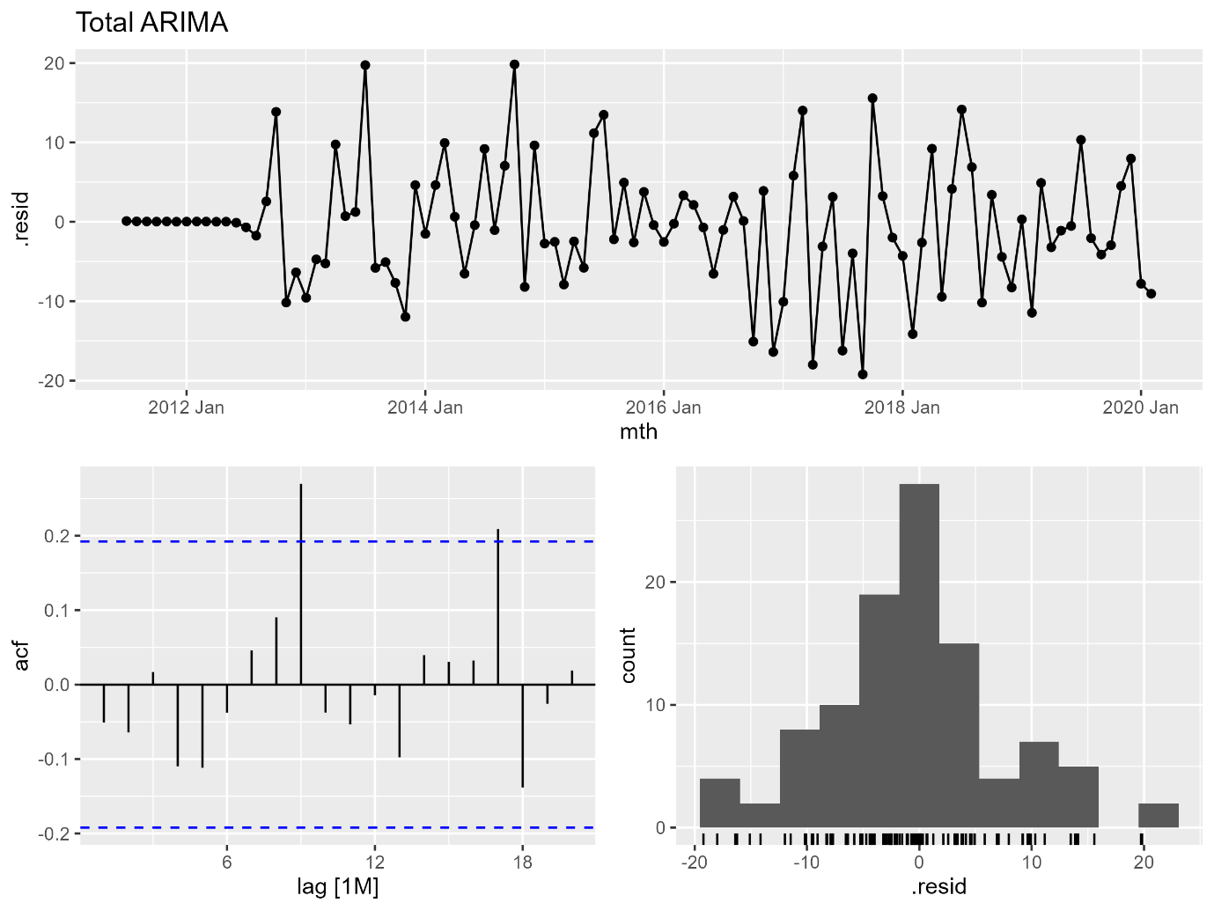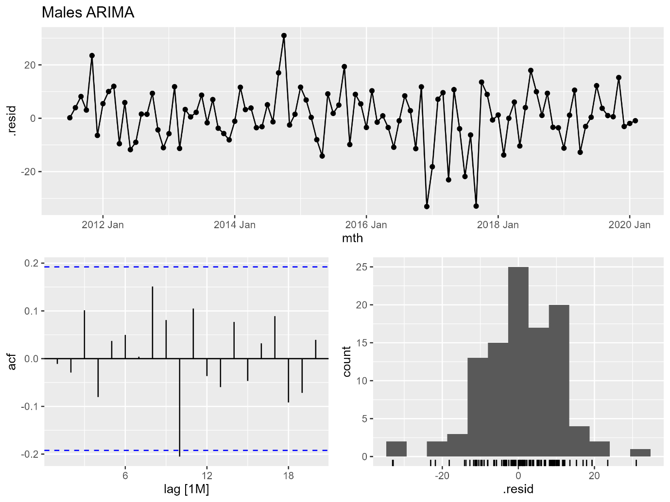
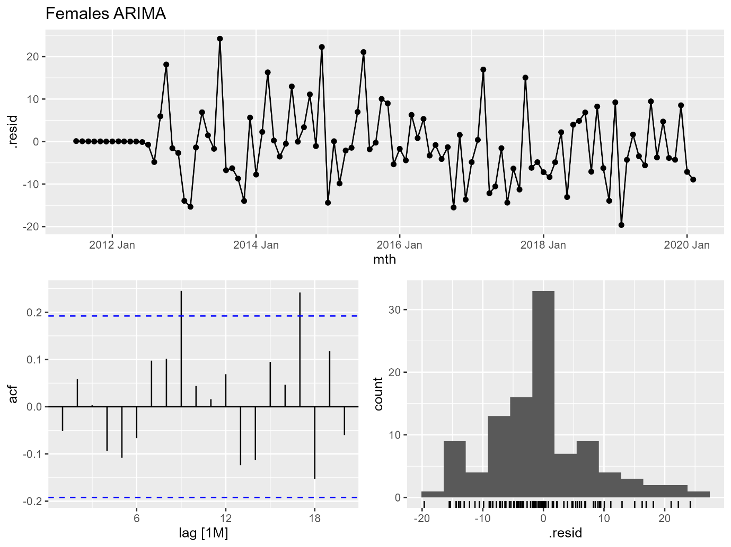
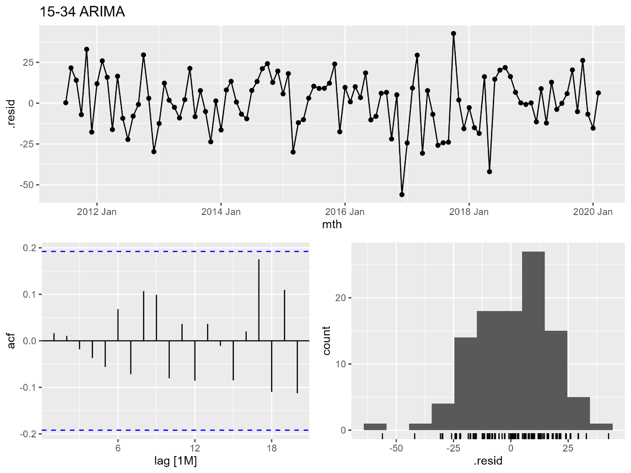
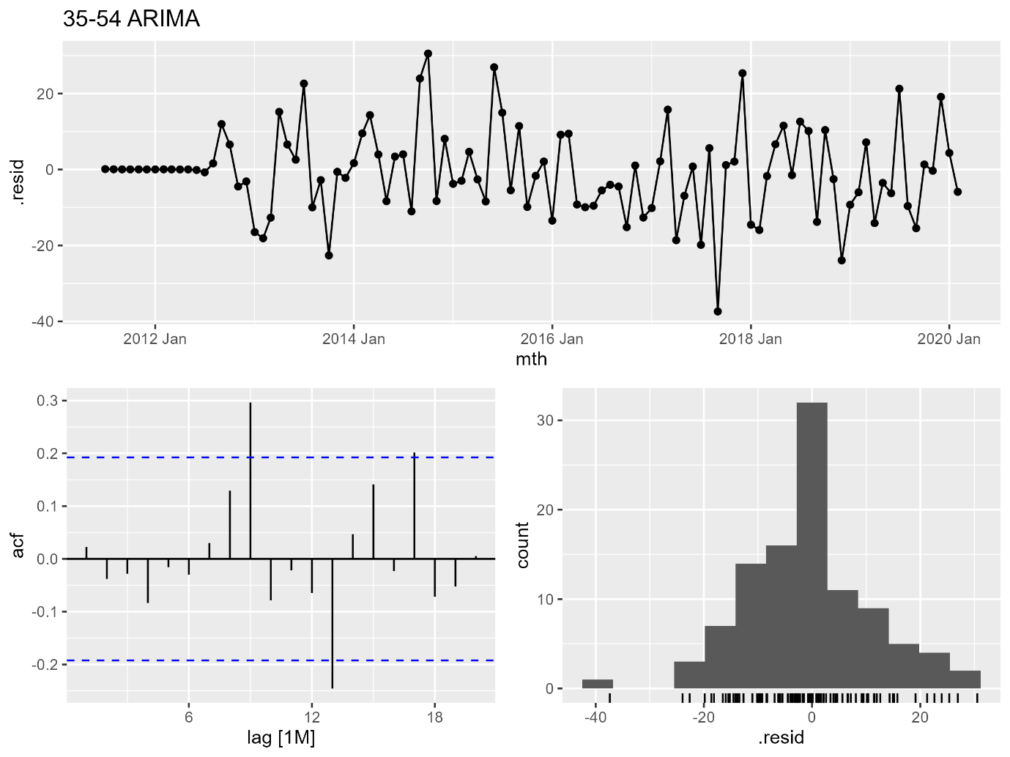
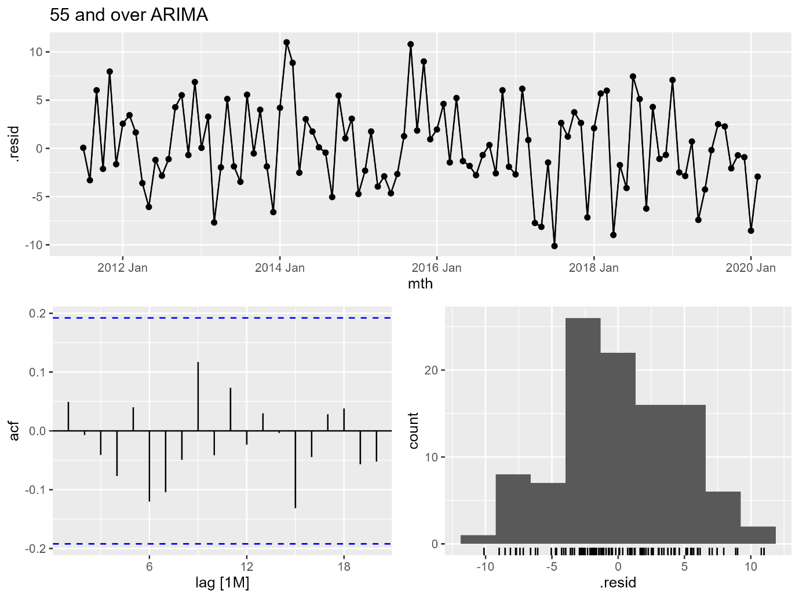
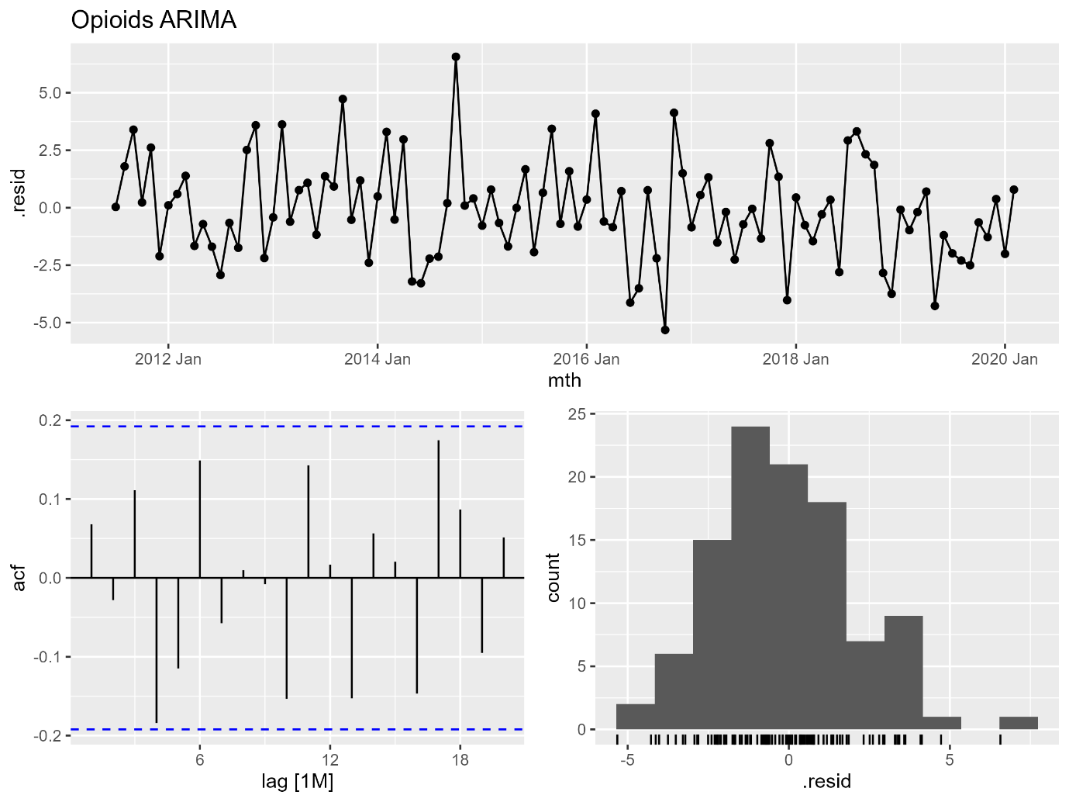
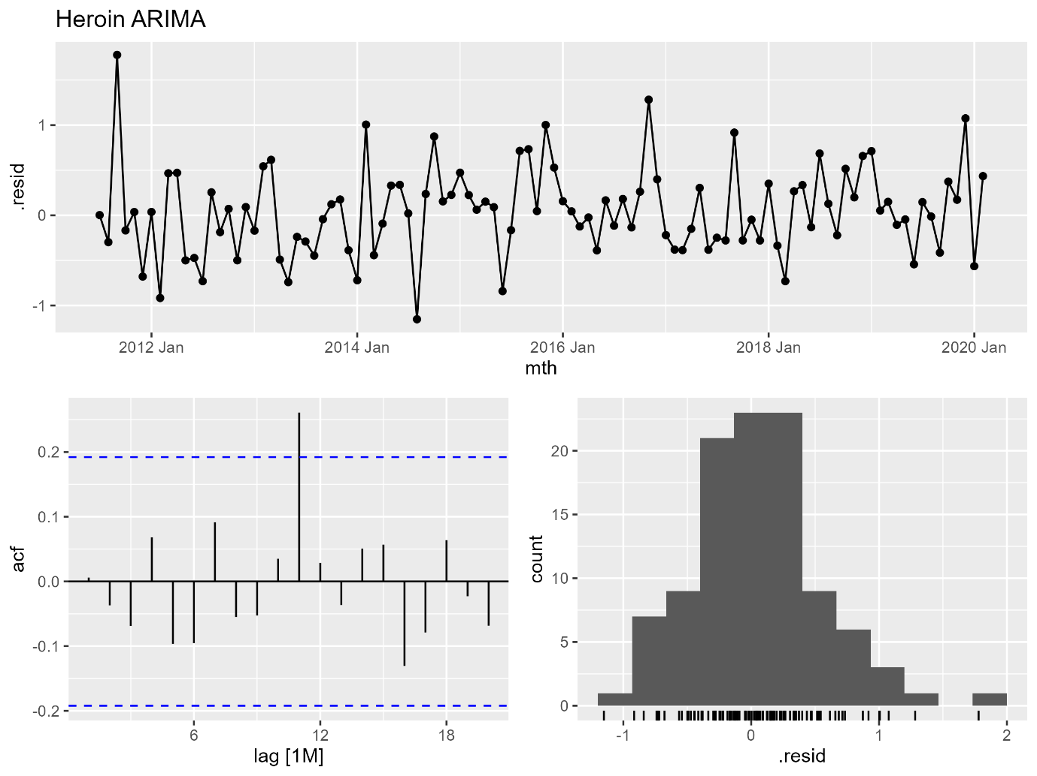
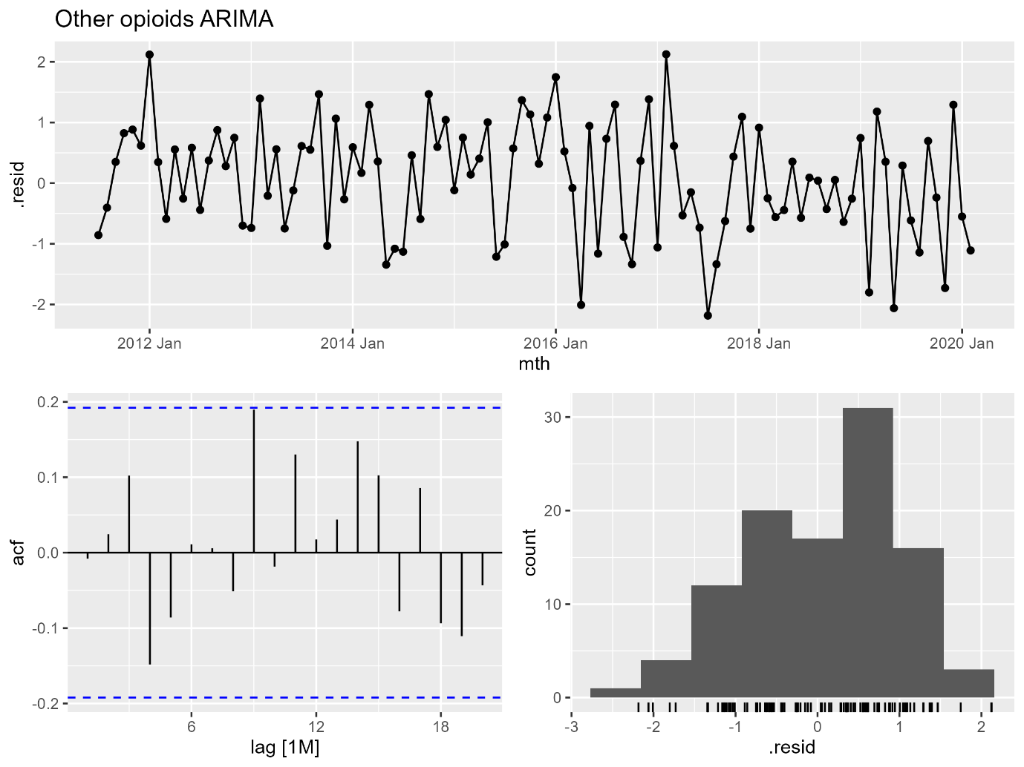
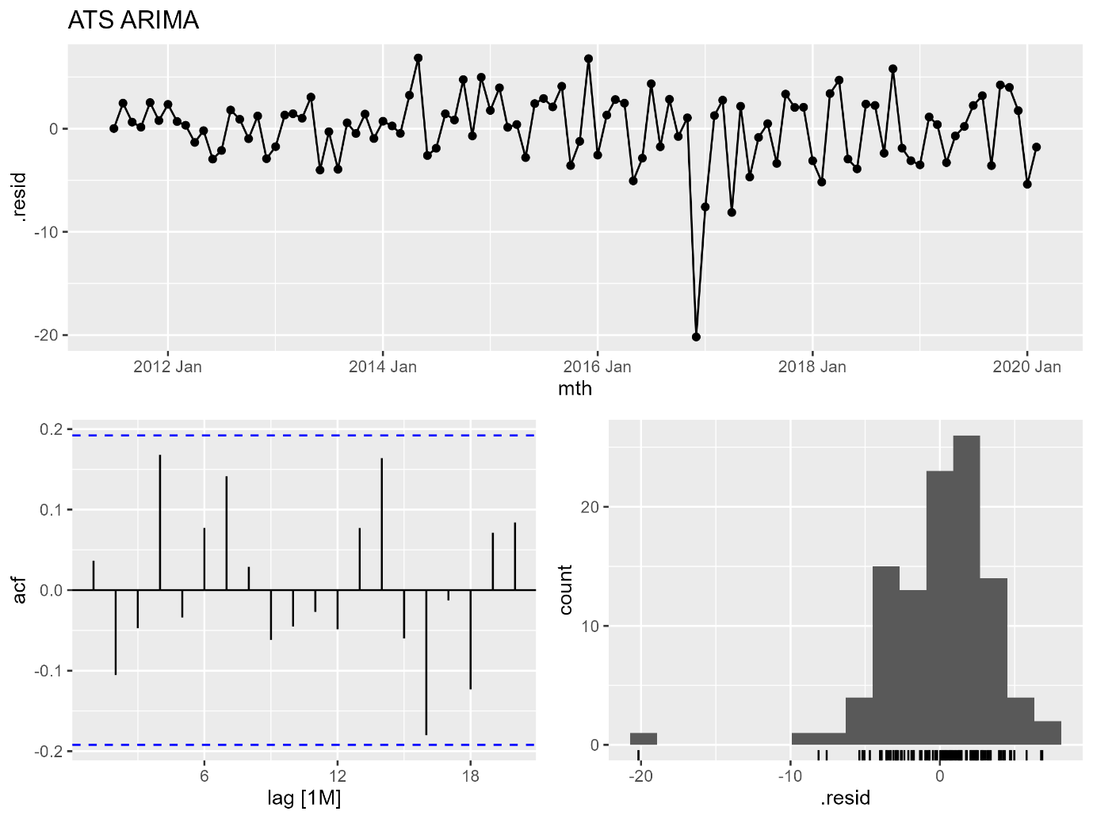
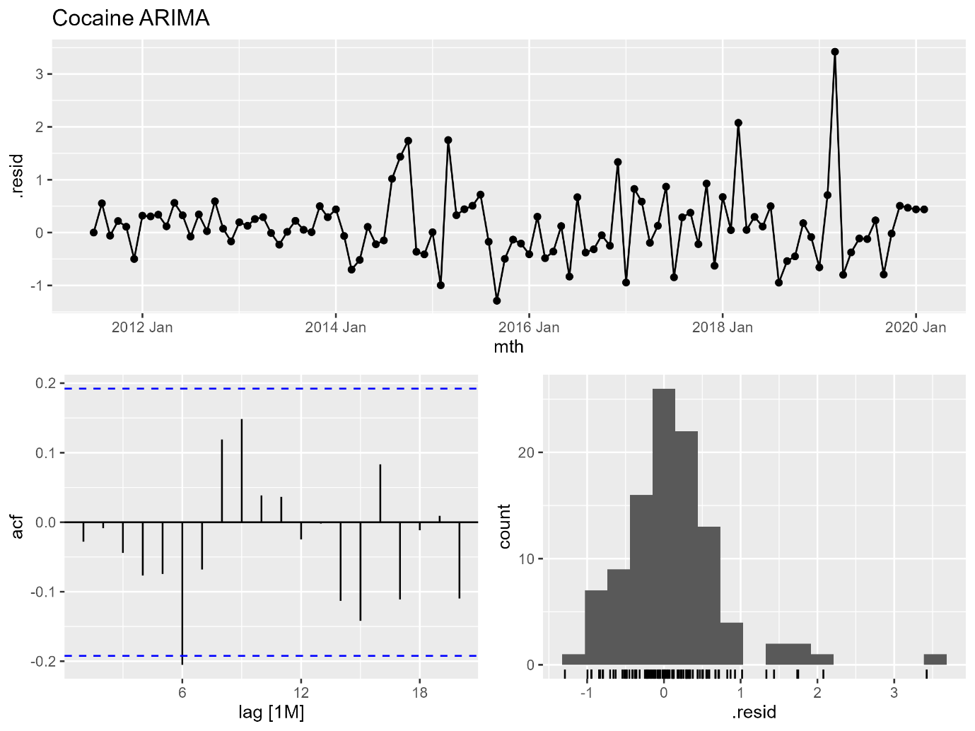
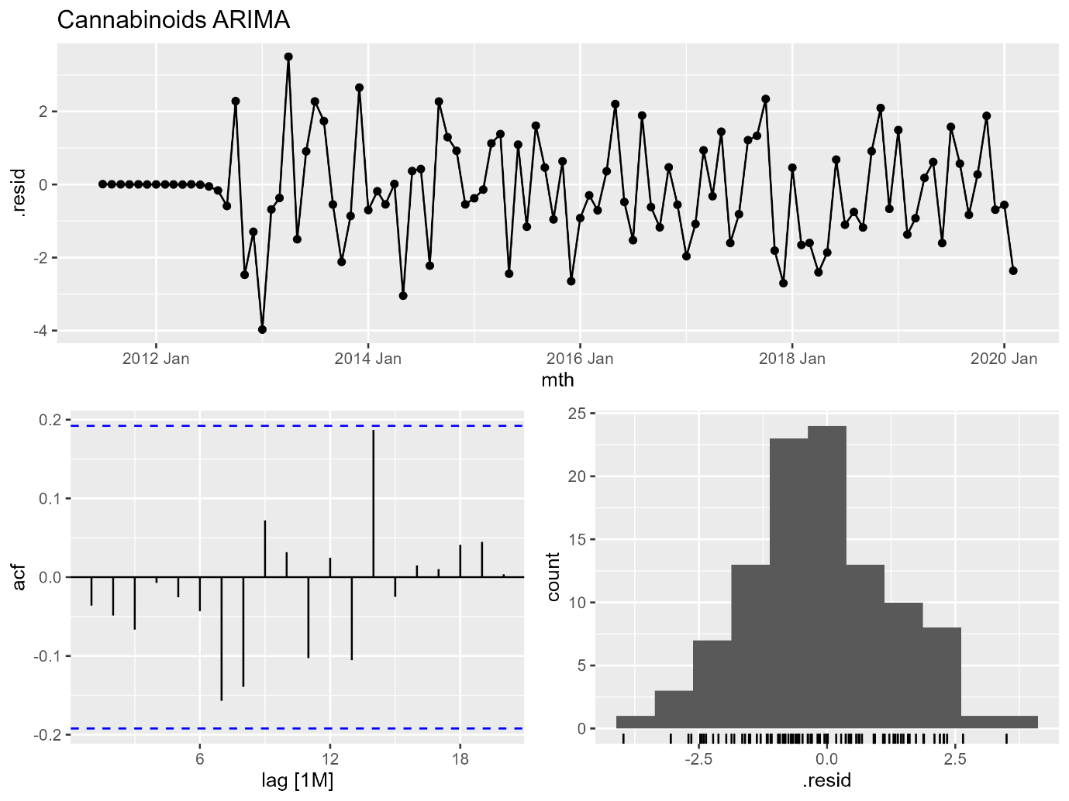
Figure C2. Residual plots for drug-induced deaths. ARIMA, autoregressive integrated moving average; ATS, amphetamine-type stimulants
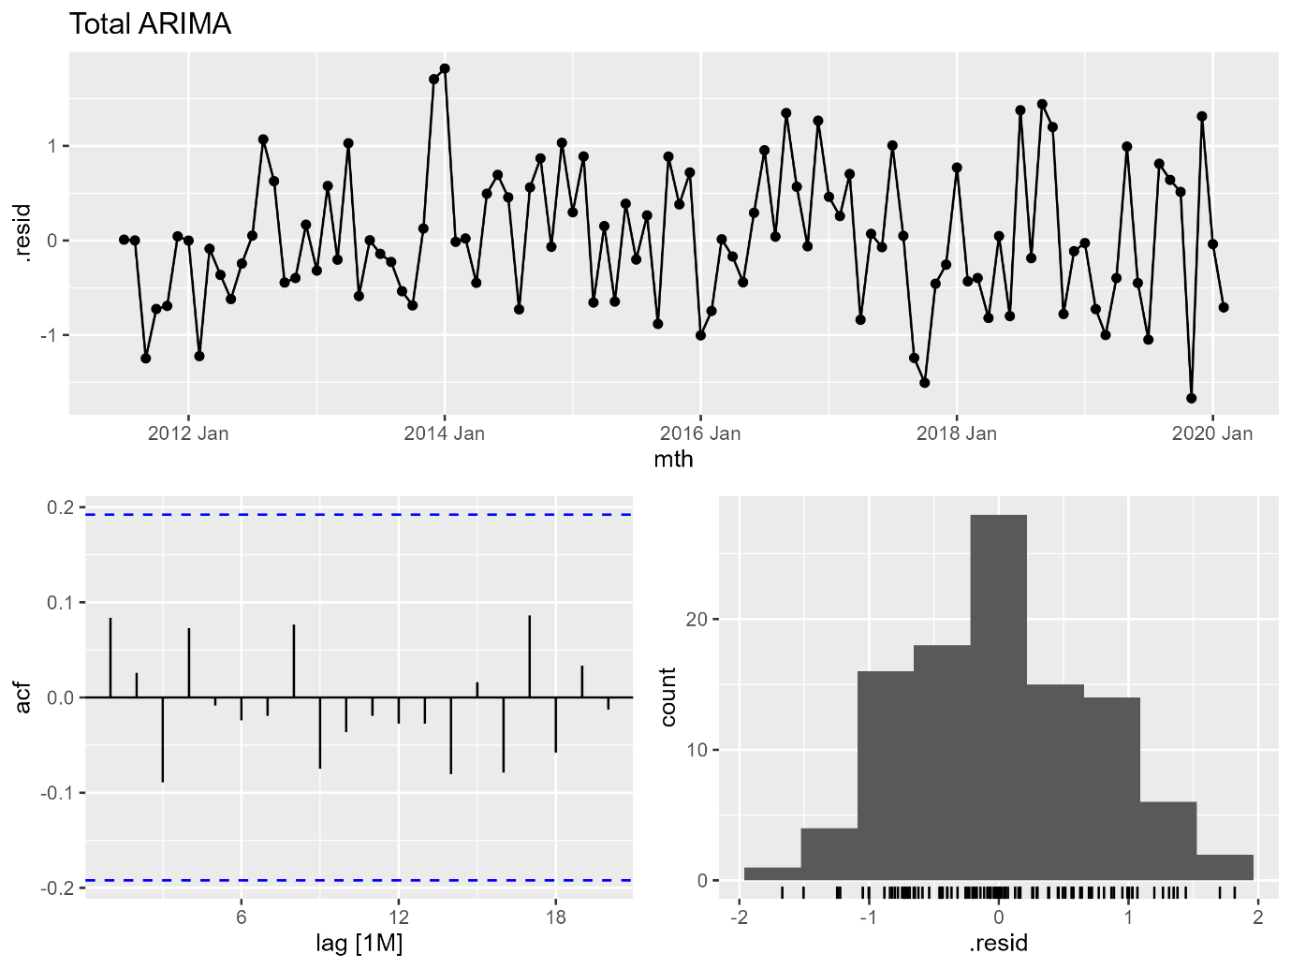
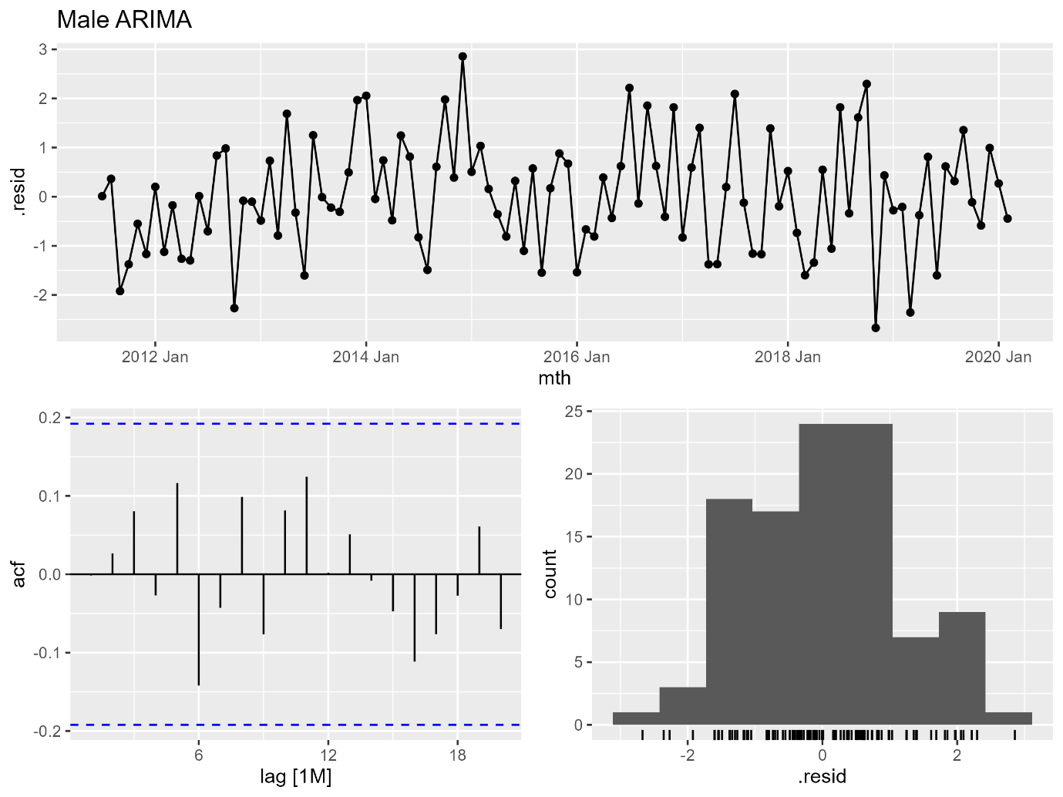
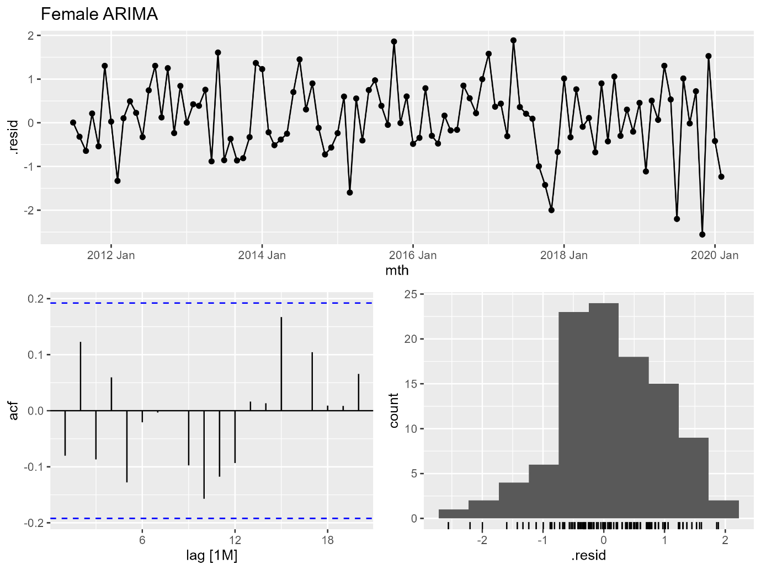
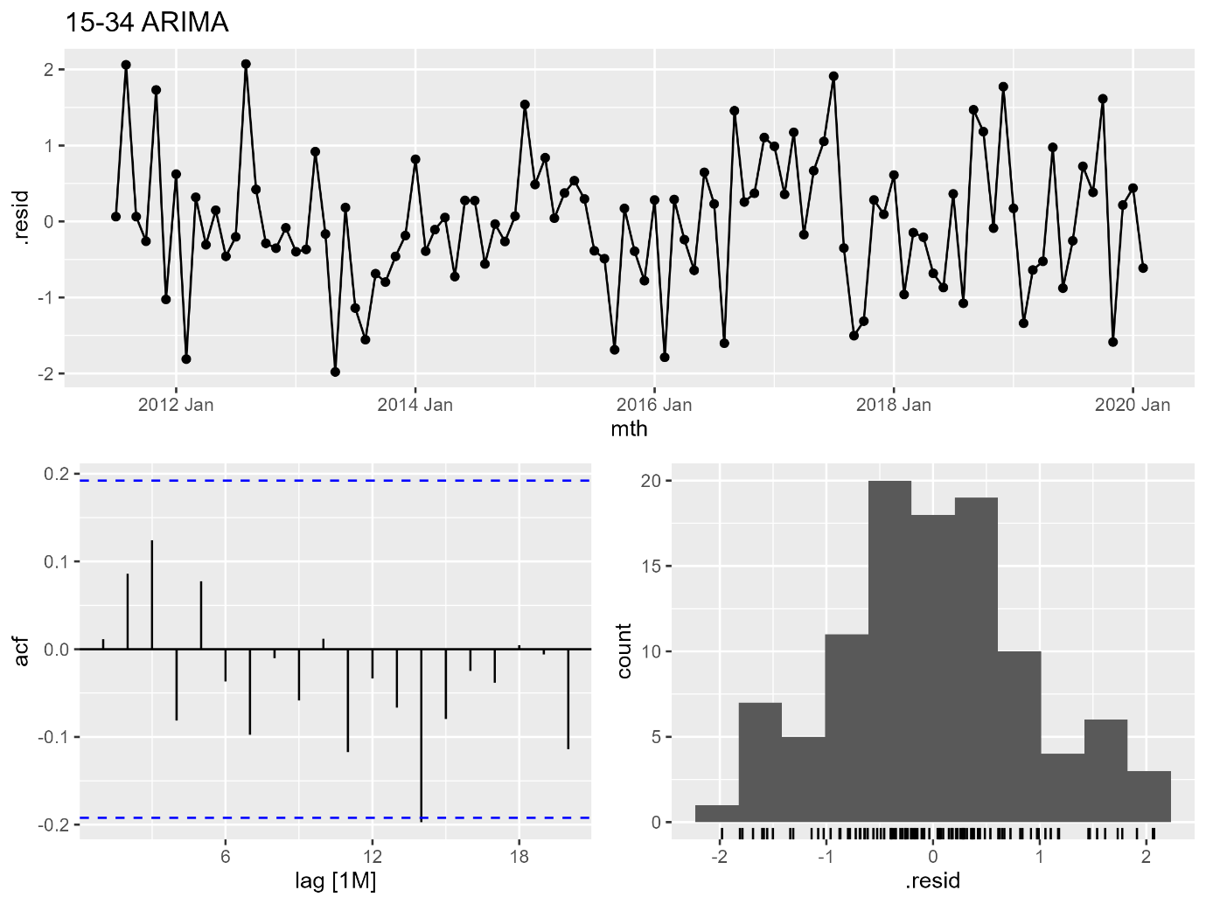
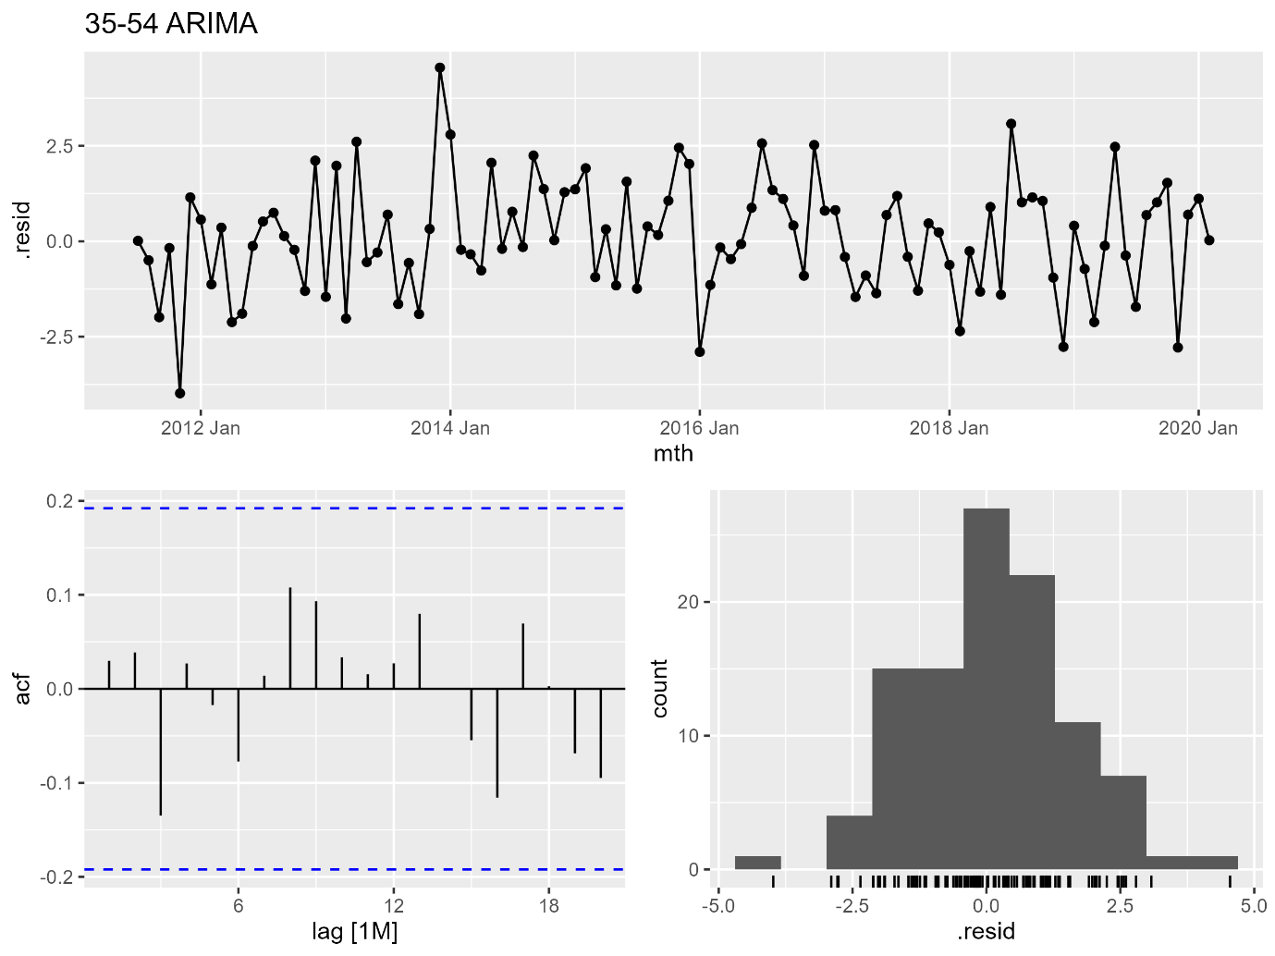
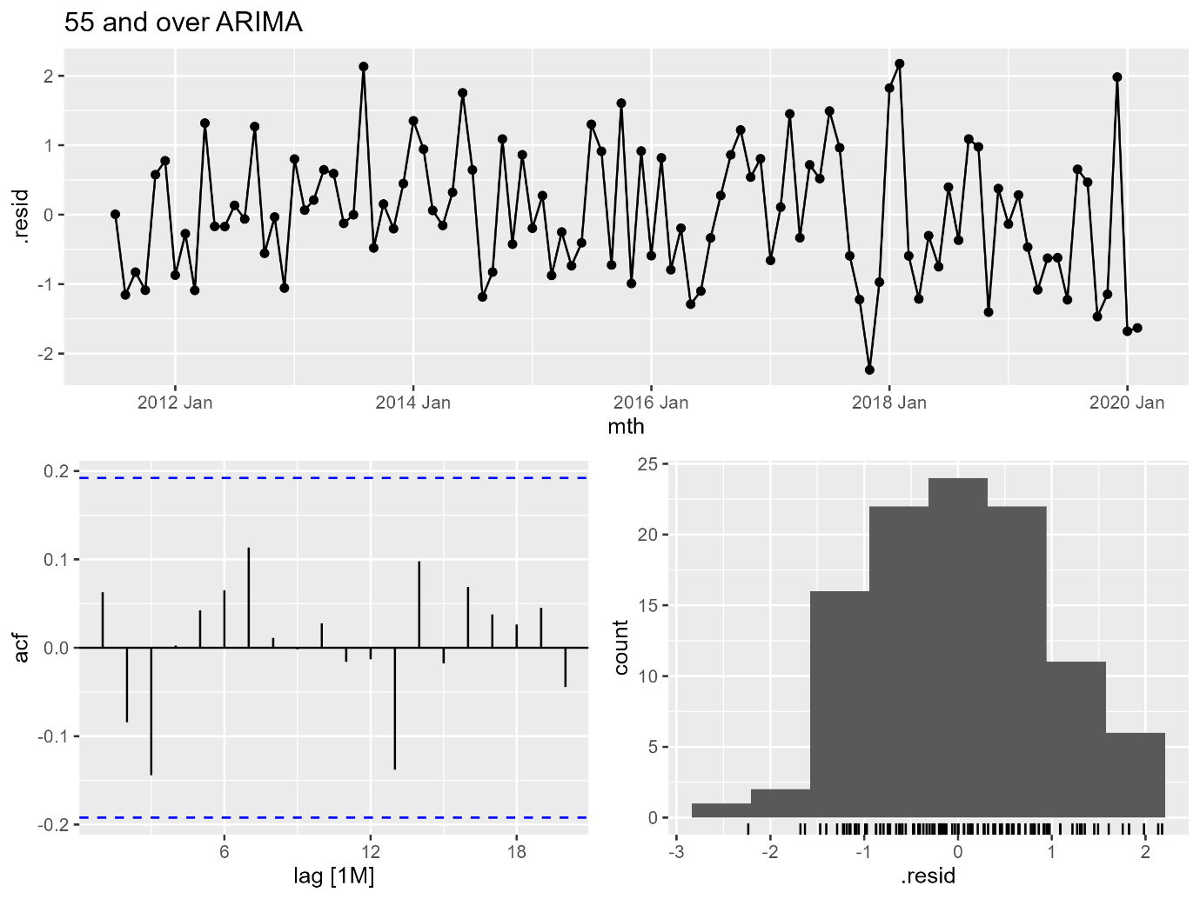
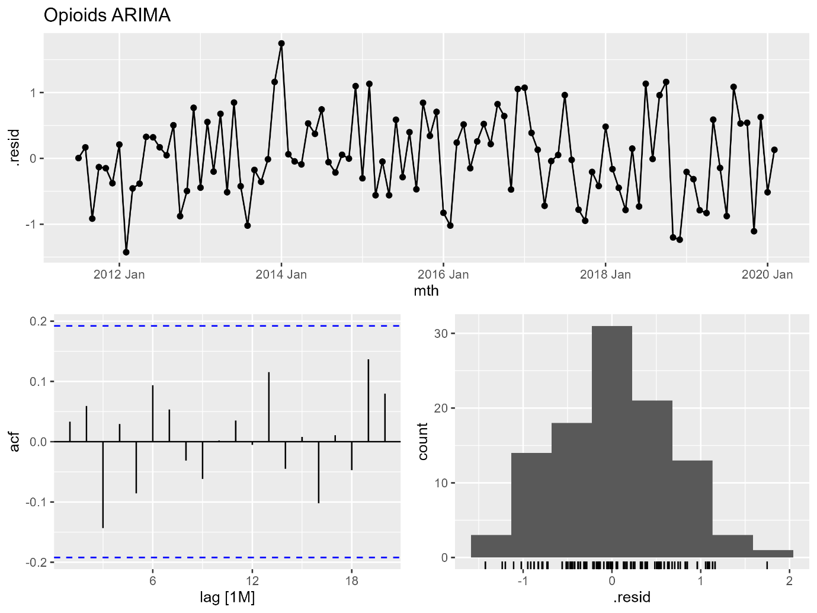
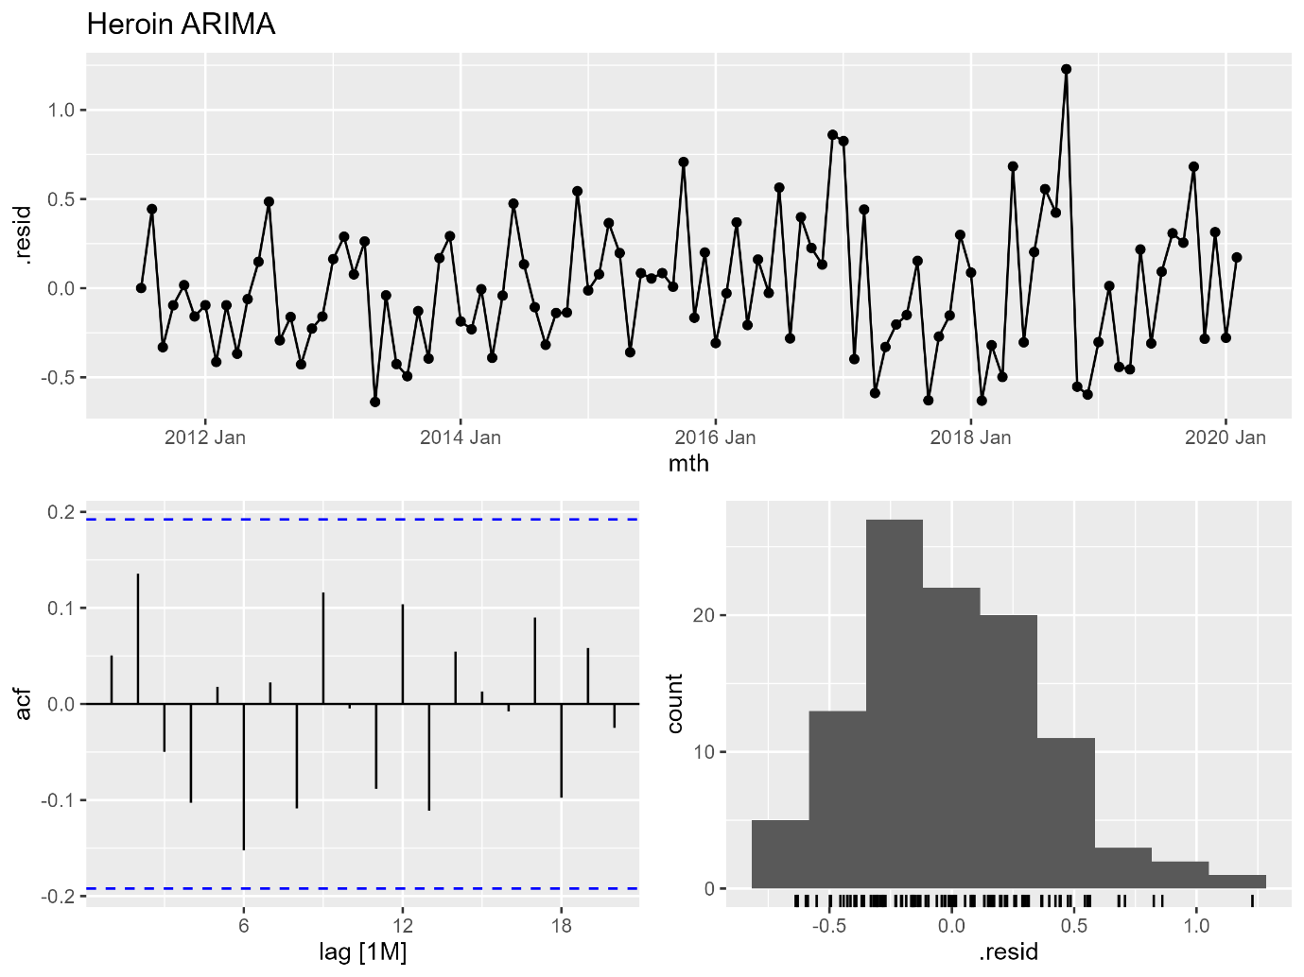
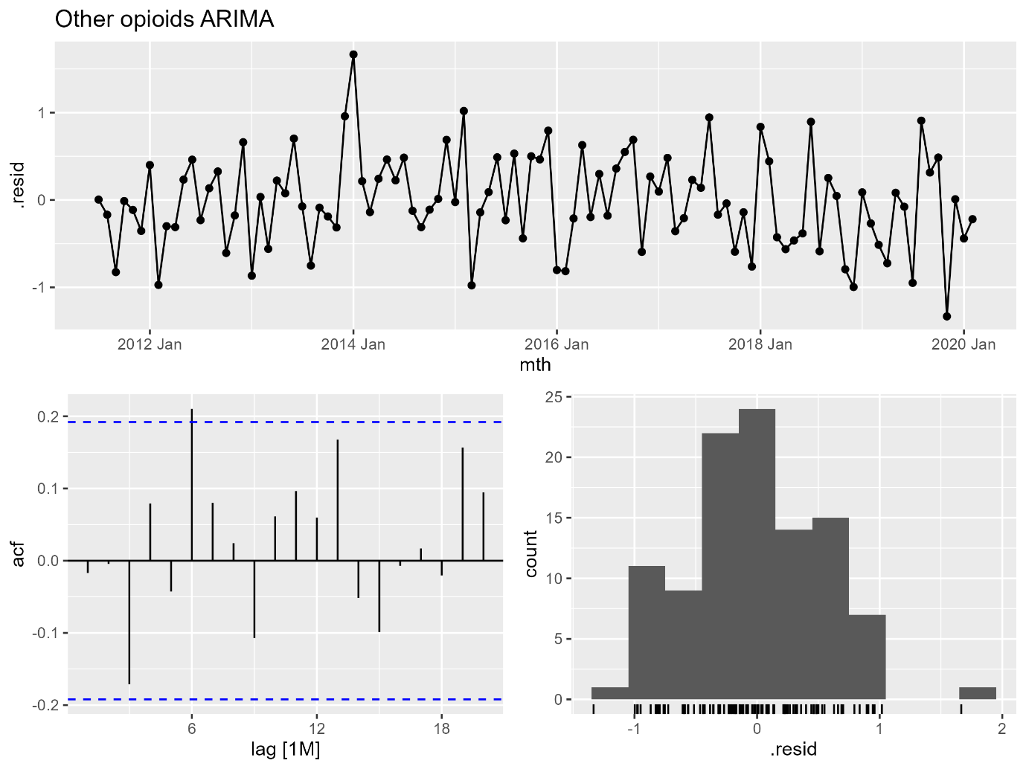
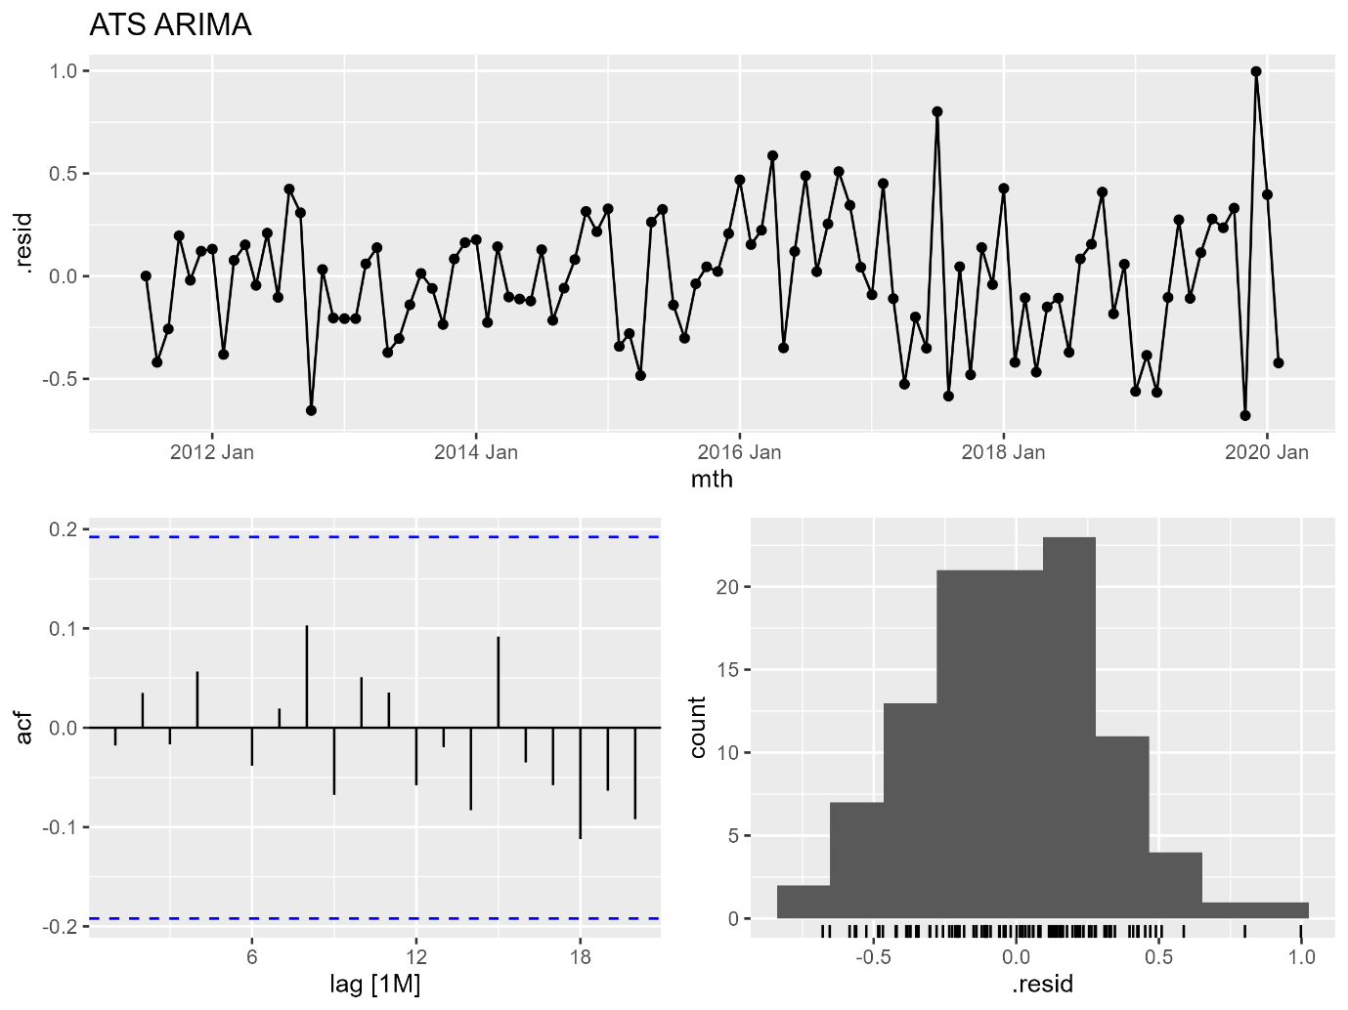
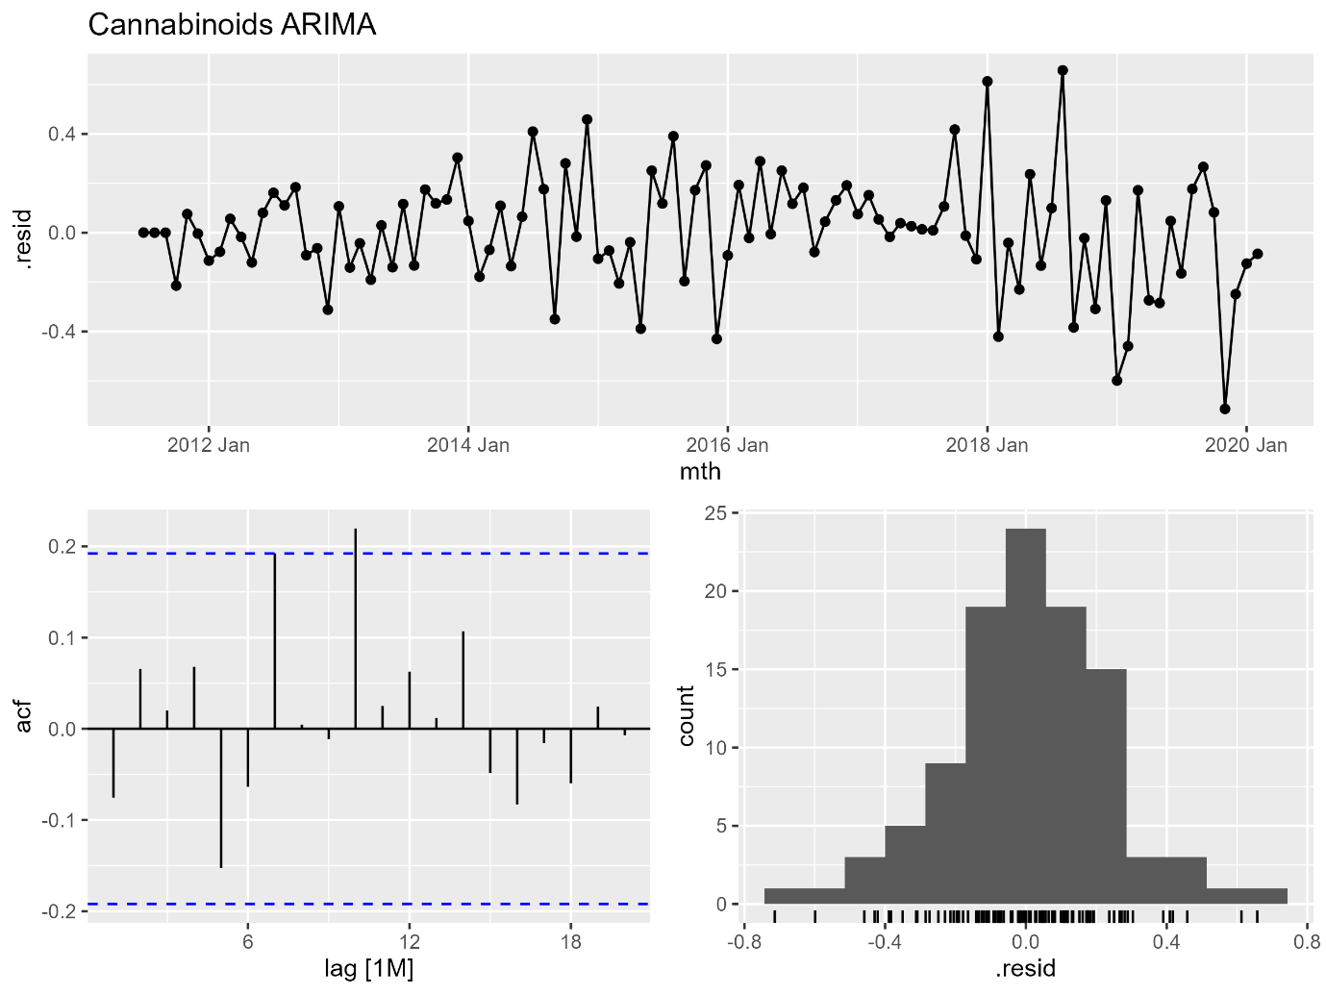

Appendix D. Results using the shorter time series from 1 July 2016 to 30 April 2021, with and without adjusting for all-cause hospitalisation rates
Table D1. Deviation in observed rate (per 1,000,000 persons per month) of drug-induced hospitalisations from the counterfactual forecast in the COVID-19 pandemic period, with and without adjustment for all-cause hospitalisation rates.
 | Estimated deviation in rate per month (95% PI)
 | With adjustment for all-cause hospitalisation | Without adjustment for all-cause hospitalisation
Overall | 7.0 (-9.1, 22.5) | -1.4 (-18.0, 13.8)
Sex
Males | -7.9 (-36.7, 22.3) | -10.3 (-32.2, 14.0)
Females | 22.9 (19.2, 26.7) | 13.7 (9.2, 18.3)
Age, years
15-34 | 21.4 (1.4, 41.9) | 16.6 (-12.7, 46.3)
35-54 | -4.3 (-10.0, 2.2) | -11.3 (-16.6, -5.9)
55+ | -8.6 (-13.1, -4.1) | -8.8 (-12.7, -5.0)
Drug
Opioids | -4.1 (-7.4, -0.7) | -4.1 (-7.4, -0.9)
Heroin | -1.8 (-3.3, -0.5) | -1.8 (-3.3, -0.5)
Other opioids | -1.0 (-3.4, 1.3) | -1.0 (-3.4, 1.3)
Amphetamine-type stimulants | -3.0 (-9.4, 4.4) | -3.3 (-9.2, 3.7)
Cocaine | -0.0 (-0.5, 0.4) | 0.1 (-0.2, 0.5)
Cannabinoids | 6.7 (6.1, 7.3) | 4.0 (2.4, 5.5)
Note: 95% PI = 95% prediction interval; bolded rows indicate estimates with 95% PI that does not include 0. ‘Other opioids’ exclude opium and heroin. For data exclusions, please refer to the methods section and Appendix B (tables B1 and B3).

Figure D1. Crude rate (per month per 1,000,000 persons) of drug-induced hospitalisations and counterfactual forecast with (A) and without (B) adjustment for all-cause hospitalisation rates, overall and by sex.
A1 – Overall with adjustment B1 – Overall without adjustment
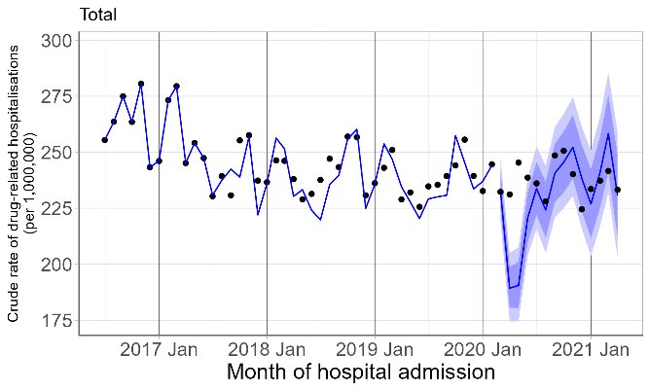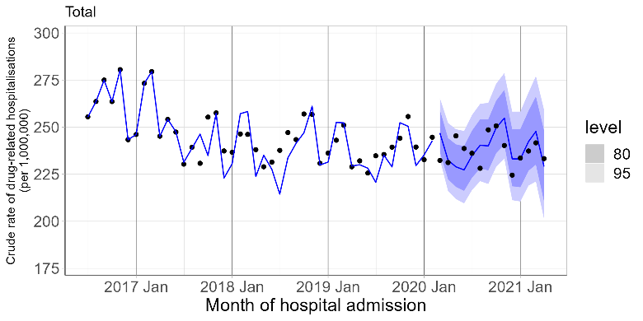
A2 – Males with adjustment B2 – Males without adjustment
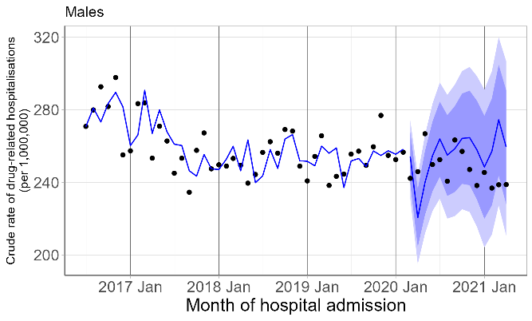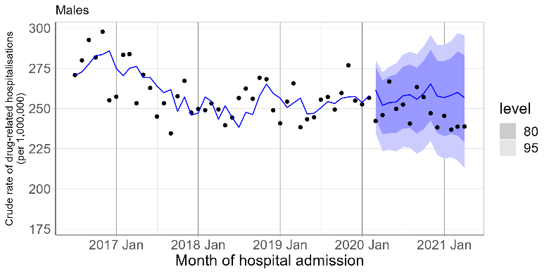
A3 – Females with adjustment B3 – Females without adjustment
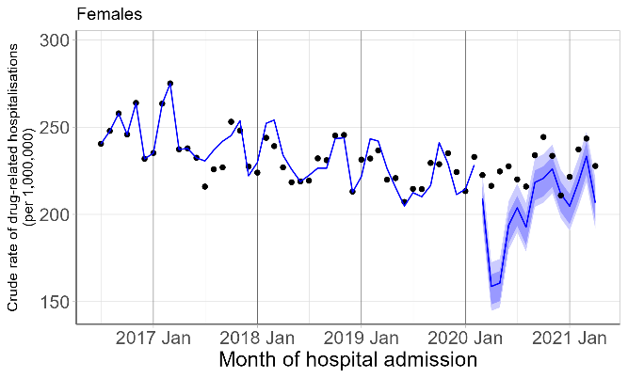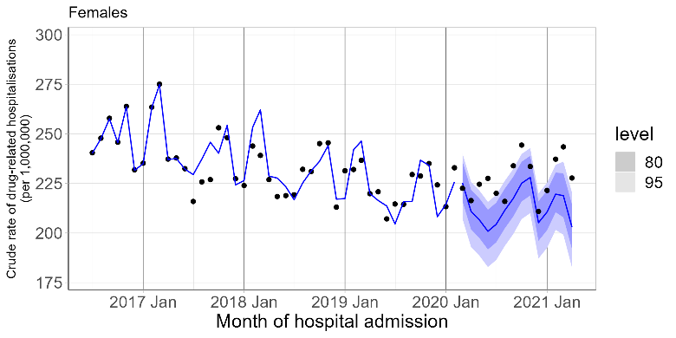
Figure D2. Crude rate (per month per 1,000,000 persons) of drug-induced hospitalisations and counterfactual forecast with (A) and without (B) adjustment for all-cause hospitalisation rates by age.
A1 – 15-34 years with adjustment B1 – 15-34 years without adjustment
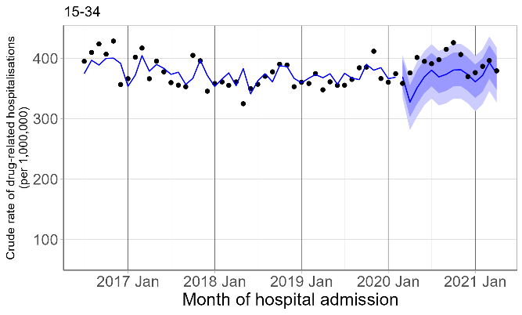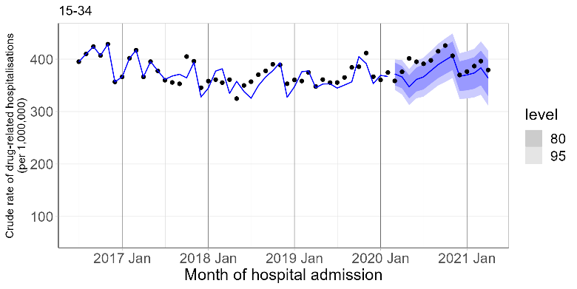
A2 – 35-54 years with adjustment B2 – 35-54 years without adjustment
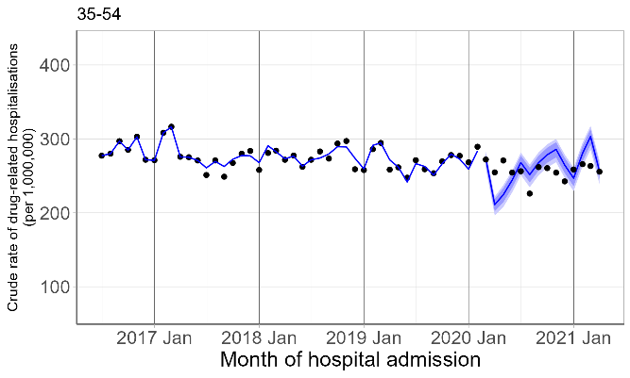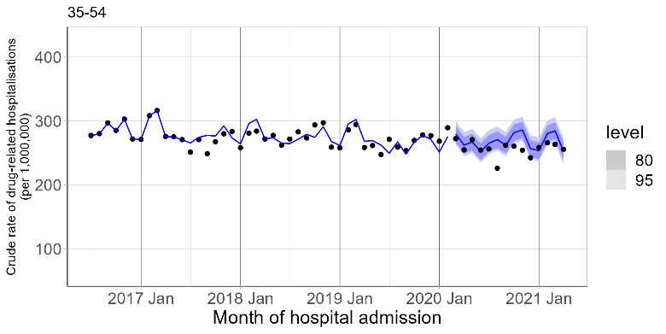
A3 – 55+ years with adjustment B3 – 55+ years without adjustment
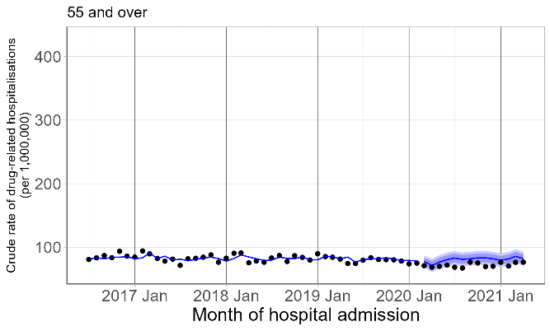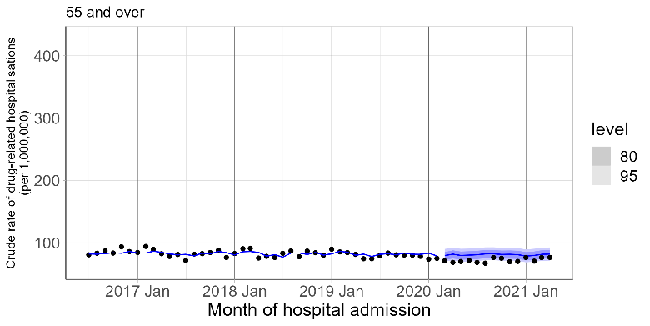
Figure D3. Crude rate (per month per 1,000,000 persons) of opioid-induced hospitalisations and counterfactual forecast with (A) and without adjustment (B) for all-cause hospitalisation rates.
A1 – All opioids with adjustment B1 – All opioids without adjustment
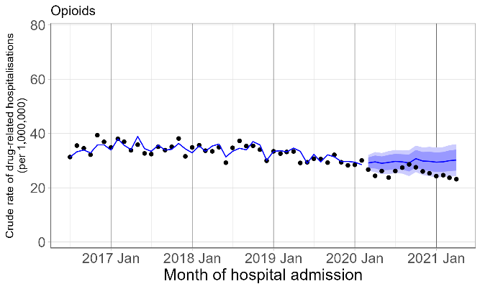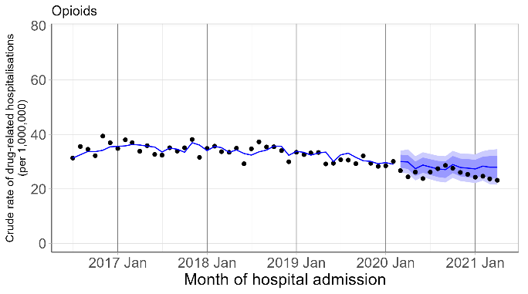
A2 – Heroin with adjustment B2 – Heroin without adjustment
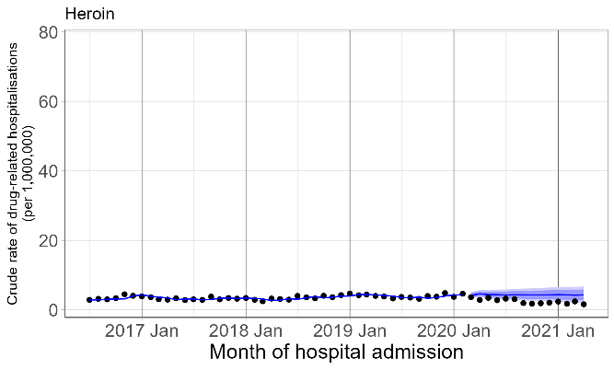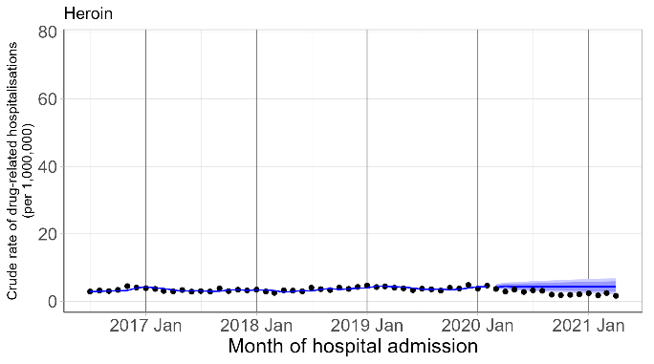
A3 – Other opioids with adjustment B3 – Other opioids without adjustment
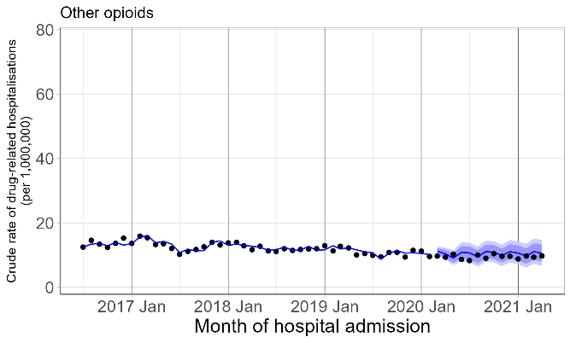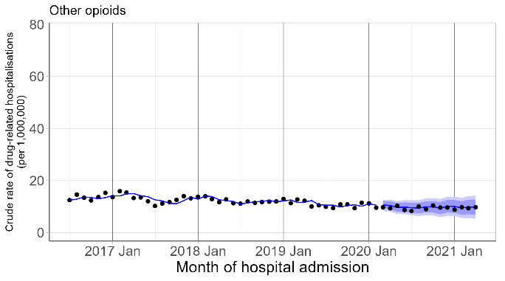
Figure D4. Crude rate (per 1,000,000 persons per month) of drug-induced hospitalisations involving amphetamine-type stimulants (ATS), cocaine and cannabinoids and counterfactual forecast with and without adjustment for all-cause hospitalisation rates.
A1 – ATS with adjustment B1 – ATS without adjustment
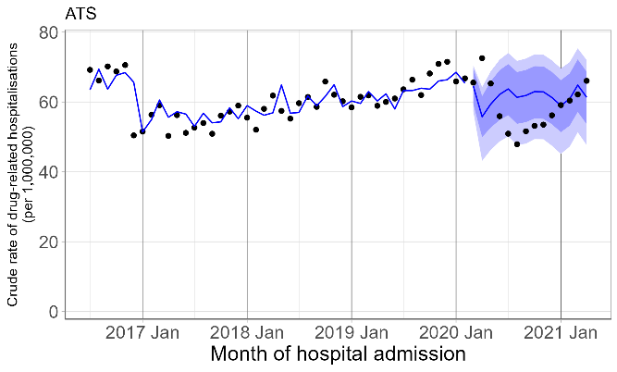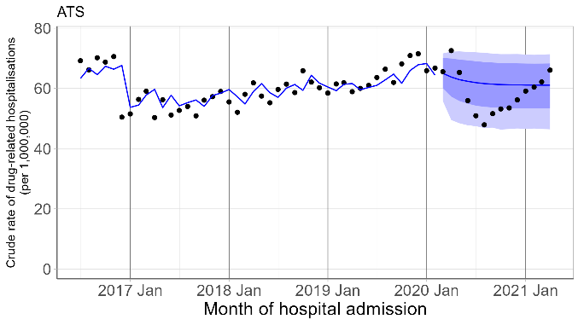
A2 – Cocaine with adjustment B2 – Cocaine without adjustment
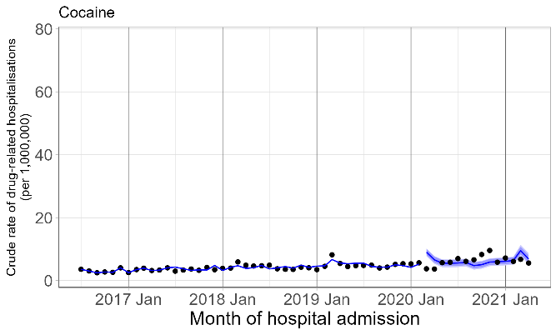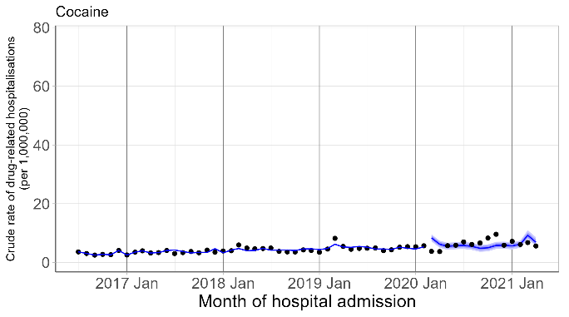
A3 – Cannabinoids with adjustment B3 – Cannabinoids without adjustment
