The Role of C1GALT1 in Cancer: Insights into Glycosylation, Prognosis, and Therapeutic Potential

Ecem Kalemoglu ^{1,2*}, Ayse Caner^{2,3,4*}

¹ Department of Internal Medicine, Rutgers-Jersey City Medical Center, 355 Grand St, Jersey City, NJ, USA, 07302.
² Department of Basic Oncology, Institute of Health Sciences, Ege University, Izmir, Turkey.
³ Translational Pulmonary Research Center (EGESAM), Ege University, Izmir, Turkey.
⁴ Department of Parasitology, Faculty of Medicine, Ege University, Bornova, 35100, Izmir, Turkey.

*Corresponding authors:

Ecem Kalemoglu, Department of Internal Medicine, Rutgers University-Jersey City Medical Center, 355 Grand St, Jersey City, NJ, USA, 07302
E-mail: ecem.kalemoglu@rutgers.edu; ecemkalemoglu@gmail.com.
Phone: +1 404 716 03 85
ORCID ID: 0000-0002-6312-0048

Ayse Caner, Department of Basic Oncology, Faculty of Medicine, Ege University, Bornova, 35100, Izmir, Turkey.
E-mail: ayse.caner@ege.edu.tr; ayecaner@gmail.com
Phone: +90 505 485 59 94
ORCID ID: 0000-0003-3058-9971

Supplemental Material

- Supplement Figure 1. C1GalT1 gene expression differences between normal and tumor samples across cancer types by using the TIMER2.0 portal.

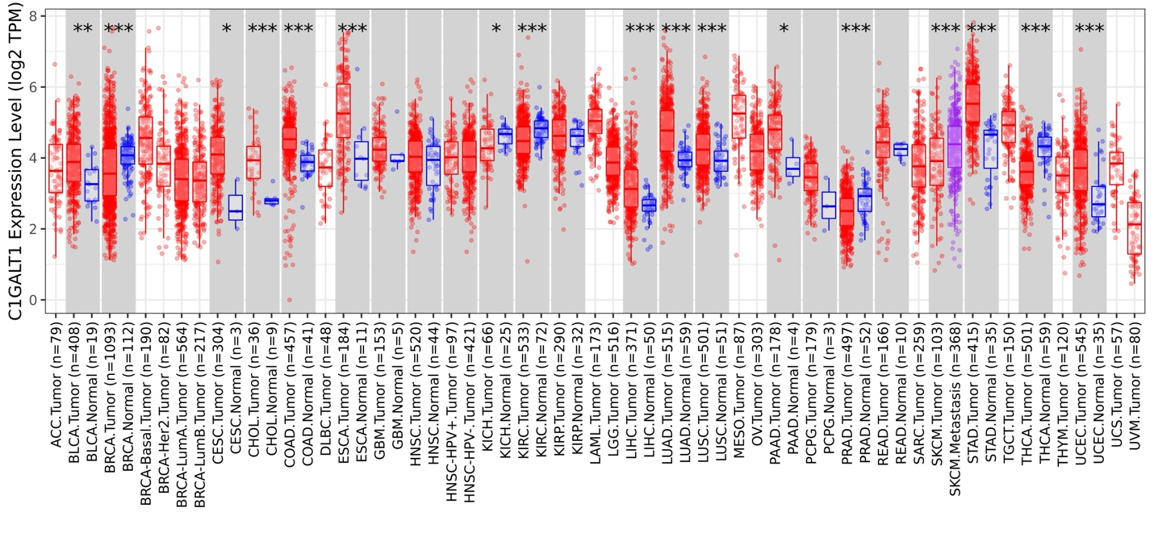
ACC: Adrenocortical Carcinoma; BLCA: Bladder Urothelial Carcinoma; BRCA: Breast Invasive Carcinoma; CESC: Cervical and Endocervical Cancer; CHOL: Cholangiocarcinoma; COAD: Colon Adenocarcinoma; DLBC: Diffuse Large B-cell Lymphoma; ESCA: Esophageal Carcinoma; GBM: Glioblastoma Multiforme; HNSC: Head and Neck Cancer; KICH: Kidney Chromophobe; KIRC: Kidney Renal Clear Cell Carcinoma; KIRP: Kidney Renal Papillary Cell Carcinoma; LAML: Acute Myeloid Leukemia; LGG: Lower Grade Glioma; LIHC: Liver Hepatocellular Carcinoma; LUAD: Lung Adenocarcinoma; LUSC: Lung Squamous Cell Carcinoma; MESO: Mesothelioma; OV: Ovarian Serous Cystadenocarcinoma; PAAD: Pancreatic Adenocarcinoma; PCPG: Pheochromocytoma and Paraganglioma; PRAD: Prostate Adenocarcinoma; READ: Rectum Adenocarcinoma; SARC: Sarcoma; SKCM: Skin Cutaneous Melanoma; STAD: Stomach Adenocarcinoma; TGCT: Testicular Germ Cell Tumors; THCA: Thyroid Carcinoma; THYM: Thymoma; UCEC: Uterine Corpus Endometrial Carcinoma; UCS: Uterine Carcinosarcoma; UVM: Uveal Melanoma; (*: p-value < 0.05; **: p-value <0.01; ***: p-value <0.001).

- Supplement Figure 2. Overall survival (OS) comparison between high and low C1GalT1 gene expression groups displayed on KM-plots across cancer types was not statistically significant.
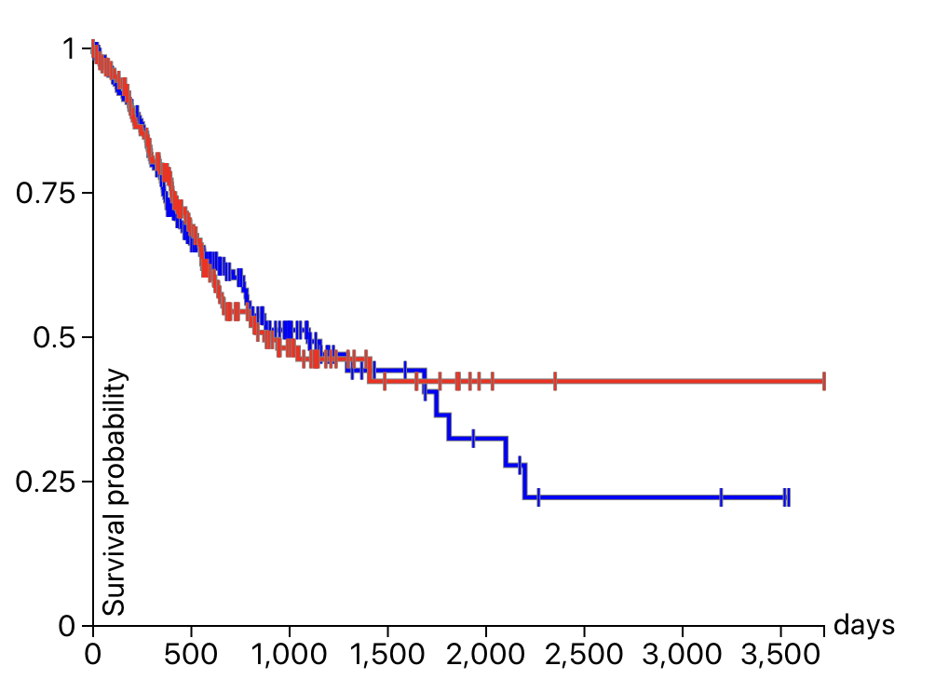
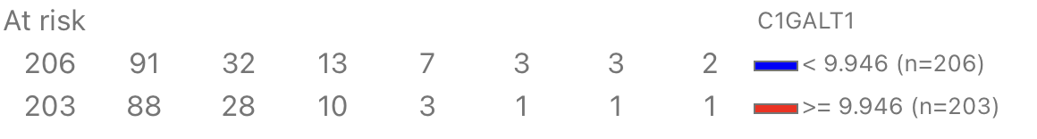
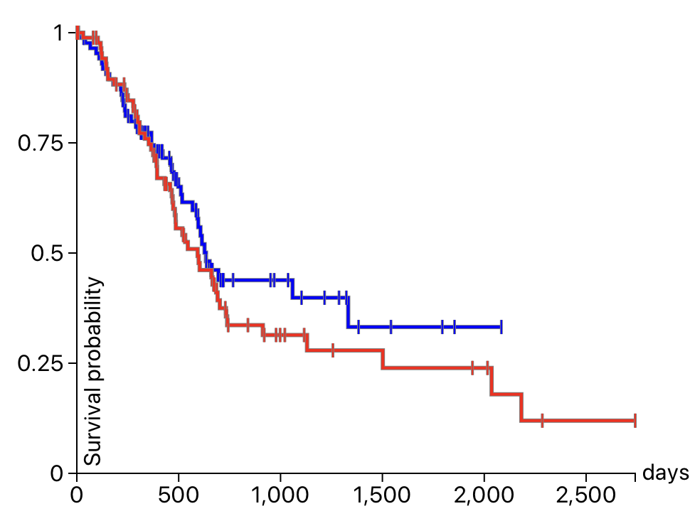
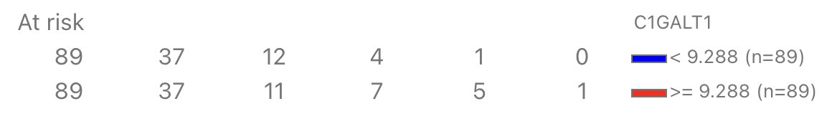
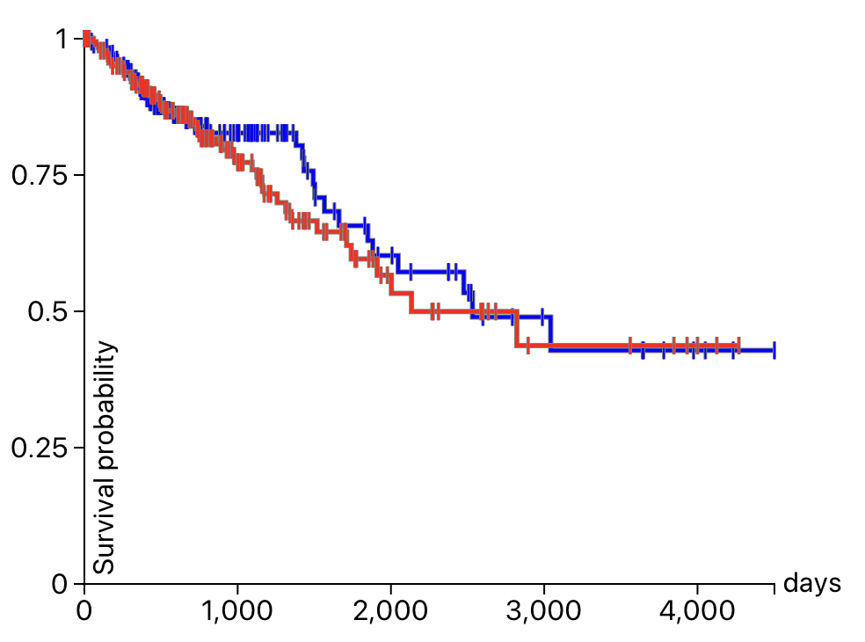
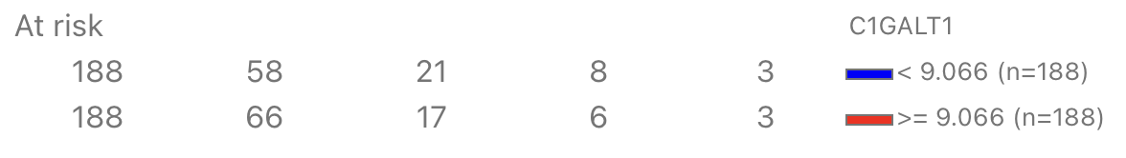
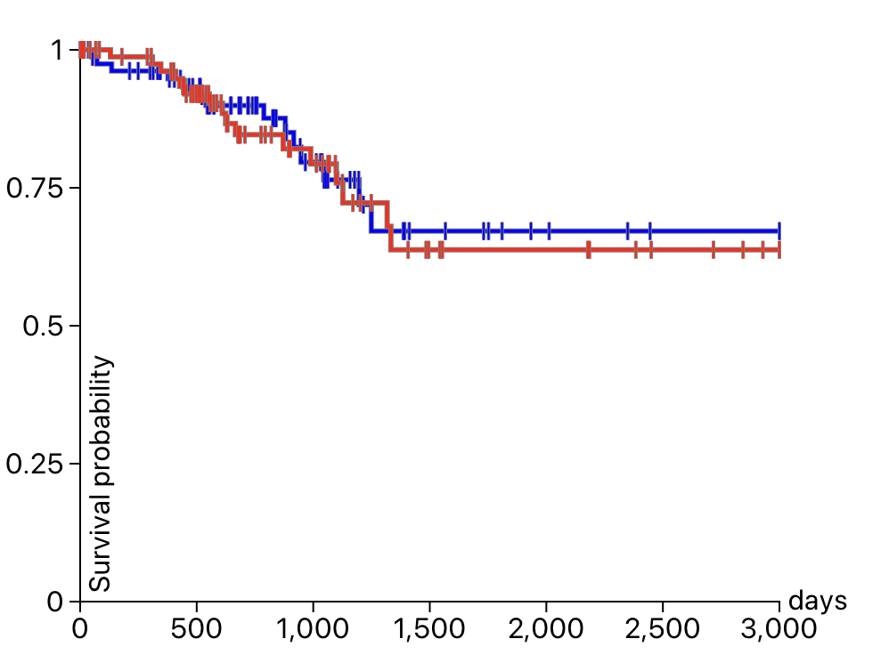
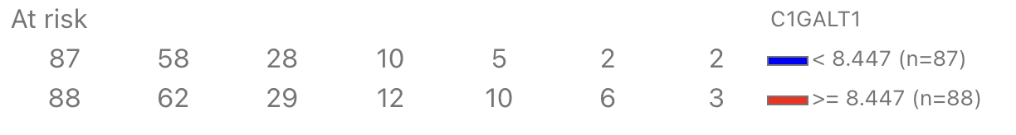
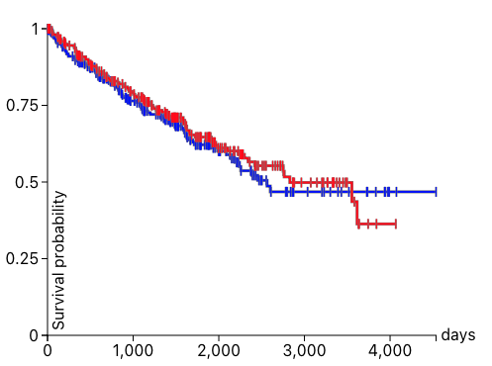
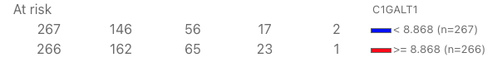
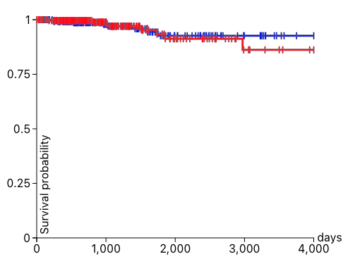
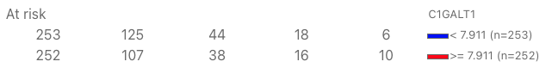
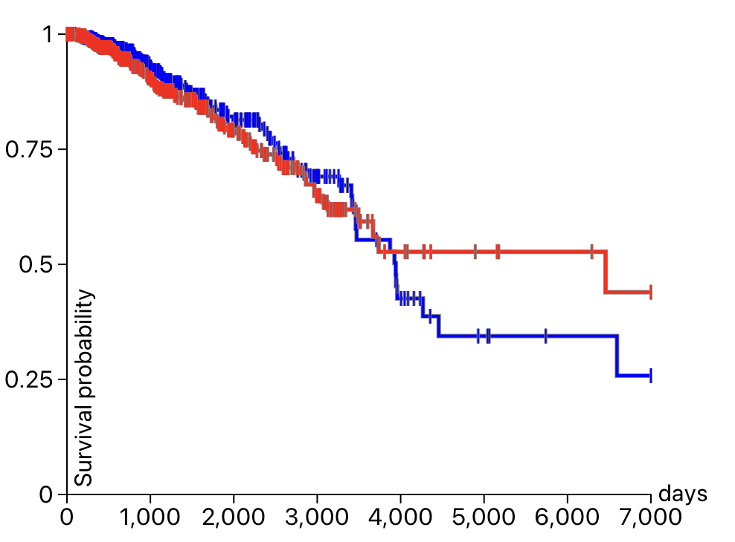
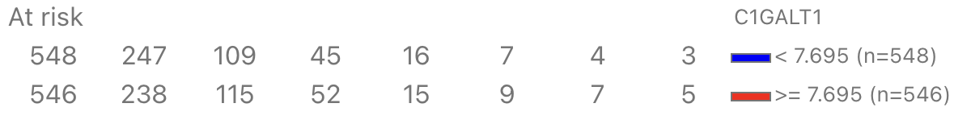
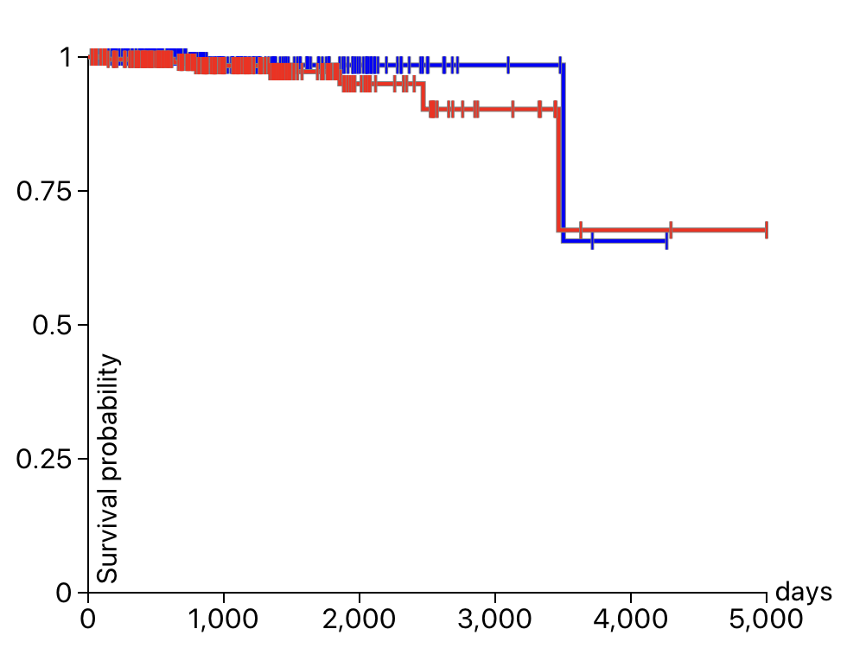
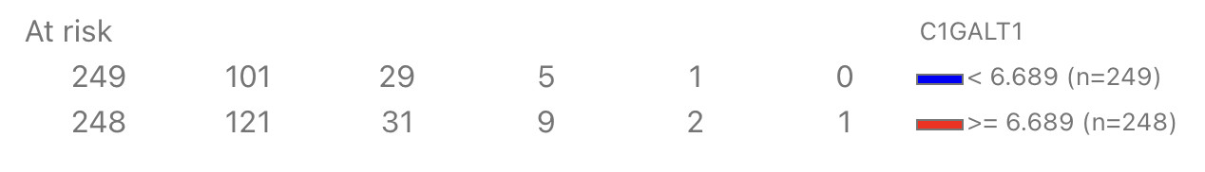
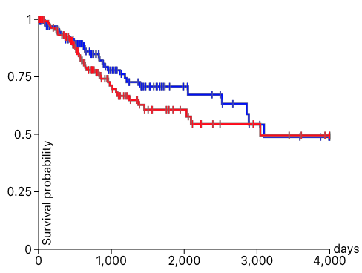
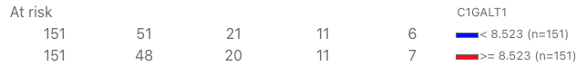
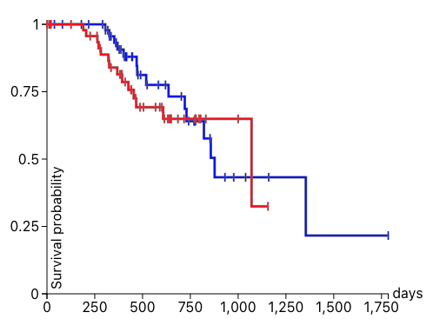
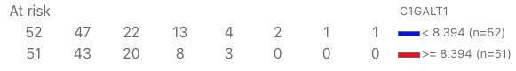
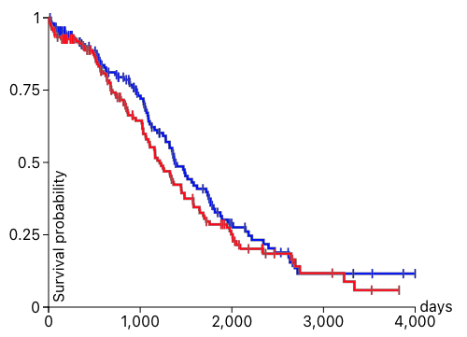
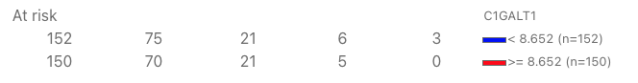
p = 0.9118
Stomach Cancer
Pancreatic Cancer
p = 0.3430
Colon and Rectal Cancer
p = 0.5490
p = 0.8237
Endometrioid Cancer
p = 0.5816
Kidney Clear Cell Carcinoma
Thyroid Cancer
p = 0.6142
Breast Cancer
p = 0.8014
p = 0.3090
Prostate Cancer
p = 0.2911
Cervical Cancer
p = 0.4636
Melanoma
p = 0.2195
Ovarian Cancer
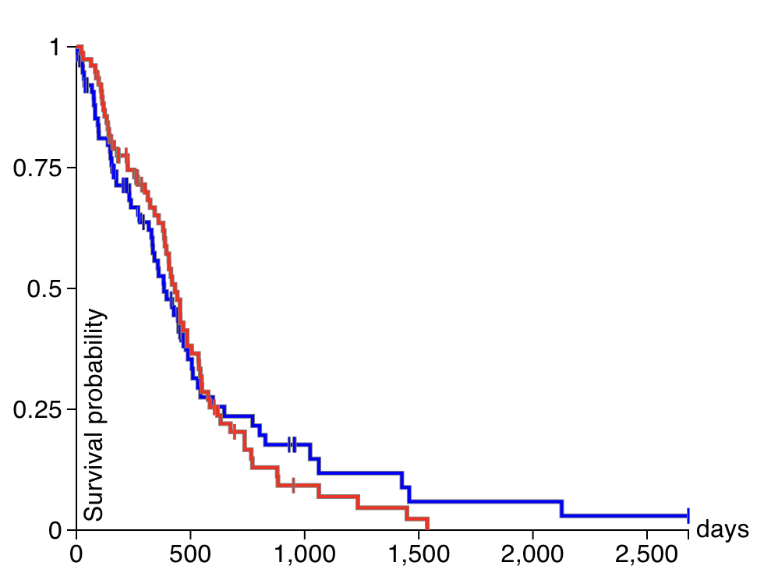
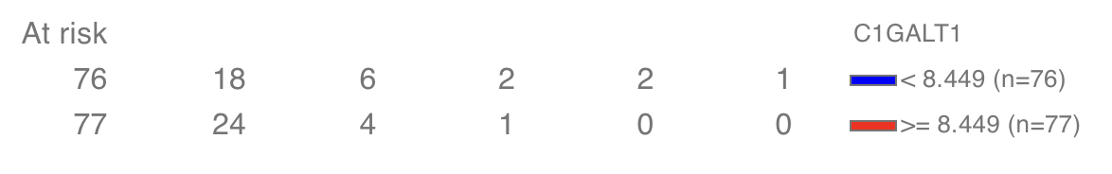
p = 0.06499
Glioblastoma

