Supplementary data Supplementary data 1. FTIR for L-His, PGAL and PGAL-His

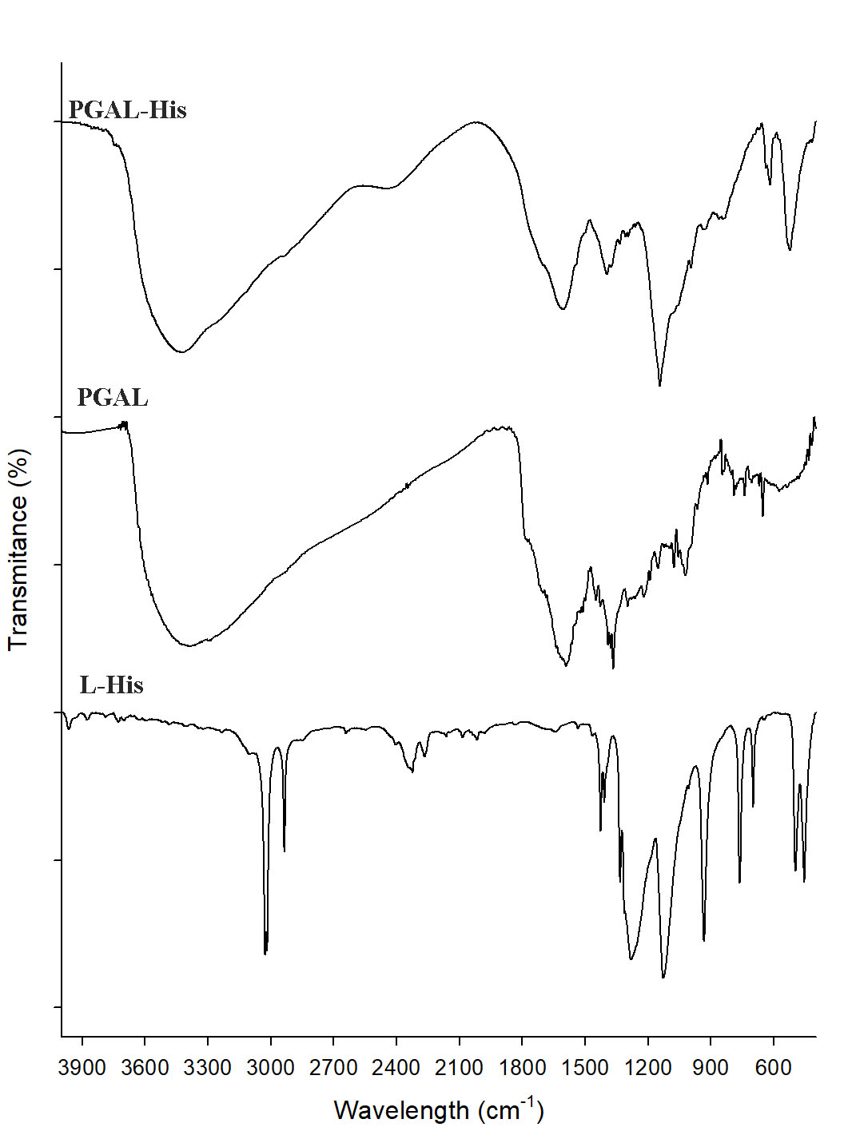
Figure: FT-IR spectra for PGAL-His sample (above); PGAL (middle) and L-Histidine (Below)

