SUPPLEMENTARY MATERIAL
SM Table 1 Assessment of flavonoid derivatives and their association to molecular mechanisms (in vitro studies) in biological systems.
Chemical class |  | Pathway alteration | Molecular alteration | Cytological alteration | Reference
Flavonoids | Luteolin | Apoptosis induction by the mitochondrial pathway | Bax upregulation, Bcl2 downregulation | Induction of morphological differentiation into granulocytes and DNA fragmentation | Ganai et al. (2021)^{[32]}
Flavonoids | Daidzein | Reduction of ANXA1 levels | Downregulation of COX-2 activity | Cell cycle arrest, apoptosis, and phagocytosis | Sabran et al. (2021)^{[35]}
Flavonoids | Flavonoid-Rich Extract of Bergamot Juice (BJe) | SIRT2/AKT/TP53 pathway | AKT phosphorylation reduction, SIRT2 downregulation, TP53 upregulation | Cell cycle arrest in S phase and apoptosis induction | Maugeri et al. (2022)^{[36]}
Isoflavonoids | Genistein | Wnt Signaling Pathway | Wnt5a upregulation, β-catenina downregulation, KMT5A upregulation, H4K20me1 enrichment rather than DNA demethylation | Cell cycle arrest in G2/M phase | Zhou et al. (2021)^{[49]}
Isoflavonoids | Genistein | VEGF/CXCL12/CXCR4 | CXCR4 downregulation and enhancement of VEGF expression and secretion | Decrease cell viability in a time- and dose-dependent manner | Shahmoradi et al. (2022)^{[77]}
Pterocarpans | Medicarpin | BCR-ABL/STAT5 pathway | BCR/Abl downregulation | Strong cytotoxic effect with apoptosis/ necrosis induction | Sarno et al (2020)^{[78]}
Pterocarpans | LQB-118 | NFκB pathway | XIAP downregulation | Apoptosis induction | Hancio et al. (2021)^{[79]}
Pterocarpans | (+)-2, 3, 9-Trimethoxypterocarpan | CEP55, AURKB, MAD2, CDC20, ATM pathways | Downregulation of AURKB expression | Morphological alterations, cell cycle arrest, and apoptosis induction | Sales (2022)^{[80]}

SM Table 2 Assessment of flavonoid derivatives and their association to epigenetic mechanisms (in vitro studies) in biological systems.
Chemical class |  | Pathway alteration | Epigenetic alteration | Cytological alteration | Reference
Flavonoids | Epigallocatechin gallate (EGCG) | p19^{Arf}-TP53-p21^{Cip1} signaling pathway | n, DNMT1 downregulation, and p19^{Arf}, TP53 and p21^{Cip1} upregulation | Cell cycle arrest in G1 phase, increase in apoptosis | Wu et al. (2020)^{[41]}
Flavonoids | Apigenin–Vorinostat-Conjugate (AVC) | Caspase cascade activation | HDACs 1, 2, 3, and 6 inhibition, p21^{Cip1} up-regulation, increase in H3 acetylation | Apoptosis at the early and late phases | Zhang et al. (2021)^{[42]}
Flavonoids | Pure total flavonoids from Citrus (PTFC) | Evaluation of exosomes and autophagosomes pathways by the expression of light chain 3 (LC3)-I, LC3-II, ZO-1, Occludin and Claudin-1 | Downregulating exosomal lncRNA H19 | Protective effect on the intestinal mucosal barrier and an autophagy inducer. | Chen et al. (2024)^{[43]}
Flavonoids | Quercetin | ERK and JNK pathways activation, increase in histone acetylation | DNMT1 and DMNT3a downregulation, increase in H3 and H4 acetylation | Apoptosis induction | Zhu et al. (2023)^{[33]}
Flavonoids | Baicalein | JAK2/STAT5 signaling pathway | DNMT1 downregulation, SHP-1 demethylation | Apoptosis induction | Xu et al. (2023)^{[44]}
Isoflavonoids | Genistein | miR-23b regulation | Up-regulation of miR-23b | Inhibits cell growth | Avci et al. (2015)^{[47]}
Isoflavonoids | Puerarin | TRPM3/miR-204/Runx2 | Downregulation of TRPM3/miR-204 and activation of Runx2. | Cell proliferation, differentiation and mineralization, | Zeng et al. (2018)^{[51]}
Isoflavonoids | Genistein-miRNA-29b-loaded hybrid nanoparticles (GMLHN) | AKT/PI3K/DNMP3B | Downregulation of DNMT3B | Antiproliferative effect and apoptosis initiation (pAKT and p-PI3K pathway) | Sacko et al (2019)^{[48]}
Isoflavonoids | Irigenin | miR-425 regulation/RIPK1 | Up-regulation of miR-425 | Suppress apoptosis, inflammation and oxidative stress | Guo et al. (2020)^{[50]}
Pterocarpans | Medicarpin | Protein Kinase A (PKA) | Interference RNA | Regulate the levels of hormone-sensitive lipase (Hsl) and adipose triglyceride lipase (Atgl) | Imran et al. (2018)^{[74]}
Pterocarpans | Medicarpin | BMP-7/PI3K- survivin signaling | miR-542-3p | Tumor repressor and inhibition of osteogenesis by BMP-7-mediated. | Kureel et al. (2014)^{[73]}

SM Table 3 STRING^{[40]} (STRING Consortium) in silico interaction data among flavonoid targets. Interaction scores, evidence types, and confidence levels highlight strong associations among AKT1, TP53, SIRT2, WNT5A, and β-catenin (CTNNB1) within key signaling pathways.
Protein A | Protein B | Score | Evidence type | Confidence of evidence
TP53 | AKT1 | 0.994 | Database, Text-mining, Experimental | Higest
AKT1 | CTNNB1 (β-catenin) | 0.979 | Database, Experimental, Text-mining | Higest
TP53 | CTNNB1 (β-catenin) | 0.927 | Text-mining | Higest
SIRT2 | CTNNB1 (β-catenin) | 0.900 | Experimental, Text-mining | Higest
WNT5A | CTNNB1 (β-catenin) | 0.869 | Experimental, Text-mining | High
SIRT2 | AKT1 | 0.773 | Experimental, Text-mining | High
SIRT2 | TP53 | 0.768 | Text-mining | High
TP53 | ANXA1 | 0.762 | Experimental, Text-mining | High
WNT5A | AKT1 | 0.750 | Experimental, Text-mining | High
ANXA1 | CTNNB1 (β-catenin) | 0.624 | Text-mining | Medium
WNT5A | TP53 | 0.477 | Text-mining | Medium
MT-CO2 | AKT1 | 0.467 | Experimental, Text-mining | Medium
ANXA1 | AKT1 | 0.424 | Text-mining | Medium

SM Table 4 Molecule class, 2D structures and SwissADME canonical SMILES.
Class | Molecule | 2D structure | Canonical SMILES
Flavonoids | General flavonoid structure | 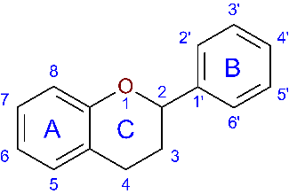 | c1cccc2CCC(Oc12)c1ccccc1
Flavonoids | Luteolin structure | 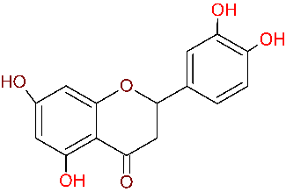 | O=C1CC(Oc2cc(O)cc(O)c21)c1cc(O)c(O)cc1
Flavonoids | Quercetin structure | 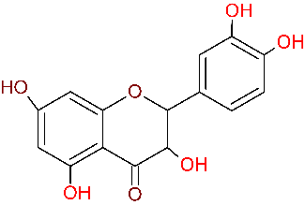 | OC1C(Oc2cc(O)cc(O)c2C1=O)c1cc(O)c(O)cc1
Isoflavonoids | General isoflavonoid structure | 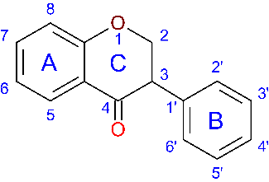 | O=C1C(COc2ccccc12)c1ccccc1
Isoflavonoids | Genistein structure | 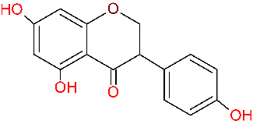 | O=C1c2c(cc(O)cc2O)OCC1c1ccc(O)cc1
Isoflavonoids | Daidzein structure | 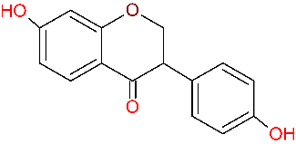 | O=C1C(COc2cc(O)ccc12)c1ccc(O)cc1
Pterocarpans | General pterocarpan structure | 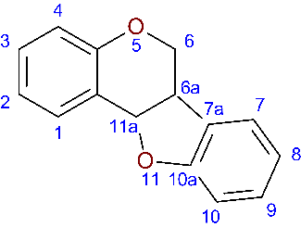 | C1Oc2ccccc2[C@H]2Oc3ccccc3[C@@H]12
Pterocarpans | (+) cis pterocarpan 6aS 11aS structure | 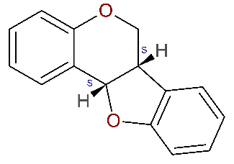 | C1Oc2ccccc2[C@H]2Oc3ccccc3[C@@H]12
Pterocarpans | (-) cis pterocarpan 6aR 11aR structure | 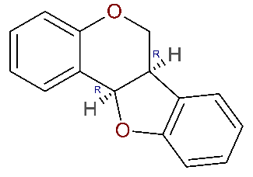 | C1Oc2ccccc2[C@@H]2Oc3ccccc3[C@H]12
Pterocarpans | (-) trans pterocarpan 6aR 11aS structure | 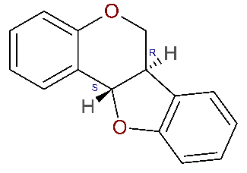 | C1Oc2ccccc2[C@H]2Oc3ccccc3[C@H]12
Pterocarpans | (+) trans pterocarpan 6aS 11aR structure | 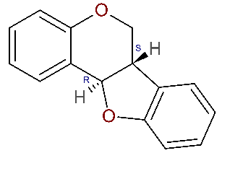 | C1Oc2ccccc2[C@@H]2Oc3ccccc3[C@@H]12
Pterocarpans | Medicarpin structure | 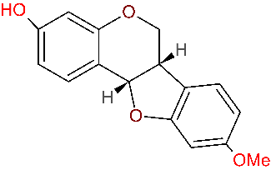 | Oc1cc2OC[C@H]3[C@H](Oc4cc(ccc43)OC)c2cc1
Pterocarpans | LQB-118 structure | 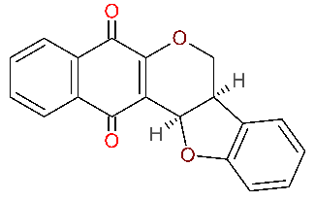 | O=C1C=2OC[C@@H]3[C@@H](Oc4ccccc43)C=2C(=O)c2ccccc12
Pterocarpans | General 2,3,9-trimethoxypterocarpan structure | 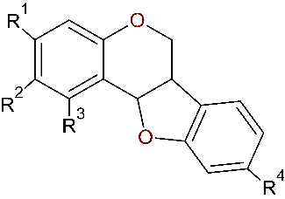 | [*]c1cc2OC3c4c([*])c([*])c([*])cc4OCC3c2cc1
Pterocarpans | (+)2,3,9-trimethoxypterocarpan structure | 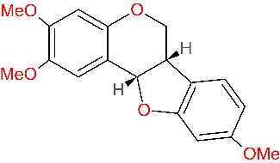 | COc1cc2OC[C@H]3[C@H](Oc4cc(ccc43)OC)c2cc1OC
 | (-)2,3,9-trimethoxypterocarpan structure | 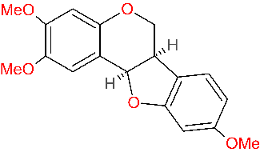 | COc1cc2OC[C@@H]3[C@@H](Oc4cc(ccc43)OC)c2cc1OC

SM Table 5 ADME prediction of different flavonoid, isoflavonoid, and pterocarpan molecules. *according to Lipinski et al.^{[86]} and Daina et al.^{[81]}.

 | Physicochemical Properties |  | Water Solubility |  | Pharmacokinetics |  | Druglikeness |  | Medicinal Chemistry
Molecule name | Formula | Molecular Weight (g/mol) | ESOL Log S (mol/L) | ESOL Class | GI absorption | BBB permeant | Lipinski violations | ABS | Pains alerts (Ideal = 0*) | Bren alerts (Ideal = 0*) | Synthetic Accessibility
 |  |  |  |  |  |  | (Ideal = 0*)
Luteolin | C15H10O6 | 286.24 | -3.71 | Soluble | High | No | 0.00 | 0.55 | 1.00 | 1.00 | 3.02
Quercetin | C15H10O7 | 302.24 | -3.16 | Soluble | High | No | 0.00 | 0.55 | 1.00 | 1.00 | 3.23
Genistein | C15H10O5 | 270.24 | -3.72 | Soluble | High | No | 0.00 | 0.55 | 0.00 | 0.00 | 2.87
Daidzein | C15H10O4 | 254.24 | -3.53 | Soluble | High | Yes | 0.00 | 0.55 | 0.00 | 0.00 | 2.79
Medicarpin | C15H12O4 | 256.25 | -3.43 | Soluble | High | Yes | 0.00 | 0.55 | 0.00 | 0.00 | 3.43
LQB-118 | C19H12O4 | 304.30 | -3.84 | Soluble | High | Yes | 0.00 | 0.85 | 1.00 | 0.00 | 4.12
(+)-2, 3, 9-Trimethoxypterocarpan | C18H18O5 | 314.33 | -3.91 | Soluble | High | Yes | 0.00 | 0.55 | 0.00 | 0.00 | 3.88

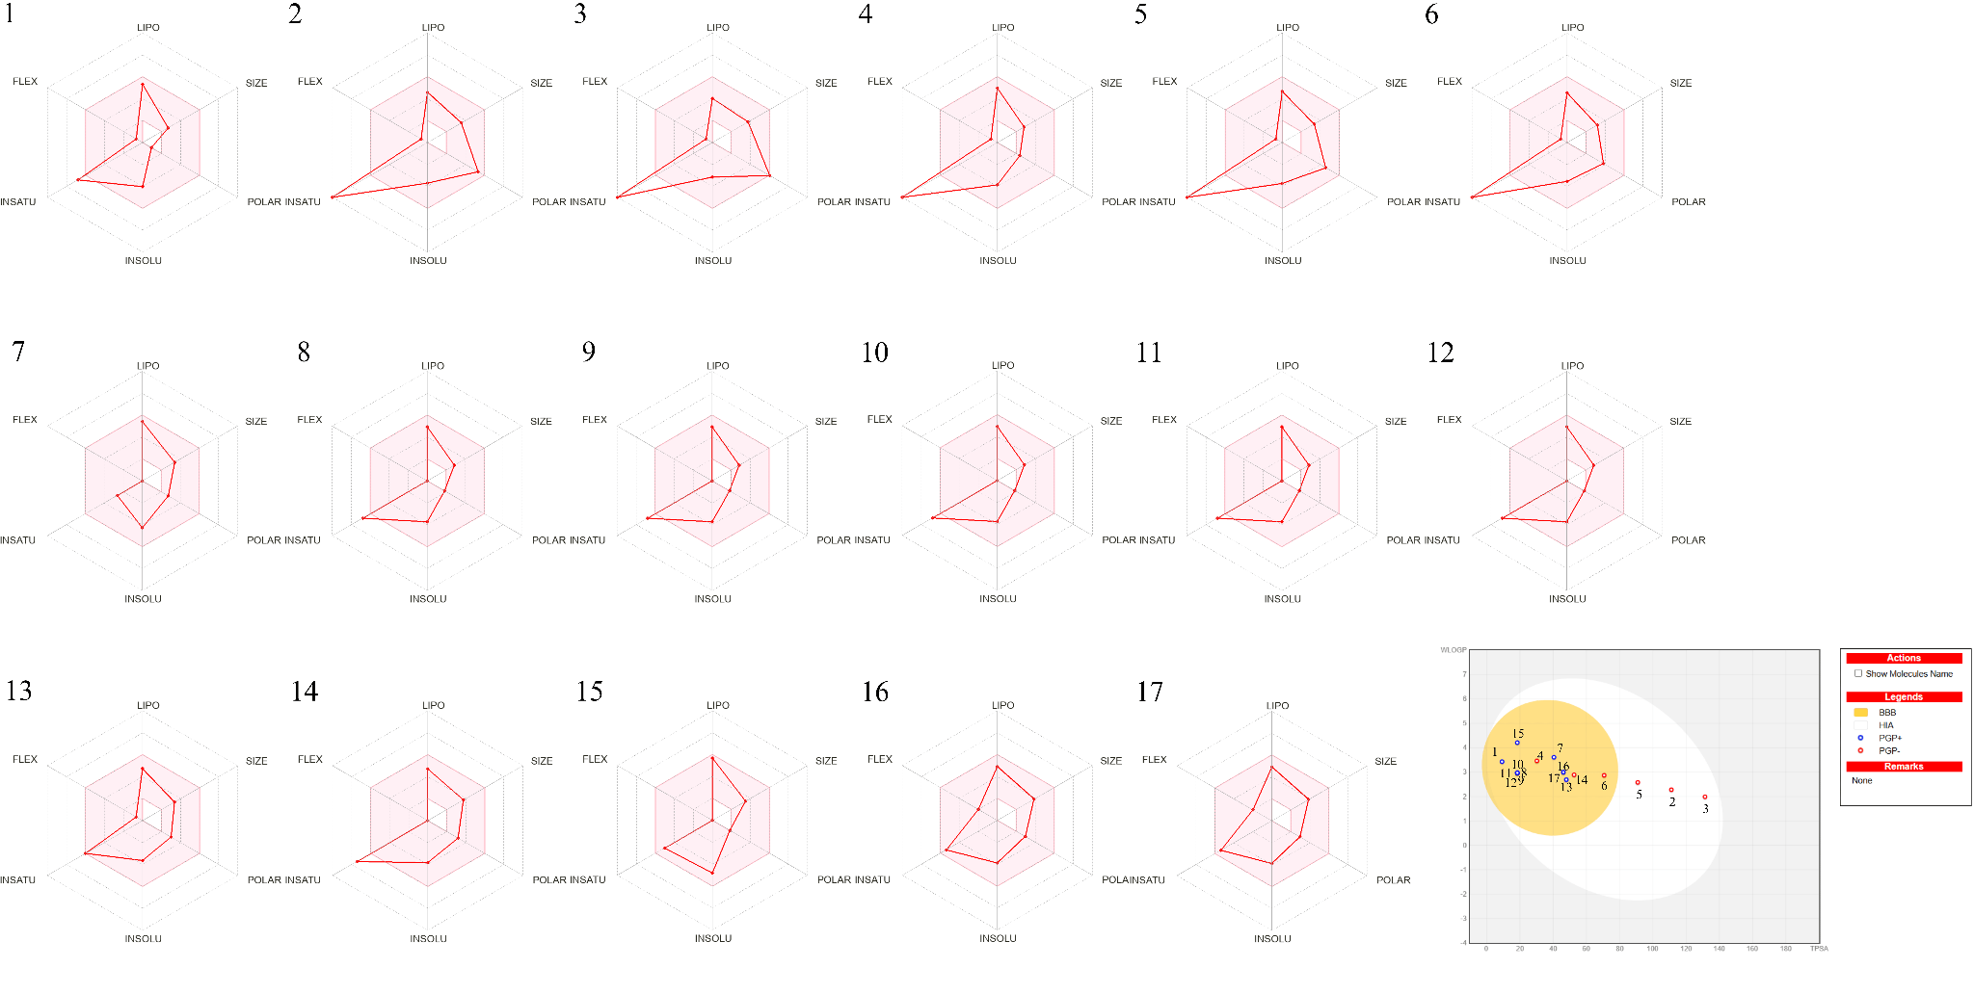
SM Figure 1 ADME BoiledEGG and radar for all the flavonoids, isoflavonoids and pterocarpans presented in the review.

