9-Deoxymuzigadial, a Sesquiterpene Isolated from Drimys brasiliensis (Winteraceae) Displays Reduced Cytotoxicity In Vitro and Modulates Leukocyte Activity and Fibrogenesis In Vivo

Bruno Antonio Ferreiraª, Isabella Silva Cassimiro^{b}, Francyelle Borges Rosa de Moura^{c},
Tais de Campos Lima^{b}, Danielle Reis Napolitano^{b}, Eric Umeharaª,
João Henrique Ghilardi Lagoª*, Fernanda de Assis Araújo^{d}*

ª Center for Natural and Human Sciences, Federal University of ABC, São Paulo 09210-170, Brazil
^{b} Institute of Biomedical Sciences, Federal University of Uberlândia, Uberlândia, 38408-100, Brazil
^{c} Institute of Biotechnology, Federal University of Catalão, Catalão, 75704-020, Brazil
^{d} Federal University de São João Del-Rei, Divinópolis, Brazil.

* Corresponding authors: joao.lago@ufabc.edu.br and fearaujo@ufsj.edu.br

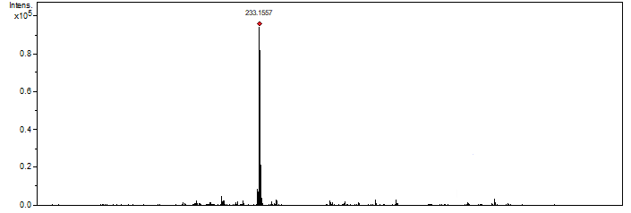

Figure S1: ESI-HRMS of 9-deoxymuzigadial

Figure S2. ¹H NMR spectrum of 9-deoxymuzigadial (δ, CDCl₃, 500 MHz)
Figure S3. ¹³C NMR spectrum of 9-deoxymuzigadial (δ, CDCl₃, 125 MHz)

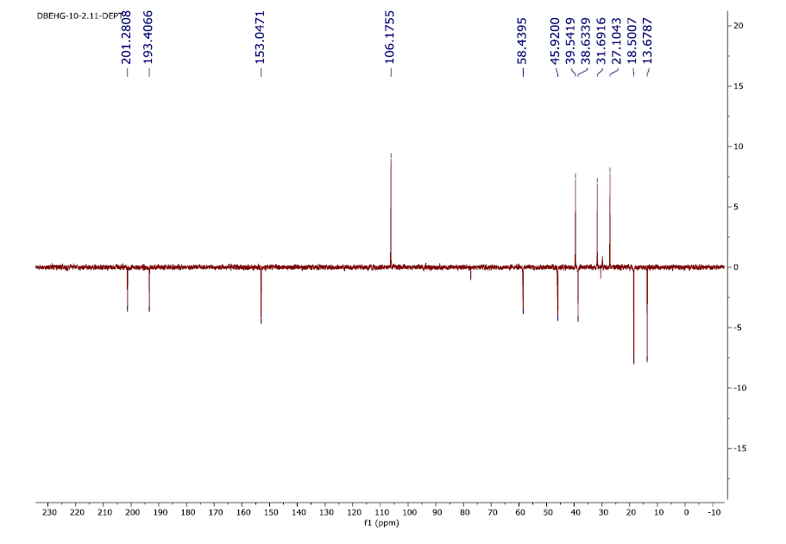
Figure S4. DEPT NMR spectrum of 9-deoxymuzigadial (δ, CDCl₃, 125 MHz)

