Supplementary material

Chemical Diversity of Three Endophytic Talaromyces Strains and their Potential for Biocontrol Against the Cocoa Pathogenic Fungus

Cecília L. S. Pereira,ª Gabrielle S. Paraguai,^{b} Thiago A. M. Brito,^{c} Josean F. Tavares,^{c} Sônia C. O. Melo,^{b} and Eliane O. Silva^{a*}

ªDepartment of Organic Chemistry, Institute of Chemistry, Universidade Federal da Bahia, Salvador 40170-115, Bahia, Brazil (elianeos@ufba.br)
^{b}Departament of Biological Sciences, Universidade Estadual de Santa Cruz, Ilhéus 45662900, Bahia, Brazil
^{c}Institute for Research in Pharmaceuticals and Medications, Universidade Federal da Paraíba, Campus I, João Pessoa 58051900, Paraíba, Brazil

*Corresponding author:

elianeos@ufba.br (E.O. Silva)
Institute of Chemistry, Organic Chemistry Department, Federal University of Bahia (UFBA), Barão de Jeremoabo 147, 40170-115 Salvador, Bahia, Brazil

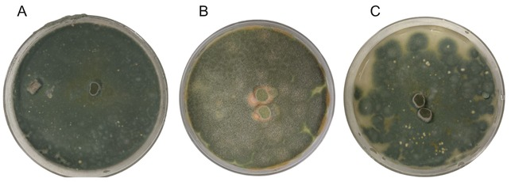
Figure S1. Axenic cultures of Talaromyces sp. H4 (A), Talaromyces pinophilus J6, and (B) Talaromyces stollii P7 (C) grown on PDA for 7 days.

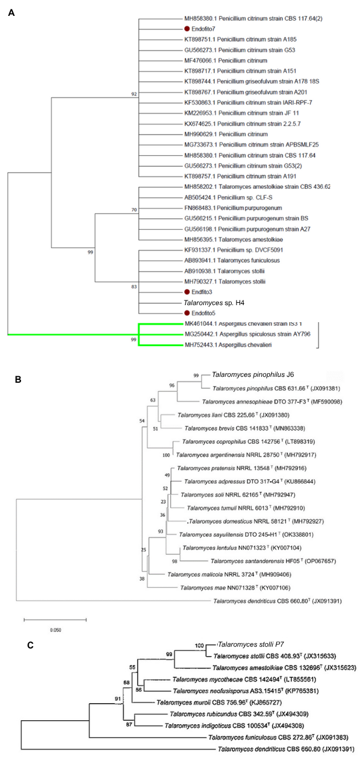
Figure S2. Phylogenetic positions based on ITS sequence of (A) Talaromyces sp. H4, and BenA sequences of (B) Talaromyces pinophilus J6 or (C) Talaromyces stolli P7. Phylogenetic trees were constructed by the Neighbor-Joining approach with MEGA 11.0. Bootstrap analysis was performed using 1,000 replications, and it is indicated at the nodes. The scale bars represent 0.050 substitutions per site.

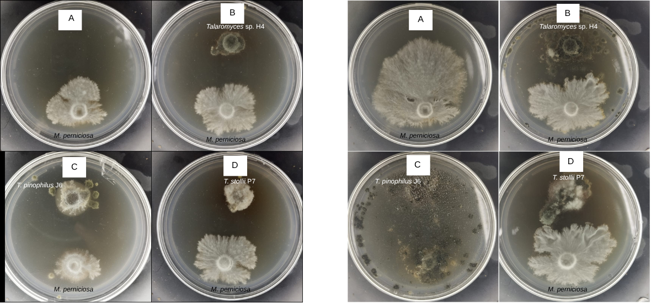
Figure S3. In vitro confrontation assays between Moniliophthora perniciosa and endophytic Talaromyces strains. Panels show: (A) M. perniciosa control, (B) Talaromyces sp. H4, (C) Talaromyces pinophilus J6, and (D) Talaromyces stollii P7. Each assay was performed on PDA plates under controlled conditions, and images were taken after 7 (left figure) or 14 (right figure) days to illustrate the inhibitory effect of each endophyte on the pathogen’s mycelial growth.

BLANK_M
BLANK_PDA
BLANK_PDB
QC
Figure S4. Base peak chromatograms (BPC) from UHPLC-HRMS (positive ion mode) of the ethyl acetate extract of controls: Blank_M = malt medium control, Blank_PDA = Potato Dextrose Agar medium control, Blank_PDB = Potato Dextrose Broth medium control, QC = Quality Control.

M_A_J6
M_S_J6
PDA_J6
PDB_A_J6
PDB_S_J6
Figure S5. Base peak chromatograms (BPC) from UHPLC-HRMS (positive ion mode) of the ethyl acetate extract of Talaromyces pinophilus J6 cultivated on M_A = malt medium with incubation under agitation, M_S = malt medium under static incubation, PDA = PDA medium, PDB_A = PDB medium with incubation under agitation, PDB_S = PDB medium under static incubation
M_A_H4
M_S_H4
PDA_H4
PDBD_A_H4
PDBD_S_H4
Figure S6. Base peak chromatograms (BPC) from UHPLC-HRMS (positive ion mode) of the ethyl acetate extract of Talaromyces sp. H4 cultivated on M_A = malt medium with incubation under agitation, M_S = malt medium under static incubation, PDA = PDA medium, PDB_A = PDB medium with incubation under agitation, PDB_S = PDB medium under static incubation
M_A_P7
M_S_P7
PDA_P7
PDB_A_P7
PDB_S_P7
Figure S7. Base peak chromatograms (BPC) from UHPLC-HRMS (positive ion mode) of the ethyl acetate extract of Talaromyces stollii P7 cultivated on M_A = malt medium with incubation under agitation, M_S = malt medium under static incubation, PDA = PDA medium, PDB_A = PDB medium with incubation under agitation, PDB_S = PDB medium under static incubation
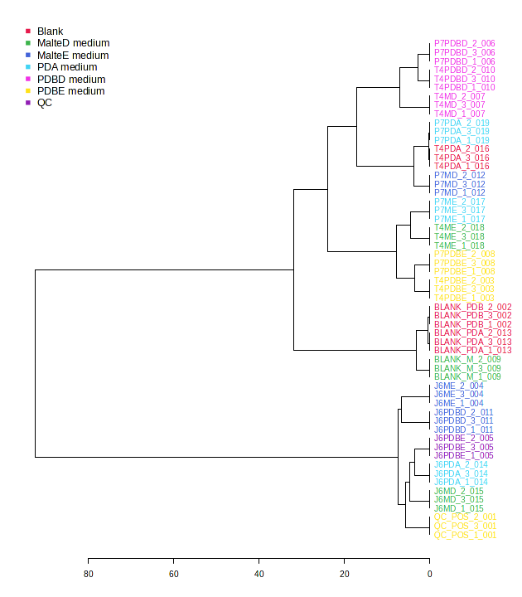

Figure S8. Hierarchical clustering analysis generated in MetaboAnalyst from metabolomic data, shown as a dendrogram, displaying sample grouping according to specialized metabolite similarities.

- 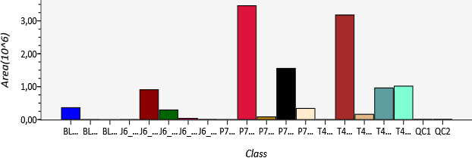
- 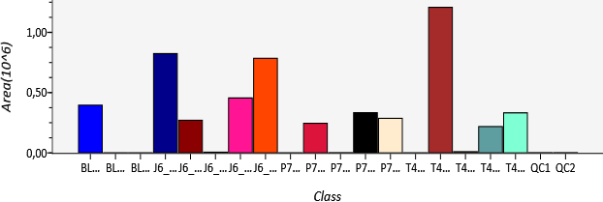
- 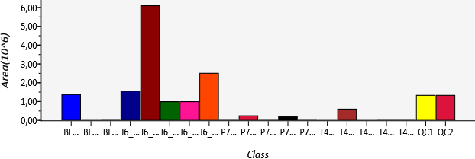
- 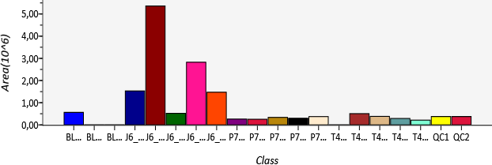
- 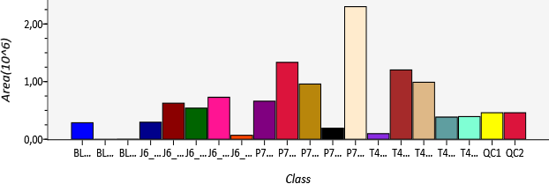
- 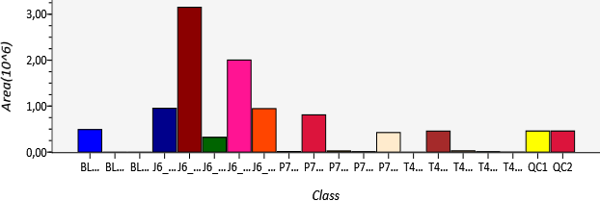
- 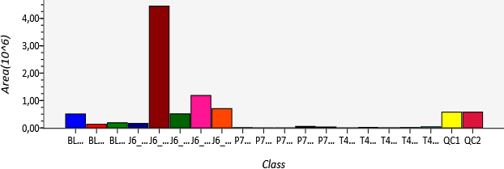
- 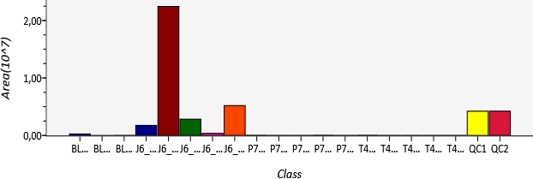
- 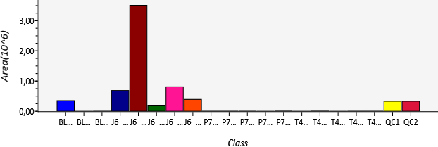
- 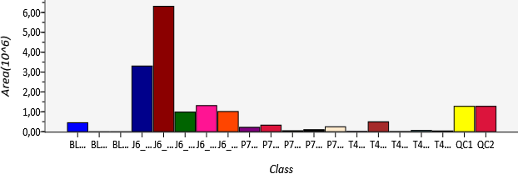
- 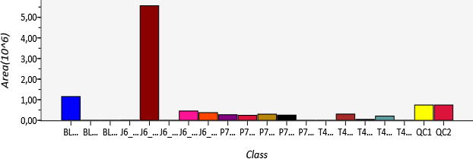
- 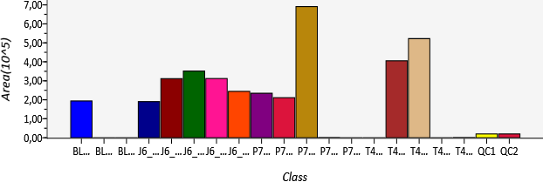
- 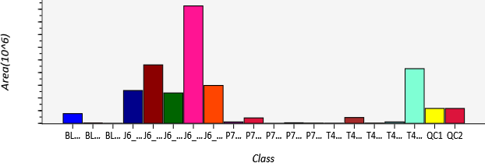
- 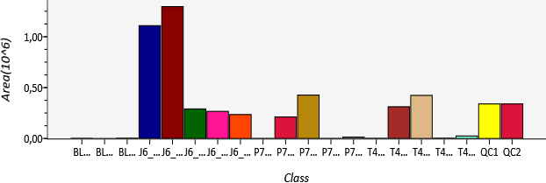
- 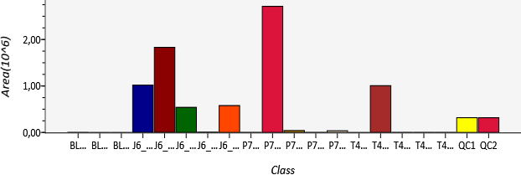
- 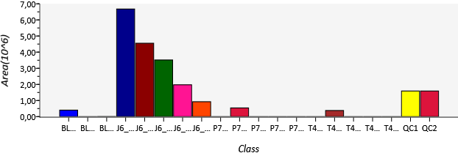
- 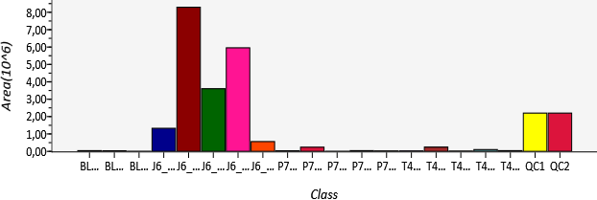
- 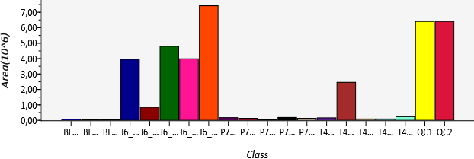
- 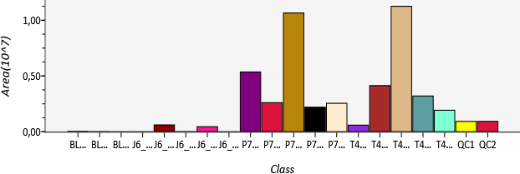
- 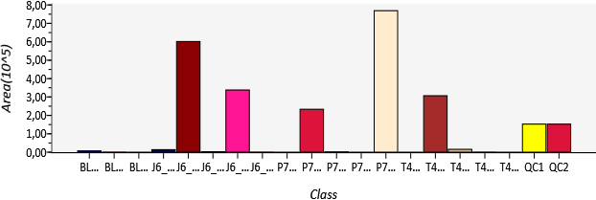
- 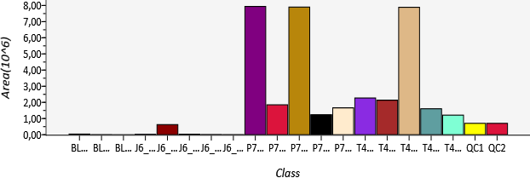
- 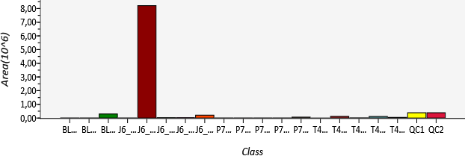

Figure S9. Chemical distribution of putatively identified specialized metabolites (compounds 1-22) among endophytic Talaromyces spp. The bar graphics were exported from MSDial software.

Table S1: The complete list of detected features, including mean values and standard deviations, can be found here

In-house database

Metabolite annotation was performed using a curated in-house database comprising chemical features previously reported for the genus Talaromyces. This database includes molecular formulae, accurate masses, and MS/MS fragmentation patterns compiled from research articles and reviews [1–29]

[1] M.-M. Zhai, J. Li, C.-X. Jiang, Y.-P. Shi, D.-L. Di, P. Crews, Q.-X. Wu, “The Bioactive Secondary Metabolites from Talaromyces species” Nat Prod Bioprospect 2016, 6, 1–24.
[2] L.-R. Lei, L.-Q. Gong, M.-Y. Jin, R. Wang, R. Liu, J. Gao, M.-D. Liu, L. Huang, G.-Z. Wang, D. Wang, Y. Deng, “Research advances in the structures and biological activities of secondary metabolites from Talaromyces” Front Microbiol 2022, 13, DOI 10.3389/fmicb.2022.984801.
[3] R. Nicoletti, R. Bellavita, A. Falanga, “The Outstanding Chemodiversity of Marine-Derived Talaromyces” Biomolecules 2023, 13, 1021.
[4] G.-C. Fu, Z.-D. Yang, S.-Y. Zhou, X.-M. Li, H.-T. Yu, X.-J. Yao, J.-G. Fang, Z.-M. Shu, H.-Y. Xue, Y.-G. Wang, “Wortmannines A–C, three novel wortmannin derivatives with an unusual five-membered B ring from the endophytic fungus Talaromyces wortmannii LGT-4” Tetrahedron Lett 2016, 57, 4608–4611.
[5] F. Vinale, R. Nicoletti, F. Borrelli, A. Mangoni, O. A. Parisi, R. Marra, N. Lombardi, F. Lacatena, L. Grauso, S. Finizio, M. Lorito, S. L. Woo, “Co-Culture of Plant Beneficial Microbes as Source of Bioactive Metabolites” Sci Rep 2017, 7, 14330.
[6] M. Wang, L. Yang, L. Feng, F. Hu, F. Zhang, J. Ren, Y. Qiu, Z. Wang, “Verruculosins A–B, New Oligophenalenone Dimers from the Soft Coral-Derived Fungus Talaromyces verruculosus” Mar Drugs 2019, 17, 516.
[7] F. Lacatena, R. Marra, P. Mazzei, A. Piccolo, M. C. Digilio, M. Giorgini, S. L. Woo, P. Cavallo, M. Lorito, F. Vinale, “Chlamyphilone, a Novel Pochonia chlamydosporia Metabolite with Insecticidal Activity” Molecules 2019, 24, 750.
[8] T. O. Akinfala, J. Houbraken, M. Sulyok, A. R. Adedeji, A. C. Odebode, R. Krska, C. N. Ezekiel, “Moulds and their secondary metabolites associated with the fermentation and storage of two cocoa bean hybrids in Nigeria” Int J Food Microbiol 2020, 316, 108490.
[9] L.-X. Feng, B.-Y. Zhang, H.-J. Zhu, L. Pan, F. Cao, “Bioactive Metabolites from Talaromyces purpureogenus, an Endophytic Fungus from Panax notoginseng” Chem Nat Compd 2020, 56, 974–976.
[10] W. Yang, Q. Tan, Y. Yin, Y. Chen, Y. Zhang, J. Wu, L. Gao, B. Wang, Z. She, “Secondary Metabolites with α-Glucosidase Inhibitory Activity from Mangrove Endophytic Fungus Talaromyces sp. CY-3” Mar Drugs 2021, 19, 492.
[11] S. P. Pelo, O. A. Adebo, E. Green, “Chemotaxonomic profiling of fungal endophytes of Solanum mauritianum (alien weed) using gas chromatography high resolution time-of-flight mass spectrometry (GC-HRTOF-MS)” Metabolomics 2021, 17, 43.
[12] Z.-D. Yang, X.-D. Zhang, X. Yang, X.-J. Yao, Z.-M. Shu, “A norbisabolane and an arabitol benzoate from Talaromyces marneffei, an endophytic fungus of Epilobium angustifolium” Fitoterapia 2021, 153, 104948.
[13] J. V. Christiansen, T. Isbrandt, C. Petersen, T. E. Sondergaard, M. R. Nielsen, T. B. Pedersen, J. L. Sørensen, T. O. Larsen, J. C. Frisvad, “Fungal quinones: diversity, producers, and applications of quinones from Aspergillus, Penicillium, Talaromyces, Fusarium, and Arthrinium” Appl Microbiol Biotechnol 2021, 105, 8157–8193.
[14] X. Li, T. Awakawa, T. Mori, M. Ling, D. Hu, B. Wu, I. Abe, “Heterodimeric Non-heme Iron Enzymes in Fungal Meroterpenoid Biosynthesis” J Am Chem Soc 2021, 143, 21425–21432.
[15] Y.-L. Li, J.-L. Yi, J. Cai, X.-M. Zhou, L. Chen, X. Zhuo, X.-Y. Lai, “Two new bioactive secondary metabolites from the endophytic fungus Talaromyces assiutensis JTY2” Nat Prod Res 2022, 36, 3695–3700.
[16] K. Zhang, X. Zhang, R. Lin, H. Yang, F. Song, X. Xu, L. Wang, “New Secondary Metabolites from the Marine-Derived Fungus Talaromyces mangshanicus BTBU20211089” Mar Drugs 2022, 20, 79.
[17] F. Song, Y. Dong, S. Wei, X. Zhang, K. Zhang, X. Xu, “New Antibacterial Secondary Metabolites from a Marine-Derived Talaromyces sp. Strain BTBU20213036” Antibiotics 2022, 11, 222.
[18] A. J. al Fahad, “Putative Biosynthesis of Talarodioxadione &amp; Talarooxime from Talaromyces stipitatus” Molecules 2022, 27, 4473.
[19] C. Cerracchio, V. Iovane, M. M. Salvatore, M. G. Amoroso, H. Dakroub, M. DellaGreca, R. Nicoletti, A. Andolfi, F. Fiorito, “Effectiveness of the Fungal Metabolite 3-O-Methylfunicone towards Canine Coronavirus in a Canine Fibrosarcoma Cell Line (A72)” Antibiotics 2022, 11, 1594.
[20] Y. A. Hasanien, A. A. Nassrallah, A. G. Zaki, G. Abdelaziz, “Optimization, purification, and structure elucidation of anthraquinone pigment derivative from Talaromyces purpureogenus as a novel promising antioxidant, anticancer, and kidney radio-imaging agent” J Biotechnol 2022, 356, 30–41.
[21] H. Farhat, F. Urooj, N. Sohail, S. F. Hameedi, M. S. Ali, S. Ehteshamul-Haque, “Evaluation of antibacterial potential of endophytic fungi and GC-MS profiling of metabolites from Talaromyces trachyspermus” South African Journal of Botany 2022, 150, 240–247.
[22] I. A. Soliman, Y. A. Hasanien, A. G. Zaki, H. A. Shawky, A. A. Nassrallah, “Irradiation impact on biological activities of Anthraquinone pigment produced from Talaromyces purpureogenus and its evaluation, characterization and application in beef burger as natural preservative” BMC Microbiol 2022, 22, 325.
[23] M. Rani, S. Jaglan, V. Beniwal, V. Chhokar, “Bioactive saponin profiling of endophytic fungi from Asparagus racemosus” Nat Prod Res 2023, 37, 3889–3895.
[24] D. Zhang, X. Wang, B. Liu, S. Li, Y. Wang, T. Guo, Y. Sun, “New Dipyrroloquinones from a Plant-Derived Endophytic Fungus Talaromyces sp.” Molecules 2023, 28, 7847.
[25] M. Dutta, A. Hazra, E. Bhattacharya, R. Bose, S. Mandal Biswas, “Characterization and metabolomic profiling of two pigment producing fungi from infected fruits of Indian Gooseberry” Arch Microbiol 2023, 205, 141.
[26] Z.-D. Yang, J. Ma, Z.-J. Li, J. Jin, L. Wang, Z.-M. Shu, “Secondary Metabolites of the Endophytic Fungi Talaromyces flavus Cultivated in Pumpkin Medium and Their Bioactivity” Chem Nat Compd 2023, 59, 549–552.
[27] W. Wang, J. Wang, F. Song, R. Jia, L. Wang, X. Xu, N. Yang, “New Secondary Metabolites from Marine-Derived Fungus Talaromyces minnesotensis BTBU20220184” Mar Drugs 2024, 22, 237.
[28] B. N. S. Ningsih, V. Rukachaisirikul, S. Phongpaichit, C. Muanprasat, S. Preedanon, J. Sakayaroj, R. Intayot, S. Jungsuttiwong, “Talarostatin, a vermistatin derivative from the soil-derived fungus Talaromyces thailandensis PSU-SPSF059” Nat Prod Res 2024, 38, 2535–2542.
[29] Y. Wang, X.-M. Li, N. Song, B.-G. Wang, H.-L. Li, L.-H. Meng, “Secondary metabolites with fungicide potentials from the deep-sea seamount-derived fungus Talaromyces scorteus AS-242” Bioorg Chem 2024, 147, 107417.

