Microbial chemical diversity and cytotoxic potential from Brazilian ferruginous caves: a pioneering metabolomic survey
Natália Naomi Kato¹, Aline Figueiredo Cardoso², Bianca Del Bianco Sahm^{1,3}, Letícia Veras Costa-Lotufo³, José Augusto Pires Bitencourt², Norberto Peporine Lopes^{1, *}
¹Núcleo de Pesquisa em Produtos Naturais e Sintéticos, Faculdade de Ciências Farmacêuticas de Ribeirão Preto, Universidade de São Paulo (USP), Av. do Café s/n°, Ribeirão Preto - SP 14040-903.
²Instituto Tecnológico da Vale Desenvolvimento Sustentável, R. Boaventura da Silva, 955, Belém - PA, 66055-090.
³Laboratório de Farmacologia de Produtos Naturais Marinhos, Instituto de Ciências Biomédicas, Universidade de São Paulo, Av. Prof. Lineu Prestes 1524, São Paulo - SP, 05508-000

Figure S1: Chromatograms from LC-MS/MS analysis of eight isolated bacteria strain.

Table S1: Parameters used in the preprocessing in MZmine 3.9.0
Mass detection | MS1 | 1E3 (centroid)
Mass detection | MS2 | 1E2 (centroid)
Mass detection | Min. cons. scan | 5
ADAP Chromatogram Build | Min. intens. for cons. scans | 1E3
ADAP Chromatogram Build | Min. absolute height | 1E3
ADAP Chromatogram Build | m/z tolerance | 0.02
Spectral deconvolution | MS/MS pairing MS1 to MS2 (m/z) | 0.03
Spectral deconvolution | RT tolerance (min.) | 0.2
Spectral deconvolution | S/N threshold | 10
Spectral deconvolution | Min. abs. height | 1E3
Spectral deconvolution | Coeff./area threshold | 10
Spectral deconvolution | Peak duration range | 0.2 to 2
Spectral deconvolution | RT wav. range | 0.01 to 0.1
Isotopic grouping | m/z tolerance (intra-sample) | 0 .02
Isotopic grouping | RT tolerance | 0.02 (abs./min.)
Isotopic grouping | Max. Charge | 2
Alignment | m/z tolerance | 0.05
Alignment | weight for m/z | 70
Alignment | weight for RT | 30
Alignment | RT tolerance | 0.3

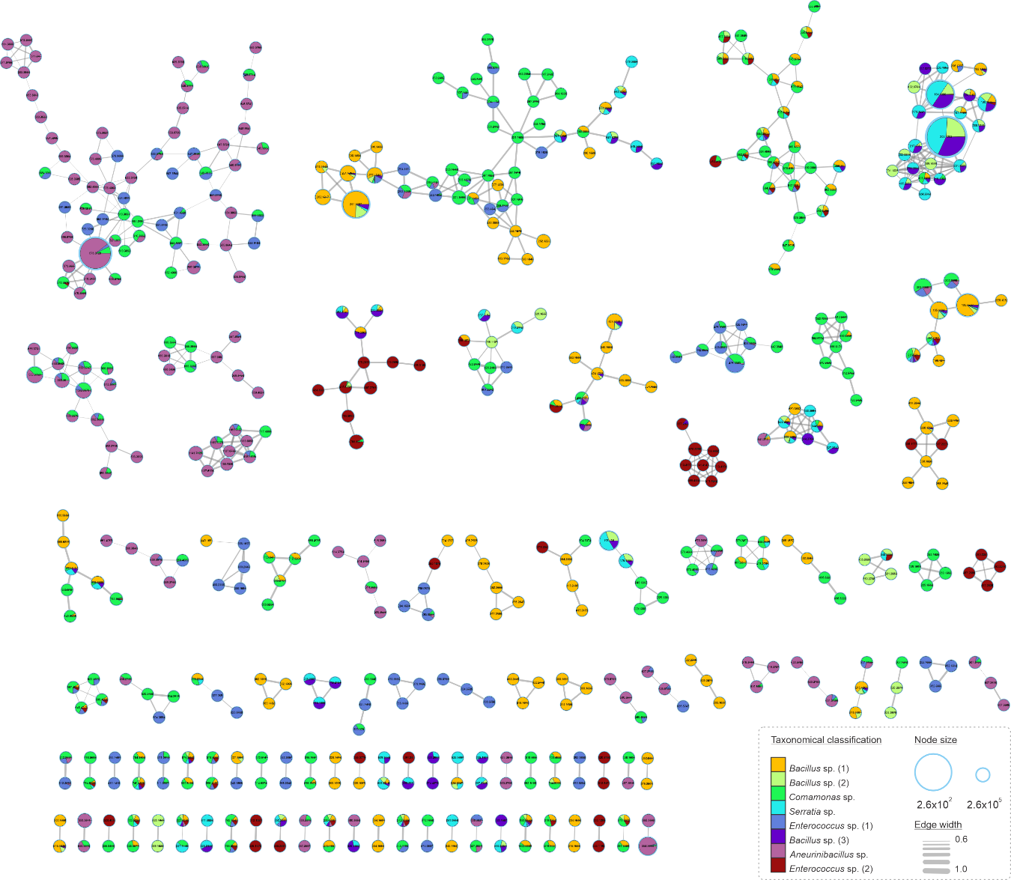
Figure S2: Molecular network of all clusters obtained by MS/MS analysis in positive ionization mode. Each color represents an isolated bacterium, whose genera are described in the legend and the node size corresponds to the relative abundance of ions. The edge size represents the cosine score among the nodes.

Data availability: The Feature Based Molecular Network workflow is available in the GNPS2 platform. The data can be assessed by the following link: https://gnps2.org/status?task=70628d36df1a461c983a3aba633d4612

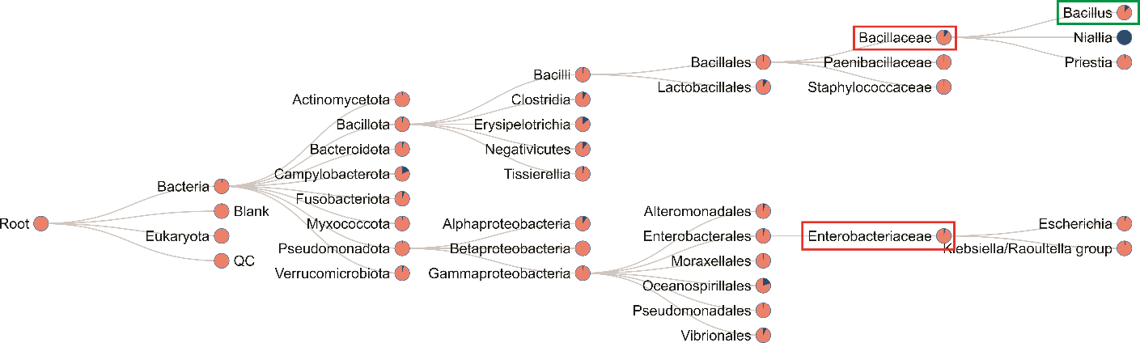
Figure S3: Cholic acid spectral search on microbeMASST. Pink nodes represent the presence of the Spectrum USI in different microbial groups.

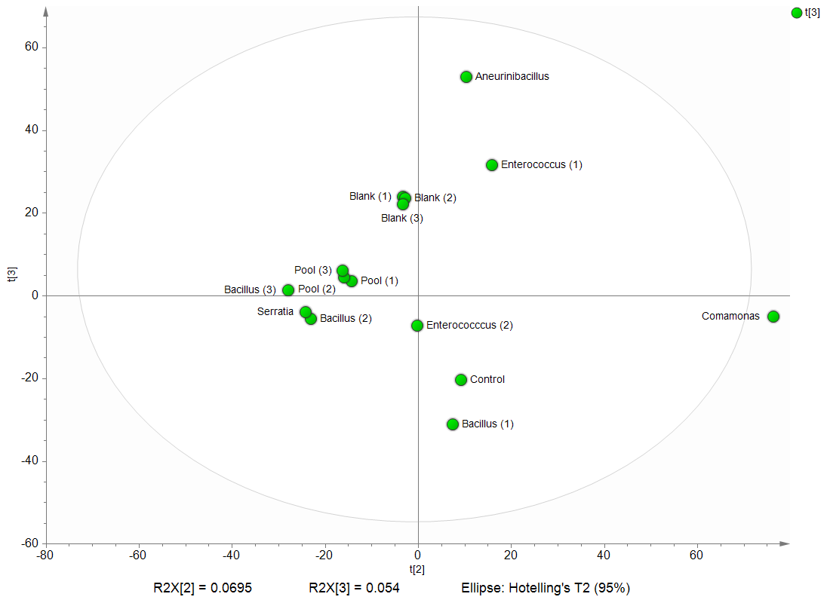
Figure S4: Principal Component Analysis (PCA) scores plot of the bacterial samples, blanks, and quality control. The model presented R² of 0.77 and Q² of 0.46 values.

Table S2. Cytotoxic activity rates of eight recovered cave-dwelling bacteria.
Samples | 501mel |  |  |  | HCT - 116
Samples | 5µg/mL |  | 50µg/mL |  | 5µg/mL |  | 50µg/mL
Samples | Mean | SD | Mean | SD | Mean | SD | Mean | SD
Bacillus sp. (1) | 34.426 | 17.86 | 51.072 | 9.881 | 14.532 | 6.924 | 31.448 | 11.694
Bacillus sp. (2) | 21.115 | 6.968 | 41.512 | 7.313 | -6.117 | 21.933 | 11.655 | 22.612
Comamonas sp. | 42.653 | 21.303 | 68.564 | 6.636 | 13.994 | 17.979 | 38.296 | 5.833
Serratia sp. | 21.595 | 18.055 | 39.146 | 11.953 | 5.596 | 8.286 | 20.199 | 6.798
Enterococcus sp. (1) | 49.735 | 18.2 | 84.846 | 6.543 | 8.715 | 11.324 | 67.998 | 20.768
Bacillus sp. (3) | 13.336 | 13.989 | 27.19 | 8.982 | -5.19 | 8.42 | 1.375 | 16.334
Aneurinibacillus sp. | 27.334 | 8.925 | 98.686 | 4.91 | 2.286 | 21.453 | 99.607 | 4.684
Enterococcus sp. (2) | 12.178 | 12.44 | 33.496 | 7.332 | 8.348 | 13.188 | 17.037 | 9.89
All samples were tested in triplicates.

Table S3. Discriminants features from the PLS-DA, showing the predicted active metabolites.
ID | m/z | RT | VIP Score | Adduct | MS/MS | Class | Groups
1155 | 578.373 | 13.55 | 3.27 | (M+2H)⁺² | 895; 448; 183; 169; 120; 115 | Cyclopeptides | Comamonas sp.; Enterococcus sp. (1); Aneurinibacillus sp.
932 | 426.098 | 11.42 | 3.04 | (M+H)+ | 382; 291; 221; 190; 172; 146 |  | Comamonas sp.; Enterococcus sp. (1); Aneurinibacillus sp.
1429 | 592.367 | 15.80 | 3.02 | (M+2H)⁺² | 311; 169 | Cyclopeptides | Comamonas sp.; Enterococcus sp. (1); Aneurinibacillus sp.
1417 | 585.36 | 15.71 | 2.91 | (M+2H)⁺² | 339; 169; 120; 115 | Cyclopeptides | Comamonas sp.; Enterococcus sp. (1); Aneurinibacillus sp.
613 | 293.129 | 8.09 | 2.85 | (M+2H)⁺² | 199; 155; 144; 117; 115 | Cyclopeptides | Comamonas sp.; Enterococcus sp. (1); Aneurinibacillus sp.
1059 | 564.354 | 12.65 | 2.78 | (M+2H)⁺² | 434; 169; 155; 120; 115 | Cyclopeptides | Comamonas sp.; Enterococcus sp. (1); Aneurinibacillus sp.
1522 | 599.375 | 16.39 | 2.74 | (M+2H)⁺² | 311; 169; 120; 115 | Cyclopeptides | Comamonas sp.; Enterococcus sp. (1); Aneurinibacillus sp.
1508 | 592.367 | 16.30 | 2.65 | (M+2H)⁺² | 353; 311; 120; 115 | Cyclopeptides | Comamonas sp.; Enterococcus sp. (1); Aneurinibacillus sp.
1562 | 638.38 | 16.61 | 2.55 | (M+2H)⁺² | 311; 120; 115 | Cyclopeptides | Comamonas sp.; Enterococcus sp. (1); Aneurinibacillus sp.
1420 | 1169.71 | 15.73 | 2.54 | (M+2H)⁺² | 859; 571; 339; 115 |  | Comamonas sp.; Enterococcus sp. (1); Aneurinibacillus sp.
1934 | 647.395 | 18.07 | 2.48 | (M+2H)⁺² | 169; 120 | Cyclopeptides | Comamonas sp.; Enterococcus sp. (1); Aneurinibacillus sp.
847 | 424.082 | 10.61 | 2.47 | (M+H)⁺ | 372; 354; 219; 172; 146 |  | Comamonas sp.; Enterococcus sp. (1); Aneurinibacillus sp.
37 | 202.09 | 2.54 | 2.44 | (M+H)⁺ | 131 |  | Bacillus sp. (1); Comamonas sp.; Enterococcus sp. (1); Aneurinibacillus sp.; Enterocuccus sp. (2)
212 | 294.113 | 4.55 | 2.43 | (M+H)⁺ | 155; 145 |  | Comamonas sp.; Enterococcus sp. (1); Aneurinibacillus sp.
381 | 201.106 | 5.843 | 2.43 | (M+H)⁺ | 131; 125; 107 |  | Bacillus sp. (1); Bacillus sp. (2), Comamonas sp.; Serratia sp.; Enterococcus sp. (1); Aneurinibacillus sp.
862 | 295.059 | 10.80 | 2.41 | (M+H)⁺ | 130 |  | Comamonas sp.; Enterococcus sp. (1); Aneurinibacillus sp.
1352 | 585.364 | 15.18 | 2.35 | (M+2H)⁺² | 339; 311; 169; 120; 115 | Cyclopeptides | Comamonas sp.; Enterococcus sp. (1); Aneurinibacillus sp.
1452 | 631.373 | 15.99 | 2.32 | (M+2H)⁺² | 431; 311; 169; 120; 115 | Cyclopeptides | Comamonas sp.; Enterococcus sp. (1); Aneurinibacillus sp.
1876 | 312.253 | 17.78 | 2.30 | (M+2H)⁺² | 116 |  | Comamonas sp.; Enterococcus sp. (1); Aneurinibacillus sp.
1358 | 607.37 | 15.23 | 2.30 | (M+2H)⁺² | 353; 339; 311; 297; 169; 155; 120; 115 | Cyclopeptides | Comamonas sp.; Enterococcus sp. (1); Aneurinibacillus sp.
1497 | 645.371 | 16.27 | 2.29 | (M+2H)⁺² | 311; 169; 120; 115 | Cyclopeptides | Comamonas sp.; Enterococcus sp. (1); Aneurinibacillus sp.
210 | 231.117 | 4.521 | 2.28 | (M+H)⁺² | 231; 201; 137; 131; 107 |  | Comamonas sp.; Enterococcus sp. (1); Aneurinibacillus sp.
1553 | 613.388 | 16.56 | 2.23 | (M+2H⁾⁺² | 311; 169; 120; 115 | Cyclopeptides | Comamonas sp.; Enterococcus sp. (1); Aneurinibacillus sp.
1626 | 633.379 | 16.91 | 2.18 | (M+2H)⁺² | 120 | Cyclopeptides | Comamonas sp.; Enterococcus sp. (1); Aneurinibacillus sp.
1589 | 583.363 | 16.73 | 2.17 | (M+2H)⁺² | 569; 534; 526; 120 | Cyclopeptides | Comamonas sp.; Enterococcus sp. (1); Aneurinibacillus sp.
1214 | 585.376 | 14.0556 | 2.15 | (M+2H)⁺² | 325; 183; 120; 115 | Cyclopeptides | Comamonas sp.; Aneurinibacillus sp.
1341 | 673.396 | 15.09 | 2.10 | (M+2H⁾⁺² | 120; 115 | Cyclopeptides | Comamonas sp.; Enterococcus sp. (1); Aneurinibacillus sp.
737 | 382.155 | 9.43 | 2.05 | (M+H)⁺ | 250; 182; 134 |  | Aneurinibacillus sp.

