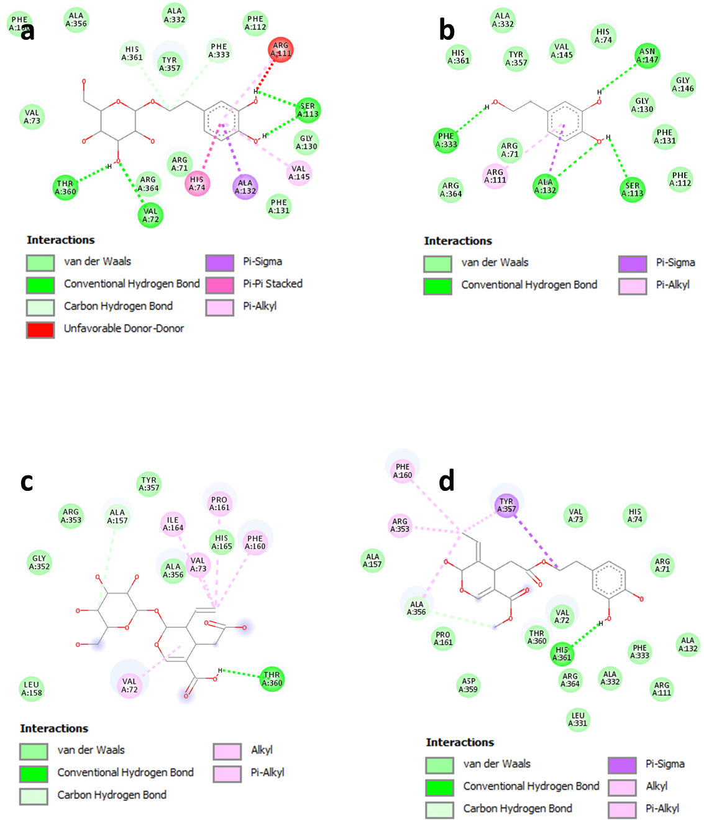
Figure S1. 2D interaction diagrams of (a) hydroxytyrosol glucoside, (b) hydroxytyrosol, (c) secologanoside, and (d) oleuropein aglycone within the active site of catalase (PDB: 1TGU).

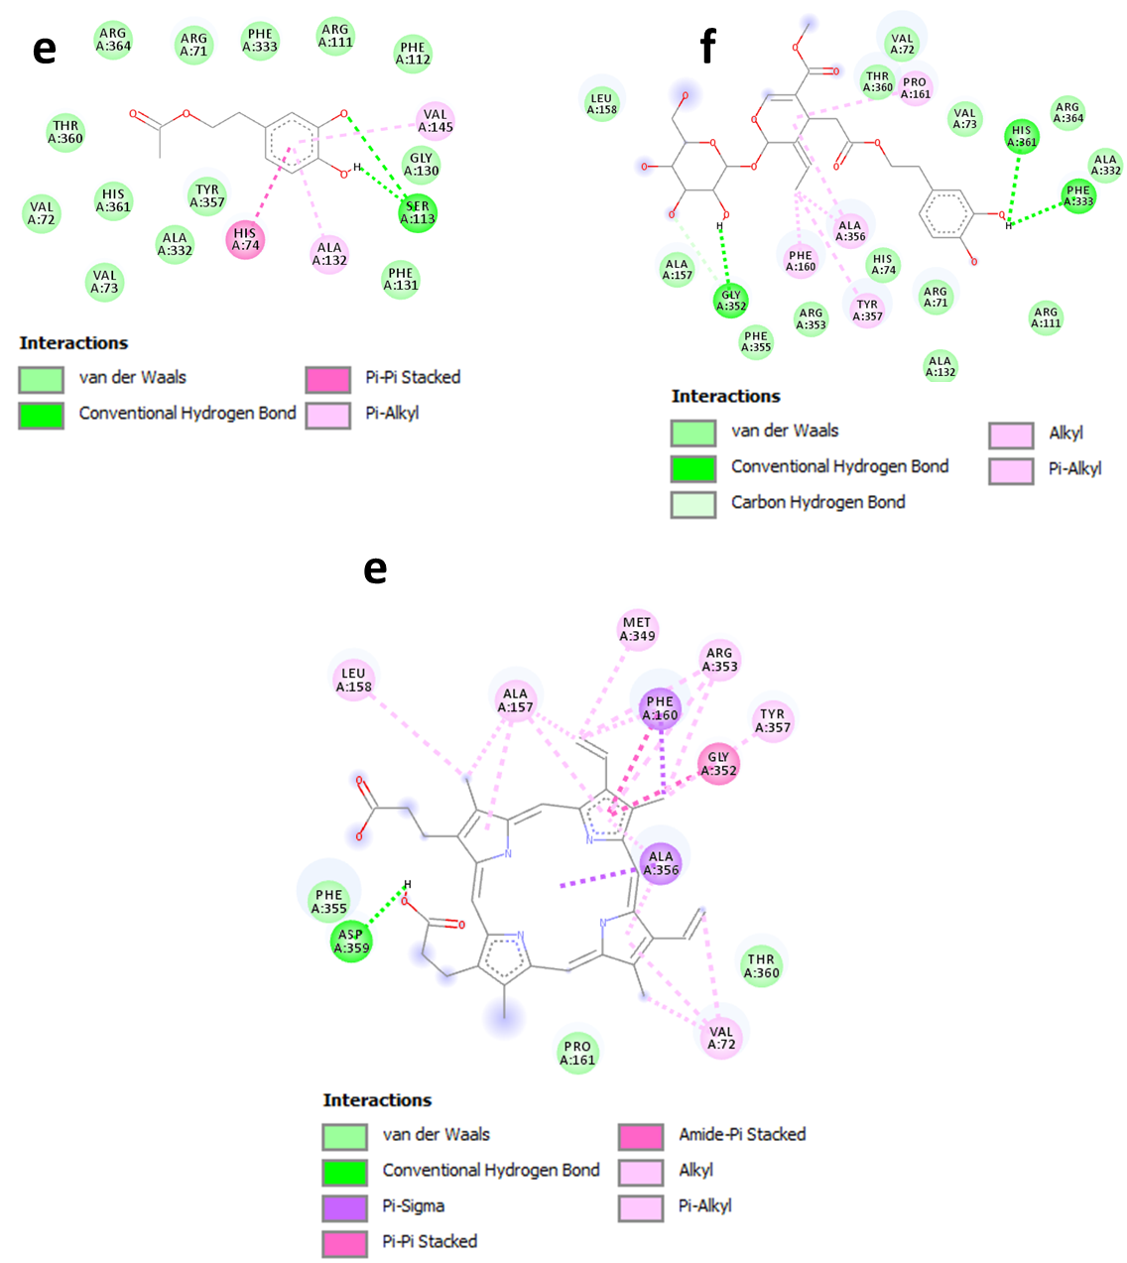
Figure S2. 2D interaction models of (e) hydroxytyrosol acetate, (f) oleuropein, and (g) the co-crystallized ligand within the active site of catalase (PDB: 1TGU).
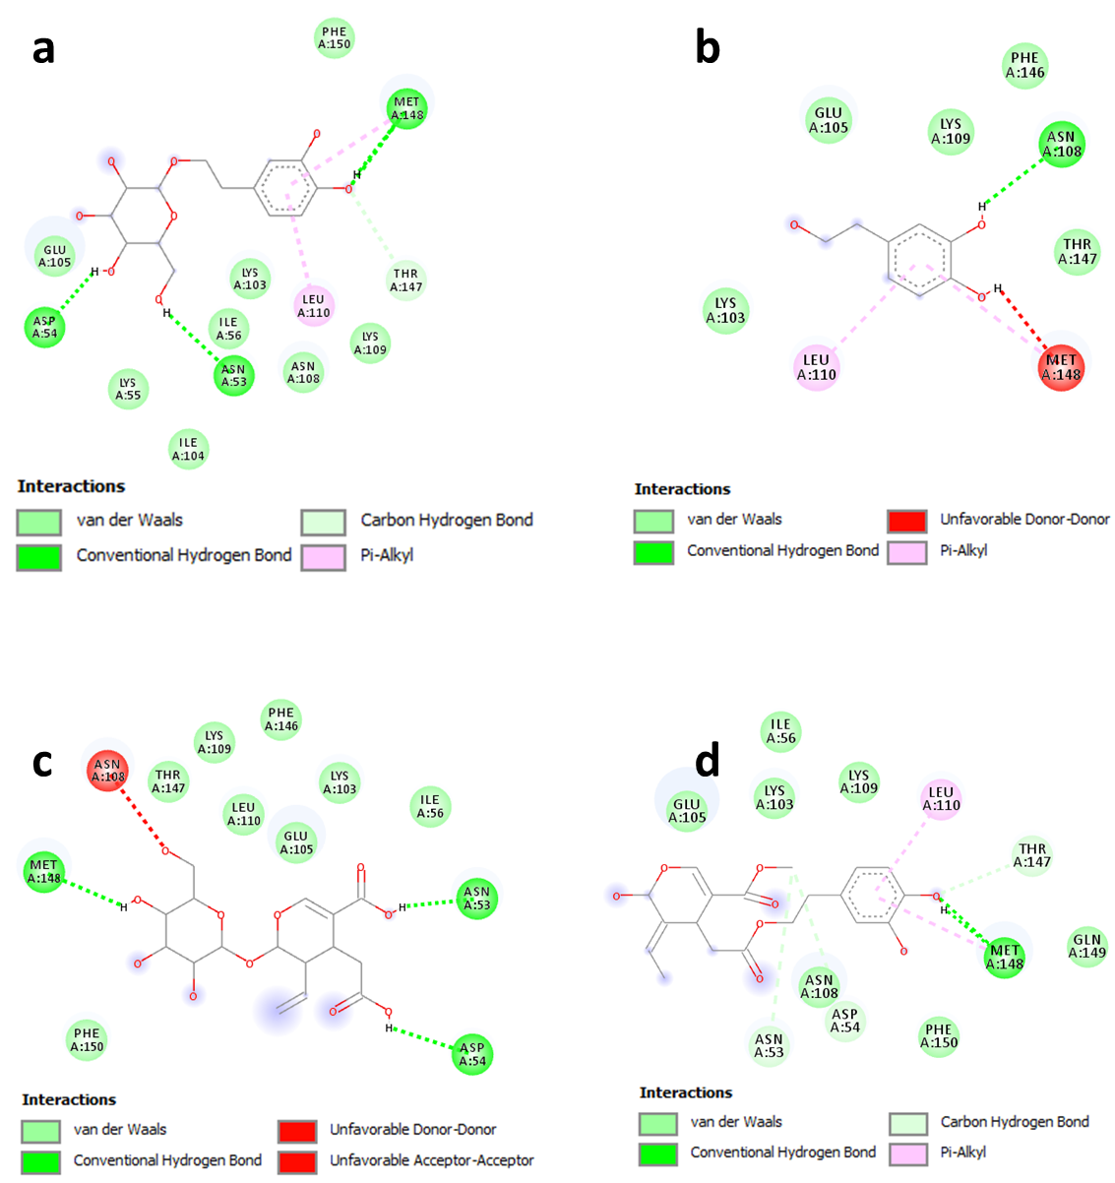
Figure S3. 2D interaction models of (a) hydroxytyrosol glucoside, (b) hydroxytyrosol, (c) secologanoside, and (d) oleuropein aglycone within the active site of IL-1β (PDB: 6Y8M).

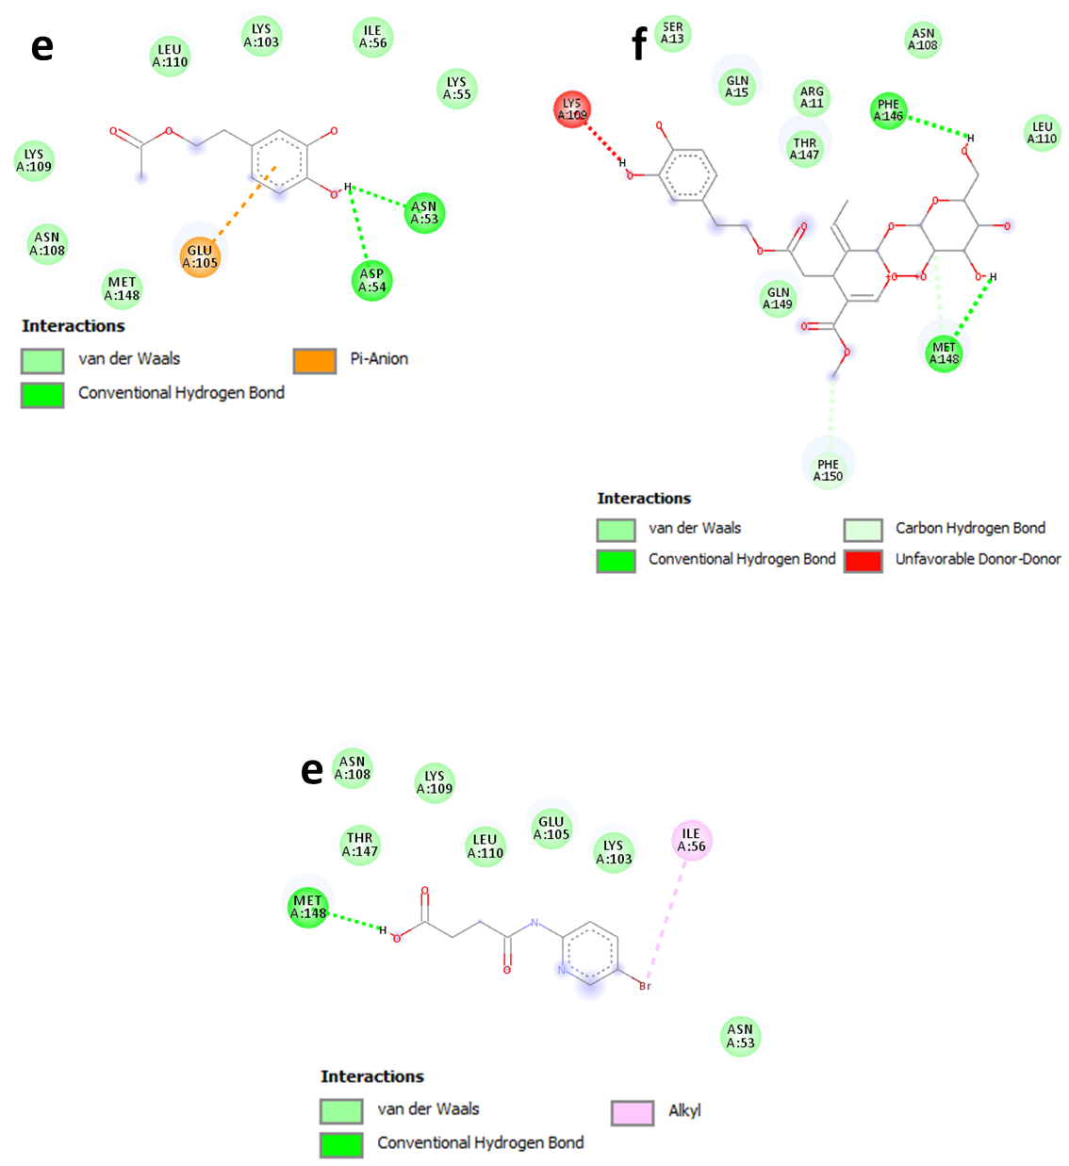
Figure S4. 2D interaction models of (e) hydroxytyrosol acetate, (f) oleuropein, and (g) the co-crystallized ligand within the active site of IL-1β (PDB: 6Y8M).
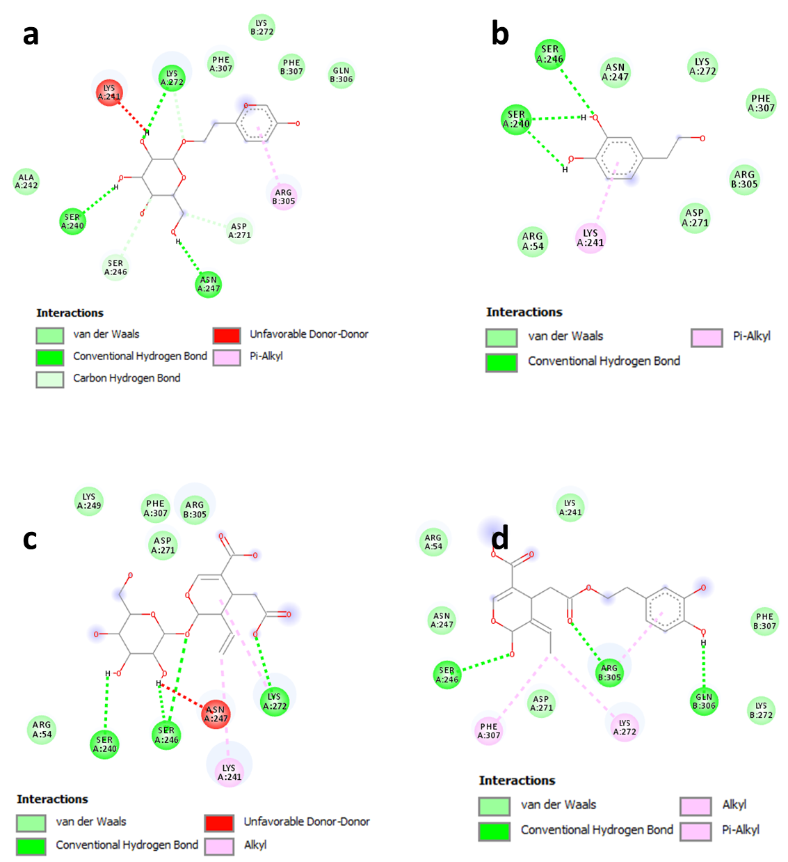
Figure S5. 2D interaction models of (a) hydroxytyrosol glucoside, (b) hydroxytyrosol, (c) secologanoside, and (d) oleuropein aglycone within the active site of NF-κB (PDB: 1NFK).
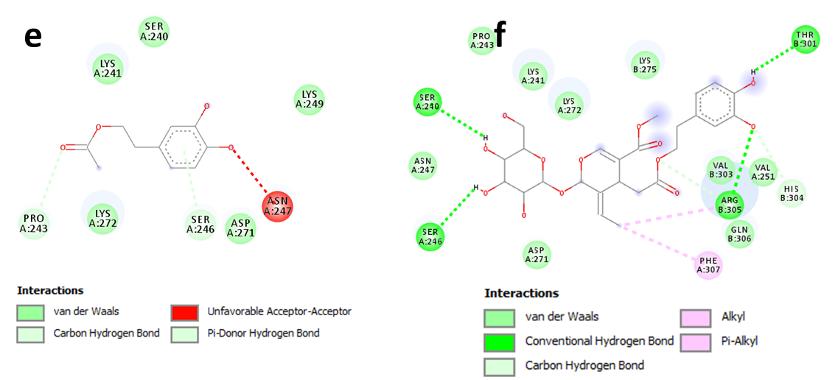
Figure S6. 2D interaction models of (e) hydroxytyrosol acetate and (f) oleuropein within the active site of NF-κB (PDB: 1NFK).
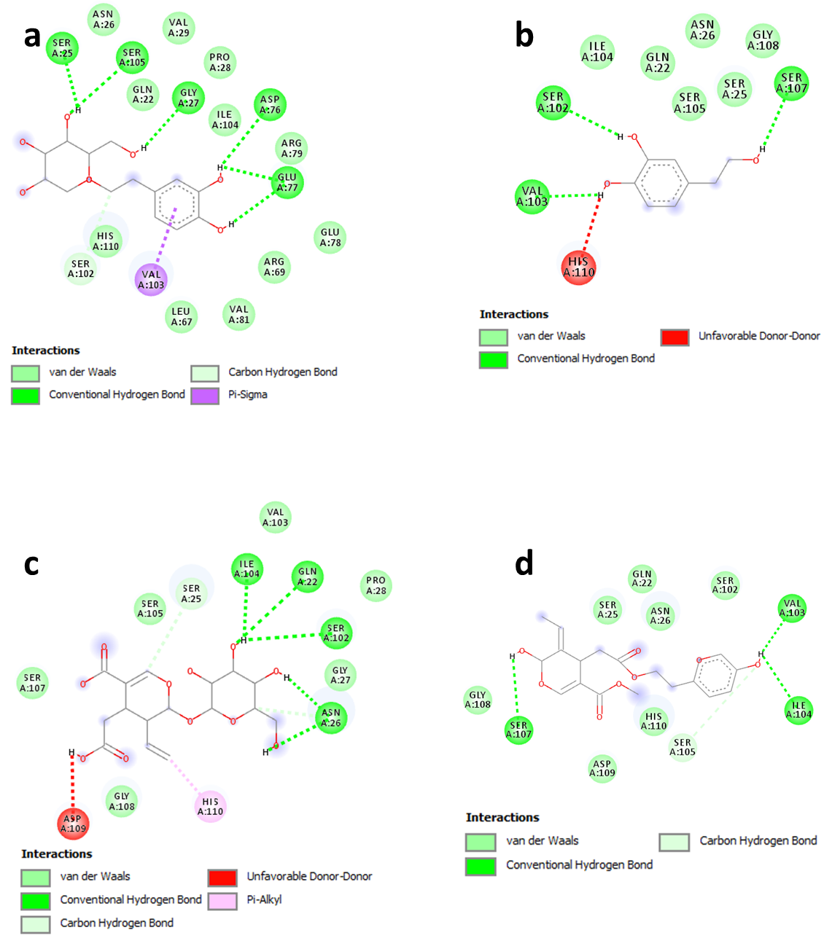
Figure S7. 2D interaction models of (a) hydroxytyrosol glucoside, (b) hydroxytyrosol, (c) secologanoside, and (d) oleuropein aglycone within the active site of SOD (PDB: 4A7G).
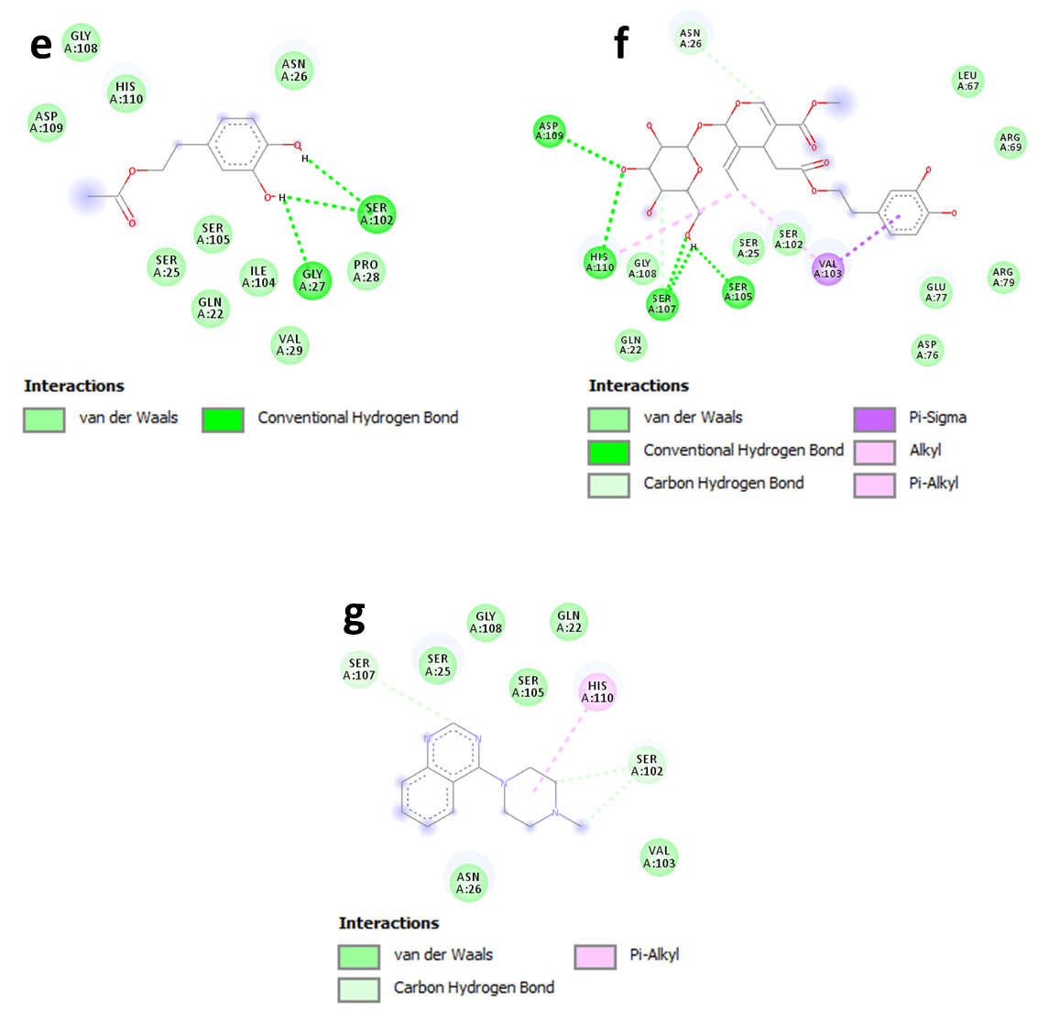
Figure S8. 2D interaction models of (e) hydroxytyrosol acetate, (f) oleuropein, and (g) the co-crystallized ligand within the active site of SOD (PDB: 4A7G).
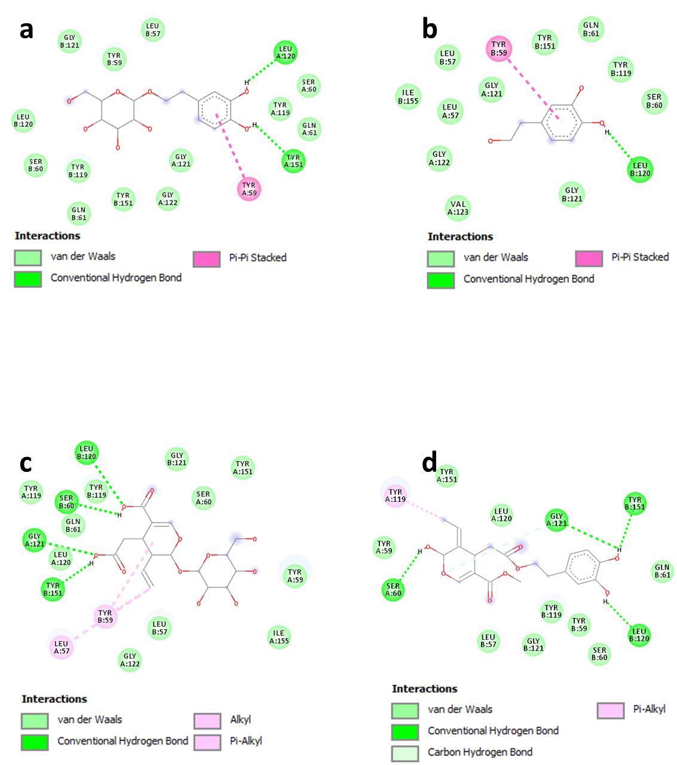
Figure S9. 2D interaction models of (a) hydroxytyrosol glucoside, (b) hydroxytyrosol, (c) secologanoside, and (d) oleuropein aglycone within the active site of TNF-α (PDB: 2AZ5).

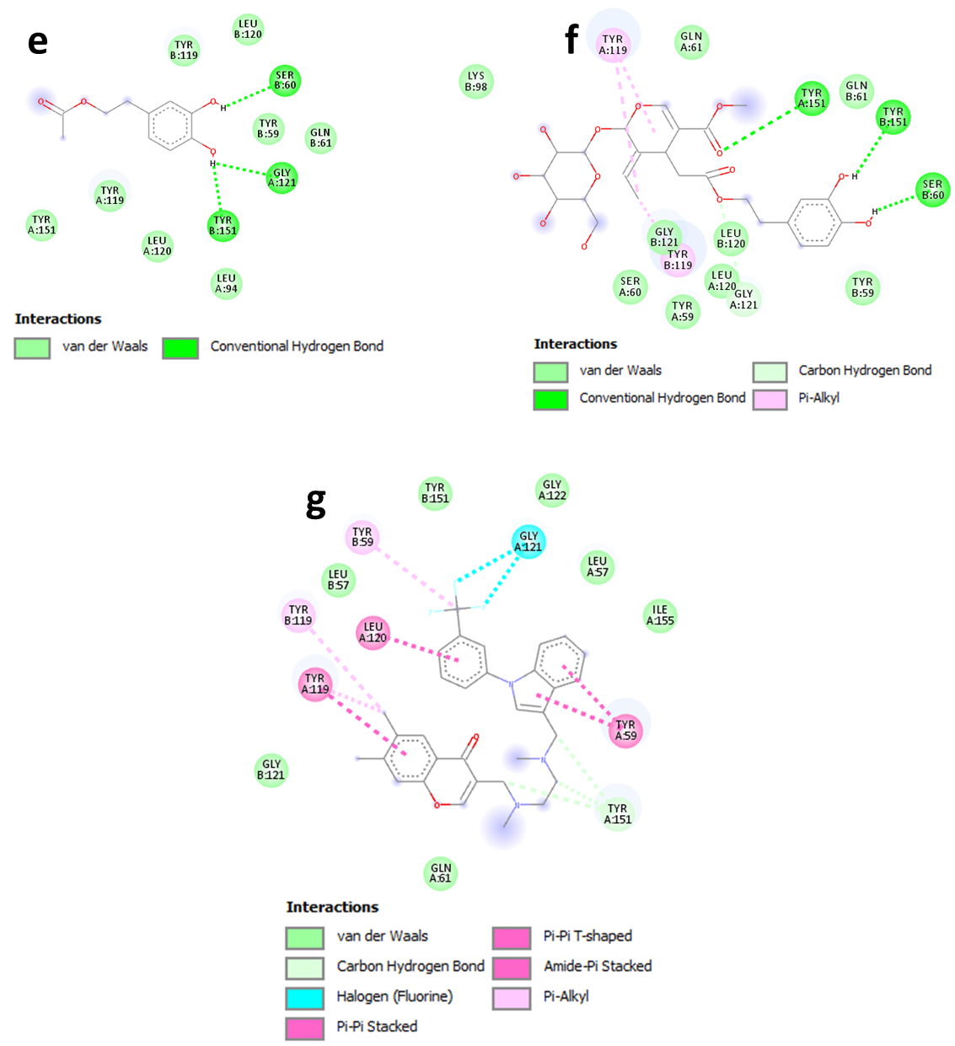
Figure S10. 2D interaction models of (e) hydroxytyrosol acetate, (f) oleuropein, and (g) the co-crystallized ligand within the active site of TNF-α (PDB: 2AZ5).

