Contents:
Table 1-SM. Crystallographic parameters of steroid 2a.
Figure 1-SM. Mass spectrum of steroid 1a (HRMS spectrum ESI ionization source).
Figure 2-SM. Mass spectrum of steroid 2a (HRMS spectrum ESI ionization source).
Figure 3-SM. ¹H NMR spectrum of steroid 1a (400 MHz, CDCl₃).
Figure 4-SM. ¹³C NMR spectrum of steroid 1a (400 MHz, CDCl₃).
Figure 5-SM. DEPT NMR spectrum of steroid 1a (400 MHz, CDCl₃).
Figure 6-SM. HMBC NMR spectrum of steroid 1a (400 MHz, CDCl₃).
Figure 7-SM. HSQC NMR spectrum of steroid 1a (400 MHz, CDCl₃).
Figure 8-SM. COSY NMR spectrum of steroid 1a (400 MHz, CDCl₃).
Figure 7-SM. ¹H NMR spectrum of steroid 2a (400 MHz, CDCl₃).
Figure 8-SM. ¹H spectrum of steroid 2a, which showed the characteristic of an epimer with a difference in the configuration of carbon 3.
Figure 9-SM. ¹³C NMR spectrum of steroid 2a (400 MHz, CDCl₃).
Figure 10-SM. Chemical structure and ultraviolet absorption of steroids 1a and 2a.
Figure 11-SM. ¹H spectrum of steroid 2a, which showed the characteristic of an epimer with a difference in the configuration of carbon 3.
Figure 12-SM. ¹³C NMR spectrum of steroid 2a (400 MHz, CDCl₃).
Figure 13-SM. One-dimensional chain formed for the steroid 2 with the intermolecular O1–H1···O1’ interactions, viewed in the [001] direction.
Figure 14-SM. PCA score plot of PC1 and PC2, using chromatographic data processed alongside the cultivation data of the fungus Talaromyces fuscoviridis in a culture medium with and without manganese.

Description | Steroid 2
Chemical formula | C₂₈H₄₂O
Molar mass (g mol⁻¹) | 394.61
Crystal system | Monoclinic
Space group | P2₁
a (Å) | 14.8904(3)
b (Å) | 5.79970(10)
c (Å) | 15.0162(3)
β (o) | 111.711(2)
V (Å³) | 1204.80(4)
Z | 2
Density /g cm⁻³ | 1.088
θmin, θmax /º | 6.336, 158.918
Index ranges | –18 ≤ h ≤ 18
 | –7 ≤ k ≤ 7
 | –18 ≤ l ≤ 14
F(000) | 436.0
μ /mm⁻¹ | 0.473
Absorption correction | Multi-scan
Max./min. transmission | 1.000/0.781
Measured reflections | 29309
Independent reflections / R_{int} | 5170/0.0486
Refined parameters | 270
Final R indexes [I≥2σ(I)] | R₁= 0.0445/wR₂= 0.1113
Final R indexes [all data] | R₁= 0.0472/wR₂= 0.1129
GooF | 1.059
Largest diff. peak and hole (eÅ⁻³) | 0.30/-0.19
Flack parameter | 0.2(5)

Table 1-SM. Crystallographic parameters of steroid 2a.

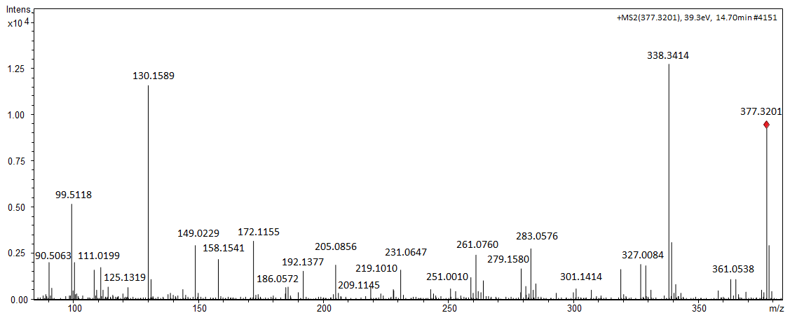

Figure 1-SM. Mass spectrum of steroid 1a (HRMS spectrum ESI ionization source).

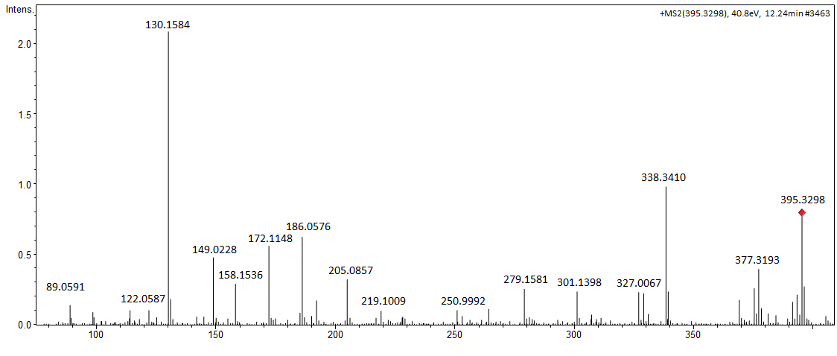

Figure 2-SM. Mass spectrum of steroid 2a (HRMS spectrum ESI ionization source).

Figure 3-SM. ¹H NMR spectrum of steroid 1a (400 MHz, CDCl₃).

Figure 4-SM. ¹³C NMR spectrum of steroid 1a (400 MHz, CDCl₃).
Figure 5-SM. DEPT NMR spectrum of steroid 1a (400 MHz, CDCl₃).

Figure 6-SM. HMBC NMR spectrum of steroid 1a (400 MHz, CDCl₃).

Figure 7-SM. HSQC NMR spectrum of steroid 1a (400 MHz, CDCl₃).
Figure 8-SM. COSY NMR spectrum of steroid 1a (400 MHz, CDCl₃).
Figure 9-SM. ¹H NMR spectrum of steroid 2a (400 MHz, CDCl₃).

1a
2a

Figure 10-SM. Chemical structure and ultraviolet absorption of steroids 1a and 2a.

Figure 11-SM. ¹H spectrum of steroid 2a, which showed the characteristic of an epimer with a difference in the configuration of carbon 3.

Figure 12-SM. ¹³C NMR spectrum of steroid 2a (400 MHz, CDCl₃).

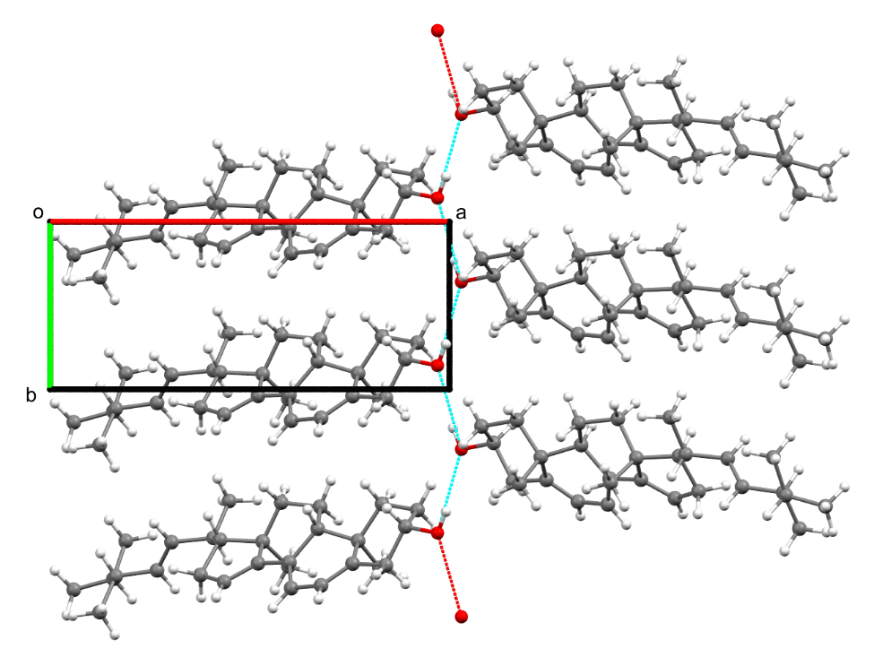
Figure 13-SM. One-dimensional chain formed for the steroid 2 with the intermolecular O1–H1···O1’ interactions, viewed in the [001] direction.

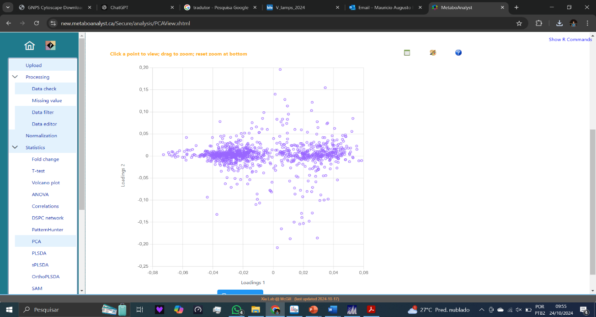
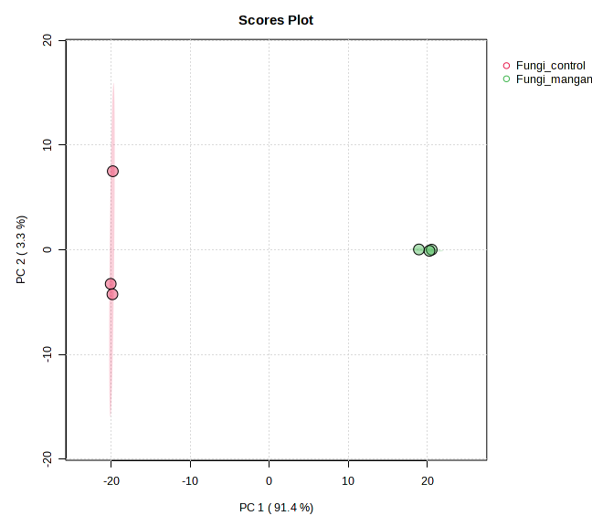
Rice
Rice Mn²⁺
Rice
Rice Mn²⁺
PCA
Loadingsplots

Figure 14-SM. PCA score plot of PC1 and PC2, using chromatographic data processed alongside the cultivation data of the fungus Talaromyces fuscoviridis in a culture medium with and without manganese.

