Predictive pharmacokinetics and in vitro toxicity assessment of enzymatically produced glucosylated quercetin derivatives: an integrated approach.

Supplementary material
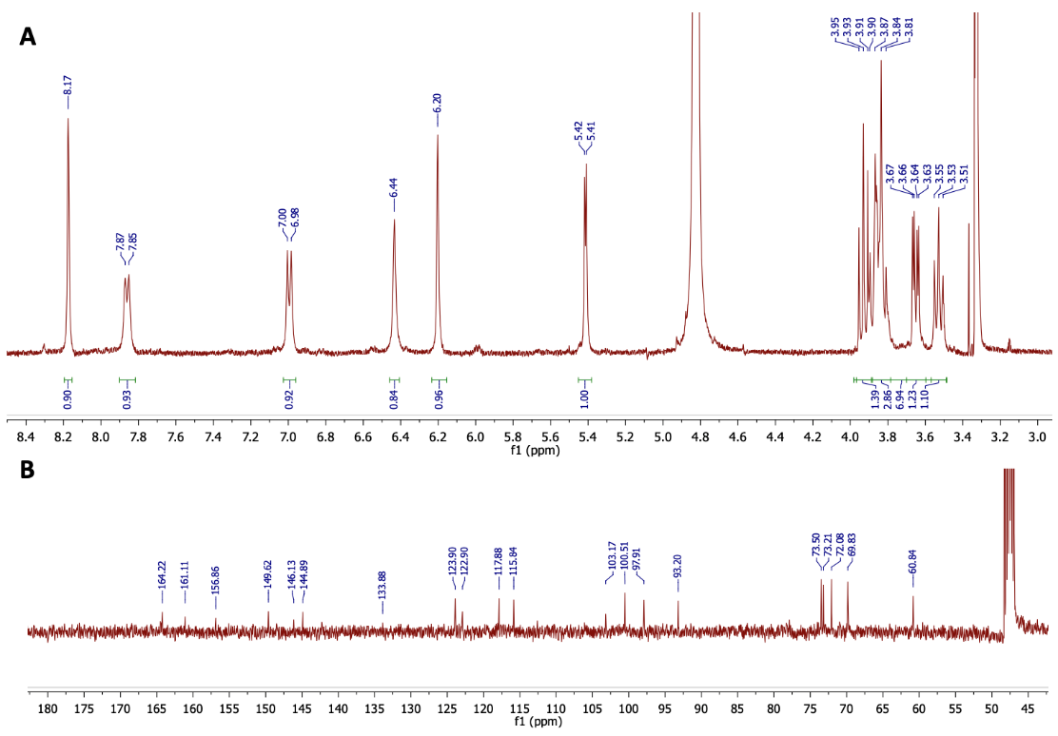
Figure S1: NMR spectra of quercetin-3’-O-α-D-glucoside (A) ¹H spectrum; (B) ¹³C spectrum.

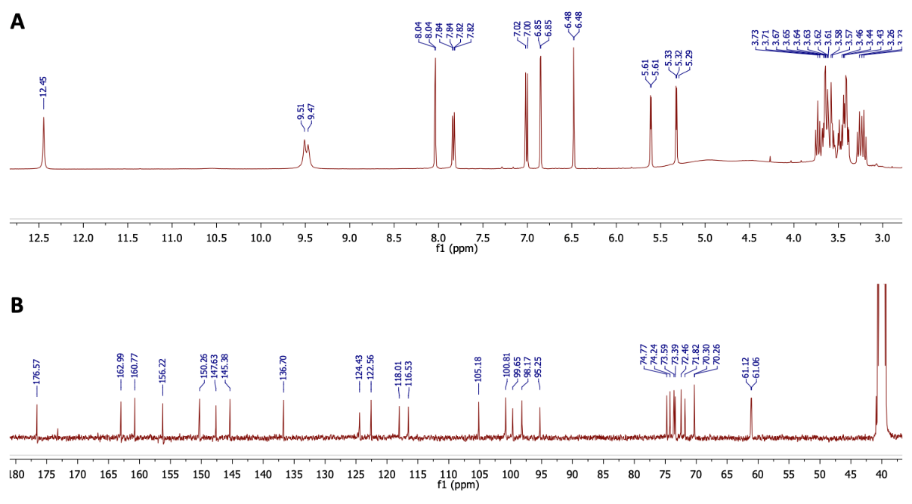
Figure S2: NMR spectra of quercetin-3’,7-O-α-D-diglucoside (A) ¹H spectrum; (B) ¹³C spectrum.

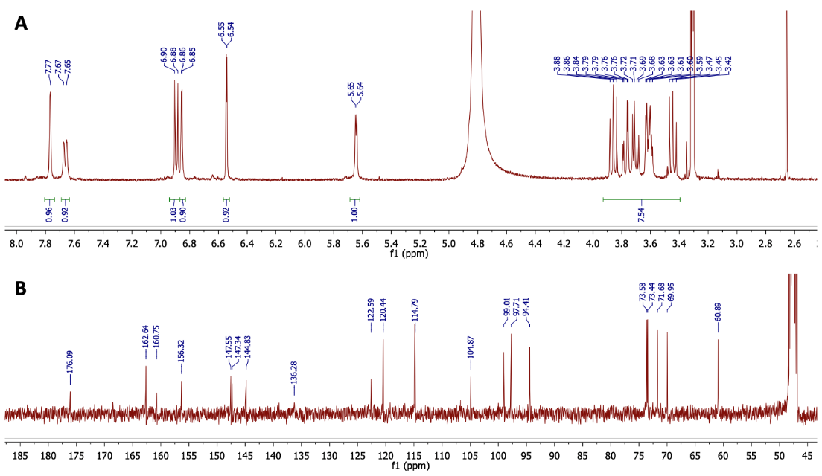
Figure S3: NMR spectra of quercetin-7-O-α-D-glucoside (A) ¹H spectrum; (B) ¹³C spectrum.

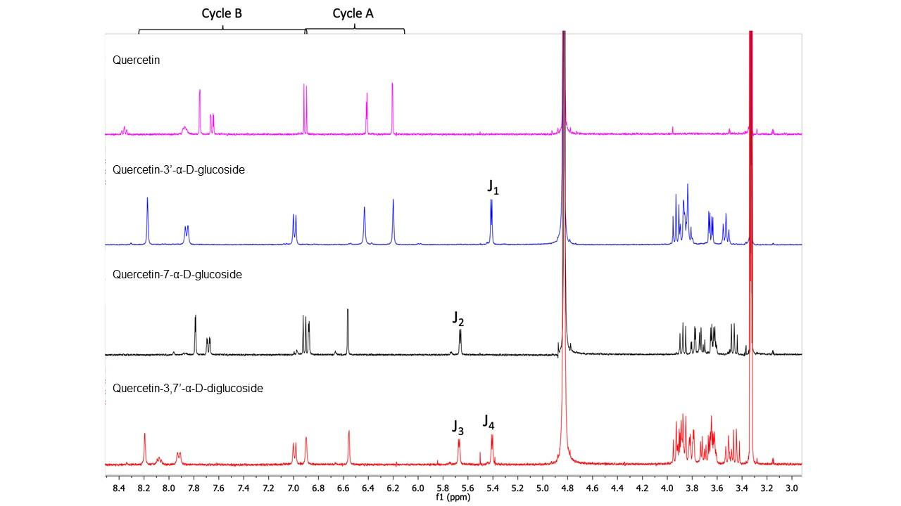
Figure S4: Comparison of the 1H NMR spectra of quercetin (magenta), quercetin-3’-⍺-D-glucoside (blue), quercetin-7-⍺-D-glucoside (black) and quercetin-3’,7-⍺-D-diglucoside (red). Coupling constant J1 = 3.6 Hz, J2 = 3.8 Hz, J3 = 3.3 Hz and J4 = 3.6 Hz.
Table S1: Validation of structures by mass spectrometry (negative ESI)
Compound | Ion formula | Calculated m/z | Experimental m/z | Error (ppm)
Quercetin-3’-⍺-D-glucoside | C₂₁H₁₉O₁₂H⁻ [M-H]⁻ | 463.0877 | 463.0877 | 0.0
Quercetin-7-⍺-D-glucoside | C₂₁H₁₉O₁₂H⁻ [M-H]⁻ | 463.0877 | 463.0877 | 0.0
Quercetin-3’,7-⍺-D-diglucoside | C₂₇H₂₉O₁₇H⁻ [M-H]⁻ | 625.1405 | 625.1413 | 1.3

