A Workflow for Selecting, Profiling, and Optimizing Plant Extracts for Cosmetic Applications
SUPPORTING INFORMATION
Maria Viéytez,ª Aline Robert-Hazotte,^{b} Amélie Thomas,^{c} Véronique Nardello-Rataj^{d},
and Xavier Fernandez*^{,a}
ª Université Côte d’Azur, CNRS, UMR 7272, Institut de Chimie de Nice, Parc Valrose, 06108 Nice Cedex 2, France, xavier.fernandez@univ-cotedazur.fr
^{b} Shiseido Europe Innovation Center, 4 Avenue du Général de Gaulle, 45140 Ormes, France
^{c} Futura Gaia Technologies, Chemin du Pont Des Iles, Mas De Polvelière, 30230 Rodilhan, France
^{d} Centrale Lille, Université de Lille, Université Artois, CNRS, UMR 8181, Unité de Catalyse et Chimie du Solide, Lille, France

HPLC-DAD/ELSD chromatograms of the 18 plants screened
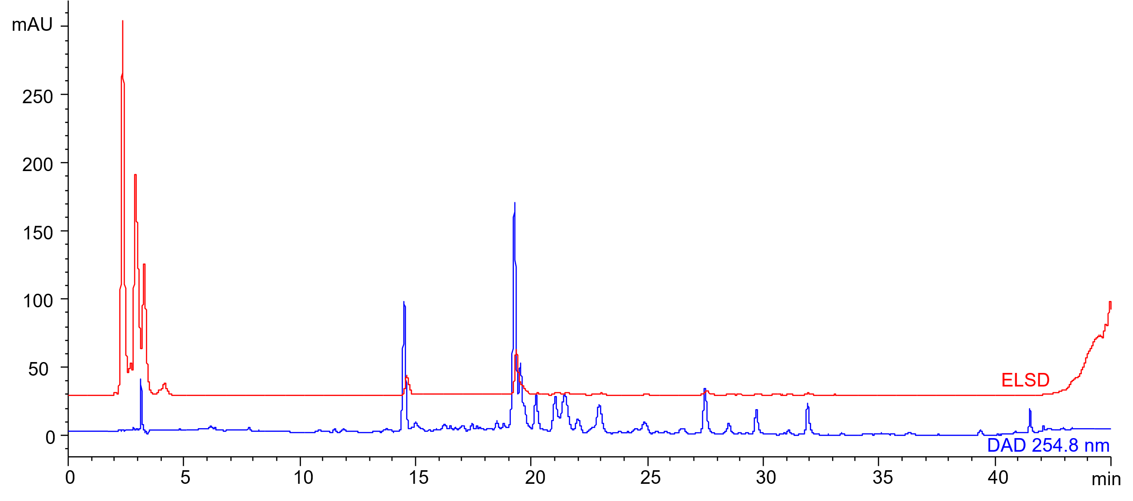
Figure 1. HPLC-DAD/ELSD chromatograms of the hydroalcoholic extract of Achillea millefolium L.
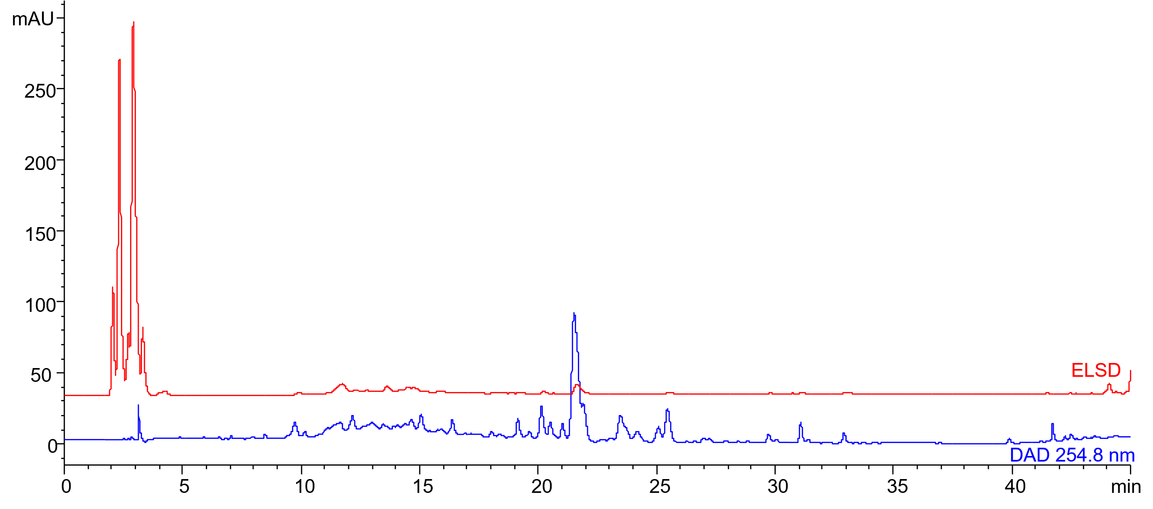
Figure 2. HPLC-DAD/ELSD chromatograms of the hydroalcoholic extract of Agrimonia eupatoria L.
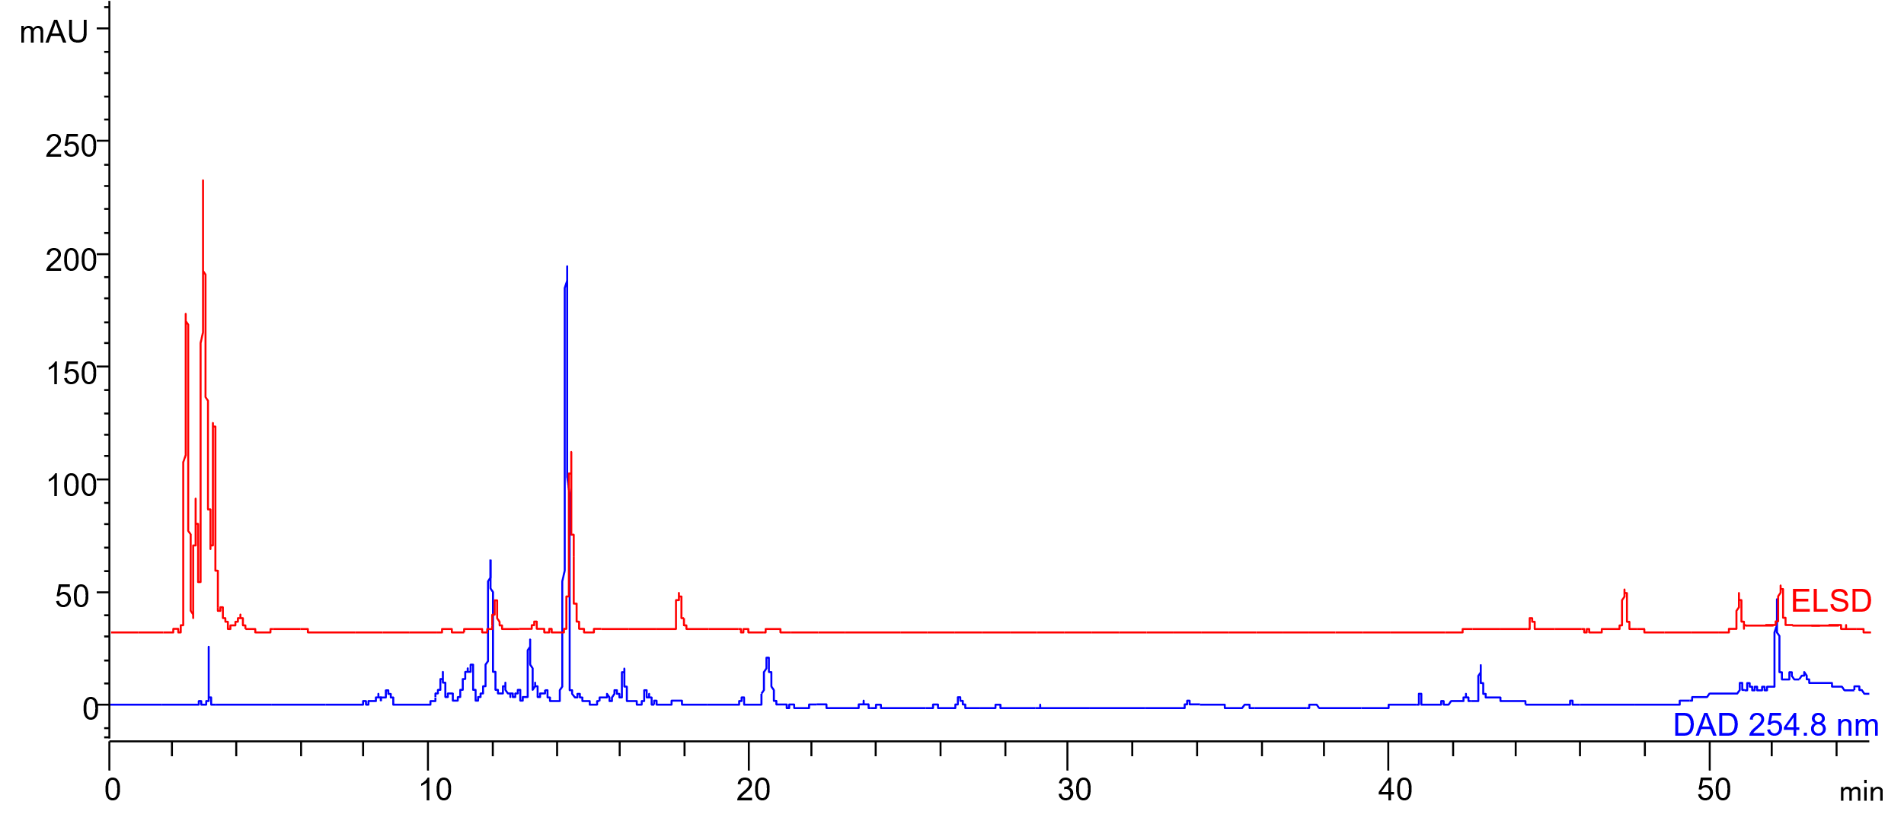
Figure 3. HPLC-DAD/ELSD chromatograms of the hydroalcoholic extract of Berberis aquifolium L.
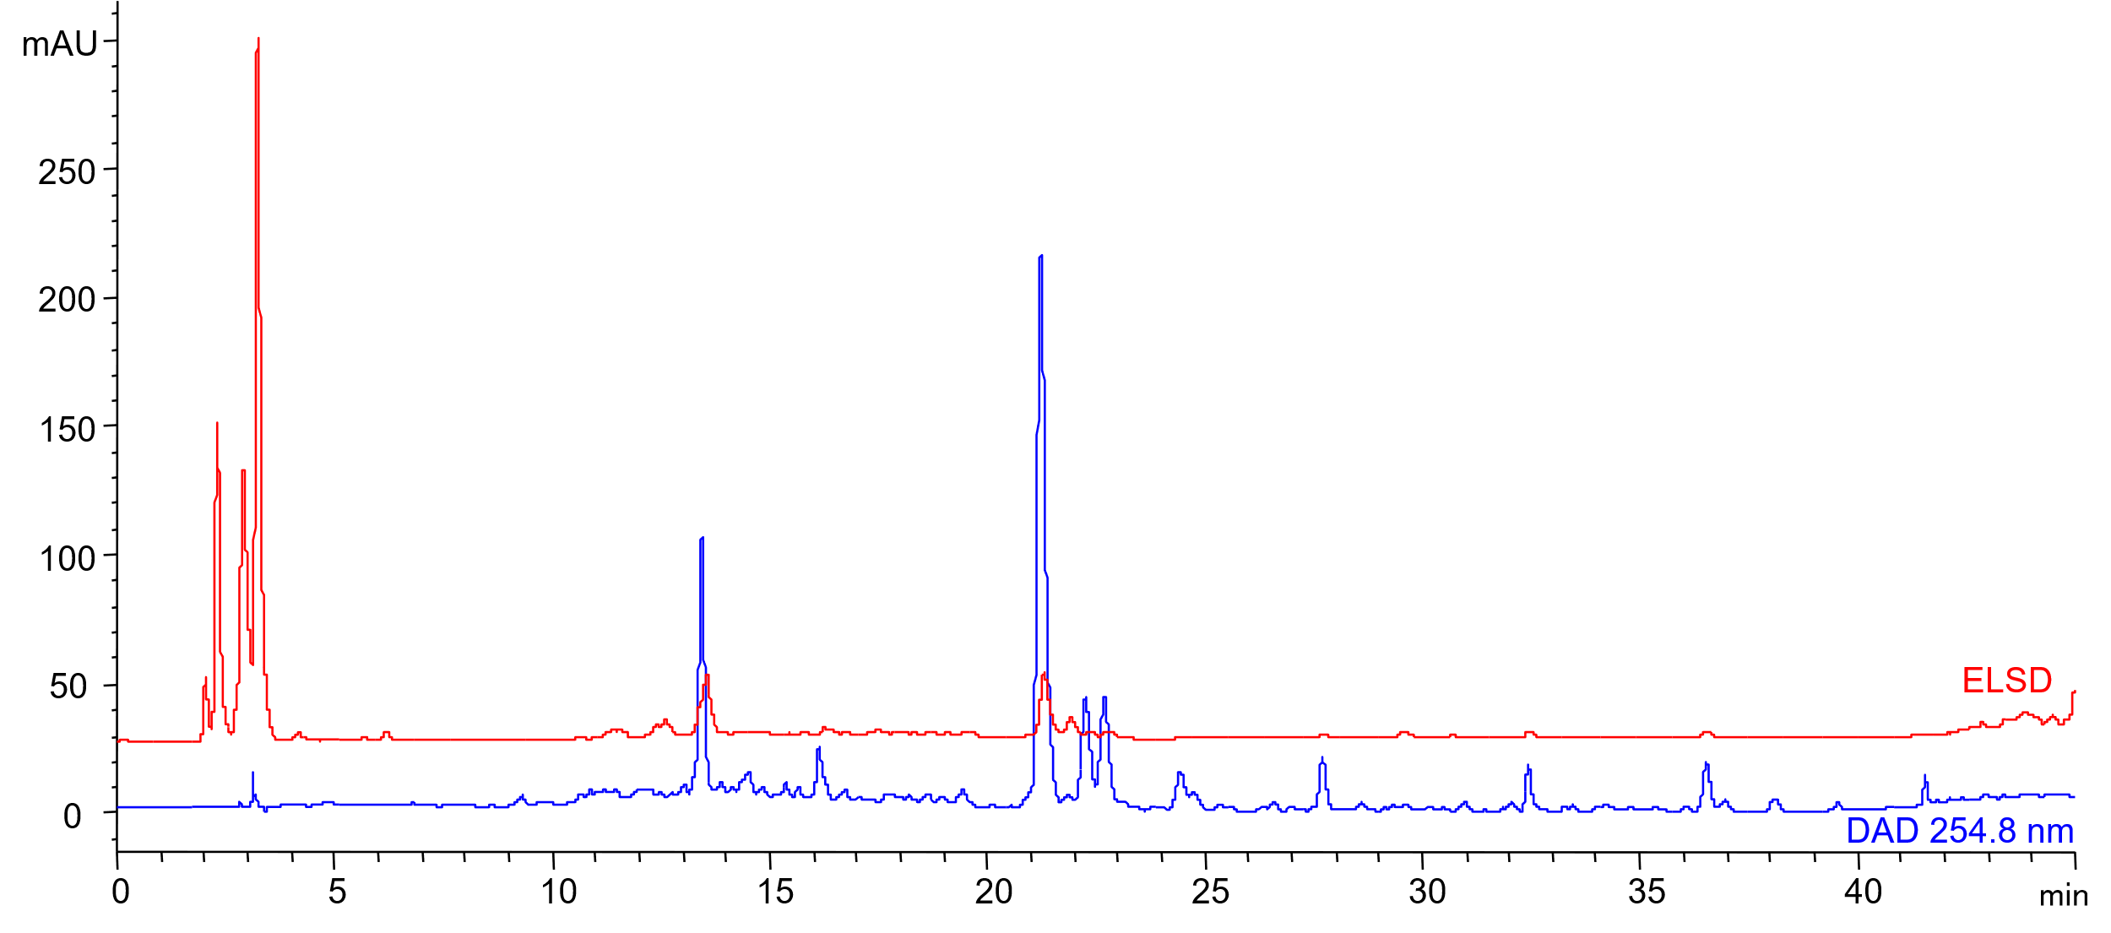
Figure 4. HPLC-DAD/ELSD chromatograms of the hydroalcoholic extract of Betula pendula Roth
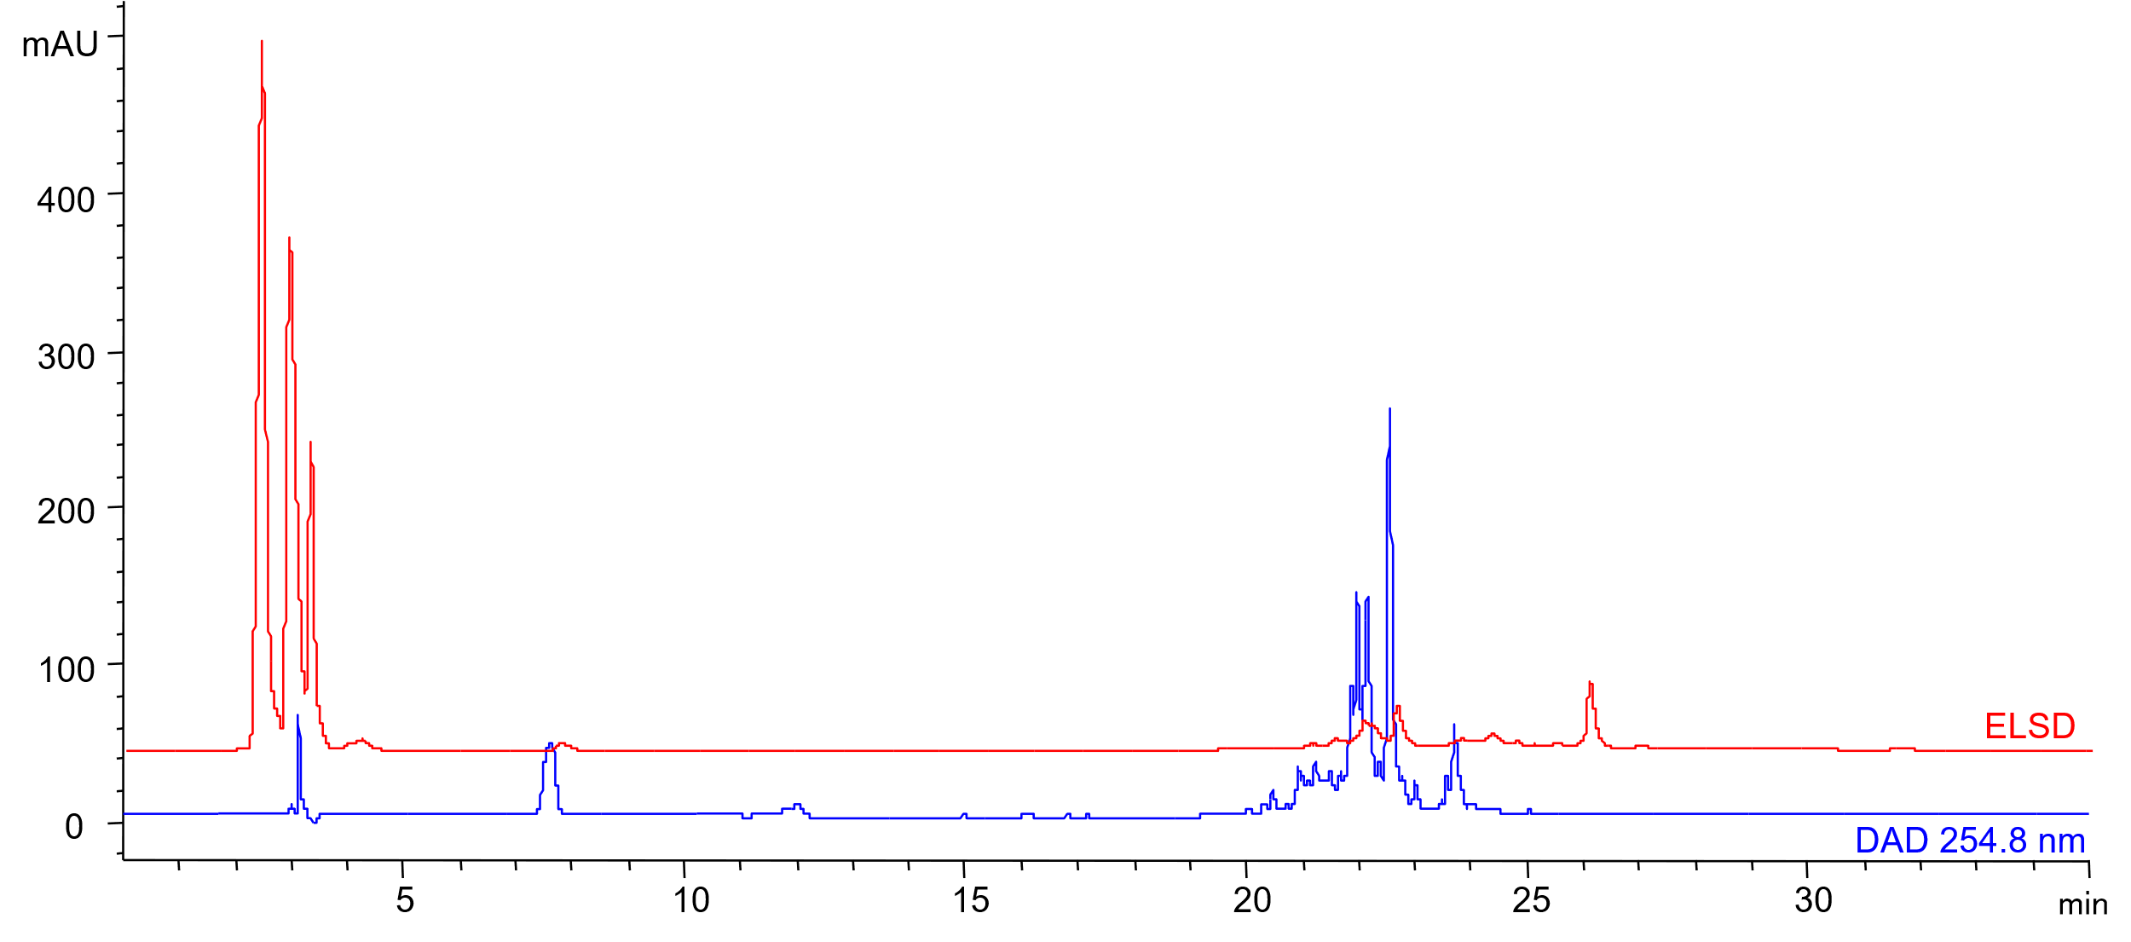
Figure 5. HPLC-DAD/ELSD chromatograms of the hydroalcoholic extract of Borago officinalis L.
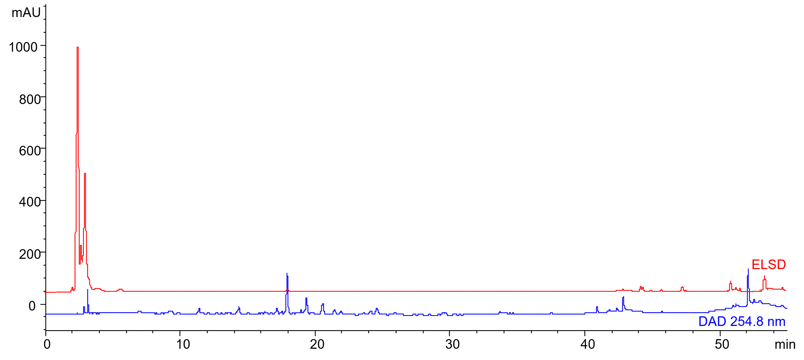
Figure 6. HPLC-DAD/ELSD chromatograms of the hydroalcoholic extract of Capsella bursa-pastoris (L.) Medik
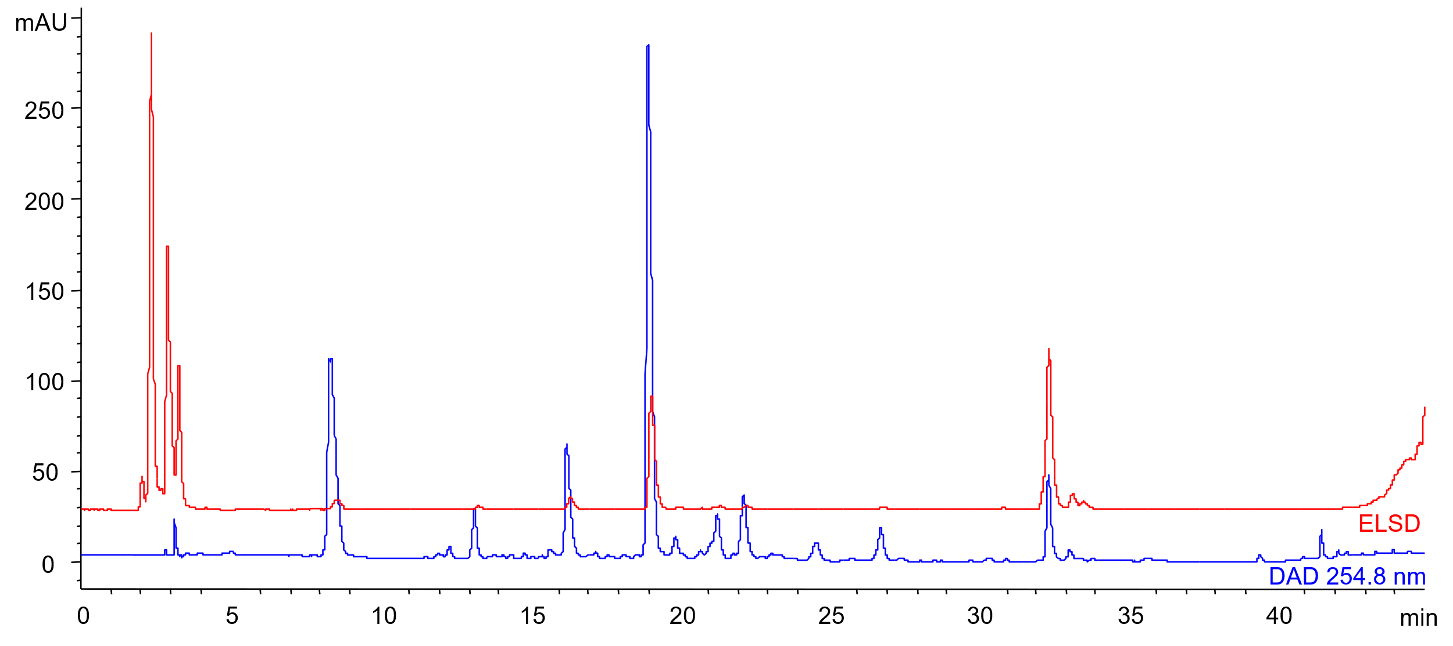
Figure 7. HPLC-DAD/ELSD chromatograms of the hydroalcoholic extract of Clematis vitalba L.
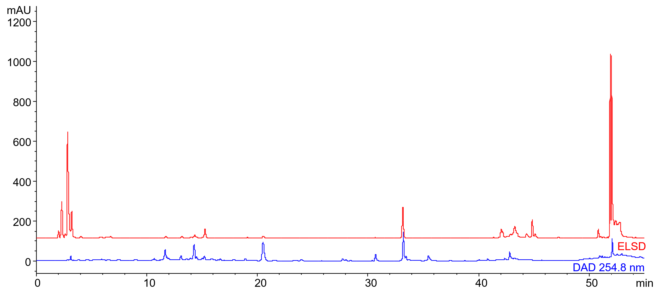
Figure 8. HPLC-DAD/ELSD chromatograms of the hydroalcoholic extract of Cormus domestica L.
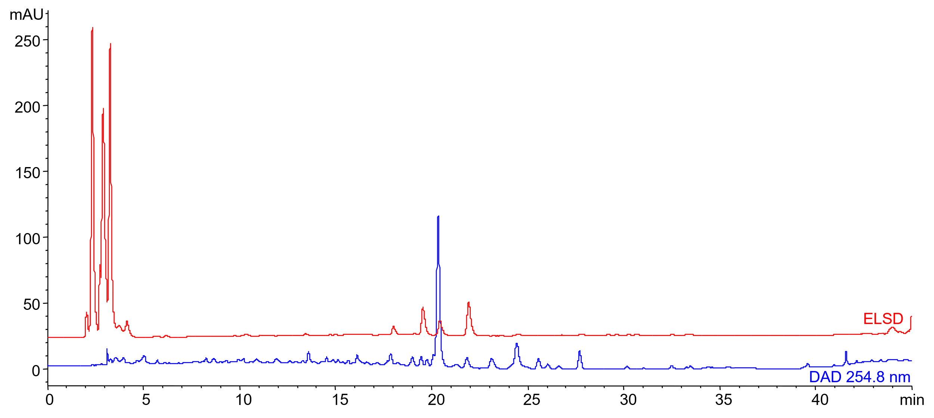
Figure 9. HPLC-DAD/ELSD chromatograms of the hydroalcoholic extract of Corylus avellana L.
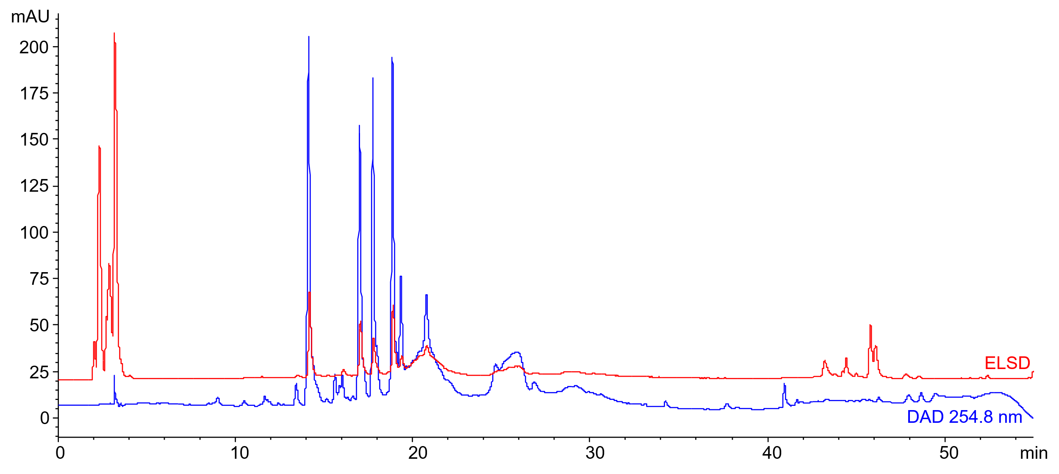
Figure 10. HPLC-DAD/ELSD chromatograms of the hydroalcoholic extract of Dipsacus fullonum L.
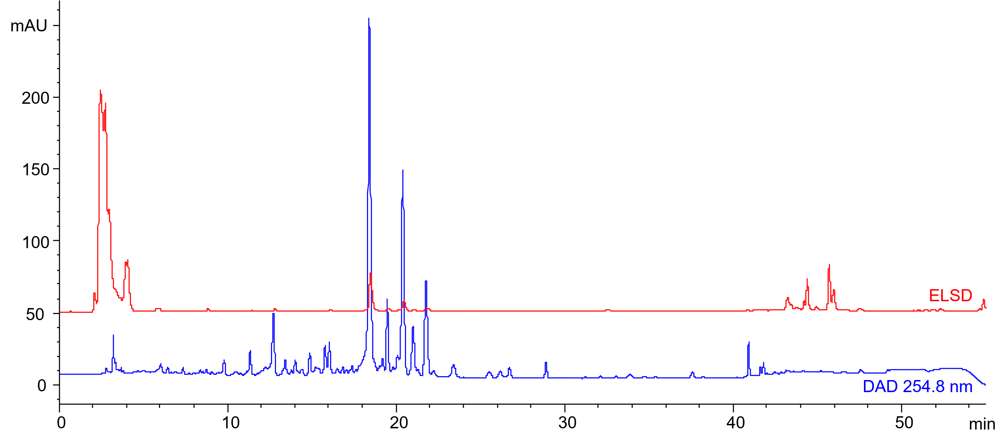
Figure 11. HPLC-DAD/ELSD chromatograms of the hydroalcoholic extract of Lactuca serriola L.
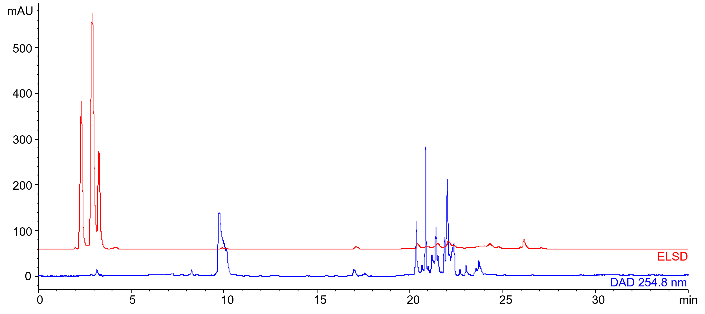
Figure 12. HPLC-DAD/ELSD chromatograms of the hydroalcoholic extract of Narcissus jonquilla L.
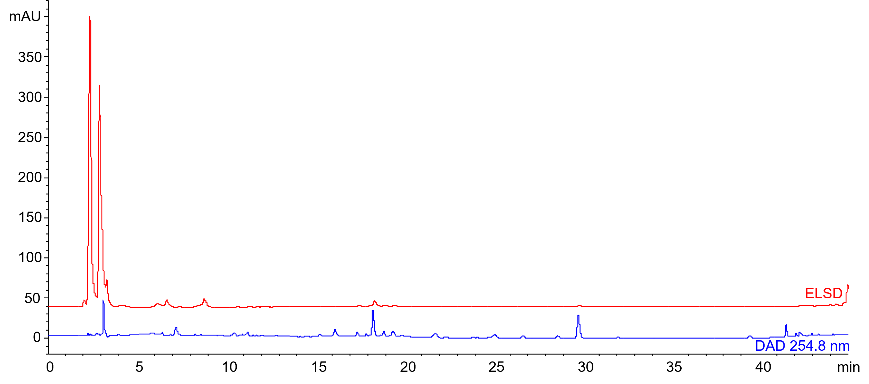
Figure 13. HPLC-DAD/ELSD chromatograms of the hydroalcoholic extract of Plantago lanceolata L.
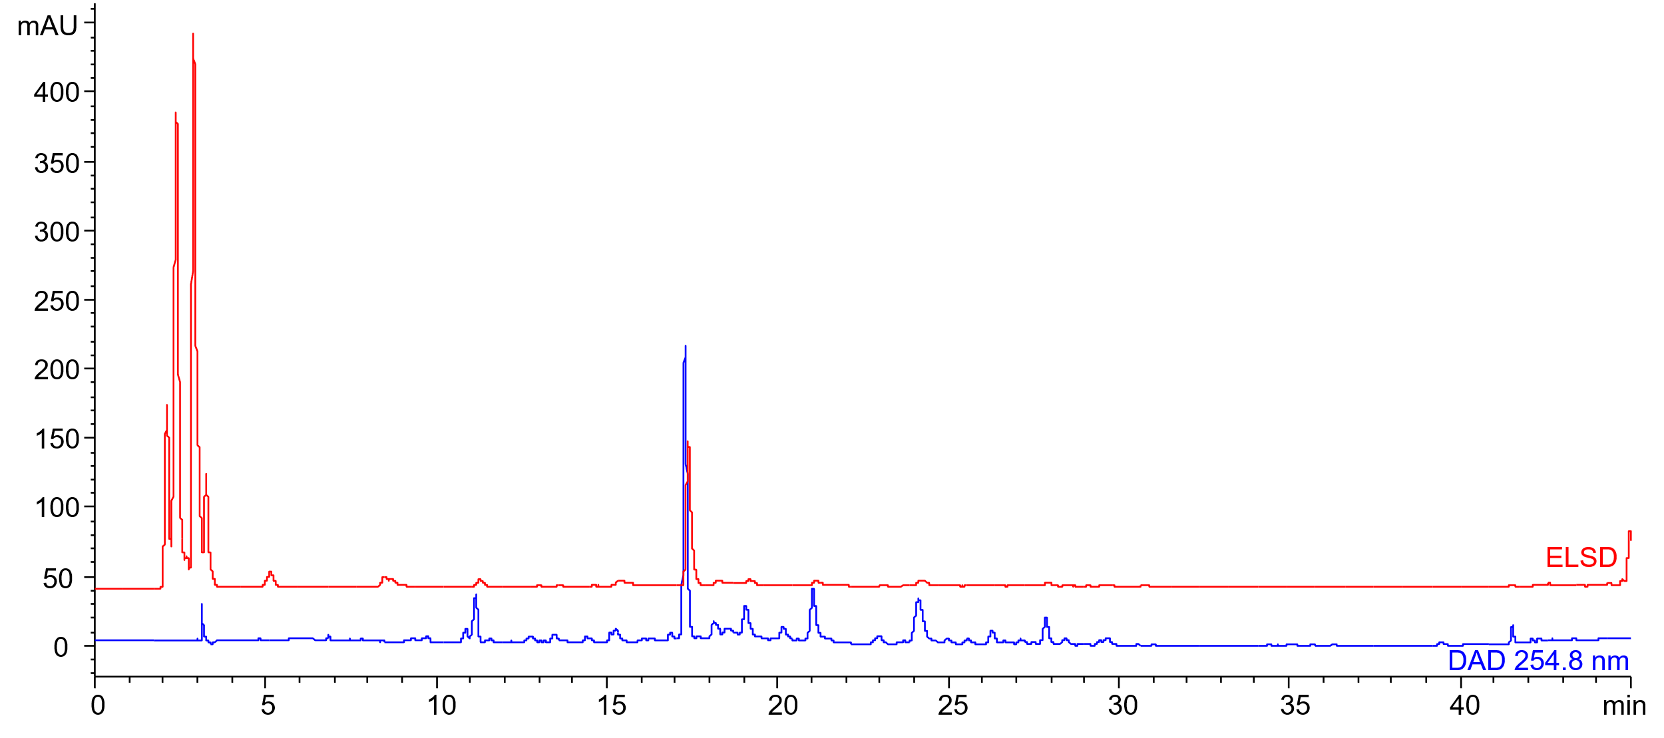
Figure 14. HPLC-DAD/ELSD chromatograms of the hydroalcoholic extract of Plantago major L.
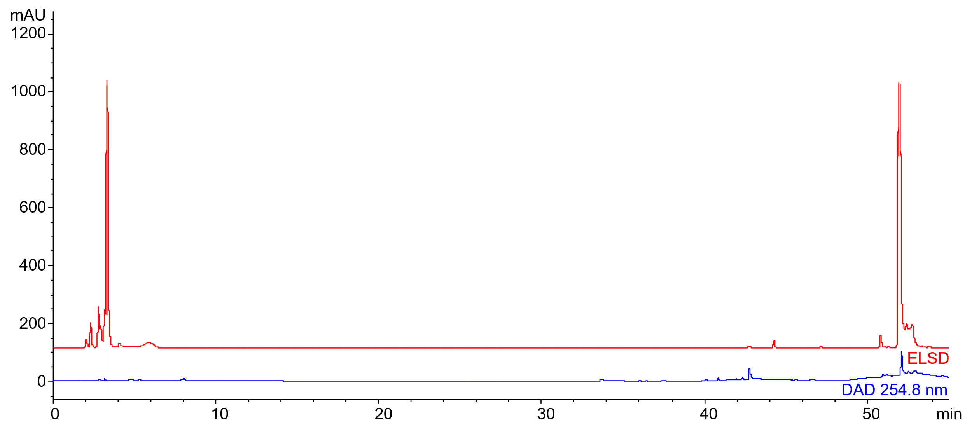
Figure 15. HPLC-DAD/ELSD chromatograms of the hydroalcoholic extract of Polygonatum multiflorum (L.) All
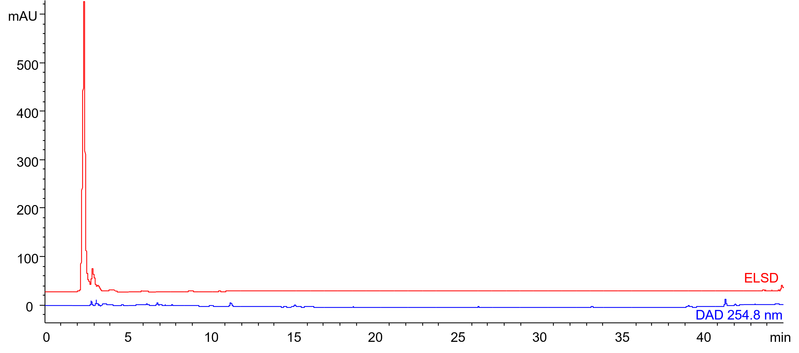
Figure 16. HPLC-DAD/ELSD chromatograms of the hydroalcoholic extract of Portulaca oleracea L.
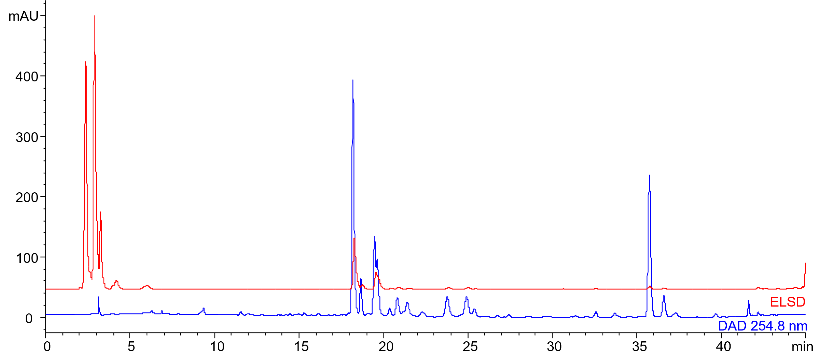
Figure 17. HPLC-DAD/ELSD chromatograms of the hydroalcoholic extract of Primula veris L.
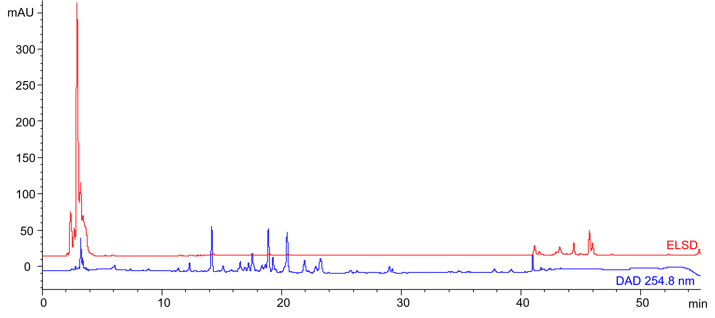
Figure 18. HPLC-DAD/ELSD chromatograms of the hydroalcoholic extract of Spartium junceum L.

HPLC-DAD/ELSD chromatograms of Borago officinalis L. ethanolic extracts cultivated using rotational indoor farming under different temperature and irrigation conditions
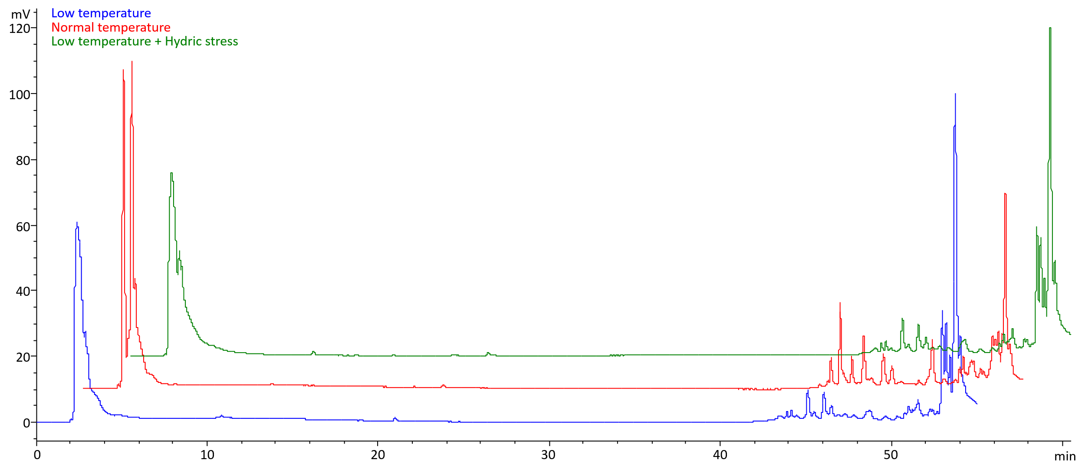
Figure 19. HPLC-ELSD chromatograms of the ethanolic extracts of Borago officinalis L. aerial parts grown using different conditions
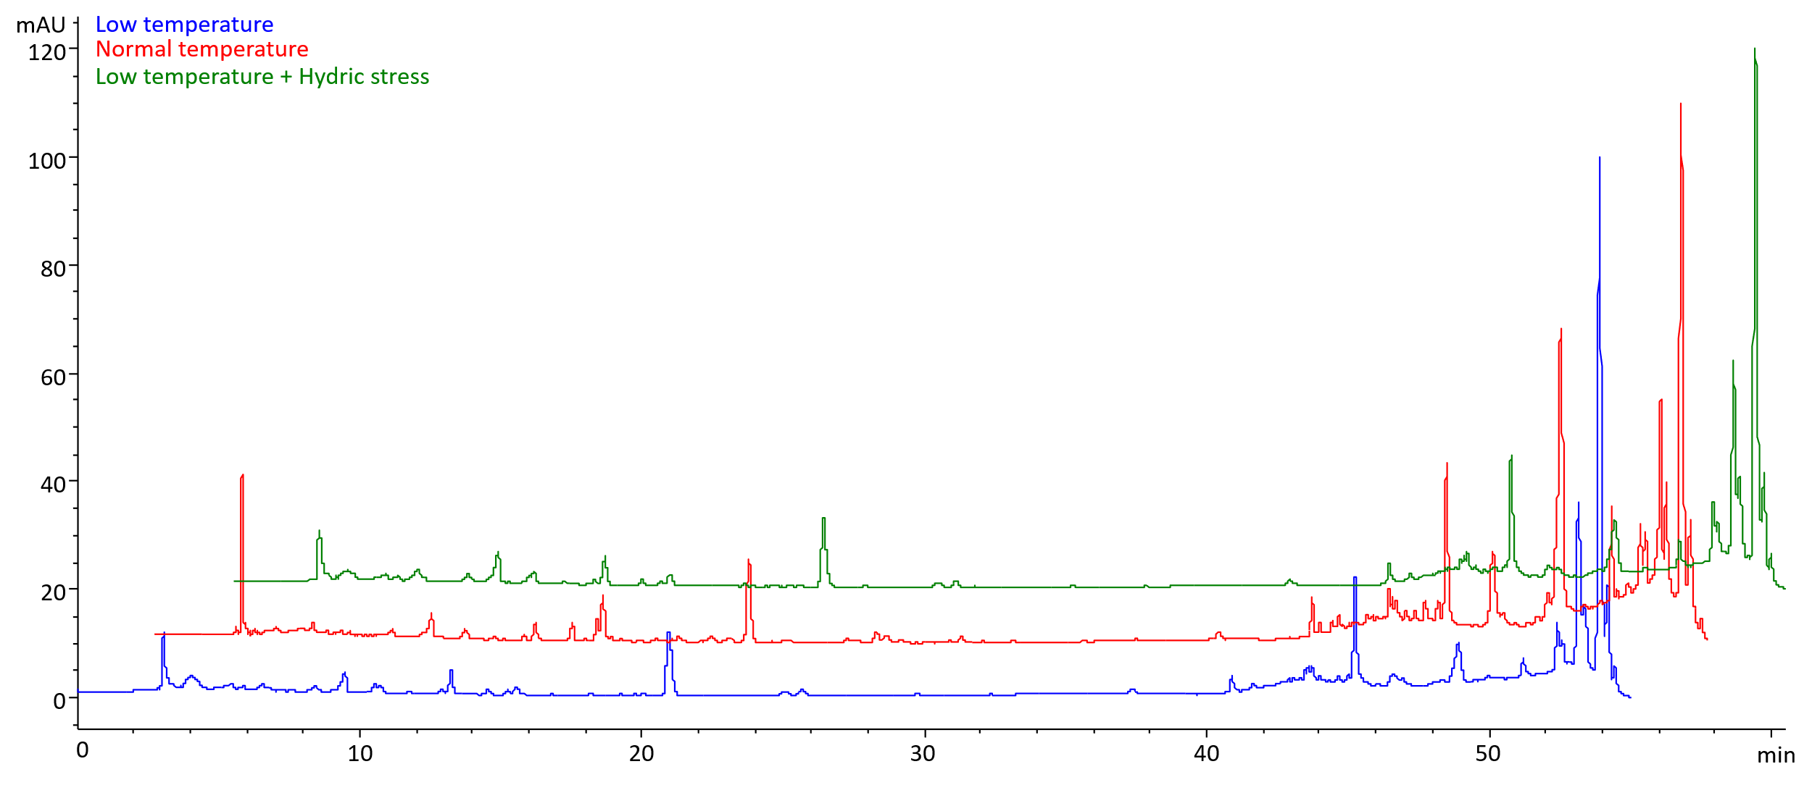
Figure 20. HPLC-ELSD chromatograms of the ethanolic extracts of Borago officinalis L. aerial parts grown using different conditions

