Supplementary Information

Figure 1S - Compounds isolated from Austroeupatorium laetevirens.

Figure 2S - Molecular networking of the dichloromethane, ethyl acetate and hydromethanol fractions of Austroeupatorium laetevirens analyzed by UHPLC-HRMS in positive mode. Nodes represent detected compounds and are colored according to the respective fraction with green (dichloromethane), pink (ethyl acetate), and blue (hydromethanolic). The blue octagonal nodes represent the substances isolated in the present work, red octagonal nodes represent putatively identified substances, and pink square nodes represent substances identified by the GNPS platform.
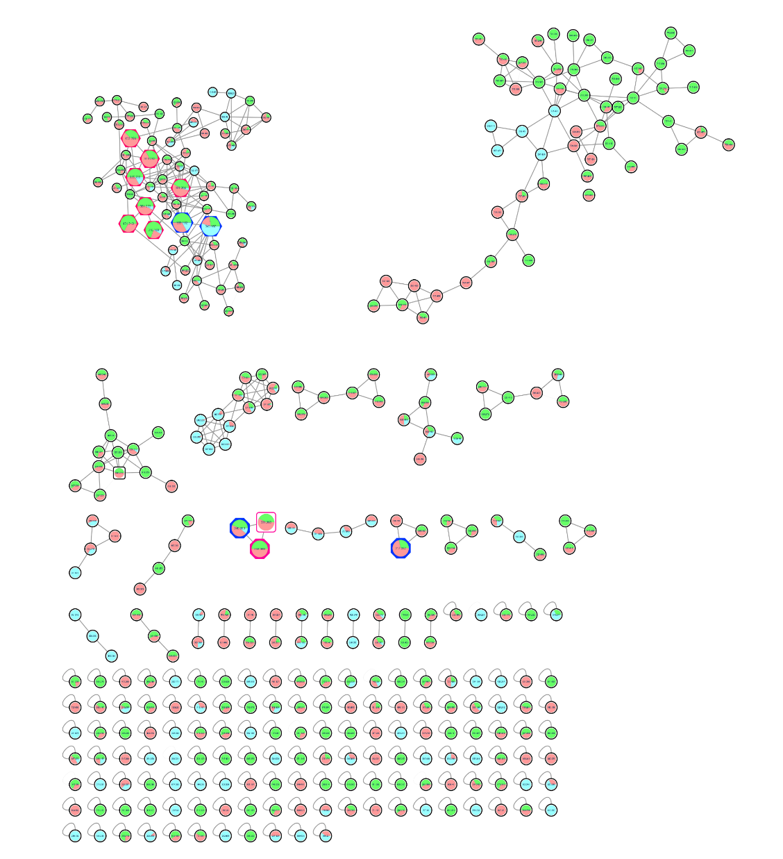

Table 1S - Labdanes data putatively identified in A. laetevirens fractions by UHPLC-HRMS/MS and molecular networking.
Compound | Molecular formula |  | Exact mass (m/z) | Íon precursor (m/z) | Error / ppm |  | Rt / min | Fragments
AL-1MS |  | C₂₀H₂₈O₄[M + H]⁺ | 333.2060 | 333.2050 |  | 3.00 | 5.00 | 270; 171; 157; 145; 119; 105; 93; 81
AL-2MS |  | C₂₀H₂₈O₅ [M + H]⁺ | 349.2010 | 349.1996 |  | 4.01 | 4.70 | 283; 255; 237;187; 171; 145; 119; 105; 95; 81
AL-3MS^{e} |  | C₂₀H₃₀O₄ [M + H]⁺ | 335.2217 | 335.2202 |  | 4.47 | 5.68 | 271; 225; 183; 159; 147; 105; 93; 81
AL-4MSª |  | C₂₀H₂₆O₃ [M+ H]⁺ | 315.1955 | 315.1944 |  | 3.49 | 5.76 | 254; 195; 121; 119; 105; 91; 81
AL-5MS^{b} |  | C₂₄H₃₈O₆ [M + H]⁺ | 423.2741 | 423.2724 |  | 4.01 | 5.62 | 357; 330; 285; 267; 225; 211; 199; 159; 145; 133; 119; 105; 95
AL-6MS^{c} |  | C₂₂H₃₄O₅ [M + H]⁺ | 379.2479 | 379.2462 |  | 4.48 | 4.90 | 285; 267; 255; 197; 183; 171; 145;119; 105; 93; 81
AL-7MS^{d} |  | C₂₀H₃₄O₄ [M + Na]⁺ | 361.2355 | 361.2351 |  | 1.11 | 4.79 | 328; 269; 213; 157; 145; 119; 91; 81
AL-8MS^{b} |  | C₁₈H₃₀O₂ [M + Na]⁺ | 301.2143 | 301.2140 |  | 0.99 | 5.06 | 255; 199; 159; 131; 119; 105; 91
AL-9MS^{f} |  | C₂₁H₃₀O₆ [M + Na]⁺ | 401.1940 | 401.1906 |  | 8.47 | 4.96 | 383; 343; 283; 187; 133; 119; 105; 93
Rt: Retention time; Reference: ªBohlmann et al., (1977); ^{b}González et al., 1990; ^{c}Manchand et al., 1979; ^{d}Zhang et al., 2008; ^{e}Castillo et al., 2016; ^{f}Bohlmann et al., 1984).

Table 2S – Flavonoids data putatively identified in A. laetevirens fractions by UHPLC-HRMS/MS and molecular networking.
Compound |  | Molecular formula | Exact mass (m/z) | Íon precursor (m/z) | Error / ppm | Rt / min | Fragments
AL-10MS | C₁₆H₁₂O₇ [M + H]⁺ |  | 317.0656 | 317.0634 | 6.93 | 4.39 | 303; 302; 168
AL-11MS | C₁₉H₁₈O₇ [M + H]⁺ |  | 359.1131 | 359.1112 | 5.29 | 5.28 | 343; 298; 162; 136
AL-12MS | C₁₈H₁₆O₇ [M + H]⁺ |  | 345.0946 | 345.0945 | 0.28 | 4.89 | 312; 284; 269; 185; 148;108
AL-13MS | C₁₇H₁₄O₇ [M + H]⁺ |  | 331.0812 | 331.0794 | 5.43 | 4.59 | 316; 298; 242; 213; 168; 136; 108
tr: tempo de retenção; Dados da literatura: ªCui et al.. 2021; ^{b}Luo et al.. 2019; ^{c}Li et al.. 2019; ^{d} Xia et al.. 2019.

Figure 3S - ESI (+)-HRMS/MS (+) spectrum of compound 5 identified as AL-1MS.

Figure 4S - ESI (+)-HRMS/MS (+) spectrum of compound 6 identified as AL-2MS

Figure 5S - ESI (+)-HRMS/MS (+) spectrum of compound AL-3MS.
Figure 6S - ESI (+)-HRMS/MS (+) spectrum of compound AL-4MS.
Figure 7S - ESI (+)-HRMS/MS (+) spectrum of compound AL-5MS.
Figure 8S - ESI (+)-HRMS/MS (+) spectrum of compound AL-6MS.
Figure 9S - ESI (+)-HRMS/MS (+) spectrum of compound AL-7MS.

Figure 10S - ESI (+)-HRMS/MS (+) spectrum of compound AL-8MS.
Figure 11S - ESI (+)-HRMS/MS (+) spectrum of compound AL-9MS.

Table 3S - Putatively identified compounds in dichloromethane fraction of A. laetevirens by UHPLC-HRMS/MS in negative ionization mode.
Substância | Fórmula | Massa exata | Íon precursor  [M-H]⁻ (m/z) | Erro / ppm | t_{R}/min | Fragmentos  (m/z) | Fração | Identificação Putativa | Database
AL-14MS | C₃H₆O₃ | 89.0236 | 89.0236 | 2.24 | 0.79 | - | EB. FHM | Lactic acid | MoNA
AL-15MS | C₆H₁₂O₇ | 195.0504 | 195.0499 | 2.56 | 0.87 | 87; 129; 151 | EB. FAE; FHM | Gluconic acid | HMDB
AL-16MS | C₇H₆O₃ | 137.0238 | 137.0242 | -2.91 | 4.54 | 93 | EB; FAE; FHM | p-Hydroxybenzoic acid | MoNA
AL-17MS | C₇H₆O₄ | 153.0187 | 153.0189 | 1.30 | 4.19 | 91; 109 | EB; FAE; FHM | Protocatechuic acid | HMDB
AL-18MS | C₉H₈O₃ | 163.0394 | 163.0394 | 0 | 4.91 | 93; 119 | EB; FAE | p-Coumaric acid | MoNA
AL-19MS | C₉H₁₆O₄ | 187.0970 | 187.0970 | 0 | 5.11 | 97; 125; 143; 169 | FDC; FAE | Azelaic acid | HMDB
AL-20MS | C₁₂H₁₈O₄ | 225.1121 | 225.1122 | -0.44 | 4.79 | 93; 135; 181 | EB; FAE | 12-Hydroxyjasmonic acid | HMDB
AL-21MS | C₁₆H₁₈O₉ | 353.0872 | 353.0867 | 1.41 | 4.41 | 135; 153; 179; 191 | EB; FAE; FHM | Chlorogenic acid | HMDB
AL-22MS | C₇H₁₂O₆ | 191.0555 | 191.0553 | 1.04 | 4.43 | 85; 153; 191 | EB; FAE; FHM | Quinic acid | MoNA
AL-23MS | C₂₅H₂₄O₁₂ | 515.1189 | 515.1176 | 2.52 | 4.9 | 179; 191; 351 | EB; FAE | 3,4-Dicaffeoylquinic acid | HMDB
AL-24MS | C₁₇H₂₀O₉ | 367.1028 | 367.102 | 2.17 | 4.73 | 164; 173; 191; 193 | EB; FAE; FHM | 3-O-Feruloylquinic acid | Ncube et al., 2014¹
AL-25MS | C₁₅H₁₈O₉ | 341.0872 | 341.0865 | 2.05 | 4.17 | 109; 135; 161; 179 | EB; FAE | Caffeic acid 3-glucoside | HMDB
AL-26MS | C₁₆H₁₆O₈ | 335.0767 | 335.0761 | 1.79 | 4.58 | 93; 135; 161; 179 | EB; FAE; FHM | 5-O-Caffeoylshikimic acid | MoNA
AL-27MS | C₆H₁₂O₆ | 179.0556 | 179.0553 | 1.67 | 1.04 | 85; 101; 113 | EB; FHM | BETA-D-glucose | HMDB
AL-28MS | C₁₂H₂₂O₁₁ | 341.1075 | 341.1075 | 2.63 | 0.88 | 89; 119; 179; 191 | EB; FHM | D-Turanose | HMDB
AL-29MS | C₆H₆O₂ | 109.0289 | 109.0289 | 0.00 | 4.12 | 109 | EB; FAE | Hidroquinone | HMDB
AL-30MS | C₉H₆O₄ | 177.0188 | 177.0187 | 0.56 | 4.68 | 105; 135; 149; 177 | EB; FDC; FAE | Daphnetin | MoNA
AL-31MS | C₁₅H₁₆O₉ | 339.0715 | 339.0708 | 2.06 | 4.32 | 135; 161; 177; 339 | EB; FAE; FHM | Esculin | MoNA
AL-32MS | C₁₅H₂₂O₉ | 345.1185 | 345.1172 | 3.76 | 4.24 | 119; 165; 181 | EB; FHM | Aucubin | HMDB
AL-33MS | C₃₃H₄₀O₂₀ | 755.2034 | 755.2004 | 3.97 | 4.48 | 163; 300; 325 | EB; FAE; FHM | Quercetin 3-O-rutinoside-4'-O-rhamnoside | HMDB
AL-34MS | C₂₇H₃₀O₁₆ | 609.1455 | 609.1438 | 2.79 | 4.57 | 155; 255; 271; 300 | EB; FAE; FHM | Rutin | MoNA
AL-35MS | C₂₁H₂₀O₁₂ | 463.0876 | 463.0866 | 2.15 | 4.76 | 161; 255; 271; 300 | EB; FAE; FHM | Quercetin-3-O-glucoside | MoNA
AL-36MS | C₂₇H₃₀O₁₅ | 593.1506 | 593.1496 | 1.68 | 4.76 | 161; 227; 255; 284 | EB; FHM | Kaempferol-3-O-rutinoside | MoNA
AL-37MS | C₁₅H₁₀O₅ | 283.0606 | 283.0596 | 3.53 | 6.40 | 117; 148; 240; 268 | EB; FDC | Apigenin | HMDB
AL-38MS | C₂₁H₁₈O₁₃ | 477.0669 | 477.0654 | 3.14 | 4.88 | 151; 229; 271; 301 | EB; FAE; FHM | Quercetin-3-O-glucuronide | MoNA
¹Ncube, E. N.; Mhlongo, M. I.; Piater, L. A.; Steenkamp, P. A.; Dubery, I. A.; Madala, N. E. 2014. Analyses of chlorogenic acids and related cinnamic acid derivatives from Nicotiana tabacumtissues with the aid of UPLC-QTOF-MS/MS based on the in-source collision-induced dissociation method. Chemistry Central Journal, v. 8, p. 1-10.

Figure 12S - ¹H-NMR spectrum (CDCl₃. 300 MHz) of compound 5.
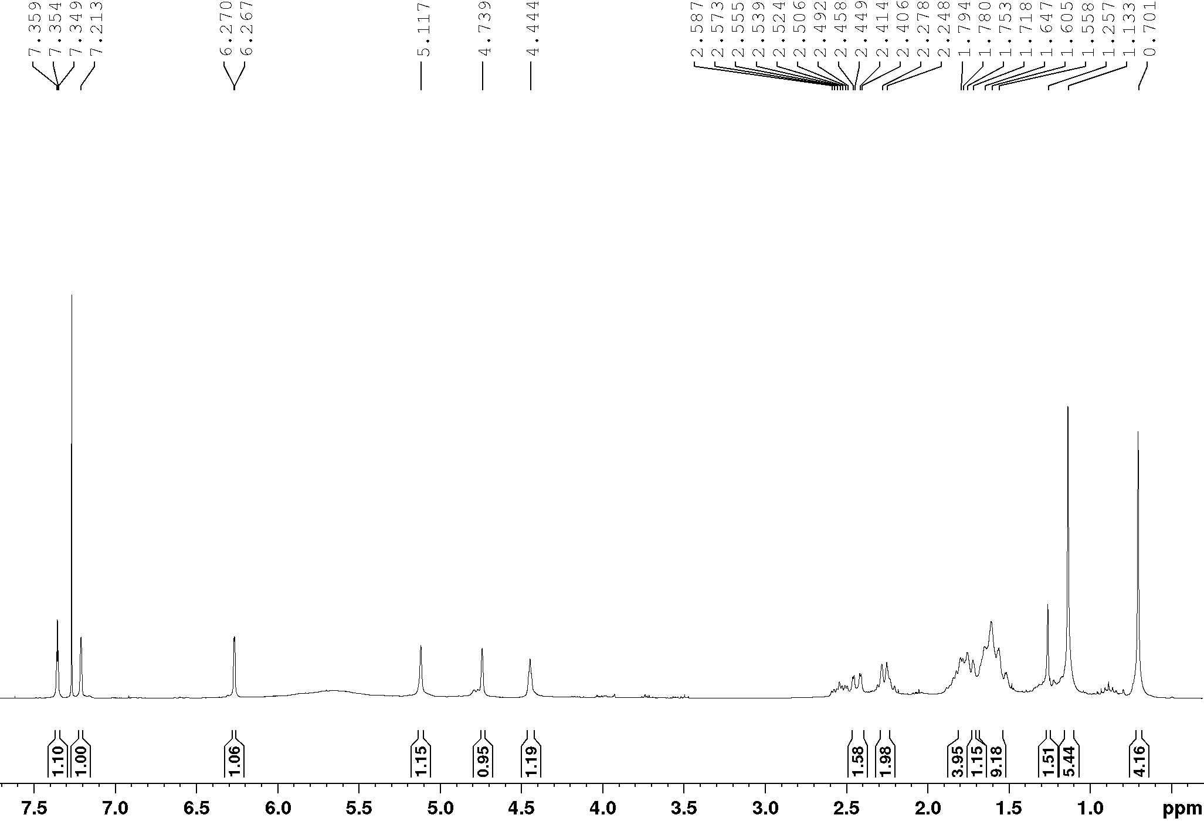

Figure 13S - ¹³C-NMR spectrum (CDCl₃. 75 MHz) of compound 5.
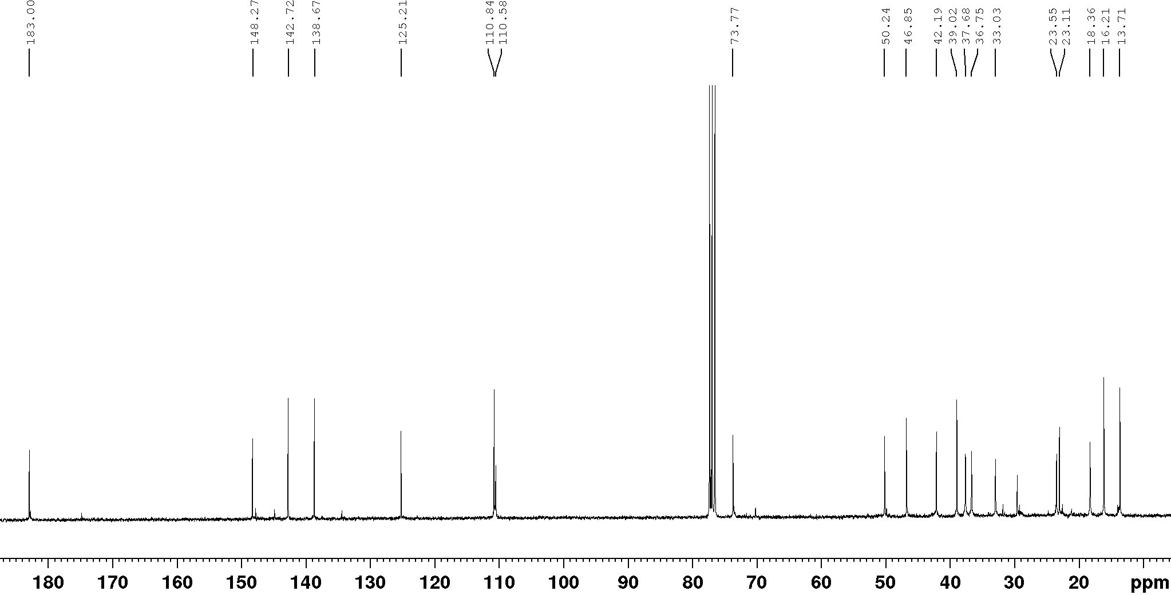

Figure 14S - HSQC spectrum (CDCl₃. 300 and 75 MHz) of compound 5.
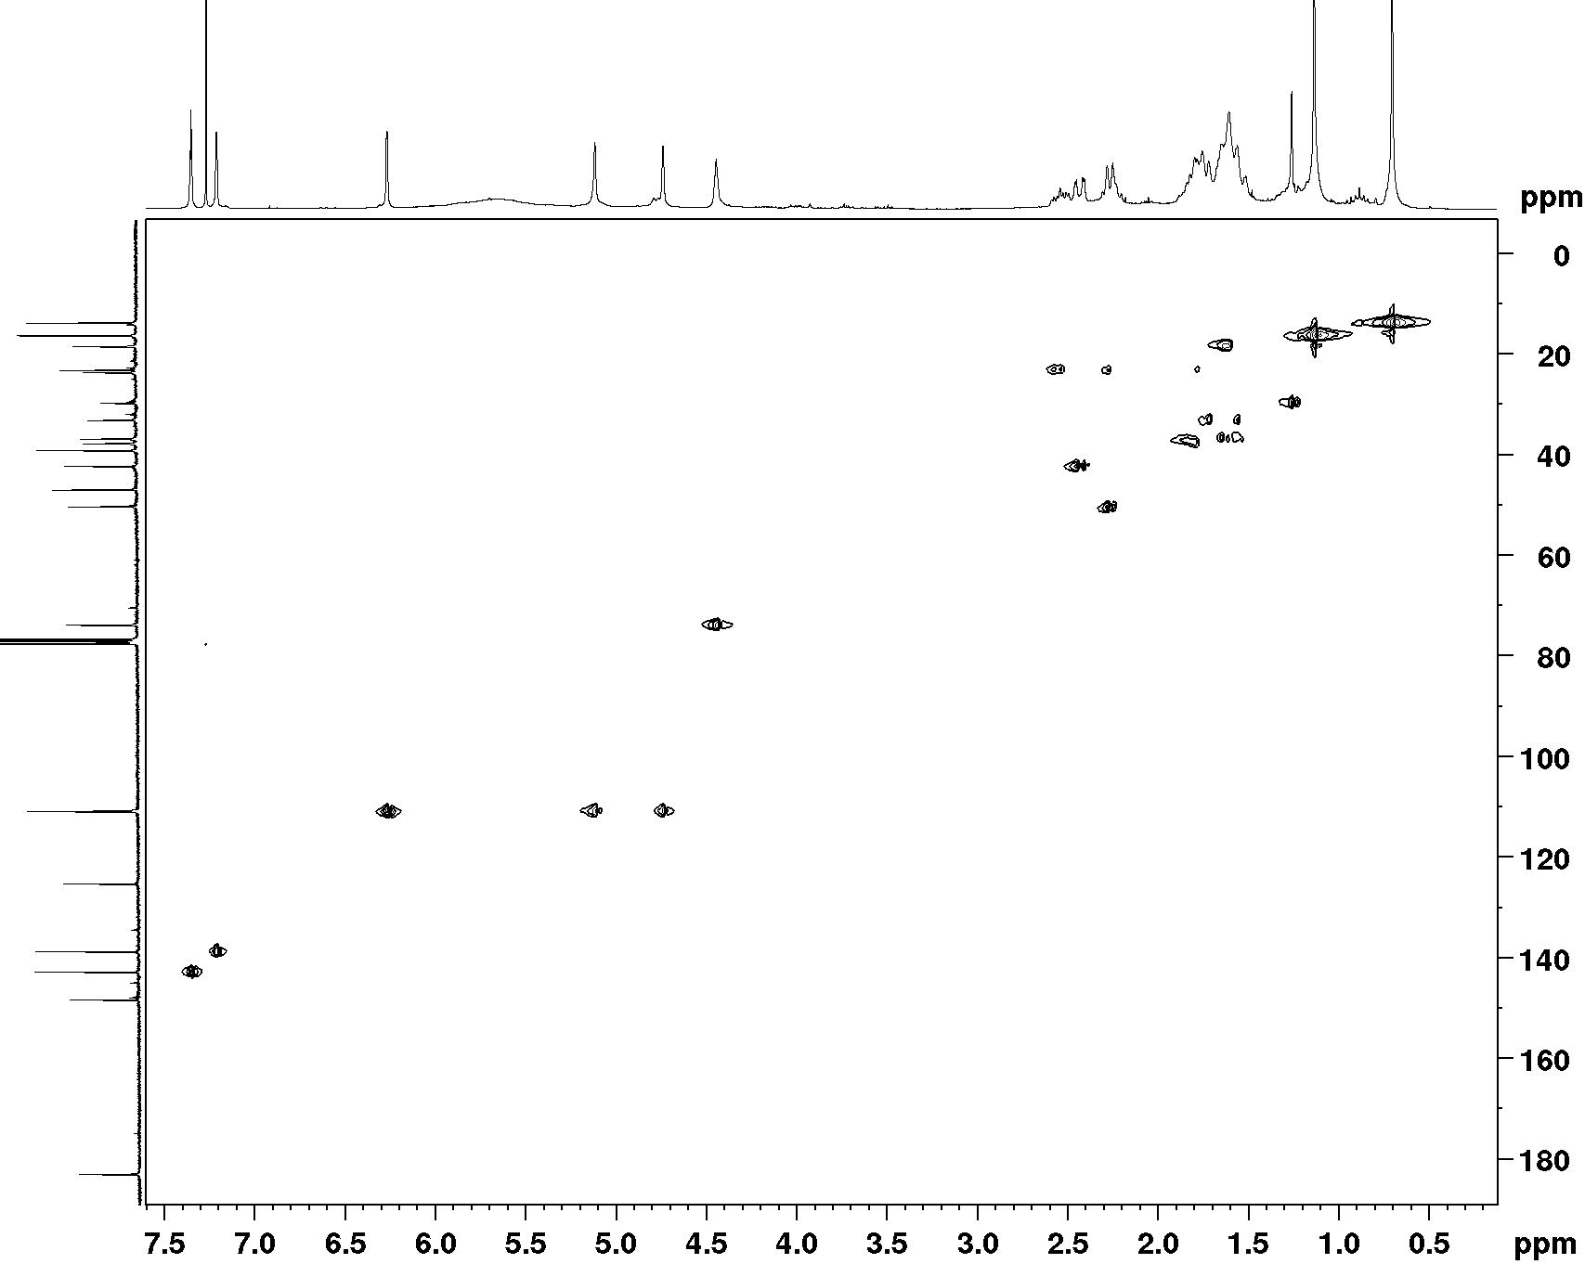

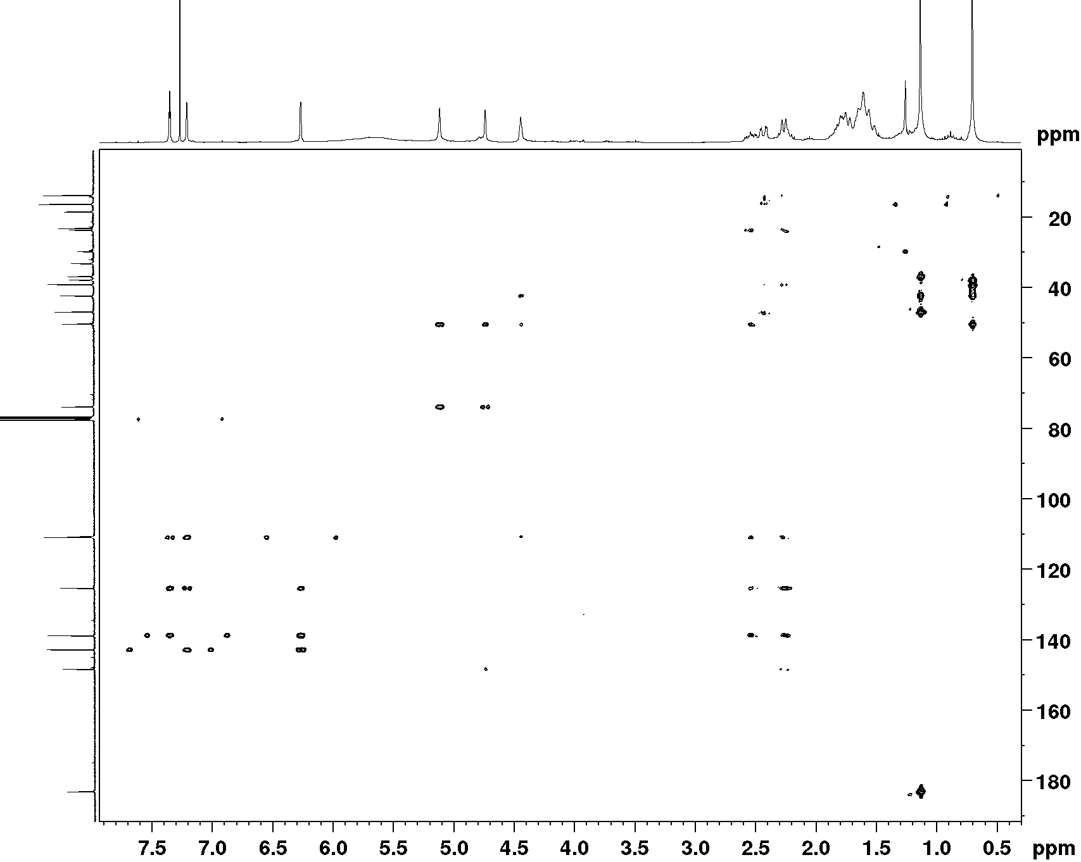
Figure 15S - HMBC spectrum (CDCl₃, 300 and 75 MHz) of compound 5.

Figure 16S - TOCSY spectrum and expansion (CDCl₃. 300 MHz) of compound 5.
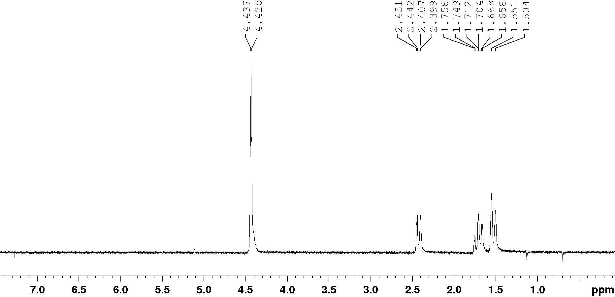

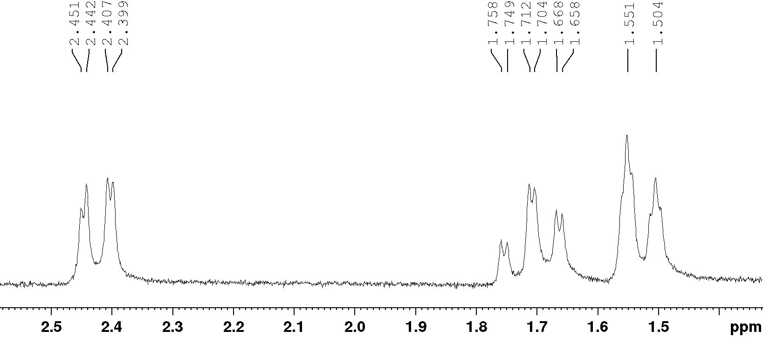

Figure 17S - pipHSQMBC spectrum for compound 5.
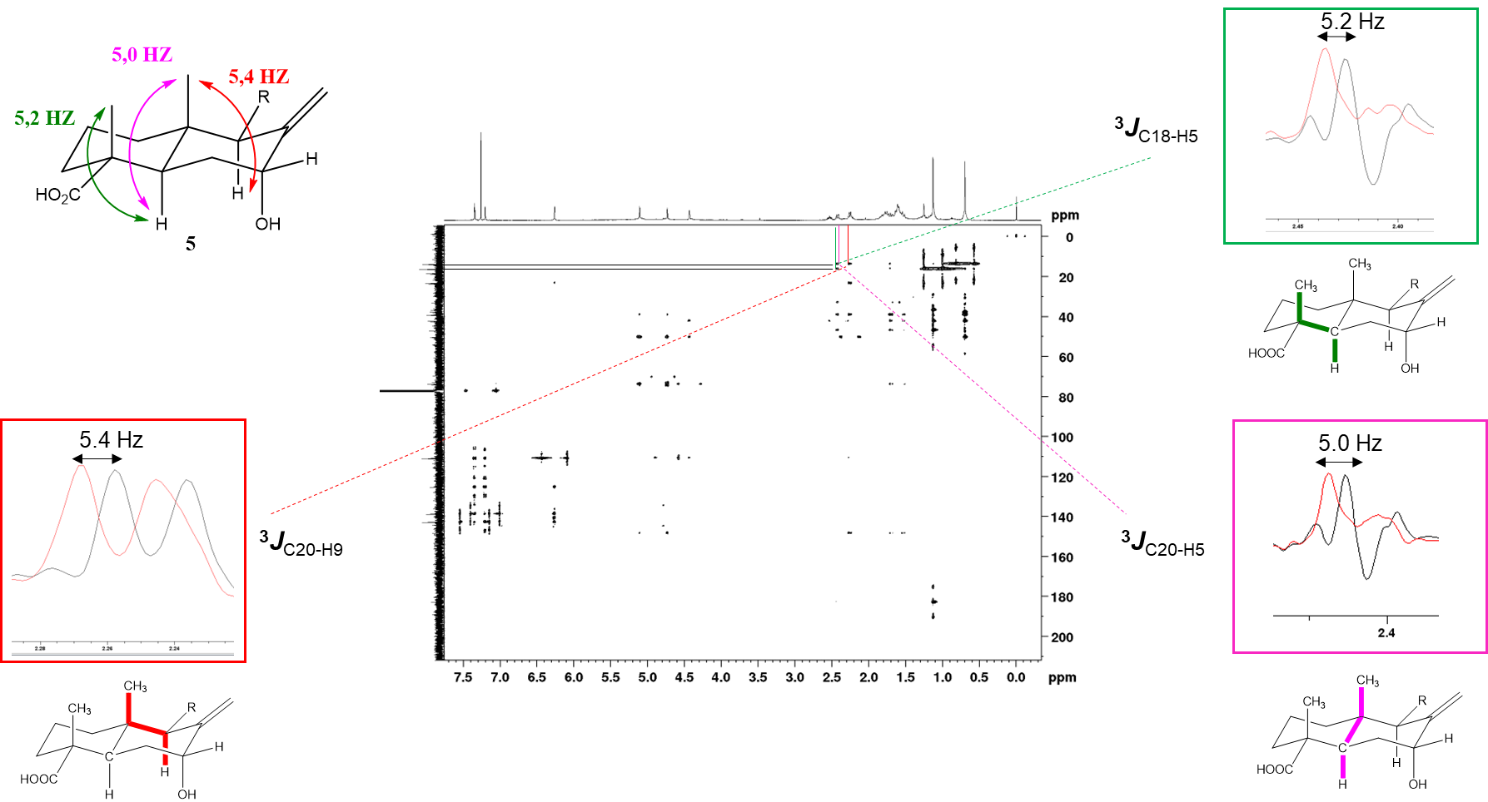

Figure 18S - ¹H-NMR spectrum (CDCl₃. 300 MHz) of compound 6.

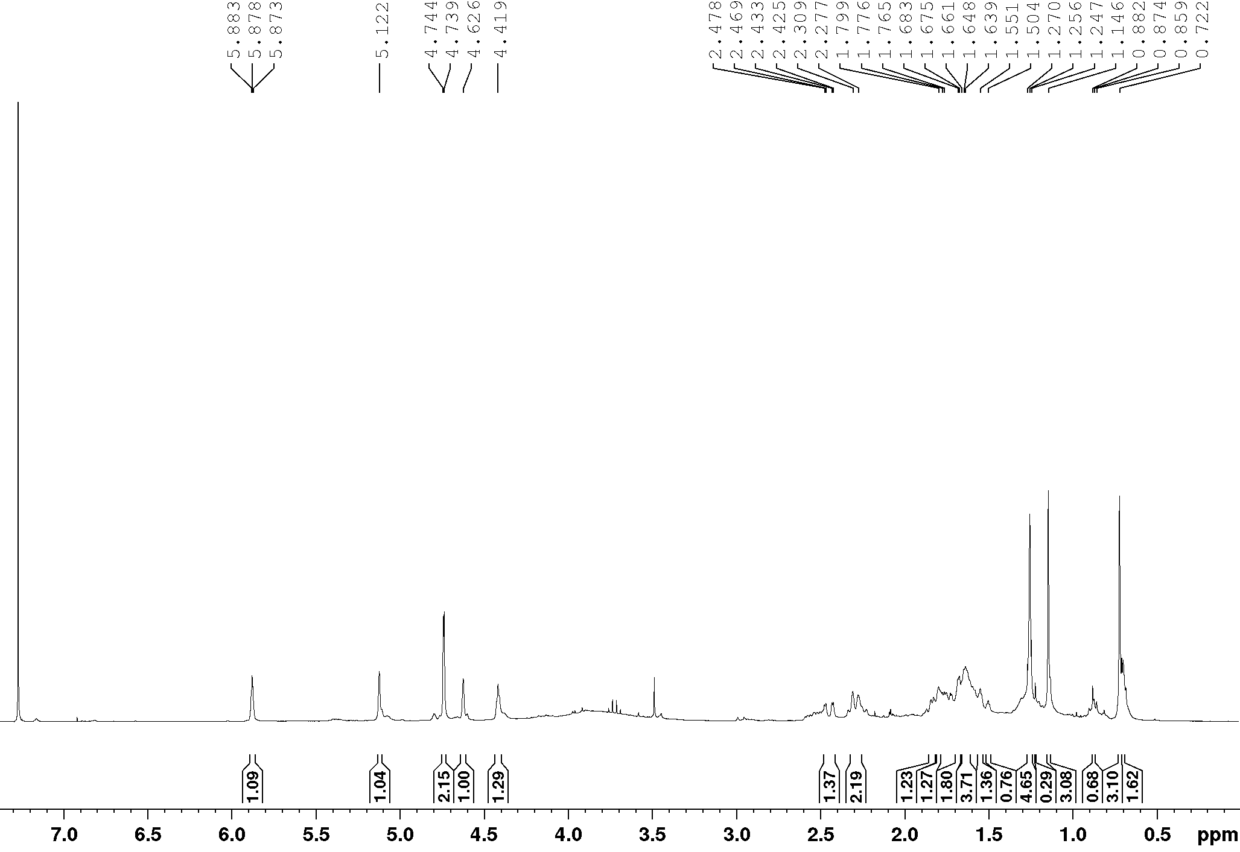

Figure 19S - ¹³C-NMR spectrum (CDCl₃. 75 MHz) of compound 6.
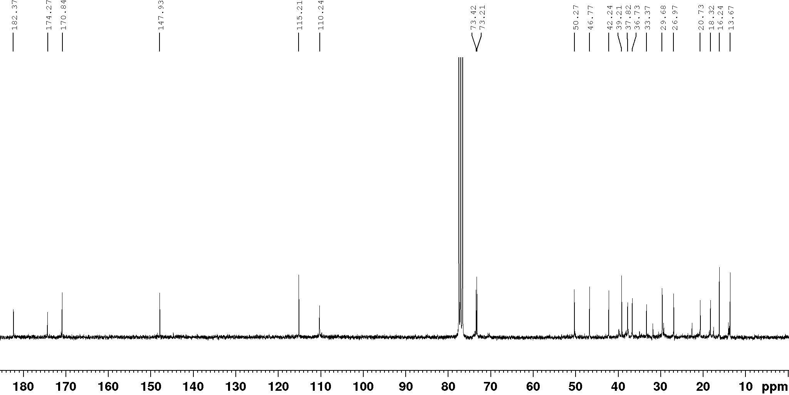

Figure 20S - HSQC spectrum (CDCl₃, 300 and 75 MHz)) for 6.

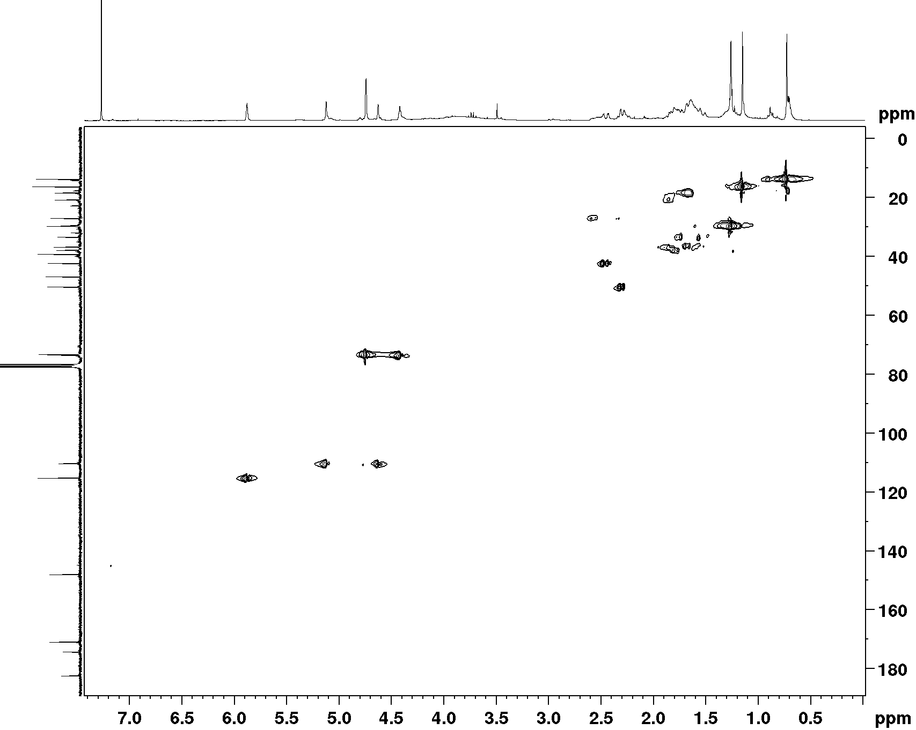

Figure 21S - HMBC spectrum (CDCl₃. 300 and 75 MHz) for 6.

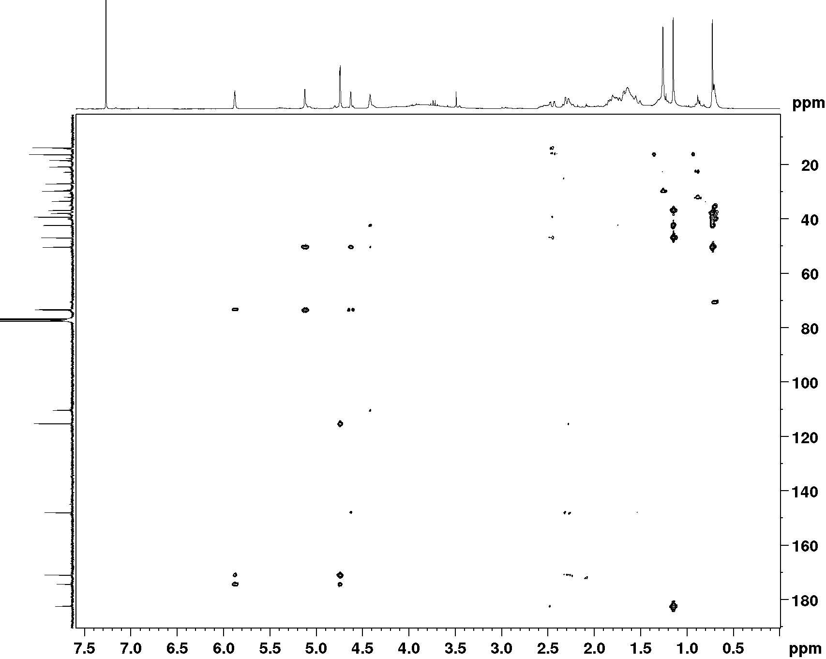
Figure 22S - pipHSQMBC spectrum for compound 6.
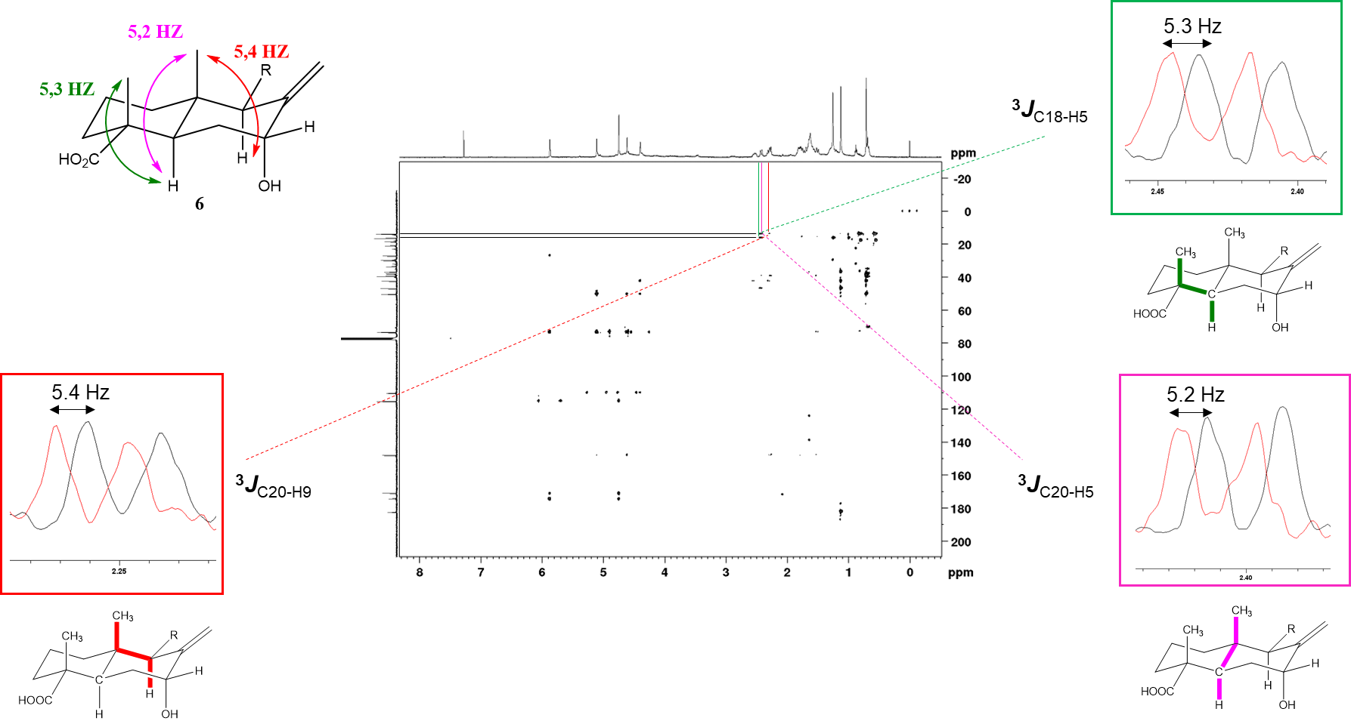
Tabela 4S - Inhibition of cell growth (%) of extracts. fractions and substances from A. laetevirens against the colon carcinoma line (HCT-116). at concentrations of 5 and 50 μg (mean ± DP).
Extract/Fractions | 5μM | 50μM
A. laetevirens | 5μM | 50μM
AL-CE | 8.4 ± 0.7 | 24.3 ± 7.9
AL-HEX | 23.8 ± 4.0 | 36.7 ± 9.8
AL-DC | 5.3 ± 3.3 | 40.6 ± 5.6
AL-EAF | 3.6 ± 1.6 | 25.3 ± 4.8
AL-HM | 11.8 ± 2.1 | 12.1 ± 7.3

Tabela 5S - Minimum Inhibitory Concentration (MIC) Values ​​of extracts. fractions and substances from A. laetevirens against M. tuberculosis (ATCC 27294).
- laetevirens M. tuberculosis MIC (μg mL⁻¹)
AL-CE | > 250
AL-HEX | > 250
AL-DC | > 250
AL-EAF | 250.0
AL-HM | > 250
5  6 | > 250  > 250
7 | 125.0
8 | 125.0
9 | > 250
Standard (Isoniazid) | 0.06

Atomic coordinates
(4R,5R,7R,9R,10R) – labdane (5)

B3PW91/PCM(CHCl₃)/6-311G(d,p) level

Conf1 (-1269.090056 Hartree)
Symbol | X | Y | Z
C | -0.59834 | 3.052347 | -0.36652
C | -1.95568 | 2.407838 | -0.61525
C | 0.528411 | 2.023432 | -0.42316
C | 0.362692 | 0.875449 | 0.593129
C | -1.06297 | 0.263832 | 0.402129
C | -2.2626 | 1.270386 | 0.389701
C | 1.367745 | -0.29047 | 0.247474
C | 1.123855 | -1.45589 | 1.184923
C | -0.2736 | -2.02602 | 1.110324
C | 2.002136 | -1.9601 | 2.053013
C | -2.64144 | 1.842449 | 1.759307
C | -3.4735 | 0.505452 | -0.14599
O | -4.51024 | 0.363658 | 0.495976
O | -3.31548 | 0.015404 | -1.35668
C | 0.667062 | 1.394167 | 2.006376
C | 2.83859 | 0.128332 | 0.141597
C | 3.69114 | -0.86857 | -0.6604
C | 5.122188 | -0.4465 | -0.78353
C | 6.209569 | -1.03576 | -0.2177
C | 5.641168 | 0.681439 | -1.50945
C | 6.984515 | 0.675927 | -1.3236
O | 7.35096 | -0.36654 | -0.53607
H | -0.5899 | 3.576341 | 0.595364
H | -0.42448 | 3.821605 | -1.12657
H | -1.96697 | 1.994151 | -1.62818
H | -2.75402 | 3.157033 | -0.56593
H | 1.482671 | 2.533108 | -0.26003
H | 0.565739 | 1.596108 | -1.43498
H | 1.062296 | -0.63751 | -0.75039
O | -0.53339 | -2.59408 | -0.17684
H | 3.010838 | -1.577 | 2.162635
H | 1.725661 | -2.78713 | 2.701319
H | -3.56066 | 2.426455 | 1.676373
H | -2.82213 | 1.055684 | 2.49369
H | -1.86293 | 2.497159 | 2.146971
H | -4.13519 | -0.47849 | -1.64357
H | 1.729403 | 1.643022 | 2.086815
H | 0.113268 | 2.301663 | 2.24734
H | 0.450119 | 0.655202 | 2.780284
H | 2.90635 | 1.098629 | -0.35595
H | 3.282017 | 0.267659 | 1.132785
H | 3.645003 | -1.85957 | -0.20075
H | 3.257047 | -0.97222 | -1.66264
H | 6.332647 | -1.90524 | 0.408451
H | 5.080632 | 1.393875 | -2.09683
H | 7.785167 | 1.31021 | -1.66882
H | -0.39243 | -2.79668 | 1.883951
H | 0.154067 | -3.24548 | -0.34611
C | -1.30834 | -0.9291 | 1.329149
H | -1.04731 | -0.14379 | -0.61513
H | -1.279 | -0.62887 | 2.380663
H | -2.29932 | -1.36151 | 1.152879
C | -6.48205 | -1.42556 | -1.4656
O | -5.48315 | -1.30104 | -2.15397
O | -6.65166 | -0.94381 | -0.26462
H | -7.36139 | -1.97909 | -1.81695
H | -5.82695 | -0.44259 | 0.025332

Conf2 (-1269.089580 Hartree)
Symbol | X | Y | Z
C | -0.6054 | 2.980549 | -0.81087
C | -1.97154 | 2.319151 | -0.93223
C | 0.511799 | 1.943732 | -0.71658
C | 0.350528 | 0.973843 | 0.469834
C | -1.08247 | 0.355222 | 0.397051
C | -2.27487 | 1.361022 | 0.243888
C | 1.343064 | -0.24197 | 0.297479
C | 1.102343 | -1.25029 | 1.402078
C | -0.30171 | -1.80752 | 1.435528
C | 1.990463 | -1.63404 | 2.320349
C | -2.62681 | 2.149436 | 1.510555
C | -3.46638 | 0.50606 | -0.19334
O | -3.46801 | -0.09666 | -1.26357
O | -4.47282 | 0.455972 | 0.650215
C | 0.679306 | 1.702591 | 1.781011
C | 2.815694 | 0.144691 | 0.115095
C | 3.646545 | -0.96144 | -0.55583
C | 5.085532 | -0.58753 | -0.73067
C | 5.725166 | -0.29313 | -1.89432
C | 6.083109 | -0.43806 | 0.294448
C | 7.229306 | -0.07239 | -0.33164
O | 7.030162 | 0.021249 | -1.6705
H | -0.57697 | 3.653474 | 0.053282
H | -0.43646 | 3.61471 | -1.68765
H | -2.00544 | 1.741296 | -1.8609
H | -2.76231 | 3.075547 | -0.99569
H | 1.472634 | 2.462291 | -0.64906
H | 0.531022 | 1.36097 | -1.64783
H | 1.023759 | -0.73298 | -0.63346
O | -0.58827 | -2.56169 | 0.253663
H | 3.005668 | -1.25447 | 2.353776
H | 1.716669 | -2.35343 | 3.087159
H | -3.54975 | 2.713674 | 1.358253
H | -2.78034 | 1.498635 | 2.372709
H | -1.84289 | 2.863052 | 1.760175
H | -5.19652 | -0.13311 | 0.289183
H | 0.486806 | 1.087041 | 2.662043
H | 1.740516 | 1.96786 | 1.798624
H | 0.120424 | 2.631359 | 1.893721
H | 2.890232 | 1.034068 | -0.51483
H | 3.2715 | 0.417328 | 1.072682
H | 3.576428 | -1.88471 | 0.028789
H | 3.212752 | -1.18333 | -1.53695
H | 5.40474 | -0.26897 | -2.92392
H | 5.956591 | -0.59023 | 1.35631
H | 8.22733 | 0.146092 | 0.012981
H | -0.41534 | -2.45032 | 2.318846
H | 0.090222 | -3.23933 | 0.175873
C | -1.32236 | -0.67806 | 1.500184
H | -1.09152 | -0.20255 | -0.54725
H | -1.2717 | -0.22095 | 2.492648
H | -2.31894 | -1.12268 | 1.408595
C | -6.34532 | -1.71333 | -1.32355
O | -6.41019 | -1.11586 | -0.26174
O | -5.3524 | -1.67179 | -2.16821
H | -7.15682 | -2.3649 | -1.66993
H | -4.62613 | -1.06645 | -1.81792

Conf3 (-1269.089362 Hartree)
Symbol | X | Y | Z
C | -0.58086 | 3.030395 | -0.52865
C | -1.94017 | 2.379212 | -0.74803
C | 0.54116 | 1.994414 | -0.52459
C | 0.366426 | 0.902688 | 0.549353
C | -1.06166 | 0.288912 | 0.386961
C | -2.25636 | 1.29931 | 0.315588
C | 1.366027 | -0.28503 | 0.265088
C | 1.114882 | -1.40248 | 1.257205
C | -0.28738 | -1.96483 | 1.214647
C | 1.993111 | -1.87575 | 2.142637
C | -2.63726 | 1.946915 | 1.650579
C | -3.46907 | 0.510491 | -0.18045
O | -4.5045 | 0.402249 | 0.469698
O | -3.31023 | -0.04212 | -1.36371
C | 0.671534 | 1.490841 | 1.934678
C | 2.838609 | 0.123371 | 0.140871
C | 3.684005 | -0.90303 | -0.63088
C | 5.120338 | -0.49975 | -0.75558
C | 5.765959 | -0.08735 | -1.87937
C | 6.107578 | -0.43978 | 0.288305
C | 7.25461 | -0.00299 | -0.28879
O | 7.065315 | 0.217876 | -1.61415
H | -0.57373 | 3.607178 | 0.402811
H | -0.39986 | 3.755815 | -1.32904
H | -1.94876 | 1.910822 | -1.73684
H | -2.73525 | 3.133372 | -0.74303
H | 1.497 | 2.507789 | -0.38524
H | 0.580536 | 1.513964 | -1.51213
H | 1.060003 | -0.67838 | -0.71535
O | -0.55267 | -2.59871 | -0.04043
H | 3.006373 | -1.49901 | 2.228543
H | 1.712795 | -2.67013 | 2.828927
H | -3.55518 | 2.527139 | 1.533578
H | -2.82157 | 1.203024 | 2.427378
H | -1.85842 | 2.62082 | 2.003019
H | -4.12346 | -0.55902 | -1.62483
H | 1.733176 | 1.746782 | 2.0004
H | 0.114773 | 2.407006 | 2.131889
H | 0.459155 | 0.789633 | 2.744195
H | 2.914415 | 1.072831 | -0.39393
H | 3.281452 | 0.298302 | 1.126823
H | 3.619135 | -1.88117 | -0.14306
H | 3.259635 | -1.02894 | -1.63293
H | 5.453359 | 0.033372 | -2.90457
H | 5.973551 | -0.69574 | 1.329045
H | 8.247176 | 0.191796 | 0.084554
H | -0.41027 | -2.69273 | 2.027995
H | 0.13001 | -3.26312 | -0.17506
C | -1.3153 | -0.8512 | 1.375429
H | -1.04427 | -0.17359 | -0.60656
H | -1.28463 | -0.49656 | 2.409744
H | -2.3085 | -1.28698 | 1.221756
C | -6.48354 | -1.49094 | -1.37541
O | -5.48293 | -1.41234 | -2.06762
O | -6.65755 | -0.92884 | -0.21043
H | -7.36361 | -2.06332 | -1.69341
H | -5.83047 | -0.41644 | 0.050885

Conf4 (-1269.089315 Hartree)
Symbol | X | Y | Z
C | -0.61117 | 3.031059 | -0.42507
C | -1.96947 | 2.377606 | -0.64622
C | 0.519851 | 2.006217 | -0.47338
C | 0.370732 | 0.875689 | 0.565154
C | -1.05503 | 0.258907 | 0.39757
C | -2.25883 | 1.257024 | 0.384429
C | 1.377567 | -0.29175 | 0.226787
C | 1.134477 | -1.45794 | 1.163888
C | -0.25651 | -2.03512 | 1.076886
C | 2.000192 | -1.93779 | 2.056275
C | -2.62372 | 1.853085 | 1.74743
C | -3.47708 | 0.488419 | -0.12877
O | -4.53874 | 0.433361 | 0.48426
O | -3.30029 | -0.10095 | -1.29328
C | 0.686683 | 1.418809 | 1.966258
C | 2.847799 | 0.131157 | 0.128971
C | 3.709544 | -0.87072 | -0.65664
C | 5.141603 | -0.44835 | -0.76596
C | 6.222104 | -1.03095 | -0.18041
C | 5.669386 | 0.672463 | -1.49667
C | 7.010278 | 0.669998 | -1.29361
O | 7.3673 | -0.36403 | -0.49079
H | -0.5948 | 3.575014 | 0.525597
H | -0.44922 | 3.785458 | -1.20247
H | -1.99073 | 1.944186 | -1.65118
H | -2.76999 | 3.124494 | -0.60107
H | 1.473219 | 2.523229 | -0.33015
H | 0.548783 | 1.559844 | -1.47715
H | 1.078986 | -0.64322 | -0.77098
O | -0.41103 | -2.59694 | -0.22865
H | 2.99678 | -1.53045 | 2.186631
H | 1.729039 | -2.77018 | 2.699221
H | -3.55357 | 2.419846 | 1.668438
H | -2.77711 | 1.079611 | 2.502419
H | -1.84934 | 2.528287 | 2.106692
H | -4.13344 | -0.5772 | -1.57252
H | 1.744361 | 1.691753 | 2.025477
H | 0.117088 | 2.316529 | 2.206454
H | 0.49992 | 0.683919 | 2.751962
H | 2.91637 | 1.098006 | -0.37569
H | 3.283122 | 0.280014 | 1.122313
H | 3.657167 | -1.85808 | -0.19042
H | 3.286725 | -0.9828 | -1.66256
H | 6.337592 | -1.89439 | 0.45545
H | 5.116014 | 1.378141 | -2.09883
H | 7.814909 | 1.30123 | -1.6352
H | -0.37097 | -2.82252 | 1.83365
H | -1.33987 | -2.8207 | -0.3424
C | -1.2818 | -0.92832 | 1.335206
H | -1.04533 | -0.15828 | -0.6158
H | -1.21538 | -0.62867 | 2.385886
H | -2.28997 | -1.34352 | 1.202681
C | -6.52316 | -1.41022 | -1.41249
O | -5.48841 | -1.39765 | -2.05822
O | -6.7194 | -0.81762 | -0.26662
H | -7.41464 | -1.9468 | -1.75901
H | -5.88187 | -0.33781 | 0.021041

Conf5 (-1269.089056 Hartree)
Symbol | X | Y | Z
C | -0.68429 | 2.957901 | -0.56087
C | -2.03372 | 2.265228 | -0.69652
C | 0.463631 | 1.951771 | -0.56958
C | 0.369256 | 0.90698 | 0.559834
C | -1.05233 | 0.259389 | 0.50054
C | -2.27439 | 1.213427 | 0.421547
C | 1.379457 | -0.27288 | 0.276874
C | 1.184678 | -1.37595 | 1.298709
C | -0.20942 | -1.95634 | 1.324905
C | 2.098159 | -1.80386 | 2.170022
C | -2.64672 | 1.899912 | 1.744075
C | -3.47319 | 0.409585 | -0.08725
O | -3.36626 | -0.66645 | -0.67356
O | -4.63208 | 1.000433 | 0.0956
C | 0.73081 | 1.566383 | 1.898418
C | 2.840298 | 0.159448 | 0.102099
C | 3.682533 | -0.87031 | -0.66844
C | 5.109335 | -0.44961 | -0.83648
C | 6.209285 | -1.01514 | -0.27085
C | 5.611186 | 0.651367 | -1.61423
C | 6.957978 | 0.655603 | -1.45474
O | 7.342643 | -0.35594 | -0.63616
H | -0.65628 | 3.566265 | 0.34981
H | -0.56064 | 3.659456 | -1.39278
H | -2.06579 | 1.757372 | -1.66912
H | -2.85208 | 2.99139 | -0.68835
H | 1.411455 | 2.493567 | -0.50187
H | 0.466675 | 1.42838 | -1.53583
H | 1.053904 | -0.69885 | -0.68298
O | -0.45186 | -2.61476 | 0.07753
H | 3.10066 | -1.39361 | 2.222174
H | 1.861537 | -2.5967 | 2.873911
H | -3.55438 | 2.491865 | 1.622015
H | -2.82624 | 1.172582 | 2.53971
H | -1.8536 | 2.567218 | 2.077716
H | -5.36989 | 0.458374 | -0.30792
H | 0.132794 | 2.454858 | 2.102994
H | 0.618828 | 0.884993 | 2.744236
H | 1.77658 | 1.886984 | 1.880329
H | 2.880105 | 1.10225 | -0.44908
H | 3.311408 | 0.359877 | 1.069945
H | 3.64716 | -1.83888 | -0.16255
H | 3.230153 | -1.02307 | -1.65605
H | 6.346583 | -1.86096 | 0.384083
H | 5.037473 | 1.340085 | -2.21699
H | 7.749996 | 1.27812 | -1.83914
H | -0.28137 | -2.68983 | 2.138594
H | -1.38369 | -2.50343 | -0.1378
C | -1.21723 | -0.83239 | 1.559448
H | -1.06505 | -0.25449 | -0.46742
H | -1.07707 | -0.43727 | 2.570044
H | -2.22776 | -1.25583 | 1.528719
C | -6.46565 | -1.46783 | -1.52911
O | -6.62331 | -0.40668 | -0.94908
O | -5.32461 | -2.06907 | -1.7302
H | -7.3089 | -2.02945 | -1.94852
H | -4.57677 | -1.52771 | -1.33128

Conf6 (-1269.088952 Hartree)
Symbol | X | Y | Z
C | 0.319765 | -1.62645 | -2.75505
C | 1.580161 | -0.88719 | -2.32661
C | -0.87242 | -1.25027 | -1.87845
C | -0.64476 | -1.53583 | -0.38042
C | 0.694429 | -0.85073 | 0.045318
C | 1.948544 | -1.14676 | -0.84691
C | -1.76978 | -0.82937 | 0.471851
C | -1.47606 | -1.01601 | 1.946974
C | -0.14503 | -0.45522 | 2.390504
C | -2.25608 | -1.6412 | 2.830854
C | 2.555342 | -2.54386 | -0.67417
C | 2.973952 | -0.07711 | -0.46479
O | 2.768144 | 1.115887 | -0.67147
O | 4.075152 | -0.5193 | 0.100441
C | -0.70655 | -3.05011 | -0.13075
C | -3.206 | -1.1921 | 0.078811
C | -4.25727 | -0.17323 | 0.558732
C | -4.16585 | 1.158314 | -0.12083
C | -3.8408 | 2.354337 | 0.439504
C | -4.4074 | 1.447877 | -1.50874
C | -4.20991 | 2.7804 | -1.66586
O | -3.8634 | 3.352044 | -0.48509
H | 0.481927 | -2.71003 | -2.73651
H | 0.095811 | -1.37606 | -3.79754
H | 1.421522 | 0.187808 | -2.45528
H | 2.427162 | -1.1656 | -2.96435
H | -1.75751 | -1.78776 | -2.23214
H | -1.08114 | -0.17933 | -2.00541
H | -1.64451 | 0.244025 | 0.270264
O | -0.10256 | 0.966825 | 2.240951
H | -3.21241 | -2.08057 | 2.569854
H | -1.94614 | -1.73938 | 3.867705
H | 3.493071 | -2.6169 | -1.22997
H | 2.775499 | -2.77203 | 0.369689
H | 1.886039 | -3.31402 | -1.05473
H | 4.679194 | 0.246084 | 0.325274
H | -0.04917 | -3.6097 | -0.79606
H | -0.44821 | -3.31608 | 0.89633
H | -1.72268 | -3.41205 | -0.31336
H | -3.28204 | -1.2622 | -1.00897
H | -3.47353 | -2.18142 | 0.463231
H | -5.25257 | -0.59607 | 0.378263
H | -4.17429 | -0.03063 | 1.639735
H | -3.58308 | 2.649479 | 1.444248
H | -4.6954 | 0.749948 | -2.28107
H | -4.27567 | 3.446979 | -2.51077
H | 0.026282 | -0.72004 | 3.44279
H | -0.85188 | 1.328208 | 2.723591
C | 0.981519 | -1.02498 | 1.538756
H | 0.514507 | 0.22042 | -0.10713
H | 1.113144 | -2.07953 | 1.797813
H | 1.907633 | -0.51285 | 1.820522
C | 5.443532 | 2.653732 | 0.498404
O | 5.705876 | 1.482703 | 0.718702
O | 4.356073 | 3.104828 | -0.06246
H | 6.135979 | 3.460761 | 0.767342
H | 3.742275 | 2.339125 | -0.29474

Conf7 (-1269.088792 Hartree)
Symbol | X | Y | Z
C | -0.60071 | 3.034579 | -0.56465
C | -1.96527 | 2.384126 | -0.74572
C | 0.516119 | 1.993377 | -0.54851
C | 0.350759 | 0.931447 | 0.555869
C | -1.08262 | 0.322001 | 0.431362
C | -2.27496 | 1.336525 | 0.349472
C | 1.34105 | -0.2681 | 0.287862
C | 1.09876 | -1.3599 | 1.310077
C | -0.3068 | -1.91495 | 1.302155
C | 1.987824 | -1.81617 | 2.193644
C | -2.63624 | 2.022884 | 1.671571
C | -3.46279 | 0.517339 | -0.16029
O | -3.45715 | -0.00141 | -1.27357
O | -4.47434 | 0.402412 | 0.670715
C | 0.677237 | 1.553592 | 1.921332
C | 2.814215 | 0.129721 | 0.13695
C | 3.648085 | -0.92139 | -0.6138
C | 5.079504 | -0.51699 | -0.78352
C | 6.171991 | -1.07626 | -0.19754
C | 5.593522 | 0.561063 | -1.58494
C | 6.93929 | 0.559705 | -1.41746
O | 7.311874 | -0.43423 | -0.57215
H | -0.57655 | 3.636621 | 0.350639
H | -0.42814 | 3.737068 | -1.38704
H | -1.99257 | 1.880811 | -1.71705
H | -2.75664 | 3.142385 | -0.75395
H | 1.476167 | 2.505391 | -0.43514
H | 0.539656 | 1.486866 | -1.52336
H | 1.021162 | -0.68328 | -0.67907
O | -0.59551 | -2.57699 | 0.06681
H | 3.003873 | -1.44205 | 2.255308
H | 1.713578 | -2.59207 | 2.90316
H | -3.55698 | 2.599437 | 1.556525
H | -2.79823 | 1.306727 | 2.478482
H | -1.85321 | 2.712381 | 1.983592
H | -5.19493 | -0.15856 | 0.261759
H | 0.47844 | 0.872277 | 2.750984
H | 1.739519 | 1.811477 | 1.964565
H | 0.122208 | 2.473753 | 2.104484
H | 2.884461 | 1.066935 | -0.41987
H | 3.272417 | 0.325798 | 1.111819
H | 3.602569 | -1.88198 | -0.09328
H | 3.19825 | -1.08354 | -1.6012
H | 6.299744 | -1.90642 | 0.478998
H | 5.028223 | 1.238879 | -2.20762
H | 7.737905 | 1.167163 | -1.81211
H | -0.42119 | -2.62254 | 2.134424
H | 0.081951 | -3.24763 | -0.06312
C | -1.32632 | -0.79198 | 1.451781
H | -1.08821 | -0.16336 | -0.55218
H | -1.2774 | -0.41222 | 2.476374
H | -2.32326 | -1.22698 | 1.324548
C | -6.32884 | -1.61688 | -1.47144
O | -6.40362 | -1.09657 | -0.37047
O | -5.33019 | -1.512 | -2.30387
H | -7.13519 | -2.24514 | -1.86909
H | -4.60895 | -0.93029 | -1.90664

Conf8 (-1269.088681 Hartree)
Symbol | X | Y | Z
C | -0.66457 | 2.915598 | -0.73122
C | -2.01929 | 2.22599 | -0.82525
C | 0.476645 | 1.902546 | -0.67892
C | 0.375055 | 0.92877 | 0.510871
C | -1.05019 | 0.288963 | 0.490087
C | -2.26591 | 1.244497 | 0.353822
C | 1.378228 | -0.27284 | 0.298279
C | 1.172883 | -1.31911 | 1.375755
C | -0.22759 | -1.88218 | 1.437014
C | 2.084716 | -1.71399 | 2.264247
C | -2.6333 | 2.012191 | 1.632434
C | -3.46889 | 0.417352 | -0.10584
O | -3.36787 | -0.69692 | -0.61723
O | -4.62385 | 1.028075 | 0.029531
C | 0.741116 | 1.663423 | 1.808426
C | 2.841543 | 0.143558 | 0.105322
C | 3.679634 | -0.92008 | -0.62259
C | 5.107926 | -0.51055 | -0.80567
C | 5.720964 | -0.1524 | -1.96576
C | 6.12053 | -0.38516 | 0.207977
C | 7.248055 | 0.030814 | -0.42056
O | 7.023499 | 0.178938 | -1.7505
H | -0.63255 | 3.576226 | 0.14206
H | -0.53576 | 3.565493 | -1.6032
H | -2.05643 | 1.661883 | -1.76614
H | -2.83235 | 2.957314 | -0.85949
H | 1.428162 | 2.440811 | -0.64466
H | 0.475445 | 1.321886 | -1.61177
H | 1.053688 | -0.74726 | -0.63911
O | -0.48447 | -2.60547 | 0.228864
H | 3.092231 | -1.31422 | 2.291701
H | 1.842188 | -2.46848 | 3.007123
H | -3.54861 | 2.585343 | 1.481251
H | -2.79604 | 1.336683 | 2.475922
H | -1.84457 | 2.709176 | 1.912133
H | -5.36298 | 0.466886 | -0.34382
H | 1.784841 | 1.98834 | 1.765937
H | 0.139 | 2.558358 | 1.967008
H | 0.637213 | 1.028861 | 2.691092
H | 2.890741 | 1.058865 | -0.48953
H | 3.309903 | 0.386632 | 1.064827
H | 3.635709 | -1.86696 | -0.07468
H | 3.232958 | -1.11198 | -1.60413
H | 5.382042 | -0.09042 | -2.98783
H | 6.015924 | -0.58676 | 1.263983
H | 8.247611 | 0.254165 | -0.08354
H | -0.30377 | -2.57002 | 2.289169
H | -1.41015 | -2.47354 | -0.00143
C | -1.22162 | -0.73548 | 1.613076
H | -1.06666 | -0.28112 | -0.44575
H | -1.06877 | -0.28284 | 2.597258
H | -2.2366 | -1.14868 | 1.614876
C | -6.46396 | -1.52493 | -1.45539
O | -6.61674 | -0.42912 | -0.94263
O | -5.32781 | -2.15046 | -1.60371
H | -7.30805 | -2.10143 | -1.85242
H | -4.57836 | -1.59538 | -1.22805

Conf9 (-1269.088515 Hartree)
Symbol | X | Y | Z
C | 0.322514 | -1.54724 | -2.75033
C | 1.572073 | -0.79893 | -2.30154
C | -0.88332 | -1.20328 | -1.87822
C | -0.66476 | -1.50446 | -0.38149
C | 0.660297 | -0.80174 | 0.058558
C | 1.923745 | -1.07858 | -0.8173
C | -1.80499 | -0.82195 | 0.46928
C | -1.51392 | -1.00567 | 1.945153
C | -0.21014 | -0.3944 | 2.393442
C | -2.26222 | -1.68411 | 2.815079
C | 2.534599 | -2.47413 | -0.6571
C | 2.992303 | -0.05554 | -0.43109
O | 4.146073 | -0.36859 | -0.15351
O | 2.581597 | 1.195753 | -0.44572
C | -0.70783 | -3.0221 | -0.14949
C | -3.23405 | -1.20583 | 0.072178
C | -4.29562 | -0.20592 | 0.571711
C | -4.23632 | 1.127008 | -0.10881
C | -3.77857 | 2.301067 | 0.4038
C | -4.6404 | 1.436489 | -1.45398
C | -4.39677 | 2.758128 | -1.63686
O | -3.86958 | 3.303641 | -0.51162
H | 0.501503 | -2.62801 | -2.74793
H | 0.10426 | -1.28293 | -3.79057
H | 1.400869 | 0.27548 | -2.42444
H | 2.428369 | -1.06277 | -2.9324
H | -1.75611 | -1.75043 | -2.24713
H | -1.10962 | -0.13454 | -1.99263
H | -1.69957 | 0.25401 | 0.273964
O | -0.31898 | 1.022177 | 2.233693
H | -3.18876 | -2.17425 | 2.537766
H | -1.96067 | -1.77162 | 3.854906
H | 3.477575 | -2.53196 | -1.20387
H | 2.749739 | -2.70579 | 0.388006
H | 1.872748 | -3.2459 | -1.04541
H | 3.331776 | 1.812034 | -0.20889
H | -0.05368 | -3.56799 | -0.82923
H | -0.43558 | -3.29763 | 0.871491
H | -1.72244 | -3.39157 | -0.32476
H | -3.31153 | -1.26185 | -1.01661
H | -3.48624 | -2.20365 | 0.444788
H | -5.28734 | -0.64325 | 0.40946
H | -4.19108 | -0.06482 | 1.6508
H | -3.36345 | 2.571449 | 1.361702
H | -5.06386 | 0.75788 | -2.18006
H | -4.54014 | 3.433072 | -2.46539
H | -0.04106 | -0.63392 | 3.451749
H | 0.558408 | 1.398466 | 2.354061
C | 0.933473 | -0.96812 | 1.554482
H | 0.458034 | 0.26461 | -0.09254
H | 1.068173 | -2.02053 | 1.823256
H | 1.865498 | -0.4603 | 1.837012
C | 5.684996 | 2.492628 | 0.45504
O | 4.54799 | 2.858722 | 0.20835
O | 6.111268 | 1.25932 | 0.453659
H | 6.479142 | 3.204507 | 0.710792
H | 5.35746 | 0.634005 | 0.218196

Atomic coordinates
(4R,5R,7R,9R,10R) – labdane (6)

B3PW91/PCM(CHCl₃)/6-311G(d,p) level

Conf1 (-1344.331643 Hartree)
Symbol | X | Y | Z
C | -0.95795 | 2.896445 | -1.13472
C | 0.176329 | 1.895867 | -0.92432
C | 0.021028 | 1.058653 | 0.36142
C | -1.39994 | 0.407512 | 0.345345
C | 1.035104 | -0.14823 | 0.336836
C | 0.805943 | -1.01856 | 1.555756
C | -0.5827 | -1.60868 | 1.632519
C | -1.6318 | -0.5069 | 1.55193
C | -2.60718 | 1.370719 | 0.080725
C | -2.31125 | 2.200467 | -1.19149
C | 0.319302 | 1.937365 | 1.585749
C | -2.97673 | 2.285746 | 1.252923
C | -3.78304 | 0.455596 | -0.26823
O | -0.82719 | -2.50121 | 0.541701
C | 1.682624 | -1.24884 | 2.534492
C | 2.502877 | 0.237017 | 0.119031
C | 3.346817 | -0.94801 | -0.3501
C | 4.79855 | -0.66582 | -0.51691
C | 5.498565 | 0.454839 | -0.30363
C | 6.912678 | 0.208381 | -0.61485
O | 7.862736 | 0.944736 | -0.55672
O | 7.035948 | -1.09379 | -1.0208
C | 5.755752 | -1.71888 | -0.99082
O | -3.76092 | -0.27094 | -1.25842
O | -4.80319 | 0.497574 | 0.558415
H | -0.79399 | 3.436285 | -2.07333
H | -0.94723 | 3.65752 | -0.34695
H | 1.12852 | 2.43492 | -0.90843
H | 0.210533 | 1.215668 | -1.78658
H | -1.39212 | -0.24617 | -0.53534
H | 0.730221 | -0.75411 | -0.52869
H | -0.69599 | -2.14734 | 2.582847
H | -1.61295 | 0.058185 | 2.488368
H | -2.61506 | -0.98563 | 1.492968
H | -3.11463 | 2.930528 | -1.34242
H | -2.32654 | 1.523598 | -2.05128
H | 0.085132 | 1.438476 | 2.528152
H | 1.383403 | 2.190277 | 1.609664
H | -0.22611 | 2.880588 | 1.562896
H | -2.19912 | 3.025887 | 1.434916
H | -3.90047 | 2.82543 | 1.032004
H | -3.13708 | 1.729302 | 2.177472
H | -0.1479 | -3.18168 | 0.571293
H | 2.683906 | -0.83159 | 2.545848
H | 1.410382 | -1.87065 | 3.382817
H | 2.568528 | 1.020897 | -0.63899
H | 2.933147 | 0.658646 | 1.03304
H | 3.240634 | -1.79168 | 0.343419
H | 2.958325 | -1.3194 | -1.30854
H | 5.146302 | 1.416035 | 0.040125
H | 5.794545 | -2.57862 | -0.3138
H | 5.511091 | -2.07925 | -1.99539
H | -5.51771 | -0.13577 | 0.258237
C | -6.63135 | -1.9005 | -1.17365
O | -6.71777 | -1.17927 | -0.1934
O | -5.62214 | -1.95749 | -1.99793
H | -7.43494 | -2.59224 | -1.45416
H | -4.9046 | -1.31014 | -1.711

Conf2 (-1344.331291 Hartree)
Symbol | X | Y | Z
C | -0.94887 | 3.062272 | -0.41075
C | 0.191852 | 2.047892 | -0.44478
C | 0.03661 | 0.915135 | 0.5901
C | -1.37978 | 0.280782 | 0.402961
C | 1.055723 | -0.24499 | 0.267269
C | 0.825831 | -1.3978 | 1.223604
C | -0.56431 | -1.98646 | 1.152781
C | -1.61285 | -0.89858 | 1.350174
C | -2.59289 | 1.270479 | 0.366194
C | -2.29566 | 2.395097 | -0.65591
C | 0.327919 | 1.459935 | 1.995937
C | -2.98936 | 1.860527 | 1.723171
C | -3.78891 | 0.478405 | -0.16443
O | -0.81103 | -2.57729 | -0.12635
C | 1.708228 | -1.87527 | 2.102421
C | 2.521046 | 0.193441 | 0.160901
C | 3.377556 | -0.81874 | -0.62325
C | 4.818344 | -0.44218 | -0.68253
C | 5.881156 | -1.08458 | -0.18474
C | 7.09911 | -0.32662 | -0.49913
O | 8.250808 | -0.55501 | -0.23573
O | 6.729767 | 0.788878 | -1.20324
C | 5.313438 | 0.799565 | -1.36291
O | -4.82703 | 0.331038 | 0.473528
O | -3.61512 | -0.0286 | -1.36589
H | -0.781 | 3.820736 | -1.1828
H | -0.95216 | 3.602743 | 0.541967
H | 1.137684 | 2.574762 | -0.28599
H | 0.238955 | 1.604399 | -1.44924
H | -1.3535 | -0.14456 | -0.60683
H | 0.758833 | -0.61206 | -0.72575
H | -0.67666 | -2.74564 | 1.938252
H | -1.59006 | -0.57963 | 2.396249
H | -2.59765 | -1.34657 | 1.179148
H | -3.10414 | 3.134057 | -0.62313
H | -2.29571 | 1.964656 | -1.66187
H | 0.134284 | 0.724609 | 2.779299
H | 1.382283 | 1.742316 | 2.072387
H | -0.25331 | 2.35269 | 2.225737
H | -2.22928 | 2.543611 | 2.098602
H | -3.92288 | 2.418917 | 1.626095
H | -3.15181 | 1.085246 | 2.473786
H | -0.13142 | -3.24276 | -0.2706
H | 2.711412 | -1.47737 | 2.21099
H | 1.440964 | -2.695 | 2.763464
H | 2.573142 | 1.156381 | -0.3515
H | 2.957423 | 0.349903 | 1.15229
H | 3.285755 | -1.81472 | -0.18507
H | 2.987732 | -0.8827 | -1.64754
H | 5.901912 | -2.016 | 0.362884
H | 5.074033 | 0.807384 | -2.43162
H | 4.916818 | 1.714777 | -0.91251
H | -4.42467 | -0.54144 | -1.64951
C | -6.75051 | -1.53484 | -1.46623
O | -5.75088 | -1.3991 | -2.15153
O | -6.93864 | -1.03429 | -0.27575
H | -7.614 | -2.11631 | -1.8115
H | -6.1281 | -0.50835 | 0.008741

Conf3 (-1344.330784 Hartree)
Symbol | X | Y | Z
C | -1.03812 | 2.959399 | -0.61797
C | 0.12535 | 1.971058 | -0.60093
C | 0.040819 | 0.947374 | 0.548574
C | -1.37032 | 0.276527 | 0.495333
C | 1.067534 | -0.22441 | 0.29286
C | 0.885951 | -1.3101 | 1.335122
C | -0.49856 | -1.91226 | 1.360973
C | -1.52356 | -0.79892 | 1.572522
C | -2.60547 | 1.21175 | 0.394757
C | -2.37635 | 2.243297 | -0.74422
C | 0.385794 | 1.636708 | 1.876194
C | -2.99121 | 1.919929 | 1.701553
C | -3.79 | 0.37898 | -0.10211
O | -0.72004 | -2.59051 | 0.121025
C | 1.799439 | -1.70374 | 2.222262
C | 2.52268 | 0.227058 | 0.118416
C | 3.373931 | -0.82328 | -0.61983
C | 4.812974 | -0.44762 | -0.71302
C | 5.884574 | -1.07549 | -0.21529
C | 7.096276 | -0.32609 | -0.57044
O | 8.252611 | -0.5463 | -0.32009
O | 6.714608 | 0.769908 | -1.29854
C | 5.295649 | 0.775408 | -1.43481
O | -3.66145 | -0.7004 | -0.67785
O | -4.96005 | 0.947557 | 0.077349
H | -0.92127 | 3.644874 | -1.464
H | -1.02312 | 3.587036 | 0.279719
H | 1.063673 | 2.530415 | -0.53906
H | 0.141341 | 1.429337 | -1.55688
H | -1.37205 | -0.25474 | -0.46312
H | 0.753894 | -0.67272 | -0.6605
H | -0.56453 | -2.6344 | 2.185058
H | -1.39344 | -0.3852 | 2.576993
H | -2.52766 | -1.23735 | 1.545042
H | -3.20509 | 2.957504 | -0.75393
H | -2.39722 | 1.71489 | -1.70601
H | 1.425815 | 1.975781 | 1.858073
H | -0.22866 | 2.518054 | 2.060325
H | 0.280253 | 0.969384 | 2.733827
H | -2.21555 | 2.616861 | 2.015236
H | -3.9146 | 2.484443 | 1.568586
H | -3.1485 | 1.207918 | 2.515432
H | -1.65684 | -2.5197 | -0.09005
H | 2.794008 | -1.27489 | 2.277355
H | 1.57079 | -2.48657 | 2.939578
H | 2.548215 | 1.156062 | -0.45567
H | 2.982416 | 0.454306 | 1.085529
H | 3.287408 | -1.79489 | -0.12923
H | 2.974354 | -0.94259 | -1.63533
H | 5.914683 | -1.99145 | 0.35735
H | 5.038455 | 0.754497 | -2.4992
H | 4.905614 | 1.702113 | -1.00239
H | -5.68769 | 0.385913 | -0.3185
C | -6.74464 | -1.573 | -1.52099
O | -6.92248 | -0.51099 | -0.94837
O | -5.59187 | -2.15215 | -1.72059
H | -7.57722 | -2.15487 | -1.93392
H | -4.85466 | -1.59238 | -1.32765

Conf4 (-1344.330760 Hartree)
Symbol | X | Y | Z
C | -0.84504 | 3.040562 | -0.39591
C | 0.273041 | 1.999932 | -0.38193
C | 0.052661 | 0.876277 | 0.649822
C | -1.37055 | 0.274215 | 0.415671
C | 1.053381 | -0.31037 | 0.365227
C | 0.765088 | -1.45071 | 1.319319
C | -0.63459 | -2.00902 | 1.202428
C | -1.66476 | -0.89627 | 1.356856
C | -2.55663 | 1.293032 | 0.335611
C | -2.1982 | 2.402592 | -0.68329
C | 0.307167 | 1.419081 | 2.063583
C | -2.98019 | 1.901519 | 1.676168
C | -3.75546 | 0.527766 | -0.22697
O | -0.84878 | -2.60121 | -0.08166
C | 1.604237 | -1.94041 | 2.233067
C | 2.530301 | 0.093608 | 0.298058
C | 3.388872 | -0.94242 | -0.45249
C | 4.817793 | -0.53567 | -0.56764
C | 5.515746 | -0.20322 | -1.65966
C | 6.893616 | 0.127449 | -1.27441
O | 7.830758 | 0.47318 | -1.94527
O | 6.996937 | -0.02 | 0.084008
C | 5.739038 | -0.43348 | 0.611411
O | -4.81535 | 0.408942 | 0.380528
O | -3.55845 | 0.010268 | -1.42022
H | -0.63221 | 3.788389 | -1.16708
H | -0.87004 | 3.588867 | 0.5521
H | 1.224173 | 2.505509 | -0.1894
H | 0.348798 | 1.551348 | -1.38223
H | -1.32003 | -0.15509 | -0.59153
H | 0.777031 | -0.6753 | -0.63428
H | -0.79164 | -2.76101 | 1.987197
H | -1.6743 | -0.57464 | 2.40232
H | -2.65205 | -1.32305 | 1.149996
H | -2.98954 | 3.16052 | -0.68377
H | -2.17358 | 1.963987 | -1.68538
H | 0.049068 | 0.699233 | 2.842746
H | 1.367987 | 1.658791 | 2.183354
H | -0.24491 | 2.33758 | 2.262084
H | -2.21068 | 2.558551 | 2.077677
H | -3.8898 | 2.491535 | 1.544832
H | -3.19722 | 1.135084 | 2.422087
H | -0.17969 | -3.28251 | -0.19879
H | 2.61042 | -1.56158 | 2.376204
H | 1.296529 | -2.74935 | 2.889712
H | 2.626616 | 1.043836 | -0.23153
H | 2.932878 | 0.260041 | 1.301852
H | 3.332237 | -1.90946 | 0.060017
H | 2.979466 | -1.08822 | -1.45625
H | 5.175451 | -0.17083 | -2.68488
H | 5.406445 | 0.306654 | 1.345979
H | 5.864033 | -1.39516 | 1.120244
H | -4.37238 | -0.48206 | -1.72666
C | -6.72885 | -1.41136 | -1.61168
O | -5.7062 | -1.30433 | -2.26745
O | -6.93809 | -0.90337 | -0.42791
H | -7.5973 | -1.96993 | -1.98145
H | -6.12244 | -0.39827 | -0.12081

Conf5 (-1344.330556 Hartree)
Symbol | X | Y | Z
C | -0.96512 | 3.039459 | -0.46363
C | 0.180885 | 2.030768 | -0.49458
C | 0.045264 | 0.91267 | 0.559289
C | -1.37101 | 0.272447 | 0.39634
C | 1.066981 | -0.24639 | 0.238069
C | 0.840459 | -1.40306 | 1.190864
C | -0.54126 | -2.00161 | 1.104815
C | -1.58257 | -0.90623 | 1.348251
C | -2.58868 | 1.252999 | 0.367037
C | -2.31309 | 2.36313 | -0.67866
C | 0.349563 | 1.477517 | 1.954058
C | -2.96608 | 1.863551 | 1.720203
C | -3.7941 | 0.458995 | -0.13893
O | -0.6812 | -2.57765 | -0.19576
C | 1.710039 | -1.85566 | 2.09351
C | 2.531248 | 0.196938 | 0.138783
C | 3.396176 | -0.82013 | -0.6299
C | 4.837186 | -0.44304 | -0.6741
C | 5.893194 | -1.0756 | -0.14961
C | 7.114503 | -0.32027 | -0.4562
O | 8.262424 | -0.5418 | -0.17057
O | 6.754846 | 0.783405 | -1.18371
C | 5.341155 | 0.788434 | -1.36643
O | -4.85658 | 0.396964 | 0.471589
O | -3.60422 | -0.14396 | -1.29432
H | -0.81178 | 3.784511 | -1.25163
H | -0.95871 | 3.597787 | 0.478746
H | 1.125579 | 2.565164 | -0.3561
H | 0.218658 | 1.571105 | -1.49206
H | -1.35302 | -0.15758 | -0.61158
H | 0.775735 | -0.6147 | -0.75555
H | -0.64698 | -2.78262 | 1.869106
H | -1.52267 | -0.5933 | 2.395392
H | -2.5842 | -1.33734 | 1.218501
H | -3.12414 | 3.099038 | -0.64537
H | -2.32594 | 1.915605 | -1.67755
H | 0.180772 | 0.746737 | 2.747509
H | 1.400143 | 1.777554 | 2.010841
H | -0.24227 | 2.363057 | 2.18433
H | -2.21096 | 2.568546 | 2.063259
H | -3.91219 | 2.40141 | 1.633956
H | -3.09412 | 1.10102 | 2.490839
H | -1.60422 | -2.82497 | -0.3086
H | 2.699179 | -1.43056 | 2.224581
H | 1.449641 | -2.68296 | 2.747097
H | 2.583957 | 1.15661 | -0.3802
H | 2.960323 | 0.362144 | 1.131886
H | 3.297756 | -1.8127 | -0.18598
H | 3.017592 | -0.89176 | -1.6577
H | 5.906187 | -1.99847 | 0.412518
H | 5.119139 | 0.778057 | -2.43888
H | 4.935472 | 1.710199 | -0.93789
H | -4.42902 | -0.63757 | -1.56943
C | -6.80422 | -1.50653 | -1.40565
O | -5.76634 | -1.4875 | -2.04643
O | -7.01639 | -0.89723 | -0.27148
H | -7.68438 | -2.06469 | -1.74685
H | -6.18904 | -0.3976 | 0.010959

Conf6 (-1344.330435 Hartree)
Symbol | X | Y | Z
C | -0.94864 | 2.897889 | -0.98673
C | 0.195275 | 1.897 | -0.83296
C | 0.04911 | 0.982149 | 0.399512
C | -1.36715 | 0.324841 | 0.340119
C | 1.073478 | -0.21382 | 0.297079
C | 0.837161 | -1.18461 | 1.436138
C | -0.54332 | -1.79186 | 1.442072
C | -1.5889 | -0.6748 | 1.476315
C | -2.57897 | 1.29166 | 0.143681
C | -2.29906 | 2.198098 | -1.08278
C | 0.344273 | 1.782084 | 1.676724
C | -2.94646 | 2.134887 | 1.368359
C | -3.79625 | 0.439874 | -0.21915
O | -0.66678 | -2.58949 | 0.261867
C | 1.697443 | -1.47228 | 2.412612
C | 2.539578 | 0.205233 | 0.13753
C | 3.406337 | -0.92207 | -0.42293
C | 4.854613 | -0.6019 | -0.54418
C | 5.533711 | 0.500917 | -0.20558
C | 6.953893 | 0.313051 | -0.52793
O | 7.890251 | 1.055238 | -0.38259
O | 7.103411 | -0.93542 | -1.07013
C | 5.833886 | -1.58165 | -1.11963
O | -4.87746 | 0.542723 | 0.351646
O | -3.59747 | -0.39985 | -1.21441
H | -0.78993 | 3.491213 | -1.89337
H | -0.94474 | 3.613151 | -0.15731
H | 1.140982 | 2.445094 | -0.78397
H | 0.238743 | 1.270282 | -1.73434
H | -1.34664 | -0.2678 | -0.58136
H | 0.791006 | -0.75234 | -0.61846
H | -0.65724 | -2.42647 | 2.330641
H | -1.54665 | -0.18744 | 2.455442
H | -2.58687 | -1.12771 | 1.405653
H | -3.10737 | 2.930881 | -1.18354
H | -2.31146 | 1.57945 | -1.98604
H | 0.154358 | 1.204842 | 2.583903
H | 1.398499 | 2.073447 | 1.694506
H | -0.23605 | 2.702075 | 1.73759
H | -2.18074 | 2.877359 | 1.584779
H | -3.88458 | 2.66279 | 1.187706
H | -3.08583 | 1.520164 | 2.259872
H | -1.59094 | -2.84264 | 0.174846
H | 2.686032 | -1.03094 | 2.477207
H | 1.428644 | -2.17229 | 3.198175
H | 2.607834 | 1.055106 | -0.54592
H | 2.951751 | 0.548011 | 1.091846
H | 3.303717 | -1.82568 | 0.190962
H | 3.035514 | -1.21283 | -1.41543
H | 5.162431 | 1.414178 | 0.235345
H | 5.882503 | -2.509 | -0.53951
H | 5.603115 | -1.83516 | -2.15953
H | -4.43421 | -0.90982 | -1.41299
C | -6.8514 | -1.62694 | -1.18097
O | -5.79227 | -1.78509 | -1.76524
O | -7.07176 | -0.78722 | -0.20691
H | -7.74631 | -2.20591 | -1.43902
H | -6.23064 | -0.27561 | 0.004355

Conf7 (-1344.330186 Hartree)
Symbol | X | Y | Z
C | -0.8593 | 3.012339 | -0.45373
C | 0.264305 | 1.977696 | -0.42972
C | 0.061772 | 0.873871 | 0.627196
C | -1.36158 | 0.264619 | 0.418685
C | 1.064791 | -0.31371 | 0.35172
C | 0.780083 | -1.45215 | 1.30949
C | -0.61192 | -2.02029 | 1.184144
C | -1.63648 | -0.89796 | 1.373902
C | -2.55336 | 1.272524 | 0.334762
C | -2.21324 | 2.363258 | -0.71269
C | 0.329217 | 1.444173 | 2.027253
C | -2.96396 | 1.907106 | 1.666885
C | -3.75994 | 0.50394 | -0.20649
O | -0.71875 | -2.61312 | -0.11185
C | 1.608671 | -1.91372 | 2.24561
C | 2.540417 | 0.095157 | 0.287729
C | 3.405255 | -0.94641 | -0.44778
C | 4.833274 | -0.53611 | -0.55897
C | 5.534782 | -0.20516 | -1.64939
C | 6.909388 | 0.132663 | -1.2597
O | 7.848 | 0.480357 | -1.92793
O | 7.007919 | -0.00928 | 0.099554
C | 5.749598 | -0.42677 | 0.62316
O | -4.84897 | 0.487428 | 0.358718
O | -3.54016 | -0.12771 | -1.34088
H | -0.65898 | 3.744337 | -1.24324
H | -0.87708 | 3.581331 | 0.482215
H | 1.214814 | 2.491899 | -0.25894
H | 0.331204 | 1.508145 | -1.42092
H | -1.31643 | -0.17765 | -0.58291
H | 0.793795 | -0.68623 | -0.6459
H | -0.76192 | -2.78688 | 1.955646
H | -1.61183 | -0.57529 | 2.419538
H | -2.64139 | -1.30852 | 1.207999
H | -3.00815 | 3.117173 | -0.71945
H | -2.19765 | 1.902918 | -1.70574
H | 1.387217 | 1.704726 | 2.125428
H | -0.23614 | 2.355519 | 2.220764
H | 0.097615 | 0.73163 | 2.821413
H | -2.19464 | 2.579105 | 2.042648
H | -3.88081 | 2.485238 | 1.536261
H | -3.16138 | 1.154872 | 2.433037
H | -1.64327 | -2.83741 | -0.25604
H | 2.602251 | -1.50892 | 2.404726
H | 1.308535 | -2.72669 | 2.90007
H | 2.63591 | 1.040858 | -0.25049
H | 2.938249 | 0.272845 | 1.291437
H | 3.34656 | -1.90797 | 0.07433
H | 3.001251 | -1.10435 | -1.45171
H | 5.198359 | -0.17857 | -2.67605
H | 5.876474 | -1.38683 | 1.134573
H | 5.411228 | 0.31359 | 1.354889
H | -4.36807 | -0.59973 | -1.6436
C | -6.77504 | -1.38356 | -1.57358
O | -5.70946 | -1.41278 | -2.16682
O | -7.01639 | -0.74512 | -0.46156
H | -7.65806 | -1.91776 | -1.94446
H | -6.18553 | -0.26868 | -0.15034

Conf8 (-1344.330005 Hartree)
Symbol | X | Y | Z
C | -0.95546 | 3.038341 | -0.61103
C | 0.177383 | 2.015046 | -0.57205
C | 0.023351 | 0.970611 | 0.550576
C | -1.3995 | 0.335635 | 0.429457
C | 1.031438 | -0.21945 | 0.308252
C | 0.802677 | -1.29819 | 1.347075
C | -0.59444 | -1.87457 | 1.339158
C | -1.63014 | -0.76404 | 1.468051
C | -2.60716 | 1.329568 | 0.324043
C | -2.30858 | 2.363227 | -0.78723
C | 0.333196 | 1.62053 | 1.906676
C | -2.98741 | 2.031333 | 1.632477
C | -3.77839 | 0.481993 | -0.17915
O | -0.86574 | -2.55617 | 0.110916
C | 1.69414 | -1.7254 | 2.24253
C | 2.498786 | 0.201574 | 0.160989
C | 3.341497 | -0.85953 | -0.57115
C | 4.783298 | -0.49454 | -0.66897
C | 5.851199 | -1.12479 | -0.16668
C | 7.067713 | -0.38776 | -0.53216
O | 8.222728 | -0.61426 | -0.28188
O | 6.692294 | 0.702967 | -1.27085
C | 5.273218 | 0.717735 | -1.40424
O | -3.75476 | -0.058 | -1.28203
O | -4.79463 | 0.368098 | 0.645663
H | -0.7896 | 3.728935 | -1.44467
H | -0.94486 | 3.656299 | 0.293747
H | 1.128215 | 2.545631 | -0.46419
H | 0.212349 | 1.491955 | -1.53776
H | -1.39237 | -0.16651 | -0.54554
H | 0.724662 | -0.65507 | -0.65365
H | -0.70286 | -2.57216 | 2.180274
H | -1.58958 | -0.36632 | 2.486151
H | -2.62018 | -1.21545 | 1.345365
H | -3.11147 | 3.108771 | -0.81183
H | -2.32337 | 1.843455 | -1.7501
H | -0.24527 | 2.528763 | 2.074129
H | 0.149639 | 0.947246 | 2.746212
H | 1.388562 | 1.906001 | 1.948217
H | -2.22024 | 2.742632 | 1.934915
H | -3.9194 | 2.586445 | 1.504334
H | -3.13746 | 1.326016 | 2.451151
H | -0.1941 | -3.23707 | 0.006752
H | 2.703717 | -1.3343 | 2.306404
H | 1.428448 | -2.49448 | 2.962381
H | 2.552638 | 1.132417 | -0.40724
H | 2.946848 | 0.413392 | 1.136944
H | 3.249875 | -1.82801 | -0.07486
H | 2.940517 | -0.98067 | -1.58602
H | 5.876391 | -2.03489 | 0.415481
H | 5.013492 | 0.688254 | -2.4678
H | 4.891277 | 1.651757 | -0.98049
H | -5.50392 | -0.21161 | 0.242325
C | -6.60158 | -1.72017 | -1.46927
O | -6.69186 | -1.17929 | -0.3794
O | -5.59793 | -1.61815 | -2.29606
H | -7.3963 | -2.36694 | -1.86048
H | -4.88786 | -1.01902 | -1.90522

Conf9 (-1344.329984 Hartree)
Symbol | X | Y | Z
C | 0.596471 | -1.59784 | -2.79766
C | -0.61594 | -1.38569 | -1.89386
C | -0.33657 | -1.6914 | -0.40855
C | 0.924239 | -0.87338 | 0.021949
C | -1.51798 | -1.13816 | 0.479764
C | -1.18355 | -1.34004 | 1.943543
C | 0.078902 | -0.63809 | 2.38842
C | 1.250441 | -1.05221 | 1.506869
C | 2.188541 | -1.00793 | -0.89183
C | 1.776887 | -0.7401 | -2.36051
C | -0.22914 | -3.21019 | -0.20565
C | 2.937408 | -2.33886 | -0.77412
C | 3.150335 | 0.107119 | -0.47783
O | -0.04734 | 0.7817 | 2.275516
C | -1.86402 | -2.09269 | 2.809582
C | -2.91079 | -1.64657 | 0.09005
C | -4.06385 | -0.7837 | 0.641727
C | -4.14312 | 0.582116 | 0.047645
C | -4.05139 | 1.774132 | 0.648219
C | -4.22911 | 2.837462 | -0.34946
O | -4.22046 | 4.034026 | -0.22486
O | -4.42997 | 2.241707 | -1.5664
C | -4.39248 | 0.825397 | -1.41143
O | 4.281764 | -0.11104 | -0.05459
O | 2.665252 | 1.321413 | -0.61811
H | 0.3285 | -1.33761 | -3.82718
H | 0.875193 | -2.65675 | -2.82118
H | -1.44061 | -2.00655 | -2.25764
H | -0.94019 | -0.33956 | -1.98238
H | 0.62046 | 0.173156 | -0.09627
H | -1.50899 | -0.05106 | 0.315924
H | 0.295381 | -0.9084 | 3.430615
H | 1.507293 | -2.09058 | 1.736279
H | 2.115717 | -0.44364 | 1.790547
H | 2.639795 | -0.91031 | -3.01423
H | 1.501544 | 0.313885 | -2.46179
H | 0.080544 | -3.47584 | 0.806891
H | -1.20377 | -3.67648 | -0.37826
H | 0.46817 | -3.67707 | -0.90101
H | 2.361899 | -3.15776 | -1.20215
H | 3.885621 | -2.28031 | -1.31277
H | 3.168961 | -2.58909 | 0.262422
H | -0.80358 | 1.046956 | 2.807468
H | -2.76098 | -2.64098 | 2.543392
H | -1.52668 | -2.19165 | 3.837535
H | -2.99998 | -1.68726 | -0.99791
H | -3.05979 | -2.67318 | 0.436541
H | -5.00825 | -1.30143 | 0.430643
H | -3.98652 | -0.69519 | 1.727373
H | -3.88299 | 1.983155 | 1.694949
H | -3.5996 | 0.423889 | -2.04989
H | -5.34861 | 0.404198 | -1.74024
H | 3.337137 | 2.003127 | -0.33036
C | 5.547044 | 2.887375 | 0.542679
O | 4.435769 | 3.158845 | 0.120396
O | 6.038845 | 1.68782 | 0.69367
H | 6.257639 | 3.666603 | 0.84404
H | 5.361834 | 0.99938 | 0.406422

Conf10 (-1344.329631 Hartree)
Symbol | X | Y | Z
C | 0.635655 | -1.65912 | -2.78633
C | -0.5807 | -1.42863 | -1.89275
C | -0.31287 | -1.72361 | -0.40335
C | 0.952677 | -0.91438 | 0.028782
C | -1.49528 | -1.15238 | 0.472545
C | -1.17236 | -1.34554 | 1.939952
C | 0.092842 | -0.65058 | 2.387146
C | 1.266415 | -1.08414 | 1.517678
C | 2.223354 | -1.06392 | -0.87614
C | 1.819571 | -0.80826 | -2.34753
C | -0.21898 | -3.2415 | -0.18702
C | 2.966204 | -2.39731 | -0.74095
C | 3.139479 | 0.09469 | -0.47429
O | -0.01912 | 0.769121 | 2.259731
C | -1.86366 | -2.08729 | 2.806841
C | -2.88983 | -1.65164 | 0.077411
C | -4.03996 | -0.77969 | 0.620801
C | -4.10268 | 0.588111 | 0.02936
C | -4.00679 | 1.777701 | 0.634091
C | -4.16691 | 2.845156 | -0.36214
O | -4.14979 | 4.041281 | -0.23411
O | -4.36155 | 2.254365 | -1.58249
C | -4.33689 | 0.83737 | -1.43115
O | 2.810169 | 1.264963 | -0.6468
O | 4.286245 | -0.24739 | 0.068686
H | 0.377164 | -1.40518 | -3.81983
H | 0.904716 | -2.72092 | -2.79941
H | -1.4087 | -2.04541 | -2.25591
H | -0.89468 | -0.38041 | -1.99269
H | 0.664584 | 0.135609 | -0.10332
H | -1.47519 | -0.0668 | 0.29984
H | 0.299846 | -0.91292 | 3.433303
H | 1.510202 | -2.12334 | 1.757316
H | 2.135618 | -0.48265 | 1.803382
H | 2.68459 | -0.98754 | -2.99624
H | 1.555186 | 0.248519 | -2.45065
H | -1.19457 | -3.70255 | -0.36807
H | 0.483679 | -3.71847 | -0.8701
H | 0.076527 | -3.50121 | 0.83127
H | 2.385811 | -3.21512 | -1.16536
H | 3.915881 | -2.35483 | -1.27901
H | 3.190168 | -2.64339 | 0.298047
H | -0.77633 | 1.046796 | 2.783886
H | -2.76242 | -2.63156 | 2.538463
H | -1.53376 | -2.18124 | 3.837685
H | -2.97367 | -1.69454 | -1.01088
H | -3.04781 | -2.67621 | 0.425998
H | -4.98681 | -1.28902 | 0.400368
H | -3.97155 | -0.6939 | 1.707219
H | -3.84622 | 1.982388 | 1.682912
H | -3.54163 | 0.431226 | -2.06365
H | -5.29343 | 0.424894 | -1.7697
H | 4.81228 | 0.570169 | 0.306871
C | 5.32514 | 3.038295 | 0.549049
O | 5.710938 | 1.894014 | 0.723973
O | 4.187466 | 3.392261 | 0.018826
H | 5.934455 | 3.903454 | 0.837468
H | 3.65474 | 2.5751 | -0.23379

Conf11 (-1344.329463 Hartree)
Symbol | X | Y | Z
C | -0.90882 | 2.941327 | -0.56126
C | 0.22321 | 1.91809 | -0.50631
C | 0.064518 | 0.894995 | 0.634484
C | -1.36117 | 0.264193 | 0.522768
C | 1.066998 | -0.3054 | 0.412935
C | 0.815531 | -1.38782 | 1.443243
C | -0.58551 | -1.95087 | 1.413382
C | -1.58655 | -0.8092 | 1.589397
C | -2.5652 | 1.232997 | 0.37643
C | -2.26148 | 2.266102 | -0.74425
C | 0.377102 | 1.570136 | 1.977355
C | -2.987 | 1.94236 | 1.671748
C | -3.75175 | 0.436981 | -0.17253
O | -0.77885 | -2.61953 | 0.163684
C | 1.682827 | -1.80663 | 2.364598
C | 2.538089 | 0.107853 | 0.289087
C | 3.387812 | -0.95665 | -0.43138
C | 4.808305 | -0.5406 | -0.6019
C | 5.468597 | -0.22943 | -1.72349
C | 6.852545 | 0.129576 | -1.38976
O | 7.763934 | 0.470404 | -2.098
O | 6.999579 | 0.019752 | -0.03195
C | 5.763998 | -0.39577 | 0.544597
O | -3.63686 | -0.65754 | -0.72193
O | -4.90574 | 1.054766 | -0.06562
H | -0.73875 | 3.627783 | -1.39732
H | -0.90992 | 3.562978 | 0.340804
H | 1.175275 | 2.44782 | -0.40862
H | 0.257331 | 1.378684 | -1.46298
H | -1.33887 | -0.26465 | -0.43683
H | 0.773942 | -0.74155 | -0.5524
H | -0.70339 | -2.67332 | 2.231429
H | -1.48369 | -0.40193 | 2.599593
H | -2.60012 | -1.21983 | 1.52096
H | -3.0685 | 3.003766 | -0.78048
H | -2.25994 | 1.745813 | -1.71079
H | 0.226134 | 0.901853 | 2.827434
H | 1.424401 | 1.885876 | 1.997625
H | -0.22311 | 2.464624 | 2.144085
H | -2.20074 | 2.6038 | 2.032034
H | -3.88014 | 2.544208 | 1.501013
H | -3.21222 | 1.22855 | 2.467946
H | -1.70022 | -2.50551 | -0.09174
H | 2.68452 | -1.40194 | 2.459727
H | 1.40712 | -2.58372 | 3.071478
H | 2.613591 | 1.032671 | -0.28732
H | 2.963369 | 0.326244 | 1.273546
H | 3.351025 | -1.89831 | 0.127867
H | 2.954917 | -1.15451 | -1.41601
H | 5.096869 | -0.22938 | -2.73827
H | 5.444113 | 0.358774 | 1.270042
H | 5.917168 | -1.3425 | 1.073301
H | -5.63347 | 0.515442 | -0.49096
C | -6.70655 | -1.42729 | -1.70585
O | -6.86871 | -0.34394 | -1.16986
O | -5.57054 | -2.05857 | -1.82939
H | -7.54036 | -1.98546 | -2.14803
H | -4.83192 | -1.5188 | -1.41244

Conf12 (-1344.328854 Hartree)
Symbol | X | Y | Z
C | 0.582488 | -1.40755 | -2.81147
C | -0.64249 | -1.21841 | -1.92018
C | -0.41595 | -1.68406 | -0.46804
C | 0.879132 | -0.98989 | 0.065275
C | -1.58146 | -1.14692 | 0.450211
C | -1.29012 | -1.47602 | 1.901528
C | 0.000511 | -0.88525 | 2.416046
C | 1.151194 | -1.35372 | 1.527531
C | 2.149924 | -1.06319 | -0.82073
C | 1.78797 | -0.64732 | -2.27378
C | -0.40223 | -3.21872 | -0.41837
C | 2.871799 | -2.41886 | -0.80747
C | 3.115289 | 0.031138 | -0.35896
O | -0.11614 | 0.540359 | 2.407592
C | -2.02536 | -2.25721 | 2.692845
C | -2.99238 | -1.54111 | 0.002886
C | -4.09423 | -0.63502 | 0.597803
C | -4.08822 | 0.744528 | 0.031372
C | -3.62674 | 1.882948 | 0.562685
C | -3.83034 | 2.98059 | -0.39195
O | -3.55731 | 4.149552 | -0.309
O | -4.43207 | 2.461538 | -1.50887
C | -4.63639 | 1.063187 | -1.32731
O | 2.76996 | 0.991907 | 0.326823
O | 4.338973 | -0.10644 | -0.81565
H | 0.357703 | -1.04791 | -3.82107
H | 0.818776 | -2.47177 | -2.91775
H | -1.48781 | -1.75629 | -2.36
H | -0.91229 | -0.15341 | -1.91183
H | 0.625333 | 0.076311 | 0.061983
H | -1.51406 | -0.05308 | 0.374851
H | 0.169559 | -1.22594 | 3.44582
H | 1.277534 | -2.43277 | 1.65695
H | 2.078107 | -0.8877 | 1.880109
H | 2.661597 | -0.79045 | -2.91654
H | 1.553874 | 0.424963 | -2.28523
H | 0.314213 | -3.65469 | -1.1151
H | -0.17612 | -3.60319 | 0.578345
H | -1.38693 | -3.60667 | -0.6965
H | 2.250142 | -3.19945 | -1.2437
H | 3.794678 | -2.36316 | -1.38577
H | 3.131527 | -2.72803 | 0.208022
H | 0.74615 | 0.907371 | 2.185844
H | -2.93827 | -2.74223 | 2.364713
H | -1.72458 | -2.44027 | 3.720392
H | -3.06322 | -1.5023 | -1.08678
H | -3.21505 | -2.57563 | 0.278765
H | -5.06862 | -1.09455 | 0.395688
H | -3.98063 | -0.57902 | 1.682442
H | -3.16391 | 2.028935 | 1.528259
H | -4.12274 | 0.523651 | -2.12965
H | -5.70788 | 0.846483 | -1.39647
H | 4.908167 | 0.667247 | -0.53417
C | 5.498213 | 2.858061 | 0.580999
O | 5.888216 | 1.917775 | -0.09088
O | 4.288335 | 3.020289 | 1.042988
H | 6.163531 | 3.682023 | 0.865162
H | 3.707896 | 2.248486 | 0.763656

Conf13 (-1344.328784 Hartree)
Symbol | X | Y | Z
C | 0.747754 | -1.84706 | -2.73288
C | -0.53106 | -1.57905 | -1.94111
C | -0.35993 | -1.76476 | -0.42057
C | 0.862753 | -0.9032 | 0.034934
C | -1.60001 | -1.14431 | 0.334034
C | -1.37043 | -1.24415 | 1.826529
C | -0.1721 | -0.46351 | 2.302066
C | 1.071454 | -0.94783 | 1.550746
C | 2.19228 | -1.10117 | -0.76277
C | 1.891006 | -0.94863 | -2.27571
C | -0.26065 | -3.26142 | -0.09147
C | 2.929739 | -2.41385 | -0.48396
C | 3.126706 | 0.048409 | -0.38216
O | -0.43534 | 0.91994 | 2.049901
C | -2.06185 | -2.0004 | 2.678513
C | -2.96923 | -1.6501 | -0.1292
C | -4.16075 | -0.81293 | 0.384387
C | -4.08992 | 0.629029 | -0.00418
C | -4.31852 | 1.204632 | -1.19122
C | -4.10815 | 2.653099 | -1.07339
O | -4.20891 | 3.524813 | -1.89852
O | -3.7502 | 2.923707 | 0.219197
C | -3.7152 | 1.707831 | 0.964103
O | 4.270248 | -0.12794 | 0.026269
O | 2.607875 | 1.247784 | -0.54354
H | 0.55806 | -1.66722 | -3.79632
H | 1.032948 | -2.90199 | -2.65477
H | -1.32395 | -2.23679 | -2.31061
H | -0.85748 | -0.54852 | -2.13669
H | 0.564923 | 0.125724 | -0.19701
H | -1.55697 | -0.07539 | 0.08729
H | -0.03419 | -0.62213 | 3.379327
H | 1.307641 | -1.96011 | 1.89387
H | 1.925107 | -0.32254 | 1.844076
H | 2.800514 | -1.16037 | -2.84891
H | 1.621095 | 0.093206 | -2.47539
H | 0.018769 | -3.44611 | 0.947425
H | -1.22874 | -3.74389 | -0.25514
H | 0.456523 | -3.77968 | -0.72779
H | 2.374391 | -3.27063 | -0.86034
H | 3.904409 | -2.40286 | -0.97567
H | 3.106295 | -2.56448 | 0.582711
H | 0.377817 | 1.412857 | 2.196991
H | -2.8954 | -2.62184 | 2.369704
H | -1.80141 | -2.02897 | 3.732517
H | -3.00535 | -1.63694 | -1.22096
H | -3.13298 | -2.68935 | 0.172613
H | -5.07953 | -1.2435 | -0.02598
H | -4.23054 | -0.88785 | 1.472326
H | -4.61638 | 0.737086 | -2.11909
H | -4.43167 | 1.776506 | 1.790511
H | -2.71261 | 1.568429 | 1.383932
H | 3.27097 | 1.952145 | -0.29096
C | 5.47207 | 2.91581 | 0.516257
O | 4.336792 | 3.144476 | 0.133479
O | 6.007332 | 1.735083 | 0.66669
H | 6.167631 | 3.722138 | 0.77829
H | 5.341862 | 1.021575 | 0.418441

