Active Isoflavones of Osaje Orange Fruits Against Staphylococcus aureus
Gabin Thierry M. Bitchagnoª *, Debbie Mulligan^{b}, Paula Coates^{c}, Erin Garcia^{b}, Sohini Bhatia^{b}, Scott Bintrim^{b}, Monique S.J. Simmondsª *
ª Royal Botanic Gardens, Kew, Richmond, London, TW9 3AE, g.bitchagnombahbou@kew.org and m.simmonds@kew.org
^{b} The Procter & Gamble Company, Mason Business Center, Mason, Ohio, USA
^{c}The Procter & Gamble Company, 452 Basingstoke Rd, Reading, RG2 0RX, UK
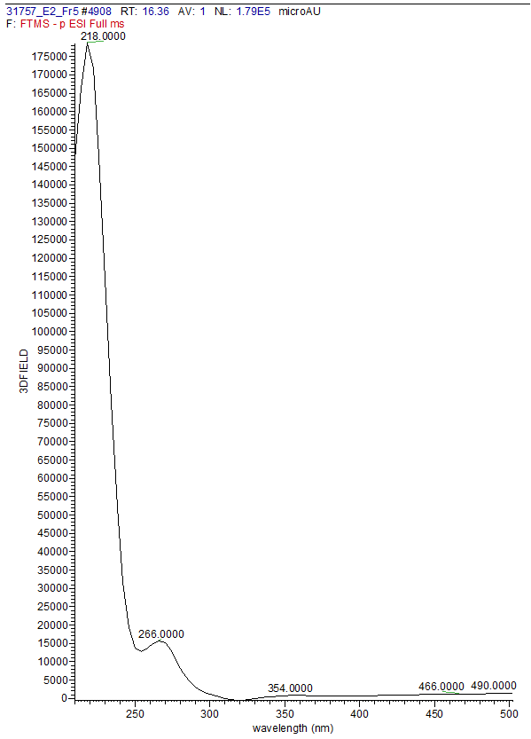
Figure S1. UV spectrum of compound 1
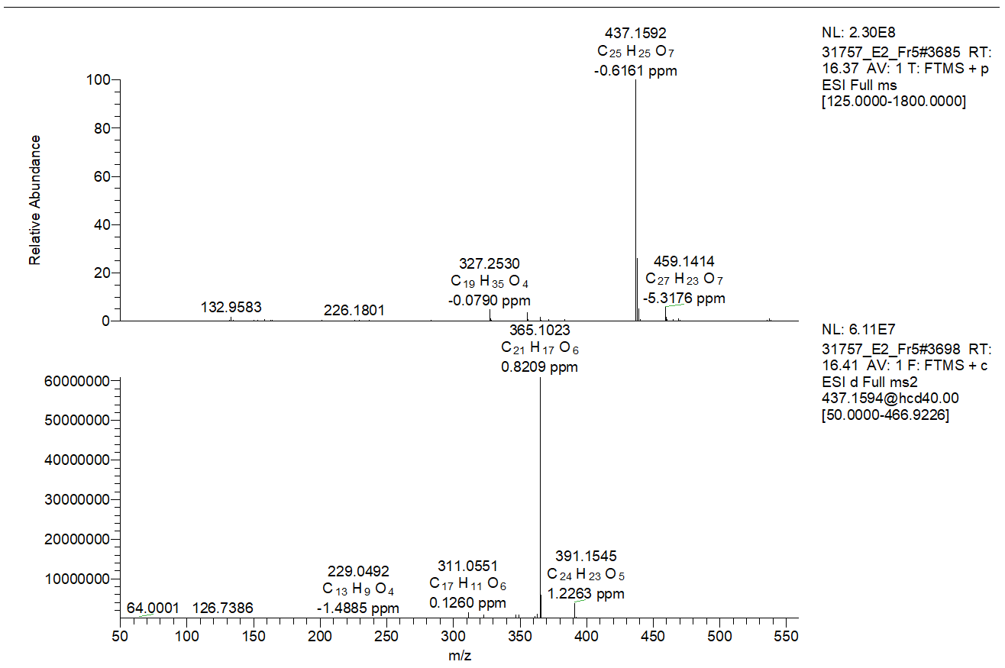
Figure S2. HRESI-MS/MS of compound 1
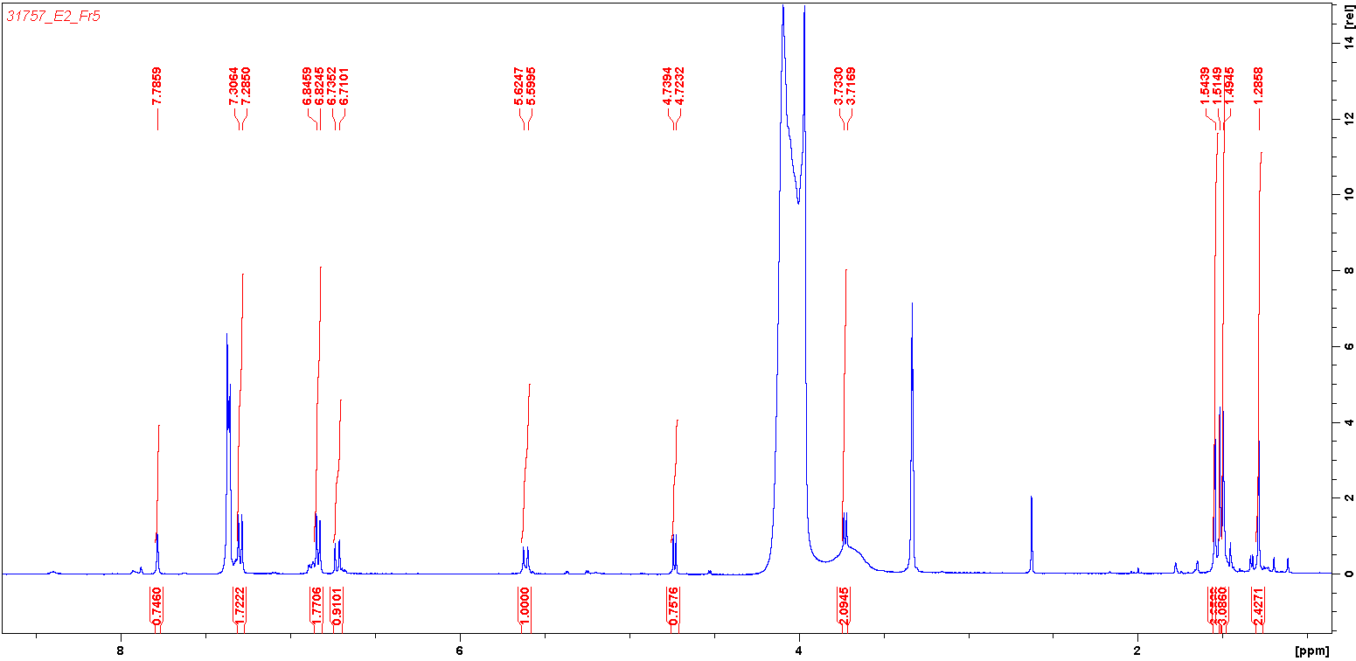
Figure S3. ¹H NMR spectrum in MeOH-d₄ of compound 1

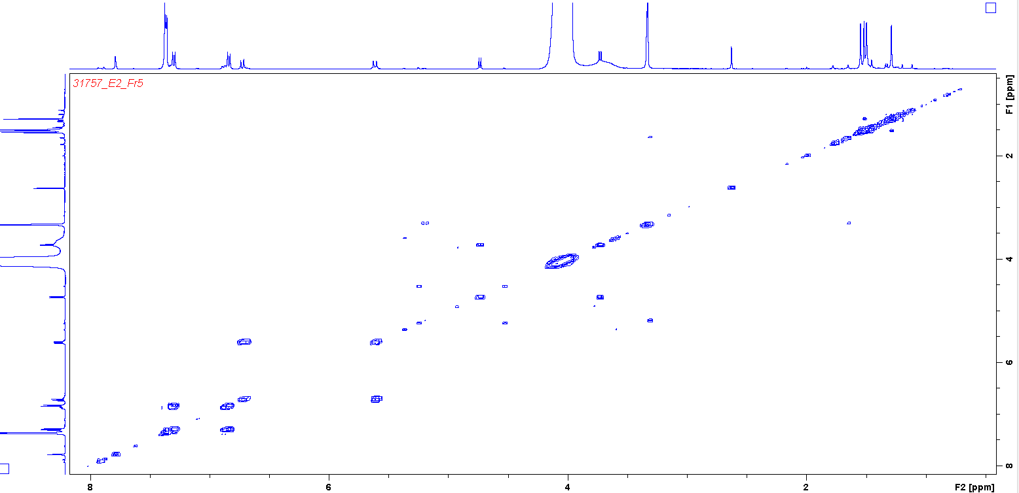
Figure S4. ¹H, ¹H COSY spectrum in MeOH-d₄ of compound 1
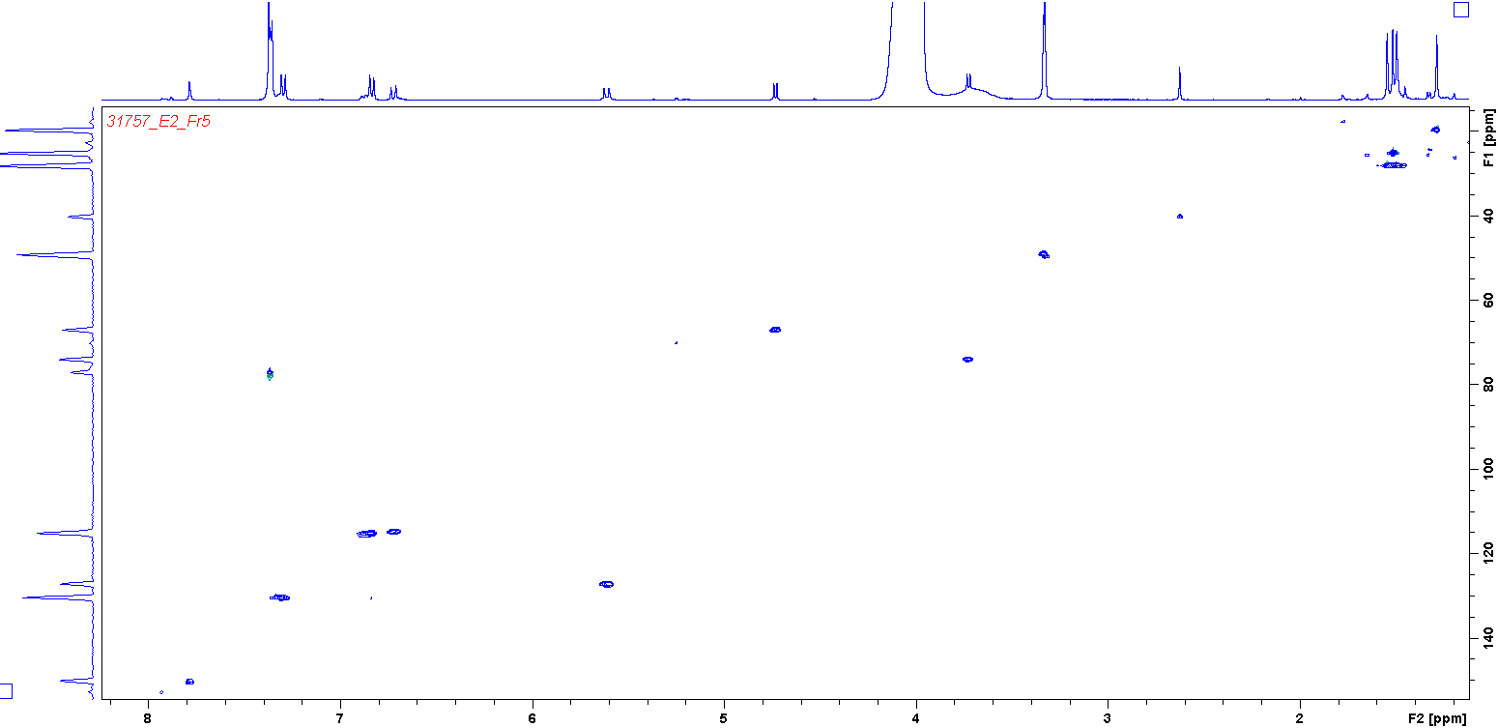
Figure S5. HSQC spectrum in MeOH-d₄ of compound 1
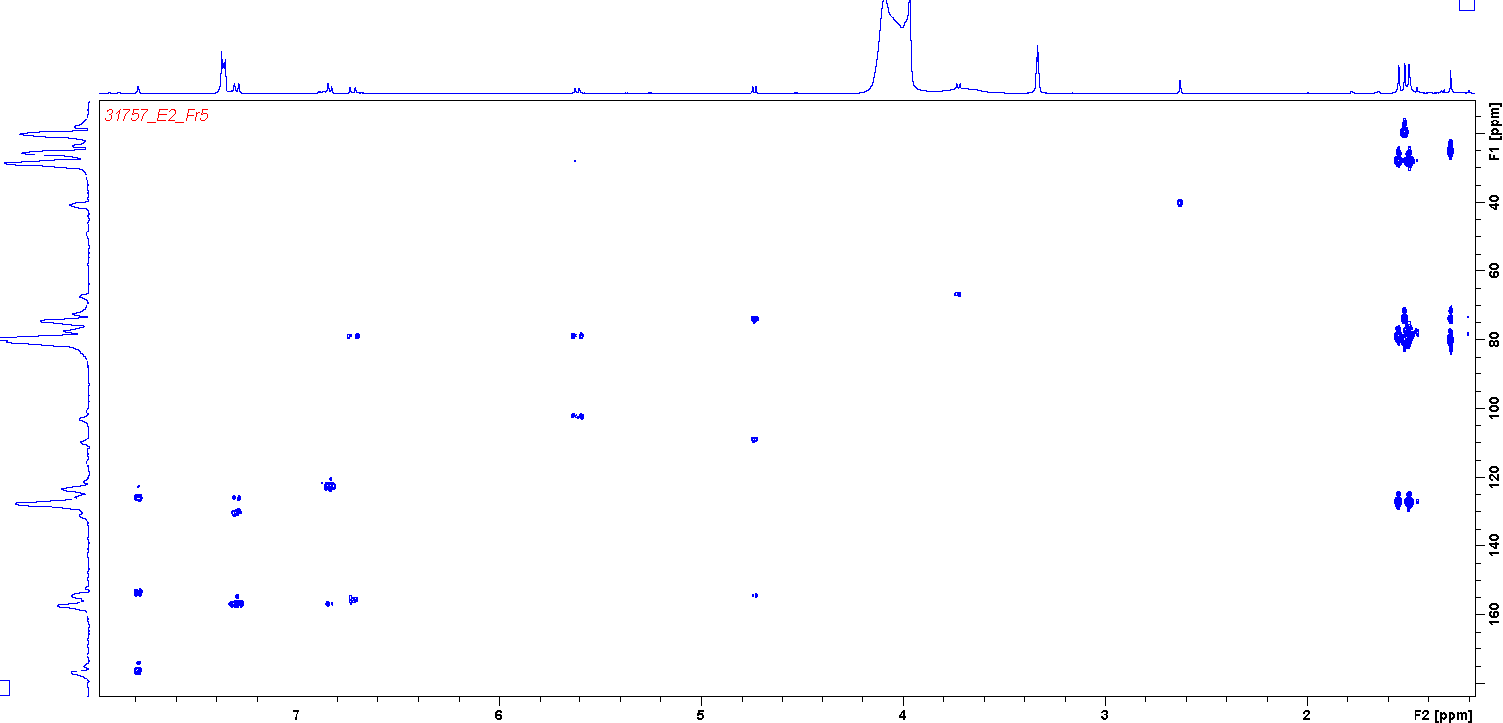
Figure S6. HMBC spectrum in MeOH-d₄ of compound 1
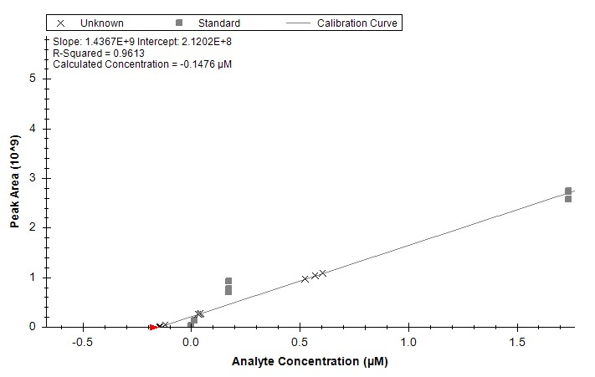
Figure S7. Calibration curve for the determination of diprenylgenistein (4)
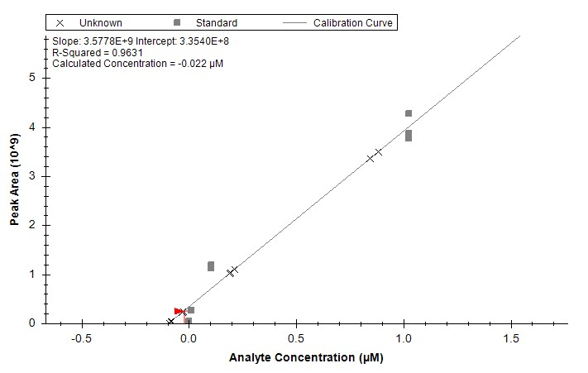
Figure S8. Calibration curve for the determination of osajin (7)
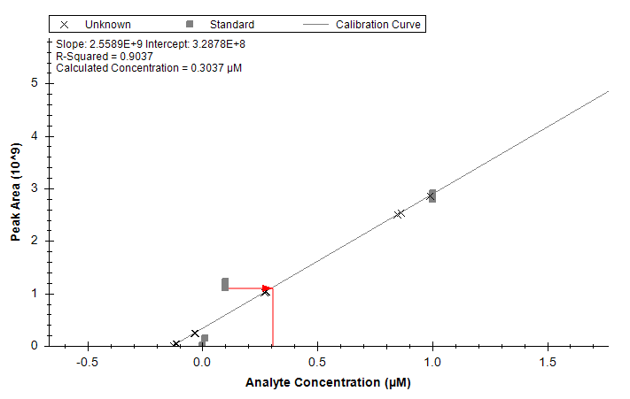
Figure S9. Calibration curve for the determination of pomiferin (8)

