Supplementary Material
Amazonian Cyanobacteria as a Source of Bioactive Compounds With Antimicrobial and Cytotoxic Properties
Samuel Cavalcante do Amaral*¹, Luciana Pereira Xavier¹, Mariana Reis², Rhuana V Médice³, Janaína Morone^{2,4}, Raquel Silva², João Morais², Vitor Vasconcelos^{2,4}, and Agenor Valadares Santos*¹.
¹Laboratory of Biotechnology of Enzymes and Biotransformation, Biological Sciences Institute, Federal University of Pará, Belém 66075-110, Brazil (samuel.amaral@usp.br; lpxavier@ufpa.br; avsantos@ufpa.br).
²CIIMAR/CIMAR-LA—Interdisciplinary Centre of Marine and Environmental Research, University of Porto, Terminal de Cruzeiros do Porto de Leixões, Av. General Norton de Matos s/n, 4450-208 Matosinhos, Portugal (mreis@ciimar.up.pt; janabavini@ciimar.up.pt; rssilva@ciimar.up.pt; jmorais@ciimar.up.pt; vmvascon@fc.up.pt).
³Department of Clinical Chemistry, School of Pharmaceutical Sciences, University of São Paulo, Av. Professor Lineu Prestes, 580 - Bloco 17, São Paulo, SP, 05508-000, Brazil (medicerv@usp.br).
⁴Departamento de Biologia, Faculdade de Ciências, Universidade do Porto, Rua do Campo Alegre, Edifício FC4, 4169-007 Porto, Portugal

Table S1. Strains utilized in this study
Strain | Morphology | Source | Assay | Media
Microcystis sp.  CACIAM 03 | Unicellular | Freshwater | Allelopathy | BG-11
Microcystis sp.  CACIAM 04 | Unicellular | Freshwater | Allelopathy | BG-11
Synechocystis sp. CACIAM 05 | Unicellular | Freshwater | Antimicrobial  Cytotoxicity  Allelopathy | Z8 and BG-11
Lyngbya sp.  CACIAM 07 | Filamentous | Freshwater | Antioxidant  Phenolic Contents  Allelopathy | Z8
Microcystis sp.  CACIAM 08 | Unicellular | Freshwater | Allelopathy | BG-11
Cyanobium sp.  CACIAM 16 | Unicellular | Freshwater | Allelopathy | BG-11
Nostoc sp.  CACIAM 19 | Filamentous | Freshwater | Allelopathy | BG-11
Nostoc sp.  CACIAM 21 | Filamentous | Freshwater | Allelopathy | BG-11
CACIAM 28 | Unicellular | Freshwater | Allelopathy | BG-11
CACIAM 29 | Unicellular | Freshwater | Allelopathy | BG-11
CACIAM 34 | Filamentous | Freshwater | Allelopathy | BG-11
Desmonostoc sp. CACIAM 45 | Filamentous | Freshwater | Cytotoxicity  Antimicrobial  Allelopathy  Phenolic Contents  Antioxidant  Phycobiliprotein | Z8, BG-11, CHU-10, ASM, AA
CACIAM 46 | Filamentous | Freshwater | Allelopathy | BG-11
CACIAM 47 | Filamentous | Terrestrial | Allelopathy | BG-11
CACIAM 52 | Filamentous | Freshwater | Allelopathy | BG-11
CACIAM 53 | Filamentous | Freshwater | Allelopathy | BG-11
CACIAM 54 | Filamentous | Freshwater | Allelopathy | BG-11
CACIAM 57 | Filamentous | Freshwater | Allelopathy | BG-11
Synechococcus sp. CACIAM 66 | Unicellular | Freshwater | Cytotoxicity  Antimicrobial  Allelopathy | Z8 and BG-11

Table S2. Details of forward (1 -2) and reverse (3-5) primers used in this study to amplify the 16S rRNA gene of cyanobacteria
Number | Primer Name | Sequence (5’-3’)
1 | 27F | AGAGTTTGATCCTGGCTCAG
2 | 359F | GGGGAATYTTCCGCAATGGG
3 | 781R | GACTACWGGGGTATCTAATCCCWTT
4 | 1494R | TACGGCTACCTTGTTACGAC
5 | 23S30R | CTTCGCCTCTGTGTGCCTAGGT

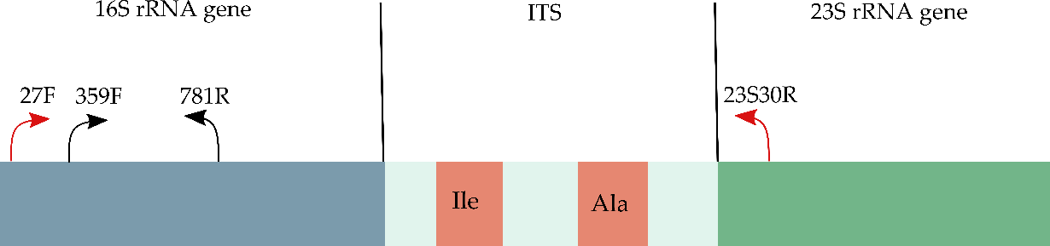
Figure S1. Schematic diagram representing the primer pairs utilized in this study. The primer set 27F and 23S30R (red) was employed to amplify the 16S-ITS-23S gene while the primer pair 359F a and 781R (black) was used to amplify the cyanobacterial 16S rRNA gene.

Figure S2. Total ion chromatogram of fraction D obtained from the methanolic extract of Synechocystis sp. CACIAM 05

Table S3. Constituents of the media used for optimizing the production of phenolic compounds and phycobiliproteins in the Desmonostoc sp. CACIAM 45
 | Final Concentration (g/L)
Component | BG-11 | ASM I | Chu-10 | AA
Na₂EDTA | 0.001 | 0.00744 |  | 0.004
Citric acid | 0.006 |  | 0.003
NaNO₃ | 1.5 | 0.17
KNO₃ |  |  |  | 2.02
Ca (NO₃)₂.4H₂O |  |  | 0.05
K₂HPO₄.3H₂O | 0.04 | 0.00174 | 0.013 | 0.456
MgSO₄.7H₂O | 0.075 | 0.049 | 0.025 | 0.456
CaCl₂.2H₂O | 0.036 | 0.026 |  | 0.074
NaCl |  |  |  | 0.232
Na₂CO₃ (H₂O) | 0.02 |  | 0.02
FeCl₃ |  | 0.00108 | 0.003
MgCl₂.6H₂O |  | 0.041
Na₂HPO₄.7H₂O |  | 0.00266
H₃BO₃ |  | 0.00248
MnCl₂.4H₂O |  | 0.00139
C₆H₈FeNO₇ | 0.006
ZnCl₂ |  | 0.00034
CoCl₂.6H₂O |  | 1.9E-05
CuCl₂ |  | 1.4E-06
Micronutrients | 1 mL

Table S4. Composition of the BG-11 medium micronutrient solution.
Components | Stock Solution Concentration (g/L)
H₃BO₃ | 2.86
MnCl₂.4H₂O | 1.81
ZnSO₄.7H₂O | 0.222
Na₂Mo₄.2H₂O | 0.39
CuSO₄.5H₂O | 0.079
Co(NO3)₂.6H₂O | 0.049

