Exploring the Antiproliferative Activity of Flavolignans
from the Leaves of Casearia arborea (Salicaceae)

Augusto L. Santos†, Mariana T. Rodrigues‡, Ana Paula Micheli‡, Rodrigo E. Tamura†,
Ileana G. S. de Rubió†&, Marisi G. Soares⁑, Marcelo J. P. Ferreira§, Patricia Sartorelli†*

SUPPLEMENTARY MATERIAL
S1 | Spectral family of phenolics and phenylpropanoids. | i
S2 | Spectral family of flavonoid derivatives. | i
S3 | Spectral family of terpenoid derivatives. | ii
S4 | Spectral family of fatty acetate derivatives. | ii
S5 | Salcolin - HR-ESI-(+)-MS/MS | iii
S6 | Salcolin - HR-ESI-(-)-MS/MS | iii
S7 | Salcolin - NOESY | iv

Supplementary Material S1: Spectral family of phenolics and phenylpropanoids.
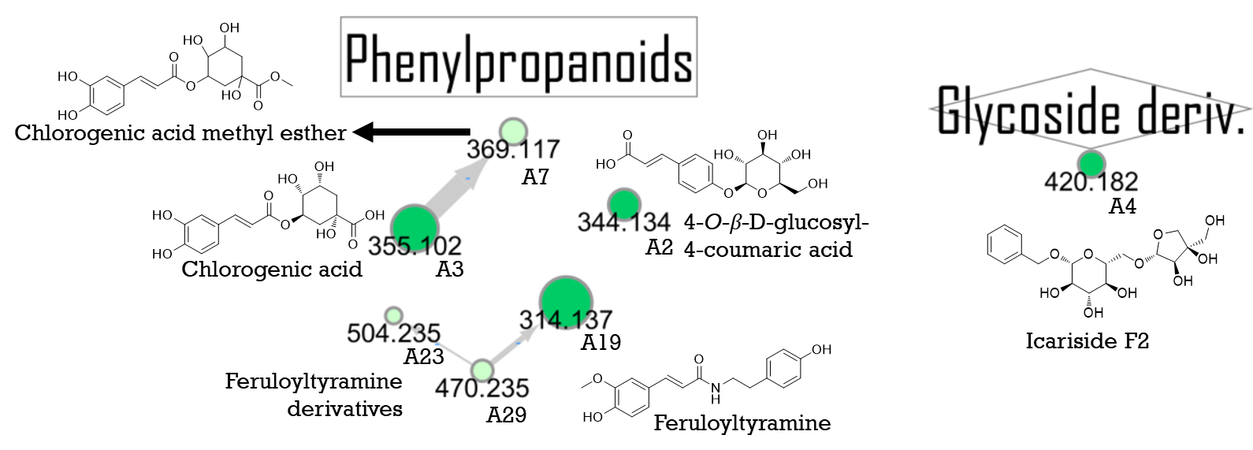

Supplementary Material S2: Spectral family of flavonoid derivatives.
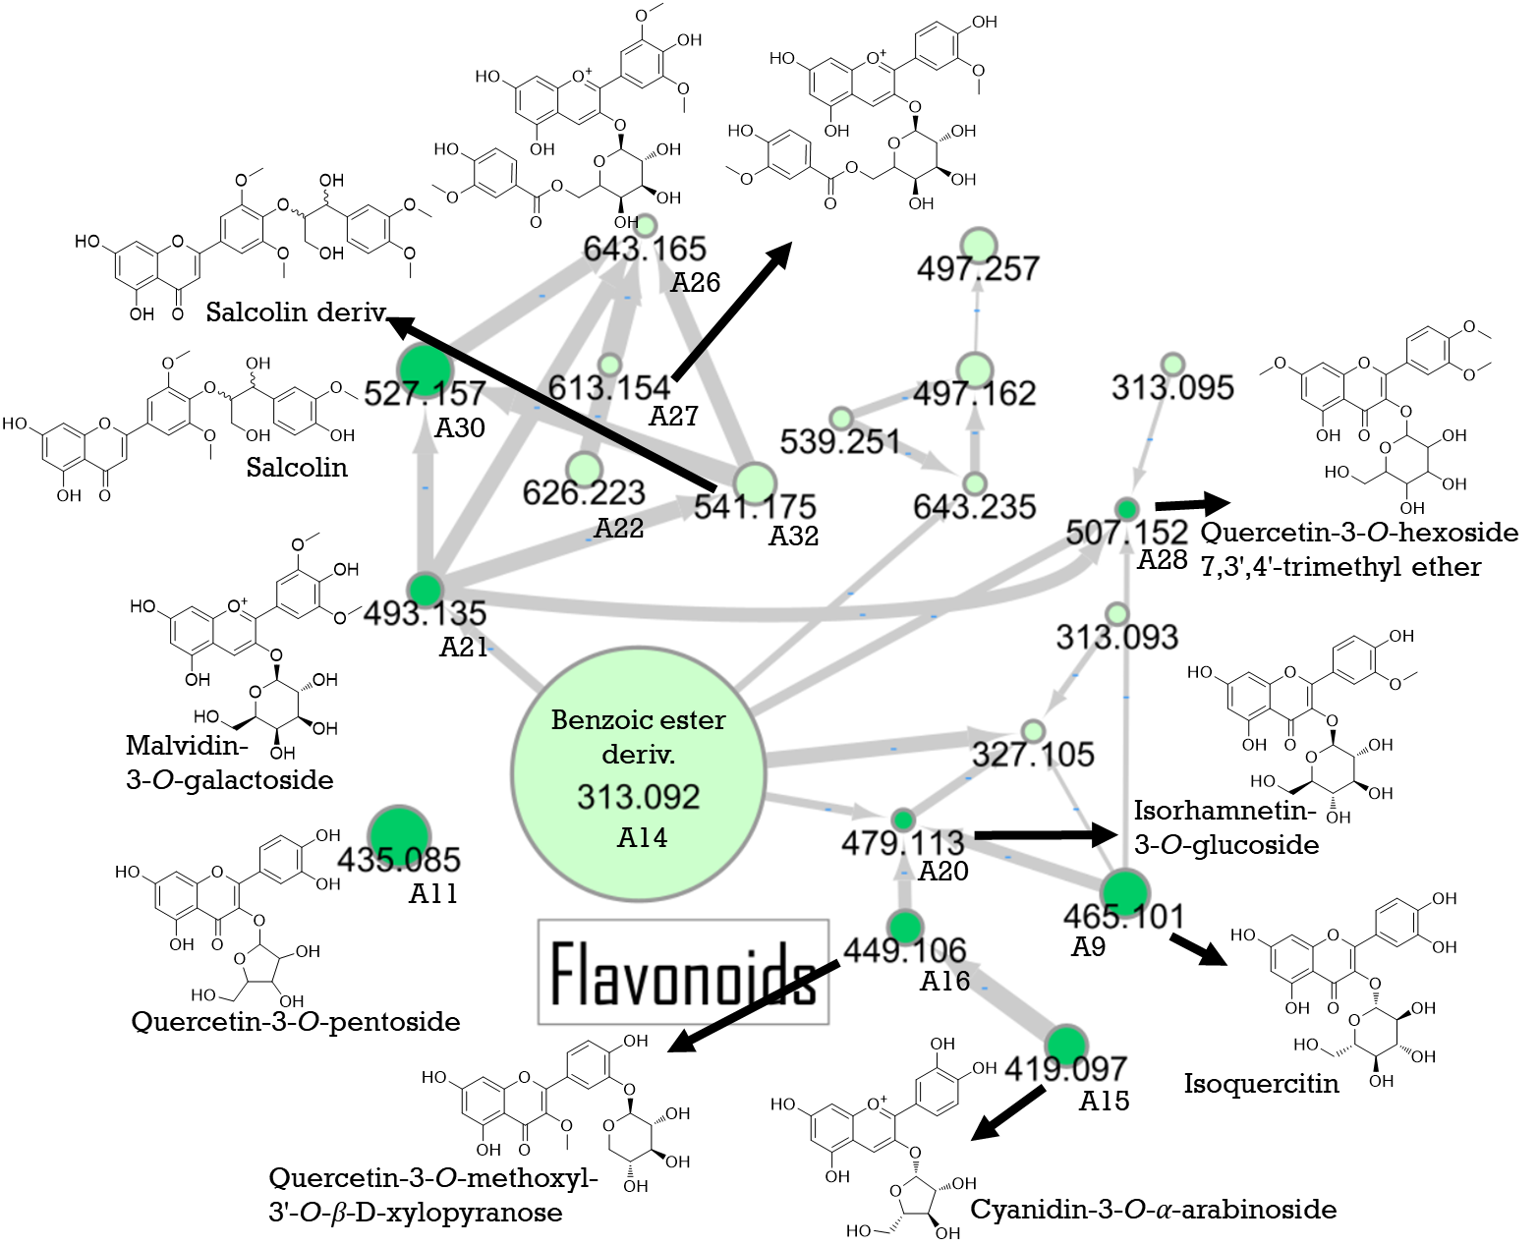

Supplementary Material S3: Spectral family of terpenoid derivatives.
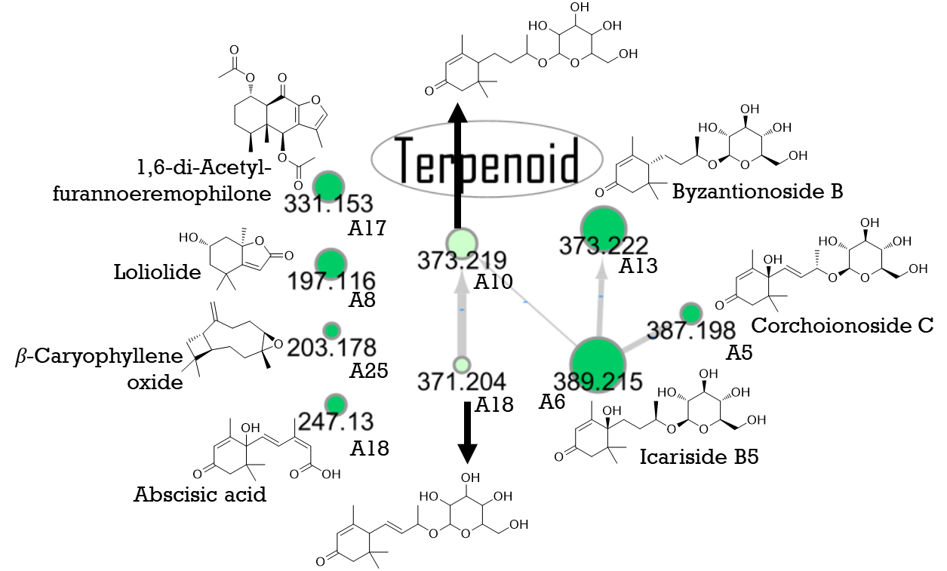
Supplementary Material S4: Spectral family of fatty acetate derivatives.
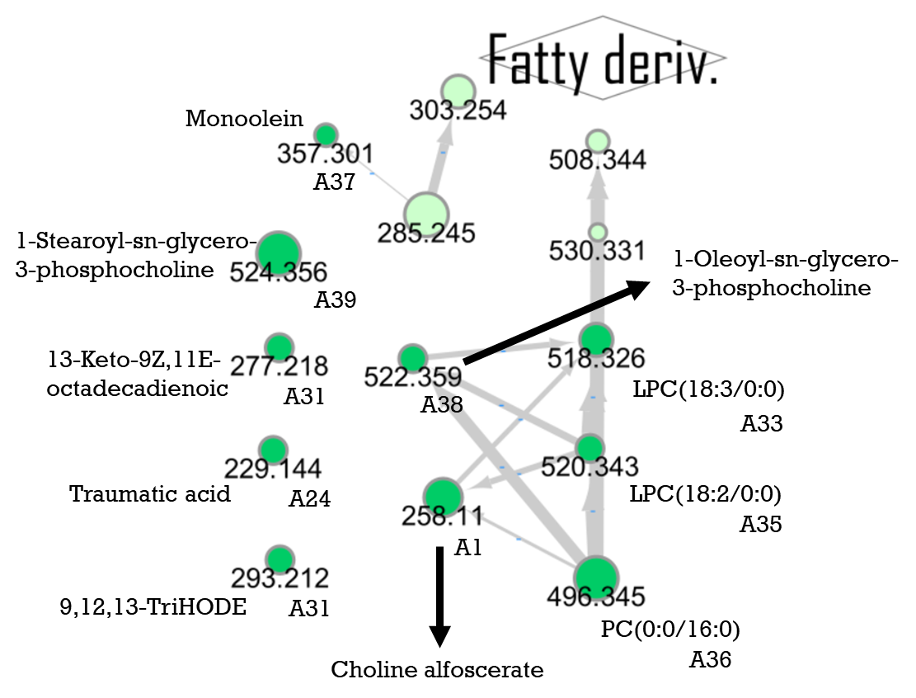
Supplementary Material S5: Salcolin - HR-ESI-(+)-MS/MS.
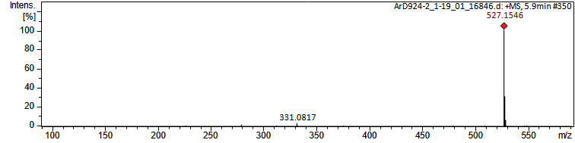

Supplementary Material S6: Salcolin - HR-ESI-(-)-MS/MS.
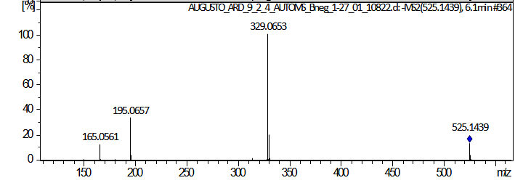
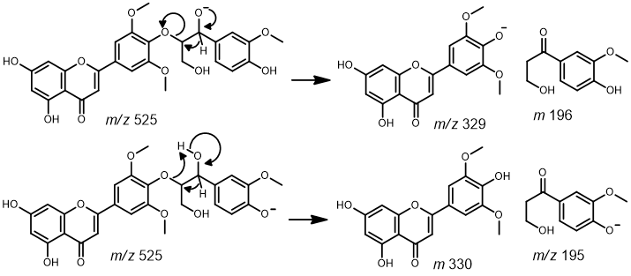

Supplementary Material S7: Salcolin - NOESY
