Supporting information

Table of Contents

Preparation of Wood Samples
- Figure S1. Samples from Trees 1, 2, and 3 of paper birch (Betula papyrifera) from 3 live trees harvested in the forest near St-Julien on August 3, 2022.
- Figure S2. (a) Process for reducing wood samples into strips approximately 2.5 cm in diameter. (b) Selection of hardwood strips without bark or visible alterations.
- Figure S3. Yardworks wood shredder machine used to reduce wood strips into woodchips.

Chromatograms of the extracts of B. papyrifera
- Figure S4. Chromatograms obtained by HS-SPME/GC-MS analysis of the hardwood of 3 B. papyrifera trees collected in St-Julien, Quebec, Canada.
- Figure S5. Chromatograms obtained by GC-MS analysis of the volatile extract obtained by hydrodistillation on the hardwood of 3 B. papyrifera trees collected in St-Julien, Quebec, Canada.
- Figure S6. Chromatograms obtained by GC-FID analysis of the volatile extract obtained by hydrodistillation on the hardwood of 3 B. papyrifera trees collected in St-Julien, Quebec, Canada. Legend key: The first digit represents the extract number, while the second digit indicates the replicate.

Preparation of Wood Samples

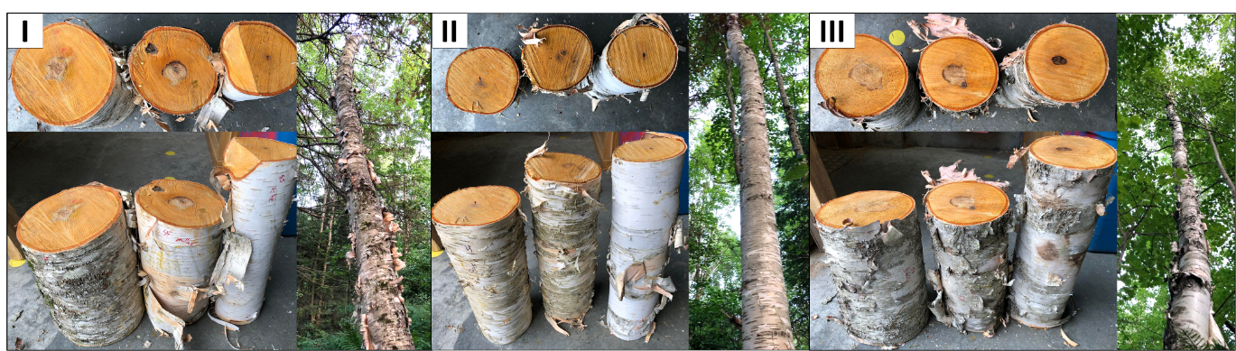
Figure S1. Sampling 3 live paper birch (B. papyrifera) trees from in the forest near St-Julien on August 3, 2022.

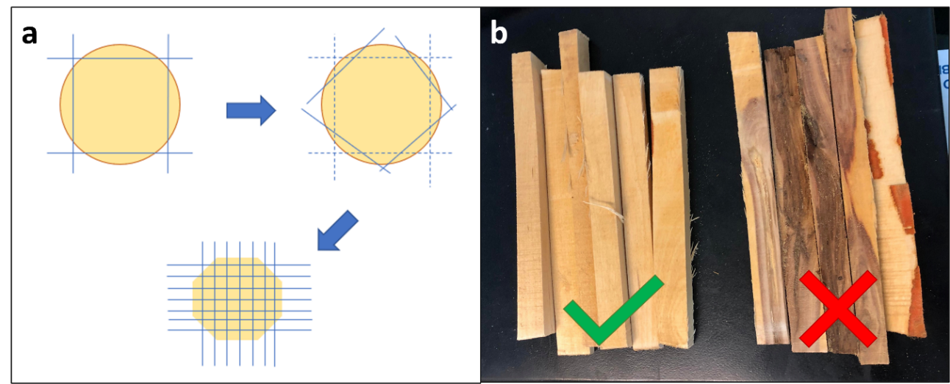
Figure S2. (a) Process for reducing wood samples into strips approximately 1 inch in diameter. (b) Selection of hardwood strips without bark or visible alterations.
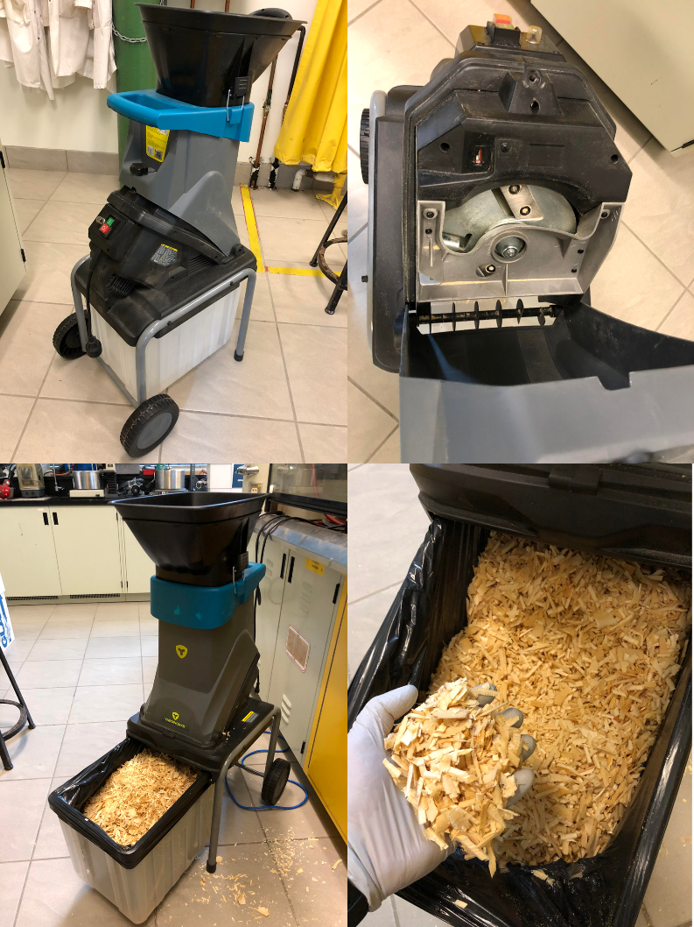
Figure S3. Yardworks wood shredder machine used to reduce wood strips into woodchips.

Chromatograms of the extracts of B. papyrifera
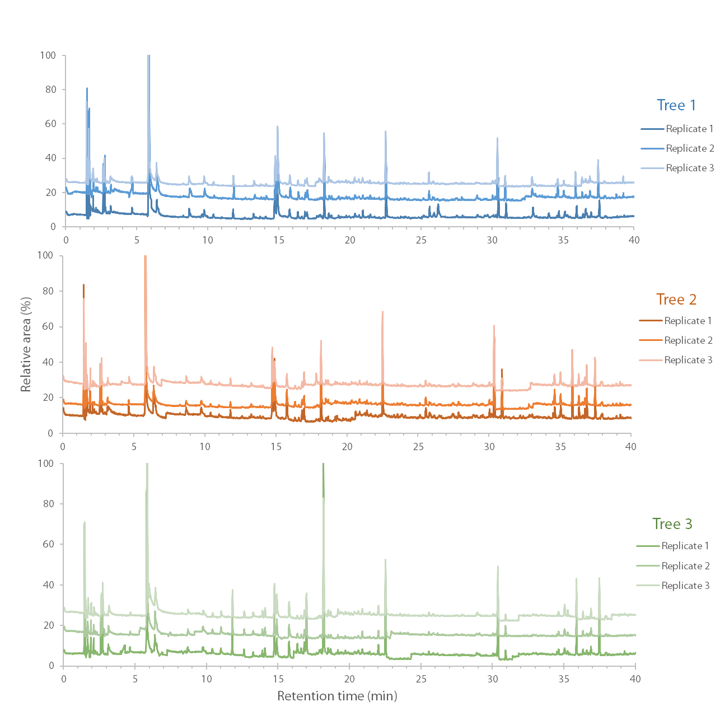
Figure S4. Chromatograms obtained by HS-SPME/GC-MS analysis of the hardwood of 3 B. papyrifera trees collected in St-Julien, Quebec, Canada.

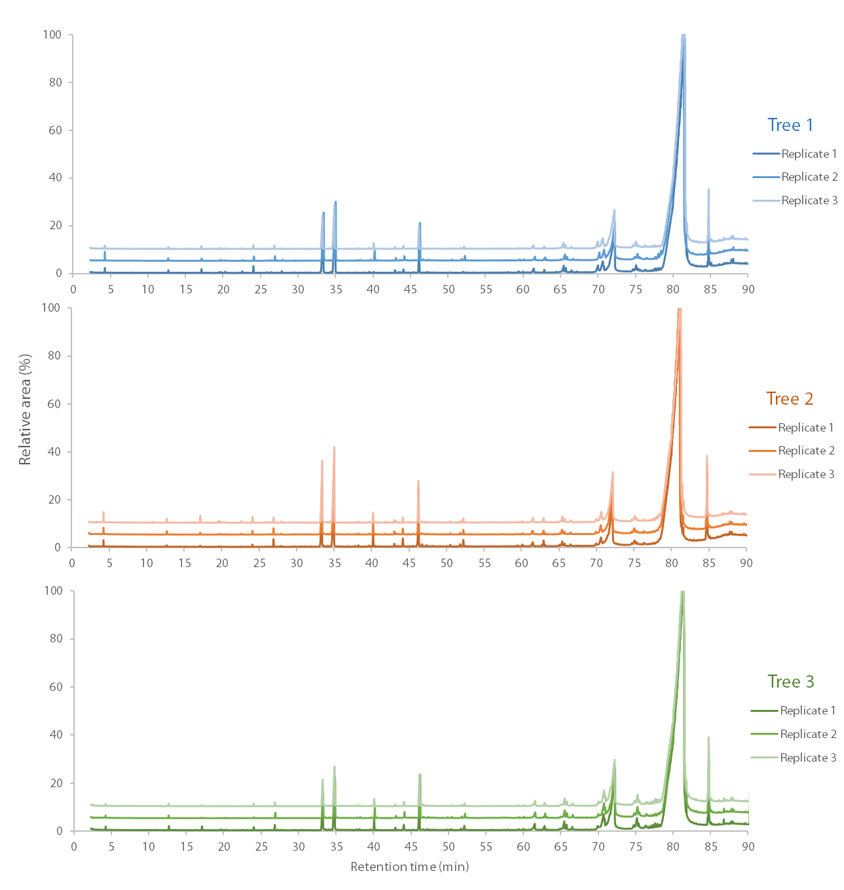
Figure S5. Chromatograms obtained by GC-MS analysis of the volatile extracts obtained by hydrodistillation on the hardwood of 3 B. papyrifera trees collected in St-Julien, Quebec, Canada.
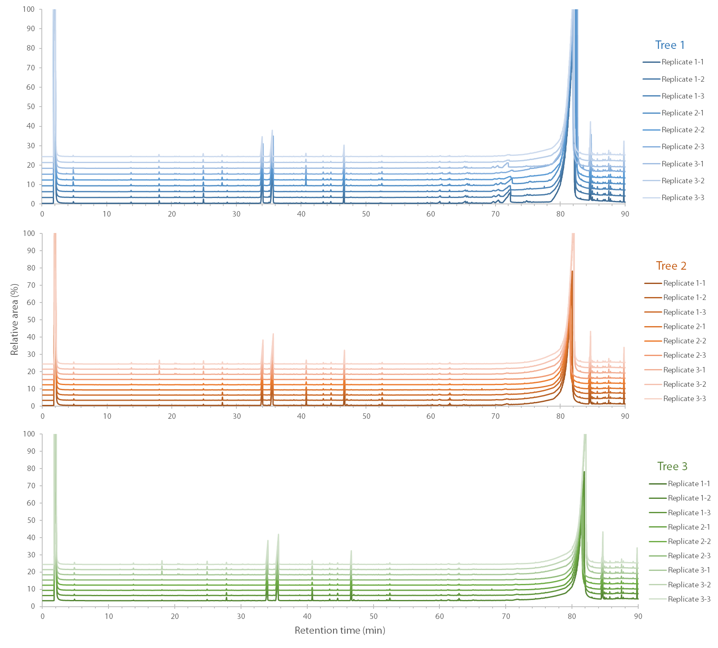
Figure S6. Chromatograms obtained by GC-FID analysis of the volatile extract obtained by hydrodistillation on the hardwood of 3 B. papyrifera trees collected in St-Julien, Quebec, Canada. Legend key: The first digit represents the extract number, while the second digit indicates the replicate.

