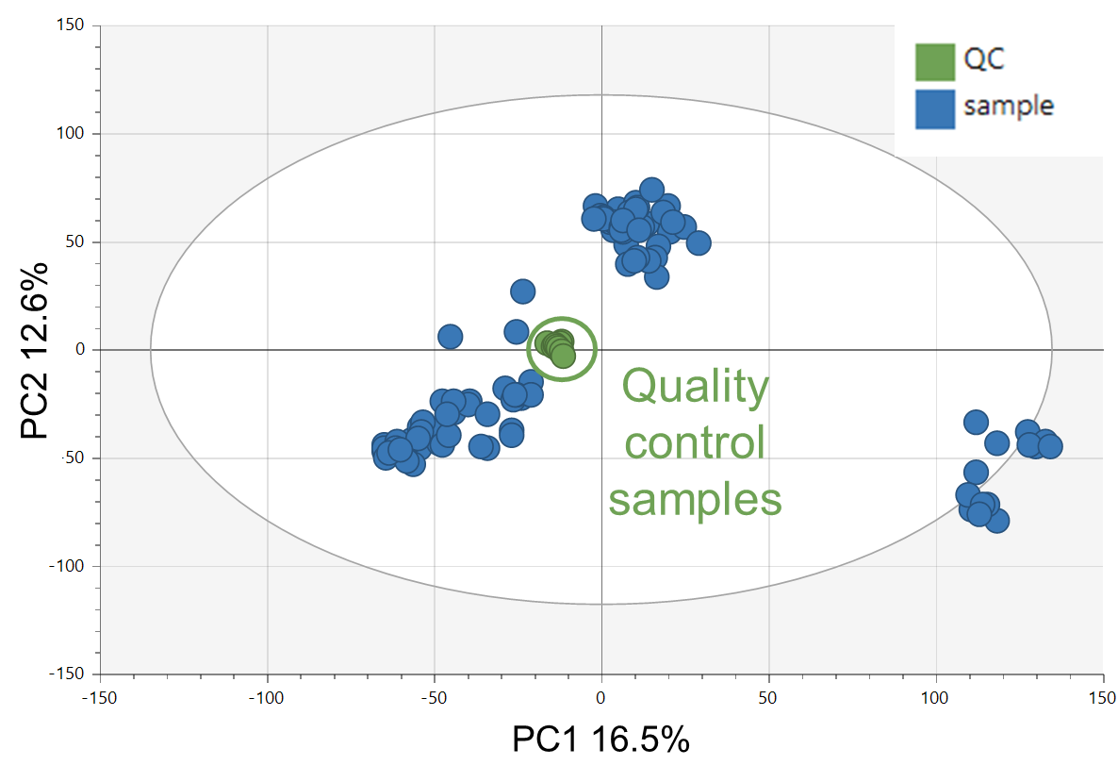
Figure S1: Principal component analysis (PCA) score plot (PC1 and PC2) for the entire sample set with highlighted quality control sample as an indicator of measurement stability.

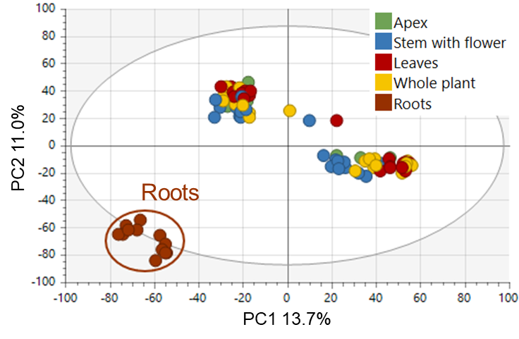
Figure S2: Principal component analysis (PCA) score plot (PC1 and PC2) of the entire experimental set clustered according to the plant part visualizing the clear distinction of roots samples.
Table S1: Antimicrobial activities expressed as IC₅₀ in mg/mL of extracts from A. eupatoria from Lednice
Species | Location | Ontogenesis | Sample processing | Plant part | S. aureus | E. faecalis | S. aureus MRSA | Enterococcus sp. VRE | P. aeruginosa | C. albicans
A. eupatoria | Lednice | Vegetative | F | A | - | - | - | - | - | 0.42 ± 0.038 ^{a,b}
A. eupatoria | Lednice | Vegetative | D | A | - | - | - | - | - | -
A. eupatoria | Lednice | Beginning of flowering | F | WP | - | 0.23 ±0.020ª | - | 0.23 ± 0.008^{a,b} | 0.07 ± 0.008 ^{a,b,c} | 0.32 ± 0.024 ^{a,b}
 |  |  |  | S | - | 0.61 ± 0.084^{c,d} | - | - | - | -
 |  |  |  | L | 0.28 ± 0.017 ^{e,f,g,h,i,j} | 0.25 ± 0.017ª | - | - | - | -
A. eupatoria | Lednice | Beginning of flowering | D | WP | 0.44 ± 0.033 ^{k,l,m,n,o,p,q} | - | - | 0.20 ± 0.064^{a,b} | - | -
 |  |  |  | S | 0.41 ± 0.019 ^{j,k,i,m,n,o,p} | - | - | 0.29 ± 0.050^{a,b} | - | -
 |  |  |  | L | 0.56 ± 0.03 ^{q,r} | - | - | 0.23 ± 0.024^{a,b} | - | -
A. eupatoria | Lednice | Full bloom | F | WP | - | 0.22 ± 0.001ª | - | - | - | -
 |  |  |  | S | - | - | - | 0.26 ± 0.040^{a,b} | - | -
 |  |  |  | L | - | 0.33 ± 0.077  ^{a,b,c} | - | 0.42 ± 0.221^{a,b,c,d} | - | -
A. eupatoria | Lednice | Full bloom | D | WP | 0.29 ± 0.009 ^{f,g,h,i,j} | - | - | - | - | -
 |  |  |  | S | - | - | - | 0.65 ± 0.161^{c,d,e} | - | -
 |  |  |  | L | - | - | - | - | - | -
A. eupatoria | Lednice | Senescence | F | R | 0.31 ± 0.010 ^{g,h,i,j,k} | 0.20 ± 0.011ª | 0.54 ± 0.008 ^{a,b,c,d,e} | 0.48 ± 0.051^{a,b,c,d,e} | - | -
A. eupatoria | Lednice | Senescence | D | R | 0.54 ± 0.035 ^{o,p,q,r} | - | - | 0.74 ± 0.136^{d,e} | - | -
A – apex, L – leaves, S – stem with flower, WP – whole plant, R – roots, F – fresh-frozen, D – dried
The extracts were applied in the concentration range of 0.01 – 1 mg/mL. The values are presented as the average of three replicates ± standard error of the mean (SEM). Data for IC₅₀ were analyzed by one-way analysis of variance (ANOVA) (p ≤ 0.05) with the Tukey's post-hoc test. The means with the same letter within columns are not significantly different at p > 0.05
Table S2: Antimicrobial activities expressed as IC₅₀ in mg/mL of extracts from A. procera from Lednice
Species | Location | Ontogenesis | Sample processing | Plant part | S. aureus | E. faecalis | S. aureus MRSA | Enterococcus sp. VRE | P. aeruginosa | C. albicans
A. procera | Lednice | Vegetative | F | A | - | - | 0.77 ± 0.101 ^{c,d,e,f,g} | - | - | 0.79 ± 0.047^{c}
A. procera | Lednice | Vegetative | D | A | - | - | - | - | - | -
A. procera | Lednice | Beginning of flowering | F | WP | - | - | - | - | - | -
 |  |  |  | S | - | - | - | - | - | -
 |  |  |  | L | 0.56 ± 0.012 ^{q,r} | - | 0.88 ± 0.046 ^{e,f,g} | - | - | -
A. procera | Lednice | Beginning of flowering | D | WP | 0.52 ± 0.030 ^{n,o,p,q,r} | - | 0.71 ± 0.100 ^{b,c,d,e,f,g} | - | 0.17 ± 0.022 ^{d,e,f,g,h} | -
 |  |  |  | S | - | - | - | - | 0.07 ± 0.006 ^{a,b,c} | -
 |  |  |  | L | 0.26 ± 0.003 ^{d,e,f,g,h,i} | - | 0.86 ± 0.016 ^{e,f,g} | - | 0.18 ± 0.010 ^{f,g,h} | -
A. procera | Lednice | Full bloom | F | WP | - | - | - | - | - | -
 |  |  |  | S | 0.53 ± 0.020 ^{n,o,p,q,r} | - | - | - | - | -
 |  |  |  | L | - | - | - | - | 0.04 ± 0.002ª | 0.89 ± 0.073^{c}
A. procera | Lednice | Full bloom | D | WP | 0.54 ± 0.020 ^{p,q,r} | - | - | - | - | -
 |  |  |  | S | 0.58 ± 0.070^{r} | - | - | - | - | -
 |  |  |  | L | 0.24 ± 0.007 ^{d,e,f,g,h} | - | 0.94 ± 0.033^{f,g} | - | 0.17 ± 0.006^{1; e,f,g,h} | -
A. procera | Lednice | Senescence | F | R | 0.10 ± 0.012 ^{a,b,c} | - | - | - | 0.03 ± 0.003ª | -
A. procera | Lednice | Senescence | D | R | 0.09 ± 0.009 ^{a,b,c} | - | - | - | 0.08 ± 0.003 ^{a,b,c,d} | -
A – apex, L – leaves, S – stem with flower, WP – whole plant, R – roots, F – fresh-frozen, D – dried
The extracts were applied in the concentration range of 0.01 – 1 mg/mL. The values are presented as the average of three replicates ± standard error of the mean (SEM). Data for IC₅₀ were analyzed by one-way analysis of variance (ANOVA) (p ≤ 0.05) with the Tukey's post-hoc test. The means with the same letter within columns are not significantly different at p > 0.05
Table S3: Antimicrobial activities expressed as IC₅₀ in mg/mL of extracts from A. eupatoria from Hlohovec
Species | Location | Ontogenesis | Sample processing | Plant part | S. aureus | E. faecalis | S. aureus MRSA | Enterococcus sp. VRE | P. aeruginosa | C. albicans
A. eupatoria | Hlohovec | Vegetative | F | A | 0.36 ± 0.018 ^{h,i,j,k,l} | 0.35 ± 0.124 ^{a,b,c} | 0.84 ± 0.016 ^{e,f,g} | 0.23 ± 0.034^{b} | 0.09 ± 0.007 ^{a,b,c,d,e} | 0.30 ± 0.009^{a,b}
A. eupatoria | Hlohovec | Vegetative | D | A | - | - | 0.86 ± 0.015 ^{e,f,g} | 0.29 ± 0.019^{a,b} | - | 0.43 ± 0.058^{a,b}
A. eupatoria | Hlohovec | Beginning of flowering | F | WP | 0.31 ± 0.022 ^{g,h,i,j,k} | 0.24 ± 0.035ª | 0.94 ± 0.025^{g} | 0.21 ± 0.004^{a,b} | - | -
 |  |  |  | L | - | 0.30 ± 0.043^{a,b} | 0.58 ± 0.153 ^{a,b,c,d,e} | 0.20 ± 0.011^{a,b} | - | -
A. eupatoria | Hlohovec | Beginning of flowering | D | WP | - | 0.68 ± 0.231^{d,e} | - | 0.25 ± 0.011^{a,b} | - | 0.49 ± 0.036^{b}
 |  |  |  | S | - | - | - | - | 0.05 ± 0.004^{a,b} | -
 |  |  |  | L | 0.30 ± 0.021 ^{f,g,h,i,j} | - | - | - | 0.24 ± 0.013 ^{h,i,j} | -
A. eupatoria | Hlohovec | Full bloom | F | WP | 0.60 ± 0.040 ^{r} | 1.0 ± 0.000e | 0.84 ± 0.105 ^{d,e,f,g} | 0.33 ± 0.007^{a,b,c} | - | -
 |  |  |  | L | - | - | 0.52 ± 0.032 ^{a,b,c,d,e} | 0.50 ± 0.047^{a,b,c,d,e} | - | -
A. eupatoria | Hlohovec | Full bloom | D | WP | 0.30 ± 0.015 ^{f,g,h,I,j} | - | 0.7 ± 0.071 ^{a,b,c,d,e,f,g} | 0.58 ± 0.126^{b,c,d,e} | 0.23 ± 0.006 ^{g,h,i,j} | -
 |  |  |  | S | - | - | - | 0.44 ± 0.057^{a,b,c,d} | 0.23 ± 0.018 ^{g,h,i,j} | -
 |  |  |  | L | - | - | 0.83 ± 0.011 ^{c,d,e,f,g} | 0.45 ± 0.184^{a,b,c,d} | - | -
A. eupatoria | Hlohovec | Senescence | F | R | 0.28 ± 0.010 ^{e,f,g,h,I,j} | 0.28 ± 0.036^{a,b} | 0.46 ± 0.008 ^{a,b,c,d} | 0.24 ± 0.004^{a,b} | - | -
A. eupatoria | Hlohovec | Senescence | D | R | 0.40 ± 0.050 ^{i,j,k,l,m,n} | - | - | 0.53 ± 0.021^{a,b,c,d,e} | 0.18 ± 0.004 ^{f,g,h} | -
A – apex, L – leaves, S – stem with flower, WP – whole plant, R – roots, F – fresh-frozen, D – dried
The extracts were applied in the concentration range of 0.01 – 1 mg/mL. The values are presented as the average of three replicates ± standard error of the mean (SEM). Data for IC₅₀ were analyzed by one-way analysis of variance (ANOVA) (p ≤ 0.05) with the Tukey's post-hoc test. The means with the same letter within columns are not significantly different at p > 0.05
Table S4: Antimicrobial activities expressed as IC₅₀ in mg/mL of extracts from A. eupatoria from Milovice
Species | Location | Ontogenesis | Sample processing | Plant part | S. aureus | E. faecalis | S. aureus MRSA | Enterococcus sp. VRE | P. aeruginosa | C. albicans
A. eupatoria | Milovice | Vegetative | F | A | - | - | - | - | - | 0.85 ± 0.055^{c}
A. eupatoria | Milovice | Vegetative | D | A | - | - | - | - | - | -
A. eupatoria | Milovice | Beginning of flowering | F | WP | - | 0.22 ± 0.029ª | - | - | - | -
 |  |  |  | S | - | 0.58 ± 0.154 ^{b,c,d} | - | - | - | -
 |  |  |  | L | - | - | - | - | - | 0.74 ± 0.001^{c}
A. eupatoria | Milovice | Beginning of flowering | D | WP | 0.40 ± 0.023 ^{i,j,k,l,m,n,o} | - | - | - | - | -
 |  |  |  | S | - | - | - | - | - | -
 |  |  |  | L | 0.86 ± 0.105 ^{s} | - | - | - | - | -
A. eupatoria | Milovice | Full bloom | F | WP | - | - | - | - | - | 0.31 ± 0.023^{a,b}
 |  |  |  | S | - | - | - | - | - | 0.33 ± 0.020^{a,b}
 |  |  |  | L | - | - | - | - | - | -
A. eupatoria | Milovice | Full bloom | D | WP | - | - | - | - | - | -
 |  |  |  | S | 0.59 ± 0.060 ^{r} | - | - | - | - | -
 |  |  |  | L | - | - | - | - | - | -
A. eupatoria | Milovice | Senescence | F | R | 0.27 ± 0.024 ^{d,e,f,g,h,i} | - | 0.37 ± 0.001^{a,b} | 0.39 ± 0.107^{a,b,c,d} | 0.13 ± 0.000 ^{b,c,d,e,f} | -
A. eupatoria | Milovice | Senescence | D | R | 0.57 ± 0.005 ^{q,r} | - | - | 0.76 ± 0.214^{d,e} | 0.04 ± 0.002ª | -
A – apex, L – leaves, S – stem with flower, WP – whole plant, R – roots, F – fresh-frozen, D – dried
The extracts were applied in the concentration range of 0.01 – 1 mg/mL. The values are presented as the average of three replicates ± standard error of the mean (SEM). Data for IC₅₀ were analyzed by one-way analysis of variance (ANOVA) (p ≤ 0.05) with the Tukey's post-hoc test. The means with the same letter within columns are not significantly different at p > 0.05

Table S5: Antimicrobial activities expressed as IC₅₀ in mg/mL of extracts from A. procera from Olomouc
Species | Location | Ontogenesis | Sample processing | Plant part | S. aureus | E. faecalis | S. aureus MRSA | Enterococcus sp. VRE | P. aeruginosa | C. albicans
A. procera | Olomouc | Vegetative | F | A | - | - | - | - | - | 0.23 ± 0.010ª
A. procera | Olomouc | Vegetative | D | A | 0.27 ± 0.033 ^{d,e,f,g,h,i} | - | 0.76 ± 0.151 ^{c,d,e,f,g} | - | 0.36 ± 0.043^{k} | -
A. procera | Olomouc | Beginning of flowering | F | WP | 0.26 ± 0.007 ^{d,e,f,g,h,i} | - | 0.96 ± 0.031^{g} | - | - | -
 |  |  |  | S | - | - | - | - | - | 0.78 ± 0.111^{c}
 |  |  |  | L | 0.20 ± 0.006 ^{b,c,d,e,f,g} | - | 0.97 ± 0.004^{g} | - | - | -
A. procera | Olomouc | Beginning of flowering | D | WP | 0.16 ± 0.012 ^{a,b,c,d,e,f} | - | 0.52 ± 0.045 ^{a,b,c,d,e} | - | - | -
 |  |  |  | S | - | 0.77 ± 0.099^{d,e} | - | 0.81 ± 0.092e | - | -
 |  |  |  | L | 0.07 ± 0.003 ^{a,b} | - | 0.36 ± 0.014ª | - | - | -
A. procera | Olomouc | Full bloom | F | WP | 0.60 ± 0.040 ^{r} | - | - | - | - | -
 |  |  |  | S | 0.52 ± 0.044 ^{n,o,p,q,r} | - | - | - | - | -
 |  |  |  | L | 0.37 ± 0.050 ^{h,i,j,k,l,m} | - | - | - | - | -
A. procera | Olomouc | Full bloom | D | WP | 0.30 ± 0.015 ^{f,g,h,i,j} | - | 0.73 ± 0.090 ^{a,b,c,d,e,f,g} | - | 0.19 ± 0.020 ^{f,g,h} | -
 |  |  |  | S | 0.51 ± 0.005 ^{m,n,o,p,q,r} | - | - | - | 0.24 ± 0.016 ^{h,i,j} | -
 |  |  |  | L | 0.30 ± 0.006 ^{f,g,h,i,j} | - | - | - | 0.21 ± 0.012 ^{f,g,h,i} | -
A. procera | Olomouc | Senescence | F | R | 0.07 ± 0.007 ^{a,b} | - | 0.44 ± 0.005 ^{a,b,c} | 0.24 ± 0.009^{a,b} | 0.02 ± 0.002ª | -
A. procera | Olomouc | Senescence | D | R | 0.04 ± 0.001 ª | - | 0.96 ± 0.011^{g} | - | 0.02 ± 0.002ª | -
A – apex, L – leaves, S – stem with flower, WP – whole plant, R – roots, F – fresh-frozen, D – dried
The extracts were applied in the concentration range of 0.01 – 1 mg/mL. The values are presented as the average of three replicates ± standard error of the mean (SEM). Data for IC₅₀ were analyzed by one-way analysis of variance (ANOVA) (p ≤ 0.05) with the Tukey's post-hoc test. The means with the same letter within columns are not significantly different at p > 0.05
Table S6: Antimicrobial activities expressed as IC₅₀ in mg/mL of extracts from A. procera from Olomouc
Species | Location | Ontogenesis | Sample processing | Plant part | S. aureus | E. faecalis | S. aureus MRSA | Enterococcus sp. VRE | P. aeruginosa | C. albicans
A. procera | Olomouc | Vegetative | F | A | 0.32 ± 0.061 ^{h,i,j,k,l,m} | - | - | - | - | -
A. procera | Olomouc | Vegetative | D | A | 0.14 ± 0.015 ^{a,b,c,d} | - | - | 0.33 ± 0.154^{a,b,c} | - | -
A. procera | Olomouc | Beginning of flowering | F | WP | 0.28 ± 0.02 ^{e,f,g,h,I,j} | - | 0.86 ± 0.015 ^{e,f,g} | - | - | -
 |  |  |  | S | - | - | - | - | - | -
 |  |  |  | L | 0.27 ± 0.012 ^{d,e,f,g,h,i} | - | 0.87 ± 0.018 ^{e,f,g} | - | - | -
A. procera | Olomouc | Beginning of flowering | D | WP | 0.44 ± 0.023 ^{k,l,m,n,o,p,q} | - | 0.70 ± 0.111 ^{a,b,c,d,e,f,g} | - | 0.29 ± 0.007 ^{i,j,k} | -
 |  |  |  | S | - | - | - | - | - | -
 |  |  |  | L | 0.29 ± 0.022 ^{f,g,h,u,j} | - | - | - | 0.29 ± 0.009^{j,k} | -
A. procera | Olomouc | Full bloom | F | WP | 0.47 ± 0.062 ^{l,m,n,o,p,q,r} | - | - | - | - | -
 |  |  |  | S | - | - | - | - | - | -
 |  |  |  | L | 0.21 ± 0.007 ^{c,d,e,f,g} | - | - | - | 0.15 ± 0.006 ^{c,d,e,f,g} | -
A. procera | Olomouc | Full bloom | D | WP | 0.54 ± 0.005 ^{o,p,q,r} | - | - | - | 0.36 ± 0.038^{k} | -
 |  |  |  | S | - | - | - | - | - | -
 |  |  |  | L | 0.15 ± 0.012 ^{a,b,c,d,e} | - | - | - | 0.04 ± 0.003ª | -
A. procera | Olomouc | Senescence | F | R | 0.05 ± 0.001 ª | - | 0.38 ± 0.004^{a,b} | 0.24 ± 0.006^{a,b} | 0.03 ± 0.003ª | -
A. procera | Olomouc | Senescence | D | R | 0.20 ± 0.010 ^{b,c,d,e,f,g} | - | - | - | 0.17 ± 0.009 ^{f,g,h} | -
A – apex, L – leaves, S – stem with flower, WP – whole plant, R – roots, F – fresh-frozen, D – dried
The extracts were applied in the concentration range of 0.01 – 1 mg/mL. The values are presented as the average of three replicates ± standard error of the mean (SEM). Data for IC₅₀ were analyzed by one-way analysis of variance (ANOVA) (p ≤ 0.05) with the Tukey's post-hoc test. The means with the same letter within columns are not significantly different at p > 0.05

Table S7: Taxonomic verification of Agrimonia samples
No. | Identification | Place of collection | Origin | Inventory | Herbarium code
S1 | A. eupatoria | Lednice | cultivated | B 3350 | 111/2025
S2 | A. procera | Lednice | cultivated | B 3351 | 111/2025
S3 | A. eupatoria | Hlohovec | cultivated | B 3352 | 111/2025
S4 | A. eupatoria | Milovice | wild | B 3353 | 111/2025
S5ª | A. procera | Olomouc | cultivated | 09A0500004 | -
S6^{b} | A. procera | Olomouc | cultivated | 09A0500001 | -
ª The plant sample initially assumed to represent A. eupatoria was taxonomically reclassified as A. procera based on evidence from UHPLC-HRMS/MS analysis and statistical evaluation (see the Experimental section of the main article for further details).
^{b} The cultivar of A. procera WALLR., which is historically misclassified as A. eupatoria L. ^{[46]}

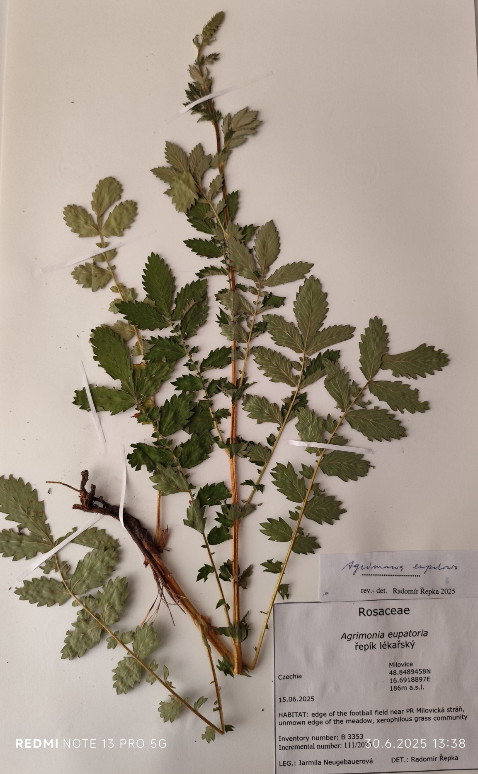
Figure S3: Herbarium item of wild A. eupatoria collected in the locality of Milovice (Agrimonia sample numbered as S4 in the Table S7)
Table S8: Agrimonia sample collection, 2021
Sampling date | Cultivated  / Wild | Locality | Variety | Ontogenesis phase | Plant  part | Post-harvest  sample processing | Extraction ratio
25.05.2021 | C | Lednice | Eupatoria | Vegetative | Apex | Fresh frozen (-18°C) | 1:5
 |  |  |  |  |  | Dried | 1:5
25.05.2021 | C | Lednice | Procera | Vegetative | Apex | Fresh frozen (-18°C) | 1:7.5
 |  |  |  |  |  | Dried | 1:5
25.05.2021 | C | Hlohovec | Eupatoria | Vegetative | Apex | Fresh frozen (-18°C) | 1:5
 |  |  |  |  |  | Dried | 1:6.25
26.05.2021 | W | Milovice | Eupatoria | Vegetative | Apex | Fresh frozen (-18°C) | 1:5
 |  |  |  |  |  | Dried | 1:6.25
28.05.2021 | C | Olomouc | Procera | Vegetative | Apex | Fresh frozen (-18°C) | 1:5
 |  |  |  |  |  | Dried | 1:5
28.05.2021 | C | Olomouc | Procera | Vegetative | Apex | Fresh frozen (-18°C) | 1:5
 |  |  |  |  |  | Dried | 1:7.5
22.06.2021 | C | Lednice | Eupatoria | Beginning  of flowering | Whole plant | Fresh frozen (-18°C) | 1:5
 |  |  |  |  | Stem with flower | Fresh frozen (-18°C) | 1:5
 |  |  |  |  | Leaves | Fresh frozen (-18°C) | 1:5
 |  |  |  |  | Whole plant | Dried | 1:5
 |  |  |  |  | Stem with flower | Dried | 1:5
 |  |  |  |  | Leaves | Dried | 1:15
22.06.2021 | C | Lednice | Procera | Beginning  of flowering | Whole plant | Fresh frozen (-18°C) | 1:5
 |  |  |  |  | Stem with flower | Fresh frozen (-18°C) | 1:5
 |  |  |  |  | Leaves | Fresh frozen (-18°C) | 1:5
 |  |  |  |  | Whole plant | Dried | 1:5
 |  |  |  |  | Stem with flower | Dried | 1:5
 |  |  |  |  | Leaves | Dried | 1:5
22.06.2021 | C | Hlohovec | Eupatoria | Beginning  of flowering | Whole plant | Fresh frozen (-18°C) | 1:5
 |  |  |  |  | Leaves | Fresh frozen (-18°C) | 1:5
 |  |  |  |  | Whole plant | Dried | 1:6.25
 |  |  |  |  | Stem with flower | Dried | 1:5
 |  |  |  |  | Leaves | Dried | 1:7.5
22.06.2021 | W | Milovice | Eupatoria | Beginning  of flowering | Whole plant | Fresh frozen (-18°C) | 1:5
 |  |  |  |  | Stem with flower | Fresh frozen (-18°C) | 1:5
 |  |  |  |  | Leaves | Fresh frozen (-18°C) | 1:5
 |  |  |  |  | Whole plant | Dried | 1:6.25
 |  |  |  |  | Stem with flower | Dried | 1:5
 |  |  |  |  | Leaves | Dried | 1:10
23.06.2021 | C | Olomouc | Procera | Beginning  of flowering | Whole plant | Fresh frozen (-18°C) | 1:5
 |  |  |  |  | Stem with flower | Fresh frozen (-18°C) | 1:5
 |  |  |  |  | Leaves | Fresh frozen (-18°C) | 1:5
 |  |  |  |  | Whole plant | Dried | 1:5
 |  |  |  |  | Stem with flower | Dried | 1:5
 |  |  |  |  | Leaves | Dried | 1:5
23.06.2021 | C | Olomouc | Procera | Beginning  of flowering | Whole plant | Fresh frozen (-18°C) | 1:5
 |  |  |  |  | Stem with flower | Fresh frozen (-18°C) | 1:5
 |  |  |  |  | Leaves | Fresh frozen (-18°C) | 1:5
 |  |  |  |  | Whole plant | Dried | 1:5
 |  |  |  |  | Stem with flower | Dried | 1:5
 |  |  |  |  | Leaves | Dried | 1:5

Table S8: Agrimonia sample collection, 2021 - continuation
Sampling date | Cultivated  / Wild | Locality | Variety | Ontogenesis phase | Plant  Part | Post-harvest  Sample processing | Extraction ratio
08.07.2021 | C | Lednice | Eupatoria | Full bloom | Whole plant | Fresh frozen (-18°C) | 1:5
 |  |  |  |  | Stem with flower | Fresh frozen (-18°C) | 1:5
 |  |  |  |  | Leaves | Fresh frozen (-18°C) | 1:5
 |  |  |  |  | Whole plant | Dried | 1:5
 |  |  |  |  | Stem with flower | Dried | 1:5
 |  |  |  |  | Leaves | Dried | 1:7.5
08.07.2021 | C | Lednice | Procera | Full bloom | Whole plant | Fresh frozen (-18°C) | 1:5
 |  |  |  |  | Stem with flower | Fresh frozen (-18°C) | 1:5
 |  |  |  |  | Leaves | Fresh frozen (-18°C) | 1:5
 |  |  |  |  | Whole plant | Dried | 1:6.25
 |  |  |  |  | Stem with flower | Dried | 1:5
 |  |  |  |  | Leaves | Dried | 1:7.5
07.07.2021 | C | Hlohovec | Eupatoria | Full bloom | Whole plant | Fresh frozen (-18°C) | 1:5
 |  |  |  |  | Leaves | Fresh frozen (-18°C) | 1:5
 |  |  |  |  | Whole plant | Dried | 1:5
 |  |  |  |  | Stem with flower | Dried | 1:5
 |  |  |  |  | Leaves | Dried | 1:7.5
07.07.2021 | W | Milovice | Eupatoria | Full bloom | Whole plant | Fresh frozen (-18°C) | 1:5
 |  |  |  |  | Stem with flower | Fresh frozen (-18°C) | 1:5
 |  |  |  |  | Leaves | Fresh frozen (-18°C) | 1:5
 |  |  |  |  | Whole plant | Dried | 1:5
 |  |  |  |  | Stem with flower | Dried | 1:5
 |  |  |  |  | Leaves | Dried | 1:7.5
08.07.2021 | C | Olomouc | Procera | Full bloom | Whole plant | Fresh frozen (-18°C) | 1:5
 |  |  |  |  | Stem with flower | Fresh frozen (-18°C) | 1:5
 |  |  |  |  | Leaves | Fresh frozen (-18°C) | 1:5
 |  |  |  |  | Whole plant | Dried | 1:5
 |  |  |  |  | Stem with flower | Dried | 1:5
 |  |  |  |  | Leaves | Dried | 1:5
08.07.2021 | C | Olomouc | Procera | Full bloom | Whole plant | Fresh frozen (-18°C) | 1:5
 |  |  |  |  | Stem with flower | Fresh frozen (-18°C) | 1:5
 |  |  |  |  | Leaves | Fresh frozen (-18°C) | 1:5
 |  |  |  |  | Whole plant | Dried | 1:5
 |  |  |  |  | Stem with flower | Dried | 1:5
 |  |  |  |  | Leaves | Dried | 1:5
11.10.2021 | C | Lednice | Eupatoria | Senescence | Roots | Fresh frozen (-18°C) | 1:5
 |  |  |  |  |  | Dried | 1:5
11.10.2021 | C | Lednice | Procera | Senescence | Roots | Fresh frozen (-18°C) | 1:5
 |  |  |  |  |  | Dried | 1:5
11.10.2021 | C | Hlohovec | Eupatoria | Senescence | Roots | Fresh frozen (-18°C) | 1:5
 |  |  |  |  |  | Dried | 1:5
10.10.2021 | W | Milovice | Eupatoria | Senescence | Roots | Fresh frozen (-18°C) | 1:5
 |  |  |  |  |  | Dried | 1:5
08.10.2021 | C | Olomouc | Procera | Senescence | Roots | Fresh frozen (-18°C) | 1:5
 |  |  |  |  |  | Dried | 1:5
08.10.2021 | C | Olomouc | Procera | Senescence | Roots | Fresh frozen (-18°C) | 1:5
 |  |  |  |  |  | Dried | 1:5

