Supplementary Material
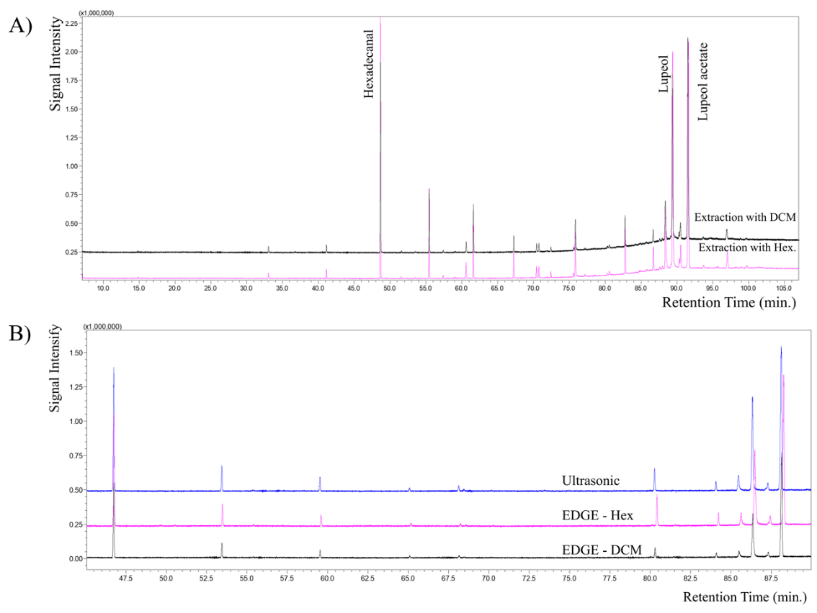
Figure 1S. A) Comparison between chromatograms (GC/qMS) for DCM and Hexane extracts from Mangabeira fruits obtained by EDGE. B) Comparison between chromatograms (GC/qMS) for extracts in DCM and Hexane obtained by EDGE and extract obtained by ultrasound.

