Supplementary Material
Figure S1. HRMS fragmentation spectrum of CBDA.
Figure S2. HRMS fragmentation spectrum of THCA A.
Figure S3. HRMS fragmentation spectrum of CBCA.
Figure S4. Fragmentation pattern approach of group 3cannabinoids isomer, C₂₂H₃₀O₄ with a DBE of 8, the precursor ion m/z 357.2071

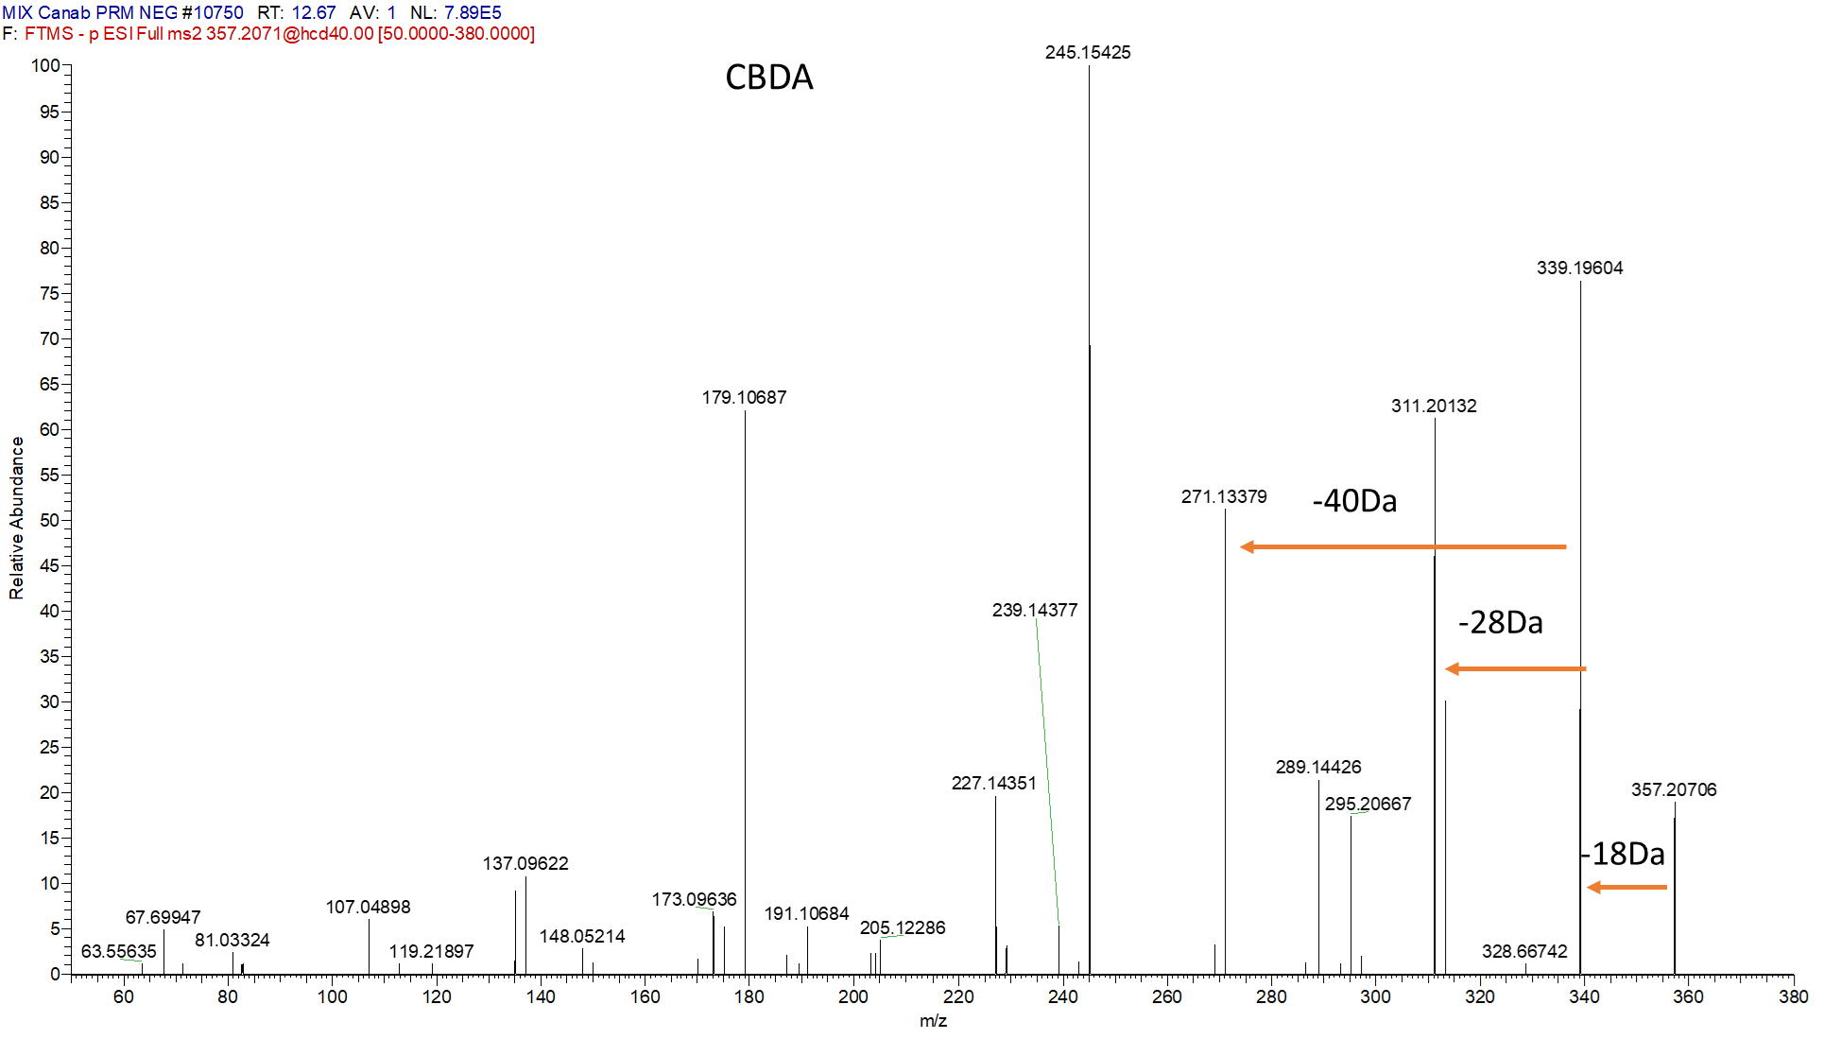
Figure S1. HRMS fragmentation spectrum of CBDA.

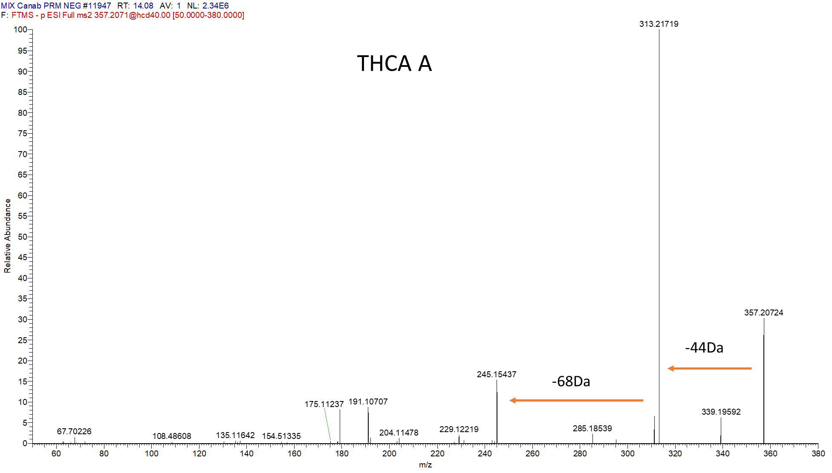
Figure S2. HRMS fragmentation spectrum of THCA A.

-44Da
-18Da

Figure S3. HRMS fragmentation spectrum of CBCA.

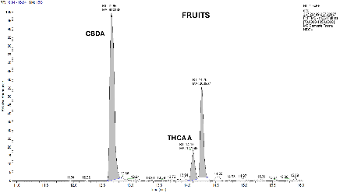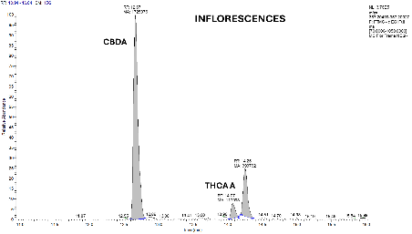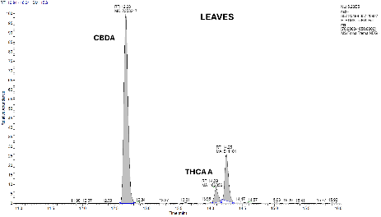
C
B
A
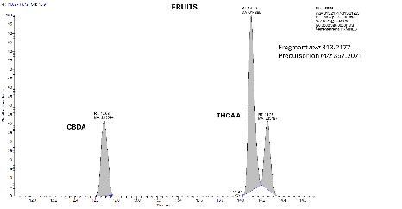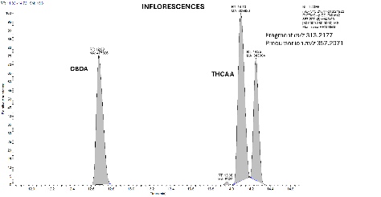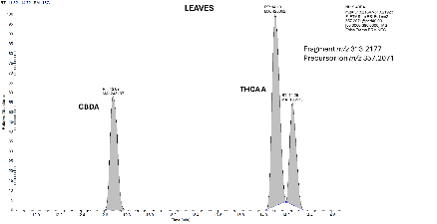
G
H
I
F
E
D
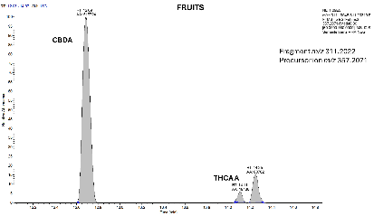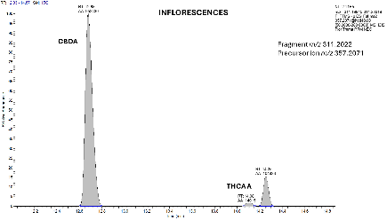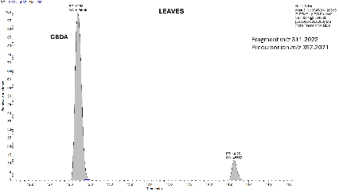
L
K
J
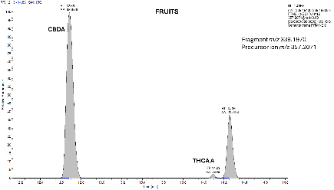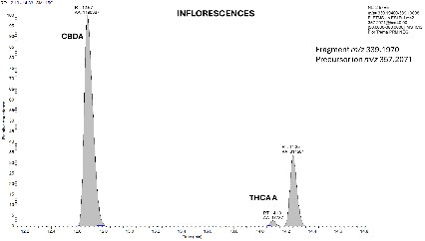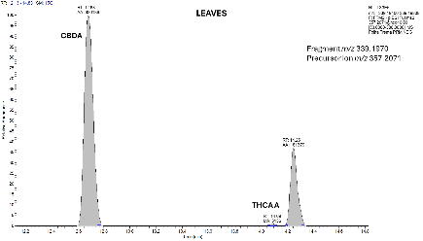
Figure S4. MS data from Trema micranthum parts. A, B and C: Extracted-ion chromatograms for m/z 357.2071. D, E and F: Extracted-ion chromatograms of fragment ion extracted m/z 313.2177. G, H and I: Chromatograms of fragment ion extracted m/z 311.2022. J, K and L: Extracted-ion chromatograms from m/z 339.1970.

