Table S1. Information of patients and tumor samples.
 | Gender | Age | Tumor |  |  | TNM stage
 | Gender | Age | Size | Type | BRAFV600E | T | N | M
Patient#1 | Male | 28 | 2 lesions with 0.1 cm or 0.8 cm in diameter | Classic PTC | (+) | T1a | N1b | M0
Patient#2 | Male | 32 | 0.8 cm in diameter | Classic PTC | (+) | T1a | N0 | M0

Table S2. Gene lists of the thyroid cancer and normal tissue genes curated from THCA gene set of TCGA.
Thyroid cancer | Normal tissue
ANXA1 | AHSA2 | HBA2 | RMST
APOC1 | AKAP8L | HBB | RPS4Y1
C19orf33 | AP1G2 | HOOK2 | SERPINF1
CCND1 | APOD | INPPL1 | SLC26A7
CD55 | ARGLU1 | LENG8 | SOD3
CHI3L1 | ATHL1 | LINC00969 | SPARCL1
CITED1 | C1QTNF1 | MALAT1 | STAG3L5P
CLDN1 | C1R | MAN2C1 | TAGLN
CST6 | C1S | MAT2A | TFF3
CTSH | C7 | MBD6 | TNS2
DUSP6 | CCL14 | MT1F | TPM2
FN1 | CCL21 | MT1G | TPO
KRT19 | CCNL1 | MT1H | TSPYL2
LGALS3 | CCNL2 | MYO15B
MDK | CFD | NDRG2
NPC2 | CLASRP | NEAT1
PDLIM4 | COL6A1 | NNMT
PROS1 | CORO6 | NPIPA1
S100A1 | CRABP1 | NPIPB3
S100A6 | DCN | NPIPB5
SDC4 | EFEMP1 | PAN2
SERPINA1 | EPOR | PAX8
SFTPB | FABP4 | PILRB
SLC34A2 | FAM193B | PKHD1L1
SLPI | FBLN1 | PLA2G6
TACSTD2 | GOLGA8A | PLCG1
TNFRSF12A | GOLGA8B | PLEKHH1
XIST | GSTM2 | PNISR
ZCCHC12 | HBA1 | RAP1GAP

Table S3. Gene lists of the constructed malignant and metastatic footprints.
Malignant footprint | Metastatic footprint
AGR2 | AOPEP
ANXA1 | ARHGDIB
APOC1 | B2M
ARMCX3 | COL8A1
CHPT1 | CTSS
CTSC | EEF1A1
CTSH | MDK
ECRG4 | NRP2
ENTPD1 | PCSK2
IGSF1 | PDLIM1
LGALS3 | PDZK1IP1
NMB | PROS1
NPC2 | RPS29
TACSTD2 | SERPINA1
TESC | SLC34A2
TPD52L1 | SSR3
TSC22D1
ZCCHC12

Supplementary Figures
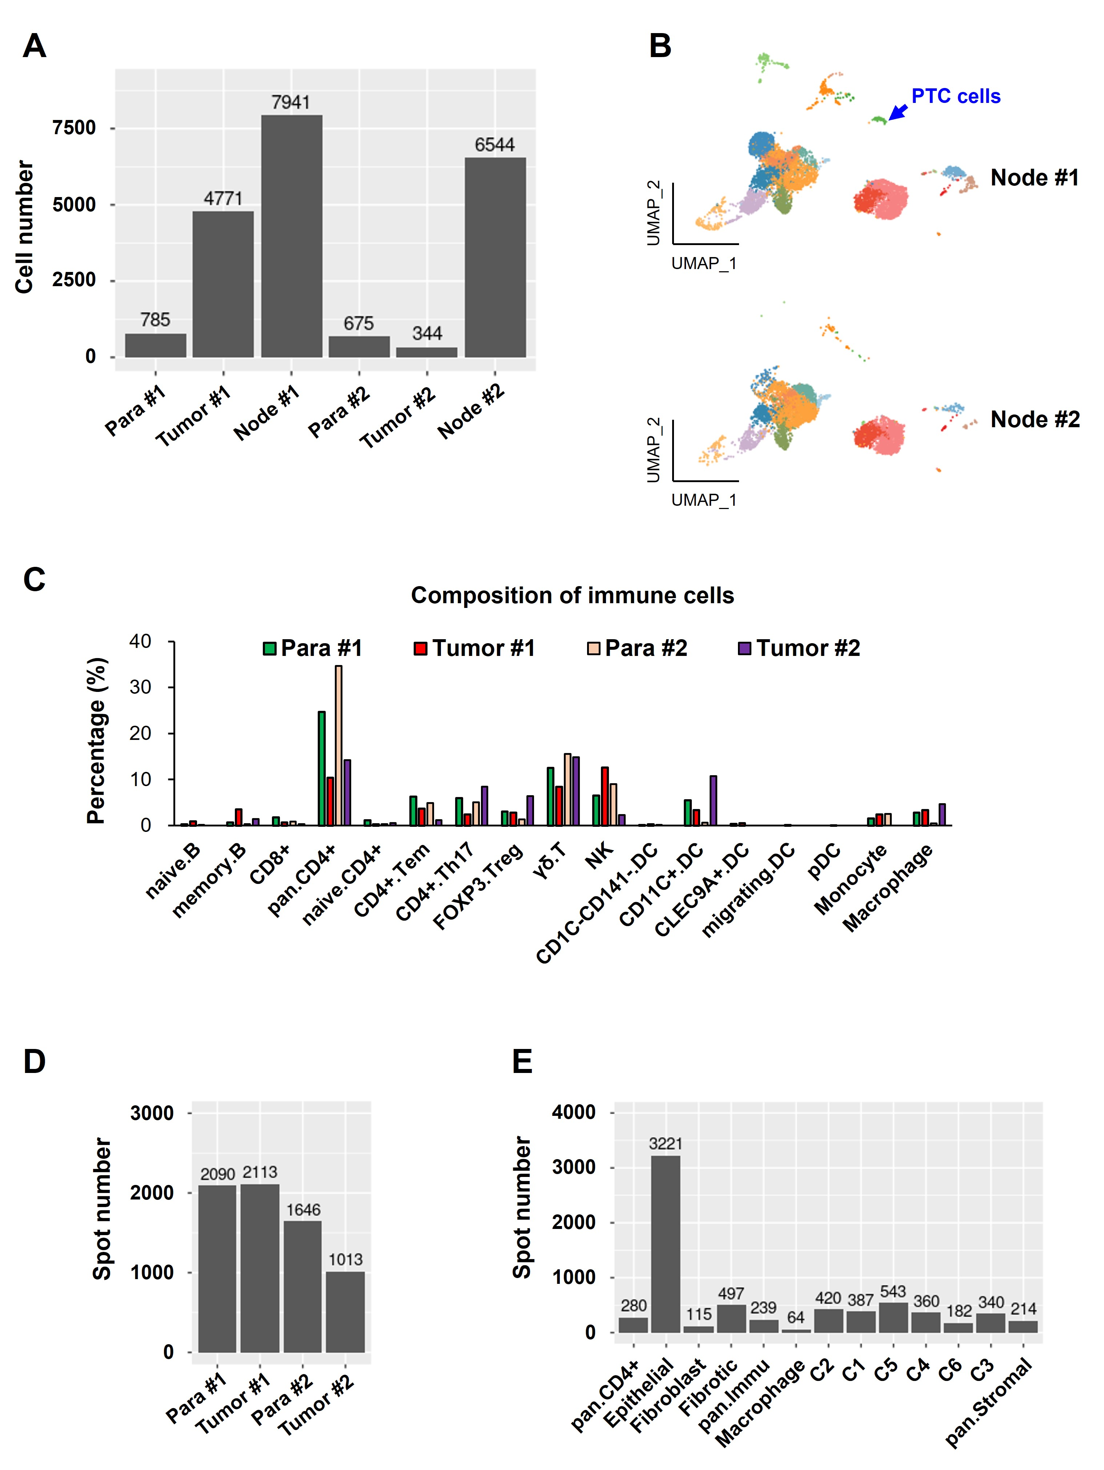
Figure S1. (A) Cell numbers, (B) UMAP visualization and (C) immune composition of the annotated cell types in scRNA-seq. (D-E) Spot numbers of the annotated spots in SRT. Blue arrow indicates the metastatic PTC cells in the lymph node tissue in (B).

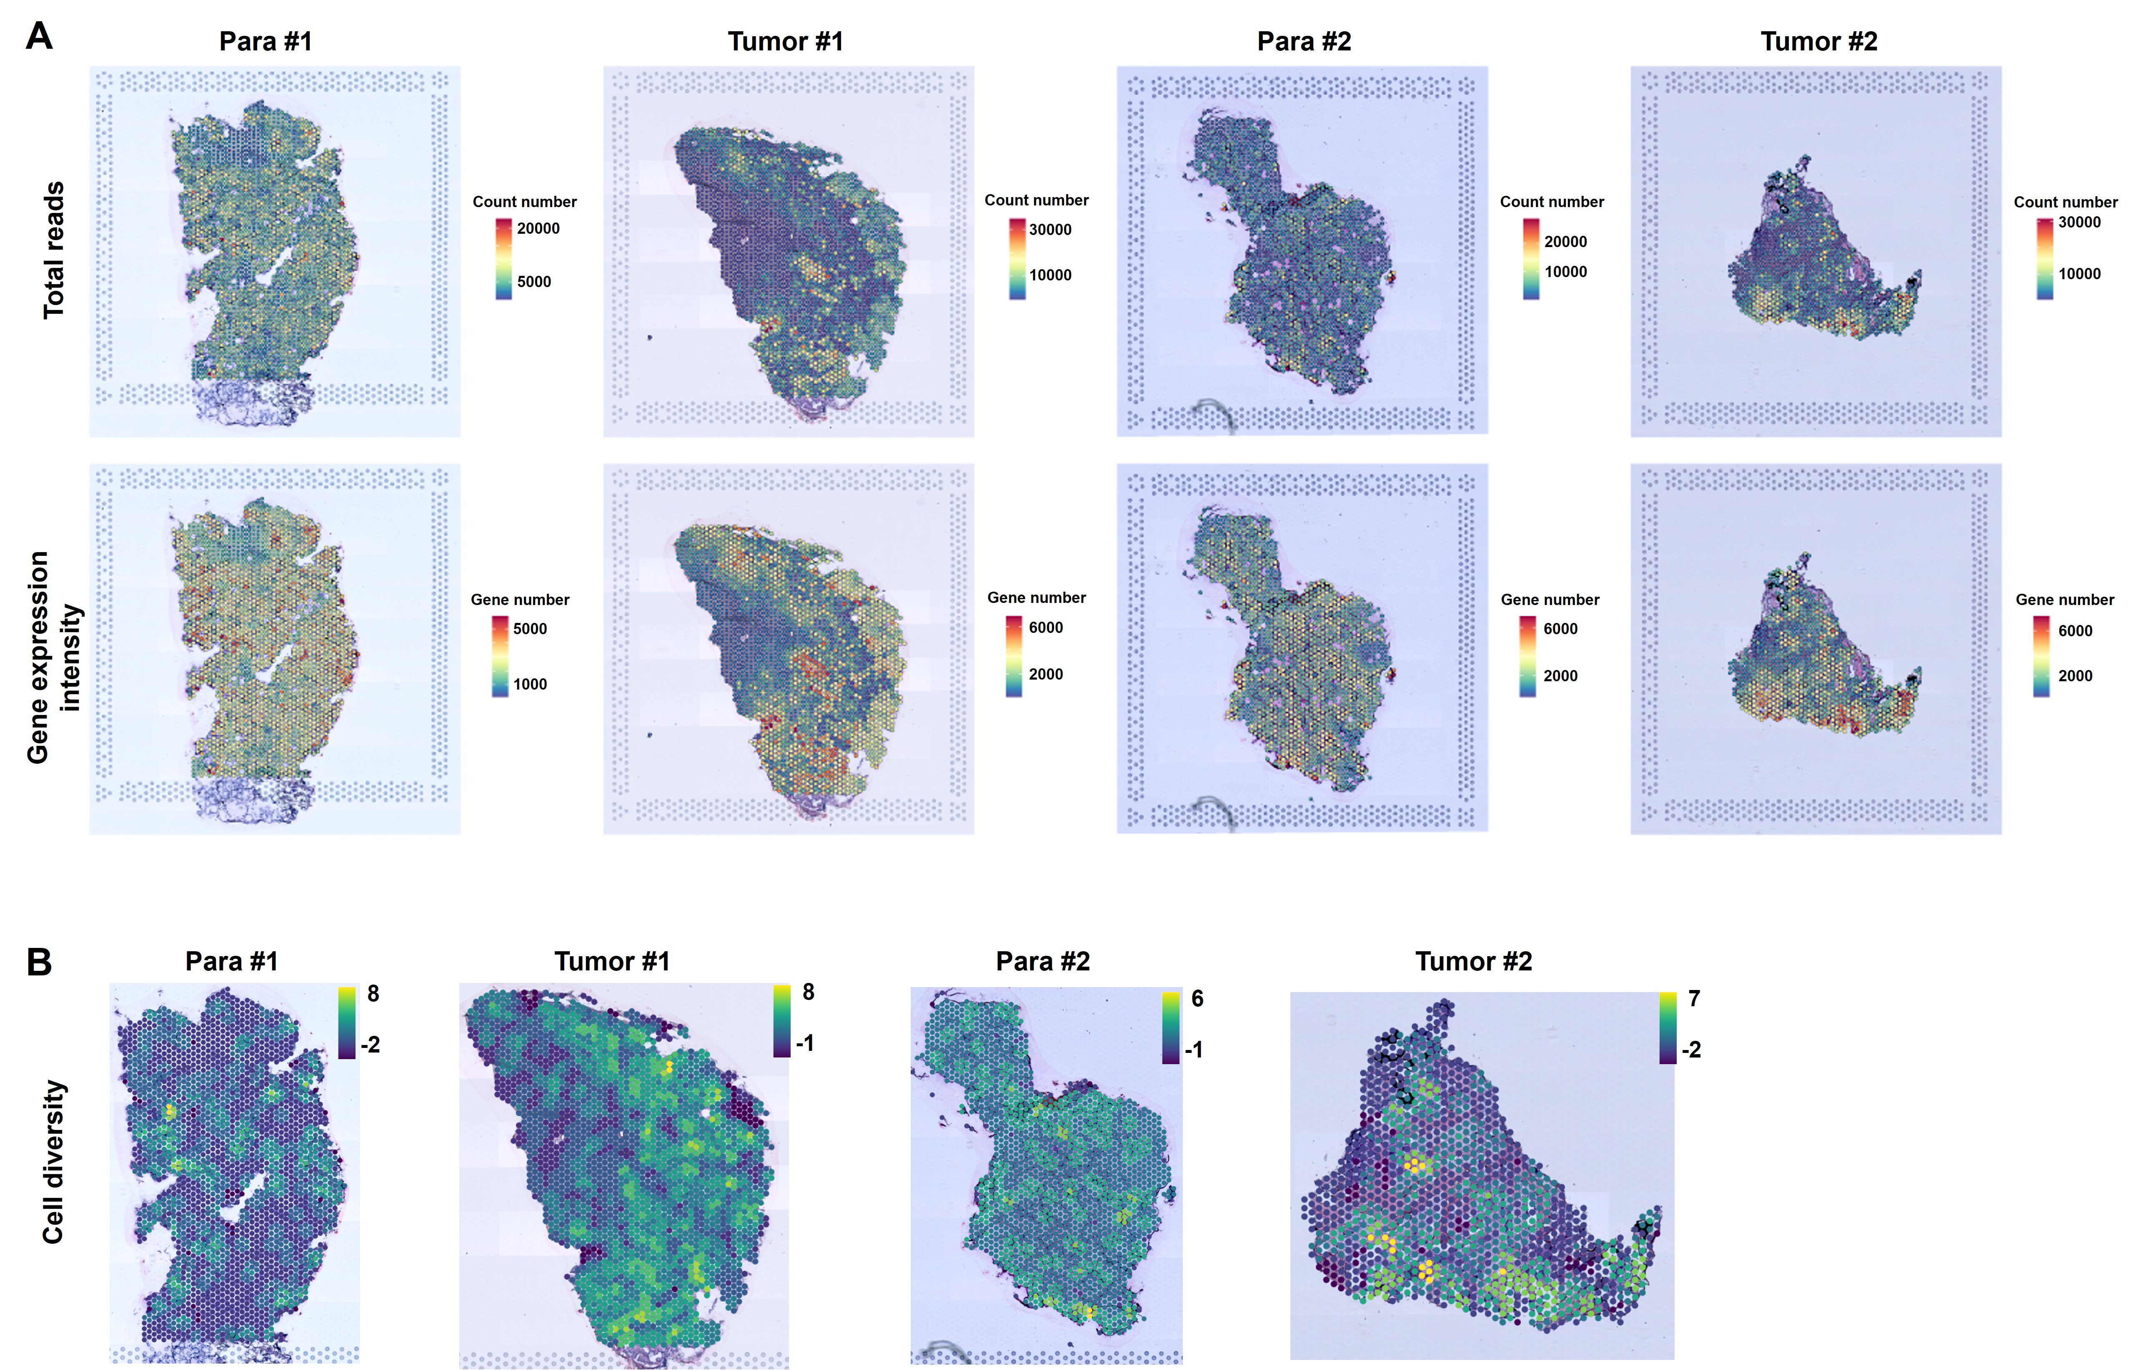
Figure S2. Spatial visualization of cell heterogeneities as demonstrated by the number of counts and genes (A) and cell diversities (B).

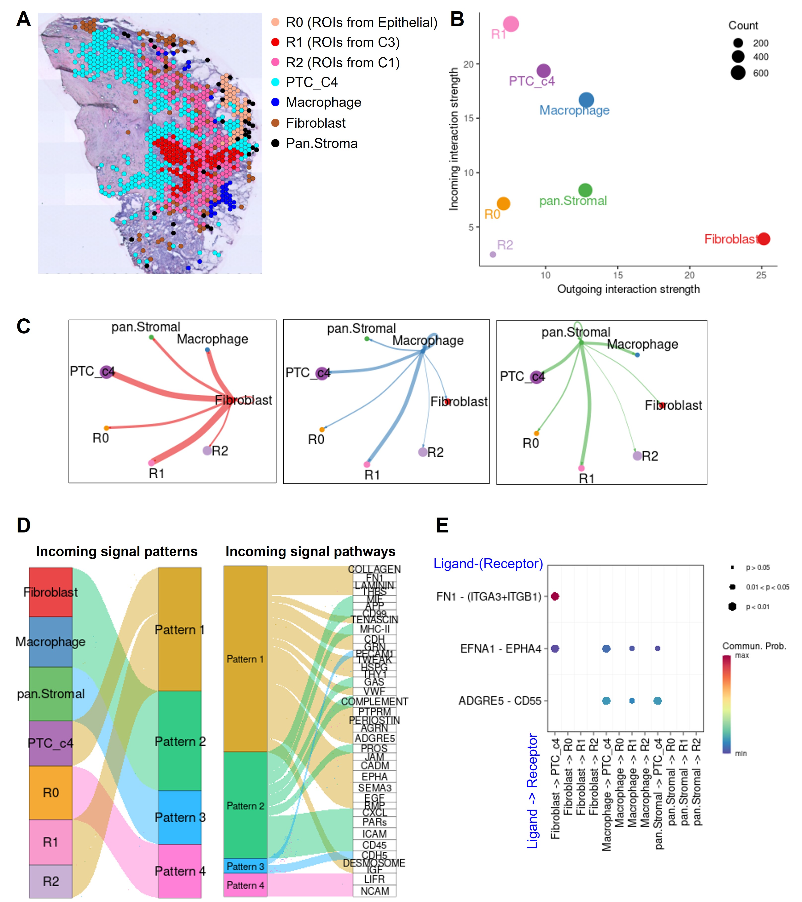
Figure S3. Cell-cell interactions may contribute to PTC evolution.
(A) Spots involved in the spatial evolutionary route selected for the cell-cell interaction analysis and these spots are denoted as ROIs (region of interest), including ROIs from Epithelial (labelled as R0), C3 (labelled as R1) and C1 clusters (labelled as R2) as well as all spots from C4 (labelled as PTC_C4). Cell-cell interactions include secreting signaling, ECM-receptor, cell-cell contact, heterodimers and other modes. (B-C) Visualization of signal senders (outgoing interaction strength) and receivers (incoming interaction strength). Line thickness indicates the interaction numbers in (C). (D) The cell-cell interaction patterns and the corresponding signaling pathways for the incoming signals. (E) The dominant ligand-receptor pairs mediating the cell-cell interactions.
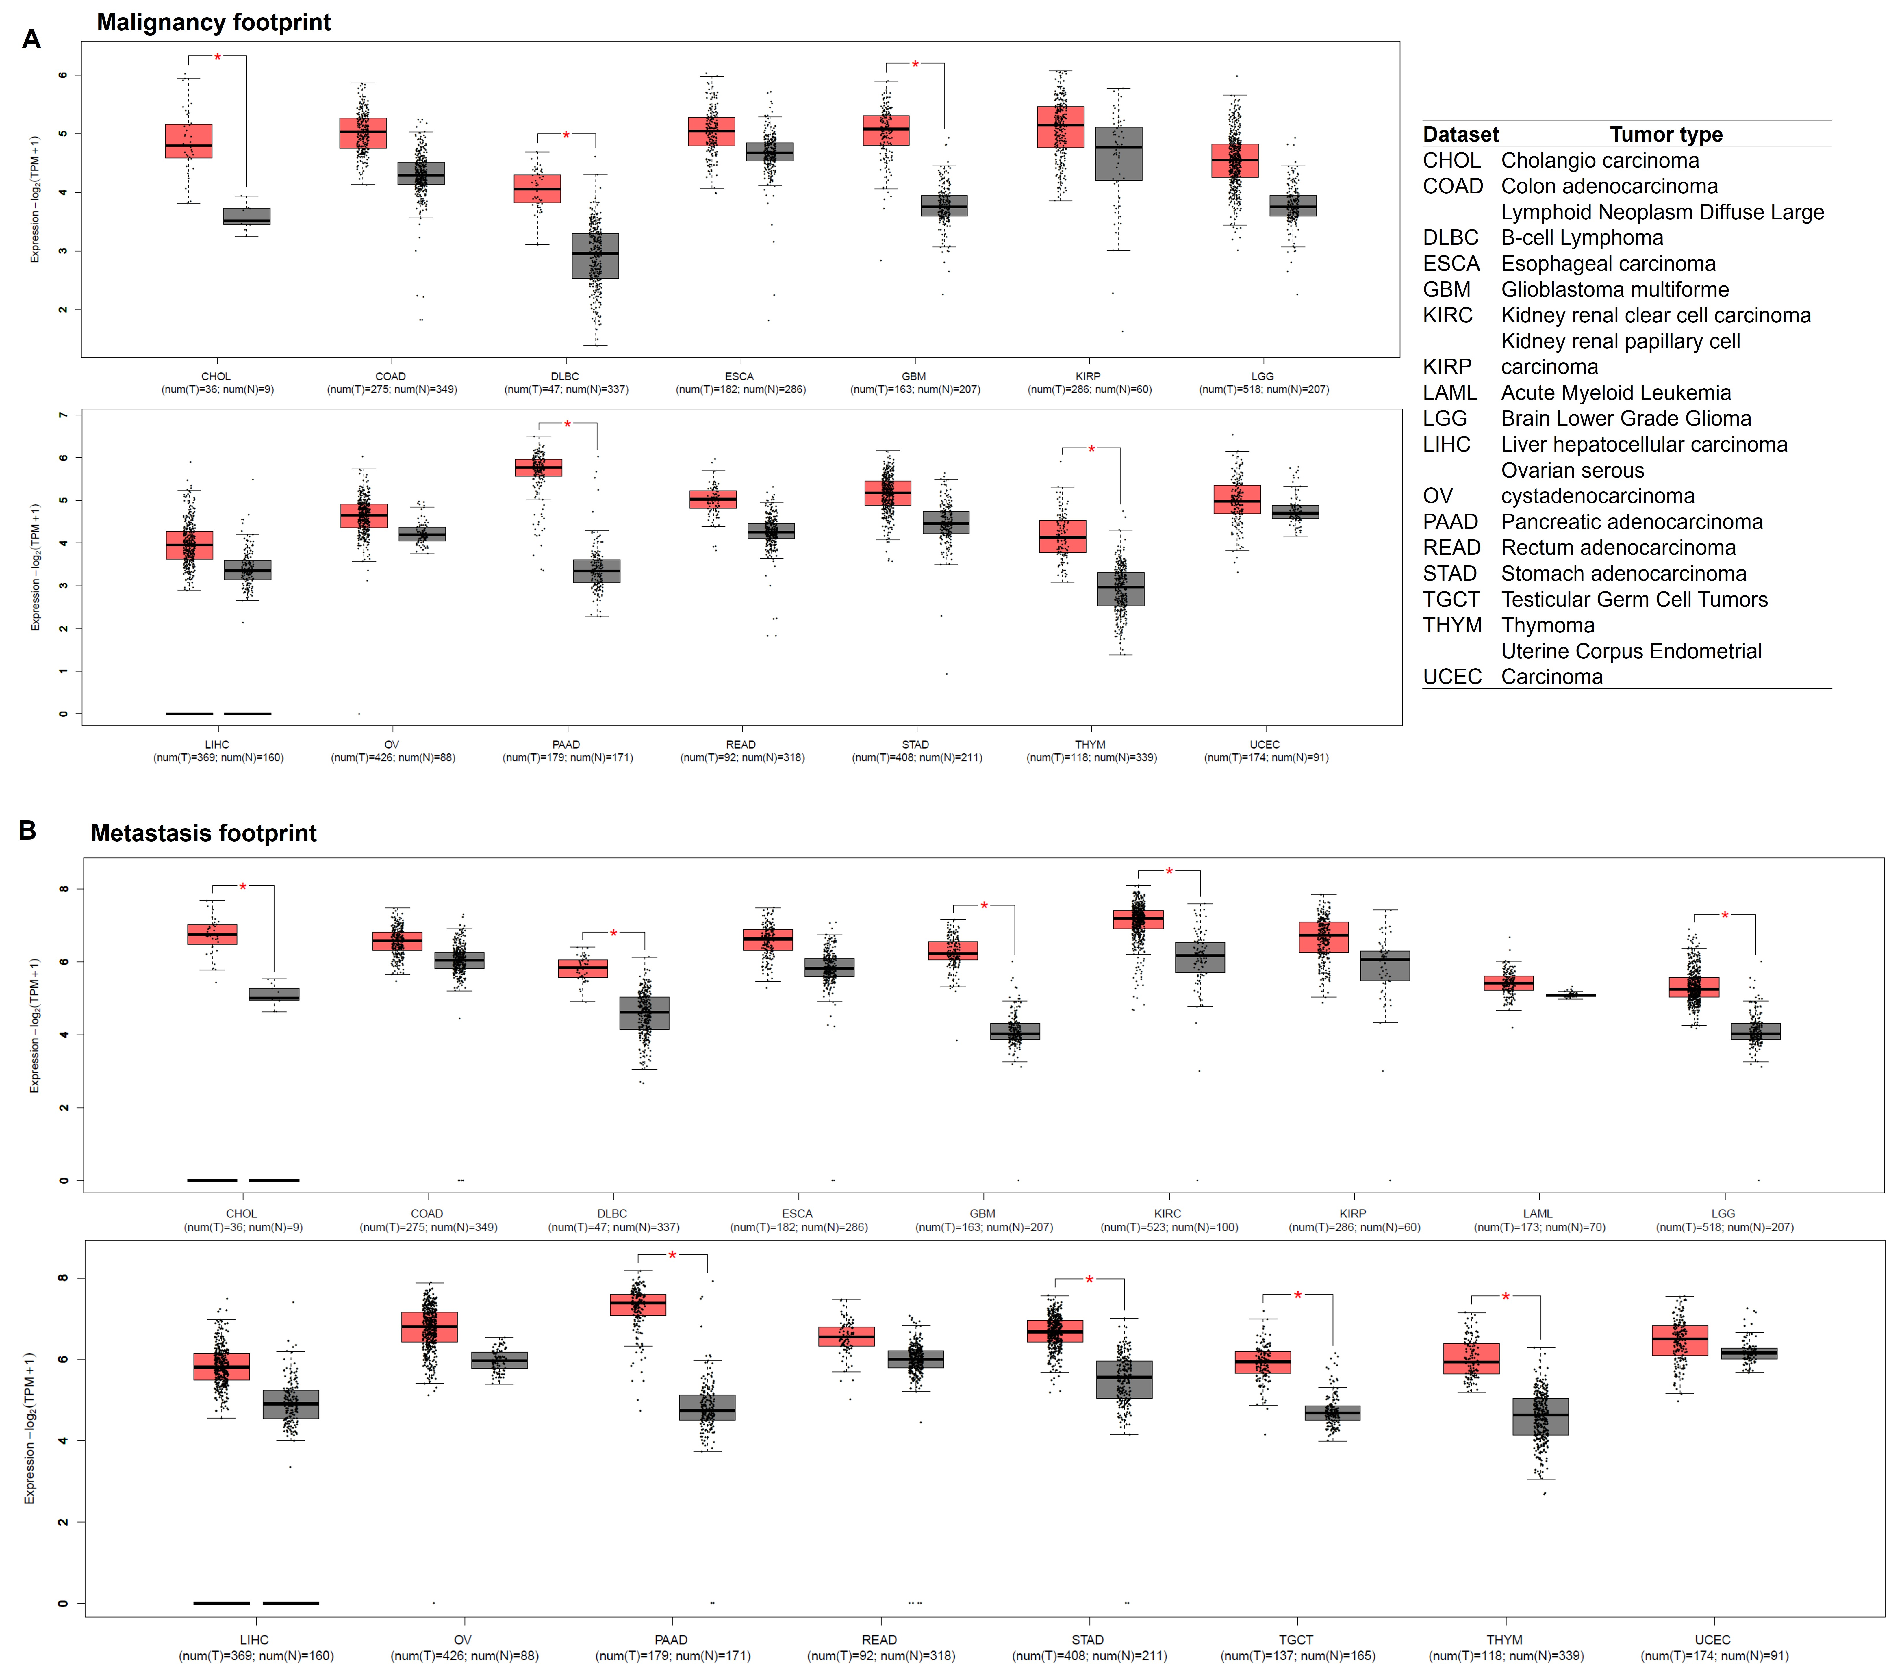
Figure S4. The expression of the curated malignant (A) and metastatic (B) footprints in a variety of cancer datasets from TCGA database.

