Supplementary Tables

Supplemental Table A1: Unweighted Counts and Weighted Proportions of ICPS 2021 Survey Respondents in Total and by Country
 | Entire Sample  N (%) | Canada  N (%) | USA  N (%) | Australia  N (%)
Total Surveyed | 49,958 | 16,952 | 30,081 | 2,925
Total with no missing gender, age, ethnicity, education | 49,513 | 16,776 | 29,845 | 2,892
Total with information on Past Year Cannabis Use | 32,161 | 10,616 | 20,020 | 1,525
Total Reporting Past Year Cannabis Use (Our base sample) | 16,951 (100) | 5,935 (36.2) | 10,472 (60.5) | 544 (3.3)
Past Year Cannabis Users by Gender
Female | 10,554 (46.9) | 3,383 (46.6) | 6,906 (47.2) | 265 (44.0)
Male | 6,397 (53.1) | 2,552 (53.4) | 3,566 (52.8) | 279 (56.0)
Past Year Cannabis Users by Age Groups
16-25 years | 2,446 (18.0) | 717 (16.7) | 1,609 (18.6) | 120 (20.3)
26-35 years | 4,057 (27.8) | 1,521 (28.5) | 2,420 (27.5) | 116 (24.1)
36-45 years | 4,341 (23.0) | 1,448 (23.8) | 2,728 (22.3) | 165 (26.5)
46-55 years | 2,857 (16.7) | 1,002 (16.5) | 1,767 (16.7) | 88 (19.8)
56-65 years | 3,250 (14.6) | 1,247 (14.5) | 1,948 (14.9) | 55 (9.2)
Past Year Cannabis Users by Race
White | 13,193 (74.6) | 4,405 (72.8) | 8,350 (75.5) | 438 (78.5)
Other/Mixed/Unstated | 3,758 (25.4) | 1,530 (27.2) | 2,122 (24.5) | 106 (21.5)
Past Year Cannabis Users by Education
Refuse to answer | 59 (0.3) | 26 (0.5) | 33 (0.2) | 0 (0.0)
Don't know | 56 (0.4) | 16 (0.3) | 38 (0.4) | 2 (0.3)
Less than high school | 1,284 (12.1) | 409 (14.8) | 795 (10.0) | 80 (20.6)
High school diploma | 3,368 (25.9) | 953 (28.6) | 2,318 (24.4) | 97 (22.1)
Some college or technical | 6,861 (37.2) | 2,593 (34.6) | 4,067 (39.0) | 201 (32.8)
Bachelor's degree or higher | 5,323 (24.2) | 1,938 (21.3) | 3,221 (25.9) | 164 (24.2)

Supplemental Table A2. Multinomial Logistic Adjusted Shares of Past Year Cannabis Users by Measure of Use and Country

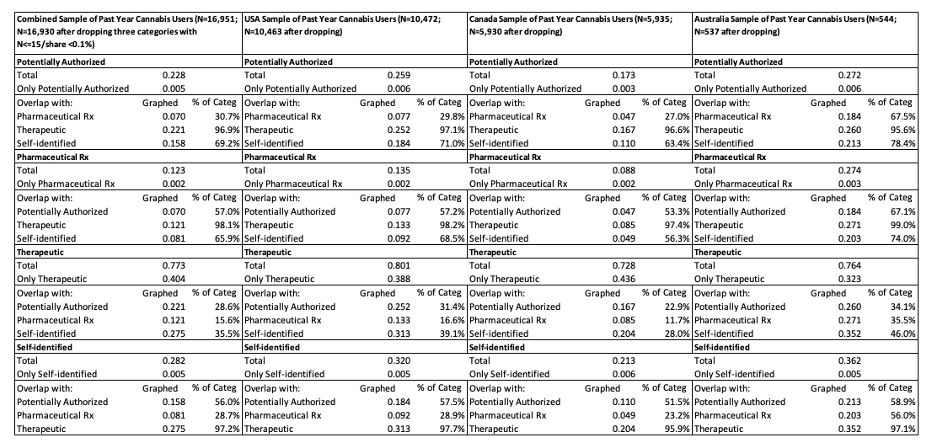

Supplemental Table A3. Confidence Intervals from Multinomial Logistic Adjusted Shares of Past Year Cannabis Users by Measure of Use and Country

