Supporting information - Synthetic cannabinoids consumed via e-cigarettes in English schools
Gyles E. Cozier,^{1‡} Matthew Gardner,^{1‡} Sam Craft,² Martine Skumlien,² Jack Spicer,³ Rachael Andrews,¹ Alexander Power,⁴ Tom Haines,⁴ Richard Bowman,⁵ Amy E. Manley,⁶ Peter Sunderland,¹ Oliver B. Sutcliffe,⁷ Stephen M. Husbands,¹ Lindsey Hines,² Gillian Taylor,⁸ Tom P. Freeman,²* Jennifer Scott,⁹* Christopher R. Pudney¹*
¹Department of Life Sciences, ²Department of Psychology, ³Department of Social and Policy Science, ⁴Department of Computer Science, University of Bath, Bath, BA2 7AY, UK. ⁵School of Physics and Astronomy, University of Glasgow, Glasgow, G12 8QQ, UK. ⁶Bristol Medical School, University of Bristol, Bristol, BS8 2PS, UK. ⁷MANchester DRug Analysis & Knowledge Exchange (MANDRAKE), Department of Natural Sciences, Manchester Metropolitan University, Manchester, M1 5GD. ⁸School of Health and Life Sciences, Teesside University, Middlesbrough, TS1 3BX ⁹Centre for Academic Primary care, Bristol Medical School, University of Bristol, Bristol, BS8 2PS, UK.

Analytical methods
Table S1. Media reports of adverse effects in schools associated with vaping and putatively associated with SC use
Table S2. Results summary for all samples in R1
Table S3. Results summary for all samples in R2
Table S4. Results summary for all samples in R3
Table S5. Results summary for all samples in R4
Table S6. Data summary for R1-3
Table S7. LC-MS parent molecule and fragment mass to charge (mz) ratios used to confirm compounds found in the e-cigarettes/liquids
Figure S1. Example LC-MS chromatogram and spectra for sample R1S1.2 with MDMB-4en-PINACA, 4F-MDMB-BINACA and MDMB-INACA SCs identified
Figure S2. Example LC-MS chromatogram and spectra for sample R1S12.119 with ADB-BUTINACA identified
Figure S3. Structures of illicit drugs identified
Figure S4. Example 1H NMR spectra used for qNMR on sample R1S8.62 containing MDMB-4en-PINACA
Figure S5. Example 1H NMR spectra used for qNMR on sample R2S1.3 containing MDMB-4en-PINACA
Figure S6. Example 1H NMR spectra used for qNMR on sample R1S12.121 containing ADB-BUTINACA
Figure S7. Example 1H NMR spectra used for qNMR on sample R1S2.13 containing MDMB-4en-PINACA
Figure S8. Plot showing the qNMR calculated values of a standard concentration range of MDMB-4en-PINACA in e-cigarette liquid
Figure S9. Photographs of THC e-cigarettes from R1-3
Figure S10. Photographs of SC and THC e-cigarettes from R4

ANALYTICAL METHODS

LC-MS
For LC-QToF-MS analysis, all e-cigarette liquid samples were initially diluted 20 000x in HPLC grade ethanol, with repeats at higher concentration where needed/possible. Analyses were performed using an Agilent QToF 6545 with a Jetstream electrospray ionization (ESI) source coupled to an Agilent 1260 Infinity II Quaternary pump HPLC with a 1260 autosampler, column oven compartment, and variable wavelength detector (VWD). The mobile phases used were (A) LC-MS grade water with 0.1% formic acid and (B) acetonitrile with 0.1% formic acid. The gradient used was 95:5 A:B from 0.00-0.60 min, change to 0:100 A:B over 0.60-3.00 min, held at 0:100 A:B from 3.00-5.50 min, change to 95:5 A:B over 5.50-5.60 min, and held at 95:5 A:B from 5.6-7.6 min. The flow rate was 0.5 mL/min at 50ºC and 5 μL of the sample was injected onto an EC-C18 3.0 x 50 mm, 2.7 μm particle size column (InfinityLab Poroshell 120, Agilent Technologies). The MS was operated in positive ionization mode with the gas temperature at 250°C, the drying gas at 11 L/min, and the nebulizer gas at 35 psi (2.41 bar). The sheath gas temperature was set to 300ºC and the flow rate was 12 L/min. The MS was calibrated using a reference calibrant introduced from an independent ESI reference sprayer. The VCap, Fragmentor and Skimmer were set to 3500, 160, and 45 V, respectively. The MS was operated in all-ions mode with three collision energy scan segments at 0, 20, and 40 eV.
The VWD was set to detect at 280 nm wavelength at a frequency of 2.5 Hz. Data processing was automated in Qual 10, with the molecular feature extraction set to the largest 20 compounds for [M⁺H]⁺, [M-H]⁻, and [M+HCOO]⁻ ions. The results were also searched against the online mass spectral databases HighResNPS (containing over 2300 unique compound entries) and ForTox, with a forward score of 25 and reverse score of 70, and mass tolerances within 5 ppm of the reference library matches. Qualified ions had co-elution scores of ≥ 90, retention time tolerances of ± 0.10, and a minimum S/N of ≥ 5.00.

GC-MS
Samples were diluted with methanol 50/50 ratio. GCMS analysis was preformed using a TQ-GC (Waters Corporation). Chromatographic separation was performed on a Thames Restek (DB-5, 30 m x 0.25 mm ID x 0.25 µm). The following temperature parameters were used: 60 °C (held for 3min) to 300 °C at 15 °C min-1, then held for 6 min. Injection port was 280°C, split ratio 25 mL/min. The analyser was set to scan m/z 50-500. GCMS peaks were identified through comparison to standards, NIST database and Cayman Chemicals forensic database.

NMR
The quantitative nuclear magnetic resonance (NMR) method used was based on a study that quantified SCs in seized e-liquids.¹⁸ Samples were prepared by mixing 200 μL of e-cigarette liquid with 400 μL of methanol-d4 (MeOD) containing 3 mg of 3-(trimethylsilyl)propionic-2,2,3,3-d4 acid sodium salt (purity ≥ 99%, isotopic purity 98 atom % D) (TSP). A set of MDMB-4en-PINACA concentrations (10 – 0.1 mg/ml) were prepared in 50/50 propylene glycol/glycerol (PG/VG) as standard e-cigarette liquids to test the quantification method.
¹H NMR data were recorded on a Bruker AvanceCore 400 MHz spectrometer (1H frequency of 400.130), with a zg pulse sequence composed of 3.18 s acquisition time, 128 scans and 20 s delay. Chemical shifts were referenced to 3.31 ppm for residual CD₂HOD solvent peak (from MeOD) and are reported in ppm. NMR spectra were processed with Mestralab Mnova 14.1 using automatic phase and Whittaker smoother baseline corrections, followed by zero filling (4 x original size) and line broadening (1 Hz) to improve signal/noise ratio. Due to the large amounts of PG/VG in e-cigarette liquid, only the 4 peaks from the aromatic indazole core of the SCs could be reliably integrated. As many of these were used for the qNMR calculation, when not obscured by other additives in the e-cigarette liquid.
The following equation was used for the ¹H qNMR quantitation:
$$[x] = \frac{n_{IC}∙{Int}_{x}∙{MW}_{x}∙m_{IC}}{n_{x}∙{Int}_{IC}{∙MW}_{IC}∙V_{s}}{∙P}_{IC}$$

Where [ ] denotes concentration in mg/mL, P is the purity, n is the number of protons, Int is the integral value, MW is the molecular weight, m is the mass in mg, V is the volume in mL, IC is the internal calibrant, x is the analyte, and s is the sample. As the indazole peaks of the different SC compounds overlayed, when multiple SC compounds were present in each sample, the molecular weight of the main SC, as judged by the LC-MS chromatogram, was used in the calculation.

Date | Location | Link
30/04/2024 | West midlands | https://www.dailystar.co.uk/news/latest-news/deadly-spice-laced-vapes-leave-32709640
25/04/2024 | West Midlands | Email
08/04/2024 | Belfast | https://www.belfasttelegraph.co.uk/news/education/surge-in-use-of-danger-drug-spice-in-vapes-as-ni-schools-warn-parents-of-concerns/a1420855242.html
20/03/2024 | Kent | https://www.dailymail.co.uk/news/article-13218931/schoolboy-vape-laced-cannabis-spice-collapsed-hospital.html
13/03/2024 | Teeside | https://www.gazettelive.co.uk/news/teesside-news/school-issues-warning-parents-after-28805683
01/03/2024 | Bolton | https://www.bbc.co.uk/news/uk-england-manchester-68536562
12/02/2024 | London | https://www.standard.co.uk/news/health/what-zombie-vapes-e-cig-children-spice-symptoms-b1138635.html
19/01/2024 | Cleveland | https://www-gazettelive-co-uk.cdn.ampproject.org/v/s/www.gazettelive.co.uk/news/teesside-news/15-year-old-arrested-over-28480443.amp?amp_gsa=1&amp_js_v=a9&usqp=mq331AQIUAKwASCAAgM%3D#amp_tf=From%20%251%24s&aoh=17061028470033&referrer=https%3A%2F%2Fwww.google.com&ampshare=https%3A%2F%2Fwww.gazettelive.co.uk%2Fnews%2Fteesside-news%2F15-year-old-arrested-over-28480443
24/01/2024 | Lancaster | Multiple
01/01/2024 | Plymouth | Email
11-Dec-23 | Gwent | https://www.mirror.co.uk/news/uk-news/urgent-warning-parents-after-three-31650064
20-Dec-23 | Falkirk | https://www.dailymail.co.uk/news/article-12885841/boy-hospital-sick-vaping-spice-drug-school.html
12-Nov-23 | Oldham | https://www.bbc.co.uk/news/health-67349297
01-Nov-23 | Sandwell | Email
27-Oct-23 | Middlesborough | https://www.itv.com/news/tyne-tees/2023-10-27/children-collapsing-in-school-after-using-vapes-laced-with-spice
25-Oct-23 | Selby | https://www.yorkpress.co.uk/news/23877890.selby-police-warn-reports-vapes-containing-drug-spice/
12-Jul-23 | Oldham | https://www.oasisacademyoldham.org/news-and-events/latest-news/news-post-page/~board/oldham-news/post/oldham-vape-warning-reminder-for-parents-and-carers
Table S1. Media reports of adverse effects in schools associated with vaping and putatively associated with SC use

Table S2. Results summary for all samples in R1
R1S1 | Sample type | Detail | Liquid colour | LC-MS result | Quant (mg / mL)
1 | RF | Vaporesso | Orange | NDD | -
2 | RF | Vaporesso | Yellow | MDMB-4en-PINACA  4F-MDMB-BINACA  MDMB-INACA | 0.63
3 | LB | 'Elux Mr Blue', Yellow Liquid | Yellow | NDD | -
4 | LB | 'Elux Lemon and Lime', Yellow Liquid | Yellow | NDD | -
5 | RF | - | - | MDMB-4en-PINACA | IM
6 | RF | Vaporesso | Brown | NDD | -
7 | RF | Vaporesso | Green | MDMB-4en-PINACA  4F-MDMB-BINACA  MDMB-INACA | 0.14
8 | RF | Vaporesso | Yellow | MDMB-4en-PINACA  4F-MDMB-BINACA  MDMB-INACA | IM
9 | UB | - | Yellow | MDMB-4en-PINACA  4F-MDMB-BINACA  MDMB-INACA | 0.89
R1S2 | Sample type | Detail | Liquid colour | LC-MS result | Quant (mg / mL)
10 | RF | Vaporesso | Clear | MDMB-4en-PINACA  MDMB-INACA | 0.11
11 | SU | - | - | NT | -
12 | SU | Gold bar | Yellow | NDD | -
13 | LB | 'Elux Mr Blue', Yellow Liquid | Blue | MDMB-4en-PINACA  MDMB-PINACA | 2.69
14 | RF | Vaporesso | Green | MDMB-4en-PINACA  MDMB-INACA | 1.32
R1S3 | Sample type | Detail | Liquid colour | LC-MS result | Quant (mg / mL)
15 | SU | Crystal bar, Cherry fizz | - | NT | -
R1S4 | Sample type | Detail | Liquid colour | LC-MS result | Quant (mg / mL)
16 | SU | Enjoy Ultra | - | NT | -
17 | SU | OXAV | - | NT | -
18 | RF | Vaporesso, orange liquid | Yellow | MDMB-4en-PINACA  MDMB-INACA  4F-MDMB-BINACA | 0.56
19 | SU | Hit Fusion, Pink Lemonade | - | NT | -
20 | SU | Elf Bar | - | NDD | -
R1S5 | Sample type | Detail | Liquid colour | LC-MS result | Quant (mg / mL)
21 | SU | Crystal Bar, Pineapple peach mango | - | NT | -
22 | SU | Crystal Bar, Cola ice | - | NT | -
23 | SU | Crystal bar, Cola ice | - | NT | -
R1S6 | Sample type | Detail | Liquid colour | LC-MS result | Quant (mg / mL)
24 | SU | Randm Tornado | - | NT | -
25 | SU | Sky Hunter | - | NT | -
26 | RF | Vaporesso | Brown | MDMB-4en-PINACA | 0.29
27 | UB | - | Yellow | MDMB-4en-PINACA  4F-MDMB-BINACA | 0.51
R1S7 | Sample type | Detail | Liquid colour | LC-MS result | Quant (mg / mL)
28 | SU | Lost Mary, Blue Razz Cherry | - | NDD | -
29 | SU | Crystal Bar, Blueberry sour raspberry | - | NT | -
30 | SU | Crystal Bar, Blueberry peach ice | - | NDD | -
31 | SU | Twister bar, Strawberry raspberry cherry | - | NDD | -
32 | SU | Elfbar | - | NDD | -
33 | SU | Lost Mary, Pineapple ice | - | NDD | -
34 | SU | Lost Mary, Cherry ice | - | NT | -
35 | SU | Lost Mary, Cherry ice | - | NDD | -
36 | SU | Elfbar, Cola | - | NDD | -
37 | SU | Brand unknown | - | NT | -
38 | SU | Crystal Bar, Lemon and Lime | - | NDD | -
39 | SU | Elfbar | - | NDD | -
40 | SU | Lost Mary, Pineapple ice | - | NT | -
41 | SU | Crystal Bar, Tiger blood | - | NDD | -
42 | SU | Crystal bar, Lemon and Lime | - | NDD | -
43 | SU | Lost Mary, Pineapple ice | - | NDD | -
44 | SU | Elfbar | - | NDD | -
45 | SU | Lost Mary, Double Apple | - | NT | -
46 | SU | Lost Mary, Blue Razz ice | - | NT | -
47 | SU | Lost Mary, Kiwi passion fruit guava | - | NDD | -
48 | SU | Bloody Mary Crystal, Strawberry ice | - | NT | -
49 | SU | Crystal Bar, Lemon and Lime | - | NT | -
50 | RF | Vaporesso | Yellow | MDMB-4en-PINACA | IM
51 | SU | Crystal Bar, Lemon and Lime | - | NT | -
52 | RF | Vaporesso | Green | ADB-BUTINACA  MDMB-4en-PINACA | 2.04
53 | RF | Vaporesso | Yellow | MDMB-4en-PINACA | ‘low’
R1S8 | Sample type | Detail | Liquid colour | LC-MS result | Quant (mg / mL)
54 | SU | Unknown brand, Cherry ice | Yellow | NDD | -
55 | LB | Labelled bottle, Elux, Blueberry raspberry, yellow liquid | Yellow | NDD | -
56 | RF | Vaporesso, yellow liquid | Yellow | MDMB-4en-PINACA | ‘low’
57 | RF | Vaporesso, yellow liquid | Yellow | NDD | -
58 | RF | Vaporesso, Brown liquid | Brown | NDD | -
59 | LB | Labelled bottle, Frunk, Pineapple express, Clear liquid | Clear | NDD | -
60 | LB | Labelled bottle, Elux, MR Blue, Green liquid | Green | MDMB-4en-PINACA | ‘low’
61 | LB | Labelled bottle, Elux, Cherry ice, yellow liquid | Yellow | NDD | -
62 | UB | - | Clear | MDMB-4en-PINACA | 3.52
63 | RF | Vaporesso, orange liquid | Yellow | MDMB-4en-PINACA | ‘low’
64 | LB | Labelled bottle, Elux, Blueberry cherry cranberry, orange liquid | Yellow | MDMB-4en-PINACA | ‘low’
65 | RF | Vaporesso, green liquid | Green | MDMB-4en-PINACA | 1.31
66 | SU | Crystal bar, Cherry ice |  | NT | -
67 | SU | Crystal bar, Watermelon strawberry | - | NT | -
68 | SU | Crystal bar, Lemon and Lime | - | NT | -
69 | SU | Crystal bar, Cherry ice | Yellow | NDD | -
70 | RF | Vaporesso, yellow liquid | Yellow | MDMB-4en-PINACA | 0.37
71 | RF | Vaporesso, green liquid | Green | MDMB-4en-PINACA  ADB-4en-PINACA | 0.39
72 | SU | Randm tornado | Yellow | MDMB-4en-PINACA | IM
73 | RF | Vaporesso, green liquid | Green | NDD | -
74 | SU | R and M, Magic mint | - | NDD | -
75 | RF | Arc Mini | - | NT | -
76 | SU | Vuse Go | - | NT | -
77 | SU | Crystal Bar, Sour apple blueberry | - | NDD | -
78 | SU | Crystal Bar, Fizzy cherry | - | NDD | -
79 | RF | Vaporesso | Yellow | MDMB-4en-PINACA | ‘low’
80 | SU | Bloody Mary, triple berry | Yellow | NDD | -
81 | SU | Crystal bar, Lemon and Lime | - | NT | -
82 | SU | Crystal bar, Lemon and Lime | Yellow | NDD | -
83 | LB | Labelled bottle, Elflic, strawberry ice cream, yellow liquid | Yellow | NDD | -
84 | SU | Elfbar, Strawberry raspberry cherry ice | Yellow | NDD | -
85 | UB | Unlabelled bottle, clear liquid | Clear | NDD | -
86 | SU | Zillion | Yellow | NDD | -
87 | SU | Elfbar, watermelon | Yellow | NDD | -
88 | LB | Zeus, clear liquid | Clear | NDD | -
89 | LB | Zeus, clear liquid | Clear | NDD | -
R1S9 | Sample type | Detail | Liquid colour | LC-MS result | Quant (mg / mL)
90 | RF | Vaporesso | Green | MDMB-4en-PINACA | 0.42
91 | RF | Vaporesso | Yellow | NDD | -
92 | RF | Vaporesso | Green | MDMB-4en-PINACA | 0.36
93 | UB | - | Blue | MDMB-4en-PINACA | 2.6
94 | UB | - | Blue | MDMB-4en-PINACA MDMB-PINACA | 1.24
95 | SU | Enjoy Ultra, peach watermelon strawberry | - | NDD | -
R1S10 | Sample type | Detail | Liquid colour | LC-MS result | Quant (mg / mL)
96 | SU | Crystal bar | Yellow | NDD | -
97 | SU | Elfbar | Yellow | NDD | -
98 | SU | Gold bar | Yellow | NDD | -
99 | SU | Crystal bar | Yellow | NDD | -
100 | SU | Crystal bar | Yellow | NDD | -
101 | SU | Ene Legend | Yellow | NT | -
102 | SU | Hyati pro | Yellow | NDD | -
103 | SU | Elux legend pro | Yellow | NDD | -
104 | SU | Elfbar | Brown | NDD | -
105 | SU | Crystal bar | Yellow | NT | -
106 | SU | Crystal bar | Yellow | NT | -
107 | SU | Elfbar | Brown | NDD | -
108 | SU | Randm Tornado | Yellow | NDD | -
109 | SU | Elfbar | Yellow | NDD | -
110 | SU | Hyati pro | Yellow | NDD | -
111 | SU | Lost mary | Yellow | NT | -
112 | SU | Gold bar | Yellow | NDD | -
113 | SU | Crystal bar | Yellow | NT | -
114 | SU | - | Yellow | NDD | -
115 | SU | Ene Legend | Brown | NDD | -
116 | SU | - | Brown | NDD | -
R1S11 | Sample type | Detail | Liquid colour | LC-MS result | Quant (mg / mL)
117 | UB | - | Pink | MDMB-4en-PINACA  MDMB-PINACA | 1.5
R1S12 | Sample type | Detail | Liquid colour | LC-MS result | Quant (mg / mL)
118 | RF | Vaporesso | Red | MDMB-4en-PINACA | ‘low’
119 | UB | - | Purple | ADB-BUTINACA | 2.16
120 | UB | - | Yellow | ADB-BUTINACA | 1.19
121 | UB | - | Yellow | ADB-BUTINACA | 1.28
122 | UB | - | Green | MDMB-4en-PINACA  4F-MDMB-BINACA  MDMB-INACA | 1.28
123 | UB | - | Green | MDMB-4en-PINACA  4F-MDMB-BINACA  MDMB-INACA | 0.34
124 | SU | - | Brown resin | THC | 508.15
125 | SU | Crystal bar | - | NT | -
126 | SU | Crystal bar | - | NT | -
127 | SU | Enjoy ultra | - | NT | -
128 | SU | Twins maxfel | - | NT | -
129 | SU | Lost mary | - | NT | -
130 | SU | Enjoy ultra | - | NT | -
131 | SU | 88. vapes | - | NT | -
132 | SU | Hayati pro ultra | - | NT | -
133 | SU | Crystal bar | - | NT | -
134 | SU | Randm tornado | - | NT | -
135 | SU | Randm tornado | - | NT | -
136 | SU | Randm tornado | - | NT | -
137 | SU | 88 vapes | - | NT | -
138 | SU | Crystal original | - | NT | -
139 | SU | Lost mary | - | NT | -
140 | SU | Lost mary | - | NT | -
141 | SU | Randm tornado | - | NT | -
142 | SU | Insta bar | - | NT | -
143 | SU | 88. vapes | - | NT | -
144 | SU | - | - | NT | -
145 | SU | - | - | NT | -
146 | SU | - | - | NT | -
147 | SU | - | - | NT | -
148 | SU | - | - | NT | -
149 | SU | - | - | NT | -
150 | SU | - | - | NT | -
R1S13 | Sample type | Detail | Liquid colour | LC-MS result | Quant (mg / mL)
151 | SU | Twister bar | - | NT | -
152 | SU | Crystal bar | Yellow | NDD | -
153 | SU | Crystal bar | Yellow | NDD | -
154 | SU | Crystal bar | - | NT | -
155 | SU | Crystal bar | - | NT | -
156 | SU | - | - | NT | -
NDD, no drug detected; ‘low’, concentration below level of NMR measurement; IM, insufficient material; NT, not tested; SU, single use; RF, refillable; UB, unlabelled bottle; LB, labelled bottle.

Table S3. Results summary for all samples in R2
R2S1 | Sample type | Detail | Liquid colour | LC-MS result | Quant (mg / mL)
1 | UB | - | Purple | MDMB-4en-PINACA  MDMB-PINACA | 1.71
2 | UB | - | Clear | MDMB-4en-PINACA | IM
3 | UB | - | Purple | MDMB-4en-PINACA  MDMB-PINACA | 1.56
4 | UB | - | Blue | MDMB-4en-PINACA | 2.92
5 | RF | Vaporesso | Clear | MDMB-4en-PINACA | IM
6 | UB | - | Yellow | MDMB-4en-PINACA | IM
7 | LB | Elux, Mr Blue | Yellow | NDD | -
8a | SU | Hyati (2nd pad) | Green | MDMB-4en-PINACA | 0.17
8b | SU | Hyati (main pad) | Yellow | MDMB-4en-PINACA | 0.05
9 | SU | - | Yellow | NDD | -
10 | SU | - | Yellow | NDD | -
11 | SU | - | Yellow | NDD | -
12 | SU | - | Yellow | NDD | -
13 | SU | - | Yellow | NDD | -
14 | SU | - | Yellow | NDD | -
15 | SU | - | Yellow | NDD | -
16 | SU | - | Yellow | NDD | -
17a | SU | Hyati (2nd pad) | Purple | MDMB-4en-PINACA | 0.4
17b | SU | Hyati (main pad) | Brown | MDMB-4en-PINACA | IM
18 | SU | - | Brown | NDD | -
19 | SU | - | - | NT | -
20 | SU | - | - | NT | -
21 | SU | - | - | NT | -
22 | SU | Randm Tornado | Yellow | MDMB-4en-PINACA  MDMB-INACA | IM
23 | SU | Randm tornado | Green | MDMB-4en-PINACA | 0.3
24 | SU | - | Clear | NDD | -
25 | SU | Quoa | Yellow | MDMB-4en-PINACA | 0.14
26 | SU | - | Yellow | NDD | -
27 | SU | - | - | NT | -
28 | SU | - | - | NT | -
29 | SU | Hyati pro ultra | Yellow | MDMB-4en-PINACA | 0.15
30 | SU | - | Yellow | NDD | -
31 | SU | - | Yellow | NDD | -
32 | SU | - | Yellow | NDD | -
33 | SU | - | Yellow | NDD | -
R2S2 | Sample type | Detail | Liquid colour | LC-MS result | Quant (mg / mL)
34 | RF | - | - | NT | -
35 | RF | Elfbar | Yellow | NDD | -
36 | UB | - | Pink | Heroin  MDMB-4en-PINACA  ADB-BUTINACA | 0.1 (heroin), 0.28 (SC)
37 | RF | 88 Vapes | Blue | MDMB-4en-PINACA | 0.4
38 | RF | Elfbar | Yellow | NDD | -
39 | RF | Caliburn | Clear | NDD | -
40 | LB | IVG salt, Cherry bubblegum breeze | Clear | NDD | -
41 | UB | - | Clear | NDD | -
42 | LB | Bar juice, watermelon | Yellow | NDD | -
43 | LB | Elux | Yellow | NDD | -
44 | RF | Vaporesso | Yellow | NDD | -
45 | RF | RPM | Brown | MDMB-4en-PINACA  MDMB-INACA | ‘low’
46 | SU | Elux legend pro | Brown | NDD | -
47 | SU | Elux legend pro | Brown | NDD | -
48 | SU | Elux legend pro | Brown | NDD | -
49 | SU | Elux legend pro | Brown | NDD | -
50 | SU | Randm tornado | Brown | NDD | -
51 | SU | Randm tornado | Yellow | NDD | -
52 | SU | Randm tornado | Yellow | NDD | -
53 | SU | Ene legend | Yellow | NDD | -
54 | SU | Hyati pro ultra | Yellow | NDD | -
55 | SU | Ene legend | Yellow | NDD | -
56 | SU | Elfbar | Yellow | NDD | -
57 | SU | Elfbar | Brown | NDD | -
58 | SU | Elfbar | Brown | NDD | -
59 | SU | Elfbar | Brown | NDD | -
60 | SU | Elfbar | Yellow | NDD | -
61 | SU | - | Brown | NDD | -
62 | SU | Hyati | Yellow | NDD | -
63 | SU | Hyati pro ultra | Yellow | NDD | -
64 | SU | Lost Mary | Yellow | NDD | -
65 | SU | Lost MAry | Brown | NDD | -
R2S3 | Sample type | Detail | Liquid colour | LC-MS result | Quant (mg / mL)
66 | UB | - | Yellow | NDD | -
67 | UB | - | Red | MDMB-4en-PINACA  MDMB-INACA | 0.54
68 | UB | - | Clear | MDMB-4en-PINACA | IM
69 | UB | - | Yellow opaque | NDD | -
70 | UB | - | Yellow | MDMB-BUTINACA  MDMB-4en-PINACA  MDMB-PINACA | 1.12
71 | UB | - | Yellow | MDMB-BUTINACA  MDMB-INACA | 0.97
72 | UB | - | Clear | MDMB-4en-PINACA  MDMB-INACA | 0.38
73 | UB | - | Clear | MDMB-4en-PINACA | IM
74 | UB | - | Clear | MDMB-4en-PINACA | IM
75 | RF | 88 Vapes | - | NT | -
76 | RF | 88 Vapes | Yellow | MDMB-4en-PINACA | ‘low’
77 | SU |  |  | NT | -
78 | RF | Vaporesso | Yellow | MDMB-4en-PINACA  ADB-4en-PINACA  MDMB-INACA | 1.26
79 | SU | WGA pro | - | NT | -
80 | LB | - | Clear | NDD | -
81 | LB | - | Yellow | NDD | -
82 | LB | - | Yellow | NDD | -
83 | LB | - | Yellow | NDD | -
84 | LB | - | Yellow | NDD | -
85 | LB | - | Yellow | NDD | -
86 | LB | - | Yellow | NDD | -
87 | RF | Vaporesso | Yellow | NDD | -
88 | RF | Solus | Clear | MDMB-4en-PINACA | IM
89 | RF | KRT | - | NDD | -
90 | RF | Caliburn | Clear | NDD | -
91 | RF | OXVA | Brown | MDMB-4en-PINACA  MDMB-BUTINACA  MDMB-INACA | 0.27
92 | RF | Vaporesso | Brown | MDMB-4en-PINACA | ‘low’
93 | RF | Just | - | NDD | -
94 | RF | - | Brown | NDD | -
95 | SU | Hyati pro | Yellow | NDD | -
96 | SU | Hyati pro | Yellow | NDD | -
97 | SU | Hyati pro | Yellow | NDD | -
98 | SU | Hyati pro | Yellow | NDD | -
99 | SU | Hyati pro | Yellow | NDD | -
100 | SU | Hyati pro | Yellow | NDD | -
101 | SU | Hyati pro | Yellow | NDD | -
102 | SU | Hyati pro | Brown | NDD | -
103 | SU | Hyati pro | Yellow | NDD | -
104 | SU | Hyati pro | Yellow | NDD | -
105 | SU | Hyati pro | Yellow | NDD | -
106 | SU | Hyati pro | Yellow | NDD | -
107 | SU | Hyati pro | Yellow | NDD | -
108 | SU | Hyati pro | Yellow | NDD | -
109 | SU | Hyati pro | Yellow | NDD | -
110 | SU | Hyati pro | Yellow | NDD | -
111 | SU | Hyati pro | Yellow | NDD | -
112 | SU | Hyati pro | Yellow | NDD | -
113 | SU | Hyati pro | Brown | NDD | -
114 | SU | Hyati pro | Yellow | NDD | -
115 | SU | Crystal pro | - | NT | -
116 | SU | Crystal pro | Yellow | NDD | -
117 | SU | Crystal pro | - | NT | -
118 | SU | WGA | Brown | NDD | -
119 | SU | Hyati pro ultra | Clear | NDD | -
120 | SU | Crystal bar | - | NT | -
121 | SU | Crystal bar | - | NT | -
122 | SU | Crystal bar | Clear | NDD | -
123 | SU | Crystal bar | Yellow | NDD | -
124 | SU | Crystal bar | - | NT | -
125 | SU | Elux legend | Yellow | NDD | -
126 | SU | Elux legend | Brown | NDD | -
127 | SU | Elux legend | Yellow | NDD | -
128 | SU | Elux legend | Yellow | NDD | -
129 | SU | Elux legend | Yellow | NDD | -
130 | SU | Elux legend | Brown | NDD | -
131 | SU | Elux legend | Yellow | NDD | -
132 | SU | Elux legend | Brown | NDD | -
133 | SU | Ene Legend | Yellow | NDD | -
134 | SU | Ene Legend | Yellow | NDD | -
135 | SU | Randm Tornado | Yellow | NDD | -
136 | SU | Randm Tornado | Yellow | NDD | -
137 | SU | Randm Tornado | Yellow | NDD | -
138 | SU | Randm Tornado | Yellow | NDD | -
139 | SU | Randm Tornado | Yellow | NDD | -
140 | SU | Randm Tornado | Brown | NDD | -
141 | SU | Randm Tornado | Brown | NDD | -
142 | SU | Randm Tornado | Brown | NDD | -
143 | SU | Ene Legend | Yellow | NDD | -
144 | SU | Elux legend | Yellow | NDD | -
145 | SU | Elux legend | Yellow | NDD | -
146 | SU | Crystal bar | Yellow | NDD | -
147 | SU | Crystal bar | - | NT | -
148 | SU | Crystal bar | Yellow | NDD | -
149 | SU | Crystal bar | Yellow | NDD | -
150 | SU | Elfbar | Yellow | NDD | -
151 | SU | Elfbar | Yellow | NDD | -
152 | SU | Elfbar | Clear | NDD | -
153 | SU | Elfbar | Yellow | NDD | -
154 | SU | Elfbar | Yellow | NDD | -
155 | SU | Elfbar | Brown | NDD | -
156 | SU | Elfbar | Yellow | NT | -
157 | SU | Elfbar | Yellow | NDD | -
158 | SU | Elfbar | Yellow | NDD | -
159 | SU | Veev | Clear | NDD | -
160 | SU | Lost mary | Yellow | NT | -
161 | SU | - | Yellow | NDD | -
162 | SU | - | Yellow | NDD | -
163 | SU | Geek | Yellow | NDD | -
164 | SU | - | Yellow | NDD | -
R2S4 | Sample type | Detail | Liquid colour | LC-MS result | Quant (mg / mL)
165 | UB | - | Yellow | MDMB-4en-PINACA | IM
166 | RF | Vaporesso | Yellow | MDMB-4en-PINACA | IM
167 | - | - | Yellow | NDD | -
R2S5 | Sample type | Detail | Liquid colour | LC-MS result | Quant (mg / mL)
168 | RF | Bear+ Aspire | Yellow | NDD | -
169 | LB | - | Yellow | NDD | -
170 | RF | Smok Fortis | - | NDD | -
171 | RF | OXVA | Brown | NDD | -
172 | RF | Tri Box | Yellow | MDMB-4en-PINACA | IM
173 | SU | Hyati pro ultra | Yellow | NDD | -
174 | SU | Hyati pro | Yellow | NDD | -
175 | SU | Hyati pro | Yellow | NDD | -
176 | SU | Randm Tornado | Yellow | NDD | -
177 | SU | Randm Tornado | Yellow | NDD | -
178 | SU | Hyati pro | Yellow | NDD | -
179 | SU | - | Yellow | NDD | -
180 | SU | - | Yellow | NDD | -
181 | SU | Hyati pro ultra | Yellow | NDD | -
182 | SU | - | Yellow | NDD | -
183 | SU | Elux legend pro | Yellow | NDD | -
184 | SU | Crystal bar | Yellow | NDD | -
185 | SU | Elux legend pro | Brown | NDD | -
186 | SU | Crystal bar | Yellow | NDD | -
187 | SU | Crystal bar | Yellow | NDD | -
188 | SU | Crystal bar | Yellow | NDD | -
189 | SU | Crystal bar | - | NT | -
190 | SU | Crystal bar | Yellow | NDD | -
191 | SU | Crystal bar | Yellow | NDD | -
192 | SU |  |  | NT | -
R2S6 | Sample type | Detail | Liquid colour | LC-MS result | Quant (mg / mL)
193 | UB | - | Pink | MDMB-4en-PINACA  MDMB-PINACA | 2.45
194 | RF | Gotek cart | Pink | MDMB-4en-PINACA  MDMB-PINACA | 2.08
195 | RF | Gotek cart | Green | MDMB-4en-PINACA  MDMB-PINACA | 1.04
196 | SU | Hyati pro | Yellow | NDD | -
197 | SU | Hyati pro | Yellow | NDD | -
198 | SU | Elux legend | Brown | NDD | -
R2S7 | Sample type | Detail | Liquid colour | LC-MS result | Quant (mg / mL)
199 | LB | Elux Banana ice | Yellow | NDD | -
200 | LB | Elux, gummy bear | Yellow | NDD | -
201 | LB | Elux, gummy bear | Yellow | NDD | -
202 | SU | Randm Tornado | Yellow | NDD | -
203 | SU | Hyati duo mesh | Yellow | NDD | -
204 | SU | - | Yellow | NDD | -
205 | SU | Lost Mary | Yellow | NDD | -
R2S8 | Sample type | Detail | Liquid colour | LC-MS result | Quant (mg / mL)
206 | RF | Vaporesso | Yellow | NDD | -
207 | SU | Randm Tornado | Yellow | NDD | -
208 | SU | Randm Tornado | Clear | NDD | -
209 | SU | Randm Tornado | Yellow | NDD | -
210 | SU | Hyati pro ultra | Yellow | NDD | -
211 | SU | Hyati pro ultra | Yellow | NDD | -
212 | SU | Crystal bar | Yellow | NDD | -
213 | SU | Crystal bar | Yellow | NDD | -
214 | SU | Crystal bar | Yellow | NDD | -
215 | SU | Hyati pro max | Yellow | NDD | -
216 | SU | Crystal bar | Yellow | NDD | -
217 | SU | 88 vapes | Yellow | NDD | -
218 | SU | - | Yellow | NDD | -
R2S9 | Sample type | Detail | Liquid colour | LC-MS result | Quant (mg / mL)
219 | RF | X-Priv | Yellow | MDMB-4en-PINACA | IM
220 | UB | - | Yellow opaque | MDMB-4en-PINACA  MDMB-INACA | 0.82
221 | RF | - | Brown | MDMB-4en-PINACA  MDMB-INACA | 0.55
222 | LB | Heizen blue | Yellow | NDD | -
223 | LB | EPIQ | Yellow | NDD | -
224 | LB | Sense by vapearts | Clear | NDD | -
225 | LB | Sense by vapearts | Clear | NDD | -
226 | LB | Vape district, Pineapple mango | Clear | NDD | -
227 | RF | Smok | Clear | NDD | -
228 | SU | Randm Tornado | Clear | NDD | -
229 | RF | - | Brown | 4F-MDMB-BINACA | IM
230 | RF | - | Green | MDMB-4en-PINACA  4F-MDMB-BINACA | IM
231 | RF | - | Brown | NDD | -
232 | SU | Hyati pro | Yellow | NDD | -
233 | SU | Hyati pro | Yellow | NDD | -
234 | SU | Hyati pro | Yellow | NDD | -
235 | SU | Hyati pro | Yellow | NDD | -
236 | SU | Hyati pro | Yellow | NDD | -
237 | SU | Hyati pro | Yellow | NDD | -
238 | SU | Hyati pro | Yellow | NDD | -
239 | SU | Hyati pro | Yellow | NDD | -
240 | SU | Hyati pro | Yellow | NDD | -
241 | SU | Hyati pro | Yellow | NDD | -
242 | SU | Hyati pro | Yellow | NDD | -
243 | SU | Hyati pro | Yellow | NDD | -
244 | SU | Hyati pro | Yellow | NDD | -
245 | SU | Hyati pro | Yellow | NDD | -
246 | SU | Hyati pro | Yellow | NDD | -
247 | SU | Ene Legend | Brown | NDD | -
248 | SU | Ene Legend | Yellow | NDD | -
249 | SU | Elux Legend | Brown | NDD | -
250 | SU | Elux Legend | Brown | NDD | -
251 | SU | Elux Legend | Brown | NDD | -
252 | SU | Crystal bar | Yellow | NDD | -
253 | SU | Crystal bar | - | NT | -
254 | SU | Crystal prime | Yellow | NDD | -
255 | SU | Randm Tornado | - | NT | -
256 | SU | Randm Tornado | Brown | MDMB-4en-PINACA | 0.05
257 | SU | Elfbar | Brown | NDD | -
258 | SU | Elfbar | Yellow | NDD | -
259 | SU | Elfbar | Brown | NDD | -
260 | SU | Elfbar | Brown | NDD | -
261 | SU | Elfbar | Brown | NDD | -
262 | SU | Crystal bar | Yellow | NDD | -
263 | SU | Crystal bar | Yellow | NDD | -
264 | SU | Crystal bar | Yellow | NDD | -
265 | SU | - | - | NT | -
266 | SU | - | Brown | NDD | -
267 | SU | Crystal pro | Brown | NDD | -
268 | SU | WGA | Yellow | NDD | -
269 | SU | WGA | - | NT | -
270 | SU | Hyati pro ultra | Yellow | NDD | -
271 | SU | Lost mary | Green | NDD | -
272 | SU | Lost mary | Yellow | NDD | -
NDD, no drug detected; ‘low’, concentration below level of NMR measurement; IM, insufficient material; NT, not tested; SU, single use; RF, refillable; UB, unlabelled bottle; LB, labelled bottle.

Table S4. Results summary for all samples in R3
R3S1 | Sample type | Detail | Liquid colour | Presumptive result
1 | SU | Boutiq, French Toast | Yellow resin | THC
2 | SU | CCELL | Yellow resin | THC
3 | SU | Bubbglegum Runtz | Yellow resin | THC
4 | RF | Argus | Yellow | SC
5 | SU | Crystal bar | - | NDD
6 | RF | Gotek | - | NDD
7 | RF | Sonder | - | NDD
8 | RF | Vaporesso | - | NDD
9 | RF | Vaporesso | - | NDD
10 | RF | Vaporesso | - | NDD
11 | SU | Crystal prime | - | NDD
12 | SU | Crystal prime | - | NDD
13 | SU | Hyati pro, blue razz cherry | - | NDD
14 | LB | Hyati, berry lemonade | - | NDD
15 | LB | Hyati, strawberry watermelon | - | NDD
R3S2 | Sample type | Detail | Liquid colour | Presumptive result
16 | RF | Vaporesso | Yellow | SC
17 | RF | Vaporesso | Blue | SC
18 | UB | - | Blue | SC
19 | UB | - | Blue | SC
20 | UB | - | Blue | SC
21 | RF | Gotek | - | NDD
22 | SU | Elfbar | - | NDD
23 | RF | Sonder | - | NDD
24 | RF | Vaporesso | - | NDD
25 | RF | Vaporesso | - | NDD
26 | LB | Hit Liquid | - | NDD
27 | LB | Elux, berry lemonade | - | NDD
28 | LB | Elux, gummy bear | - | NDD
29 | SU | Hyati, Cherry cola | - | NDD
30 | SU | Hyati, blue soure raspberry | - | NDD
31 | SU | Hyati, triple mango | - | NDD
32 | SU | Lux pro, Mr blue | - | NDD
33 | SU | Hyati, strawberry raspberry ice | - | NDD
34 | SU | Hyati | - | NDD
35 | SU | Crystal prime | - | NDD
36 | SU | Crystal prime | - | NDD
37 | SU | Hyati ultra, blue razz gummy bear | - | NDD
38 | SU | Hyati duo, rainbow sherbert | - | NDD
39 | SU | Crystal, juicy peach | - | NDD
40 | SU | Crystal pro plus | - | NDD
41 | SU | Hyati, mad blue | - | NDD
R3S3 | Sample type | Detail | Liquid colour | Presumptive result
42 | UB | - | Clear | SC
43 | UB | - | Clear | SC
44 | UB | - | Pink | SC
45 | UB | - | Yellow | SC
46 | UB | - | Yellow | SC
47 | UB | - | Yellow | SC
48 | LB | Elux, gummy bear | - | NDD
R3S4 | Sample type | Detail | Liquid colour | Presumptive result
49 | RF | Gotek | Green | SC
R3S5 | Sample type | Detail | Liquid colour | Presumptive result
50 | RF | Backpackboyz | Yellow resin | THC
51 | RF | CCELL | Yellow | THC
52 | RF | Gotek | Green | SC
53 | SU | Elfbar | - | NDD
54 | RF | Vaporesso | - | NDD
55 | LB | Gost red | - | NDD
56 | LB | Elux, Gummey bear | - | NDD
57 | LB | Bar juice, blueberry soure raspberry | - | NDD
58 | LB | Pod salt nexus | - | NDD
59 | RF | Vaporesso | - | NDD
60 | RF | Vaporesso | - | NDD
61 | RF | Gotek | - | NDD
62 | RF | Gotek | - | NDD
63 | RF | Powtop | - | NDD
64 | RF | Vaporesso | - | NDD
65 | RF | Vaporesso | - | NDD
66 | RF | Gotek | - | NDD
67 | RF | Gotek | - | NDD
68 | RF | Gotek | - | NDD
69 | RF | Gotek | - | NDD
70 | SU | Randm Tornado | - | NDD
71 | SU | Randm Tornado | - | NDD
72 | SU | Randm Tornado | - | NDD
73 | SU | Crystal bar | - | NDD
74 | SU | Crystal bar | - | NDD
75 | SU | Crystal bar | - | NDD
76 | SU | Crystal bar | - | NDD
77 | SU | Crystal prime | - | NDD
78 | SU | Hyati pro, blue razz cherry | - | NDD
79 | SU | Hyati pro, blue razz cherry | - | NDD
80 | SU | Hyati pro ultra | - | NDD
81 | SU | Hyati | - | NDD
82 | SU | Hyati | - | NDD
83 | SU | Hyati | - | NDD
84 | SU | Elux | - | NDD
NDD, no drug detected; SC, synthetic cannabinoid; THC, tetrahydrocannabinol; SU, single use; RF, refillable; UB, unlabelled bottle; LB, labelled bottle.

Table S5. Results summary for all samples in R4.
R4S7 | Sample type | Detail | Liquid colour | GC-MS result
1 | SU | crystal prime | - | NDD
2 | SU | Jeeter | - | THC
3 | RF | ox | - | 4F-MDMB-BINACA
4 | SU | novo | - | 4F-MDMB-BINACA
5 | SU | non refillable firerose | - | NDD
6 | RF | red oxva | - | 4F-MDMB-BINACA
7 | RF | blue oxva | - | 4F-MDMB-BINACA
8 | SU | happy vibes | - | NDD
9 | SU | green crystal prime | - | NDD
10 | LB | elux vape refill blueberry | - | NDD
11 | LB | jucce candy black jack | - | NDD
12 | UB | unknown -in small vial no ID | Clear | MDMB-4en-PINACA
13 | LB | pukka juice lime lemonade | - | NDD
14 | LB | soda king lemon lime | - | NDD
15 | LB | crystal clear blueberry sour raspberry | - | NDD
16 | RF | - | - | MDMB-4en-PINACA
17 | RF | OXVA gold/green with refill top | - | NDD
18 | LB | elux vape refill strawberry ice cream | - | NDD
19 | LB | elux vape refill kiwi passion fruit | - | NDD
20 | LB | elux vape refill cherry cola | - | NDD
21 | RF | unknown | - | NDD
22 | RF | black and gold | - | MDMB-4en-PINACA
23 | SU | pale green KLAK | - | NDD
24 | RF | lime green and green OXVA | - | NDD
25 | LB | elux tiger blood | - | NDD
26 | RF | blue and black OXVA | - | NDD
27 | LB | elflio - cherry | - | NDD
28 | RF | silver oxva | - | MDMB-4en-PINACA
29 | SU | - | - | NDD
30 | RF | - | - | MDMB-4en-PINACA
31 | RF | - | - | NDD
32 | RF | - | - | NDD
33 | RF | - | - | MDMB-4en-PINACA
34 | UB | - | Pink | MDMB-4en-PINACA
35 | RF | - | - | MDMB-4en-PINACA
36 | RF | - | - | NDD
37 | RF | - | - | MDMB-4en-PINACA
38 | RF | - | - | NDD
39 | RF | - | - | MDMB-4en-PINACA
40 | RF | - | - | MDMB-4en-PINACA
41 | LB | mango | - | NDD
42 | LB | watermelon | - | NDD
43 | LB | blueberry | - | NDD
44 | UB | - | green | MDMB-4en-PINACA
45 | SU | yellow with white top | - | THC
46 | SU | crystal fire blue and yellow | - | NDD
47 | LB | lemon and lime nearly full | - | NDD
48 | LB | lemon and lime nearly empty | - | NDD
49 | SU | lost mary red/yellow | - | NDD
50 | SU | Hayati pro max | - | NDD
NDD, no drug detected; THC, tetrahydrocannabinol; SU, single use; RF, refillable; UB, unlabelled bottle; LB, labelled bottle.

Table S6. Data summary for R1, R2 and R3 for SC positives.
School | SC detected | Total submission | Total single use | Total liquid/refillable | Total positive | Single use positive | Liquid/refillable positive | [Average] (mg / mL) | Total positive rate | Single use positive rate | Liquid/refillable positive rate
R1S1 | Yes | 9 | 0 | 9 | 5 | 0 | 5 | 0.55 | 0.56 | 0.00 | 0.56
R1S2 | Yes | 5 | 2 | 3 | 3 | 0 | 3 | 1.37 | 0.60 | 0.00 | 0.60
R1S3 | No | 1 | 1 | 0 | 0 | 0 | 0 | 0.00 | 0.00 | 0.00 | 0.00
R1S4 | Yes | 5 | 4 | 1 | 1 | 0 | 1 | 0.56 | 0.20 | 0.00 | 0.20
R1S5 | No | 3 | 3 | 0 | 0 | 0 | 0 | 0.00 | 0.00 | 0.00 | 0.00
R1S6 | Yes | 4 | 2 | 2 | 2 | 0 | 2 | 0.40 | 0.50 | 0.00 | 0.50
R1S7 | Yes | 26 | 23 | 3 | 3 | 0 | 3 | 2.04 | 0.12 | 0.00 | 0.12
R1S8 | Yes | 36 | 16 | 20 | 10 | 1 | 9 | 1.40 | 0.28 | 0.03 | 0.25
R1S9 | Yes | 6 | 1 | 5 | 4 | 0 | 4 | 1.16 | 0.67 | 0.00 | 0.67
R1S10 | No | 21 | 21 | 0 | 0 | 0 | 0 | 0.00 | 0.00 | 0.00 | 0.00
R1S11 | Yes | 1 | 0 | 1 | 1 | 0 | 1 | 1.50 | 1.00 | 0.00 | 1.00
R1S12 | Yes | 33 | 27 | 6 | 6 | 0 | 6 | 1.25 | 0.18 | 0.00 | 0.18
R1S13 | No | 6 | 6 | 0 | 0 | 0 | 0 | 0.00 | 0.00 | 0.00 | 0.00
R1 |  | 156 | 106 | 50 | 35 | 1 | 34 | 0.00 | 0.224 | 0.01 | 0.22
R2S1 | Yes | 31 | 24 | 7 | 12 | 6 | 6 | 0.88 | 0.39 | 0.19 | 0.19
R2S2 | Yes | 32 | 20 | 12 | 3 | 0 | 3 | 0.34 | 0.09 | 0.00 | 0.09
R2S3 | Yes | 99 | 71 | 28 | 13 | 0 | 13 | 0.76 | 0.13 | 0.00 | 0.13
R2S4 | Yes | 3 | 0 | 3 | 2 | 0 | 2 | 0 | 0.67 | 0.00 | 0.67
R2S5 | Yes | 25 | 20 | 5 | 1 | 0 | 1 | 0 | 0.04 | 0.00 | 0.04
R2S6 | Yes | 6 | 3 | 3 | 3 | 0 | 3 | 1.86 | 0.50 | 0.00 | 0.50
R2S7 | No | 7 | 4 | 3 | 0 | 0 | 0 | 0 | 0.00 | 0.00 | 0.00
R2S8 | No | 13 | 12 | 1 | 0 | 0 | 0 | 0 | 0.00 | 0.00 | 0.00
R2S9 | Yes | 54 | 42 | 12 | 6 | 1 | 5 | 0.47 | 0.11 | 0.02 | 0.09
R2 |  | 270 | 196 | 74 | 40 | 7 | 33 | 0 | 0.148 | 0.03 | 0.12

School | SC detected | Total submission | Total single use | Total liquid/refillable | Total positive | Single use positive | Liquid/refillable positive | [Average] (mg / mL) | Total positive rate | Single use positive rate | Liquid/refillable positive rate
R3S1 | Yes | 15 | 7 | 8 | 1 | 0 | 1 | NT | 0.07 | 0.00 | 0.07
R3S2 | Yes | 26 | 14 | 12 | 5 | 0 | 5 | NT | 0.19 | 0.00 | 0.19
R3S3 | Yes | 7 | 0 | 7 | 6 | 0 | 6 | NT | 0.86 | 0.00 | 0.86
R3S4 | Yes | 1 | 0 | 1 | 1 | 0 | 1 | NT | 1.00 | 0.00 | 1.00
R3S5 | Yes | 35 | 16 | 19 | 1 | 0 | 1 | NT | 0.03 | 0.00 | 0.03
R3 |  | 84 | 37 | 47 | 14 | 0 | 14 | NT | 0.167 | 0.00 | 0.167
R1+R2+R3 | 0.75 | 510 | 339 | 171 | 89 | 8 | 81 | 1.03 | 0.1745 | 0.0157 | 0.159

NT, not tested

Table S7. LC-MS parent molecule and fragment ion mass to charge (mz) ratios used to confirm compounds found in the e-cigarettes/liquids.
Compound | Parent | F1 | F2 | F3 | F4 | F5 | F6
MDMB-4en-PINACA | 358.2125 | 213.1022 | 298.1914 | 145.0396 | 86.0964 | 171.089 | 163.0502
ADB-BUTINACA | 331.2128 | 201.1022 | 286.1914 | 314.1863 | 163.0502 | 145.0396 | 219.1128
4F-MDMB-BINACA | 364.2031 | 219.0928 | 304.1819 | 145.0396 | 237.1034 | 237.1022 | 236.1193
MDMB-PINACA | 360.2281 | 215.1179 | 145.0396 | 300.207
ADB-4en-PINACA | 343.2128 | 213.1022 | 298.1914 | 326.1863 | 365.1948
MDMB-INACA | 290.1499 | 145.0396 | 230.1288 | 86.0964
Δ9-THC | 315.2131 | 193.1223 | 123.0441 | 259.1693 | 235.1693 | 233.1536 | 221.1536

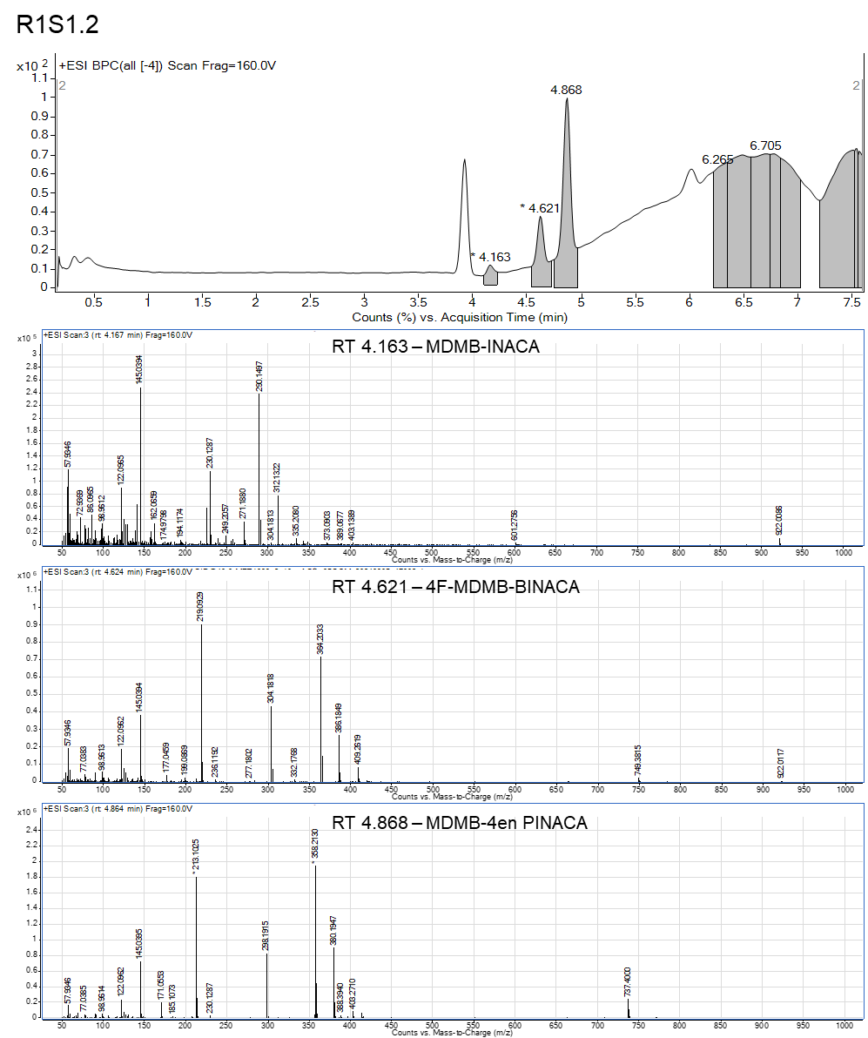

Figure S1. Example LC-MS chromatogram and spectra for sample R1S1.2 with MDMB-4en-PINACA, 4F-MDMB-BINACA and MDMB-INACA SCs identified. Molecular weights of compounds: MDMB-INACA – 289.330 g mol⁻¹, 4F-MDMB-BINACA – 363.433 g mol⁻¹, MDMB-4en-PINACA - 357.454 g mol⁻¹.

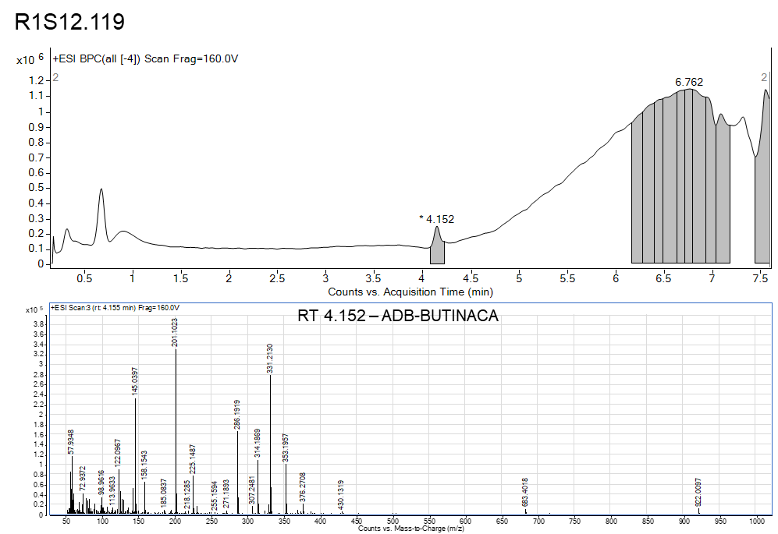

Figure S2. Example LC-MS chromatogram and spectra for sample R1S12.119 with ADB-BUTINACA identified. Molecular weight of ADB-BUTINACA is 330.432 g mol⁻¹.

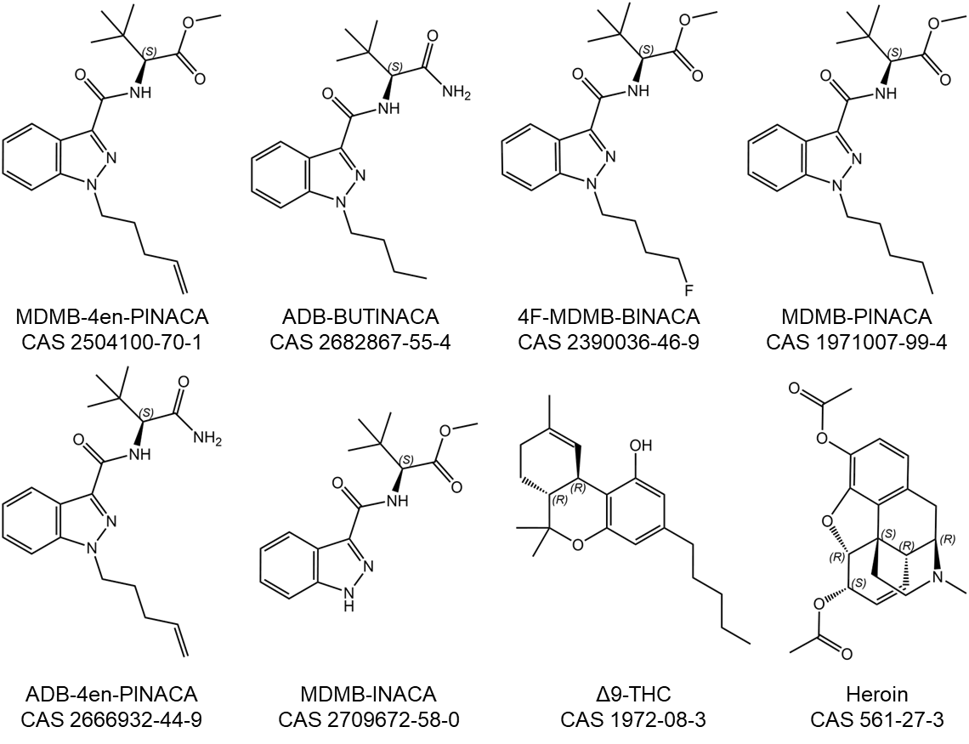

Figure S3. Structures of illicit drugs identified.

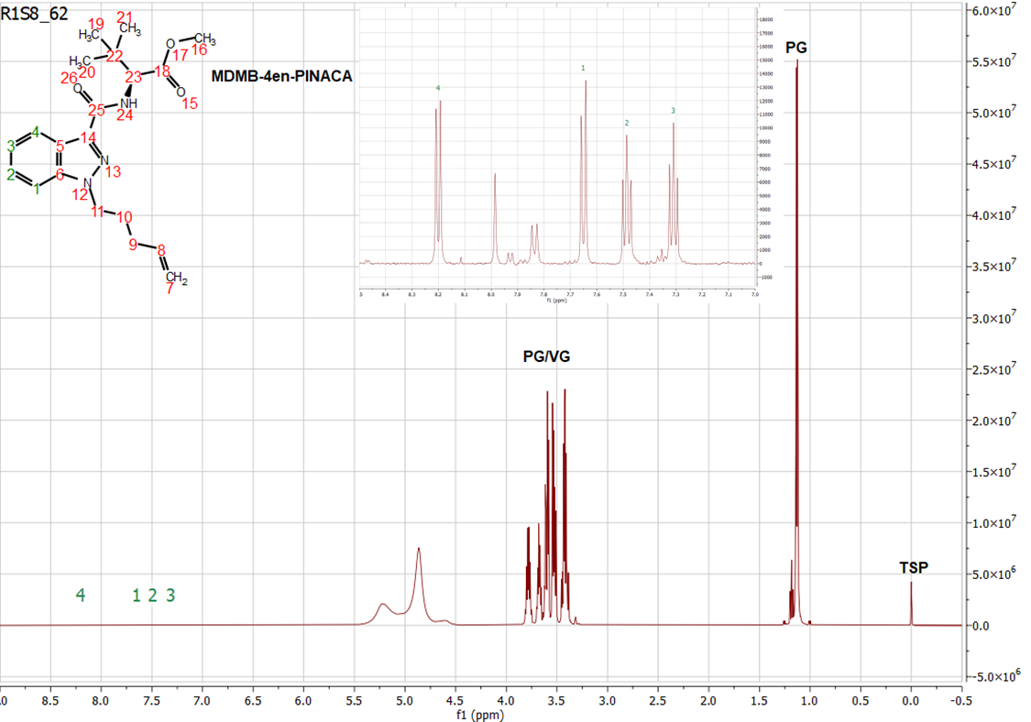

Figure S4. Example 1H NMR spectra used for qNMR on sample R1S8.62 containing MDMB-4en-PINACA. Main spectra shows the sample is dominated by propylene glycol (PG) and vegetable glycerin (VG) that form the basis of e-cigarette liquid. Insert is of the 8.5 – 7.0 ppm region which shows the aromatic indazole peaks for hydrogens 1-4 used for the quantification. The internal standard 3-(trimethylsilyl)propionic-2,2,3,3-d4 acid sodium salt (TSP) is shown at 0.0 ppm (3 mg added). The qNMR method used a 20 s delay, 128 scans and processing techniques (as described in materials and methods) such that ratio of the integration of the sample to TSP peaks can be used to calculate the concentration of the sample, 3.53 mg/mL in this case.

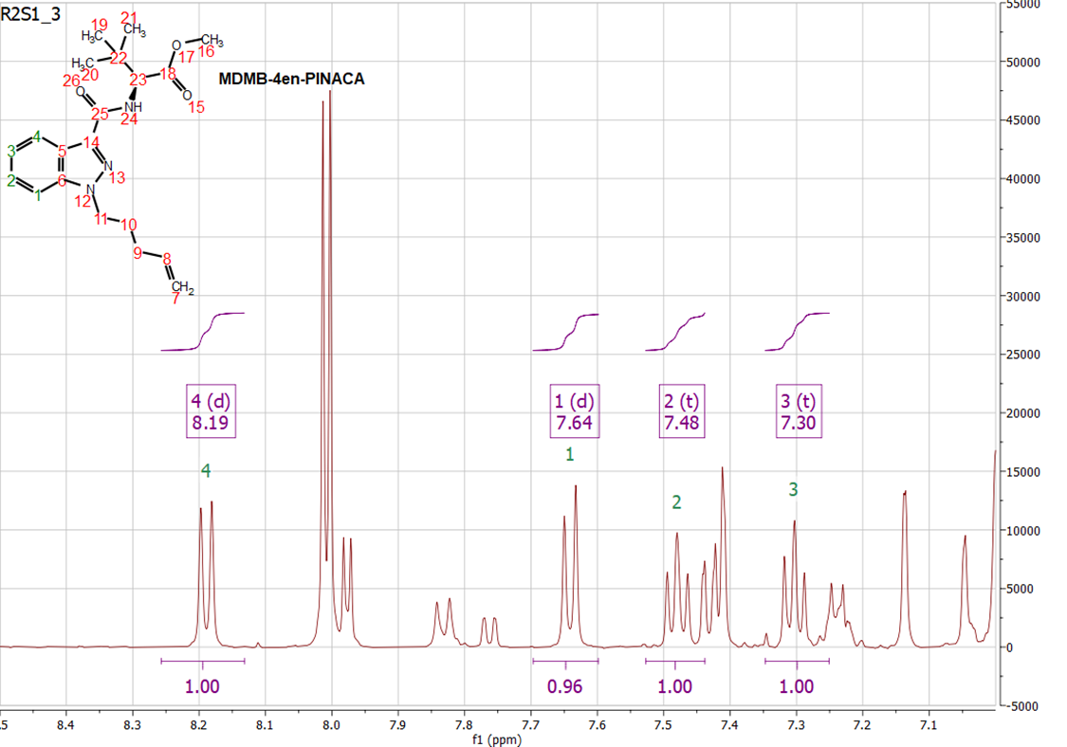

Figure S5. Example 1H NMR spectra used for qNMR on sample R2S1.3 containing MDMB-4en-PINACA. The aromatic indazole 8.5 – 7.0 ppm region is shown with the multiplets and integration of hydrogens 1-4 used for the quantification.

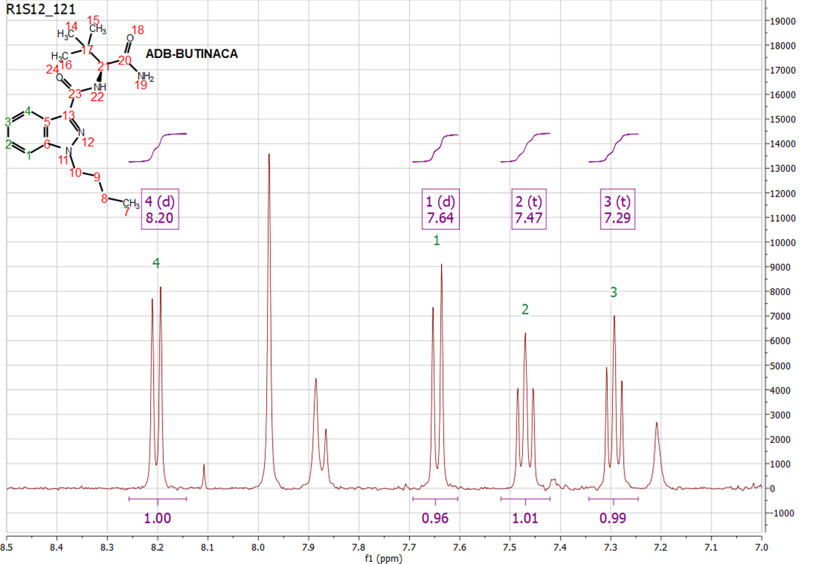

Figure S6. Example 1H NMR spectra used for qNMR on sample R1S12.121 containing ADB-BUTINACA. The aromatic indazole 8.5 – 7.0 ppm region is shown with the multiplets and integration of hydrogens 1-4 used for the quantification.

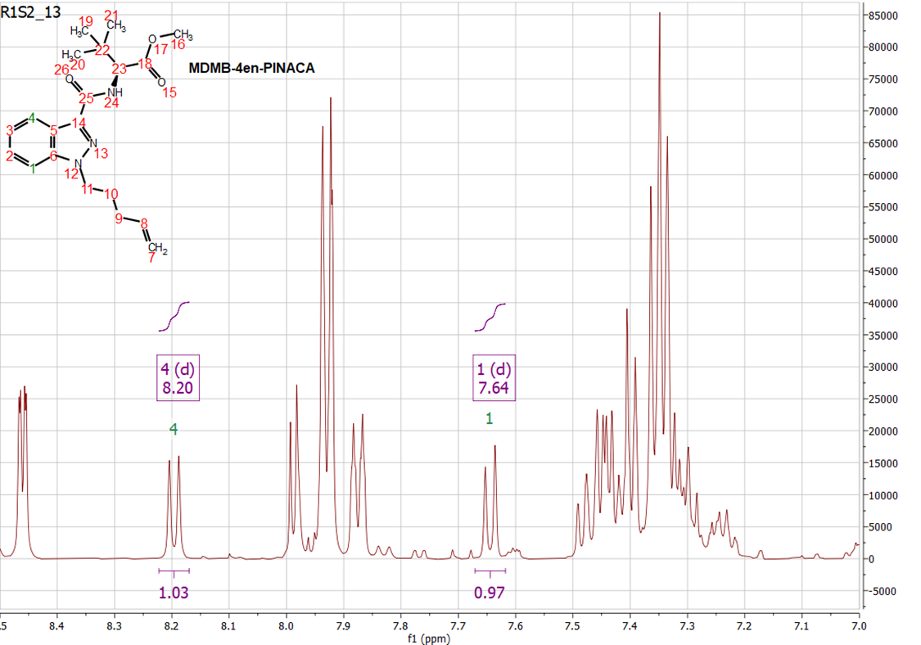

Figure S7. Example 1H NMR spectra used for qNMR on sample R1S2.13 containing MDMB-4en-PINACA. The aromatic indazole 8.5 – 7.0 ppm region is shown highlighting that only the multiplets and integration of hydrogens 1 and 4 are able to be used for quantification due to additives in the e-cigarette liquid masking the other hydrogens.

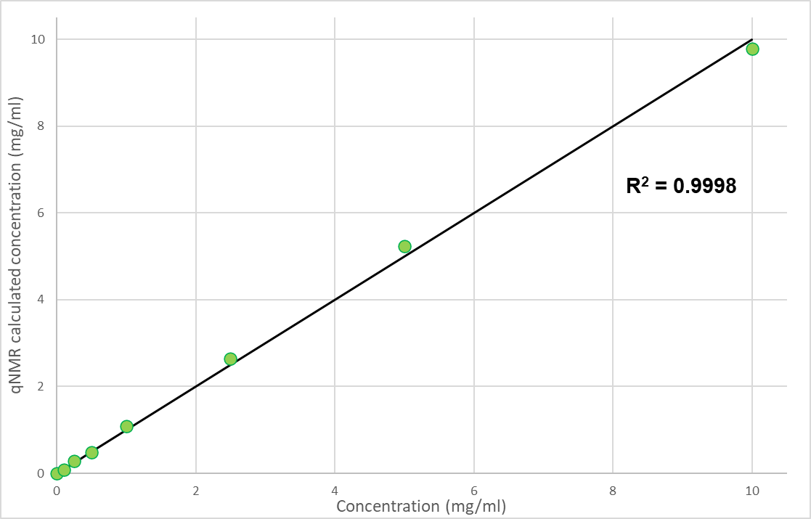

Figure S8. Plot showing the qNMR calculated values of a standard concentration range of MDMB-4en-PINACA in e-cigarette liquid. This shows good agreement with the true values (black line) highlighting the suitability of the qNMR technique for quantifying the e-cigarettes and liquids.

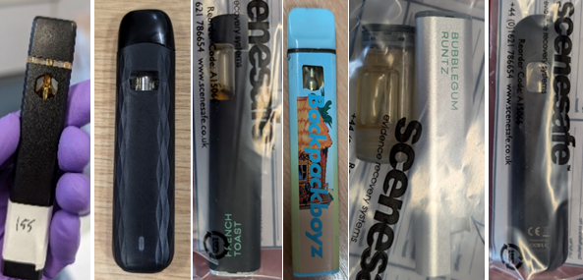
Figure S9. THC e-cigarettes from R3.

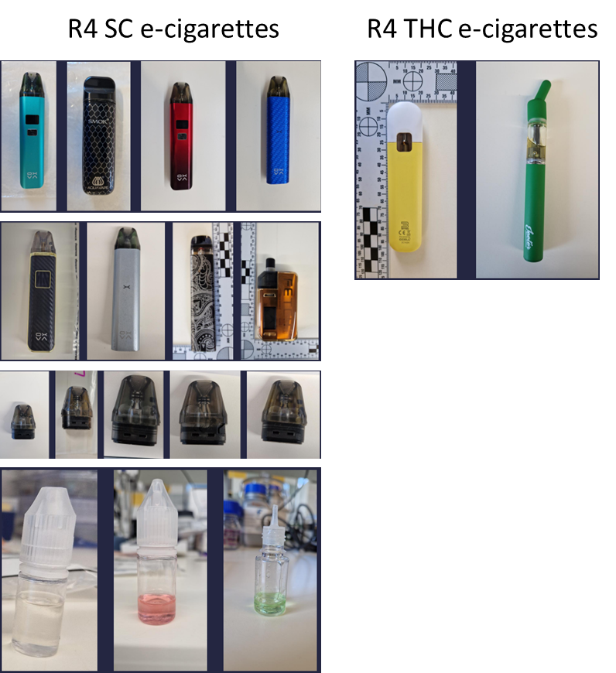
Figure S10. Positive samples (SC and THC) from R4.

