Supplementary Material
Oliver D, Englund A, Chesney E, Chester L, Wilson J, Sovi S, Wigroth S, Hodsoll J, Strang J, Murray R, Freeman T, Fusar-Poli P, McGuire P. Cannabidiol does not attenuate acute delta-9-tetrahydrocannabinol-induced attentional bias changes in healthy volunteers: A randomised, double-blind, crossover study

eTable 1 Weight of Bedrocan, Bedrolite and placebo cannabis in each CBD:THC ratio
eTable 2 Results of linear mixed models for attentional bias task
eFigure 1 Attentional bias stratified by durations of stimulus presentation
eTable 3 Results of linear mixed models for durations of stimulus presentation on attentional bias
eFigure 2 Attentional bias stratified by congruency of stimulus presentation
eTable 4 Results of linear mixed models for congruency of stimulus presentation on attentional bias
eFigure 3 Sensitivity analysis: attentional bias with re-included excluded trials due to reaction time and incorrect responses
eTable 5 Sensitivity analysis: attentional bias with re-included excluded trials due to reaction time and incorrect responses
eFigure 4 Cumulative THC effect on attentional bias
eTable 6 Results of linear mixed models for cumulative THC effect on attentional bias
eTable 7 Results of linear mixed models for picture rating task
eFigure 5 Cumulative THC effect on picture rating
eTable 8 Results of linear mixed models for cumulative THC effect on picture rating
eFigure 6 Correlations between plasma cannabinoids and attentional bias
eFigure 7 Correlations between plasma cannabinoids and picture rating
eFigure 8 Study CONSORT flow diagram

eTable 1 Weight of Bedrocan, Bedrolite and placebo cannabis in each CBD:THC ratio
CBD:THC ratio | 0:1 | 1:1 | 2:1 | 3:1
THC dose (mg) | 10 | 10 | 10 | 10
CBD dose (mg) | 0 | 10 | 20 | 30
Bedrocan cannabis (mg) | 44.2 | 42.5 | 40.7 | 38.9
Bedrolite cannabis (mg) | 0.0 | 132.8 | 266.1 | 399.5
Placebo cannabis (mg) | 394.2 | 263.1 | 131.6 | 0.0

eTable 2 Results of linear mixed models for attentional bias task
Contrast | Estimated marginal mean difference | Lower 95% CI | Upper 95% CI | p-value
 | Cannabis
0:1 - 1:1 | 1.657 | -10.777 | 14.092 | 0.993
0:1 - 2:1 | -1.991 | -14.344 | 10.363 | 0.988
0:1 - 3:1 | 2.327 | -10.192 | 14.846 | 0.982
1:1 - 2:1 | -3.648 | -16.083 | 8.787 | 0.935
1:1 - 3:1 | 0.670 | -11.931 | 13.271 | 1.000
2:1 - 3:1 | 4.318 | -8.202 | 16.837 | 0.899
 | Food
0:1 - 1:1 | -1.203 | -14.547 | 12.141 | 0.998
0:1 - 2:1 | -1.079 | -14.340 | 12.181 | 0.998
0:1 - 3:1 | 1.247 | -12.183 | 14.677 | 0.998
1:1 - 2:1 | 0.123 | -13.221 | 13.467 | 1.000
1:1 - 3:1 | 2.450 | -11.063 | 15.963 | 0.983
2:1 - 3:1 | 2.327 | -11.104 | 15.757 | 0.985

eFigure 1 Attentional bias stratified by durations of stimulus presentation
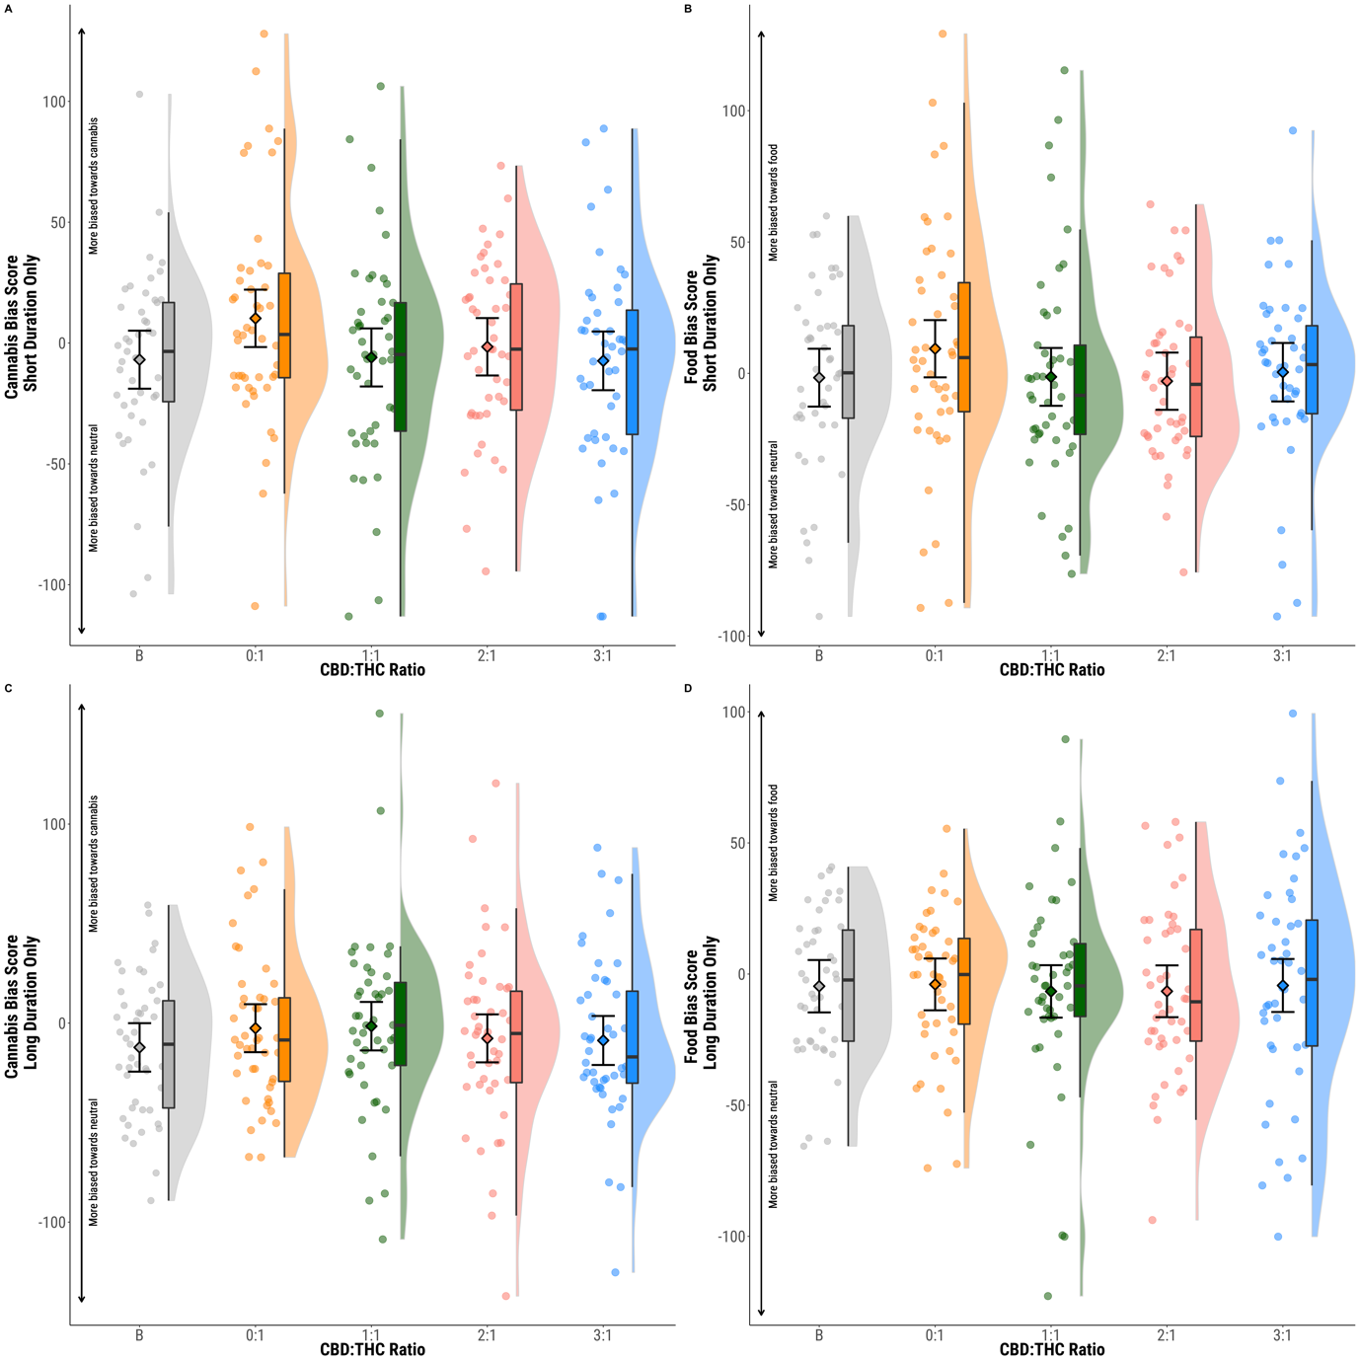
eTable 3 Results of linear mixed models for durations of stimulus presentation on attentional bias
Contrast | Estimated marginal mean difference | Lower 95% CI | Upper 95% CI | p-value
 | Cannabis Short
0:1 - 1:1 | 14.541 | -1.804 | 30.886 | 0.282
0:1 - 2:1 | 10.170 | -6.077 | 26.417 | 0.590
0:1 - 3:1 | 11.297 | -5.150 | 27.744 | 0.512
1:1 - 2:1 | -4.371 | -20.716 | 11.974 | 0.949
1:1 - 3:1 | -3.244 | -19.788 | 13.301 | 0.979
2:1 - 3:1 | 1.128 | -15.319 | 17.575 | 0.999
 | Cannabis Long
0:1 - 1:1 | 0.213 | -16.220 | 16.645 | 1.000
0:1 - 2:1 | 5.113 | -11.214 | 21.440 | 0.922
0:1 - 3:1 | 6.237 | -10.305 | 22.779 | 0.872
1:1 - 2:1 | 4.900 | -11.532 | 21.333 | 0.932
1:1 - 3:1 | 6.024 | -10.623 | 22.671 | 0.885
2:1 - 3:1 | 1.124 | -15.418 | 17.666 | 0.999
 | Food Short
0:1 - 1:1 | 8.876 | -6.187 | 23.938 | 0.636
0:1 - 2:1 | 12.362 | -2.605 | 27.329 | 0.347
0:1 - 3:1 | 2.043 | -13.120 | 17.205 | 0.993
1:1 - 2:1 | 3.486 | -11.577 | 18.549 | 0.966
1:1 - 3:1 | -6.833 | -22.091 | 8.425 | 0.804
2:1 - 3:1 | -10.319 | -25.481 | 4.843 | 0.520
 | Food Long
0:1 - 1:1 | -0.805 | -15.293 | 13.683 | 0.999
0:1 - 2:1 | 2.623 | -11.780 | 17.026 | 0.983
0:1 - 3:1 | 0.414 | -14.162 | 14.989 | 1.000
1:1 - 2:1 | 3.428 | -11.060 | 17.916 | 0.964
1:1 - 3:1 | 1.219 | -13.441 | 15.878 | 0.998
2:1 - 3:1 | -2.209 | -16.785 | 12.366 | 0.990

eFigure 2 Attentional bias stratified by congruency of stimulus presentation
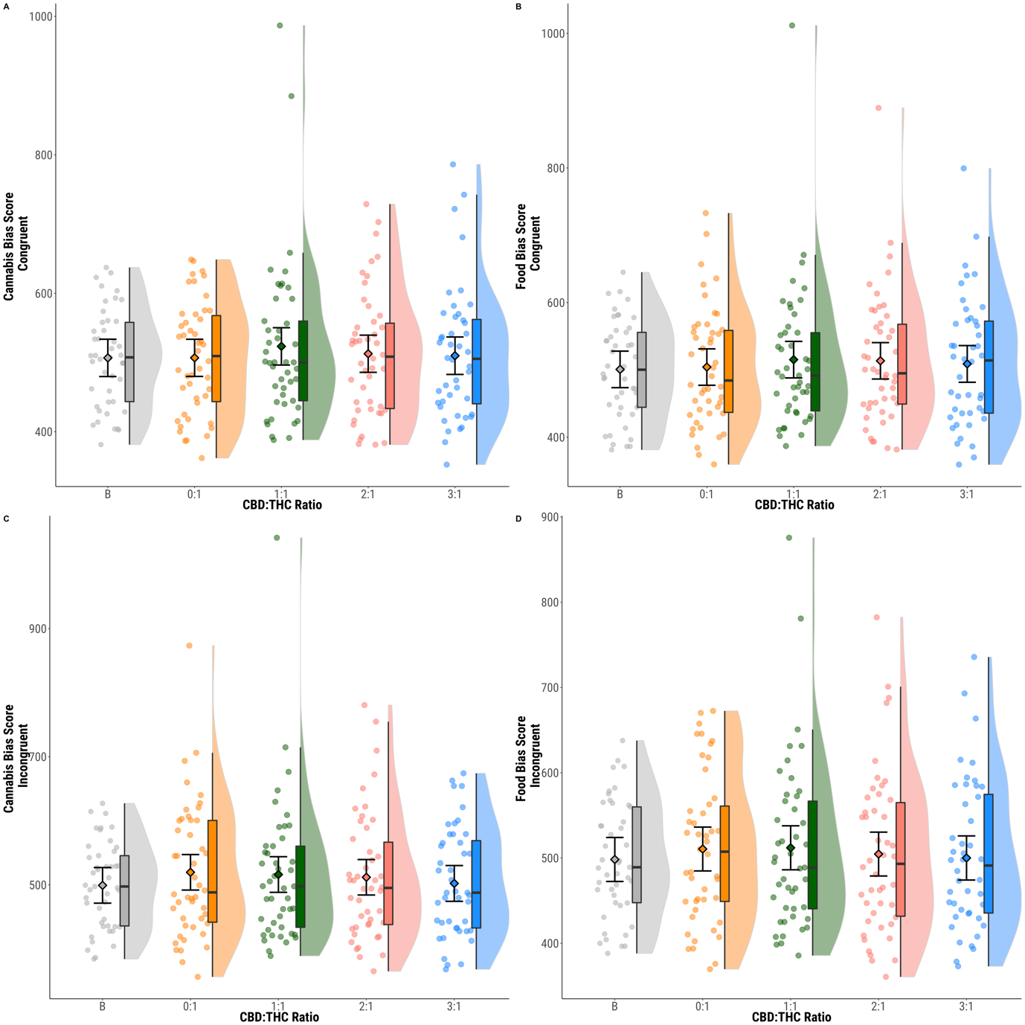
eTable 4 Results of linear mixed models for congruency of stimulus presentation on attentional bias
Contrast | Estimated marginal mean difference | Lower 95% CI | Upper 95% CI | p-value
 | Cannabis Congruent
0:1 - 1:1 | -16.826 | -36.154 | 2.501 | 0.301
0:1 - 2:1 | -5.909 | -25.097 | 13.280 | 0.925
0:1 - 3:1 | -2.411 | -21.883 | 17.061 | 0.995
1:1 - 2:1 | 10.918 | -8.410 | 30.246 | 0.667
1:1 - 3:1 | 14.415 | -5.197 | 34.028 | 0.452
2:1 - 3:1 | 3.497 | -15.974 | 22.969 | 0.984
 | Cannabis Incongruent
0:1 - 1:1 | 3.499 | -17.921 | 24.920 | 0.988
0:1 - 2:1 | 7.769 | -13.498 | 29.036 | 0.883
0:1 - 3:1 | 18.127 | -3.452 | 39.707 | 0.332
1:1 - 2:1 | 4.269 | -17.151 | 25.690 | 0.978
1:1 - 3:1 | 14.628 | -7.107 | 36.363 | 0.529
2:1 - 3:1 | 10.358 | -11.221 | 31.938 | 0.769
 | Food Congruent
0:1 - 1:1 | -11.185 | -30.850 | 8.481 | 0.662
0:1 - 2:1 | -9.290 | -28.814 | 10.235 | 0.773
0:1 - 3:1 | -4.068 | -23.880 | 15.744 | 0.976
1:1 - 2:1 | 1.895 | -17.771 | 21.560 | 0.997
1:1 - 3:1 | 7.117 | -12.838 | 27.072 | 0.890
2:1 - 3:1 | 5.222 | -14.590 | 25.034 | 0.951
 | Food Incongruent
0:1 - 1:1 | -1.296 | -17.522 | 14.930 | 0.999
0:1 - 2:1 | 5.919 | -10.189 | 22.028 | 0.881
0:1 - 3:1 | 11.025 | -5.322 | 27.373 | 0.528
1:1 - 2:1 | 7.215 | -9.011 | 23.441 | 0.807
1:1 - 3:1 | 12.321 | -4.146 | 28.787 | 0.436
2:1 - 3:1 | 5.106 | -11.242 | 21.453 | 0.923

eFigure 3 Sensitivity analysis: attentional bias with re-included excluded trials due to reaction time and incorrect responses
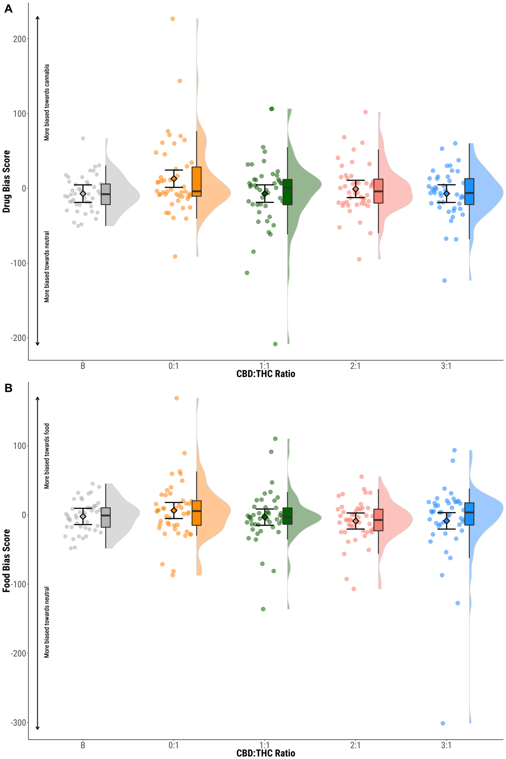
eTable 5 Sensitivity analysis: attentional bias with re-included excluded trials due to reaction time and incorrect responses
Contrast | Estimated marginal mean difference | Lower 95% CI | Upper 95% CI | p-value
 | Cannabis
0:1 - 1:1 | 19.937 | 1.931 | 37.943 | 0.120
0:1 - 2:1 | 13.677 | -4.225 | 31.580 | 0.417
0:1 - 3:1 | 19.972 | 1.859 | 38.085 | 0.123
1:1 - 2:1 | -6.260 | -24.266 | 11.746 | 0.897
1:1 - 3:1 | 0.035 | -18.181 | 18.250 | 1.000
2:1 - 3:1 | 6.294 | -11.819 | 24.407 | 0.897
 | Food
0:1 - 1:1 | 9.641 | -7.874 | 27.155 | 0.685
0:1 - 2:1 | 15.209 | -2.201 | 32.619 | 0.298
0:1 - 3:1 | 14.941 | -2.683 | 32.565 | 0.324
1:1 - 2:1 | 5.569 | -11.946 | 23.084 | 0.919
1:1 - 3:1 | 5.301 | -12.428 | 23.029 | 0.931
2:1 - 3:1 | -0.268 | -17.892 | 17.356 | 1.000

eFigure 4 Cumulative THC effect on attentional bias
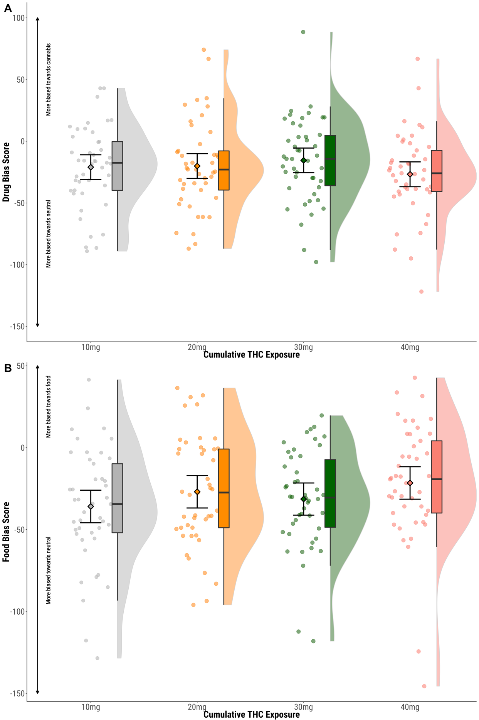
eTable 6 Results of linear mixed models for cumulative THC effect on attentional bias
Contrast | Estimated marginal mean difference | Lower 95% CI | Upper 95% CI | p-value
 | Cannabis
10mg-20mg | -0.406 | -12.808 | 11.995 | 1.000
10mg – 30mg | -5.680 | -18.000 | 6.641 | 0.790
10mg – 40mg | 5.067 | -7.334 | 17.468 | 0.844
20mg – 30mg | -5.273 | -17.594 | 7.047 | 0.824
20mg – 40mg | 5.473 | -6.928 | 17.874 | 0.811
30mg – 40mg | 10.746 | -1.574 | 23.067 | 0.299
 | Food
10mg-20mg | -8.994 | -22.178 | 4.190 | 0.518
10mg – 30mg | -4.521 | -17.624 | 8.581 | 0.899
10mg – 40mg | -14.354 | -27.538 | -1.170 | 0.131
20mg – 30mg | 4.472 | -8.630 | 17.575 | 0.902
20mg – 40mg | -5.361 | -18.545 | 7.824 | 0.845
30mg – 40mg | -9.833 | -22.935 | 3.269 | 0.434

eTable 7 Results of linear mixed models for picture rating task
Contrast | Estimated marginal mean difference | Lower 95% CI | Upper 95% CI | p-value
 | Cannabis
0:1 - 1:1 | 0.330 | 0.041 | 0.620 | 0.104
0:1 - 2:1 | 0.197 | -0.093 | 0.486 | 0.521
0:1 - 3:1 | 0.137 | -0.153 | 0.426 | 0.778
1:1 - 2:1 | -0.133 | -0.423 | 0.156 | 0.790
1:1 - 3:1 | -0.194 | -0.483 | 0.096 | 0.535
2:1 - 3:1 | -0.060 | -0.350 | 0.229 | 0.975
 | Food
0:1 - 1:1 | 0.214 | -0.134 | 0.562 | 0.604
0:1 - 2:1 | 0.126 | -0.221 | 0.474 | 0.884
0:1 - 3:1 | -0.032 | -0.380 | 0.315 | 0.998
1:1 - 2:1 | -0.087 | -0.435 | 0.260 | 0.958
1:1 - 3:1 | -0.246 | -0.594 | 0.102 | 0.486
2:1 - 3:1 | -0.159 | -0.506 | 0.189 | 0.795

eFigure 5 Cumulative THC effect on picture rating
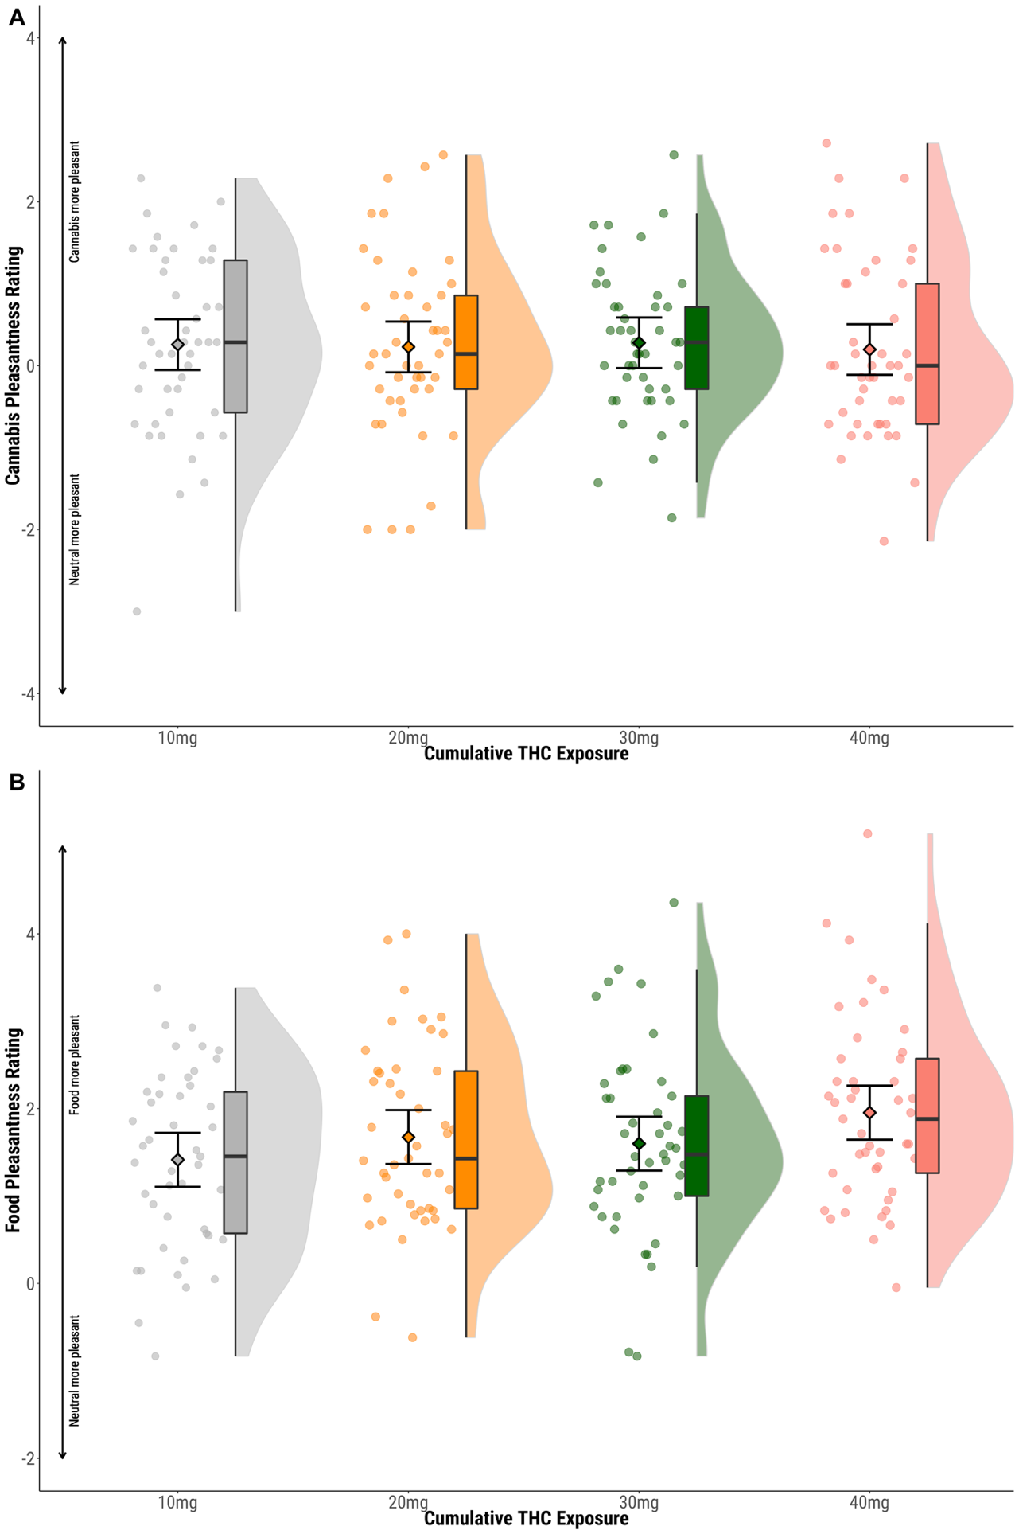
eTable 8 Results of linear mixed models for cumulative THC effect on picture rating
Contrast | Estimated marginal mean difference | Lower 95% CI | Upper 95% CI | p-value
 | Cannabis
10mg-20mg | 0.029 | -0.266 | 0.324 | 0.997
10mg – 30mg | -0.022 | -0.317 | 0.273 | 0.999
10mg – 40mg | 0.060 | -0.235 | 0.355 | 0.976
20mg – 30mg | -0.051 | -0.346 | 0.244 | 0.986
20mg – 40mg | 0.032 | -0.263 | 0.327 | 0.996
30mg – 40mg | 0.083 | -0.212 | 0.378 | 0.943
 | Food
10mg-20mg | -0.260 | -0.598 | 0.077 | 0.410
10mg – 30mg | -0.186 | -0.523 | 0.152 | 0.686
10mg – 40mg | -0.539 | -0.877 | -0.201 | 0.009
20mg – 30mg | 0.075 | -0.263 | 0.412 | 0.971
20mg – 40mg | -0.279 | -0.617 | 0.059 | 0.348
30mg – 40mg | -0.353 | -0.691 | -0.016 | 0.156

eFigure 6 Correlations between plasma cannabinoids and attentional bias
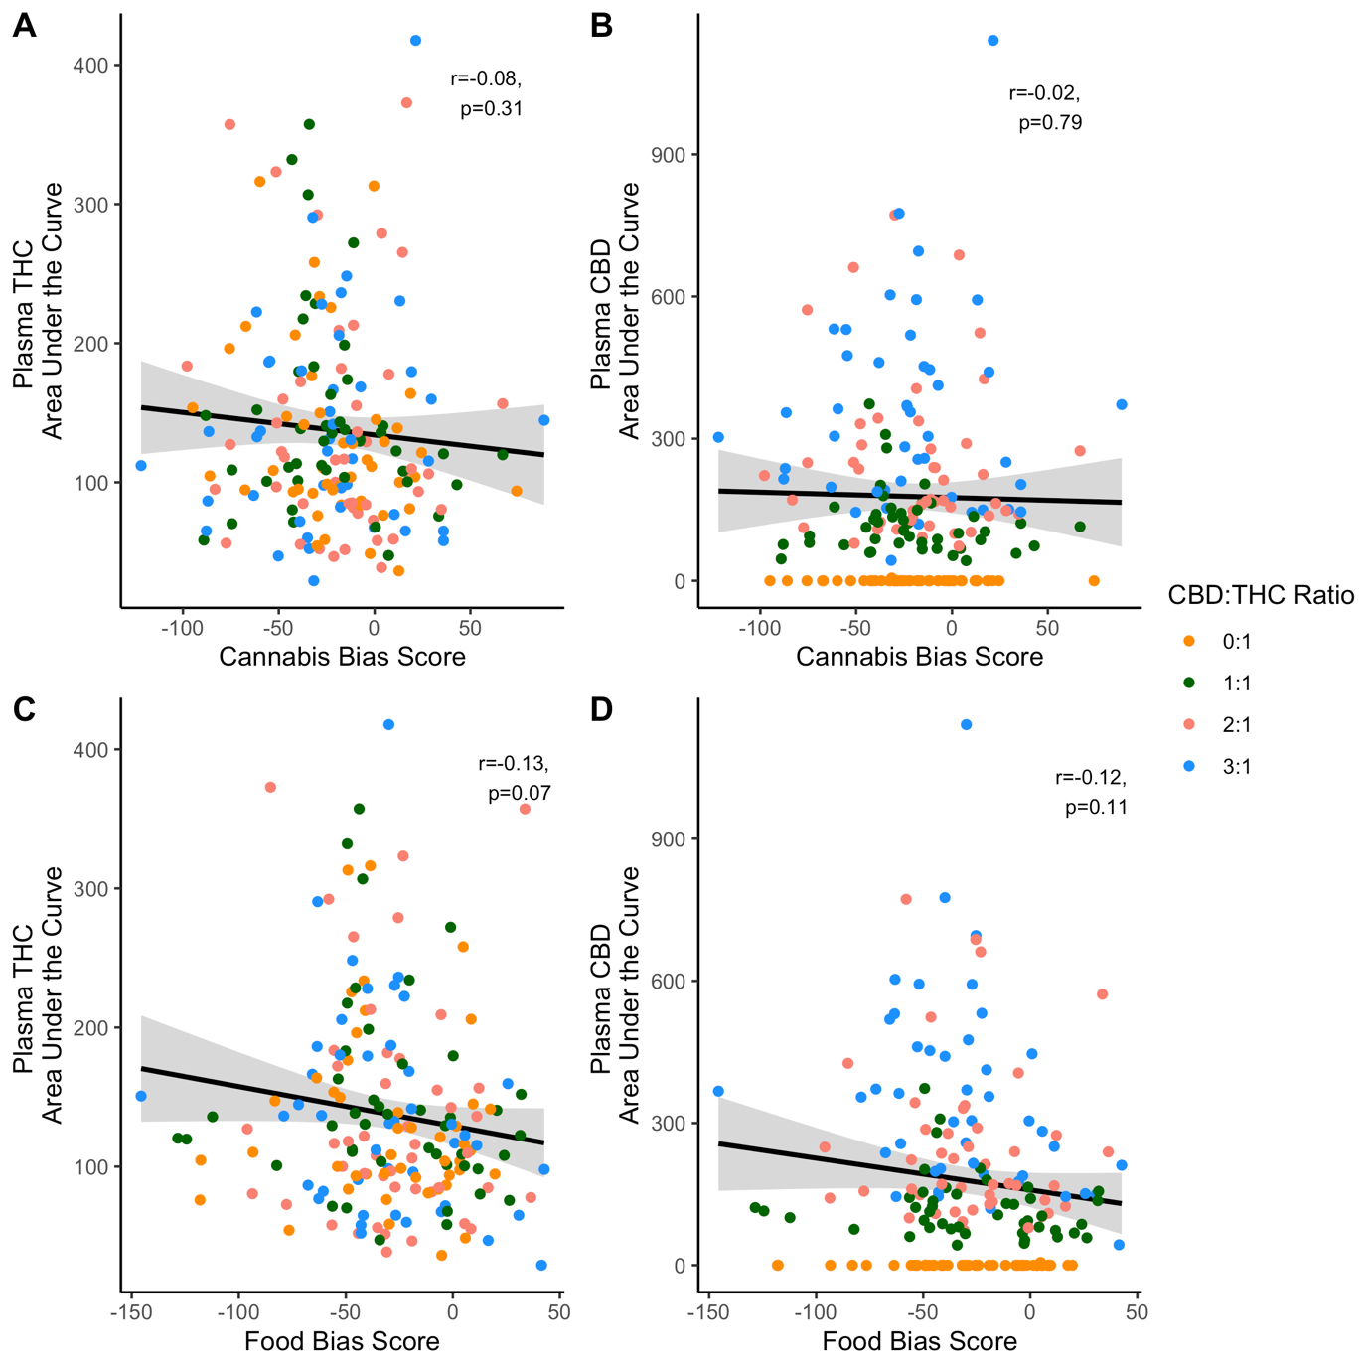
eFigure 7 Correlations between plasma cannabinoids and picture rating

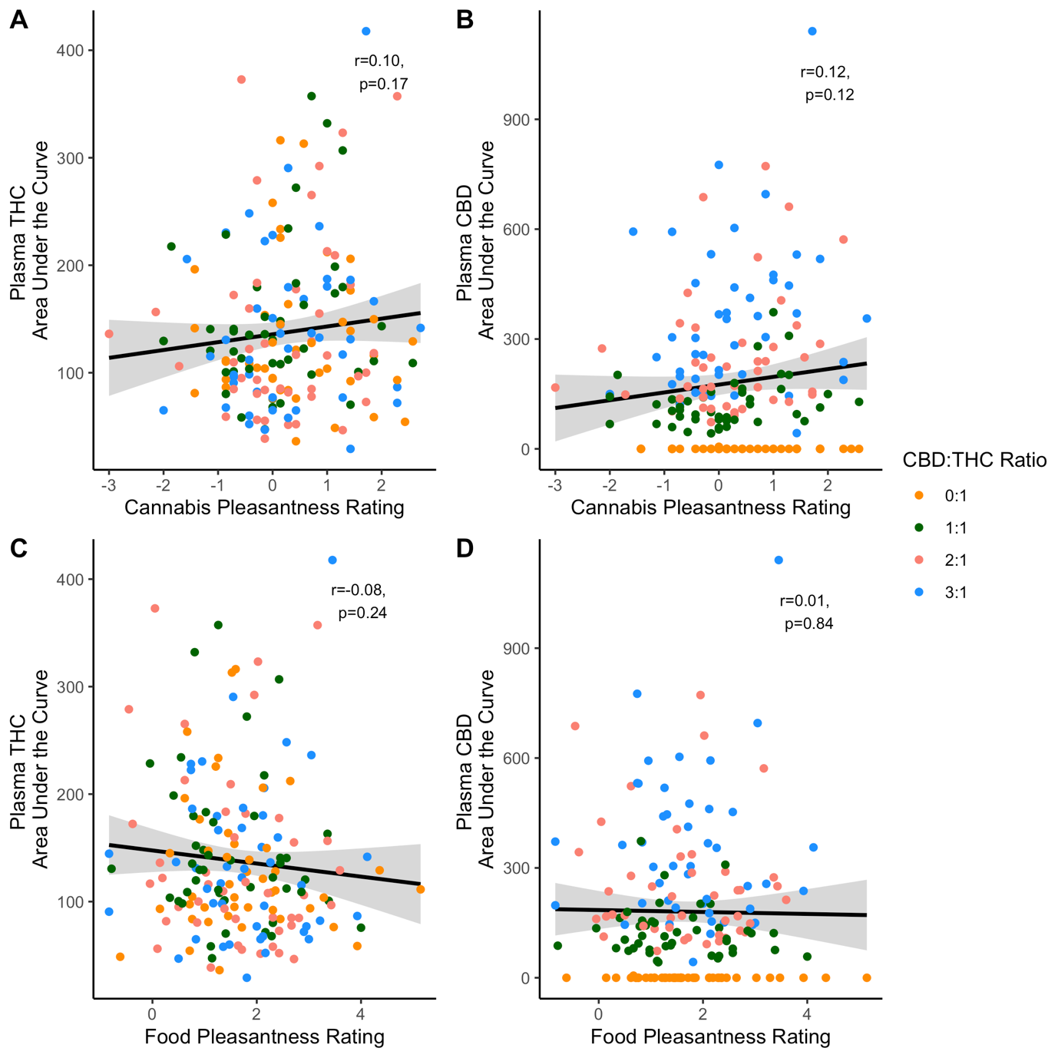

eFigure 8 Study CONSORT flow diagram
