Electronic Supplementary Material

Efficient controlled release of cannabinoids loaded in γ-CD-MOFs and DPPC Liposomes as novel delivery systems in oral health
Jorge Rodríguez-Martínez^{1(¥)}, María-Jesús Sánchez-Martín*^{1(¥)}, Manuel Valiente¹

¹ GTS Research Group, Department of Chemistry, Faculty of Science, Universitat Autònoma de Barcelona, 08193 Bellaterra, Spain.
^{(¥)} Shared co-first authorship
*Co-first author and author for correspondence: mariajesus.sanchez@uab.cat (ORCiD: 0000-0003-1678-6055)

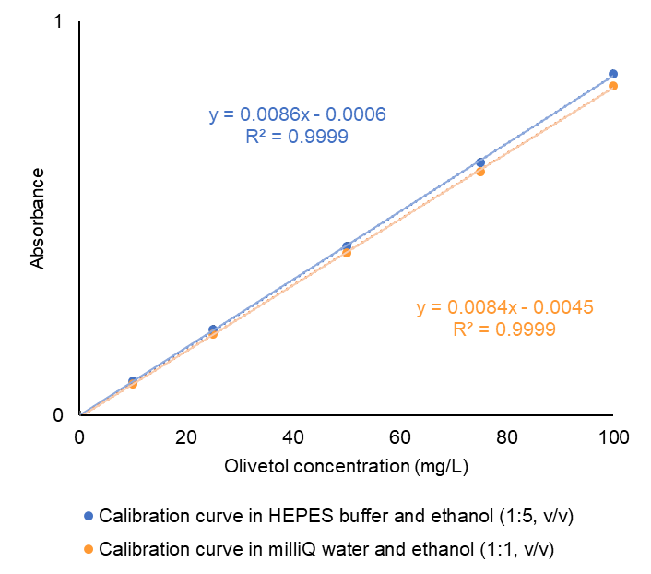
Figure S.1: Calibration curves of different known concentrations of olivetol from 0 to 100 mg/L in HEPES buffer and ethanol (1:5, v/v) (blue) and milliQ water and ethanol (1:1, v/v) (orange) media for the quantification of the drug in DPPC liposomes and MOFs, respectively.

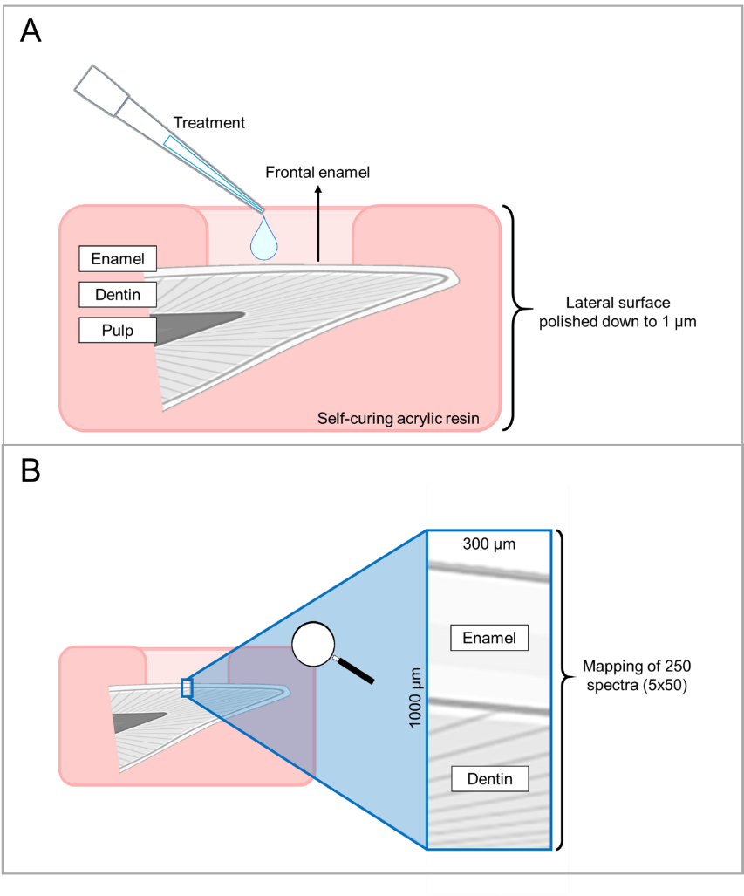
Figure S.2: Sample preparation and treatment application over the teeth diagram (A) and synchrotron source infrared spectroscopy measurements procedure (B).
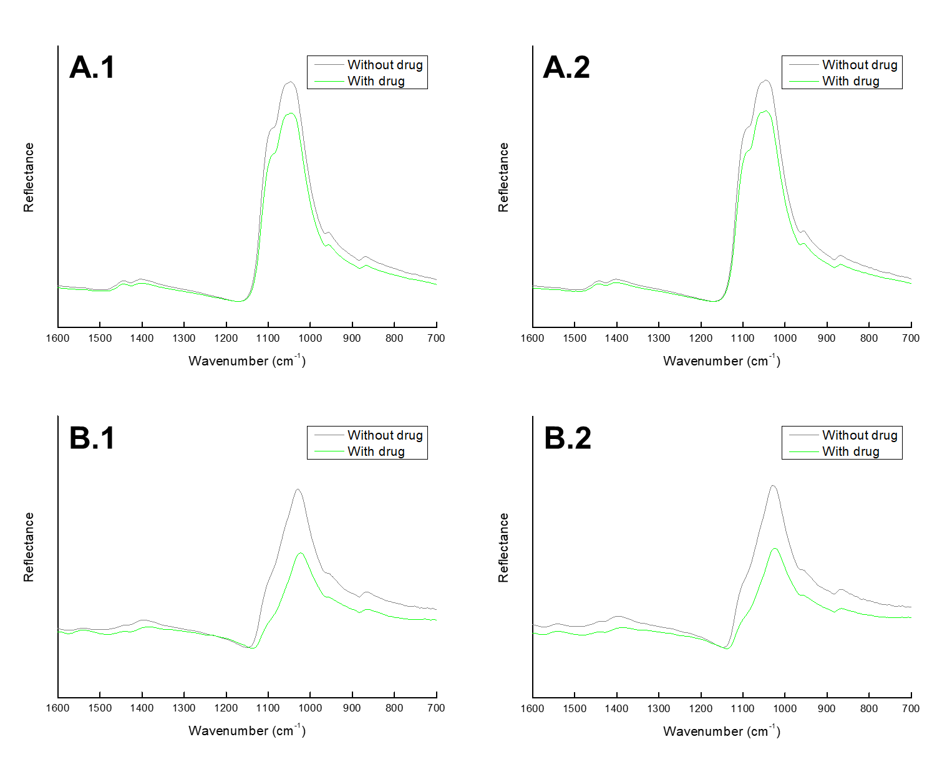
Figure S.3: Average of the spectra of the groups with and without drug for liposomes (1) and MOFs (2) in the enamel (A) and the dentin (B).

