Additional file 4 (Figure 4)
Dynamics of changes in the content of metabolites in rat urine: g - inosine; h - hypoxanthine; i - adenine; j - 3-hydroxymethylbutyrate (3-HMB); k - 2-hydroxymethylbutyrate (2-HMB). The vertical bars at each point on the graph denote the interquartile range.
g
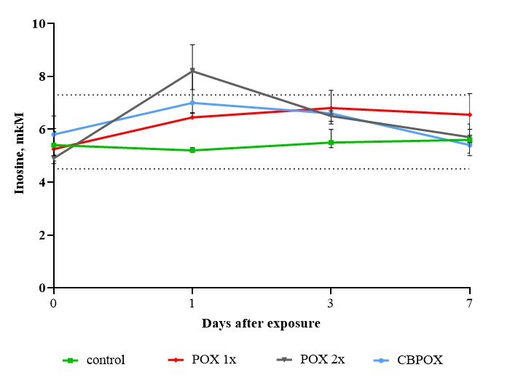
h
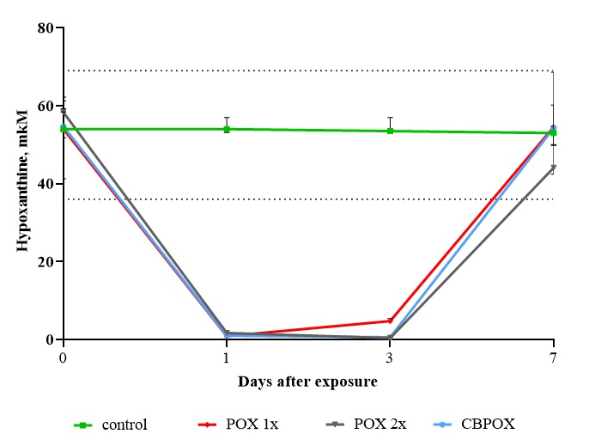

i
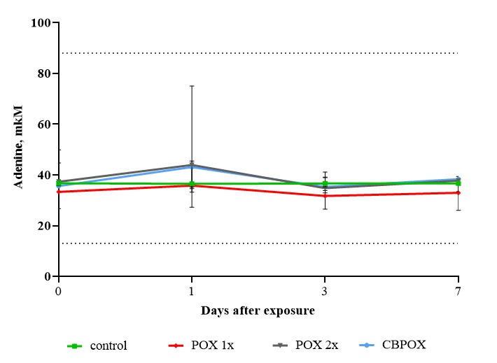
j
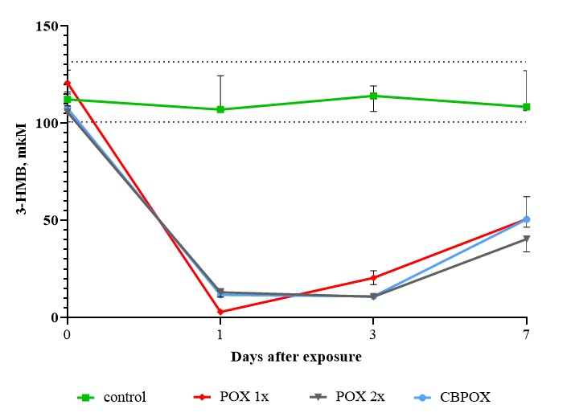

k
