Additional file 3 (Figure 3)
Dynamics of metabolite content changes in rat urine: a - 3-methylhistidine; b - threonine; c - creatine; d - creatinine; e - lactic acid; f - acetyl-carnitine. The vertical bars at each point on the graph denote the interquartile range.
a
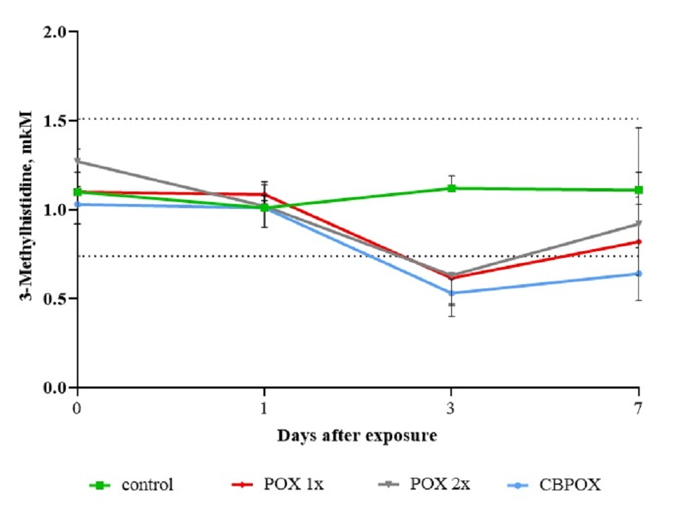
b
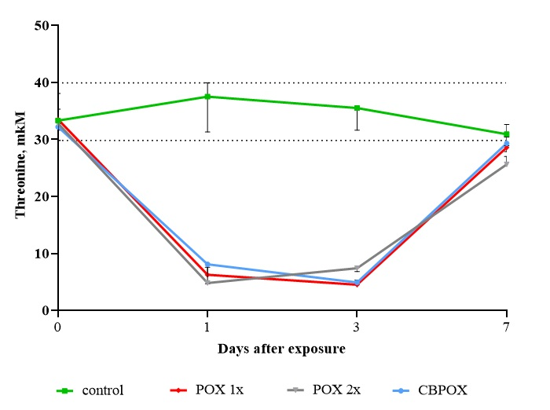

c
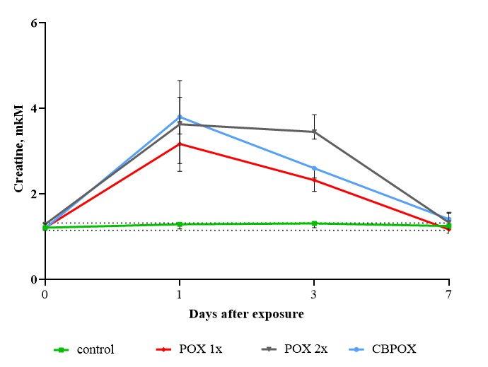
d
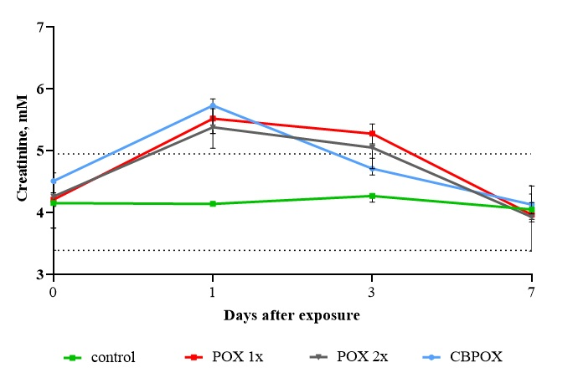

e
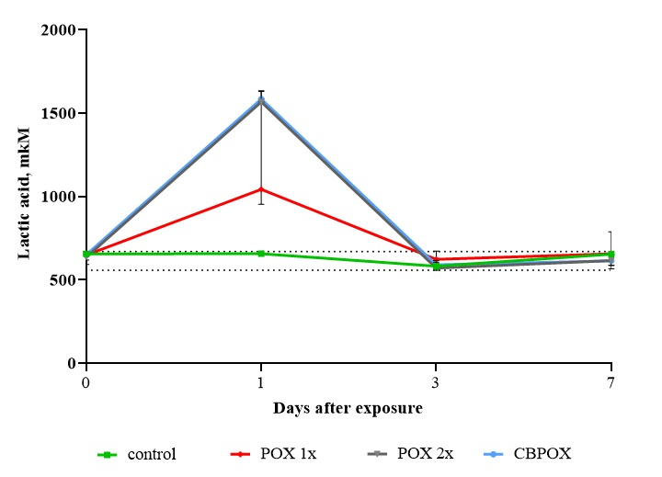
f
