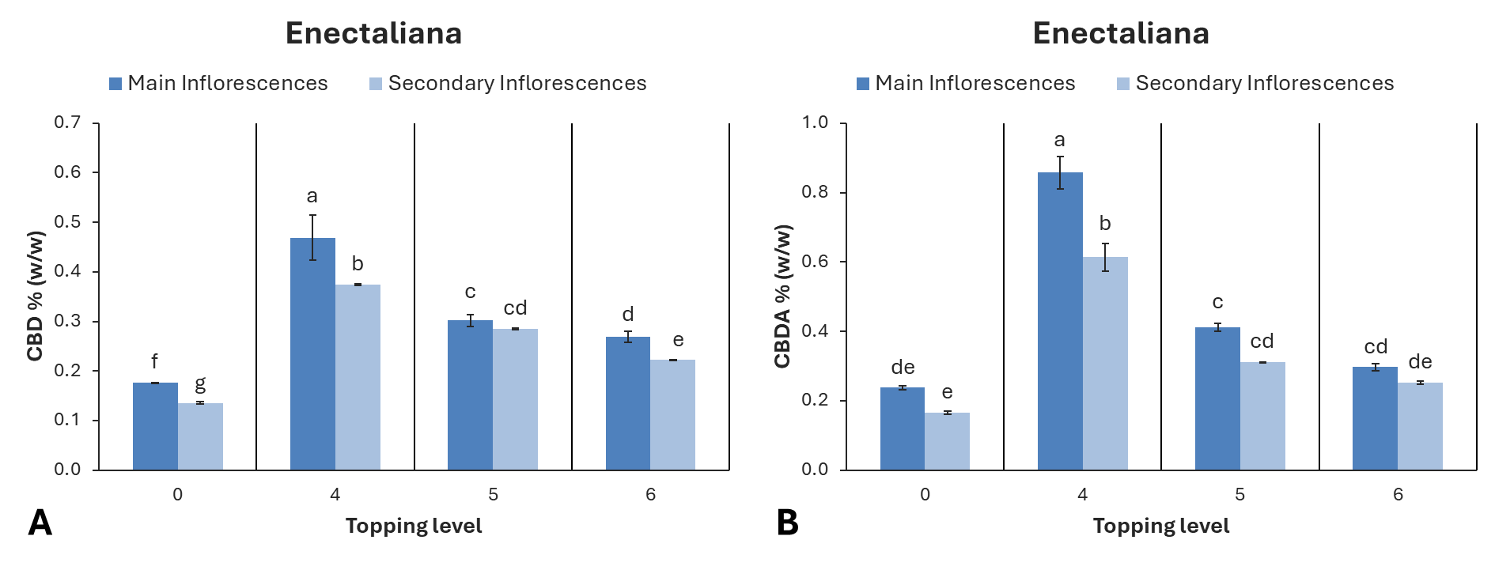
Figure 8. Cannabinoid content of hemp cultivar ‘Enectaliana’ under different topping levels.
(A) Cannabidiol (CBD) and (B) cannabidiolic acid (CBDA) content (% w/w) in main and secondary inflorescences as affected by topping level (0 = control; 4 = topping above the 4th node; 5 = topping above the 5th node; 6 = topping above the 6th node). Data represent mean ± standard error. Different letters above bars indicate significant differences among treatments according to Tukey’s HSD test (p ≤ 0.05).

