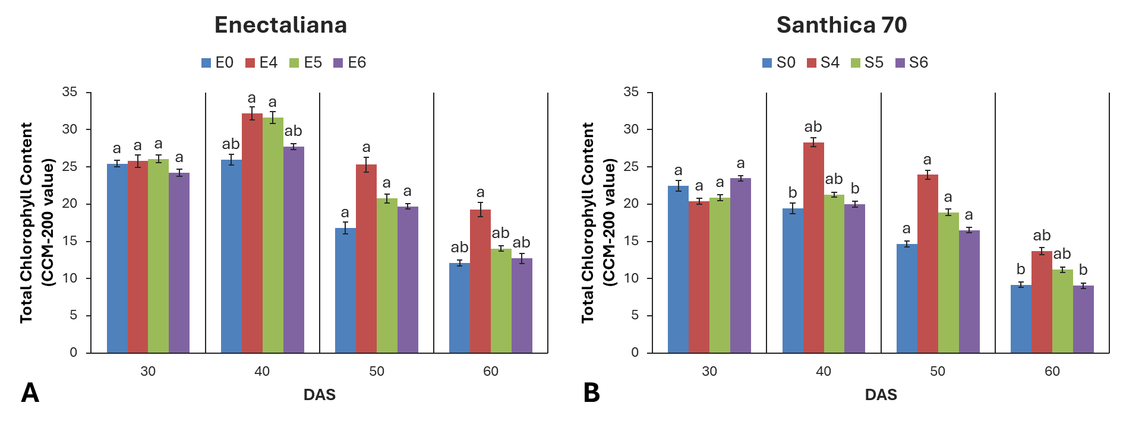
Figure 4. Total chlorophyll content of hemp cultivars under different topping levels.
Total chlorophyll content of Cannabis sativa L. cultivars (A) ‘Enectaliana’ and (B) ‘Santhica 70’ as affected by topping level (E0/S0 = control; E4/S4 = topping above the 4th node; E5/S5 = topping above the 5th node; E6/S6 = topping above the 6th node) at four growth stages (30, 40, 50, and 60 days after sowing, DAS). Data represent mean ± standard error. Different letters above bars indicate significant differences among all treatments (cultivars and topping levels combined) within each sampling date according to Tukey’s HSD test (p ≤ 0.05). The day corresponding to 30 days after sowing (30 DAS) represents the first day after the topping treatment.

