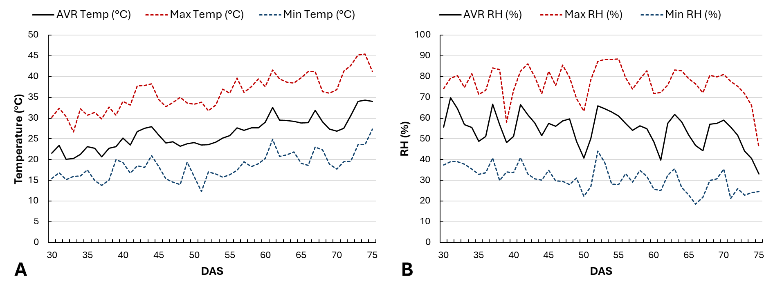
Figure 1. Daily variation of greenhouse temperature and relative humidity.
Daily variation of (A) temperature (°C) and (B) relative humidity (RH, %) recorded inside the greenhouse during the experimental period. The day corresponding to 30 days after sowing (30 DAS) represents the first day after the topping treatment. Data represent daily averages measured with a HOBO MX2301A Temperature/RH Data Logger (Onset Computer Corporation, USA).

