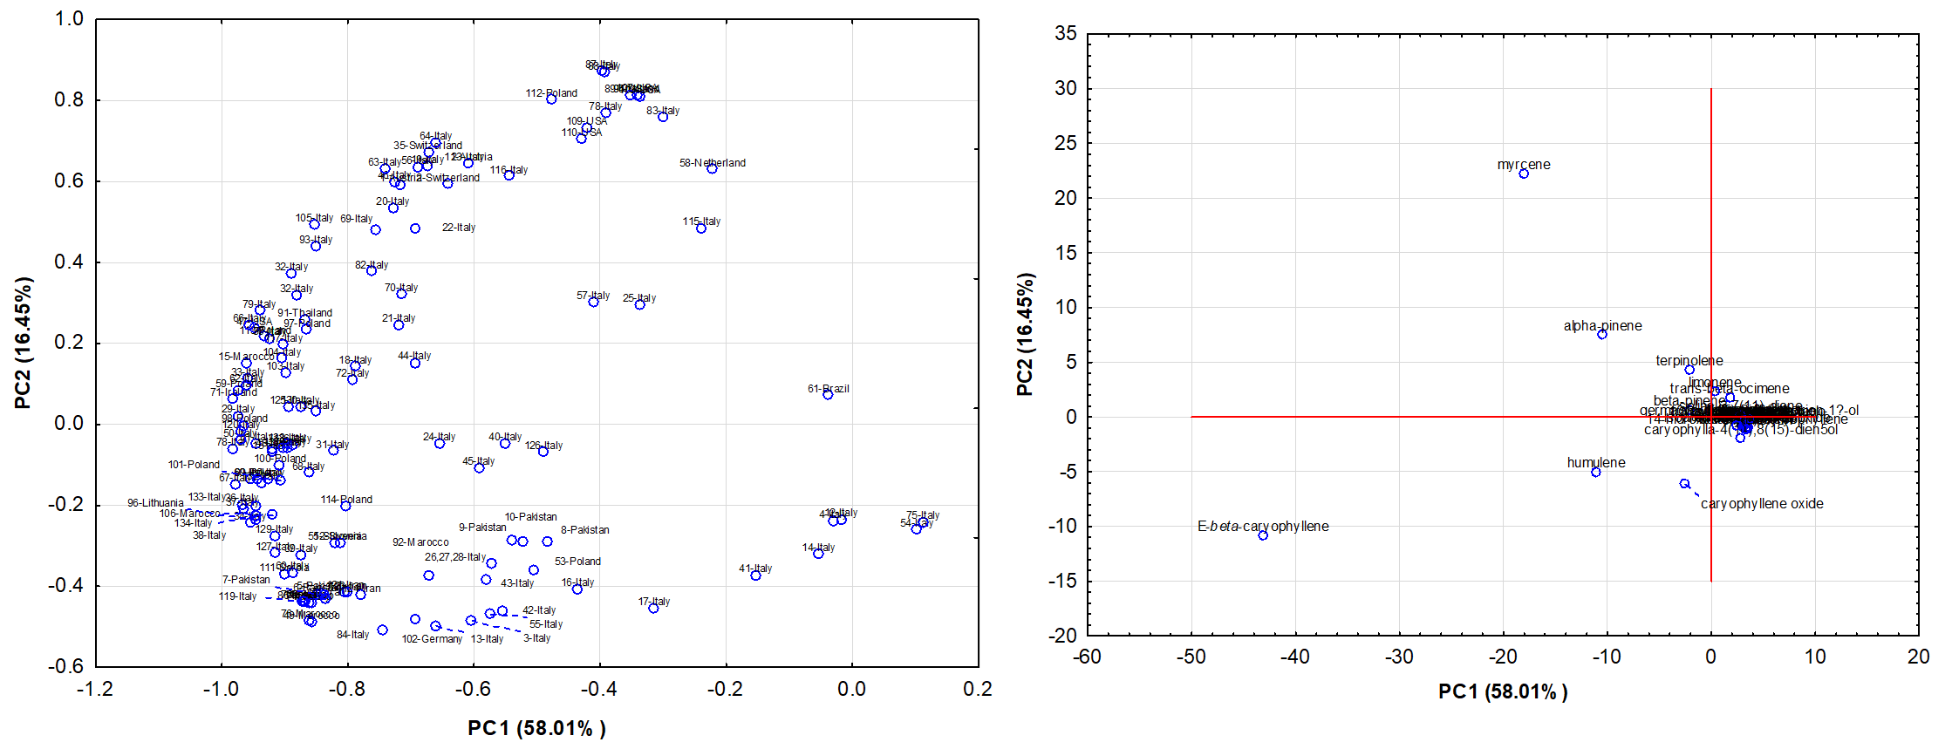
Supplementary Figure SS2. Principal component analysis (PCA) conducted on the complete composition of volatile oils extracted from all the Cannabis spp. samples on a global scale

