Supplementary material for: Expected population outcomes following decriminalization of recreational use of cannabis in Sweden

Filip Andersson, MSc^{1,2}, Robert Thiesmeier, MSc¹, Cecilia Magnusson, PhD^{1,2}, Nicola Orsini, PhD^{1,2}, Mats Ramstedt, PhD^{3,4}, Maria Rosaria Galanti, PhD¹
¹Department of Global Public Health, Karolinska Institutet, SE-17177 Stockholm, Sweden; ²Centre for Epidemiology and Community Medicine, Stockholm Health Care District, Stockholm Region, Box 45436 10431 Stockholm, Sweden; ³Department of Clinical Neuroscience, Karolinska Institutet, SE-17177 Stockholm, Sweden; ⁴The Swedish Council for Information on Alcohol and Other Drugs, Östergötagatan 90 11664 Stockholm, Sweden

Appendix A1
Table A1 Description of the data sources.
Variable | Country | Source
Socio-Demographic index | All | Global Burden of Disease Collaborative Network. Global Burden of Disease Study 2021 (GBD 2021) Socio-Demographic Index (SDI) 1950–2021. Seattle, United States of America: Institute for Health Metrics and Evaluation (IHME), 2024.
Gini-coefficient | All – only country level | Gini Coefficient World Bank
Gini-coefficient | Hawaii  Louisiana  New Hampshire  North Dakota | Useful Stats: Income inequality across the states | SSTI
Share with tertiary education | All – only country level, except Australia | https://w3.unece.org/PXWeb2015/pxweb/en/STAT/
Share age 15-24 years old | All – only country level | All countries compared for People > Age distribution > Population aged 15-24 > Percent
GDP per capita | All – only country level | https://countryeconomy.com/gdp
Cannabis use | Australia | National Drug Strategy Household Survey 2022–2023: Cannabis in the NDSHS - Australian Institute of Health and Welfare
Cannabis use | Austria, Belgium, Croatia, Czech Republic, Estonia, Italy, Luxemburg, Portugal, Slovenia, Spain, Sweden | EMCDDA – Statistical Bulletin 2004-2024
Cannabis use | Switzerland | Cannabis consumption (age: 15-64) | MonAM | FOPH
Cannabis use | Hawaii, Louisiana, New Hampshire, North Dakota | National Survey on Drug Use and Health
Share with tertiary education | Croatia – added data | Statistics | Eurostat

Table A2 BIC of the estimated models of cannabis use after decriminalization.
 | Time  [95% CI] | Interaction between Time and Gini-coefficient [95% CI] | Interaction between Time and SDI  [95% CI] | Interaction between Time and Share with tertiary education  [95% CI] | Interaction between Time and Share age 15-24 years old  [95% CI] | Interaction between Time and GDP per capita  [95% CI]
Past 12-month
BIC | 1738·953 | 1732·732 | 1738·556 | 1739·994 | 1710·781 | 1744·510
Past 30-days
BIC | -11·824 | -13·795 | -15·042 | -129·993 | -12·496 | -12·914

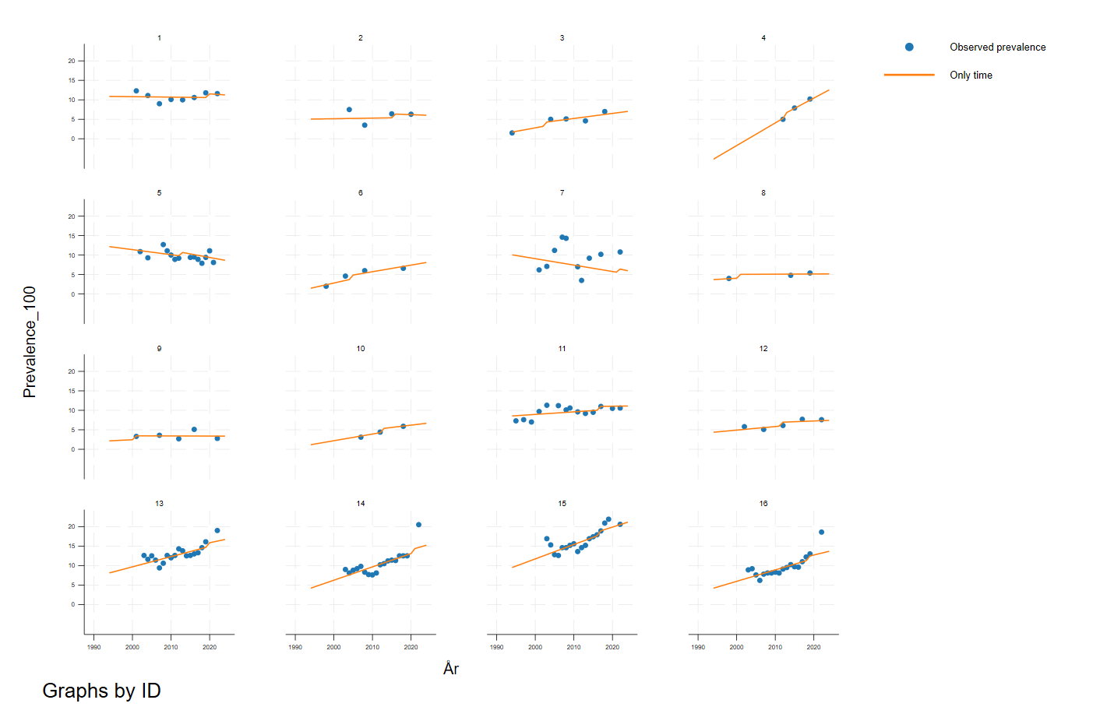
Figure A1 Predicted past 12-month prevalence of cannabis use pre and post decriminalization, by country.
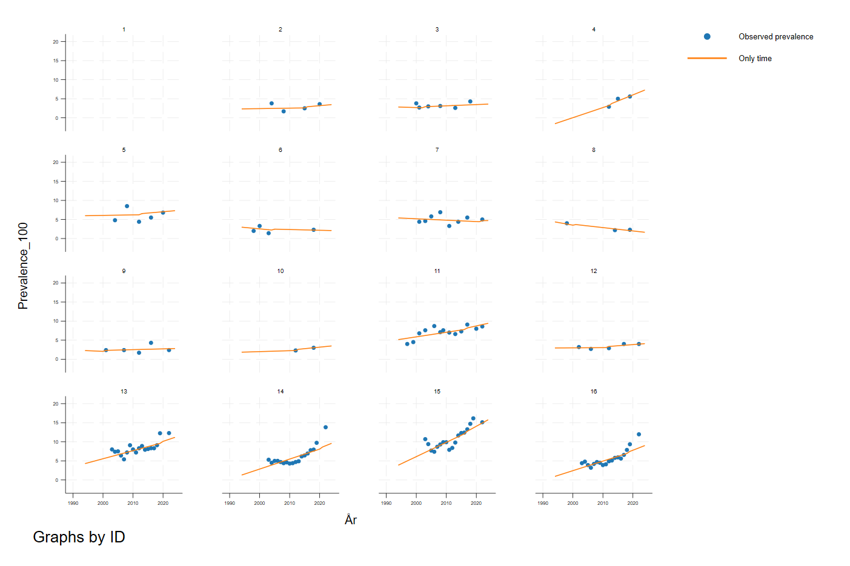
Figure A2 Predicted post 30-days prevalences of cannabis use pre and post decriminalization.

