Supplementary Information for:

Exploring the neuroprotective effects of phytocannabinoids on oxygen-glucose deprived neurons in an in-vitro model of stroke

Bhavya Chatragadda*, Emily M. Potts*, Alicia Collins, Hang Ma, Claudia Fallini

Content:
Supplementary Figure 1. Characterization of Kolf2.1J iPSC-derived cortical neurons.
Supplementary Figure 2. Validation of live-cell screening pipeline using sodium arsenite (NaArs) as toxic agent.
Supplementary Figure 3. Phytocannabinoids modulate neuronal survival after OGD.
Supplementary Figure 4. CBGOA treatment does not affect caspase-3 activation.
Supplementary Table 1. List of the tested phytocannabinoids.

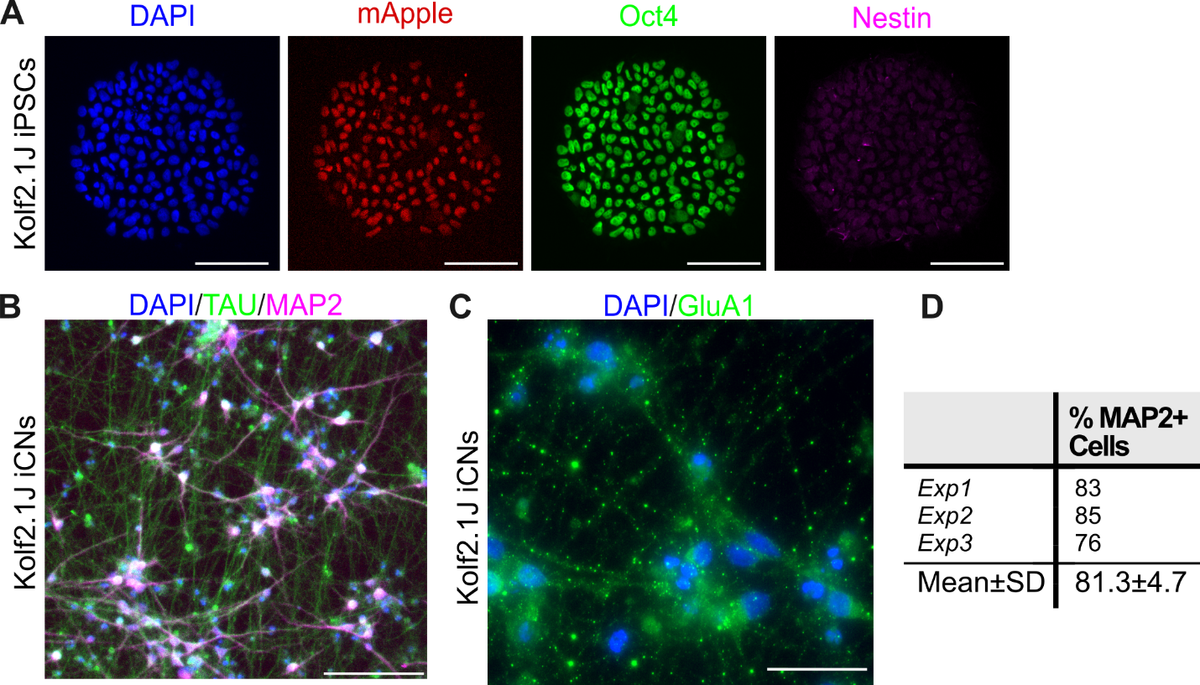
Supplementary Figure 1. Characterization of Kolf2.1J iPSC-derived cortical neurons. A. Immunocytochemistry of Kolf2.1J iPSCs expressing the pluripotency marker Oct4 (green) but not the progenitor marker Nestin (magenta). Cells express the red fluorescent protein mApple^{NLS} (red), that was integrated in the cell’s genome as part of the differentiation cassette and used as positive selection marker (see Materials and Methods). Scale bars 50 µm. B. Representative image of differentiated induced cortical neurons (iCNs) stained for MAP2 (magenta) and TAU (green), confirming neuronal identity. Scale bars are 100µm. C. Mature iCNs also express the glutamatergic receptor subunit GluA1 (green). Scale bars are 100µm. All nuclei are counterstained with DAPI (blue). D. Quantification of the efficiency of neuronal differentiation as the percentage of MAP2⁺ cells.

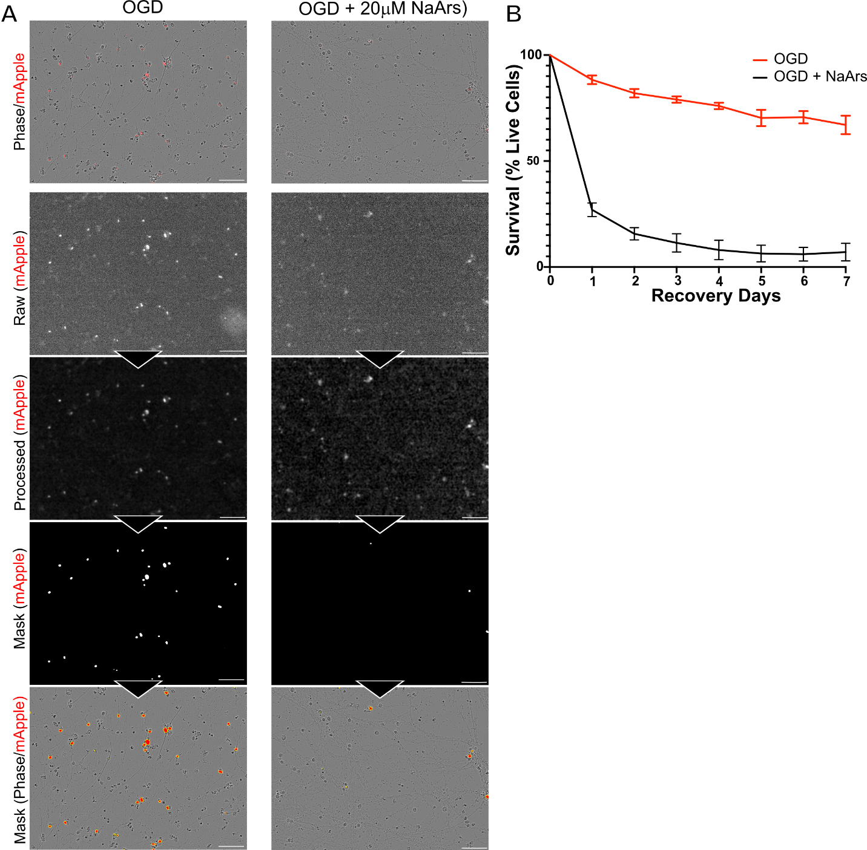
Supplementary Figure 2. Validation of live-cell screening pipeline using sodium arsenite (NaArs) as toxic agent. A. Representative images of live cell analysis pipelines in OGD-exposed neurons with or without NaArs, used as a negative control. From top to bottom, columns show phase contrast of neurons with mApple signal (red), raw mApple fluorescence, processed mApple signal (ROF denoise, top-hat filter, despeckle, smooth), binary mask of detected cells, and overlay of mask (red) with phase contrast. Neurons treated with NaArs (20 µM) exhibited markedly reduced survival compared to untreated controls 7 days post injury. B. Quantification of neuronal survival over a 7-day recovery period shows a rapid decline in survival with OGD+NaArs treatment compared to OGD alone. Data are shown as mean ± SEM across independent replicates. Scale bars: 100 µm.

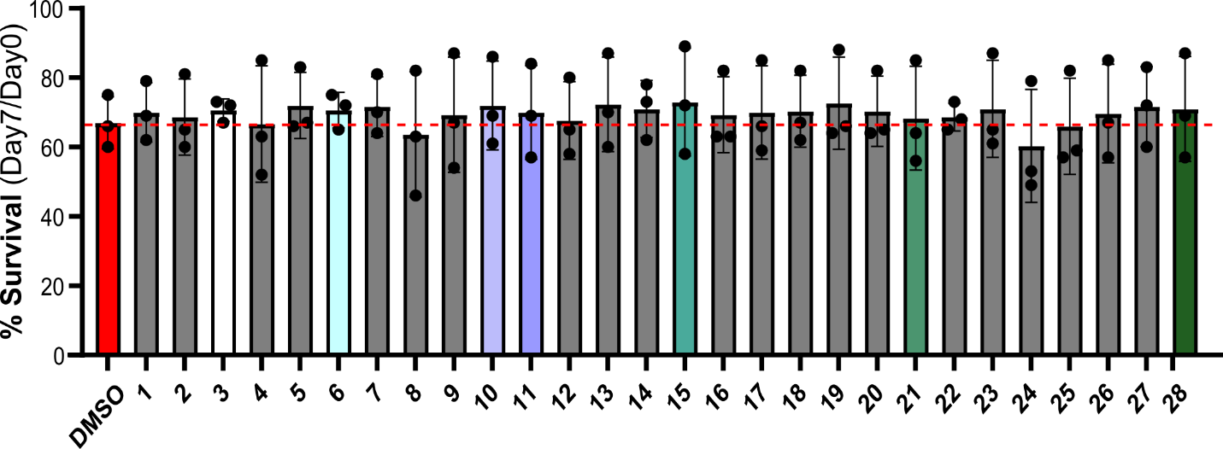

Supplementary Figure 3. Phytocannabinoids modulate neuronal survival after OGD. Quantification of survival of iCNs exposed to OGD and treated with DMSO or a panel of 28 phytocannabinoids. Neuronal numbers were evaluated immediately after OGD (Day 0) and after 7 days of recovery. Data is displayed as the percentage of cells still alive at day 7 (n = 3, one way ANOVA with mixed effects model, not significant).

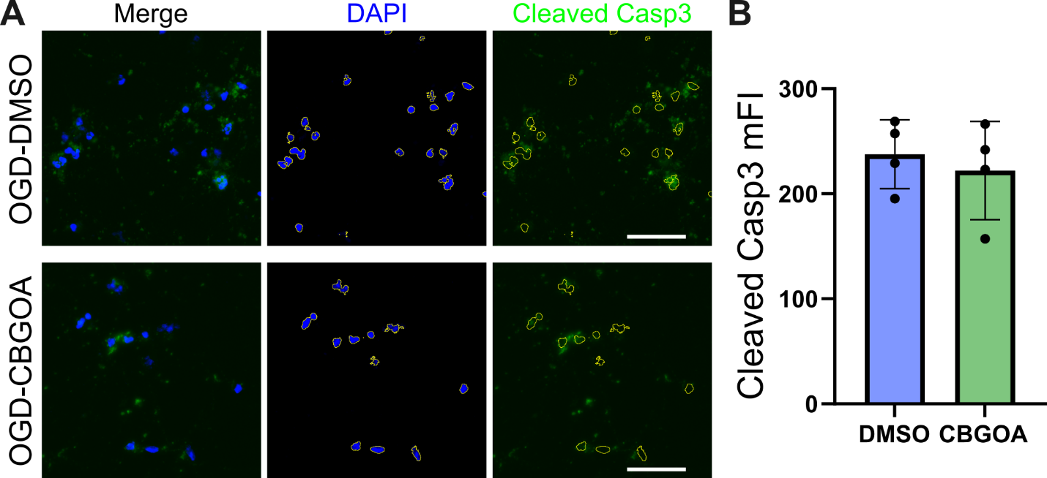

Supplementary Figure 4. CBGOA treatment does not affect caspase 3 activation. A. Representative images of untreated and CBGOA-treated neurons one day after OGD exposure. Caspase 3 activation was detected using an antibody specific for its cleaved form (Cleaved Casp3, green). DAPI (blue) was used to identify cells and define a mask (indicated by the yellow outline) for quantification. B. Quantification of cleaved caspase 3 mean fluorescence intensity (mFI) shows no difference between DMSO- and CBGOA-treated neurons at day 1 after OGD (ratio paired two-tailed t-test; n = 4, p = 0.71).

ID Number | Compound Name | Abbreviation | Molecular Weight
1 | cannabidiolic acid methyl ester | CAME | 372.5
2 | Δ⁹-THCB | Δ⁹-THCB | 300.4
3 | cannabinol | CBN | 310.43
4 | cannabinodiol | CBND | 310.44
5 | cannabicitran | CBT | 314.5
6 | THCA-A | THCA-A | 358.5
7 | 11-nor-9-carboxy-9-THC | THCCOOH | 344.4
8 | cannabidivarin | CBDV | 286.42
9 | cannabichromene | CBC | 314.46
10 | 11-hydroxy- Δ⁹-THC | 11H- Δ⁹THC | 330.5
11 | tetrahydrocannabivarin | THCV | 286.41
12 | cannabidiolic acid | CBDA | 358.5
13 | cannabigerovarinic acid | CBGVA | 332.4
14 | cannabichromevarin | CBCV | 286.4
15 | cannabigerovarin | CBGV | 288.4
16 | varinolic acid | Varinolic acid | 196.2
17 | cannabicyclol | CBL | 314.47
18 | Δ⁸-THCA-A | Δ⁸-THCA-A | 358.5
19 | cannabinol monomethyl ether | CBGM | 324.5
20 | cannabivarin | CBV | 282.4
21 | cannabigerorcinic acid | CBGOA | 304.4
22 | 6α-hydroxy cannabidiol | 6H-CBD | 330.5
23 | cannabigerol | CBG | 316.48
24 | cannabigerolic acid | CBGA | 360.49
25 | cannabidibutol | CBDB | 300.4
26 | cannabidiphorol | CBDP | 342.5
27 | Δ⁹-THCP | Δ⁹-THCP | 342.5
28 | cannabidiol | CBD | 314.47
Supplementary Table 1. List of the tested phytocannabinoids. Compound ID number used throughout the study is shown, together with full name, abbreviation, and molecular weight.

