Additional file 1: Individual data corresponding to the bar graphs presented in Figures 2, 3, and 4 of the main manuscript

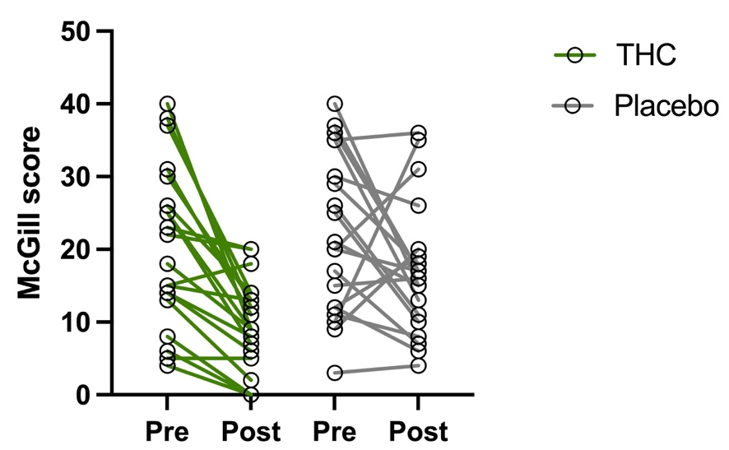
Supp_Figure 1. Individual values of McGill scores in the THC and placebo conditions. The graph displays individual values at baseline and after treatment for each experimental condition. McGill pain scores were 20.45 ± 11.06 at baseline and 9.50 ± 6.21 after THC administration. In the placebo condition, scores were 22.65 ± 11.89 at baseline and 17.05 ± 9.05 after placebo administration.

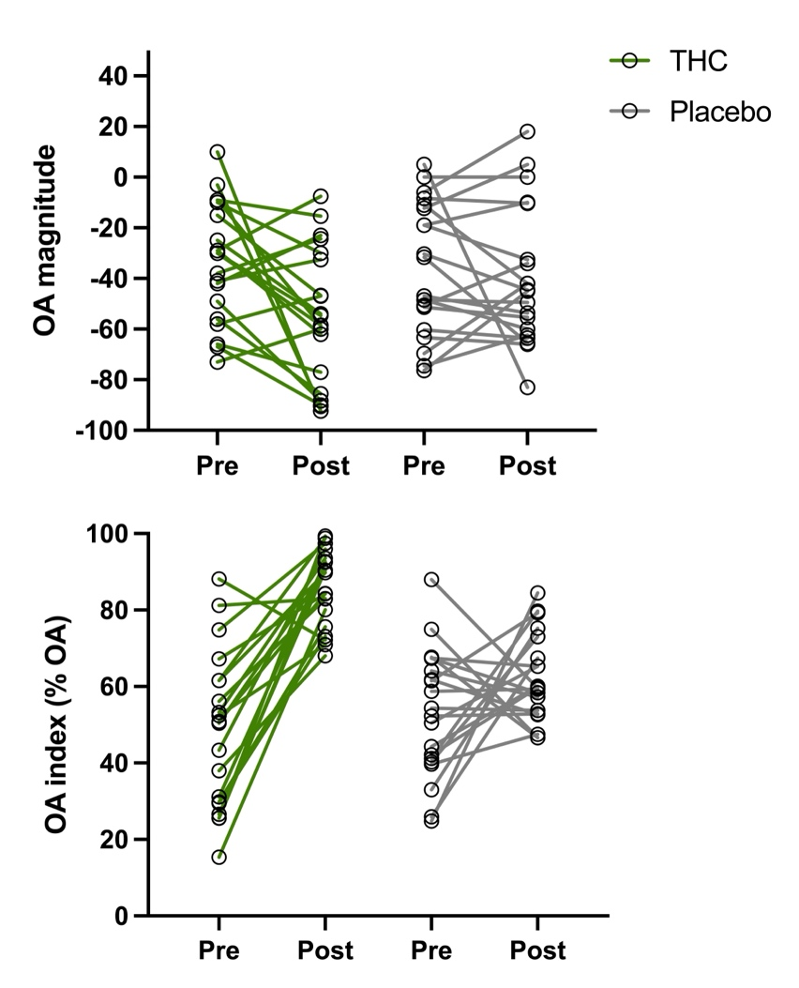
Supp_Figure 2. Individual values of OA magnitude and OA index in THC and placebo conditions. The graph displays individual values at baseline and after treatment for each experimental condition. For OA magnitude, the scores were –33.45 ± 23.27 at baseline and –54.88 ± 26.71 after THC administration. In the placebo condition, scores were –36.13 ± 26.07 at baseline and –39.80 ± 27.19 following placebo administration. For the OA index, values were 48.12 ± 20.40 at baseline and 85.78 ± 9.83 after THC administration. In the placebo condition, the OA index was 52.99 ± 16.63 at baseline and 62.20 ± 11.35 following placebo administration.

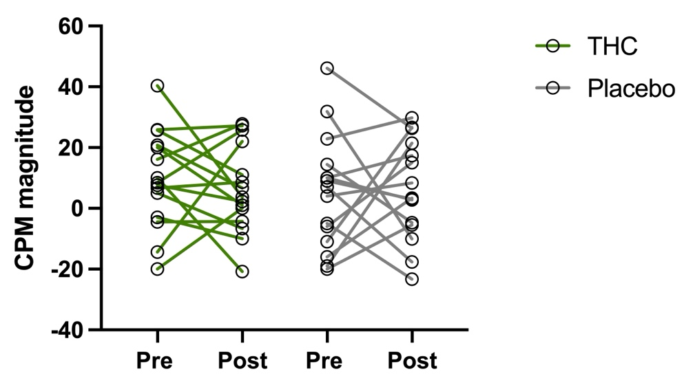

Supp_Figure 3. Individual values of CPM magnitude in THC and placebo conditions. The mean ± SD values for CPM magnitude were 9.65 ± 16.02 at baseline and 6.29 ± 14.45 after THC administration. In the placebo condition, scores were 5.22 ± 18.92 at baseline and 6.19 ± 16.49 following placebo administration.

